Supplementary Material

Trifluridine/tipiracil with or without bevacizumab in metastatic colorectal cancer:
results of a systematic review and meta-analysis

TABLES

Supplemental Table 1. PICOS elements and eligibility criteria

Category | Inclusion criteria | Exclusion criteria
Population | - Patients with mCRC | - Non-human studies
Intervention/  comparators | - FTD/TPI + BEV or FTD/TPI monotherapy | - Any study which does not include FTD/TPI + BEV or FTD/TPI monotherapy in any of the treatment arms
Outcome | - Clinical efficacy: ORR, DCR, duration of response, PFS, OS  - Safety: Frequencies and grades of any AEs  - Tolerability: Proportion of patients discontinuing treatment because of AEs | - Studies not reporting any of the relevant outcomes
Study design | - RCTs  - Non-RCTs  - Observational studies | - Case studies, case reports, case series  - Comments, editorials, narratives, letters to editor, opinion pieces  - Systematic literature reviews and meta-analyses
Other criteria | - Studies in English | - Non-English studies

AE, adverse event; DCR, disease control rate; FTD/TPI, trifluridine/tipiracil; FTD/TPI + BEV, trifluridine/tipiracil plus bevacizumab; mCRC, metastatic colorectal cancer; ORR, objective response rate; OS, overall survival; PFS, progression-free survival; PICOS, population, intervention, comparator, outcome, and study design; RCT, randomized controlled trial.

Supplemental Table 2. Search strategy for MEDLINE® (via Ovid®) and number of hits

Term number | Search strategy | Number of hits
1 | exp colorectal cancer/ or exp colon cancer/ or exp rectum cancer/ or exp colon tumor/ or exp rectum tumor/ or exp colon carcinoma/ or exp rectum carcinoma/ | 210,046
2 | ((colorectal or colon or rectum or rectal or bowel or large intestine) adj3 (cancer* or neoplasm* or tumo?r* or oncolog* or malignan* or carcinoma* or sarcoma* or adenocarcinoma* or leiomyosarcoma*)).ti,ab,kw. | 227,238
3 | 1 or 2 | 286,300
4 | (lonsurf or tas 102 or tas102 or tas-102 or "trifluridine/tipiracil" or "Tipiracil-hydrochloride/trifluridine" or "Trifluridine/tipiracil hydrochloride" or "tipiracil hydrochloride plus trifluridine" or "trifluridine plus tipiracil" or "trifluridine plus tipiracil hydrochloride" or "tipiracil plus trifluridine" or "FTD/TPI" or "trifluridine - tipiracil" or "trifluridine-tipiracil" or ("trifluridine" and "tipiracil") or Orcantas or "S 95005" or "S 95005/TAS-102" or "T15, T20" or "T15/T20").ti,ab,kw. | 400
5 | 3 and 4 | 327
6 | limit 5 to humans | 233
7 | limit 6 to English language | 205

Supplemental Table 3. Publications identified for use in the meta-analysis

Citation | Trial ID/name | Study design | Phase | Patient setting | Regimen 1 | Regimen 2 | Study size | Treatment arm(s) size | Median follow-up, mo | Outcomes
Karthaus 2016 | RECOURSE | RCT | Phase 3 | 3L+ | FTD/TPI (35 mg/m²; PO, BD, days 1–5 and 8–12, 28-d cycle) | Placebo (PO, BD, days 1–5 and 8–12, 28-d cycle) | 800 | 534; 266 | NR | OS
Mayer 2015 | RECOURSE | RCT | Phase 3 | 3L+ | FTD/TPI (35 mg/m²; PD, BD, days 1–5 and 8–12 , 28-d cycle) | Placebo (PO, BD, days 1–5 and 8–12, 28-d cycle) | 800 | 534; 266 | 11.8 | PFS, OS, DCR, ORR, AEs
Van Cutsem 2017 | RECOURSE | RCT | Phase 3 | 3L+ | FTD/TPI (35 mg/m²; PO, BD, days 1–5 and 8–12, 28-d cycle) | Placebo (PO, BD, days 1–5 and 8–12, 28-d cycle) | 800 | 534; 266 | FTD/TPI: 1.57; placebo: 1.33ª | AEs, HRQoL^{d}
Xu  2018 | TERRA | RCT | Phase 3 | 3L+ | FTD/TPI (35 mg/m²; PO, BD, days 1–5 and 8–12, 28-d cycle) | Placebo (PO, BD, days 1–5 and 8–12, 28-d cycle) | 406 | 271; 135 | FTD/TPI: 13.8; placebo: 13.4 | PFS, OS, DCR, ORR, AEs
Pfeiffer 2020 | EudraCT, 2016‐005241‐23 | RCT | Phase 2 | 2L+ | FTD/TPI (35 mg/m²; PO, BD, days 1–5 and 8–12, 28-d cycle) + BEV (5 mg/kg; IV, days 1 and 15, 28-d cycle) | FTD/TPI (35 mg/m²; PO, BD, days 1–5 and 8–12, 28-d cycle) | 93 | 46; 47 | 10·0 | PFS, OS, DCR, ORR, AEs
Yoshino 2016a | J003-10040030 | RCT | Phase 2 | 3L+ | FTD/TPI (35 mg/m²; PO, BD, days 1–5 and 8–12, 28-d cycle) | Placebo (PO, BD, days 1–5 and 8–12, 28-d cycle) | 169 | 112; 57 | 57.5 | OS, AEs
Yoshino 2012 | J003-10040030 | RCT | Phase 2 | 3L+ | FTD/TPI (35 mg/m²; PO, BD, days 1–5 and 8–12, 28-d cycle) | Placebo (PO, BD, days 1–5 and 8–12, 28-d cycle) | 169 | 112; 57 | 11.3 | PFS, OS, DCR, AEs
Kasper 2020 | RAMTAS | RCT | Phase 2b | Previously treated (relapsed/  refractory) | FTD/TPI (35 mg/m²; PO, BD, days 1–5 and 8–12, 28-d cycle) | FTD/TPI (35 mg/m²; PO, BD, days 1–5 and 8–12, 28-d cycle) + RAM (8 mg/kg, IV, days 1 and 15, 28-d cycle) | 80 | 40; 40 | NR | AEs
Bachet 2020 | PRECONNECT | Non-RCT | Phase 3b | 2L+ | FTD/TPI (35 mg/m²; PO, BD, days 1–5 and 8–12, 28-d cycle) | NR | 793 | — | NR | PFS, ORR, DCR, AEs, HRQoL^{d}
Fedyanin 2019 | NCT03274882 | Non-RCT | Phase 2/3 | 3L+ | FTD/TPI (NR) | NR | 26 | — | NR | DCR, PFS, AEs
Takahashi 2021 | JFMC51-1702-C7 | Non-RCT | Phase 2 | 2L+ | FTD/TPI (35 mg/m²; PO, BD, days 1–5 and 8–12, 28-d cycle) + BEV (5 mg/kg; IV, days 1 and 15, 28-d cycle) | NR | 97 | — | 15.8 | PFS, OS, ORR, DCR, AEs
Yoshida 2021 | TAS-CC3 | Non-RCT | Phase 2 | 3L | FTD/TPI (35 mg/m²; PO, BD, days 1–5 and 8–12, 28-d cycle) + BEV (5 mg/kg; IV, days 1 and 15, 28-d cycle) | NR | 32 | — | NR | PFS, OS, ORR, DCR, AEs
Takahash 2018 | T-CORE1401 | Non-RCT | Phase 2 | 2L+ (older adults) | FTD/TPI (35 mg/m²; PO, BD, days 1–5 and 8–12, 28-d cycle) | NR | 30 | — | NR | PFS, OS, AEs
Yoshida 2019 | NA | Non-RCT | Phase 2 | 2L+ | FTD/TPI (35 mg/m²; PO, BD, days 1–5 and 15-19, 28-d cycle) + BEV (5 mg/kg; IV, days 1 and 15, 28-d cycle)^{b} | NR | 45 | — | NR | PFS, ORR, DCR, AEs
Satake 2020 | BiTS Study | Non-RCT | Phase 1b, 2 | 3L+ | FTD/TPI (35 mg/m²; PO, BD, days 1–5 and 15-19, 28-d cycle) + BEV (5 mg/kg; IV, days 1 and 15, 28-d cycle)^{b} | NR | 44 | — | 15.36 | PFS, OS, ORR, DCR, AEs
Kuboki 2017 | C-TASK FORCE | Non-RCT | Phase 1/2 | 2L+ | FTD/TPI (35 mg/m²; PO, BD, days 1–5 and 8–12, 28-d cycle) + BEV (5 mg/kg; IV, days 1 and 15, 28-d cycle) | NR | 25 | — | 11·4 | PFS, OS, ORR, DCR, AEs
Bendell 2015 | NA | Non-RCT | Phase 1 | 3L+ | FTD/TPI (35 mg/m²; PO, BD, days 1–5 and 8–12, 28-d cycle) | FTD/TPI (30 mg/m²; PO, BD, days 1–5 and 8–12, 28-d cycle)^{b} | 27 | — | NR | DCR, PFS, OS, AEs
Ridolfi 2017 | NA | Non-RCT | NR | 3L+ | FTD/TPI (NR) | NR | 50 | — | NR | TTP, OS, AEs
Mayer 2018 | NCT02286492 | Non-RCT | Expanded access | 3L+ | FTD/TPI (35 mg/m²; PO, BD, days 1–5 and 8–12, 28-d cycle) | NR | 549 | — | NR | AEs
Yoshino 2021 | JapicCTI-142659 | Prospective observational | NR | 2L+ | FTD/TPI (35 mg/m²; PO; BD; days 1–5 and 8–12; 28-d cycle) | NR | 823 | 823 | 12 | AE, DCR, response rates, OS
Cheung 2020 | NA | Prospective observational | NR | 3L+ | FTD/TPI (35 mg/m²; PO; BD; days 1–5 and 8–12; 28-d cycle) | BSC | 105 | 50; 55 | NR | HRQoL^{d}
Jalali 2021 | NA | Prospective observational | NR | Previously treated (refractory) | FTD/TPI (NR) | NR | 107 | 107 | NR | PFS, OS, AEs
Coutzac 2020 | NA | Prospective observational | NR | Previously treated (refractory) | FTD/TPI (NR) | REG | 237 | 177; 60 | NR | PFS, OS, AEs
Cremolini 2018 | NA | Prospective observational | NR | 2L+ | FTD/TPI (35 mg/m²; PO, BD, days 1–5 and 8–12, 28-d cycle) | NR | 341 | 341 | 6 | PFS, OS, AEs, DCR
Kasper 2018 | NA | Prospective observational | NR | Previously treated (refractory) | FTD/TPI (130 mg/day^{c}, NR) | NR | 226 | 226 | NR | AEs
Garcia-Alfonso 2017 | NA | Prospective observational | NR | 93% pts 3L+ | FTD/TPI (35 mg/m²; BD) | NR | 538 | 538 | NR | AEs
Yoshino 2016b | NA | Prospective observational | NR | Previously treated (refractory) | FTD/TPI (35 mg/m²; PO, BD, days 1–5 and 8–12, 28-d cycle) | NR | 3420 | 3420 | NR | AEs
Salvatore 2016 | NA | Prospective observational | NR | 92% of patients in 3L+ | FTD/TPI (35 mg/m²; BD) | NR | 725 | 725 | NR | AEs
Hamers 2020 | QUALITAS | Prospective observational | NR | Previously treated | FTD/TPI (NR) | NR | 497 | 497 | NR | HRQoL^{d}

ªIn this publication, median follow-up was not reported, and duration of treatment was used as the proxy for median follow-up.
^{b}Nonapproved dosing regimen (shown in bold).
^{c}130 mg/day translates approximately to 35 mg/m² twice daily dose.
^{d}HRQoL was not assessed in the quantitative synthesis.
2L+, second-line or later; 3L+, third-line or later; AE, adverse event; BD, twice daily; BEV, bevacizumab; BSC, best standard of care; d, day; DCR, disease control rate; FTD/TPI, trifluridine/tipiracil; HRQoL, health-related quality of life; IV, intravenous; NA, not available; NR, not reported; ORR, objective response rate; OS, overall survival; PFS, progression-free survival; PO, orally; RAM, ramucirumab; RCT, randomized controlled trial; REG, regorafenib; TTP, time to progression.

Supplemental Table 4. Publication bias quality assessment of the 5 RCTs using the Cochrane risk-of-bias tool.

Citation | Trial ID/name | Random sequence generation (selection bias) | Allocation concealment (selection bias) | Blinding of participants and personnel (performance bias) | Blinding of outcome assessment (detection bias) | Incomplete outcome data (attrition bias) | Selective reporting (reporting bias) | Other bias
Mayer 2015 | RECOURSE | Low risk | Low risk | Low risk | Low risk | Low risk | Low risk | Low risk
Xu 2018 | TERRA | Low risk | Low risk | Low risk | Low risk | Low risk | Low risk | Low risk
Peffeifer 2020 | EudraCT, 2016–005241–23 | Low risk | High risk | High risk | High risk | Low risk | Low risk | Low risk
Yoshino 2012 | J003-10040030 | Low risk | Low risk | Low risk | Low risk | Low risk | Low risk | Low risk
Kasper 2020 | RAMTAS | Unclear | Unclear | High risk | High risk | Low risk | Low risk | Low risk

RCT, randomized controlled trial.

Supplemental Table 5. Publication bias quality assessment of the 11 non-RCTs using the Downs and Black checklist

Citation | Trial ID/name | Reporting  (10 items) | External validity  (3 items) | Internal validity – bias  (7 items) | Internal validity – confounding (selection bias)  (6 items) | Power  (1 item) | Total score  (31 items) | Interpretationª
Bachet 2020 | PRECONNECT | 9 | 1 | 3 | 1 | 0 | 14 | Poor
Fedyanin 2019 | NCT03274882 | 8 | 1 | 1 | 1 | 0 | 11 | Poor
Takahashi 2021 | JFMC51-1702-C7 | 10 | 1 | 5 | 1 | 1 | 18 | Fair
Yohsida 2021 | TAS-CC3 | 11 | 0 | 4 | 3 | 2 | 20 | Good
Takahashi 2018 | T-CORE1401 | 7 | 1 | 1 | 2 | 0 | 11 | Poor
Yoshida 2019 | NA | 4 | 1 | 2 | 1 | 0 | 8 | Poor
Satake 2020 | BiTS Study | 10 | 0 | 3 | 2 | 1 | 16 | Fair
Kuboki 2017 | C-TASK FORCE | 10 | 1 | 4 | 2 | 1 | 18 | Fair
Bendell 2015 | NA | 9 | 1 | 3 | 2 | 0 | 15 | Fair
Ridolfi 2017 | NA | 6 | 1 | 3 | 1 | 0 | 11 | Poor
Mayer 2018 | NCT02286492 | 10 | 1 | 4 | 3 | 0 | 18 | Fair

ªScores of ≤14, 15–19, 20–25, and 26–32 were considered poor, fair, good, and excellent, respectively.
NA, not available; RCT, randomized controlled trial.

Supplemental Table 6. Publication bias quality assessment of the 10 observational studies using the Newcastle-Ottawa scale

Citation | Trial ID/name | Total scoreª | Interpretationª
Yoshino 2021 | JapicCTI-142659 | 6 | Medium
Cheung 2020 | NA | 7 | High
Jalali 2021 | NA | 2 | Low
Coutzac 2020 | NA | 4 | Medium
Cremolini 2018 | NA | 6 | Medium
Kasper 2018 | NA | 5 | Medium
Garcia 2017 | NA | 5 | Medium
Yoshino 2016b | NA | 2 | Low
Salvatore 2016 | NA | 4 | Medium
Hamers 2020 | QUALITAS | 3 | Low

ªScores of 0–3, 4–6, and 7–9 were considered low, medium, and high quality, respectively.
NA, not available.

Supplemental Table 7. Absolute (pooled) PFS rates

 | No. of patients | Median PFS (95% CI), monthsª | PFS (95% CI), %
 |  |  | 3 months | 6 months | 12 months | 18 months | 24 months
FTD/TPI + BEV
Kuboki 2017 | 25 | 5.5 (3.8–7.6) | 72 (56–92) | 36 (21–61) | 16 (7–39) | 5 (1–33) | NA
Pfeiffer 2020 | 46 | 4.6 (3.5–6.5) | 69 (57–84) | 43 (31–61) | 17 (8–37) | NA | NA
Satake 2020 | 44 | 4.3 (2.7–5.9) | 61 (48–77) | 26 (16–43) | 11 (5–26) | NA | NA
Takahashi 2021 | 97 | 3.7 (3.1–4.3) | 60 (51–71) | 21 (14–31) | NA | NA | NA
Yoshida 2021 | 32 | 4.4 (2.6–5.9) | 59 (45–79) | 26 (15–48) | 17 (7–37) | 13 (5–33) | 13 (5–33)
Pooled estimate | 244 | 4.2 (3.8–4.8) | 63 (57–69) | 28 (23–35) | 9 (6–14) | 3 (2–7) | 3 (2–7)
FTD/TPI monotherapy
Bachet 2020 | 790 | 2.8 (2.8–2.9) | 46 (42–50) | 19 (16–22) | 2 (1–4) | NA | NA
Bendell 2015 | 27 | 4.7 (2.3–8.4) | 61 (45–83) | 34 (20–60) | 9 (2–47) | NA | NA
Mayer 2015 | 534 | 2.1 (1.9–2.4) | 41 (37–46) | 16 (13–20) | 3 (2–6) | NA | NA
Pfeiffer 2020 | 47 | 2.6 (1.6–3.5) | 43 (31–59) | 15 (8–29) | NA | NA | NA
Xu 2018 | 271 | 2.1 (1.9–3.1) | 46 (41–53) | 16 (12–22) | 4 (2–8) | NA | NA
Yoshino 2012 | 112 | 2.2 (1.9–2.8) | 35 (27–46) | 20 (13–30) | 2 (0–10) | NA | NA
Pooled estimate | 1781 | 2.6 (2.4–2.8) | 44 (42–46) | 18 (16–20) | 3 (2–4) | NA | NA

ªEstimated median PFS values were derived from recreated Kaplan-Meier analyses using pseudo-individual patient data that were generated from digitized Kaplan-Meier data according to the Guyot algorithm.
FTD/TPI, trifluridine/tipiracil; FTD/TPI + BEV, trifluridine/tipiracil plus bevacizumab; NA, not available; PFS, progression-free survival.

Supplemental Table 8. Absolute OS (pooled) ratesª

 | No. of patients | Median OS (95% CI), monthsª | OS (95% CI), %
 |  |  | 3 months | 6 months | 12 months | 18 months | 24 months
FTD/TPI + BEV
Kuboki 2017 | 25 | 11.5  (8.2–15.8) | 100  (100–100) | 84 (71–100) | 44 (28–68) | 14 (5–39) | NA
Pfeiffer 2020 | 46 | 9.4 (7.9–NA) | 91 (83–100) | 79 (68–92) | 30 (17–52) | NA | NA
Satake 2020 | 44 | 10.9  (9.1–15.4) | 98 (93–100) | 80 (68–92) | 43 (31–61) | NA | NA
Takahashi 2021 | 97 | 9.1 (7.4–10.8) | 95 (91–99) | 73 (65–83) | 35 (27–47) | NA | NA
Yoshida 2021 | 32 | 9.4 (7.5–22.1) | 91 (81–100) | 69 (54–87) | 40 (26–62) | 30 (18–52) | 26 (15–48)
Pooled estimate | 244 | 9.8 (8.8–10.9) | 95 (92–98) | 76 (71–82) | 38 (32–45) | 18 (13–25) | 14 (9–23)
FTD/TPI monotherapy
Bendell 2015 | 27 | 8.9 (5.3–NA) | 89 (78–100) | 55 (38–77) | 39 (24–63) | 13 (3–63) | NA
Mayer 2015 | 534 | 7.3 (6.9–8.1) | 86 (83–89) | 60 (56–64) | 27 (23–32) | 13 (8–19) | NA
Pfeiffer 2020 | 47 | 6.7 (5.6–8.5) | 87 (77–97) | 54 (41–71) | 20 (10–39) | NA | NA
Xu 2018 | 271 | 8.1 (7.2–9.2) | 91 (87–94) | 66 (60–72) | 30 (24–36) | 16 (11–24) | 8 (3–18)
Yoshino 2012 | 112 | 8.9 (7.6–12.0) | 93 (88–98) | 71 (63–80) | 37 (29–48) | NA | NA
Yoshino 2021 | 823 | 8.5 (7.5–9.2) | 86 (83–88) | 63 (60–66) | 34 (31–38) | NA | NA
Pooled estimate | 1814 | 8.1 (7.5–8.5) | 87 (85–89) | 63 (60–65) | 32 (30–34) | 16 (12–20) | 8 (4–17)

ªEstimated median OS values were derived from recreated Kaplan-Meier analyses using pseudo-individual patient data that were generated from digitized Kaplan-Meier data according to the Guyot algorithm.
FTD/TPI, trifluridine/tipiracil; FTD/TPI + BEV, trifluridine/tipiracil plus bevacizumab; NA, not available; OS, overall survival.

Supplemental Table 9. AE monitoring schedule and G-CSF use

Study | Trial | Study design | Phase | AE monitoring schedule | G-CSF use
Karthaus 2016 | RECOURSE | RCT | Phase 3 | Every 2 weeks | Yes
Mayer 2015 | RECOURSE | RCT | Phase 3 | Every 2 weeks | Yes
Van Cutsem 2017 | RECOURSE | RCT | Phase 3 | Every 2 weeks | NR
Xu 2018 | TERRA | RCT | Phase 3 | Day 15 of cycle 1 and day 15 of cycle 2 | Yes
Pfeiffer 2020 | EudraCT, 2016–005241–23 | RCT | Phase 2 | Every 2 weeks | Yes (only in case of febrile neutropenia or delay in treatment administration because of neutropenia)
Yoshino 2016a | J003-10040030 | RCT | Phase 2 | Days 15, 22, and 29 in cycle 1 | NR
Yoshino 2012 | J003-10040030 | RCT | Phase 2 | Every 2 weeks | NR
Kasper 2020 | RAMTAS | RCT | Phase 2b | Every 2 weeks | NR
Bachet 2020 | PRECONNECT | Non-RCT | Phase 3b | NR | NR
Fedyanin 2019 | NCT03274882 | Non-RCT | Phase 2/3 | NR | NR
Takahashi 2021 | JFMC51-1702-C7 | Non-RCT | Phase 2 | Every 2 weeks | NR
Yoshida 2021 | TAS-CC3 | Non-RCT | Phase 2 | NR | No (prophylactic administration of G-CSF was prohibited, but there was no provision for its use in treatment for neutropenia)
Takahashi 2018 | T-CORE1401 | Non-RCT | Phase 2 | NR | NR
Yoshida 2019 | NR | Non-RCT | Phase 2 | NR | No
Satake 2020 | BiTS Study | Non-RCT | Phase 1b, 2 | Every 2 weeks | NR
Kuboki 2017 | C-TASK FORCE | Non-RCT | Phase 1/2 | Every 2 weeks | Yes
Bendell 2015 | NR | Non-RCT | Phase 1 | Days 8, 15, and 22 of cycle 1 and days 1 and 22 of subsequent cycles | Yes (G-CSF use was not permitted during cycle 1, but it was allowed to treat hematologic toxicity)
Ridolfi 2017 | NR | Non-RCT | NR | NR | NR
Mayer 2018 | NCT02286492 | Non-RCT | Exp. access | NR | NR
Yoshino 2021 | JapicCTI-142659 | Prospective observational | NR | NR | NR
Cheung 2020 | NR | Prospective observational | NR | NR | NR
Jalali 2021 | NR | Prospective observational | NR | NR | NR
Coutzac 2020 | NR | Prospective observational | NR | NR | NR
Cremolini 2018 | NR | Prospective observational | NR | NR | NR
Kasper 2018 | NR | Prospective observational | NR | NR | NR
Garcia-Alfonso 2017 | NR | Prospective observational | NR | NR | NR
Yoshino 2016b | NR | Prospective observational | NR | Days 15 and 22 of cycle 1 | NR
Salvatore 2016 | NR | Prospective observational | NR | NR | NR
Hamers 2020 | QUALITAS | Prospective observational | NR | NR | NR

AE, adverse event; G-CSF, granulocyte colony-stimulating factor; NR, not reported; RCT, randomized controlled trials.

FIGURES

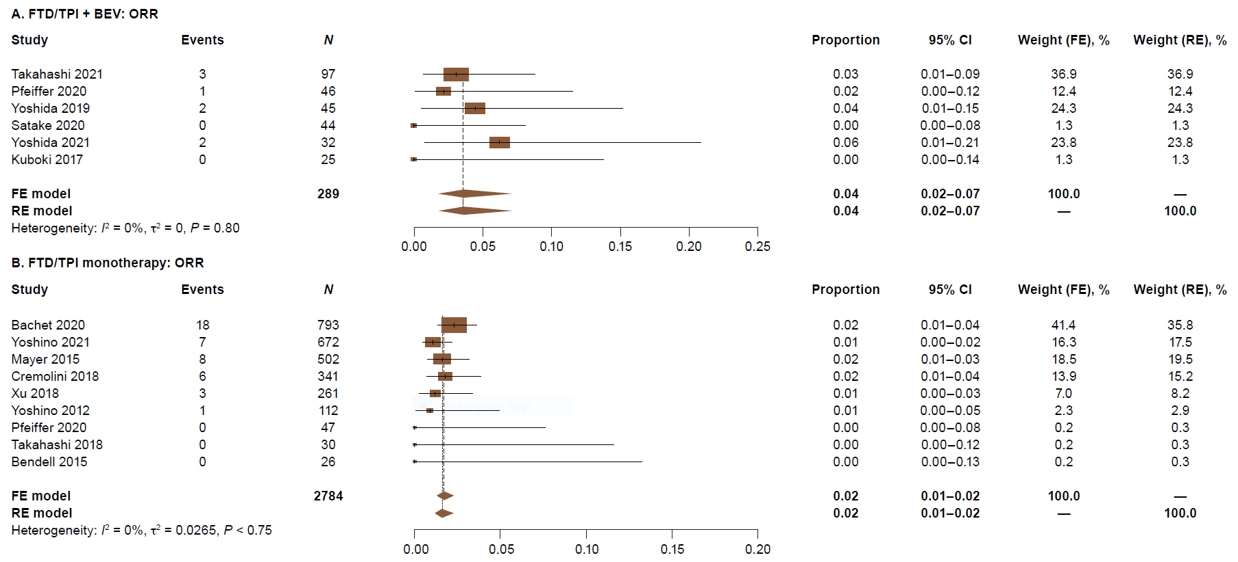

Supplemental Figure 1. Absolute objective response rates (ORRs) for (A) trifluridine/tipiracil (FTD/TPI) + bevacizumab (BEV) and (B) FTD/TPI monotherapy.
FE, fixed-effects; RE, random-effects.

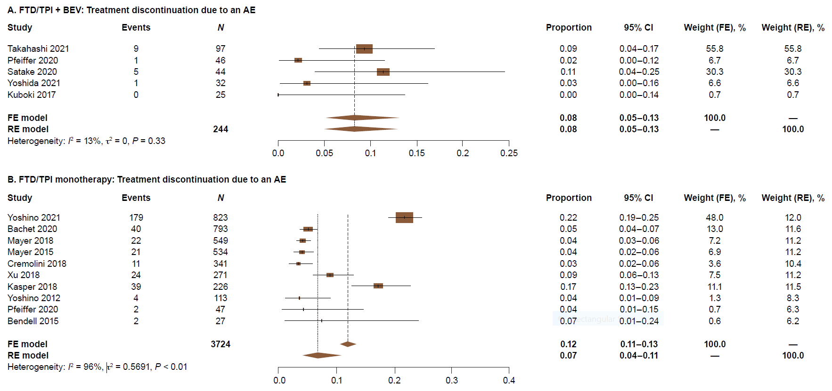

Supplemental Figure 2. Absolute discontinuation rates due to adverse events (AEs) for (A) trifluridine/tipiracil (FTD/TPI) + bevacizumab (BEV) and (B) FTD/TPI monotherapy.
FE, fixed-effects; RE, random-effects.

