Online Supplementary Materials

APPENDIX B: SUPPLEMENTAL ANALYSES

CBA Renegotiation Frequency
Because my analyses rely on within-district comparisons over time, one possible concern is that CBAs will tend to be monotonically increasing in length and restrictiveness over time as they are renegotiated (e.g., Fuller & Mitchell, 2006), and that this is a somewhat distinct phenomenon from the union exercising greater influence. I suspect that this is less of a concern in my context than it might be in other contexts for three reasons. First, my use of district fixed effects means I am effectively comparing districts to themselves over time. For example, the average rate at which districts renegotiate their CBAs, even if unobserved, would be accounted for by the district fixed effects. Second, to the extent that CBA renegotiation is a mechanism by which teachers’ unions exercise influence, more frequent renegotiation within the district may reflect genuine union influence that I would not want to “control away”. Third, and perhaps most importantly, under California law CBAs are supposed to be renegotiated at least every three years. Districts and their labor partners may choose to renegotiate more frequently than that, and negotiations may drag on too long or otherwise be delayed, but in practice this state requirement means that renegotiation cycles are substantially standardized across the state.
Nevertheless, CBA renegotiation rates are not perfectly standardized. This may mean that my results are driven disproportionately by districts that renegotiate CBAs more frequently (thus generating a disproportionate amount of CBA variation). This could be particularly concerning if renegotiation frequency is driven by unobservable factors that are distinct from “union influence” but correlated with my compensation measures within districts over time (e.g., unexpected local economic shocks).
I cannot rule those possibilities out, but I take advantage of the fact that my CBA data include some information about the years spanned by the CBA (i.e., the year the CBA was first supposed to be effective and the year in which the CBA was officially supposed to expire). These data are imperfect in a variety of ways. These span dates are missing altogether for roughly one quarter of the observations used to estimate model 2 (i.e., for the first research question, focused on union influence), including for all observations from 2005-2006 (i.e., the first year CBAs were collected). The observed dates may also not perfectly reflect the true start and end dates of the CBA (e.g., if the contract was reopened early or renegotiation was delayed), and I do not observe CBAs at all that may have been bargained in between data collections. Still, the dates allow me to at least roughly approximate the rate at which districts are renegotiating contracts.
Table B1 and figure B1 present results like those in table 1 and figure 1, except that I exclude districts for which the mean CBA span dates I observe are two years or less or five years or more. This corresponds to roughly the top and bottom decile of mean CBA spans. (There are no districts for which I observe no CBA spans in any year.) Thus, I include in these models only districts that appear to renegotiate their CBAs at a relatively “normal” rate on average (i.e., less frequently than every two years but more frequently than every five years). Despite substantially reducing my estimation sample (i.e., by roughly a quarter), results are essentially unchanged.

The Relationship Between Monitoring Intensity and Health Benefits
Table B2 presents results referenced in the main manuscript where my proxies for monitoring intensity are used to predict health benefits. There is no significant relationship between administrator:teacher ratios and employer healthcare contributions for either one party plans or family plans (columns 1, 2, 4, and 5). The only estimate consistent with the monitoring intensity hypothesis is found in column 7: a SD increase in the administrator:teacher ratio is associated with a roughly 3 percentage point lower probability that a district offers retiree benefits. Yet even this estimate is highly sensitive to controlling for unobserved heterogeneity between districts (column 8). And since I observe these ratios for far more districts and in more years than I do for CBAs, this sensitivity is not simply driven by minimal within-district variation; these models include 92 districts with at least some variation in their retiree benefit offerings. And in no case do I find a statistically significant relationship between administrators’ evaluation flexibility and the provision of health benefits, either for active employees (columns 3 and 6) or for retirees (columns 10 and 11).

Ideology and Achievement Controls
Despite the fact that union influence and teacher compensation have both been shown to be related to political ideology in the local community (e.g., Babcock & Engberg, 1999) and to student outcomes (e.g., Cowen & Strunk, 2015), the models presented as my primary specifications do not include as controls variables related to either ideology or school outputs. This is to avoid controlling away the impacts of unions on compensation. For example, if more left-wing electorates increase support for unions and those more powerful unions are in turn able to bargain for higher compensation levels, the effect of unions on compensation will be obscured by controlling for political ideology in the community. Similarly, to the extent that union power impacts both student achievement and teacher compensation, controlling for achievement will obscure the effects of unions on compensation.
Nevertheless, it is possible that political ideology and student outcomes may have impacts on compensation over and above their relationships to union influence (or how teachers are monitored). To assess this possibility, I estimate models like those described in the main text but that additionally control for measures of local political ideology and student achievement. As a measure of political ideology, I include Democratic party vote share in the most recent U.S. House of Representatives election. I accomplish this by linking Congressional district information on districts from the Common Core of Data to election results from the MIT Election Lab (MIT Election Data and Science Lab, 2017). Though Congressional district boundaries do not perfectly align with school district attendance boundaries, this provides at least a rough proxy of the local political climate.
As two measures of student outcomes, I include student proficiency rates on state-administered standardized tests in (i) English language arts (ELA) and (ii) mathematics, using data publicly available from the California Department of Education. Like my political ideology measure, these measures are imperfect, both because student test scores are an incomplete measure of students’ educational outcomes and because during the time under consideration California made substantial changes to its statewide standardized testing regime. Nevertheless, student proficiency rates are an outcome that is commonly of interest and they can provide a reasonable sense of students’ educational outcomes and advantages.
Results are shown in tables B3 and B4 and figures B2 and B3. Results are essentially unchanged in these models, even when the new predictors are themselves statistically significant.

Monitoring and Compensation at Different Levels of Overall CBA Restrictiveness
One premise of testing for substitution between deferred compensation and monitoring is that administrators have autonomy to make such substitutions in the first place. As noted in the main text, school districts in California enjoy substantial autonomy over compensation, with relatively few external (e.g., state) constraints. However, compensation is within the scope of local collective bargaining processes, and so is not unilaterally determined by administrators. Thus, administrators may lack the ability to strategically defer compensation if unions dominate the collective bargaining process. Such a lack of administrator autonomy could explain my null results when answering my second research question. If so, then the results should be substantively and significantly different when administrators have more autonomy in setting compensation. I cannot definitively identify the presence of such autonomy, but as a simple test I take advantage of the fact that I am already using a proxy for overall union influence to answer my first research question: overall CBA restrictiveness. Table B5 and figure B4 present results where my proxies for monitoring intensity are interacted with overall CBA restrictiveness. These results provide little reason to think that overall CBA restrictiveness – and thus union influence – moderates to a meaningful degree the relationships between monitoring and compensation: coefficients on interaction terms are small and statistically insignificant, and so estimated average marginal effects are quite similar regardless of whether unions’ influence in bargaining is relatively high or relatively low.

Varying Levels of Stakes for Monitoring
One explanation for why backloaded compensation does not appear to serve as a substitute for monitoring intensity is that teachers are unlikely to face serious consequences even if their performance is deemed to be lacking (Ballou & Podgursky, 2002). One implication of this is that in circumstances where teachers face more accountability for their evaluated performance, the monitoring/backloading trade off could be more salient for administrators. If so, the monitoring/backloading trade off could be more salient in schools serving lower grade levels because that is where (due to less teacher subject specialization) administrators are most comfortable evaluating teachers (Donaldson, 2013), and incentives to terminate teachers may be greatest due to school accountability pressure (Grissom, Kalogrides, & Loeb, 2017; Lavigne, 2020) and a greater supply of replacement teachers from which to hire (Donaldson, 2013; Goldhaber, et al., 2018). To test for this possibility, I estimate models that interact my proxies for monitoring intensity with indicators of whether the district serves primarily high school grades (i.e., 9-12) or is unified (i.e., K-12), with districts serving elementary grades (i.e., K-8) as the comparison group. This allows relationships between monitoring intensity and compensation to vary across district type. However, as shown in figure B5 and table B6, these results do not provide evidence of a monitoring/backloading substitution by administrators, even in elementary school districts.

REFERENCES
Babcock, L., & Engberg, J. (1999). Bargaining Unit Composition and the Returns to Education and Tenure. ILR Review, 52(2), 163–178.
Ballou, D., & Podgursky, M. (2002). Returns to Seniority among Public School Teachers. The Journal of Human Resources, 37(4), 892–912.
Cowen, J. M., & Strunk, K. O. (2015). The impact of teachers’ unions on educational outcomes: What we know and what we need to learn. Economics of Education Review, 48, 208–223.
Donaldson, M. L. (2013). Principals’ Approaches to Cultivating Teacher Effectiveness: Constraints and Opportunities in Hiring, Assigning, Evaluating, and Developing Teachers. Educational Administration Quarterly, 49(5), 838–882.
Fuller, H., & Mitchell, G. (2006, June 22). A Culture of Complaint. Education Next, 6(3), 18–22.
Goldhaber, D., Strunk, K. O., Brown, N., Chambers, A., Naito, N., & Wolff, M. (2018). Teacher Staffing Challenges in California: Exploring the Factors That Influence Teacher Staffing and Distribution (Getting Down to Facts II) [Technical Report]. Policy Analysis for California Education. https://eric.ed.gov/?id=ED594738
Grissom, J. A., Kalogrides, D., & Loeb, S. (2017). Strategic Staffing? How Performance Pressures Affect the Distribution of Teachers Within Schools and Resulting Student Achievement. American Educational Research Journal, 54(6), 1079–1116.
Lavigne, A. L. (2020). Examining individual- and school-level predictors of principal adaptation to teacher evaluation reform in the United States: A two-year perspective. Educational Management Administration & Leadership, 48(2), 379–395.
MIT Election Data and Science Lab. (2017). U.S. House 1976–2020 (MIT Election Data and Science Lab, Ed.; V11 ed.). Harvard Dataverse.

TABLES

Table B1 – Teacher Benefits as a Function of Collective Bargaining Agreement (CBA) Restrictiveness, Excluding High- and Low-Frequency Renegotiation Districts
 | IHS of Maximum District Healthcare Contribution |  |  |  |  |  |  |  | Probability Retiree  Benefits Offered
 | One-Party Plans |  |  |  | Family Plans
 | (1) | (2) | (3) |  | (4) | (5) | (6) |  | (7) | (8) | (9) | (10)
CBA Restrictiveness | -0.053 | 0.114 | 0.181 |  | -0.055 | 0.093 | 0.163 |  | 0.034⁺ | -0.071 | 0.028 | -0.045
 | (0.134) | (0.250) | (0.375) |  | (0.134) | (0.252) | (0.380) |  | (0.018) | (0.055) | (0.026) | (0.061)
Median Prior | -0.043 | -0.044 | -0.072 |  | -0.066 | -0.066 | -0.090 |  | 0.005 | 0.005 | 0.003 | 0.003
Teacher Experience | (0.052) | (0.052) | (0.064) |  | (0.053) | (0.053) | (0.065) |  | (0.007) | (0.007) | (0.010) | (0.010)
CBA Restrictiveness x |  | -0.022 | -0.033 |  |  | -0.020 | -0.033 |  |  | 0.011* |  | 0.008
Median Experience |  | (0.031) | (0.051) |  |  | (0.031) | (0.052) |  |  | (0.005) |  | (0.006)
% Hispanic | 0.025 | 0.026 | 0.094 |  | 0.026 | 0.027 | 0.090 |  | 0.001 | 0.001 | -0.001 | -0.001
 | (0.035) | (0.035) | (0.069) |  | (0.035) | (0.036) | (0.070) |  | (0.002) | (0.002) | (0.002) | (0.002)
% Black | 0.083 | 0.084 | 0.202 |  | 0.094 | 0.094 | 0.224 |  | 0.006⁺ | 0.006⁺ | 0.013 | 0.012
 | (0.067) | (0.067) | (0.192) |  | (0.065) | (0.065) | (0.193) |  | (0.004) | (0.004) | (0.011) | (0.011)
% FRL | -0.012 | -0.012 | 0.001 |  | -0.011 | -0.011 | 0.006 |  | 0.000 | 0.000 | -0.003 | -0.003
 | (0.008) | (0.008) | (0.016) |  | (0.008) | (0.008) | (0.017) |  | (0.002) | (0.002) | (0.002) | (0.002)
Enrollment (Natural Log) | -0.320 | -0.347 | -0.437 |  | -0.825 | -0.838 | -1.062 |  | 0.043* | 0.040⁺ | 0.031 | 0.033
 | (0.918) | (0.933) | (2.517) |  | (0.906) | (0.917) | (2.431) |  | (0.022) | (0.022) | (0.277) | (0.281)
=1 if Declining Enrollment | 0.020 | 0.012 | 0.314 |  | -0.002 | -0.009 | 0.303 |  | -0.073* | -0.076* | 0.003 | 0.004
 | (0.137) | (0.137) | (0.212) |  | (0.142) | (0.142) | (0.221) |  | (0.032) | (0.032) | (0.022) | (0.022)
Service Days for | 0.050 | 0.050 | 0.043 |  | 0.050 | 0.050 | 0.047 |  | -0.004 | -0.004 | 0.005 | 0.005
Returning Teachers | (0.033) | (0.033) | (0.045) |  | (0.036) | (0.036) | (0.048) |  | (0.007) | (0.006) | (0.005) | (0.005)
District FEs | X | X | X |  | X | X | X |  |  |  | X | X
Linear District Trends |  |  | X |  |  |  | X
Labor Market x Year FEs | X | X | X |  | X | X | X |  | X | X | X | X
Observations | 758 | 758 | 758 |  | 760 | 760 | 760 |  | 693 | 693 | 618 | 618
Districts | 221 | 221 | 221 |  | 222 | 222 | 222 |  | 384 | 384 | 309 | 309
Adj. R-sq. | 0.73 | 0.73 | 0.77 |  | 0.75 | 0.75 | 0.79 |  | 0.06 | 0.06 | 0.79 | 0.79
Note. Standard errors clustered on districts in parentheses. All predictors are lagged by one year except service days and CBA restrictiveness. These models exclude districts with mean observed CBA spans of 2 years or less or 5 years or more, roughly the top and bottom deciles. IHS = Inverse Hyperbolic Sine. FEs = Fixed Effects.
+ p<.1, * p<.05, ** p<.01, *** p<.001

Table B2 – Teacher Benefits as a Function of Monitoring Intensity

 | IHS of Maximum District  Healthcare Contribution |  |  |  |  |  |  |  | Probability Retiree  Benefits Offered
 | One-Party Plans |  |  |  | Family Plans
 | (1) | (2) | (3) |  | (4) | (5) | (6) |  | (7) | (8) | (9) | (10) | (11)
Administrator to Teacher Ratio | -0.044 | -0.038 |  |  | -0.077 | -0.030 |  |  | -0.029** | 0.006 | 0.004
(Standardized) | (0.050) | (0.063) |  |  | (0.052) | (0.080) |  |  | (0.011) | (0.005) | (0.006)
Administrator Evaluation |  |  | 0.220 |  |  |  | 0.228 |  |  |  |  | 0.011 | -0.022
Flexibility (Standardized) |  |  | (0.174) |  |  |  | (0.188) |  |  |  |  | (0.015) | (0.015)
Time-Varying District Controls | X | X | X |  | X | X | X |  | X | X | X | X | X
District FEs | X | X | X |  | X | X | X |  |  | X | X |  | X
Labor Market x Year FEs | X | X | X |  | X | X | X |  | X | X | X | X | X
Linear District Trends | X |  | X |  | X |  | X |  |  |  | X
Cubic District Trends |  | X |  |  |  | X
Observations | 5223 | 5223 | 966 |  | 5161 | 5161 | 974 |  | 5401 | 5375 | 5375 | 875 | 778
Districts | 531 | 531 | 282 |  | 511 | 511 | 285 |  | 816 | 790 | 790 | 486 | 389
Adj. R-sq. | 0.74 | 0.60 | 0.75 |  | 0.76 | 0.64 | 0.77 |  | 0.23 | 0.87 | 0.91 | 0.08 | 0.82
Note. Standard errors clustered on districts in parentheses. All predictors are lagged by one year except service days and CBA restrictiveness. IHS = Inverse Hyperbolic Sine. FEs = Fixed Effects.
+ p<.1, * p<.05, ** p<.01, *** p<.001

Table B3 – Teacher Benefits as a Function of Collective Bargaining Agreement (CBA) Restrictiveness, Controlling for Democratic Vote Share and Student Proficiency
 | IHS of Maximum District Healthcare Contribution |  |  |  |  |  |  |  | Probability Retiree  Benefits Offered
 | One-Party Plans |  |  |  | Family Plans
 | (1) | (2) | (3) |  | (4) | (5) | (6) |  | (7) | (8) | (9) | (10)
CBA Restrictiveness | 0.048 | 0.272 | 0.493 |  | 0.047 | 0.265 | 0.462 |  | 0.024 | -0.053 | 0.023 | -0.046
 | (0.123) | (0.218) | (0.420) |  | (0.123) | (0.220) | (0.417) |  | (0.016) | (0.054) | (0.020) | (0.052)
Median Prior | -0.019 | -0.020 | -0.042 |  | -0.029 | -0.030 | -0.054 |  | 0.005 | 0.006 | 0.003 | 0.003
Teacher Experience | (0.039) | (0.039) | (0.072) |  | (0.039) | (0.039) | (0.072) |  | (0.006) | (0.006) | (0.008) | (0.008)
CBA Restrictiveness x |  | -0.029 | -0.063 |  |  | -0.029 | -0.060 |  |  | 0.008 |  | 0.007
Median Experience |  | (0.024) | (0.048) |  |  | (0.024) | (0.048) |  |  | (0.005) |  | (0.005)
% Hispanic | 0.017 | 0.017 | 0.051 |  | 0.020 | 0.020 | 0.061 |  | -0.001 | -0.001 | -0.002 | -0.002
 | (0.021) | (0.021) | (0.047) |  | (0.021) | (0.021) | (0.042) |  | (0.001) | (0.001) | (0.002) | (0.002)
% Black | 0.029 | 0.025 | 0.063 |  | 0.035 | 0.031 | 0.086 |  | 0.002 | 0.002 | 0.009 | 0.009
 | (0.056) | (0.056) | (0.227) |  | (0.055) | (0.055) | (0.227) |  | (0.004) | (0.004) | (0.009) | (0.009)
% FRL | -0.000 | 0.000 | 0.008 |  | 0.001 | 0.002 | 0.013 |  | -0.001 | -0.001 | 0.000 | -0.000
 | (0.011) | (0.011) | (0.019) |  | (0.011) | (0.011) | (0.019) |  | (0.002) | (0.002) | (0.002) | (0.002)
Enrollment | -0.114 | -0.119 | -0.926 |  | -0.386 | -0.379 | -1.509 |  | 0.047* | 0.046* | 0.009 | 0.023
(Natural Log) | (0.801) | (0.804) | (2.428) |  | (0.801) | (0.804) | (2.370) |  | (0.019) | (0.019) | (0.274) | (0.272)
=1 if Declining | -0.052 | -0.060 | 0.116 |  | -0.077 | -0.085 | 0.102 |  | -0.057⁺ | -0.058* | 0.002 | 0.003
Enrollment | (0.129) | (0.129) | (0.224) |  | (0.132) | (0.132) | (0.231) |  | (0.029) | (0.029) | (0.019) | (0.019)
Service Days for | 0.027 | 0.025 | 0.012 |  | 0.030 | 0.028 | 0.020 |  | -0.008 | -0.007 | 0.003 | 0.004
Returning Teachers | (0.027) | (0.027) | (0.036) |  | (0.029) | (0.029) | (0.038) |  | (0.006) | (0.006) | (0.004) | (0.004)
House Democratic | -0.007 | -0.008 | -0.017 |  | -0.008 | -0.008 | -0.019 |  | 0.002** | 0.002** | 0.000 | 0.000
Vote Share | (0.007) | (0.007) | (0.014) |  | (0.007) | (0.007) | (0.015) |  | (0.001) | (0.001) | (0.001) | (0.001)
% Proficient in Math | 0.037* | 0.038* | 0.032 |  | 0.039* | 0.040** | 0.031 |  | 0.002 | 0.002 | -0.000 | -0.000
 | (0.015) | (0.015) | (0.027) |  | (0.015) | (0.015) | (0.027) |  | (0.002) | (0.002) | (0.002) | (0.002)
% Proficient in ELA | -0.038⁺ | -0.040⁺ | -0.054 |  | -0.040⁺ | -0.042* | -0.051 |  | -0.005⁺ | -0.005⁺ | 0.002 | 0.002
 | (0.021) | (0.021) | (0.043) |  | (0.021) | (0.021) | (0.042) |  | (0.003) | (0.003) | (0.002) | (0.002)
District FEs | X | X | X |  | X | X | X |  |  |  | X | X
Linear District Trends |  |  | X |  |  |  | X
Labor Market x Year FEs | X | X | X |  | X | X | X |  | X | X | X | X
Observations | 965 | 965 | 965 |  | 973 | 973 | 973 |  | 874 | 874 | 778 | 778
Districts | 282 | 282 | 282 |  | 285 | 285 | 285 |  | 485 | 485 | 389 | 389
Adj. R-sq. | 0.72 | 0.72 | 0.75 |  | 0.75 | 0.75 | 0.77 |  | 0.10 | 0.10 | 0.82 | 0.82
Note. Standard errors clustered on districts in parentheses. Models are as described in table 2 except for the inclusion of three additional control variables. FEs = Fixed Effects.
+ p<.1, * p<.05, ** p<.01, *** p<.001

Table B4 – Teacher Benefits as a Function of Monitoring Intensity, Controlling for Democratic Vote Share and Student Proficiency

 | IHS of Maximum District Healthcare Contribution |  |  |  |  |  |  |  | Probability Retiree  Benefits Offered
 | One-Party Plans |  |  |  | Family Plans
 | (1) | (2) | (3) |  | (4) | (5) | (6) |  | (7) | (8) | (9) | (10) | (11)
Administrator to Teacher Ratio | -0.028 | -0.109 |  |  | -0.025 | -0.067 |  |  | -0.030* | 0.009 | -0.000
(Standardized) | (0.068) | (0.073) |  |  | (0.073) | (0.092) |  |  | (0.014) | (0.007) | (0.007)
Administrator Evaluation |  |  | 0.209 |  |  |  | 0.216 |  |  |  |  | 0.017 | -0.022
Flexibility (Standardized) |  |  | (0.173) |  |  |  | (0.186) |  |  |  |  | (0.015) | (0.015)
House Democratic | -0.003 | -0.007 | -0.016 |  | -0.002 | -0.005 | -0.018 |  | 0.002* | 0.000 | 0.001 | 0.003** | 0.000
Vote Share | (0.004) | (0.005) | (0.014) |  | (0.004) | (0.004) | (0.014) |  | (0.001) | (0.000) | (0.000) | (0.001) | (0.001)
% Proficient or | -0.005 | 0.002 | 0.032 |  | -0.007 | -0.002 | 0.031 |  | 0.002 | -0.001 | -0.001 | 0.003 | -0.000
Advanced in Math | (0.006) | (0.007) | (0.027) |  | (0.005) | (0.008) | (0.027) |  | (0.002) | (0.001) | (0.001) | (0.002) | (0.002)
% Proficient or | 0.007 | -0.000 | -0.050 |  | 0.005 | 0.001 | -0.049 |  | -0.003⁺ | 0.001 | 0.001 | -0.007* | 0.002
Advanced in ELA | (0.008) | (0.009) | (0.041) |  | (0.009) | (0.011) | (0.041) |  | (0.002) | (0.001) | (0.001) | (0.003) | (0.002)
Time-Varying District Controls | X | X | X |  | X | X | X |  | X | X | X | X | X
District FEs | X | X | X |  | X | X | X |  |  | X | X |  | X
Labor Market x Year FEs | X | X | X |  | X | X | X |  | X | X | X | X | X
Linear District Trends | X |  | X |  | X |  | X |  |  |  | X
Cubic District Trends |  | X |  |  |  | X
Observations | 4356 | 4356 | 965 |  | 4322 | 4322 | 973 |  | 4001 | 3965 | 3965 | 874 | 778
Districts | 501 | 501 | 282 |  | 486 | 486 | 285 |  | 788 | 752 | 752 | 485 | 389
Adj. R-sq. | 0.75 | 0.49 | 0.75 |  | 0.78 | 0.56 | 0.78 |  | 0.22 | 0.87 | 0.91 | 0.10 | 0.82
Note. Standard errors clustered on districts in parentheses. Models are as described in table 2 except for the inclusion of three additional control variables. IHS = Inverse Hyperbolic Sine. FEs = Fixed Effects.
+ p<.1, * p<.05, ** p<.01, *** p<.001

Table B5 – Teacher Benefits as a Function of Monitoring Intensity at Varying Levels of Overall CBA Restrictiveness
 | IHS of Maximum District  Healthcare Contribution |  |  |  |  |  | Probability Retiree  Benefits Offered
 | One-Party Plans |  |  | Family Plans
 | (1) | (2) |  | (3) | (4) |  | (5) | (6) | (7) | (8)
Administrator to Teacher Ratio | -0.084 |  |  | -0.066 |  |  | 0.010 | -0.062⁺
(Standardized) | (0.272) |  |  | (0.271) |  |  | (0.036) | (0.032)
Administrator to Teacher Ratio | 0.014 |  |  | -0.034 |  |  | 0.001 | 0.009
x CBA Restrictiveness | (0.229) |  |  | (0.238) |  |  | (0.034) | (0.026)
Administrator Evaluation |  | 0.187 |  |  | 0.190 |  |  |  | 0.017 | -0.021
Flexibility (Standardized) |  | (0.131) |  |  | (0.143) |  |  |  | (0.015) | (0.015)
Evaluation Flexibility |  | 0.238 |  |  | 0.243 |  |  |  | -0.024⁺ | -0.015
x CBA Restrictiveness |  | (0.149) |  |  | (0.152) |  |  |  | (0.013) | (0.014)
CBA Restrictiveness | 0.041 | 0.121 |  | 0.028 | 0.118 |  | 0.030⁺ | 0.021 | 0.035* | 0.016
 | (0.210) | (0.181) |  | (0.215) | (0.183) |  | (0.017) | (0.020) | (0.016) | (0.018)
Time-Varying District Controls | X | X |  | X | X |  | X | X | X | X
District FEs | X | X |  | X | X |  |  | X |  | X
Labor Market x Year FEs | X | X |  | X | X |  | X | X | X | X
Linear District Trends | X | X |  | X | X
Observations | 966 | 966 |  | 974 | 974 |  | 873 | 778 | 875 | 778
Districts | 282 | 282 |  | 285 | 285 |  | 484 | 389 | 486 | 389
Adj. R-sq. | 0.75 | 0.75 |  | 0.77 | 0.78 |  | 0.09 | 0.82 | 0.09 | 0.82
Note. Standard errors clustered on districts in parentheses. Models are as described in figure 2 except that monitoring proxies are interacted with overall CBA restrictiveness. All predictors are lagged by one year except service days and CBA restrictiveness. IHS = Inverse Hyperbolic Sine. FEs = Fixed Effects.
+ p<.1, * p<.05, ** p<.01, *** p<.001

Table B6 – Teacher Benefits as a Function of Monitoring Intensity by District Grade Level
 | IHS of Maximum District  Healthcare Contribution |  |  |  |  |  |  |  | Probability Retiree  Benefits Offered
 | One-Party Plans |  |  |  | Family Plans
 | (1) | (2) | (3) |  | (4) | (5) | (6) |  | (7) | (8) | (9) | (10) | (11)
Administrator to Teacher | 0.022 | 0.008 |  |  | -0.019 | 0.004 |  |  | -0.026* | 0.012⁺ | 0.004
Ratio (Standardized) | (0.062) | (0.077) |  |  | (0.053) | (0.083) |  |  | (0.013) | (0.006) | (0.006)
Administrator Evaluation |  |  | 0.256 |  |  |  | 0.284 |  |  |  |  | -0.006 | -0.005
Flexibility (Standardized) |  |  | (0.287) |  |  |  | (0.327) |  |  |  |  | (0.022) | (0.018)
x Unified | -0.180 | -0.187 | -0.047 |  | -0.221 | -0.264 | -0.080 |  | -0.004 | -0.023⁺ | -0.009 | 0.006 | -0.027
 | (0.147) | (0.160) | (0.376) |  | (0.164) | (0.193) | (0.412) |  | (0.024) | (0.013) | (0.012) | (0.030) | (0.033)
x High School | -0.136 | 0.265 | -0.189 |  | -0.101 | 0.650⁺ | -0.244 |  | -0.023 | -0.003 | 0.036 | 0.163** | -0.054
 | (0.234) | (0.234) | (0.350) |  | (0.236) | (0.390) | (0.385) |  | (0.091) | (0.022) | (0.030) | (0.057) | (0.056)
Unified |  |  |  |  |  |  |  |  | -0.042 |  |  | -0.039
 |  |  |  |  |  |  |  |  | (0.034) |  |  | (0.041)
High |  |  |  |  |  |  |  |  | -0.004 |  |  | -0.080
 |  |  |  |  |  |  |  |  | (0.051) |  |  | (0.070)
Time-Varying District Controls | X | X | X |  | X | X | X |  | X | X | X | X | X
District FEs | X | X | X |  | X | X | X |  |  | X | X |  | X
Labor Market x Year FEs | X | X | X |  | X | X | X |  | X | X | X | X | X
Linear District Trends | X |  | X |  | X |  | X |  |  |  | X
Cubic District Trends |  | X |  |  |  | X
Observations | 5223 | 5223 | 966 |  | 5161 | 5161 | 974 |  | 5401 | 5375 | 5375 | 875 | 778
Districts | 531 | 531 | 282 |  | 511 | 511 | 285 |  | 816 | 790 | 790 | 486 | 389
Adj. R-sq. | 0.74 | 0.60 | 0.75 |  | 0.76 | 0.65 | 0.77 |  | 0.23 | 0.87 | 0.91 | 0.10 | 0.82
Note. Standard errors clustered on districts in parentheses. All predictors are lagged by one year except service days and CBA restrictiveness. IHS = Inverse Hyperbolic Sine. FEs = Fixed Effects.
+ p<.1, * p<.05, ** p<.01, *** p<.001

FIGURES

Figure B1 – Difference in Log Salary Associated with +1SD in CBA Restrictiveness, Excluding High- and Low-Frequency Renegotiation Districts
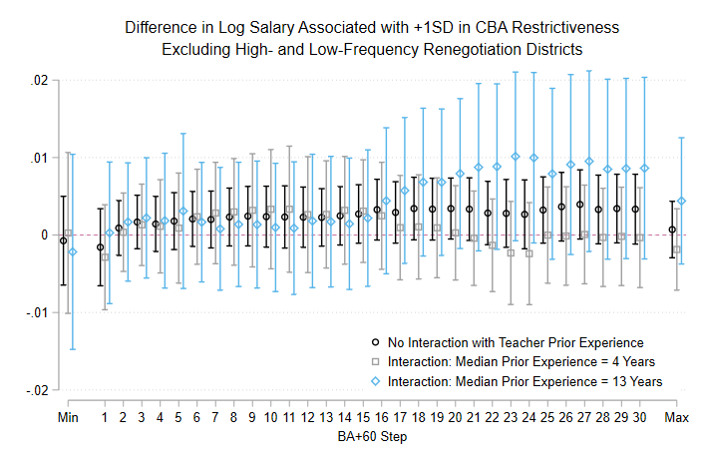
Figure B1. Difference in natural log of salary associated with a one standard deviation increase in collective bargaining agreement (CBA) restrictiveness excluding high- and low-frequency renegotiation districts. Black markers come from models without interactions between CBA restrictiveness and median teacher experience. Gray and blue estimates are separate average marginal effects of CBA restrictiveness at different levels of median teacher experience from single models interacting CBA restrictiveness with median teacher experience. Models are as described in figure 1 except that districts are excluded if their mean observed CBA spans two or fewer years or five or more years. All estimates include 1,327 observations of 384 districts, each observed at least twice, and are accompanied by 95% confidence intervals based on standard errors clustered on districts.

Figure B2 – Difference in Log Salary Associated with +1SD in CBA Restrictiveness, Controlling for Democratic Vote Share and Student Proficiency
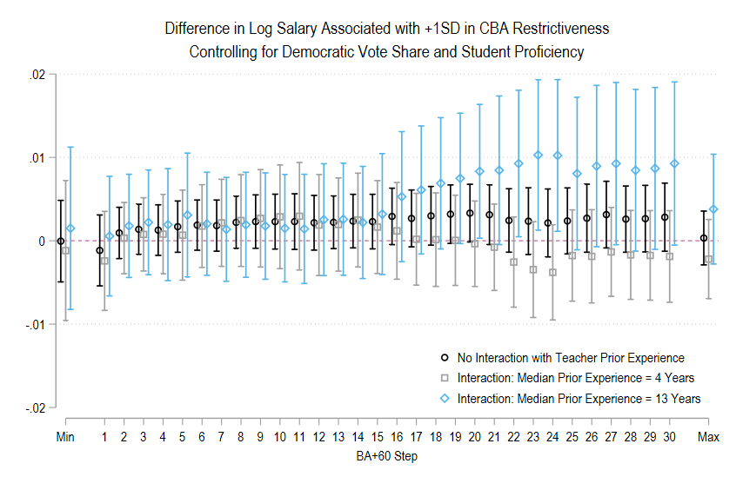
Figure B2. Difference in natural log of salary associated with a one standard deviation increase in collective bargaining agreement (CBA) restrictiveness controlling for Democratic vote share and student proficiency. Black markers come from models without interactions between CBA restrictiveness and median teacher experience. Gray and blue estimates are separate average marginal effects of CBA restrictiveness at different levels of median teacher experience from single models interacting CBA restrictiveness with median teacher experience. Models are as described in figure 1 except that they additionally control for Democratic party vote share in the Congressional district in the most recent House election as well as the percentages of students in the district who were proficient (or above) on statewide standardized tests in math and English language arts. All estimates include 1,685 observations of 489 districts, each observed at least twice, and are accompanied by 95% confidence intervals based on standard errors clustered on districts.

Figure B3 – Difference in Log Salary Associated with +1SD in Monitoring Intensity, Controlling for Democratic Vote Share and Student Proficiency
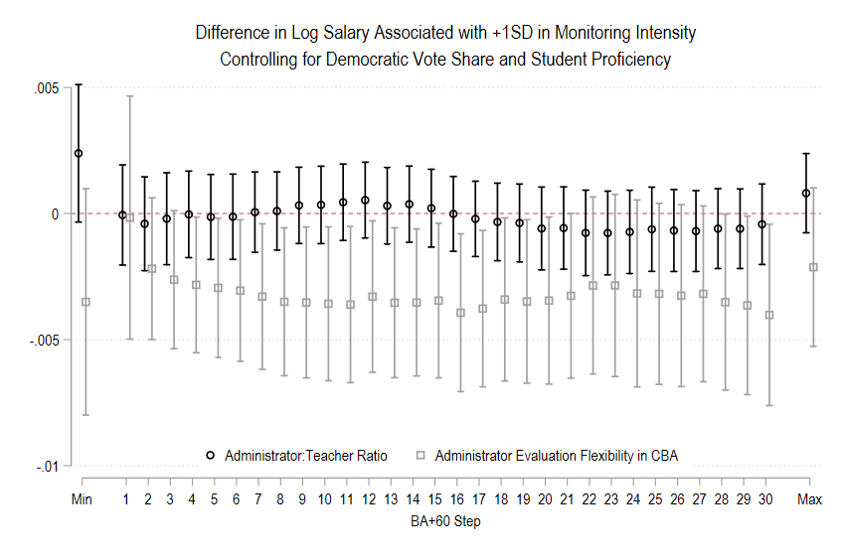
Figure B3. Difference in natural log of salary associated with a one standard deviation increase in monitoring intensity. Models are as described in figure 1 except that they additionally control for Democratic party vote share in the Congressional district in the most recent House election as well as the percentages of students in the district who were proficient (or above) on statewide standardized tests in math and English language arts. Black markers come from models where monitoring intensity is proxied by the administrator:teacher ratio (8,007 observations of 823 districts). Gray markers are from models where the proxy for monitoring intensity is administrator flexibility in evaluating teaches as captured in the collective bargaining agreement (CBA; 1,685 observations of 489 districts). Estimates include 95% confidence intervals based on standard errors clustered on districts.

Figure B4 – Differences in Log Salary Associated with +1 SD in Monitoring Intensity at Varying Levels of Overall CBA Restrictiveness
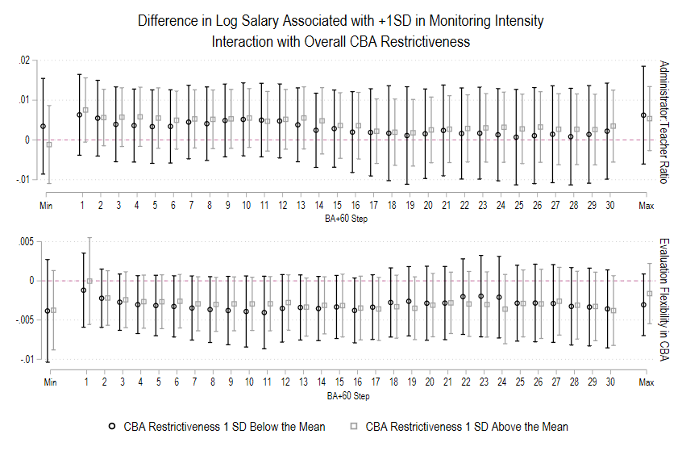
Figure B4. Difference in natural log of salary associated with a one standard deviation increase in monitoring intensity at varying levels of overall collective bargaining agreement (CBA) restrictiveness. Models are as described in figure 2 except that monitoring proxies are interacted with overall CBA restrictiveness. Coefficients are average marginal effects at the indicated levels of overall CBA restrictiveness and associated 95% confidence intervals. Models include 1,684 (for administrator:teacher ratios) or 1,686 (for evaluation flexibility in CBA) observations of 489 districts.

Figure B5 – Difference in Log Salary Associated with +1 SD in Monitoring Intensity by District Grade Level
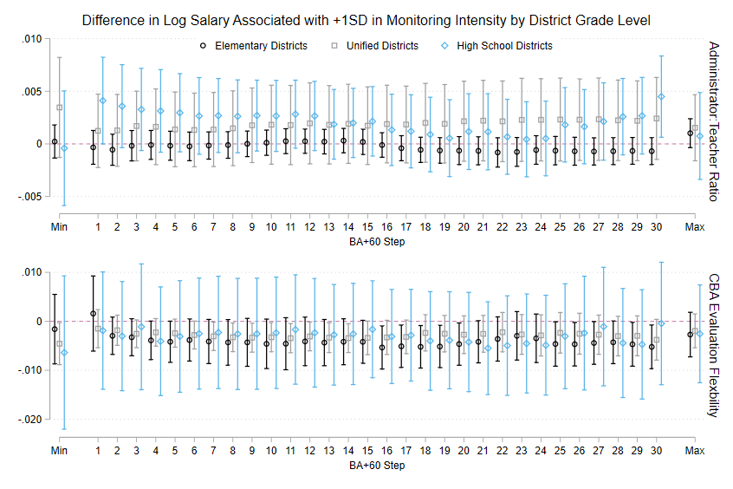
Figure B5. Difference in natural log of salary associated with a one standard deviation increase in monitoring intensity, estimated separately by district grade level. Models are as described in figure 2 except that relationships with proxies for monitoring intensity are allowed to vary between elementary (K-8), unified (K-12), and high school (9-12) districts. Coefficients are average marginal effects and associated 95% confidence intervals.

