Supplementary Table 1 Composition of AlSi10Mg alloy powder（wt.%）
Element | Si | Fe | Mg | Mn | Ti | O | Al
Content | 10.23 | 0.17 | 0.41 | 0.013 | 0.044 | 0.045 | Bal.
Supplementary Figure 1 SEM image of AlSi10Mg powder
Supplementary Table 2 Process parameters of different scanning strategies
 |  | Laser Power  (W) | Scanning Spacing  (mm) | Scanning Speed  (mm·s⁻¹) | Powder Thickness  (μm)
First Scan |  | 300 | 0.12 | 1600 | 30
Rescan | A1 | No Rescan
 | A2&A3 | 240
 | A2&A3 | 270
 | A2&A3 | 300
 | A2&A3 | 330
 | A2&A3 | 360
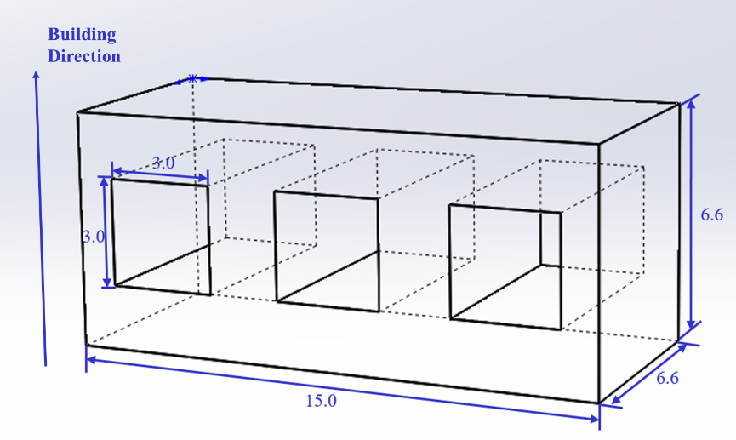
Supplementary Figure 2 The design sketch of the printed AlSi10Mg parts

