Supplementary Figure captions
Supplementary Figure 1. Actual photograph of experimental setup for polishing tests.

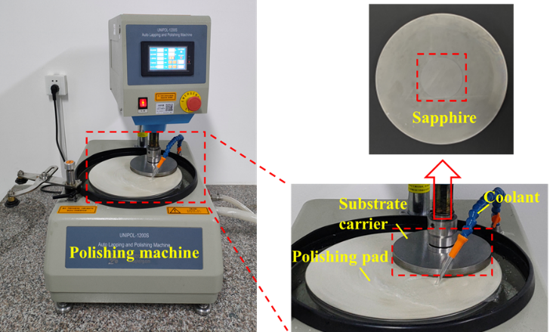
Supplementary Figure. 1. Actual photograph of experimental setup for polishing tests

