Supplemental Table 1. Quality assessment of studies

Authors, Year | Prospective Design | Standardized antiplatelet protocol | Standardized Follow-up | Complications individually reported | Angiographic outcomes reported | Total attributes*
Aguilar-Perez, et al.; 2020¹ | No | Yes | Yes | Yes | Yes | 4
Goertz, et al.; 2019² | No | Yes | Yes | Yes | Yes | 4
Guzzardi, et al.; 2020³ | No | Yes | No | Yes | Yes | 3
Kaschner, et al.; 2020⁴ | No | Yes | Yes | Yes | Yes | 4
Lobsien, et al.; 2021⁵ | No | No | No | Yes | No | 1
Manning, et al.;2019⁶ | No | No | Yes | No | Yes | 2
*≤2 = low quality, 3 = moderate quality, ≥4 = high quality

References
- Aguilar-Perez M, Hellstern V, AlMatter M, et al. The p48 Flow Modulation Device with Hydrophilic Polymer Coating (HPC) for the Treatment of Acutely Ruptured Aneurysms: Early Clinical Experience Using Single Antiplatelet Therapy. Cardiovasc Intervent Radiol 2020; 43: 740-748. 2020/02/08. DOI: 10.1007/s00270-020-02418-4.
- Goertz L, Dorn F, Kraus B, et al. Safety and efficacy of the Derivo Embolization Device for the treatment of ruptured intracranial aneurysms. J Neurointerv Surg 2019; 11: 290-295. 2018/08/08. DOI: 10.1136/neurintsurg-2018-014166.
- Guzzardi G, Galbiati A, Stanca C, et al. Flow diverter stents with hydrophilic polymer coating for the treatment of acutely ruptured aneurysms using single antiplatelet therapy: Preliminary experience. Interv Neuroradiol 2020; 26: 525-531. 2020/08/18. DOI: 10.1177/1591019920950878.
- Kaschner MG, Petridis A and Turowski B. Single-center experience with the new generation Derivo Embolization Device in ruptured dissecting and blister aneurysms. Acta Radiol 2020; 61: 37-46. 2019/06/06. DOI: 10.1177/0284185119852731.
- Lobsien D, Clajus C, Behme D, et al. Aneurysm Treatment in Acute SAH with Hydrophilic-Coated Flow Diverters under Single-Antiplatelet Therapy: A 3-Center Experience. AJNR Am J Neuroradiol 2021; 42: 508-515. 2021/01/16. DOI: 10.3174/ajnr.A6942.
- Manning NW, Cheung A, Phillips TJ, et al. Pipeline shield with single antiplatelet therapy in aneurysmal subarachnoid haemorrhage: multicentre experience. J Neurointerv Surg 2019; 11: 694-698. 2018/12/16. DOI: 10.1136/neurintsurg-2018-014363.

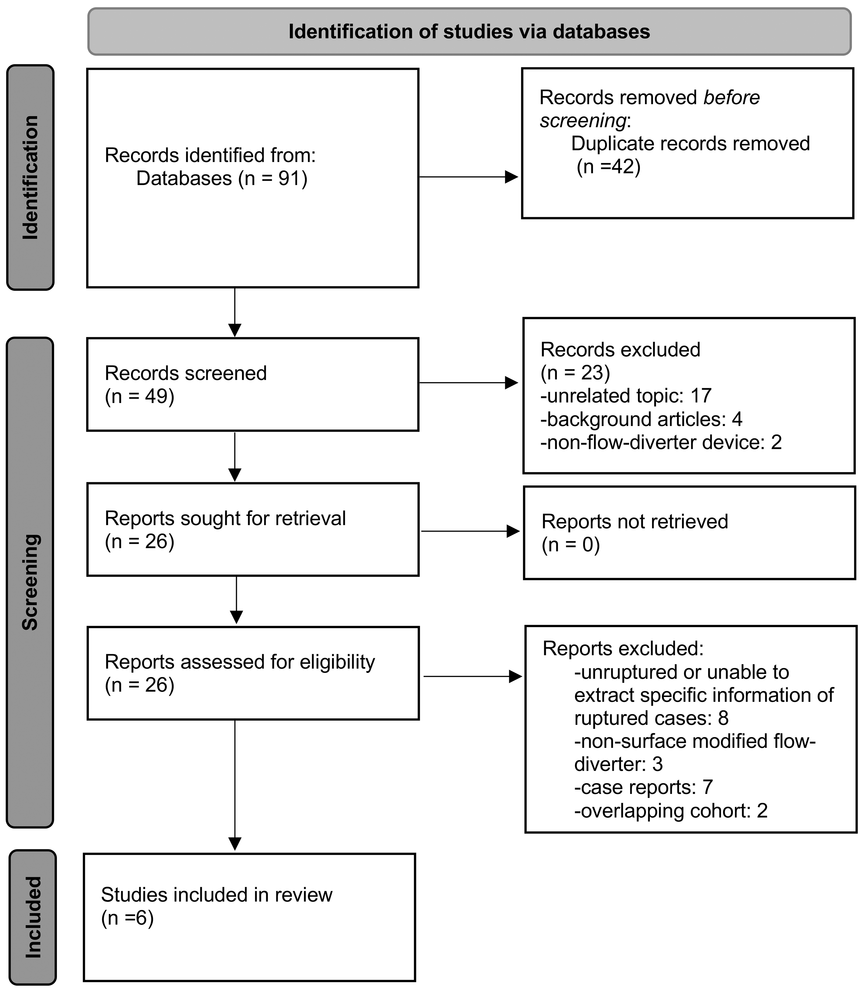
Supplemental Fig 1: Preferred Reporting Items in Systematic Reviews and Meta Analyses flow diagram demonstrating the selection process.

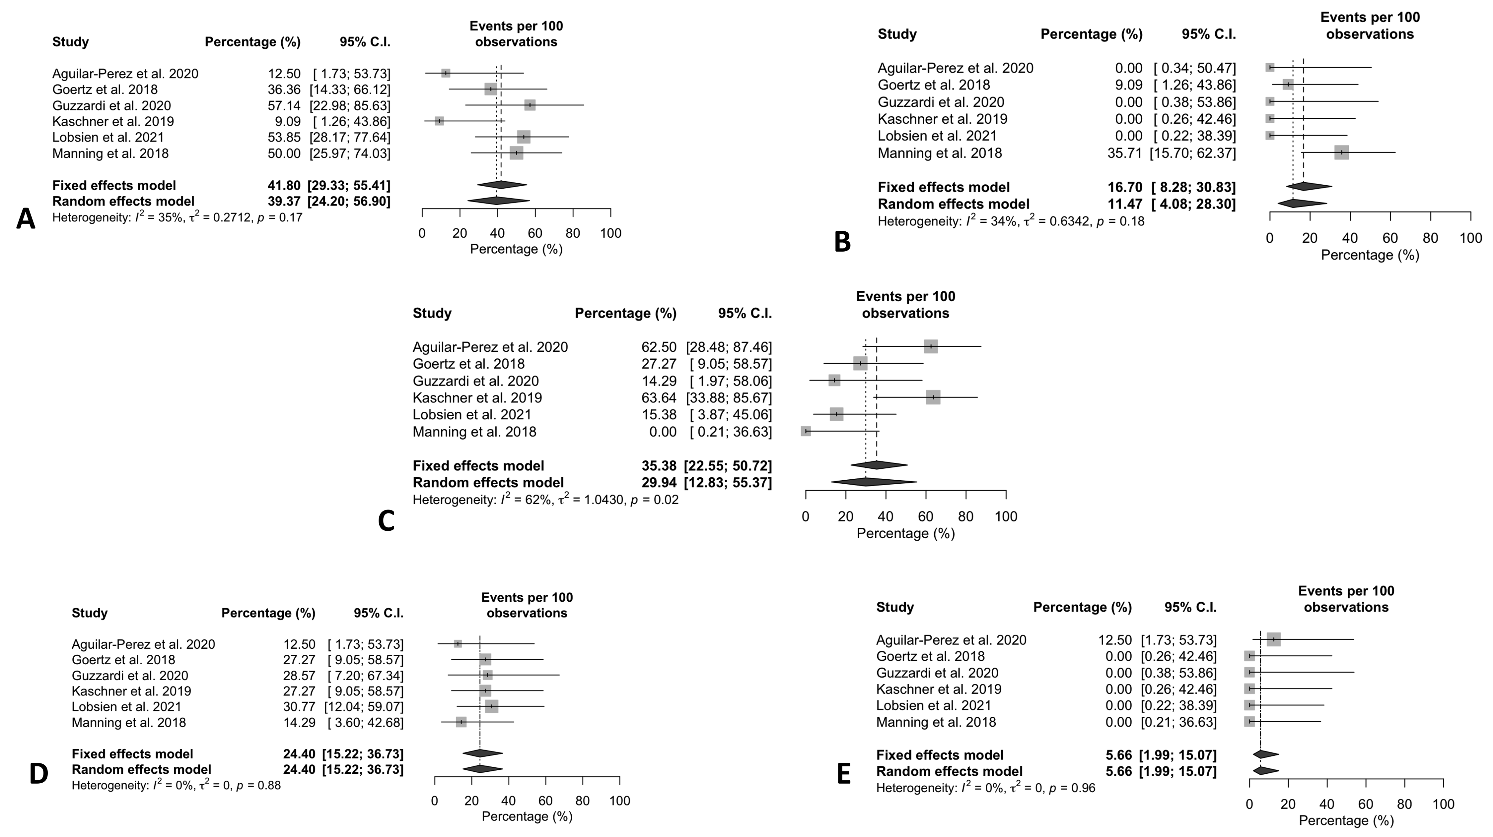
Supplemental Fig 2: Estimated weighted rates of saccular (A), fusiform (B), dissecting (C), blood blister (D), and mycotic (E) aneurysms.

