Supplementary Material
Expanded Patients and Methods
Data on comorbidities/vascular risk factors are collected at baseline when patients are registered in the Danish Stroke Registry (DSR). Stroke severity was determined at admission and classified as a continuous variable according to the Scandinavian Stroke Scale (SSS) score. Furthermore, we categorized a score of 0 to 30 points as “severe stroke” and >30 as “less severe stroke” in the interaction analysis. Education was classified as low (primary and lower secondary education), medium (upper secondary, post-secondary non-tertiary, and short cycle tertiary education), or high (bachelor, master, and doctoral education) according to the International Standard Classification of Education. Income was grouped into tertiles as low, middle, and high. Occupation was categorized as employed, pensioner, or unemployed. Marital status was grouped as cohabiting, living alone, and other. Duration of residence was first handled as a continuous variable and subsequently categorized as <10 years and ≥10 years of residence among immigrants compared with Danish-born residents in the further analysis.

Supplementary Table 1. List of anatomical therapeutic chemical (ATC) codes included
Class | ATC code | Prescription drug | Package | Average price per pack at the pharmacy in EUR
Anticoagulants | B01AA03  B01AE07  B01AF01  B01AF02  B01AF03 | Warfarin (2.5 mg)  Dabigatran (75 mg)  Rivaroxaban (2.5 mg)  Apixaban (2.5 mg)  Edoxaban (30 mg) | 100 tablets  60 tablets  100 tablets  60 tablets  100 tablets | 18.77  97.89  121.09  90.05  227.40
Antiplatelets | B01AC04  B01AC06  B01AC07 | Clopidogrel (75 mg)  Acetylsalicylic acid (75 mg)  Dipyridamole (100 mg) | 100 tablets  100 tablets  100 tablets | 8.97  5.11  23.91
Angiotensin-converting enzyme inhibitors | C09AA01  C09AA02  C09AA03  C09AA05 | Captopril (25 mg)  Enalapril (10 mg)  Lisinopril (5 mg)  Ramipril (2.5 mg) | 100 tablets  100 tablets  100 tablets  100 tablets | 5.16  8.60  6.57  7.33
Angiotensin II receptor blockers | C09CA01  C09CA03  C09CA06  C09CA07 | Losartan (100 mg)  Valsartan (160 mg)  Candesartan (4 mg)  Telmisartan (80 mg) | 100 tablets  100 tablets  100 tablets  100 tablets | 6.92  21.51  26.18  22.91
Beta-blockers | C07AA05  C07AB02  C07AB03 | Propranolol (40 mg)  Metoprolol (25 mg)  Atenolol (25 mg) | 100 tablets  100 tablets  100 tablets | 4.53  5.44  8.14
Calcium channel blockers | C08CA01  C08CA02  C08CA05  C08DA01 | Amlodipine (5 mg)  Felodipine (10 mg)  Nifedipine (30 mg)  Verapamil (80 mg) | 100 tablets  100 tablets  100 tablets  100 tablets | 5.58  6.75  28.30  15.94
Statins | C10AA01  C10AA03  C10AA05  C10AA07 | Simvastatin (80 mg)  Pravastatin (20 mg)  Atorvastatin (40 mg)  Rosuvastatin (20 mg) | 100 tablets  100 tablets  100 tablets  100 tablets | 9.32  5.25  5.52  8.60

Supplementary Table 2. Use of preventive medications within 180 days after stroke discharge among immigrants compared with Danish-born residents
 |  |  |  | Region-Specific Immigrants |  | Country-Specific Immigrants
 |  | Danish-born  (n=101 777) | Immigrants  (n=4447) | Western  (n=2660) | Non-Western  (n=1787) | Polish  (n=178) | Turkish  (n=308) | Pakistani  (n=225) | Iraqi  (n=146)
Anticoagulants
Use of medication | n (%) | 13 891 (13.6) | 539 (12.1) | 380 (14.3) | 159 (8.9) | 27 (15.2) | 31 (10.1) | 7 (3.1) | 14 (9.6)
Unadjusted | OR (95% CI) | 1.00 (Reference) | 0.88 (0.82−0.96) | 1.07 (0.98−1.18) | 0.61 (0.53−0.71) | 1.30 (0.92−1.84) | 0.75 (0.55−1.03) | - | 0.82 (0.51−1.33)
Fully adjusted | OR (95% CI) | 1.00 (Reference) | 0.66 (0.53−0.82) | 0.72 (0.55−0.95) | 0.58 (0.43−0.79) | 0.77 (0.35−1.67) | 0.50 (0.25−0.97) | - | 1.40 (0.68−2.88)
Antiplatelets
Use of medication | n (%) | 60 170 (59.1) | 2686 (60.4) | 1526 (57.4) | 1160 (64.9) | 89 (50.0) | 198 (64.3) | 164 (72.9) | 96 (65.8)
Unadjusted | OR (95% CI) | 1.00 (Reference) | 1.03 (0.99−1.08) | 0.97 (0.92−1.02) | 1.13 (1.06−1.20) | 0.74 (0.59−0.93) | 1.08 (0.93−1.26) | 1.14 (0.96−1.34) | 1.28 (1.01−1.63)
Fully adjusted | OR (95% CI) | 1.00 (Reference) | 1.04 (0.94−1.15) | 1.02 (0.89−1.16) | 1.06 (0.93−1.20) | 0.89 (0.61−1.30) | 1.11 (0.84−1.46) | 1.03 (0.78−1.35) | 1.07 (0.74−1.55)
ACE inhibitors/ARB

Use of medication | n (%) | 24 365 (23.9) | 1065 (23.9) | 631 (23.7) | 434 (24.2) | 40 (22.5) | 69 (22.4) | 65 (28.9) | 24 (16.4)
Unadjusted | OR (95% CI) | 1.00 (Reference) | 0.97 (0.92−1.03) | 0.99 (0.91−1.07) | 0.95 (0.87−1.05) | 0.95 (0.69−1.30) | 0.86 (0.68−1.08) | 1.01 (0.79−1.28) | 0.67 (0.44−1.01)
Fully adjusted | OR (95% CI) | 1.00 (Reference) | 0.87 (0.75−0.98) | 1.04 (0.86−1.26) | 0.74 (0.61−0.90) | 0.78 (0.43−1.41) | 0.45 (0.26−0.76) | 0.66 (0.42−1.03) | 0.51 (0.26−1.00)
Beta-blockers
Use of medication | n (%) | 13 822 (13.6) | 623 (14.0) | 373 (14.0) | 250 (14.0) | 37 (20.8) | 47 (15.3) | 44 (19.6) | 15 (10.3)
Unadjusted | OR (95% CI) | 1.00 (Reference) | 1.04 (0.96−1.13) | 1.06 (0.96−1.18) | 1.01 (0.89−1.14) | 1.82 (1.32−2.50) | 1.14 (0.87−1.50) | 1.22 (0.91−1.64) | 0.77 (0.46−1.30)
Fully adjusted | OR (95% CI) | 1.00 (Reference) | 1.25 (1.02−1.53) | 1.20 (0.92−1.56) | 1.30 (1.01−1.67) | 2.05 (1.12−3.75) | 1.88 (1.17−2.99) | 1.46 (0.86−2.50) | 1.16 (0.49−2.75)
Calcium channel blockers

Use of medication | n (%) | 17 739 (17.4) | 762 (17.1) | 451 (17.0) | 311 (17.4) | 24 (13.5) | 53 (17.2) | 44 (19.6) | 17 (11.6)
Unadjusted | OR (95% CI) | 1.00 (Reference) | 0.97 (0.90−1.04) | 1.00 (0.91−1.10) | 0.92 (0.82−1.03) | 0.85 (0.57−1.25) | 0.91 (0.69−1.19) | 0.88 (0.65−1.18) | 0.70 (0.43−1.14)
Fully adjusted | OR (95% CI) | 1.00 (Reference) | 0.94 (0.79−1.13) | 0.93 (0.73−1.18) | 0.95 (0.77−1.19) | 0.62 (0.30−1.29) | 0.49 (0.26−0.92) | 1.09 (0.70−1.69) | 0.96 (0.50−1.85)
Statins
Use of medication | n (%) | 52 058 (51.1) | 2338 (52.6) | 1339 (50.3) | 999 (55.9) | 93 (52.2) | 175 (56.8) | 153 (68.0) | 80 (54.8)
Unadjusted | OR (95% CI) | 1.00 (Reference) | 1.00 (0.96−1.05) | 0.98 (0.92−1.03) | 1.04 (0.98−1.12) | 1.07 (0.85−1.33) | 1.06 (0.91−1.25) | 1.15 (0.96−1.36) | 1.14 (0.88−1.47)
Fully adjusted | OR (95% CI) | 1.00 (Reference) | 1.08 (0.97−1.20) | 1.03 (0.89−1.18) | 1.12 (0.98−1.27) | 1.26 (0.88−1.82) | 1.32 (1.01−1.73) | 1.19 (0.89−1.59) | 1.14 (0.78−1.67)

Abbreviations: OR = odds ratio; CI = confidence interval; ACE = angiotensin-converting enzyme; ARB = angiotensin II receptor blockers. The fully adjusted model composed age at stroke, sex, income, occupation, education, marital status, duration of residence, Scandinavian stroke scale (SSS) score, history of stroke or transient ischemic attack, smoking, myocardial infarction, atrial fibrillation, diabetes, and hypertension.

Supplementary Table 3. Factors associated with use of preventive medications after stroke discharge comparing immigrants and Danish-born residents
 | Anti  coagulants | Fully adjustedª | Anti  platelets | Fully adjustedª | ACE inhibitors /ARB | Fully adjustedª | Beta-blockers | Fully adjustedª | Calcium channel blockers | Fully adjustedª | Statins | Fully adjustedª
 | n | OR (95% CI) | n | OR (95% CI) | n | OR (95% CI) | n | OR (95% CI) | n | OR (95% CI) | n | OR (95% CI)
Education
Danish-born low education | 5968 | 1.00 (Reference) | 25 665 | 1.00 (Reference) | 10 454 | 1.00 (Reference) | 6218 | 1.00 (Reference) | 7846 | 1.00 (Reference) | 21 733 | 1.00 (Reference)
Immigrants low education | 137 | 0.60 (0.40─0.88) | 702 | 1.03 (0.87─1.23) | 281 | 0.74 (0.56─0.96) | 170 | 1.28 (0.91─1.81) | 216 | 0.99 (0.72─1.34) | 621 | 1.15 (0.96─1.38)
Danish-born high education | 1960 | 1.21 (0.92─1.58) | 7180 | 0.97 (0.84─1.12) | 2843 | 0.87 (0.71─1.07) | 1526 | 0.87 (0.64─1.17) | 2084 | 1.24 (0.97─1.58) | 6668 | 0.98 (0.85─1.14)
Immigrants high education | 85 | 0.89 (0.59─1.34) | 411 | 1.00 (0.82─1.21) | 160 | 0.89 (0.66─1.18) | 79 | 0.82 (0.51─1.31) | 118 | 1.21 (0.87─1.70) | 374 | 1.05 (0.85─1.29)
Income
Danish-born low income | 4269 | 1.00 (Reference) | 18 028 | 1.00 (Reference) | 7169 | 1.00 (Reference) | 4609 | 1.00 (Reference) | 5409 | 1.00 (Reference) | 14 079 | 1.00 (Reference)
Immigrants low income | 207 | 0.64 (0.43─0.94) | 986 | 1.02 (0.83─1.24) | 405 | 1.06 (0.79─1.42) | 254 | 1.19 (0.80─1.76) | 312 | 0.82 (0.58─1.17) | 808 | 1.10 (0.89─1.36)
Danish-born high income | 4686 | 0.82 (0.59─1.14) | 22 073 | 0.91 (0.77─1.08) | 9106 | 1.21 (0.94─1.56) | 4404 | 0.86 (0.59─1.23) | 6315 | 0.94 (0.70─1.26) | 20 511 | 1.12 (0.94─1.34)
Immigrants high income | 145 | 0.53 (0.34─0.82) | 780 | 0.96 (0.79─1.17) | 281 | 0.96 (0.71─1.30) | 177 | 1.24 (0.81─1.88) | 198 | 0.90 (0.63─1.27) | 727 | 1.22 (0.99─1.50)
Marital status
Danish-born living alone | 5591 | 1.00 (Reference) | 23 650 | 1.00 (Reference) | 9435 | 1.00 (Reference) | 5716 | 1.00 (Reference) | 7135 | 1.00 (Reference) | 19 425 | 1.00 (Reference)
Immigrants living alone | 221 | 0.77 (0.55─1.10) | 966 | 1.07 (0.90─1.28) | 387 | 0.88 (0.68─1.14) | 238 | 1.30 (0.91─1.85) | 305 | 0.86 (0.63─1.18) | 789 | 1.02 (0.85─1.23)
Danish-born cohabiting | 7789 | 1.11 (0.87─1.42) | 34 004 | 0.92 (0.81─1.05) | 14 110 | 1.00 (0.83─1.20) | 7593 | 1.27 (0.97─1.67) | 9976 | 0.97 (0.78─1.21) | 30 852 | 1.00 (0.87─1.14)
Immigrants cohabiting | 290 | 0.65 (0.48─0.88) | 1580 | 0.95 (0.82─1.09) | 616 | 0.88 (0.71─1.08) | 357 | 1.55 (1.16─2.08) | 417 | 0.92 (0.72─1.17) | 1445 | 1.13 (0.97─1.31)
Stroke severity^{b}
Danish-born less severe stroke | 11 555 | 1.00 (Reference) | 53 931 | 1.00 (Reference) | 21 811 | 1.00 (Reference) | 12 003 | 1.00 (Reference) | 15 975 | 1.00 (Reference) | 47 318 | 1.00 (Reference)
Immigrants less severe stroke | 437 | 0.69 (0.54─0.87) | 2375 | 1.04 (0.94─1.16) | 949 | 0.91 (0.78─1.07) | 529 | 1.26 (1.02─1.57) | 661 | 0.93 (0.77─1.12) | 2094 | 1.04 (0.93─1.16)
Danish-born severe stroke | 2336 | 1.38 (0.97─1.96) | 6239 | 1.02 (0.82─1.26) | 2554 | 1.30 (0.98─1.73) | 1819 | 1.13 (0.75─1.70) | 1764 | 0.77 (0.51─1.16) | 4740 | 0.76 (0.61─0.96)
Immigrants severe stroke | 102 | 0.88 (0.58─1.34) | 311 | 0.98 (0.77─1.25) | 116 | 0.81 (0.56─1.17) | 94 | 1.34 (0.88─2.04) | 101 | 0.84 (0.54─1.31) | 244 | 1.11 (0.87─1.42)
Sex
Danish-born women | 7681 | 1.00 (Reference) | 33 224 | 1.00 (Reference) | 14 036 | 1.00 (Reference) | 7343 | 1.00 (Reference) | 9873 | 1.00 (Reference) | 29 361 | 1.00 (Reference)
Danish-born men | 6210 | 0.91 (0.71─1.16) | 26 946 | 1.00 (0.89─1.13) | 10 329 | 0.84 (0.70─1.00) | 6479 | 1.11 (0.85─1.43) | 7866 | 0.83 (0.67─1.04) | 22 697 | 1.14 (1.01─1.29)
Immigrant women | 255 | 0.60 (0.45─0.79) | 1435 | 1.08 (0.95─1.22) | 566 | 0.83 (0.69─0.98) | 327 | 1.25 (0.97─1.60) | 389 | 0.89 (0.72─1.10) | 1262 | 1.12 (0.98─1.28)
Immigrant men | 284 | 0.70 (0.51─0.96) | 1251 | 0.99 (0.85─1.15) | 499 | 0.81 (0.64─0.98) | 296 | 1.39 (1.03─1.88) | 373 | 0.89 (0.68─1.15) | 1076 | 1.15 (0.98─1.35)

Abbreviations: OR = odds ratio; CI = confidence interval; n = number of patients; ACE = angiotensin-converting enzyme; ARB = angiotensin II receptor blockers. ªThe fully adjusted model composed age at stroke, sex, income, occupation, education, marital status, duration of residence, Scandinavian stroke scale (SSS) score, history of stroke or transient ischemic attack, smoking, myocardial infarction, atrial fibrillation, diabetes, and hypertension. ^{b}Stroke severity measured by the Scandinavian Stroke Scale score and 0 to 30 points was classified as “severe stroke” and >30 as “less severe stroke”.

Supplementary Table 4. Treatment persistence within 180 days follow-up comparing immigrants with Danish-born residents
 |  |  |  | Region-Specific Immigrants |  | Country-Specific Immigrants
 |  | Danish-born | Immigrants | Western | Non-Western | Polish | Turkish | Pakistani | Iraqi
Anticoagulants
Treatment persistence | n (%) | 11 771 (84.7) | 458 (85.0) | 331 (87.1) | 127 (79.9) | 25 (92.6) | 22 (71.0) | 6 (85.7) | 12 (85.7)
Unadjusted | SHR (95% CI) | 1.00 (Reference) | 1.05 (0.96−1.14) | 1.10 (0.99−1.21) | 0.94 (0.80−1.10) | 1.07 (0.81−1.40) | 1.15 (0.76−1.73) | - | 1.32 (0.76−2.32)
Fully adjusted | SHR (95% CI) | 1.00 (Reference) | 1.21 (0.97−1.51) | 1.37 (1.06−1.78) | 1.04 (0.77−1.41) | 0.80 (0.54−1.22) | 1.25 (0.50−3.10) | - | 2.15 (0.75−5.13)
Antiplatelets
Treatment persistence | n (%) | 49 517 (82.3) | 2158 (80.3) | 1243 (81.5) | 915 (78.9) | 68 (76.4) | 150 (75.8) | 130 (79.3) | 69 (71.9)
Unadjusted | SHR (95% CI) | 1.00 (Reference) | 1.07 (1.03−1.12) | 1.06 (1.00−1.12) | 1.09 (1.03−1.16) | 0.93 (0.73−1.18) | 1.11 (0.96−1.29) | 1.03 (0.89−1.20) | 1.09 (0.88−1.34)
Fully adjusted | SHR (95% CI) | 1.00 (Reference) | 1.00 (0.91−1.10) | 0.97 (0.85−1.11) | 1.02 (0.91−1.15) | 0.83 (0.56−1.23) | 0.83 (0.64−1.08) | 0.92 (0.71−1.18) | 0.92 (0.67−1.26)
ACE inhibitors/ARB

Treatment persistence | n (%) | 19 789 (81.2) | 830 (77.9) | 505 (80.0) | 325 (74.9) | 37 (92.5) | 51 (73.9) | 56 (86.2) | 19 (79.2)
Unadjusted | SHR (95% CI) | 1.00 (Reference) | 0.99 (0.92−1.06) | 0.99 (0.92−1.08) | 0.98 (0.88−1.10) | 0.89 (0.70−1.15) | 1.25 (0.95−1.65) | 1.08 (0.83−1.40) | 1.35 (0.85−2.17)
Fully adjusted | SHR (95% CI) | 1.00 (Reference) | 1.01 (0.86−1.20) | 1.10 (0.91−1.33) | 0.93 (0.74−1.17) | 1.42 (0.83−2.41) | 0.90 (0.44−1.86) | 0.81 (0.49−1.35) | 1.96 (1.08−3.55)
Beta-blockers
Treatment persistence | n (%) | 11 221 (81.2) | 497 (79.8) | 301 (80.7) | 196 (78.4) | 30 (81.1) | 40 (85.1) | 34 (77.3) | 12 (80.0)
Unadjusted | SHR (95% CI) | 1.00 (Reference) | 1.07 (0.97−1.17) | 1.07 (0.95−1.21) | 1.07 (0.92−1.23) | 1.23 (0.86−1.74) | 1.13 (0.84−1.52) | 1.13 (0.77−1.65) | 1.17 (0.69−1.99)
Fully adjusted | SHR (95% CI) | 1.00 (Reference) | 1.08 (0.86−1.35) | 1.09 (0.82−1.44) | 1.07 (0.80−1.43) | 1.34 (0.95−1.90) | 0.92 (0.53−1.60) | 0.99 (0.48−2.01) | 0.55 (0.20−1.51)
Calcium channel blockers

Treatment persistence | n (%) | 14 186 (80.0) | 589 (77.3) | 353 (78.3) | 236 (75.9) | 21 (87.5) | 38 (71.7) | 32 (72.7) | 13 (76.5)
Unadjusted | SHR (95% CI) | 1.00 (Reference) | 1.04 (0.95−1.12) | 1.03 (0.93−1.14) | 1.04 (0.91−1.18) | 1.50 (0.95−2.39) | 1.15 (0.79−1.69) | 0.86 (0.65−1.16) | 1.04 (0.62−1.74)
Fully adjusted | SHR (95% CI) | 1.00 (Reference) | 1.01 (0.81−1.26) | 1.00 (0.76−1.33) | 1.02 (0.79−1.32) | 1.65 (0.81−3.35) | 0.75 (0.29−1.92) | 0.91 (0.53−1.54) | 0.51 (0.19−1.34)
Statins
Treatment persistence | n (%) | 43 419 (83.4) | 1896 (81.1) | 1125 (84.0) | 771 (77.2) | 71 (76.3) | 125 (71.4) | 118 (77.1) | 57 (71.3)
Unadjusted | SHR (95% CI) | 1.00 (Reference) | 1.04 (0.99−1.09) | 1.05 (0.98−1.11) | 1.04 (0.96−1.12) | 1.05 (0.85−1.29) | 1.10 (0.90−1.33) | 1.01 (0.86−1.20) | 0.97 (0.75−1.26)
Fully adjusted | SHR (95% CI) | 1.00 (Reference) | 0.96 (0.86−1.07) | 0.94 (0.82−1.07) | 0.99 (0.86−1.14) | 1.01 (0.70−1.43) | 0.83 (0.59−1.16) | 1.02 (0.78−1.32) | 0.77 (0.49−1.22)

Abbreviations: SHR = subhazard ratio; CI = confidence interval; ACE = angiotensin-converting enzyme; ARB = angiotensin II receptor blockers; n = number of patients. Western immigrants include Swedish, Norwegian, Finnish, German, Polish and British immigrants. Non-Western immigrants include Turkish, Former Yugoslavian, Iraqi, Iranian, and Pakistani immigrants. The fully adjusted model composed age at stroke, sex, income, occupation, education, marital status, duration of residence, Scandinavian stroke scale (SSS) score, history of stroke or transient ischemic attack, smoking, myocardial infarction, atrial fibrillation, diabetes, and hypertension.

Supplementary Table 5. Use and persistence of anticoagulants in patients with ischemic stroke and atrial fibrillation by region and country of origin

 | Use of  anticoagulants | Unadjusted | Fully adjusted | Persistence of  anticoagulants | Unadjusted | Fully adjusted
 | n | OR (95% CI) | OR (95% CI) | n | SHR (95% CI) | SHR (95% CI)
Danish-born | 8247 | 1.00 (Reference) | 1.00 (Reference) | 6990 | 1.00 (Reference) | 1.00 (Reference)
Immigrants | 331 | 0.95 (0.84−1.06) | 0.93 (0.66−1.31) | 282 | 1.09 (0.97−1.21) | 0.92 (0.65−1.31)
Western | 246 | 0.95 (0.83−1.08) | 1.03 (0.70−1.50) | 217 | 1.17 (1.00−1.33) | 1.11 (0.78−1.60)
Non-Western | 85 | 0.96 (0.76−1.19) | 0.77 (0.47−1.27) | 65 | 0.86 (0.69−1.08) | 0.61 (0.35−1.04)
Polish | 18 | 0.91 (0.55−1.50) | 1.03 (0.34−3.10) | 16 | 1.12 (0.78−1.60) | 0.52 (0.27−1.01)
Turkish | 20 | 1.06 (0.68−1.64) | 0.68 (0.24−1.91) | 15 | 1.13 (0.70−1.79) | 0.83 (0.23−2.94)

Abbreviations: OR = odds ratio; SHR = subhazard ratios; CI = confidence interval. The fully adjusted model composed age at stroke, sex, income, occupation, education, marital status, duration of residence, Scandinavian stroke scale (SSS) score, history of stroke or transient ischemic attack, smoking, myocardial infarction, diabetes, and hypertension.

Supplementary Table 6. Use and persistence of secondary preventive medications by duration of residence
 | Use of  medication | Unadjusted | Fully adjusted | Persistence of  medication | Unadjusted | Fully adjusted
 | n | OR (95% CI) | OR (95% CI) | n | SHR (95% CI) | SHR (95% CI)
Anticoagulants
Danish-born | 13 891 | 1.00 (Reference) | 1.00 (Reference) | 11 771 | 1.00 (Reference) | 1.00 (Reference)
Immigrants (≥10 years of residence) | 246 | 0.98 (0.97−0.99) | 0.75 (0.63−0.90) | 210 | 1.06 (0.94−1.20) | 1.21 (0.97-1.51)
Immigrants (<10 years of residence) | 14 | 0.94 (0.92−0.97) | ª | 12 | 1.00 (0.70−1.43) | ª
Antiplatelets
Danish-born | 60 170 | 1.00 (Reference) | 1.00 (Reference) | 49 517 | 1.00 (Reference) | 1.00 (Reference)
Immigrants (≥10 years of residence) | 1507 | 1.02 (1.01−1.03) | 1.08 (1.00−1.17) | 1203 | 1.06 (1.01−1.12) | 1.00 (0.91−1.10)
Immigrants (<10 years of residence) | 107 | 1.08 (1.03−1.13) | 1.09 (0.67−1.77) | 93 | 1.19 (0.97−1.46) | 1.10 (0.72−1.69)
ACE inhibitors/ARB
Danish-born | 24 365 | 1.00 (Reference) | 1.00 (Reference) | 19 789 | 1.00 (Reference) | 1.00 (Reference)
Immigrants (≥10 years of residence) | 554 | 0.99 (0.98−1.00) | 0.88 (0.78−1.00) | 439 | 1.02 (0.93−1.11) | 1.01 (0.86−1.20)
Immigrants (<10 years of residence) | 38 | 0.99 (0.96−1.02) | 1.40 (0.76−2.57) | 31 | 1.10 (0.74−1.61) | 1.14 (0.66−1.97)
Beta-blockers
Danish-born | 13 822 | 1.00 (Reference) | 1.00 (Reference) | 11 221 | 1.00 (Reference) | 1.00 (Reference)
Immigrants (≥10 years of residence) | 328 | 1.00 (0.99−1.01) | 1.13 (0.98−1.33) | 267 | 1.11 (0.98−1.26) | 1.07 (0.86−1.34)
Immigrants (<10 years of residence) | 20 | 0.98 (0.95−1.00) | 0.51 (0.13−2.10) | 15 | 1.39 (0.89−2.17) | ª
Calcium channel blockers
Danish-born | 17 739 | 1.00 (Reference) | 1.00 (Reference) | 14 186 | 1.00 (Reference) | 1.00 (Reference)
Immigrants (≥10 years of residence) | 394 | 0.99 (0.98−1.00) | 0.93 (0.81−1.07) | 301 | 1.10 (0.99−1.23) | 1.01 (0.82−1.26)
Immigrants (<10 years of residence) | 25 | 0.99 (0.97−1.02) | 1.21 (0.58−2.54) | 19 | 0.87 (0.59−1.29) | 1.08 (0.48−2.44)
Statins
Danish-born | 52 508 | 1.00 (Reference) | 1.00 (Reference) | 43 419 | 1.00 (Reference) | 1.00 (Reference)
Immigrants (≥10 years of residence) | 1292 | 1.01 (0.99−1.02) | 1.03 (0.95−1.12) | 1024 | 1.01 (0.95−1.08) | 0.97 (0.87−1.08)
Immigrants (<10 years of residence) | 92 | 1.00 (0.96−1.05) | 0.91 (0.54−1.55) | 80 | 1.20 (0.95−1.50) | 0.75 (0.57−1.02)

Abbreviations: OR = odds ratio; SHR = subhazard ratios; CI = confidence interval; n = number of patients; ACE = angiotensin-converting enzyme; ARB = angiotensin II receptor blockers. ªEstimates could not be produced due to small numbers. Fully adjusted model composed age at stroke, sex, income, occupation, education, marital status, duration of residence, stroke severity, history of stroke or transient ischemic attack, smoking, myocardial infarction, atrial fibrillation, diabetes, and hypertension.

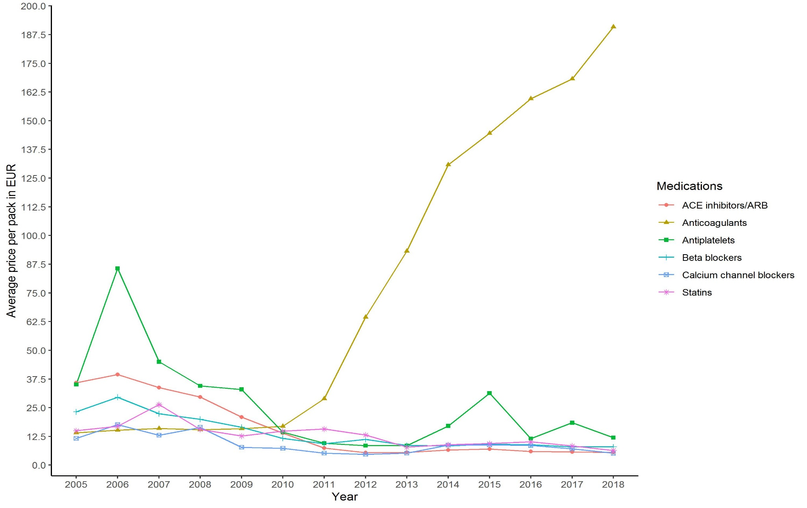
Supplementary Figure 1. Average price per pack on dispensed medications in patients with ischemic stroke. Higher prices of anticoagulants from 2011 onwards is due to introduction of novel oral anticoagulants.

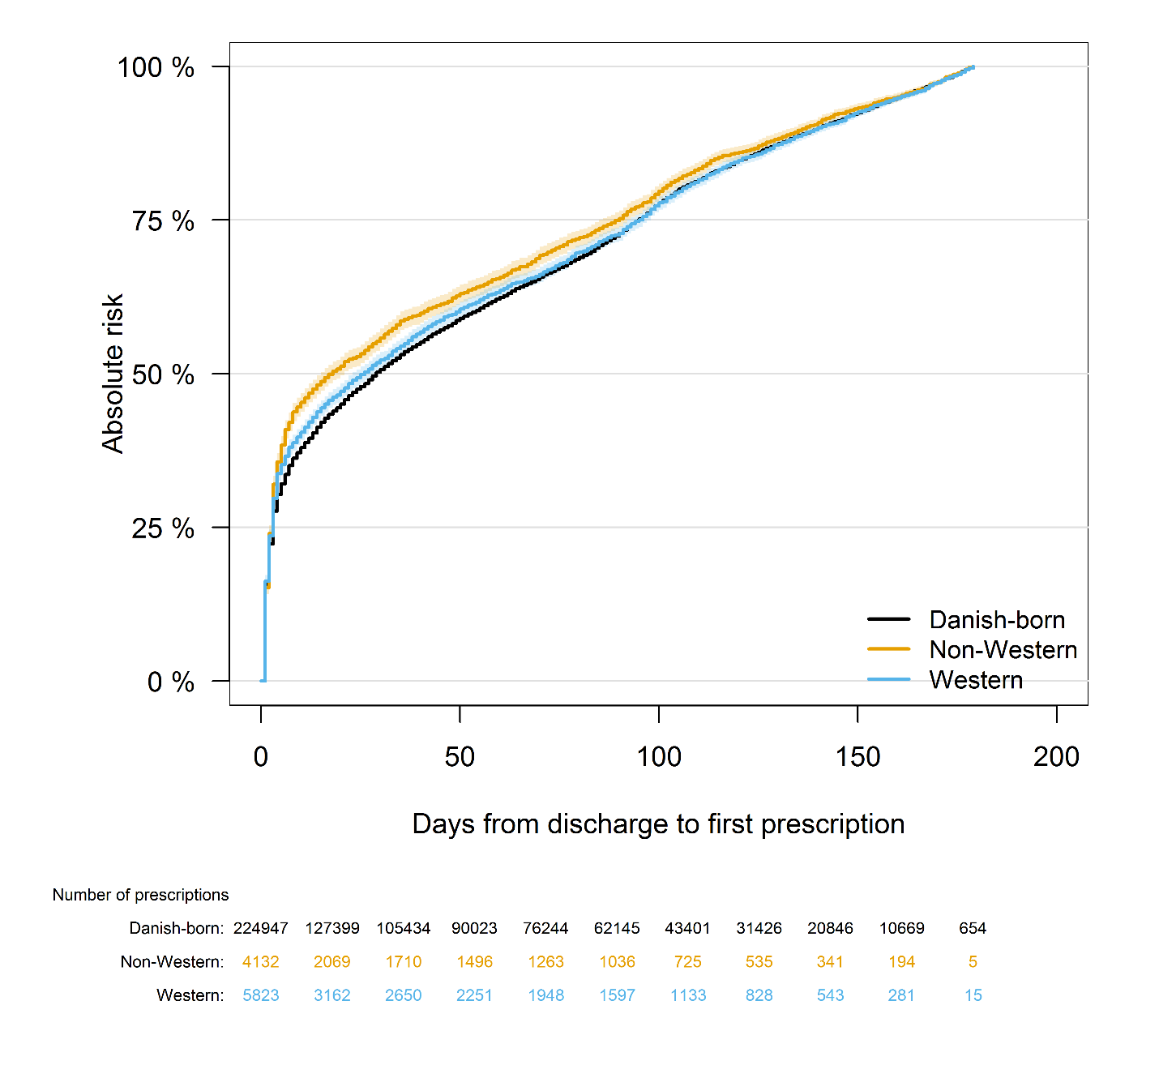
Supplementary Figure 2. Use of at least one of the preventive medications by region of origin

