Appendix 2: Technical Report

Note to the reader: This technical report provides more detailed information on the procedural aspects of the systematic literature review. It contains some excerpts from the paper repeating information provided in the paper on main steps to put the more detailed information provided in this report in context.

Study Aim and Research Questions
This review seeks to provide a comprehensive analysis of the field and its evolution in order to supplement past reviews with a basis for appraising and advancing TESD research. In pursuing this objective, we ask two research questions:
- What are the general characteristics of TESD research as a field and how has it evolved?
- What are the main types of TESD research and what are the aims, themes, insights, and gaps for each type?
As a result of this review, this paper aims to determine the innovation potentials that TESD research can offer to support TE to respond to socio-ecological challenges in research, policy, and practice.

Study Design
We utilized a systematic literature review in order to gain a more comprehensive overview of research on TESD. We utilized the following search string to collect publications from the Scopus database:
TITLE-ABS-KEY ( "teacher education" AND sustainab* ) AND ( LIMIT-TO ( DOCTYPE , "ar" ) OR LIMIT-TO ( DOCTYPE , "ch" ) ) AND ( LIMIT-TO ( LANGUAGE , "English" ) )

Our data contain all publications until the end of 2019. They comprise peer-reviewed articles and book chapters published in English. Reviews, meta-analyses, and short summaries of graduate as well as publications in languages other than English were excluded.

A set of criteria were developed to determine if publications concerned both teacher education and sustainable development. The PRISMA process was followed to produce a final sample of n=158 publications. Data was extracted from the full texts of these publications and analyzed to determine research contexts and themes. Bibliographic data obtained through the Scopus database was also utilized to provide further characteristics of TESD research.

Data Collection

Inclusion/Exclusion Criteria
When reviewing publications to determine if they were to become a part of our final sample, we utilized a set of criteria developed by the research team. These criteria were followed during both the abstract and full text review stages. Publications needed to meet criteria associated with both teacher education and sustainable development in order to be included and judged relevant to the topic of TESD.

Inclusion Criteria - Teacher Education
Generally, the search aimed to collect publications that considered teacher education in the following way:
The publication focuses on the education, training, and/or professional development of in-service or pre-service teachers (either early childhood/pre-school, kindergarten/elementary, middle, high school, or vocational school level) and the delivery of these education, training, and/or professional development programs through teacher education institutions, which can be university-based or have other organizational forms (e.g. colleges, seminars, mentor-mentee supervision programs, etc.).
We included publications concerning their connection to teacher education if:
TE.I.1: The publication focuses on education systems, or educational policy making with regard to, or as an enabler of, teacher education.
TE.I.2: Teacher education is the context of the research presented (e.g. research grounded in a teacher education institutions) or is mentioned as part of the research (e.g. X is applied to teacher education or implications of X are discussed for teacher education or X should be included in teacher education), but it remains unclear in how far the research itself informs or discusses clear implications for teacher education practices or was conducted involving pre-service teachers.
TE.I.3: The publication talks about teachers, but remains unclear/unspecific about the educational sector that teachers are working in.
TE.I.4: The publication addresses formal school system teachers (in-service and/or pre-service) among other groups of non-teachers.
TE.I.5: The publication talks about “professional development” (unspecifically) in the formal school education system, even if it just mentions implications for teacher education

Exclusion Criteria - Teacher Education
We excluded publications concerning their connection to teacher education if:
TE.E.1: The training/education program is exclusively focused on lecturers/instructors in higher education and continuing education like community colleges (training of faculty members) and does not include formal school system teachers (either in-service or pre-service), even if the paper focuses on teacher educators (i.e. instructors in higher education institutions that work with pre-service teachers).
TE.E.2: The publication talks generally about learning, learning technologies, classroom interaction, curricula, historical developments of education systems etc. without linking this to teacher education.
TE.E.3: The paper only touches on teacher education, but focuses more on general notions of implementing sustainability education, education systems, educational policy making, unspecific to teacher education.
TE.E.4: Teacher education is only mentioned to make the case for the research (but not followed up afterward).
TE.E.5: The research is on teachers and factors that influence their professional practices, but does not discuss this with regard to teacher education (“teacher education” only as a keyword).

Inclusion Criteria - Sustainable Development
Generally, the search aimed to collect publications that considered sustainable development in the following way:
The paper's usage of sustainability refers to the idea of sustainability as expressed in, for example, the Brundtland definition ("Sustainable development is development that meets the needs of the present without compromising the ability of future generations to meet their own needs”) or more generally the interrelatedness of environmental, socio-cultural and economic concerns. It also refers to it as a challenge for future teaching and a skill set for teachers.
We included publications concerning their connection to sustainable development if:

SD.I.1: The publication mentions “sustainable development”, “sustainability education”, “sustainable education” or “Education for Sustainable Development”, but remains unclear/unspecific about it.
SD.I.2: The publication mentions “sustainability” or “sustainable” in a context that indicates that it is used in a sophisticated way (e.g. when it is mentioned in connection with equity, future vision, social justice, environmental sustainability, etc.).

Exclusion Criteria - Sustainable Development
We exclude publications concerning their connection to sustainable development if:
SD.E.1: The publication uses sustainability only in the meaning of something lasting long, being particularly strong or intense (everyday language meaning of sustainable); also exclude if sustainable is just used as an adjective without any indication of a sophisticated meaning behind it.
SD.E.2: The publication only touches on sustainability, but focuses more on general notions of implementing sustainability education, education systems, educational policy making, unspecific to teacher education.
SD.E.3: Sustainability is only mentioned to make the case for the research (but not followed up afterward).
SD.E.4: The research is on teacher education, but does not discuss this with regard to sustainability (“sustainability” only as a keyword).

Excluded Papers
The initial database search in Scopus identified n=455 publications. After 13 duplicates were removed we screened n=442 publications by reviewing their abstracts against the inclusion and exclusion criteria. This led to n=217 publications undergoing full text review. Ultimately, this produced a final sample of n=158. Here, we list the papers that were excluded during the full text review.

Publication Reference
Fazal, S., Khan, M. I., & Majoka, M. I. (2014). Teacher education in transition: A reform program in initial teacher education in Pakistan. In Annual Review of Comparative and International Education 2014. Emerald Group Publishing Limited.
Zellermayer, M., & Tabak, E. (2013). Chapter 29 The Sustainability and Nonsustainability of a Decade of Change and Continuity in Teacher Education'. From Teacher Thinking to Teachers and Teaching: The Evolution of a Research Community (Advances in Research on Teaching, Volume 19). Emerald Group Publishing Limited, 615-635.
Craig, C. J., & Orland-Barak, L. (2015). Series Concluding Chapter (Parts A, B and C). In International Teacher Education: Promising Pedagogies (Part C). Emerald Group Publishing Limited.
Åhlberg, M. K., Aineslahti, M., Alppi, A., Houtsonen, L., Nuutinen, A. M., & Salonen, A. (2015). Education for sustainable development in Finland. In Schooling for sustainable development in Europe (pp. 221-239). Springer, Cham.
Gough, S., & Scott, W. (2008). Case Study Three–A UNESCO initiative: Re-orienting teacher education to address sustainability. In Higher Education and Sustainable Development (pp. 55-60). Routledge.
Espinet, M., Junyent, M., Amat, A., & Castelltort, A. (2015). Moving schools towards ESD in Catalonia, Spain: The tensions of a change. In Schooling for sustainable development in Europe (pp. 177-199). Springer, Cham.
Huggins, V., & Evans, D. (Eds.). (2017). Introduction. In Early Childhood Education and Care for Sustainability: International Perspectives. Routledge.
Johnston, R. (2012). Fieldwork, Schooling, Sustainability: A Tasmanian Case. In Schooling for Sustainable Development: (pp. 87-100). Springer, Dordrecht.
Karunanayaka, S. P., & Naidu, S. (2017). Impact of integrating OER in teacher education at the Open University of Sri Lanka. International Development Research Centre (IDRC).
Brown, R. M., & Tignor, S. E. (2016). Preparing Culturally Competent Teachers through Faculty-Led Study Abroad. In Teacher Education: Concepts, Methodologies, Tools, and Applications (pp. 92-108). IGI Global.
Øvrebø, E. M. (2013). Curriculum education and development in home economics. Curriculum development, innovation, and reform, p.39-54.
Wheeler, G. (2013). Integrating Education for Sustainability into the K-12 System: A Model from Washington State. In Schooling for sustainable development in Canada and the United States (pp. 109-122). Springer, Dordrecht.
Day, C., & Smethem, L. (2010). Partnerships between schools and higher education.
Krasilchik, M., de Carvalho, L. M., & Silva, R. L. F. (2017). Education for Sustainability of Water Resources. In Waters of Brazil (pp. 105-117). Springer, Cham.
Boland, J. (2010). Teaching and learning through civic engagement: Prospects for sustainability in teacher education.
Ferreira, J. A., Ryan, L., & Tilbury, D. (2007). Mainstreaming education for sustainable development in initial teacher education in Australia: A review of existing professional development models. Journal of Education for Teaching, 33(2), 225-239.
Halpin, D. (2007). Utopian spaces of “robust hope”: The architecture and nature of progressive learning environments. Asia‐Pacific Journal of Teacher Education, 35(3), 243-255.
Mirza, M. S. (2015). Institutionalizing ESD standards in teacher education programs: Case of national accreditation council for teacher education, Pakistan. Applied Environmental Education & Communication, 14(2), 97-104.
Rowe, D., Gentile, S. J., & Clevey, L. (2015). The US partnership for education for sustainable development: Progress and challenges ahead. Applied Environmental Education & Communication, 14(2), 112-120.
Simoncini, K. M., Lasen, M., & Rocco, S. (2014). Professional dialogue, reflective practice and teacher research: Engaging early childhood pre-service teachers in collegial dialogue about curriculum innovation. Australian Journal of Teacher Education (Online), 39(1), 27.
Tilbury, D. (2001). Sustaining innovation in education: Experiences in the Learning for a Sustainable Environment Project. Australian Journal of Environmental Education, 17, 87-93.
Papadimitriou, F., & Kidman, G. (2012). Statistical and scientometric analysis of international research in geographical and environmental education. International Research in Geographical and Environmental Education, 21(1), 11-20.
Liddy, M. (2012). From marginality to the mainstream: learning from action research for sustainable development. Irish Educational Studies, 31(2), 139-155.
Vega, P., & Alvarez, P. (2012). Teacher training in Spain towards sustainability: implementation and analysis of'ecomethodology'. European Journal of Teacher Education, 35(4), 495-510.
Clarke, D. A., & Mcphie, J. (2016). From places to paths: Learning for Sustainability, teacher education and a philosophy of becoming. Environmental Education Research, 22(7), 1002-1024.
Almeida, A., & Vasconcelos, C. (2013). Teachers’ perspectives on the human-nature relationship: implications for environmental education. Research in Science Education, 43(1), 299-316.
America, C. (2014). Understanding economic and management sciences teachers' conceptions of sustainable development. Perspectives in Education, 32(3), 159-171.
Amado, A., Dalelo, A., Adomßent, M., & Fischer, D. (2017). Engaging teacher educators with the sustainability agenda. International Journal of Sustainability in Higher Education.
Heimann, R. (2013). A dialogue forum of teachers and students as a resource of sustainability in a teacher education programme. Journal of Organisational Transformation & Social Change, 10(2), 148-162.
Li, J. (2013). Environmental education in China's College English context: A pilot study. International Research in Geographical and Environmental Education, 22(2), 139-154.
O'Flaherty, J., Liddy, M., Tansey, L., & Roche, C. (2011). Educating engaged citizens: four projects from Ireland. Education+ Training.
Sund, P. (2015). Experienced ESD-schoolteachers’ teaching–an issue of complexity. Environmental Education Research, 21(1), 24-44.
Liarakou, G., Daskolia, M., & Flogaitis, E. (2007). Investigating the associative meanings of sustainability among Greek kindergarten teachers.
Löfström, E. (2008). Student Teachers' Experiences of Their Studies in Educational Science and Psychology. Journal of Teacher Education for Sustainability, 10(2008), 56-67.
Kalungwizi, V. J., Gjøtterud, S. M., Krogh, E., Mattee, A., & Ahmad, A. K. (2018). Participative planning of environmental education activities: experiences from tree planting project at a teacher training college in Tanzania. Educational Action Research, 26(3), 403-419.
Hüttner, J., Smit, U., & Mehlmauer-Larcher, B. (2009). ESP teacher education at the interface of theory and practice: Introducing a model of mediated corpus-based genre analysis. System, 37(1), 99-109.
Furness, J., Cowie, B., & Cooper, B. (2017). Scoping the meaning of ‘critical’in mathematical thinking for Initial Teacher Education. Policy Futures in Education, 15(6), 713-728.
Bertschy, F., Künzli, C., & Lehmann, M. (2013). Teachers’ competencies for the implementation of educational offers in the field of education for sustainable development. Sustainability, 5(12), 5067-5080.
Tal, T., & Peled, E. (2017). The philosophies, contents and pedagogies of environmental education programs in 10 Israeli elementary schools. Environmental Education Research, 23(7), 1032-1053.
Ozel, A., Senyurt, S., Ozturk, M., & Ozel, E. (2013). Turkish geography prospective teachers perspective and attitudes of sustainable development. Journal of Environmental Protection and Ecology, 14, 1273-1282.
Power, K., & Green, M. (2014). Reframing primary curriculum through concepts of place. Asia-Pacific Journal of Teacher Education, 42(2), 105-118.
Raus, R. (2016). Modelling a learning journey towards teacher ecological self. Journal of Teacher Education for Sustainability, 18(2), 41-52.
Elias, D. (2006). UNESCO's Approach to Implementing the Decade of Education for Sustainable Development (DESD) in Asia and the Pacific. Australian Journal of Environmental Education, 22(1), 83-86.
Hardy, J., Quinn, F., & Smith, S. (2015). Education for Sustainability in Pre-service Teacher Education: An Opportunity for Change. The International Journal of Sustainability Education.
Peks, L., & Briede, B. (2011). Evaluation of education for sustainable development: Pillars, significance and adoption [Evaluación de la educación para el desarrollo sostenible: Pilares, importancia y adopción].
Poom-Valickis, K., & Elvisto, T. (2009). Students motives and satisfaction with studies in the area of natural sciences and their willingness to continue studies in teacher education. Journal of Teacher Education for Sustainability, 11(2), 41-50.
Buchanan, J. (2012). Sustainability education and teacher education: Finding a natural habitat?. Australian Journal of Environmental Education, 28(2), 108-124.
Rasmussen, V. B., & Rivett, D. (2000). The European Network of Health Promoting Schools–an alliance of health, education and democracy. Health education.
Ghaemi, H., & Kargozari, H. (2011). An investigation into the elements of the international english language testing system: Instructors' success. Journal of Teacher Education for Sustainability, 13(1), 84-98.
Reid, J. A., Green, B., Cooper, M., Hastings, W., Lock, G., & White, S. (2010). Regenerating rural social space? teacher education for rural—Regional sustainability. Australian Journal of Education, 54(3), 262-276.
Bonyadi, A. (2019). Discourse Analysis and Language Pedagogy: A Review. Journal of Teacher Education for Sustainability, 21(1), 128-136.
Türk, N., Kalayci, N., & Yamak, H. (2018). New trends in higher education in the globalizing world: STEM in teacher education. Universal journal of educational research, 6(6), 1286-1304.
Hordatt Gentles, C. (2018). Reorienting Jamaican Teacher Education to Address Sustainability: Challenges, Implications and Possibilities. Caribbean Quarterly, 64(1), 149-166.
Stants, N. B. (2016). Understanding the education for sustainable development knowledge and teacher self-efficacy of middle level preservice teachers. Environmental Education Research, 22(3), 446-447.
Bencze, L., Carter, L., Levinson, R., Martins, I., Pouliot, C., Weinstein, M., & Zouda, M. (2018). EcoJust STEM Education Mobilized Through Counter‐Hegemonic Globalization. The Wiley Handbook of Global Educational Reform, 389-411.
Franco, A., Marques Vieira, R., & Tenreiro-Vieira, C. (2018). Educating for critical thinking in university: The criticality of critical thinking in education and everyday life. ESSACHESS. Journal for Communication Studies, 11(2), 22.
Gough, A. (2016). Teacher education for sustainable development: Past, present and future. In Teaching education for sustainable development at university level (pp. 109-122). Springer, Cham.
Winter, J., Cotton, D., & Warwick, P. (2016). The university as a site of socialisation for sustainability education. In Teaching Education for Sustainable Development at University Level (pp. 97-108). Springer, Cham.
Wagner, J. T., & Samuelsson, I. P. (2019). WASH from the START: Water, Sanitation and Hygiene Education in Preschool. International Journal of Early Childhood, 51(1), 5-21.

Resolution of Disputes
During the full text review the decision to include or exclude some papers was unclear after screening the publication. In these instances, the two lead authors would review the comments of the original reviewer and the publication to resolve the dispute. Ultimately n=21 publications were unclear, with n=15 of these publications being included and n=6 of the publications being excluded. These publications, their final inclusion or exclusion decision, and the rationale behind the decision are listed below.

Publication Reference | Inclusion/ Exclusion Decision
Namafe, C. M. (2015). Next Steps at the University of Zambia in Implementing ESD. Applied Environmental Education & Communication, 14(2), 121-125. | Include
Nolet, V. (2009). Preparing sustainability-literate teachers. Teachers College Record, 111(2), 409-442. | Include
Rodgers, C. R. (2006). " The turning of one's soul"-Learning to teach for social justice: The Putney Graduate School of Teacher Education (1950-1964). Teachers College Record, 108(7), 1266. | Include
Tilbury, D. (2001). Sustaining innovation in education: Experiences in the Learning for a Sustainable Environment Project. Australian Journal of Environmental Education, 17, 87-93. | Exclude
Tomas, L., Lasen, M., Field, E., & Skamp, K. (2015). Promoting Online Students' Engagement and Learning in Science and Sustainability Preservice Teacher Education. Australian Journal of Teacher Education, 40(11), n11. | Include
Varga, A., Kószó, M. F. Z., Mayer, M., & Sleurs, W. (2007). Developing teacher competences for education for sustainable development through reflection: The environment and school initiatives approach. Journal of Education for teaching, 33(2), 241-256. | Include
Stevahn, L., & McGuire, M. E. (2017). The plot thickens: Supporting pre-service teachers in authentic use of cooperative learning through the Storypath instructional approach. Journal of Education for Teaching, 43(3), 316-327. | Include
Colucci-Gray, L., Perazzone, A., Dodman, M., & Camino, E. (2013). Science education for sustainability, epistemological reflections and educational practices: From natural sciences to trans-disciplinarity. Cultural Studies of Science Education, 8(1), 127-183. | Include
Sund, P. (2015). Experienced ESD-schoolteachers’ teaching–an issue of complexity. Environmental Education Research, 21(1), 24-44. | Exclude
Zellermayer, M., & Tabak, E. (2013). Chapter 29 The Sustainability and Nonsustainability of a Decade of Change and Continuity in Teacher Education'. From Teacher Thinking to Teachers and Teaching: The Evolution of a Research Community (Advances in Research on Teaching, Volume 19). Emerald Group Publishing Limited, 615-635. | Exclude
Clarke, D. A., & Mcphie, J. (2016). From places to paths: Learning for Sustainability, teacher education and a philosophy of becoming. Environmental Education Research, 22(7), 1002-1024. | Exclude
Avissar, I., Alkaher, I., & Gan, D. (2018). The role of distributed leadership in mainstreaming environmental sustainability into campus life in an Israeli teaching college. International Journal of Sustainability in Higher Education. | Include
Paige, K., Lloyd, D., & Smith, R. (2016). Pathway to ‘Knowing Places’—and Ecojustice—Three Teacher Educators’ Experiences. Australian Journal of Environmental Education, 32(3), 260-287. | Include
Katane, I., & Baltusite, R. (2007). Ecological approach for the formation and development of prospective teachers' readiness for the professional activities at Latvian schools. Transformations in Business & Economics, 6(2), 114-132. | Include
Shallcross, T., & Wilkinson, G. (1998). The Primacy of Action: The Basis of Initial Teacher Education for Sustainability?. International Journal of Environmental Education and Information, 17(3), 243-56. | Include
Grabovska, R., & Grabowski, J. (2009). Implementing the United Nations decade on education for sustainable development in latvian higher education. Journal of Teacher Education for Sustainability, 11(1), 18-30. | Include
Poom-Valickis, K., & Elvisto, T. (2009). Students motives and satisfaction with studies in the area of natural sciences and their willingness to continue studies in teacher education. Journal of Teacher Education for Sustainability, 11(2), 41-50. | Exclude
Lynch, T. (2016). United Nations Sustainable Development Goals: Promoting health and well-being through physical education partnerships. Cogent Education, 3(1), 1188469. | Include
Ghaemi, H., & Kargozari, H. (2011). An investigation into the elements of the international english language testing system: Instructors' success. Journal of Teacher Education for Sustainability, 13(1), 84-98. | Exclude
Fien, J. (1995). Teaching for a sustainable world: the environmental and development education project for teacher education. Environmental Education Research, 1(1), 21-33. | Include
Emery, S., Davis, J. M., Sageidet, B. M., Hirst, N., Boyd, D., & Browder, J. K. (2017). Transnational dialogues for sustainability research in early childhood education: A model for building capacity for ESD in universities?. In Handbook of theory and practice of sustainable development in higher education (pp. 143-156). Springer, Cham. | Include

Data Extraction Scheme
The following data extraction scheme was utilized during full text analysis to provide information about the research being conducted. Data was collected through a Google Forms online form and organized in a spreadsheet.

What is the geographical focus/context that the paper discusses?
This question is about where the study takes place or the specific location that conclusions are recommended for, not where the authors are from. Please ensure to be as specific as possible.
Sub-national | Paper focuses on a single course, program, or school at a single site on a local level
National | Paper focuses on national level teacher education programs/projects, or uses data from at least two sites/regions within a single nation
Multinational | Paper involves several nations or sub-national regions from different regions
Global | Paper has a global scope that goes beyond a particular world region or a few national comparisons
Unclear/unspecific | Paper does not identify a relevant geographical context, or remains ambiguous on its focus
Not Relevant | Geographical focus is not relevant for the paper (e.g. conceptual paper)
Specify the geographical focus/context that the paper discusses.
This question is a follow-up to the previous, in order to give the specific geographical focus/context. Examples of possible types of answers are listed below.
Examples: Sub-national (Arizona State University), National (Germany), Multinational (South America), Global (UNESCO Program)
What phase of teacher education did the paper address? Mark all that apply.
This question is about the phase of teacher education that the paper collects data on, specifically gives implications for, or generally considers. The general, and typical, progression of teacher education would be pre-service (in a university), practical training (as an apprentice in a classroom), and in-service (professional development).
Pre-service | Phase before becoming a licensed educator, possibly in a university/college setting (if student is enrolled as a university undergraduate it would be pre-service)
Practical Training | Phase where educator has completed or is completing their degree and is working in a classroom as an apprentice or student teacher
In-service | Phase where educator is a licensed educator and is experiencing on-the-job training or professional development
Other | Select if paper addresses a different phase of teacher education. Comment here if the phase is unclear. If teacher education is addressed broadly, try to select the best option above instead of “Other”.
What was the research focus/type of the paper?
This question is about the perceived type of research being conducted in the paper and how the paper presents itself and the research questions it seeks to answer. While the research type may remain vague when reviewing the paper, utilize the descriptions of each type to guide your decision-making process. Examples of papers for each research focus/type have been provided as examples, if it is helpful to compare the paper you are reviewing with others of each focus/type.
Exploratory Study | A qualitative study that seeks detailed understanding on a topic
Explanatory Study | A quantitative study that seeks to explain causes or relationships
Descriptive Study | A non-empirical, non-conceptual, narrative-style single-case study
Conceptual Paper | Paper is theoretical, abstract, or philosophical, without empirical research methods
Mixed Methods Study | A study that uses both quantitative and qualitative methods to conduct research on its topic
Unclear | The research focus/type is unclear or vague
Other | Select and describe if the type of paper does not fit one of the above categories
What was the research design of the paper?
This question is about the design of how the paper conducts research, with considerations about the role of the researcher, methods for collecting data, and how data will be analyzed and conclusions made. Use the descriptions to help categorize the research design of the paper you are realizing. Your answer should correspond to the description of research design provided by the author(s) (if provided).
Case Study/Case Studies | An intensive analysis of a single example, or multiple examples, of a program, project, or practice
Conceptual Paper | Papers of a rather abstract, philosophical, normative nature, with the focus on understanding theoretical distinctions
Survey and/or Trend Study | Data gathered and analyzed on a specific group for a snapshot at a given point in time, to understand changes over the short- or long-term, or predict trends and trajectories
Naturalistic and/or Ethnographic Research | Primarily an observation and detailed account of participants in a cultural and social setting
Action and/or Participatory Research | Research where the researcher is actively involved in generating change in a process or organization through collaboration and reflection
Historical and/or Documentary Research | Overviews, reflections, and analysis of the history of a topic or documents pertaining to that topic
Experiment, Quasi-Experiment, Single Case Research and/or Meta-Analysis | Research aimed at comparing effects of a treatment, comparing groups, or analysis on outcomes produced through the manipulation of variables
Other | If paper does not fit any of the categories listed above, select this option and describe your perception of the paper’s research design
Briefly provide any further relevant information about the research design.
This question could be used to expand on the multiple choice option above about research design. It is not meant to be a judgment of quality, but allows for further detail to be provided if necessary. For example, comments could be about a topic such as if the publication is about a single case or compares multiple case studies.
If data were collected, how were they collected? Mark all that apply.
This question is about the specific methods of data collection utilized in the paper you are reviewing. While many papers may use a mixed-methods approach and several types or tools for data collection, please use the provided descriptions to guide the selection of data collection strategies. Because of the common use of several data collection approaches, please select all of the options that apply for this question. Even if the paper does not describe its methodology but collects data, please select how that data were collected.
Document Analysis | Description: Data were collected by reviewing documents to code and describe themes  Examples: Analysis of course syllabi; systematic literature review of articles
Focus Groups | Description: Interviews with a group of people with the purpose of discovering both diverse and common experiences and themes among participants  Examples: Teachers at a school are asked to reflect on their training in sustainability education; university instructors describe the challenges of implementing sustainability education into teacher education programs
Interview | Description: Participants were questioned by researchers to gain information on the study’s topic  Examples: Teacher education students questioned about their experience in a course; principals were interviewed separately on what they are looking for in teacher candidates concerning their understanding of sustainability
Observation | Description: Data were collected through observation of participants or processes  Examples: Researchers watched a teacher education course to see how frequently sustainability was mentioned; teachers were observed during a practice lesson on a sustainability topic to record their sustainability education competencies
Survey or Questionnaire | Description: Participants completed a quantitative or qualitative survey/questionnaire that was not specifically part of a class or course, but was utilized directly for research  Examples: Teacher educators completed a pre- and post-test survey on their attitudes towards sustainability; Teachers filled out a questionnaire after a professional development workshop rating which parts of the training were most beneficial to learning about sustainability
Tests or Assignments | Description: Data were collected through tests or assignments (essays, journals, blogs, projects, etc.) that were part of the teaching and learning experience of a class or course  Examples: Exam answers on a question about sustainability are compared between teacher education students in a course on sustainability and those in a different course; students’ assigned blog posts were analyzed
Unclear/Unspecified | Specific methods of data collection are not clearly described
Other | Select this option and describe how data were collected, only if the necessary response is not listed above
Which specific content/subject areas did the paper study or discuss? Mark all that apply.
This question is about the focus of any specific teaching and learning processes or experiences described in the paper. Content/subject areas may be mentioned specifically by name, or implied by a discussion of certain topics relevant to the content/subject area. Select specific content/subject areas if they are discussed as being the context for the study, a specific area for the application of the paper’s implications, an area for the integration of topics concerning sustainable development, or are mentioned in any other specific ways regarding teacher education for sustainable development. Descriptions of content/subject areas are presented here broadly to give space for more specific applications described in the papers to fit into broad categories. Make sure to mark any options that may apply.
Art | Creative endeavors such as drawing, painting, music, dance, etc.
Biology | Study of living organisms, earth systems, and natural processes
Chemistry | Study of substance composition, properties, and interactions
Civic Education | Study of the rights and duties of citizenship, often specific to a particular country or locality
Economics and Business | Study of micro- or macro-economics, finance, marketing, economic patterns of production and consumption, or business strategy/process
Education | Study of teaching and learning processes
Engineering | Study of design relating to the built and natural environment
Geography | Study of the physical features of the earth and how they shape, and are shaped by, human activity
Geosciences | Study of earth sciences, such as geology, hydrology, atmospheric science, soil science, space science, or others
Health and Wellness/Physical Education | Study focused on human health, wellness practices, and/or physical activity
History | Study of past events, people, and processes
Interdisciplinary Studies | Study involving the combination of two or more disciplines into one activity
Mathematics | Study of numbers and mathematical functions, such as geometry, algebra, trigonometry, calculus, etc.
Physics | Study of the nature and properties of matter and energy
Political Science | General study of political systems, processes, or theories
Psychology | Study of human mind and its functions, particularly focused on behavior
Reading and Writing | Study of language or literature
Technology/Computer Science | Any study of technological devices or processes, specifically in relation to computers
Unclear/unspecified | Select this option if no particular subject has been identified or if the subject remains vague
Other | Select only if the subject does not fit into one of the broad categories above, and then describe
If any specific issues related to the field of sustainability were used as a topic for learning, please list.
This question is to determine relevant topics related to sustainability and teacher education. Examples could be issues such as: climate change, systems thinking, social inequity, biodiversity loss, etc. List if the topics are described as being a part of the teacher education process in the publication, but not if they are mentioned as a motivation for integrating sustainability into teacher education but is not followed up as part of the research (e.g. Increased biodiversity loss compels teacher education programs to consider similar issues of sustainability.)
At what level of education was the research conducted?
This question is about the specific implementation of the research being conducted as described in the paper. Consider with what audience the research is conducted and data is collected. The question is not about the scope of the paper’s implications.
Class/Course | Paper focuses on research occurring in a single class or course
Program/Curriculum | Paper focuses on research conducted on a teacher education program at a university, analyzes a curriculum in relation to teacher education and sustainable development, or goes beyond a class/course level, but does not study practices at a whole-institution or greater level
Whole-Institution | Paper focuses on practices occurring throughout the entirety of a single educational organization (school, university, non-profit, etc., but not a partnership of organizations)
Small Network | Paper focuses on a collaboration or comparison occuring in a small network, such as a school district, partnership of several schools/universities, or a state-wide initiative
Large Network | Paper focuses on a collaboration or comparison in a large network, defined here as larger than state-wide, such as regional, national, or international partnerships or projects
Other | Describe if the paper does not fit into any of the above categories
At what time points were data collected from which samples?
This question is about the data collection process and when data was collected. It is not about the duration of the treatment or how long after the intervention the effects were measured. Even if there is no mention of research design and data is reported, this would be considered data collection.
Data was collected once | Data is collected in one effort (even if both quantitative and qualitative data were collected from the same sample)
Data was collected multiple times from the same sample | If data is generated at different points of time with the same sample, even if it is all part of a broader data collection effort
Data was collected multiple times from different samples | If data is generated at different points of time with multiple, differing samples, even if it is all part of a broader data collection effort
Data was Not Collected | Data was not collected as a part of the research process
Unclear/unspecified | Select this option if it is unclear when data was collected
Other
If the paper describes any learning theories utilized in the teacher education process, please list.
If the authors explicitly describe or mention learning theories, either as a guiding framework or consideration throughout the paper or if they are mentioned in the discussion, then provide those theories in this question. You may want to copy and paste the section from the publication in which the learning theory is mentioned. Do not imply the learning theory being utilized by the authors, but only list if explicitly mentioned. Learning theories could be broad such as behaviorism, cognitivism, constructivism, or humanism, or more specific such as social learning theory.
Were research questions explicitly stated?
This question is simply about if the authors clearly posed research questions (different than aims, objectives, etc.).
Yes | Research questions are explicitly stated
No | If research questions are not explicitly stated, or just research aims or objectives are listed, or if the research questions are unclear, select this option
Please list the paper’s research questions.
If you are able to, please copy and paste the research questions from the document. Otherwise, please type them in as a quotation from the paper. If research questions are not provided, please respond “No research questions provided”. If the research questions are unclear, please respond “Research questions are unclear”. Research questions could be explicitly stated questions, a list of aims or objectives, or areas of inquiry described as the central focus of the paper.
What were the paper’s key messages on the current state and future advancement of teacher education for sustainable development?
This may include a discussion of both positive and negative trends and trajectories concerning this area. Potential takeaways to highlight could include: characteristics of successful teacher education for sustainable development programs, innovative approaches (pedagogy, curriculum, assessment) to teacher education, effective strategies for the integration of education for sustainable development, competencies for teachers of education for sustainable development, drivers and barriers of teacher education for sustainable development programs, lacking or absent qualities of programs or teachers, or a diversity of other topics for discussion.
Please note any other observations that may be relevant for further analysis.
This may include observations on the quality or rigor of the paper, questions that reviewing the paper raised for you, general reflection on the ideas, findings, research design, or methods described in the paper, or other areas of interest that may deserve further attention.

For some characteristics, publications could satisfy multiple categories. For example, a publication may have used multiple forms of data collection instruments (e.g. surveys, interviews, and document analysis), and would be counted for each.

Data Analysis
After the final sample was obtained, the publications were further analyzed to determine types of TESD research. This process followed the steps described below:

- Two reviewers worked separately to systematically identify the research questions, aims, purpose, and/or objectives for each publication.
- These were then consensually coded to build emergent themes that were sorted to determine distinct yet overlapping “types” of TESD research.
- Unclear cases, publications initially identified as belonging to more than one type, were reviewed by the coding team in order to sort all publications into a single type.
- Rules and profiles for each thematic category were iteratively established to guide the coding process so that each publication could be linked to a single type of research.
Once each publication was sorted into a single type, the five most heavily cited papers for each type were reviewed to determine common aims and themes, the body of existing knowledge and its robustness, and remaining gaps and opportunities in the research agenda. A team of three of the authors reviewed two types (Measuring Learning Outcomes and Advancing Visions for the Field) to establish a consistent procedure for appraising the key messages of each type. After establishing this reliability with the types perceived to present the most and least consolidated bodies of knowledge, the three authors each reviewed one of the remaining types. Bibliographic and research characteristics data were also sorted from the overall sample into the five types. Through this process, descriptive and qualitative profiles of each TESD research type were developed.

Results

Descriptive Results of Overall Sample Characteristics
In this section we present the results of the bibliographic data, as well as the data collected on research characteristics in the overall sample through the full text review. This data can be divided into sections about: inclusion/exclusion during screening stages, publications and authors, geographic context, research context, and research methods.

Inclusion/Exclusion during Screening Stages

Overview of Samples by Screening Stages

Screening Stage | Number of Publications | Percentage of Publications
Duplicates Removed | 13 | 2.9%
Excluded in Abstract Review | 225 | 49.5%
Excluded in Full Text Review | 59 | 13.0%
Included in Final Sample | 158 | 34.7%

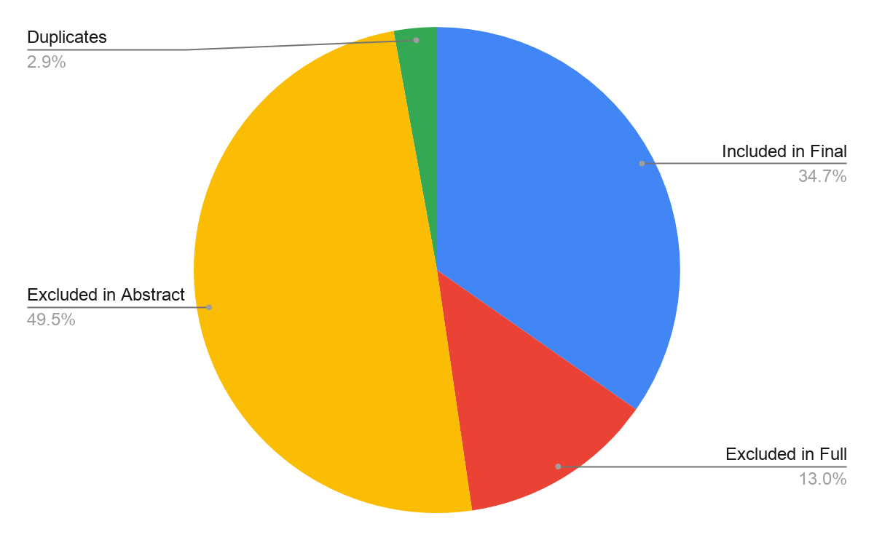

Author Region by Screening Stage

Author Region | Excluded in Abstract Review | Excluded in Full Text Review | Included in Final Sample | Total
Africa | 17 | 3 | 6 | 26
Asia | 37 | 10 | 18 | 65
Australia & Oceania | 36 | 11 | 40 | 87
Europe | 67 | 23 | 77 | 167
Latin America and the Caribbean | 5 | 2 | 1 | 8
North America | 59 | 5 | 16 | 80
Not Relevant | 4 | 5 | 0 | 9

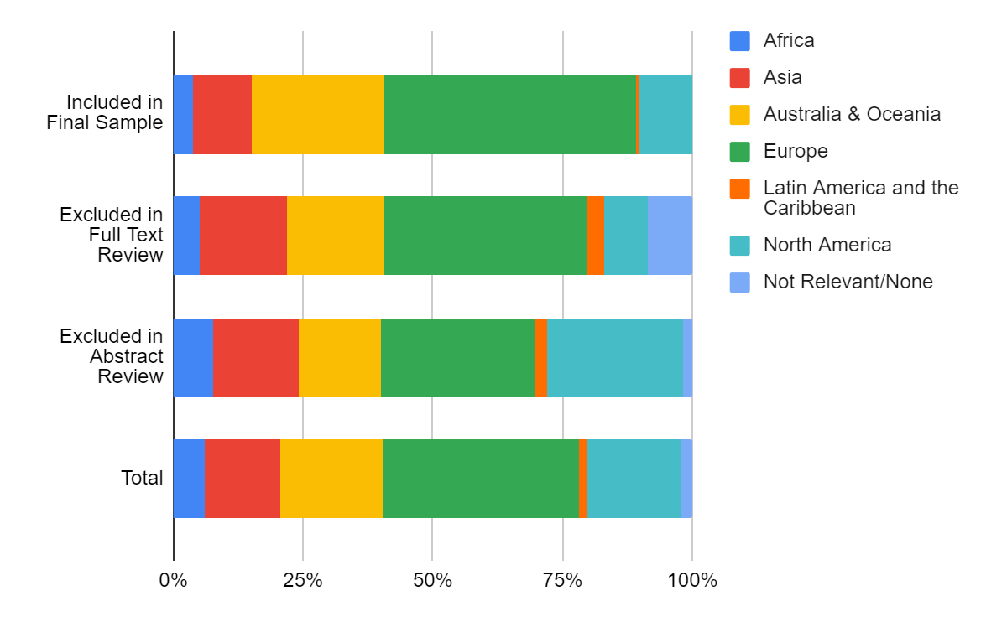

Citations by Screening Stage

 | Average | Standard Deviation
Excluded in Abstract Review | 9.24 | 37.55
Excluded in Full Text Review | 4.86 | 8.943
Included in Final Sample | 6.66 | 11.69
Total | 7.74 | 27.89

Publication Year by Screening Stage

 | Average | Median
Excluded in Abstract Review | 2013.39 | 2015
Excluded in Full Text Review | 2013.24 | 2014
Included in Final Sample | 2013.07 | 2015
Total | 2013.20 | 2014.50

Publications and Authors

Publication Type

Publication Type | Number of Publications | Percentage
Journal Articles | 143 | 90.5%
Book Chapters | 15 | 9.5%

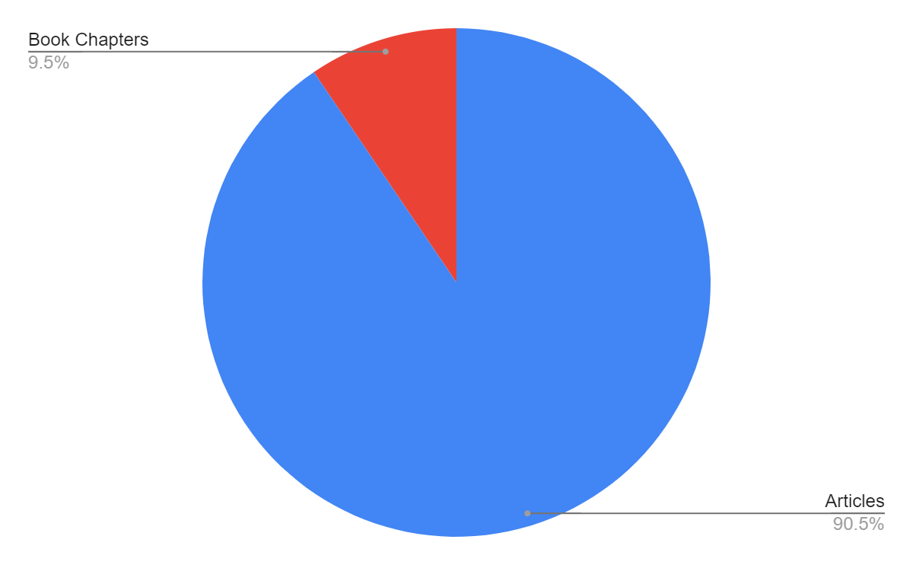

Publication Year

Year | Publications | Year | Publications | Year | Publications
1995 | 1 | 2004 | 0 | 2013 | 14
1996 | 1 | 2005 | 2 | 2014 | 11
1997 | 0 | 2006 | 4 | 2015 | 18
1998 | 1 | 2007 | 12 | 2016 | 9
1999 | 1 | 2008 | 4 | 2017 | 20
2000 | 0 | 2009 | 5 | 2018 | 13
2001 | 2 | 2010 | 7 | 2019 | 21
2002 | 0 | 2011 | 7
2003 | 0 | 2012 | 5

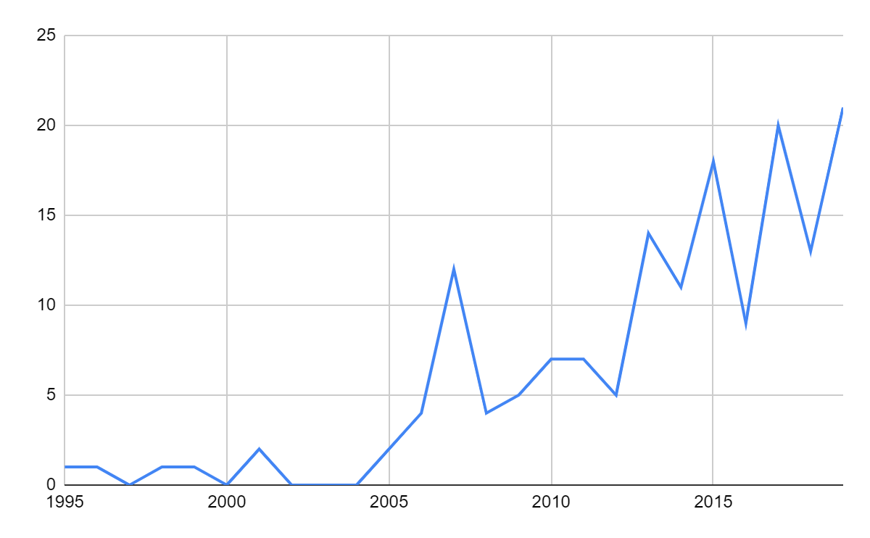

Publication Source
Publications were published in 60 different sources. The top five journals were:
- Environmental Education Research (n=21)
- Australian Journal of Environmental Education (n=14)
- Sustainability (n=13)
- Journal of Teacher Education for Sustainability (n=12)
- International Journal of Sustainability in Higher Education (n=11)

Author Countries
The affiliations of authors were based in 41 different countries. The top five countries for authors’ affiliations, which may include duplicate authors and their affiliations, were:
- Australia (n=39)
- United Kingdom (n=22)
- United States (n=14)
- Germany (n=13)
- Canada (n=9)

Author Regions
Region | Number of Publications | Percentage
Europe | 93 | 49.2%
Australia/Oceania | 43 | 22.8%
North America | 23 | 12.2%
Asia | 22 | 11.6%
Africa | 7 | 3.7%
Latin America and the Caribbean | 1 | 0.5%

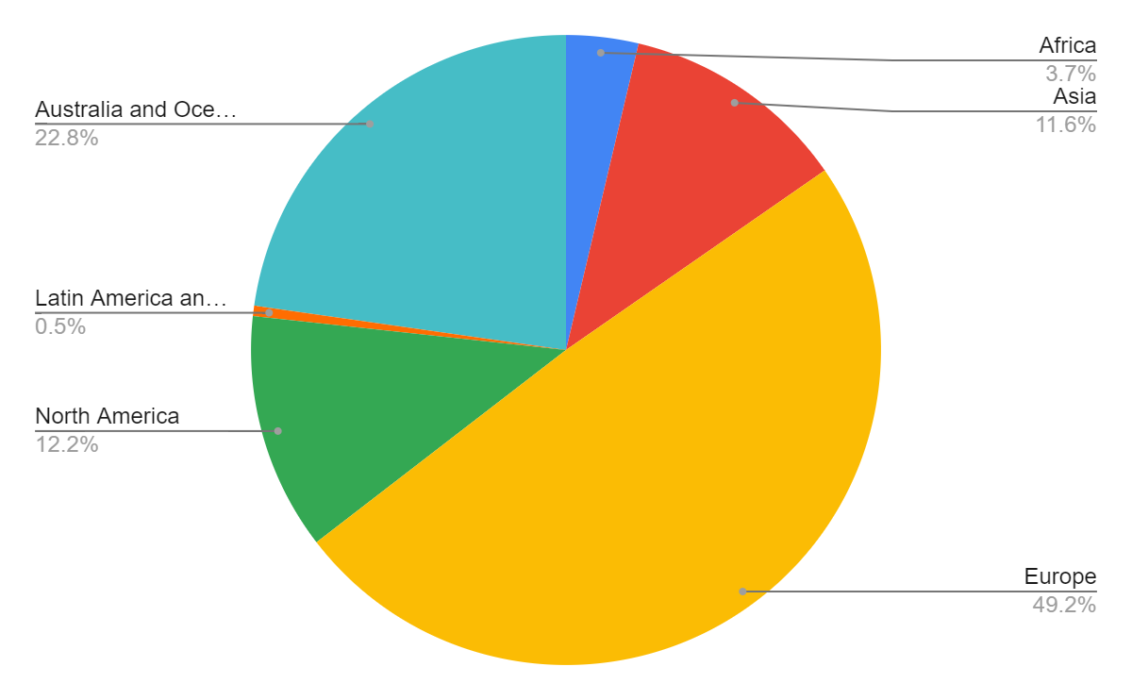

Authors
Publications were associated with 313 unique authors. These authors were distributed in the following way, with regards to number of publications:

Number of Publications | Number of Authors | Percentage
1 | 252 | 80.5%
2 | 49 | 15.6%
3 | 4 | 1.2%
4 | 6 | 1.9%
5 | 2 | 0.6%

The authors with 5 publications were:
- Julie M. Davis (Queensland University of Technology, Australia)
- Chrysanthi Kadji-Beltran (Frederick University, Cyprus)
The authors with 4 publications were:
- Jo-Anne L. Ferreira (La Trobe University, Australia)
- Julie Kennelly (University of New England, Australia)
- Petra Lindemann-Matthies (University of Zurich, Switzerland)
- Kathryn Paige (University of South Australia, Australia)
- Neil Taylor (University of New England, Australia)
- Louisa Tomas (James Cook University, Australia)

Geographic Context

Country of Research
Data analysis revealed that research on TESD was being conducted in 53 different countries. The most common countries were Australia (n-37), the United Kingdom (n=15), Germany (n=11), Sweden (n=9), and the United States (n=9). The chart below shows the top 10 countries, each with 5 or more associated publications, where research was being conducted in terms of publications. Additionally, it is important to note that some studies described research being conducted in multiple countries.
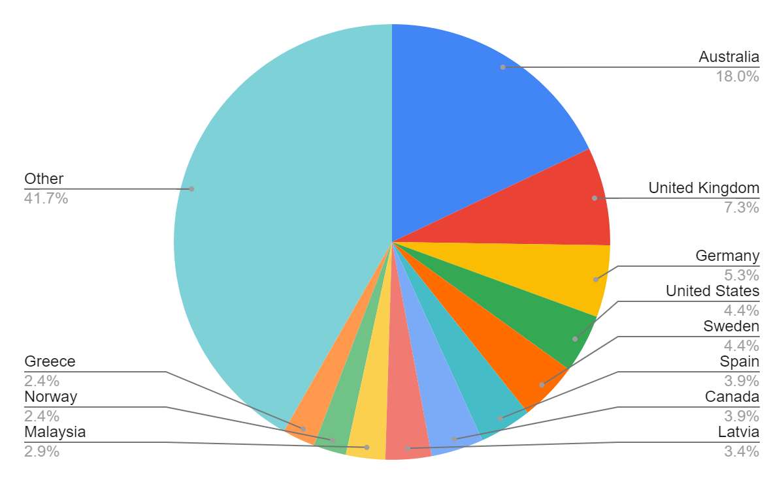

Region of Research
Region | Number of Publications
Europe | 88
Australia and Oceania | 44
Asia | 36
North America | 17
Africa | 6
Latin America and the Caribbean | 3
Other/Not Relevant | 12

Research Context

Phase of Teacher Education
Publications could conduct research on multiple phases of teacher education, thus the total number exceeds the final sample of n=158.
Phase | Number of Publications | Percentage
Pre-Service | 146 | 81.6%
In-Service | 29 | 16.2%
Other | 4 | 1.7%

Geographic Level
Focus | Amount | Percentage
Sub-National | 101 | 63.9%
National | 31 | 19.6%
Multinational | 15 | 9.5%
Global | 5 | 3.2%
Not Relevant | 6 | 3.8%

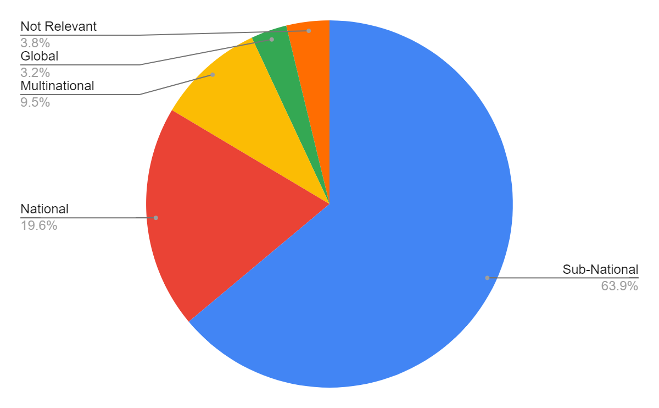

Research Level

Level | Number of Publications | Percentage
Class/Course | 56 | 35.4%
Program/Curriculum | 50 | 31.6%
Large Network | 20 | 12.7%
Small Network | 11 | 7.0%
Whole-Institution | 10 | 6.3%
Not Relevant | 6 | 3.8%
Other | 5 | 3.2%

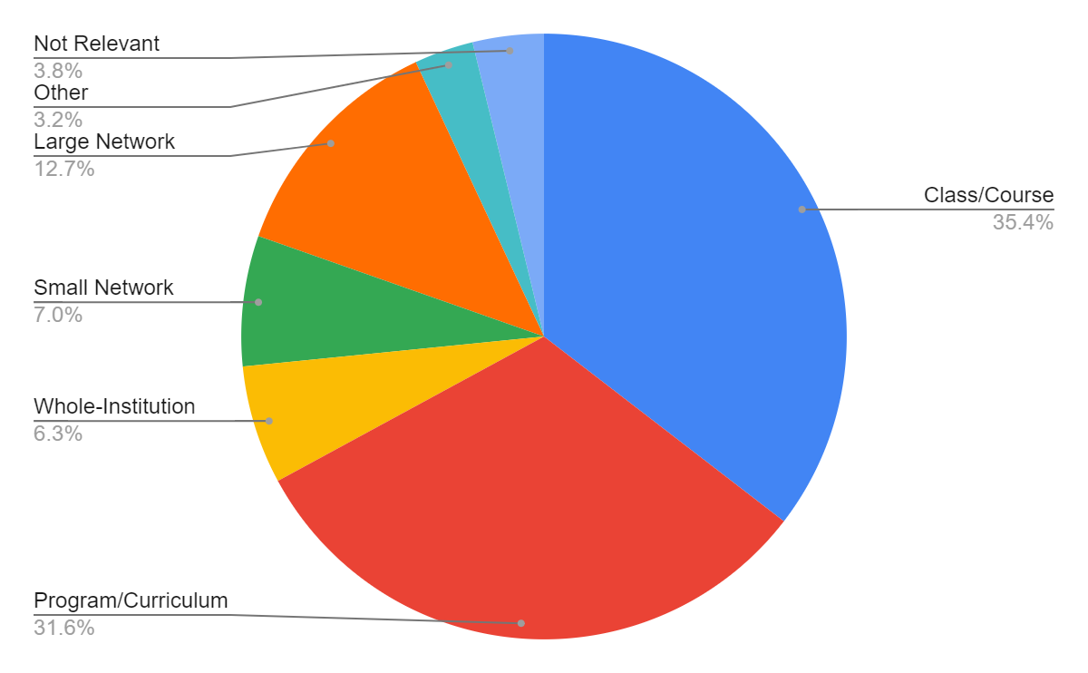

Research Methods

Research Focus

Research Focus | Number of Publications | Percentage
Exploratory Studies | 67 | 42.4%
Descriptive Studies | 25 | 15.8%
Explanatory Studies | 24 | 15.2%
Mixed Methods | 24 | 15.2%
Conceptual Papers | 18 | 11.4%

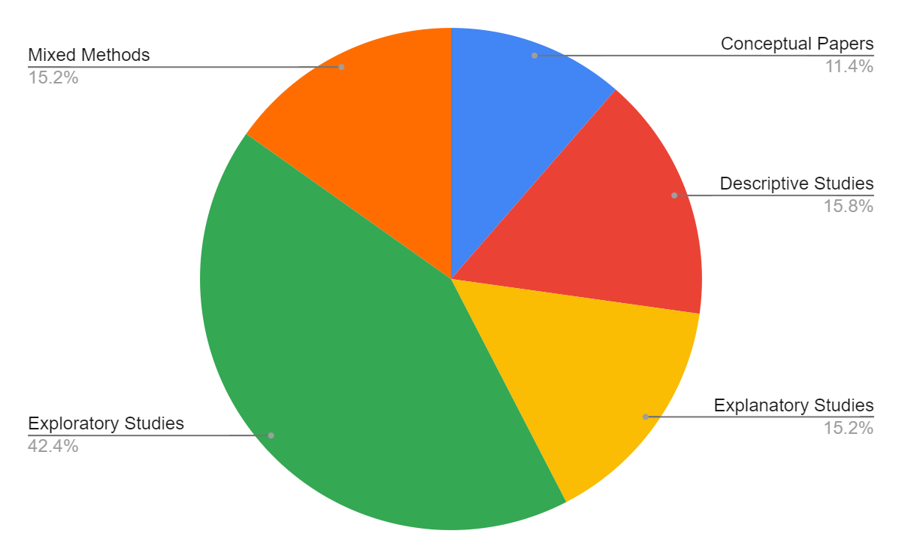

Research Design

Research Design | Number of Publications | Percentage
Case Study/Case Studies | 77 | 48.7%
Survey and/or Trend Study | 36 | 22.8%
Conceptual Paper | 18 | 11.4%
Action and/or Participatory Research | 15 | 9.5%
Experiment, Quasi-Experiment, Single Case Research and/or Meta-Analyses Research | 5 | 3.2%
Historical and/or Documentary Research | 2 | 1.3%
Naturalistic and/or Ethnographic Research | 1 | 0.6%
Other | 4 | 2.5%

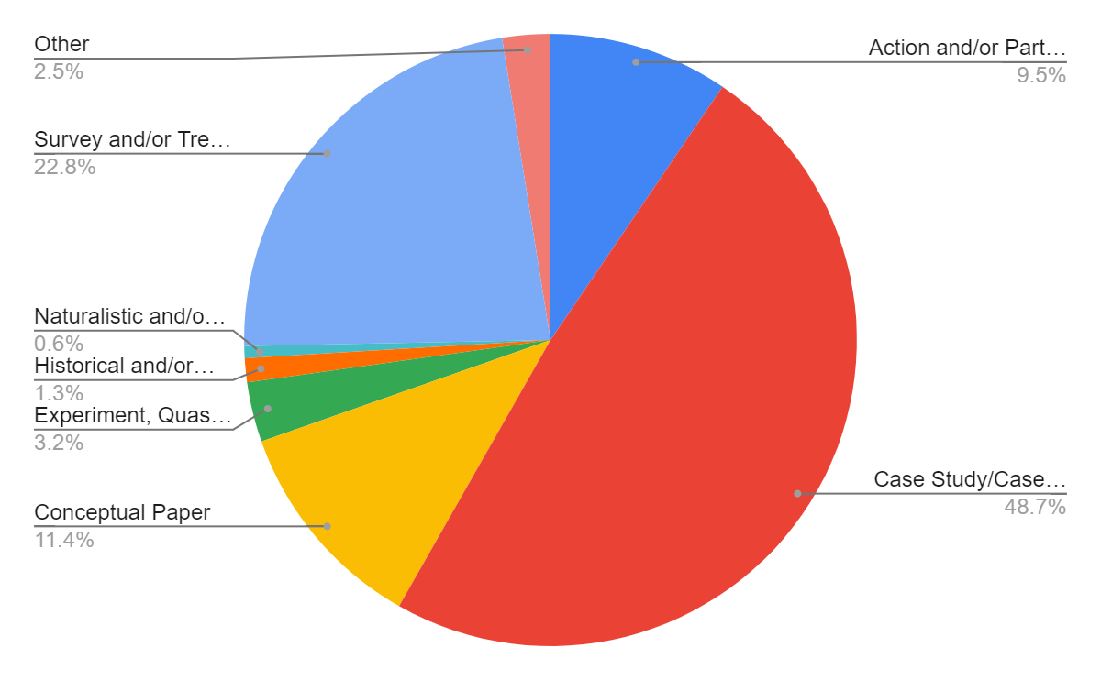

Data Collection Methods

Data Collection Method | Number of Publications | Percentage
Survey or Questionnaire | 65 | 27.8%
Interview | 46 | 19.7%
Document Analysis | 41 | 17.5%
Observation | 21 | 9.0%
Data were not collected | 21 | 9.0%
Focus Groups | 18 | 7.7%
Unclear/Unspecified | 12 | 5.1%
Tests or Assignments | 10 | 4.3%

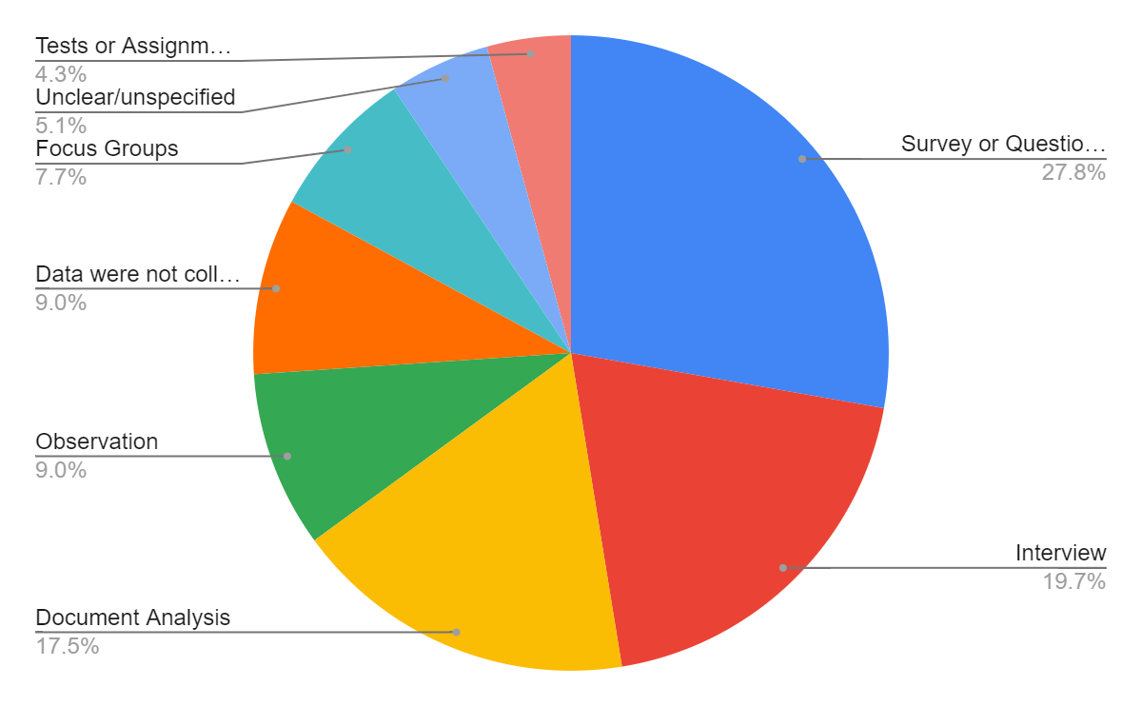

Data Collection Time Point

Data Collection Time Point | Number of Publications | Percentage
Data was collected once | 62 | 39.2%
Data was collected multiple times from the same sample | 46 | 29.1%
Data was not collected | 31 | 19.6%
Data was collected multiple times from different samples | 12 | 7.6%
Unclear/unspecified | 7 | 4.4%

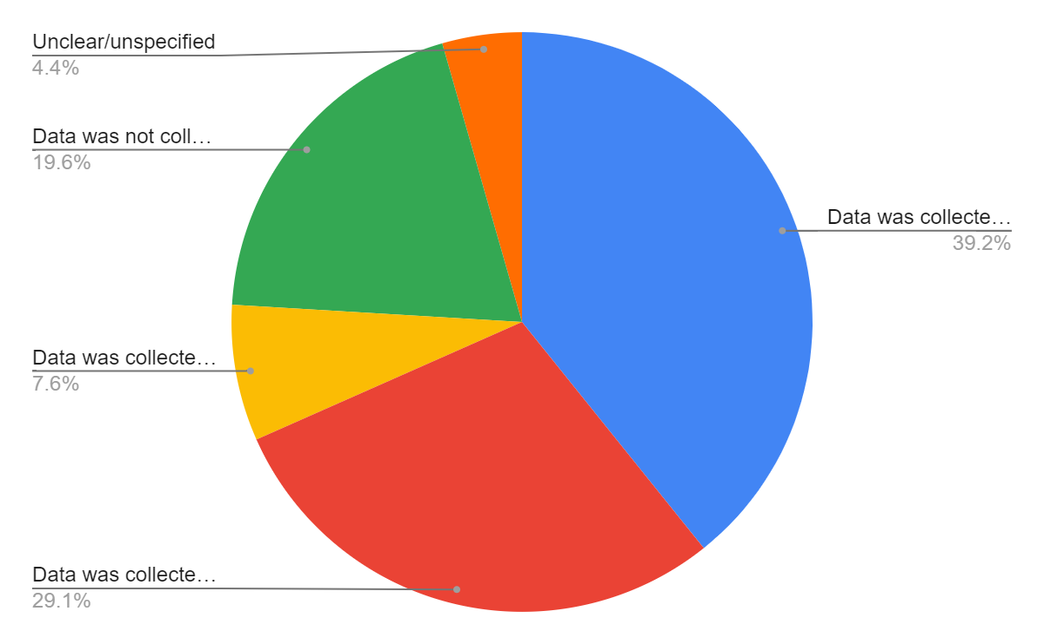

Research Questions

Research Questions | Number of Publications | Percentage
Yes (Explicitly Stated or Clear) | 100 | 63.3%
No (Not explicitly or clearly stated) | 58 | 36.7%

