Supplementary Figure
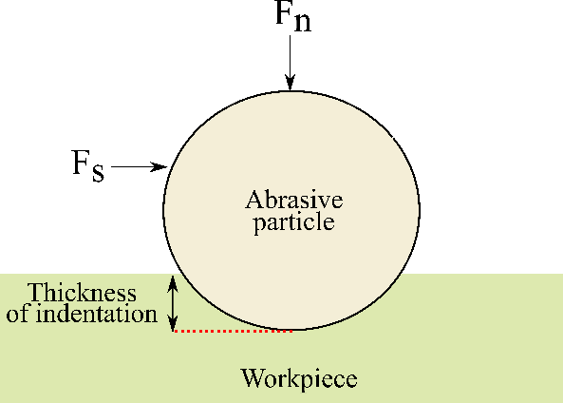
Fig. 6.1 Forces applied on workpiece by a single abrasive particle

Supplementary Table
Table 2.1. Mechanical properties of UHMWPE
Properties | Magnitude
Impact strength | 150 kJ m⁻²
Tensile strength | 40 MPa
Density | 940 kg m⁻³
Hardness | 45 HRB
Molecular weight | 3×10⁶ g mol⁻¹

