Supplementary materials
Supplement 1. GRADE evidence for comparisons between rasagiline and placebo.
Supplement 2. GRADE evidence for comparisons between 1- and 2-mg rasagiline.
Supplement 3. Forest plot of rasagiline treatment compared with placebo. Outcome: risk ratio of adverse events. Subgroups: total adverse events, headache, back pain, and dizziness.
Supplement 4. Forest plot of 1mg rasagiline treatment compared with placebo between Eastern and Western countries. Outcome: mean difference of total UPDRS, part 1, part 2, and part 3. Subgroups: Eastern and Western groups.
Supplement 5. Forest plot of rasagiline treatment compared with placebo between east and west. Outcome: risk ratio of total adverse events, headache, back pain, and dizziness. Subgroups: Eastern and Western groups.

Supplement 1. GRADE evidence for comparisons between rasagiline and placebo.
Certainty assessment |  |  |  |  |  |  | No of patients |  | Effect |  | Certainty | Importance
No of studies | Study design | Risk of bias | Inconsistency | Indirectness | Imprecision | Other considerations | Rasagiline | placebo | Relative  (95% CI) | Absolute  (95% CI)
Total UPDRS - 1mg vs placebo
4 | randomised trials | not serious | not serious | not serious | not serious | none | 501 | 514 | - | MD 3.05 lower  (3.76 lower to 2.34 lower) | ⨁⨁⨁⨁  HIGH
Total UPDRS - 2mg vs placebo
3 | randomised trials | not serious | not serious | not serious | not serious | none | 439 | 446 | - | MD 3.24 lower  (3.96 lower to 2.53 lower) | ⨁⨁⨁⨁  HIGH
UPDRS part 1 - 1mg vs placebo
4 | randomised trials | not serious | not serious | not serious | not serious | none | 594 | 889 | - | MD 0.33 lower  (0.57 lower to 0.1 lower) | ⨁⨁⨁⨁  HIGH
UPDRS part 1 - 2mg vs placebo
2 | randomised trials | not serious | not serious | not serious | not serious | none | 422 | 726 | - | MD 0.12 lower  (0.29 lower to 0.06 higher) | ⨁⨁⨁⨁  HIGH
UPDRS Part 2 - 1mg vs placebo
5 | randomised trials | not serious | serious ª | not serious | not serious | none | 789 | 1084 | - | MD 0.87 lower  (1.48 lower to 0.27 lower) | ⨁⨁⨁◯  MODERATE
UPDRS Part 2 - 2mg vs placebo
2 | randomised trials | not serious | not serious | not serious | not serious | none | 422 | 726 | - | MD 0.98 lower  (1.28 lower to 0.68 lower) | ⨁⨁⨁⨁  HIGH
UPDRS Part 3 - 1mg vs placebo
4 | randomised trials | not serious | not serious | not serious | not serious | none | 594 | 889 | - | MD 2.41 lower  (3.26 lower to 1.56 lower) | ⨁⨁⨁⨁  HIGH
UPDRS Part 3 - 2mg vs placebo
2 | randomised trials | not serious | not serious | not serious | not serious | none | 422 | 726 | - | MD 2.05 lower  (2.64 lower to 1.46 lower) | ⨁⨁⨁⨁  HIGH
CI: Confidence interval; MD: Mean difference

Explanations
a. I-square: 79%

Supplement 2. GRADE evidence for comparisons between 1- and 2-mg rasagiline.
Certainty assessment |  |  |  |  |  |  | No of patients |  | Effect |  | Certainty | Importance
No of studies | Study design | Risk of bias | Inconsistency | Indirectness | Imprecision | Other considerations | Rasagiline 1mg | Rasagiline 2mg | Relative  (95% CI) | Absolute  (95% CI)
Total UPDRS- 1mg vs 2mg
3 | randomised trials | not serious | not serious | not serious | not serious | none | 437 | 439 | - | MD 0  (0.82 lower to 0.81 higher) | ⨁⨁⨁⨁  HIGH
CI: Confidence interval; MD: Mean difference

Supplement 3. Forest plot of rasagiline treatment compared with placebo. Outcome: risk ratio of adverse events. Subgroups: total adverse events, headache, back pain, and dizziness.
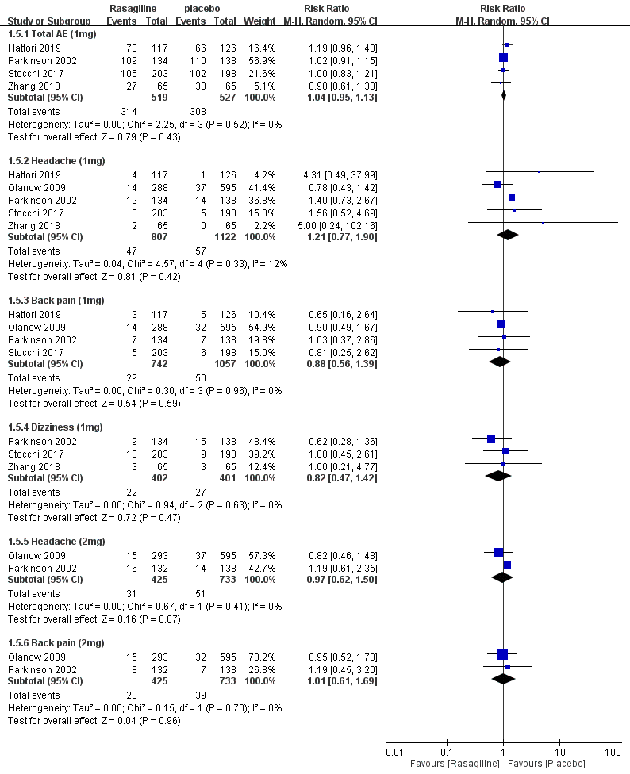

Supplement 4. Forest plot of 1mg rasagiline treatment compared with placebo between Eastern and Western countries. Outcome: mean difference of total UPDRS, part 1, part 2, and part 3. Subgroups: Eastern and Western groups.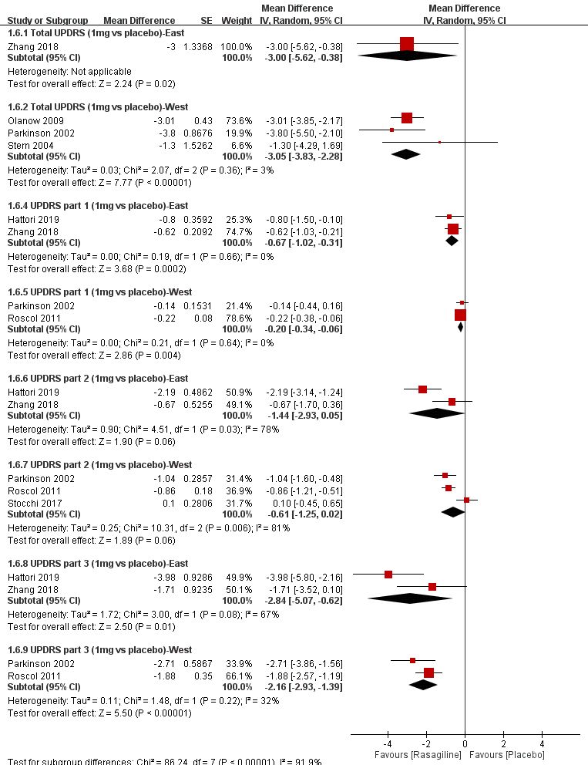

Supplement 5. Forest plot of rasagiline treatment compared with placebo between east and west. Outcome: risk ratio of total adverse events, headache, back pain, and dizziness. Subgroups: Eastern and Western groups
