Appendices

Appendix 1: Search histories

PubMed
Search date (original): 21/09/2018
Update: 14/10/2020
ID | Search
Block 1 (Intervention
telemedicine)
#1 | Telecommunication [Mesh]
#2 | Telenursing [Mesh]
#3 | "Computer Communication Networks"[Mesh]
#4 | (Telemedicin*[Title/Abstract] OR tele medicin*[Title/Abstract] OR telenurs*[Title/Abstract] OR tele nurs*[Title/Abstract] OR teleassist*[Title/Abstract] OR tele assist*[Title/Abstract] OR telebase*[Title/Abstract] OR tele base*[Title/Abstract] OR teleconsult*[Title/Abstract] OR tele consult*[Title/Abstract] OR telecouns*[Title/Abstract] OR tele couns*[Title/Abstract] OR telederm*[Title/Abstract] OR tele derm*[Title/Abstract] OR telediagnos*[Title/Abstract] OR tele diagnos*[Title/Abstract] OR telefollow*[Title/Abstract] OR tele follow*[Title/Abstract] OR teleguid*[Title/Abstract] OR tele guid*[Title/Abstract] OR telehealth*[Title/Abstract] OR tele health*[Title/Abstract] OR telehome*[Title/Abstract] OR tele home*[Title/Abstract] OR teleintervention*[Title/Abstract] OR tele intervention*[Title/Abstract] OR telemanag*[Title/Abstract] OR tele manag*[Title/Abstract] OR telemed*[Title/Abstract] OR tele med*[Title/Abstract] OR telemonitor*[Title/Abstract] OR tele monitor*[Title/Abstract] OR teleophthalmo*[Title/Abstract] OR tele ophthalmo*[Title/Abstract] OR telepatholog*[Title/Abstract] OR tele patholog*[Title/Abstract] OR teleprocedu*[Title/Abstract] OR tele procedu*[Title/Abstract] OR telerefer*[Title/Abstract] OR tele refer*[Title/Abstract] OR telerehab*[Title/Abstract] OR tele rehab*[Title/Abstract] OR teletherap*[Title/Abstract] OR tele therap*[Title/Abstract] OR teletreat*[Title/Abstract] OR tele treat*[Title/Abstract] OR telecare[Title/Abstract] OR tele care[Title/Abstract] OR telematic*[Title/Abstract] OR tele matic*[Title/Abstract] OR telecommunica*[Title/Abstract] OR tele communica*[Title/Abstract] OR telehomecare[Title/Abstract] OR tele home care[Title/Abstract] OR telehome care[Title/Abstract] OR tele homecare[Title/Abstract] OR mobile health[Title/Abstract] OR selfmonitor*[Title/Abstract] OR self monitor*[Title/Abstract] OR ehealth[Title/Abstract] OR digital health[Title/Abstract] OR dhealth[Title/Abstract] OR home monitor*[Title/Abstract] OR electronic care[Title/Abstract] OR ecare[Title/Abstract] OR econsult*[Title/Abstract] OR electronic consult*[Title/Abstract] OR ediagnos*[Title/Abstract] OR electronic diag*[Title/Abstract] OR electronic health[Title/Abstract] OR emedicine[Title/Abstract] OR electronic medicine[Title/Abstract] OR enurs*[Title/Abstract] OR electronic nurs*[Title/Abstract] OR ephysic*[Title/Abstract] OR electronic physic*[Title/Abstract] OR etherap*[Title/Abstract] OR electronic therap*[Title/Abstract] OR electronic mail*[Title/Abstract] OR mhealth[Title/Abstract] OR iphone*[Title/Abstract] OR smartphone*[Title/Abstract] OR PDA[Title/Abstract] OR Personal Digital Assistant*[Title/Abstract] OR phone*[Title/Abstract] OR tablet*[Title/Abstract] OR internet[Title/Abstract] OR compute*[Title/Abstract] OR app[Title/Abstract] OR application*[Title/Abstract] OR digital*[Title/Abstract] OR mobile*[Title/Abstract] OR cellphone*[Title/Abstract] OR telephone*[Title/Abstract] OR remote*[Title/Abstract] OR web base*[Title/Abstract] OR webbase*[Title/Abstract] OR cellular[Title/Abstract] OR landline[Title/Abstract] OR land line[Title/Abstract] OR blackberr*[Title/Abstract] OR black berr*[Title/Abstract] OR palmpilo*[Title/Abstract] OR palm pilot*[Title/Abstract] OR android[Title/Abstract] OR pocket PC*[Title/Abstract] OR radio*[Title/Abstract] OR walkee talkee*[Title/Abstract])
#5 | #1 OR #2 OR #3 Or #4
Block 2
(Patient- diabetics)
#6 | “Diabetes Mellitus”[Mesh]
#7 | (diabet*[Title/Abstract] OR DM[Title/Abstract] OR IDDM[Title/Abstract] OR NIDDM[Title/Abstract] OR MODY[Title/Abstract])
#8 | #6 OR #7
Block 3
(Publication type - RCT)
#9 | "Controlled Clinical Trials as Topic"[Mesh]
#10 | "Controlled Clinical Trial" [Publication Type]
#11 | ((((trial*[Title/Abstract] OR study[Title/Abstract] OR studies[Title/Abstract]))) AND random*[Title/Abstract]) AND control*[title/Abstract]
#12 | #9 OR #10 OR #11
Limitations
Block 3
(combined block searches)
#9 | #5 AND #8 AND #12
#10 | #9  Filters: Danish; English; Norwegian; Swedish

Embase
Search date (original): 25/9/2018
Updated: 14/10/2020
ID | Search
Block 1 (Intervention
telemedicine)
#1 | 'telecommunication'/exp
#2 | telemedicin*:ab,kw,ti OR 'tele medicin*':ab,kw,ti OR telenurs*:ab,kw,ti OR 'tele nurs*':ab,kw,ti OR teleassist*:ab,kw,ti OR 'tele assist*':ab,kw,ti OR telebase*:ab,kw,ti OR 'tele base*':ab,kw,ti OR teleconsult*:ab,kw,ti OR 'tele consult*':ab,kw,ti OR telecouns*:ab,kw,ti OR 'tele couns*':ab,kw,ti OR telederm*:ab,kw,ti OR 'tele derm*':ab,kw,ti OR telediagnos*:ab,kw,ti OR 'tele diagnos*':ab,kw,ti OR telefollow*:ab,kw,ti OR 'tele follow*':ab,kw,ti OR teleguid*:ab,kw,ti OR 'tele guid*':ab,kw,ti OR telehealth*:ab,kw,ti OR 'tele health*':ab,kw,ti OR telehome*:ab,kw,ti OR 'tele home*':ab,kw,ti OR teleintervention*:ab,kw,ti OR 'tele intervention*':ab,kw,ti OR telemanag*:ab,kw,ti OR 'tele manag*':ab,kw,ti OR telemed*:ab,kw,ti OR 'tele med*':ab,kw,ti OR telemonitor*:ab,kw,ti OR 'tele monitor*':ab,kw,ti OR teleophthalmo*:ab,kw,ti OR 'tele ophthalmo*':ab,kw,ti OR telepatholog*:ab,kw,ti OR 'tele patholog*':ab,kw,ti OR teleprocedu*:ab,kw,ti OR 'tele procedu*':ab,kw,ti OR telerefer*:ab,kw,ti OR 'tele refer*':ab,kw,ti OR telerehab*:ab,kw,ti OR 'tele rehab*':ab,kw,ti OR teletherap*:ab,kw,ti OR 'tele therap*':ab,kw,ti OR teletreat*:ab,kw,ti OR 'tele treat*':ab,kw,ti OR telecare:ab,kw,ti OR 'tele care':ab,kw,ti OR telematic*:ab,kw,ti OR 'tele matic*':ab,kw,ti OR telecommunica*:ab,kw,ti OR 'tele communica*':ab,kw,ti OR telehomecare:ab,kw,ti OR 'tele home care':ab,kw,ti OR 'telehome care':ab,kw,ti OR 'tele homecare':ab,kw,ti OR 'mobile health':ab,kw,ti OR selfmonitor*:ab,kw,ti OR 'self monitor*':ab,kw,ti OR ehealth:ab,kw,ti OR 'digital health':ab,kw,ti OR dhealth:ab,kw,ti OR 'home monitor*':ab,kw,ti OR 'electronic care':ab,kw,ti OR ecare:ab,kw,ti OR econsult*:ab,kw,ti OR 'electronic consult*':ab,kw,ti OR ediagnos*:ab,kw,ti OR 'electronic diag*':ab,kw,ti OR 'electronic health':ab,kw,ti OR emedicine:ab,kw,ti OR 'electronic medicine':ab,kw,ti OR enurs*:ab,kw,ti OR 'electronic nurs*':ab,kw,ti OR ephysic*:ab,kw,ti OR 'electronic physic*':ab,kw,ti OR etherap*:ab,kw,ti OR 'electronic therap*':ab,kw,ti OR 'electronic mail*':ab,kw,ti OR mhealth:ab,kw,ti OR iphone*:ab,kw,ti OR smartphone*:ab,kw,ti OR pda:ab,kw,ti OR 'personal digital assistant*':ab,kw,ti OR phone*:ab,kw,ti OR tablet*:ab,kw,ti OR internet:ab,kw,ti OR compute*:ab,kw,ti OR app:ab,kw,ti OR application*:ab,kw,ti OR digital*:ab,kw,ti OR mobile*:ab,kw,ti OR cellphone*:ab,kw,ti OR telephone*:ab,kw,ti OR remote*:ab,kw,ti OR 'web base*':ab,kw,ti OR webbase*:ab,kw,ti OR cellular:ab,kw,ti OR landline:ab,kw,ti OR 'land line':ab,kw,ti OR blackberr*:ab,kw,ti OR 'black berr*':ab,kw,ti OR palmpilo*:ab,kw,ti OR 'palm pilot*':ab,kw,ti OR android:ab,kw,ti OR 'pocket pc*':ab,kw,ti OR radio*:ab,kw,ti OR 'walkee talkee*':ab,kw,ti
#3 | #1 OR #2
Block 2
(Patient- diabetics)
#4 | 'diabetes mellitus'/exp
#5 | diabet*:ab,kw,ti OR dm:ab,kw,ti OR iddm:ab,kw,ti OR niddm:ab,kw,ti OR mody:ab,kw,ti
#6 | #4 or #5
Block 3 (Publication type - RCT)
#7 | 'controlled clinical trial'/exp
#8 | (trial*:ab,kw,ti OR study:ab,kw,ti OR studies:ab,kw,ti) AND random*:ab,kw,ti AND control*:ab,kw,ti
#9 | #7 OR #8
Block 4
(combined block searches)
#10 | #3 AND #6 AND #9
#11 | #3 AND #6 AND #9 AND [embase]/lim
#12 | #11 AND ('article'/it OR 'article in press'/it OR 'conference paper'/it)
#13 | #12 AND ([danish]/lim OR [english]/lim OR [norwegian]/lim OR [swedish]/lim)

CINAHL
Search day (original): 24/9/2018
Updated: 14/10/2020

ID | Search
Block 1 (Intervention
telemedicine)
#1 | (MH "Telecommunications+")
#2 | TI(Telemedicin* OR tele medicin* OR telenurs* OR tele nurs* OR teleassist* OR tele assist* OR telebase* OR tele base* OR teleconsult* OR tele consult* OR telecouns* OR tele couns* OR telederm* OR tele derm* OR telediagnos* OR tele diagnos* OR telefollow* OR tele follow* OR teleguid* OR tele guid* OR telehealth* OR tele health* OR telehome* OR tele home* OR teleintervention* OR tele intervention* OR telemanag* OR tele manag* OR telemed* OR tele med* OR telemonitor* OR tele monitor* OR teleophthalmo* OR tele ophthalmo* OR telepatholog* OR tele patholog* OR teleprocedu* OR tele procedu* OR telerefer* OR tele refer* OR telerehab* OR tele rehab* OR teletherap* OR tele therap* OR teletreat* OR tele treat* OR telecare OR tele care OR telematic* OR tele matic* OR telecommunica* OR tele communica* OR telehomecare OR tele home care OR telehome care OR tele homecare OR mobile health OR selfmonitor* OR self monitor* OR ehealth OR digital health OR dhealth OR home monitor* OR electronic care OR ecare OR econsult* OR electronic consult* OR ediagnos* OR electronic diag* OR electronic health OR emedicine OR electronic medicine OR enurs* OR electronic nurs* OR ephysic* OR electronic physic* OR etherap* OR electronic therap* OR electronic mail* OR mhealth OR iphone* OR smartphone* OR PDA OR Personal Digital Assistant* OR phone* OR tablet* OR internet OR compute* OR app OR application* OR digital* OR mobile* OR cellphone* OR telephone* OR remote* OR web base* OR webbase* OR cellular OR landline OR land line OR blackberry* OR black berr* OR palmpilo* OR palm pilot* OR android OR pocket PC* OR radio* OR walkee talkee*) OR AB(Telemedicin* OR tele medicin* OR telenurs* OR tele nurs* OR teleassist* OR tele assist* OR telebase* OR tele base* OR teleconsult* OR tele consult* OR telecouns* OR tele couns* OR telederm* OR tele derm* OR telediagnos* OR tele diagnos* OR telefollow* OR tele follow* OR teleguid* OR tele guid* OR telehealth* OR tele health* OR telehome* OR tele home* OR teleintervention* OR tele intervention* OR telemanag* OR tele manag* OR telemed* OR tele med* OR telemonitor* OR tele monitor* OR teleophthalmo* OR tele ophthalmo* OR telepatholog* OR tele patholog* OR teleprocedu* OR tele procedu* OR telerefer* OR tele refer* OR telerehab* OR tele rehab* OR teletherap* OR tele therap* OR teletreat* OR tele treat* OR telecare OR tele care OR telematic* OR tele matic* OR telecommunica* OR tele communica* OR telehomecare OR tele home care OR telehome care OR tele homecare OR mobile health OR selfmonitor* OR self monitor* OR ehealth OR digital health OR dhealth OR home monitor* OR electronic care OR ecare OR econsult* OR electronic consult* OR ediagnos* OR electronic diag* OR electronic health OR emedicine OR electronic medicine OR enurs* OR electronic nurs* OR ephysic* OR electronic physic* OR etherap* OR electronic therap* OR electronic mail* OR mhealth OR iphone* OR smartphone* OR PDA OR Personal Digital Assistant* OR phone* OR tablet* OR internet OR compute* OR app OR application* OR digital* OR mobile* OR cellphone* OR telephone* OR remote* OR web base* OR webbase* OR cellular OR landline OR land line OR blackberry* OR black berr* OR palmpilo* OR palm pilot* OR android OR pocket PC* OR radio* OR walkee talkee*)
#3 | #1 OR #2
Block 2
(Patient- diabetics)
#4 | (MH "Diabetes Mellitus+")
#5 | TI (diabet* OR dm OR iddm OR niddm OR mody) OR AB (diabet* OR dm OR iddm OR niddm OR mody)
#6 | #4 OR #5
Block 3
(Publication type - RCT)
#9 | MH "Randomized Controlled Trials"
#10 | ((TI(trial* OR study OR studies)) OR (AB(trial* OR study OR studies))) AND (TI(random*) OR AB(random*)) AND (TI(control*) OR AB(control*))
#11 | #9 OR #10
Block 3
(combined block searches)
#12 | #3 AND #6 AND #11
#13 | #12  Limiters Language: Danish, English, Norwegian, Swedish

Cochrane Library
Search date (original): 11/09/2018
Updated: 14/10/2020
ID | Search
Block 1
(Intervention -telemedicine)
#1 | MeSH descriptor: [Telecommunications]
#2 | MeSH descriptor: [Telenursing]
#3 | ´Computer Communication Networks´[Mesh]
#4 | (Telemedicin* OR `tele medicin*´ OR telenurs* OR `tele nurs*´ OR teleassist* OR `tele assist*´ OR telebase* OR `tele base*´ OR teleconsult* OR `tele consult*´ OR telecouns* OR `tele couns*´ OR telederm* OR `tele derm*´ OR telediagnos* OR `tele diagnos*´ OR telefollow* OR `tele follow*´ OR teleguid* OR `tele guid*´ OR telehealth* OR `tele health*´ OR telehome* OR `tele home*´ OR teleintervention* OR `tele intervention*´ OR telemanag* OR `tele manag*´ OR telemed* OR `tele med*´ OR telemonitor* OR `tele monitor*´ OR teleophthalmo* OR `tele ophthalmo*´ OR telepatholog* OR `tele patholog*´ OR teleprocedu* OR `tele procedu*´ OR telerefer* OR `tele refer*´ OR telerehab* OR `tele rehab*´ OR teletherap* OR `tele therap*´ OR teletreat* OR `tele treat*´ OR telecare OR `tele care´ OR telematic* OR `tele matic*´ OR telecommunica* OR `tele communica*´ OR telehomecare OR `tele home care´ OR `telehome care´ OR `tele homecare´ OR `mobile health´ OR selfmonitor* OR `self monitor*´ OR ehealth OR `digital health´ OR dhealth OR `home monitor*´ OR `electronic care´ OR ecare OR econsult* OR `electronic consult*´ OR ediagnos* OR `electronic diag*´ OR `electronic health´ OR emedicine OR `electronic medicine´ OR enurs* OR `electronic nurs*´ OR ephysic* OR `electronic physic*´ OR etherap* OR `electronic therap*´ OR `electronic mail*´ OR mhealth OR iphone* OR smartphone* OR PDA OR `Personal Digital Assistant*´ OR phone* OR tablet* OR internet OR compute* OR app OR application* OR digital* OR mobile* OR cellphone* OR telephone* OR remote* OR `web base*´ OR webbase* OR cellular OR landline OR `land line´ OR blackberr* OR `black berr*´ OR palmpilo* OR `palm pilot*´ OR android OR `pocket PC*´ OR radio* OR `walkee talkee*´):ti,ab,kw
#5 | #1 OR #2 OR #3 OR #4
Block 2
(Population: diabetes)
#6 | MeSH descriptor: [Diabetes Mellitus] explode all trees
#7 | (diabet* OR DM OR IDDM OR NIDDM OR MODY):ti,ab,kw
#8 | #6 OR #7
Block 3
(Publication type - RCT)
#9 | MeSH descriptor: [Controlled Clinical Trials as Topic] explode all trees
#10 | MeSH descriptor: [Controlled Clinical Trial] explode all trees
#11 | (trial* OR study OR studies):ti,ab,kw AND random*:ti,ab,kw AND control*:ti,ab,kw
#12 | #9 OR #10 OR #11
Block 3
(combined block searches)
#13 | #5 AND #8 AND #12
#14 | #13 (NOT from EMBASE and PubMed and Cinahl)

Appendix 2: Risk of bias assessment across studies

Study ID | Randomization process | Deviations from intended interventions | Mising outcome data | Measurement of the outcome | Selection of the reported result | Overall Bias
Homko 2007 | Some concerns | High | Low | Low | Some concerns | High
Durnwald 2016 | Some concerns | Some concerns | Low | Low | Low | Some concerns
Given 2015 | Low | Low | Low | Low | Low | Low
Homko 2012 | Some concerns | Low | Low | Low | Some concerns | Some concerns
Mackillop | Low | Low | Low | Low | Low | Low
Miremberg 2018 | Low | Low | Low | Low | Low | Low
Perez-Ferre 2010 | Some concerns | Low | Low | Low | Some concerns | Some concerns
Raseka 2018 | Low | Low | Low | Low | Low | Low
Carolan-Olah 2019 | Low | Some concerns | High | Low | Low | High
Cheung 2019 | Low | Low | High | Low | Low | Some concerns
Sung 2019 | Low | Low | Low | Low | Low | Low

Appendix 3: Forest plots for all subgroups
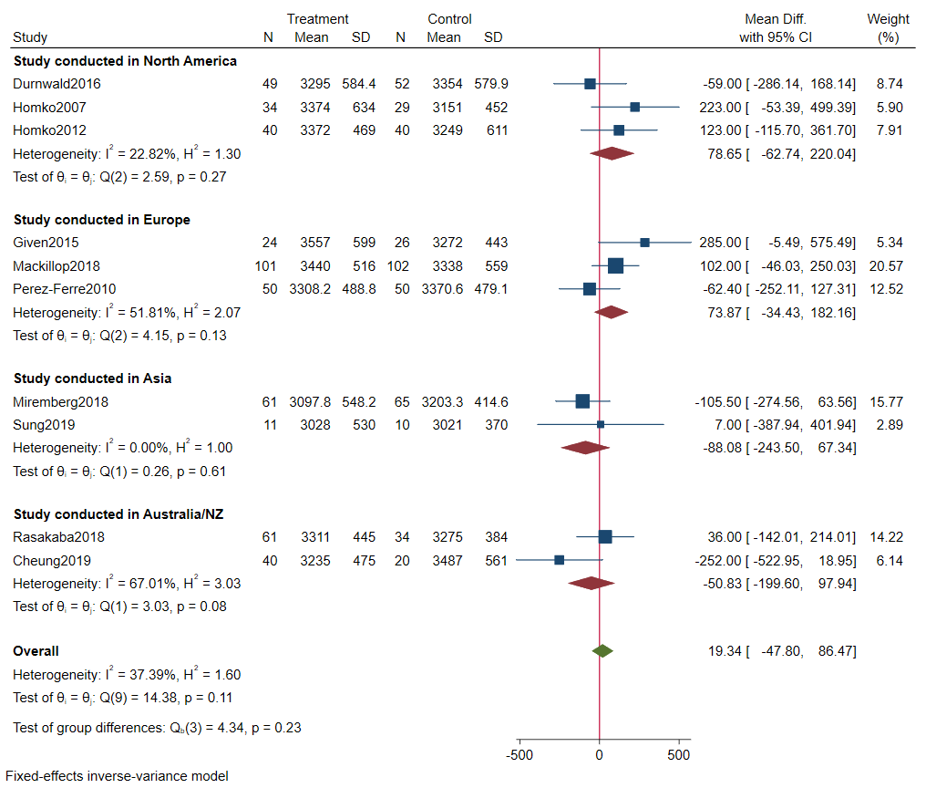
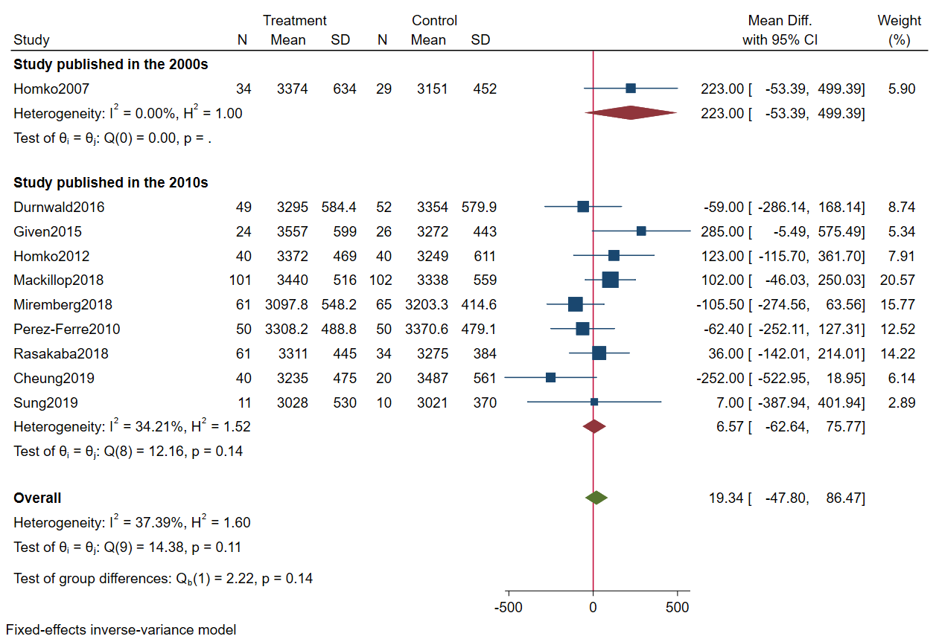
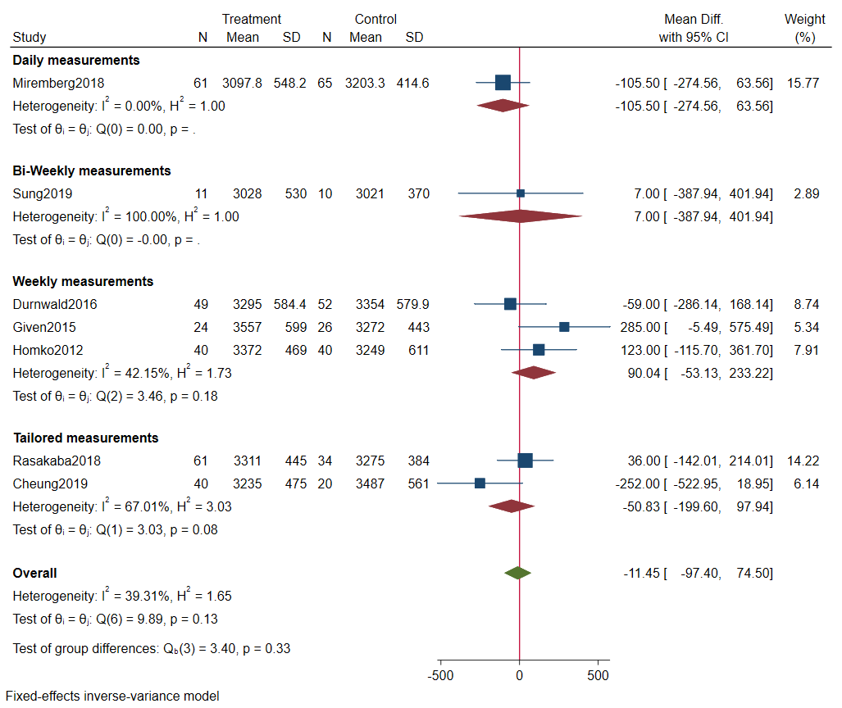
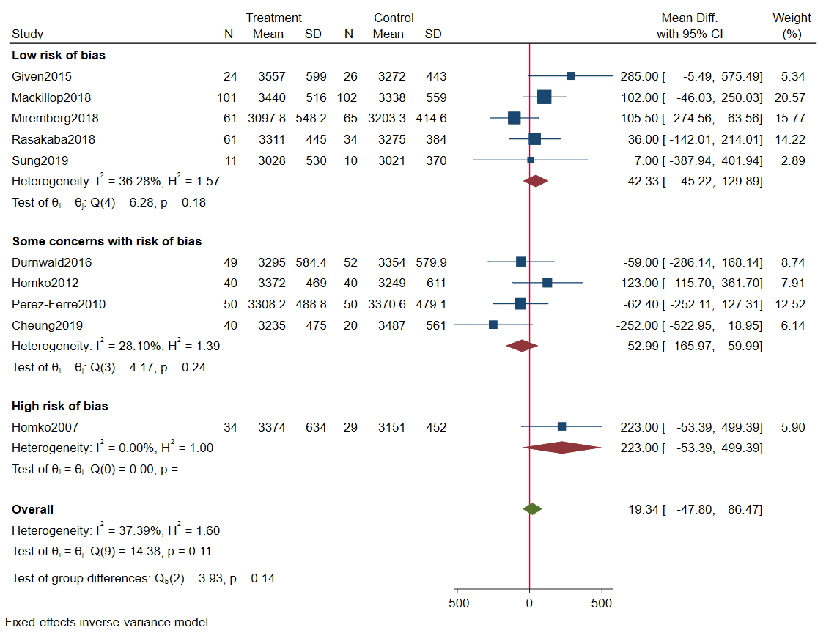
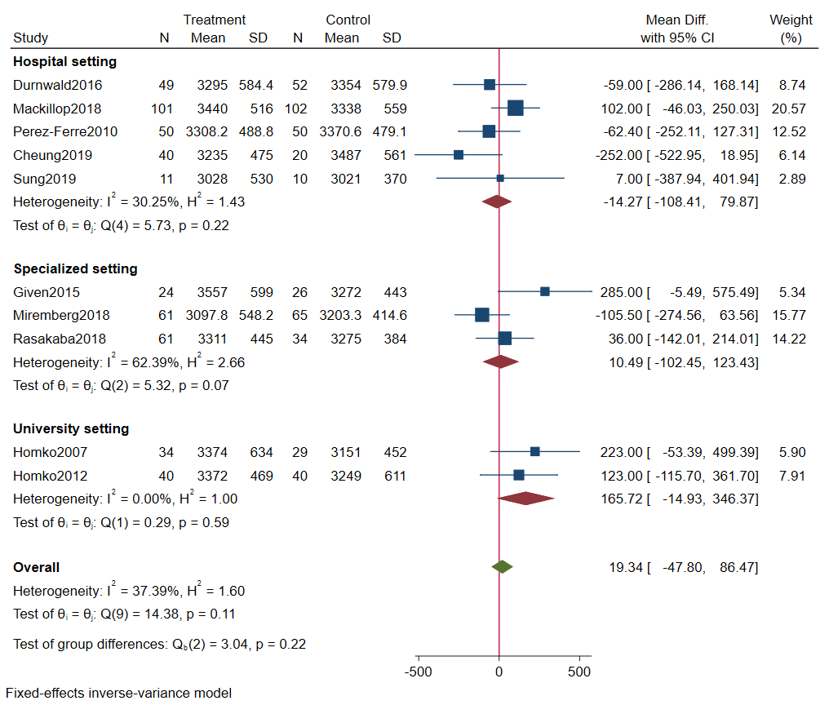
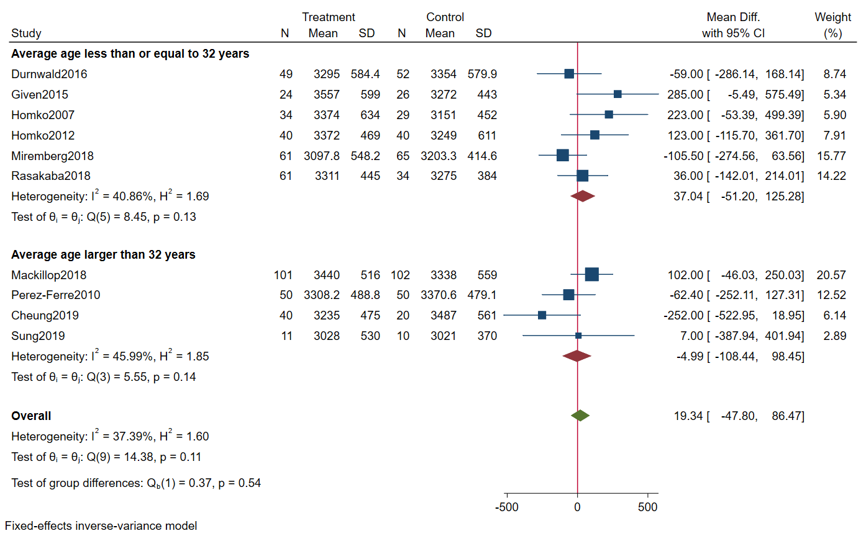
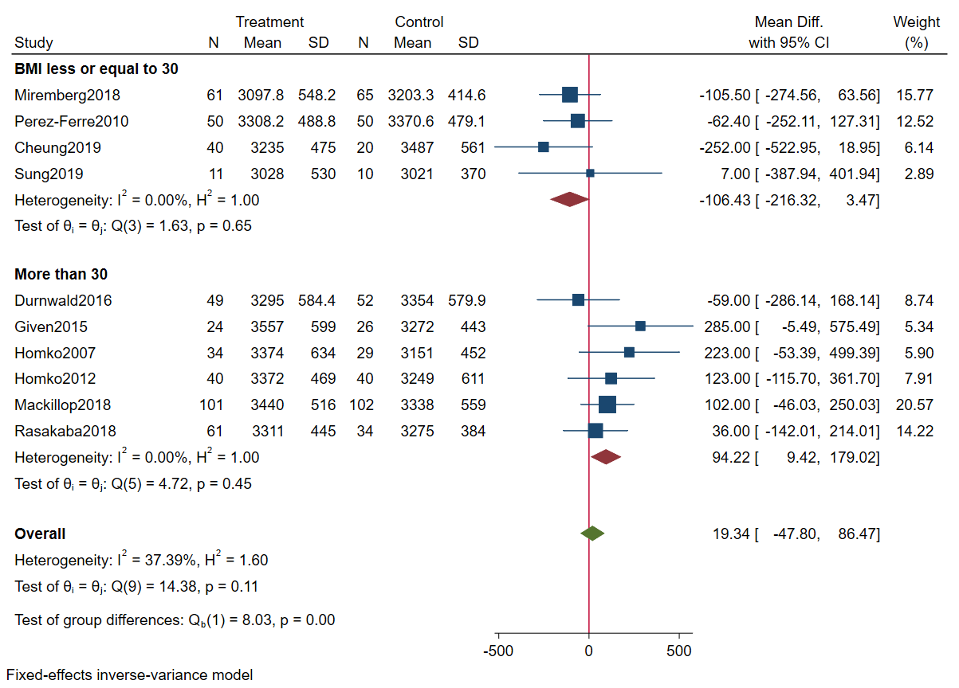
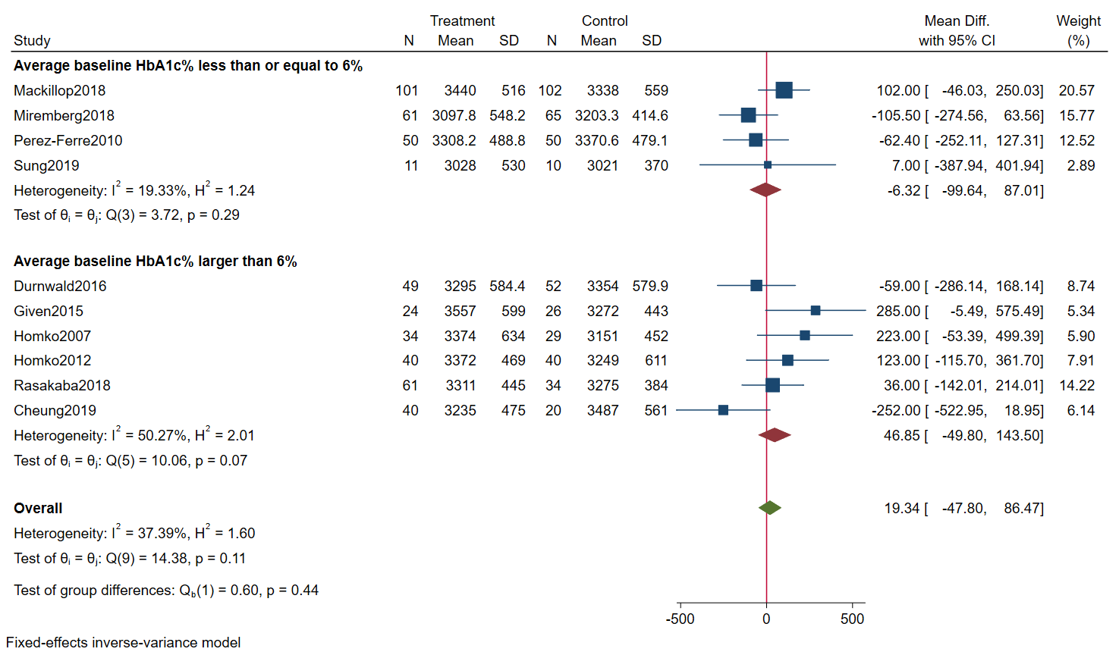
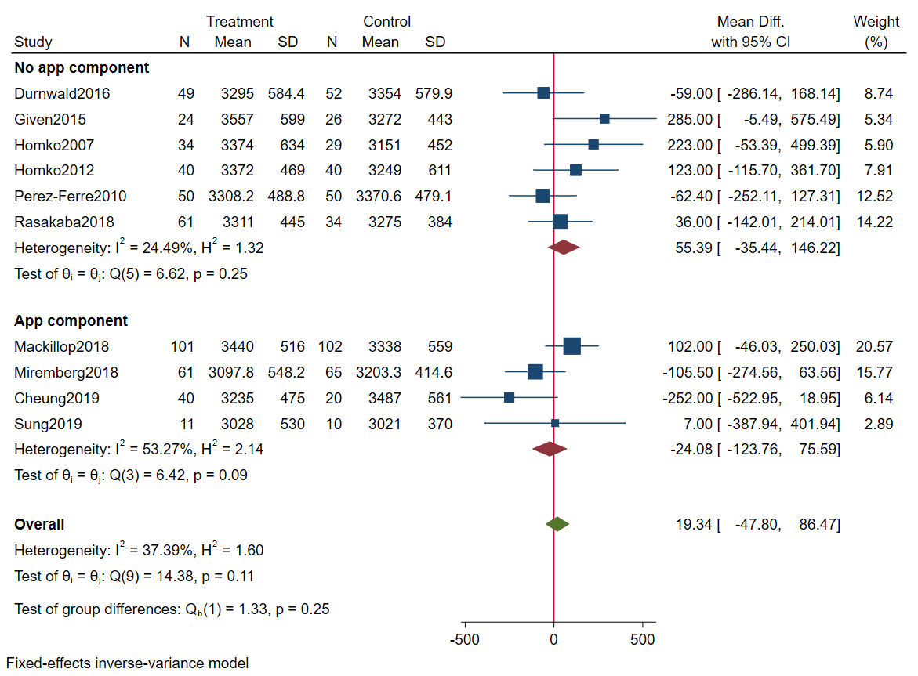
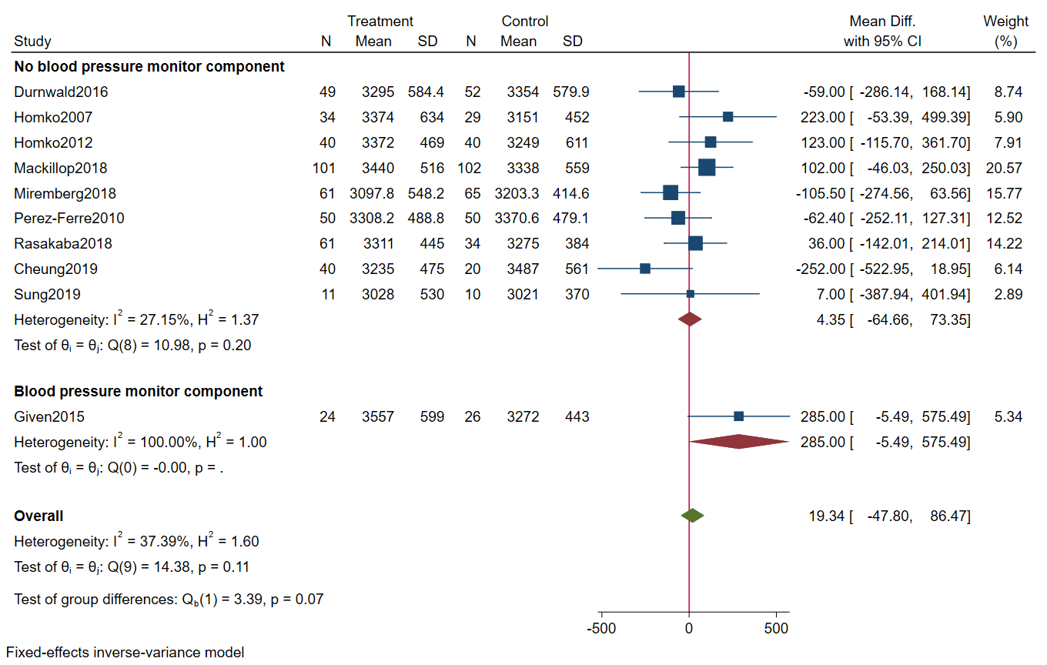
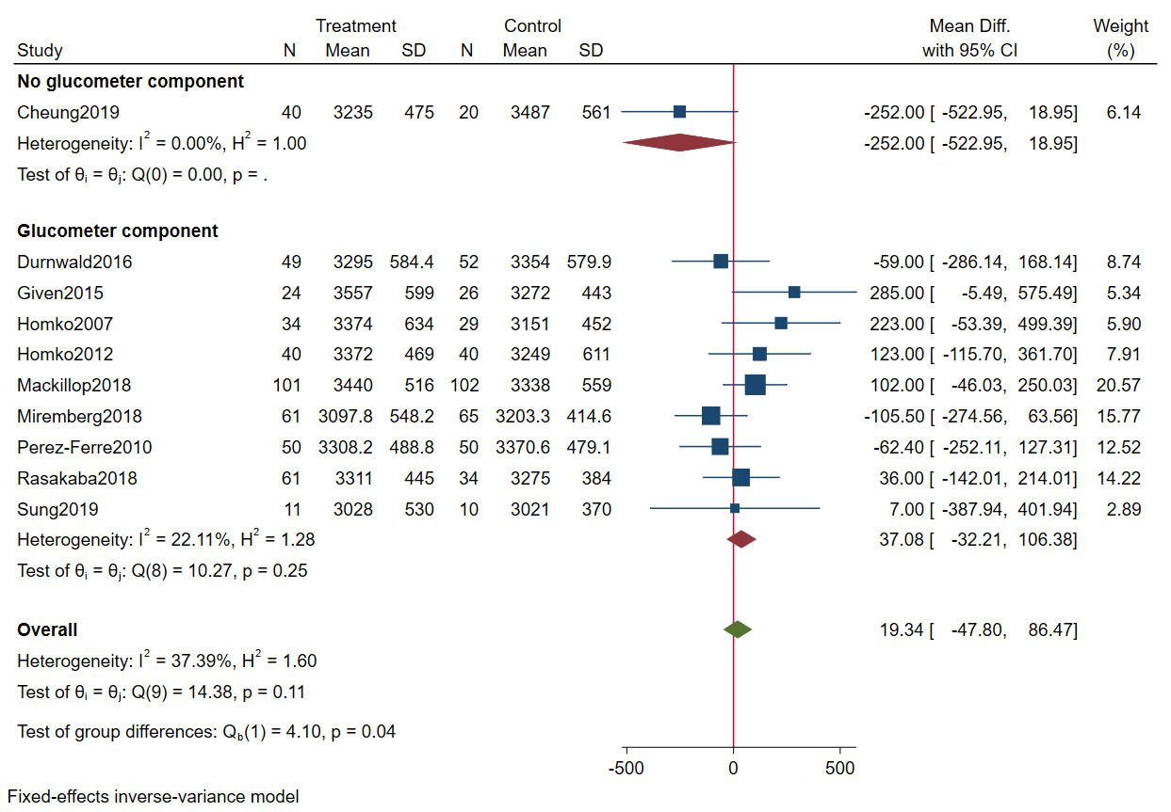
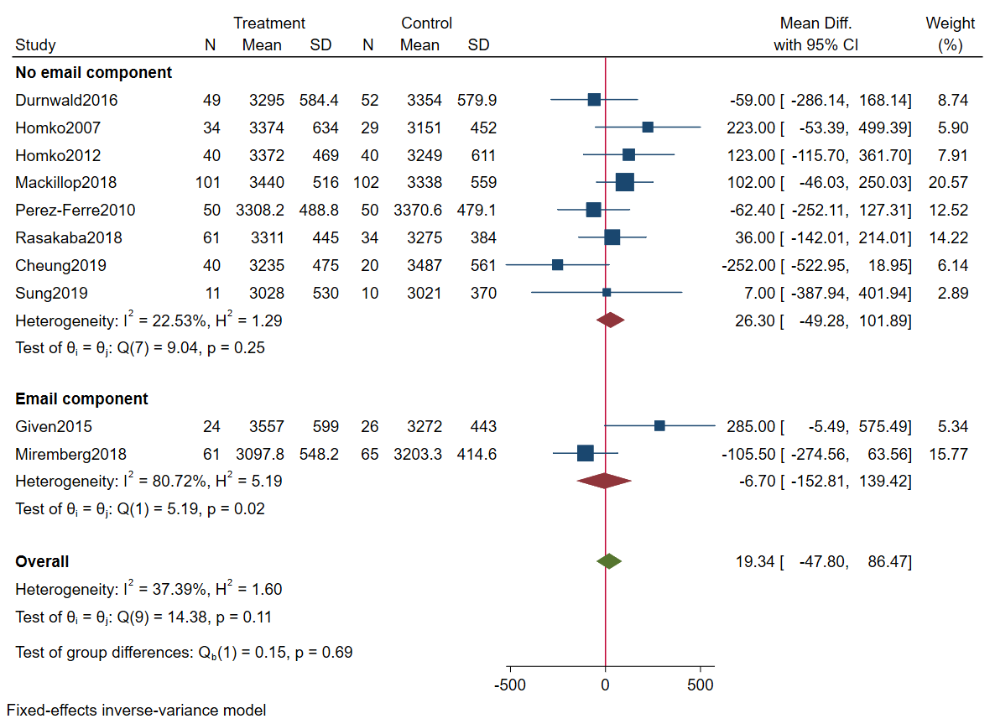
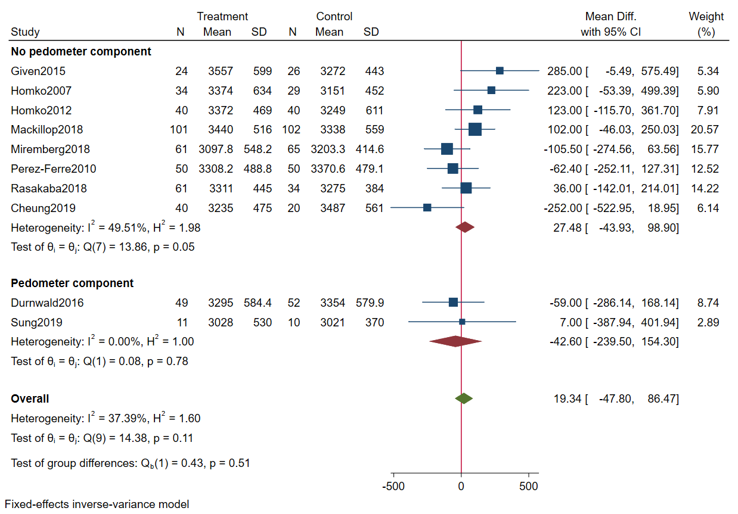
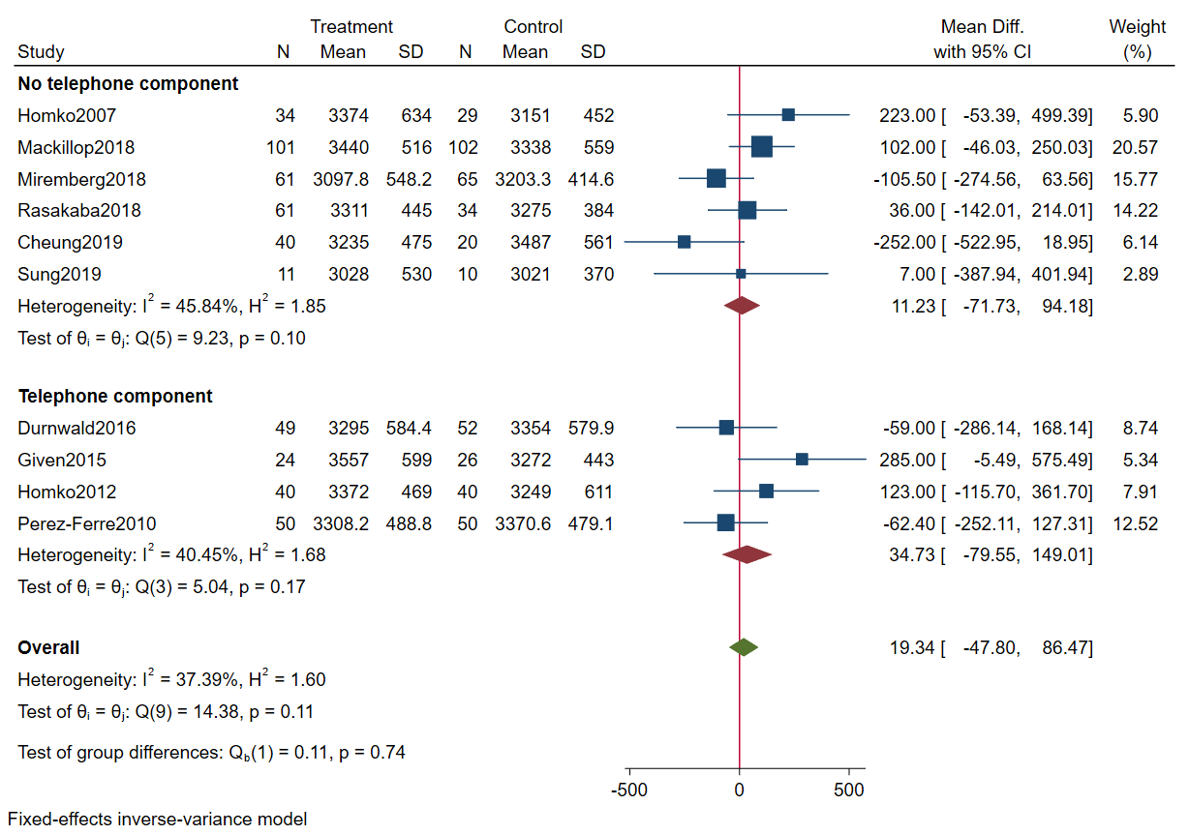
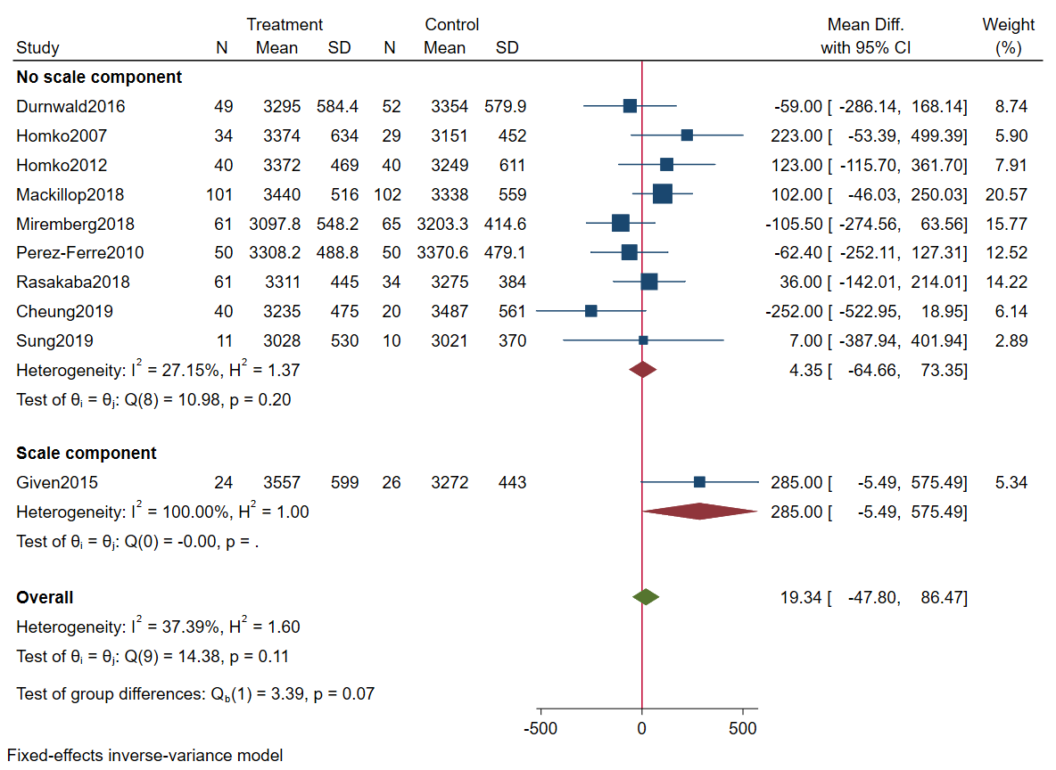
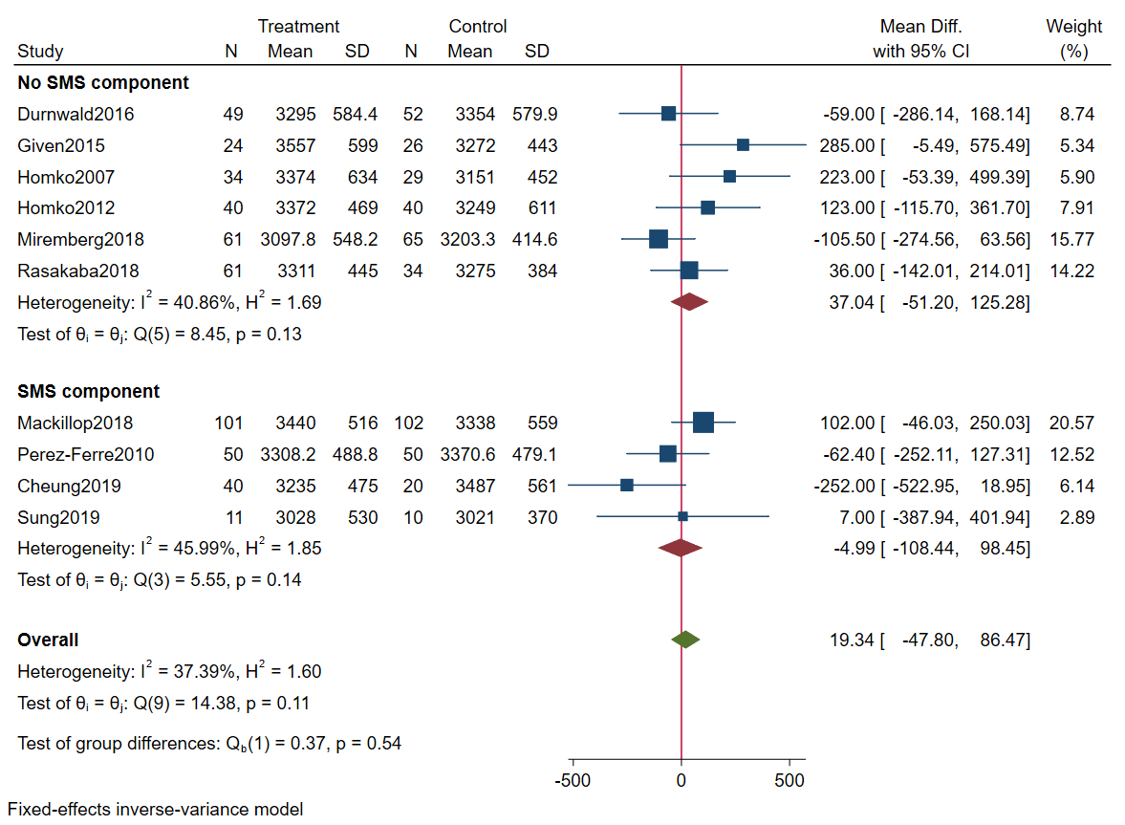
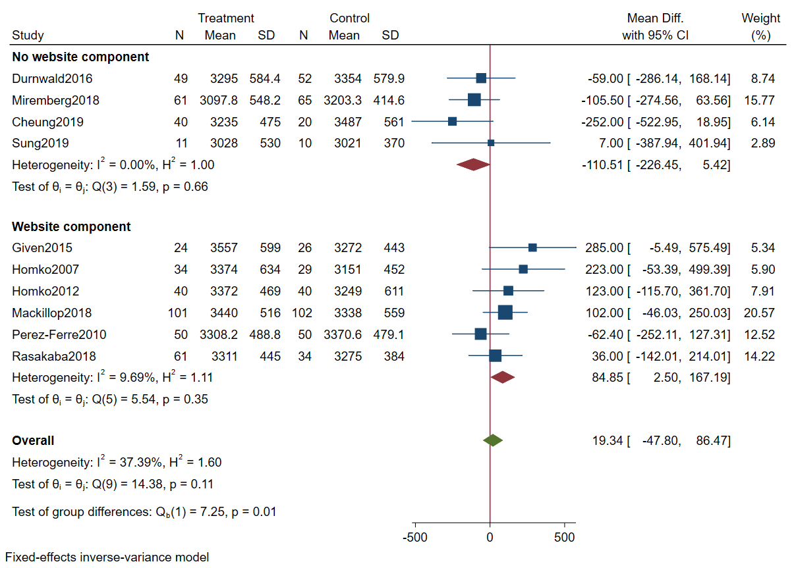
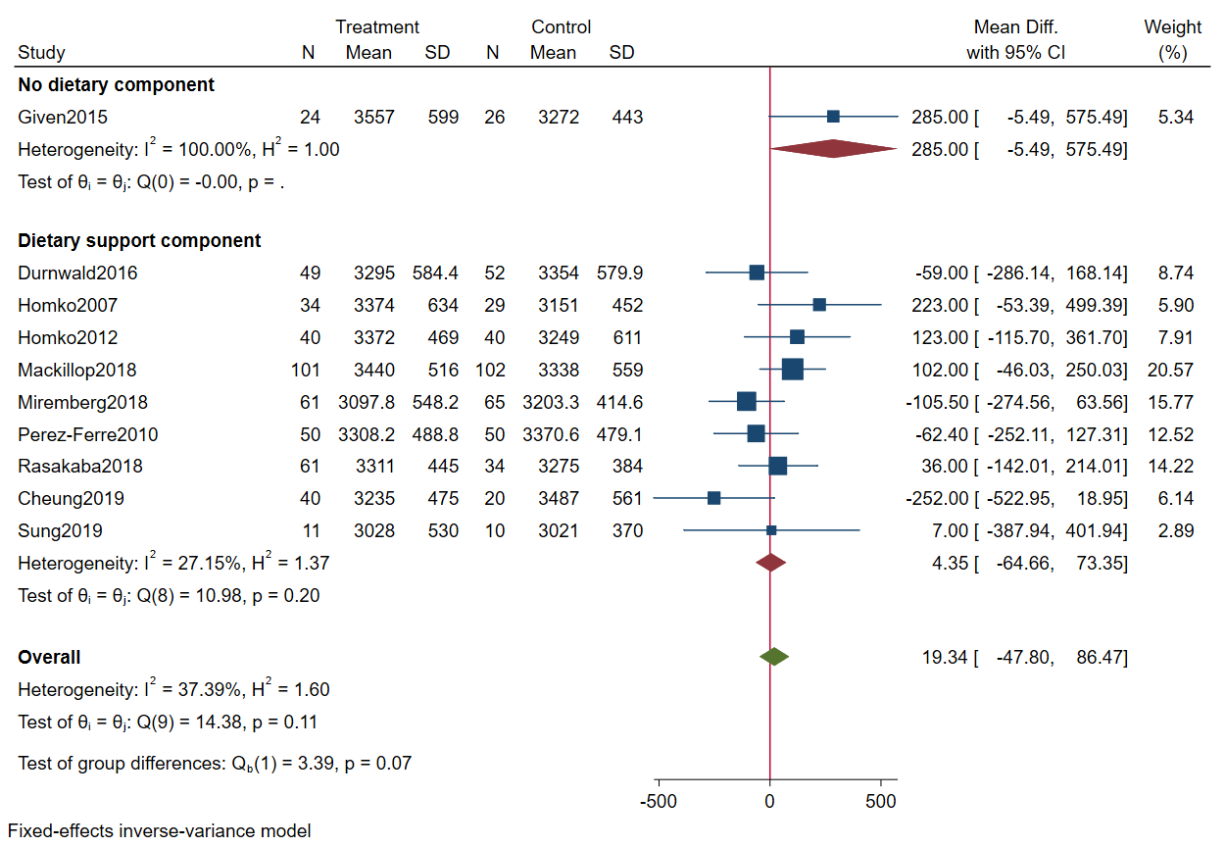
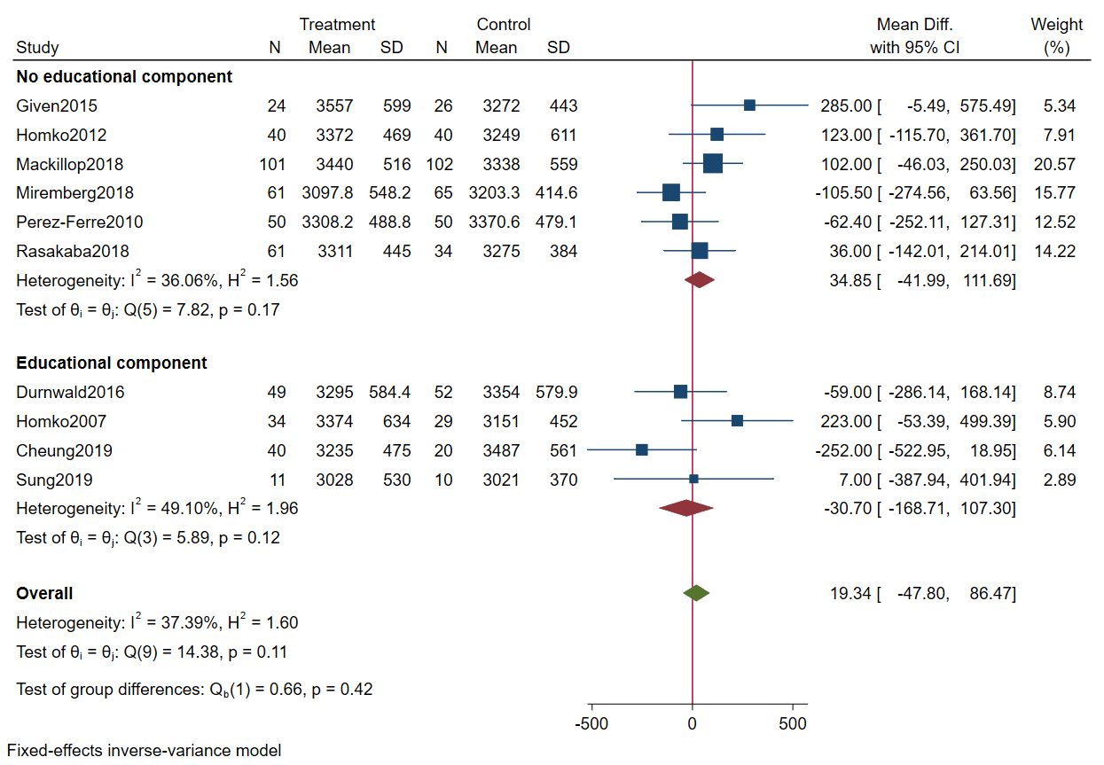
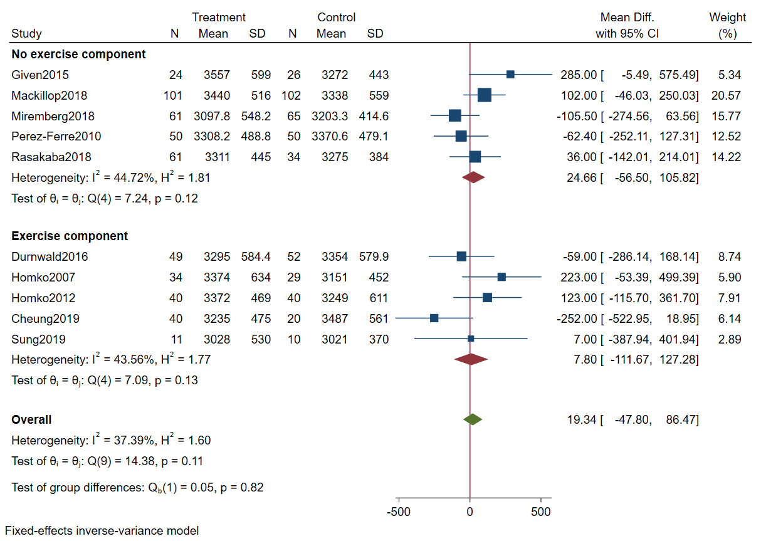
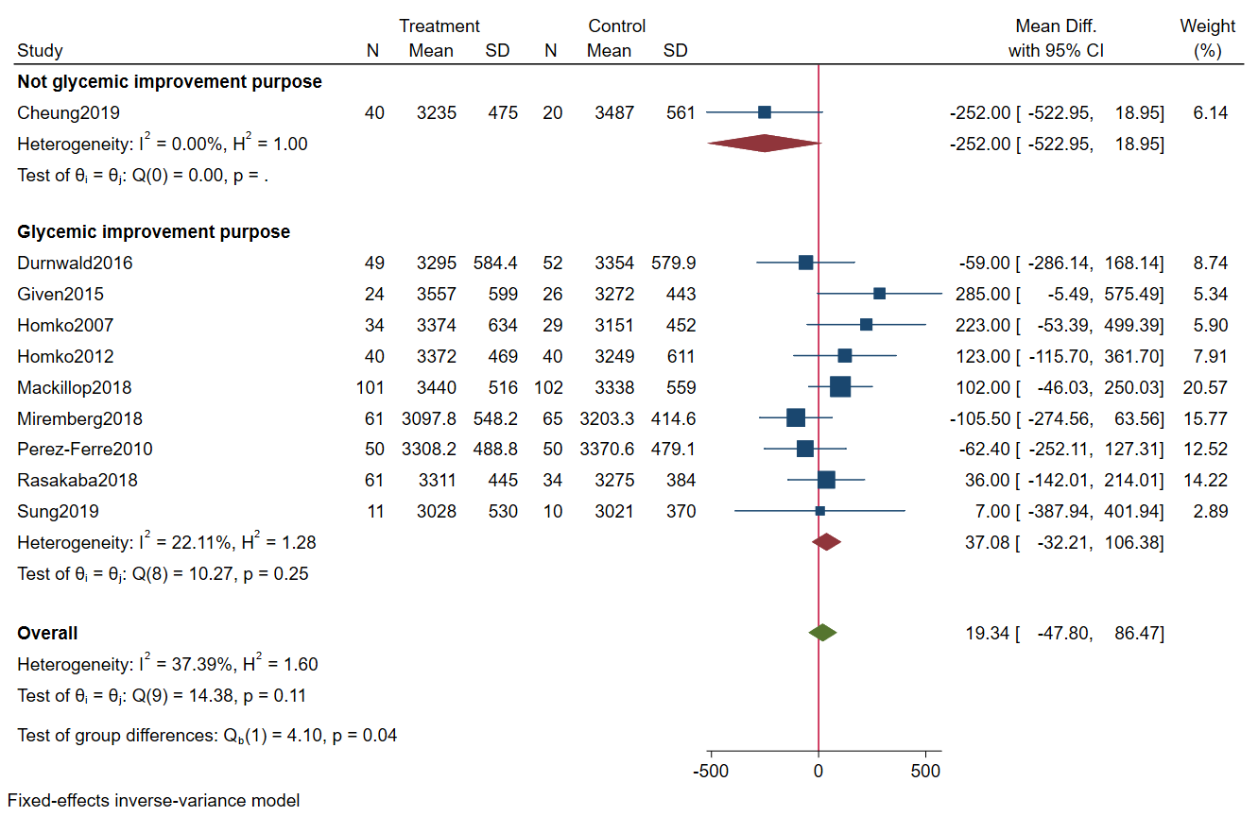
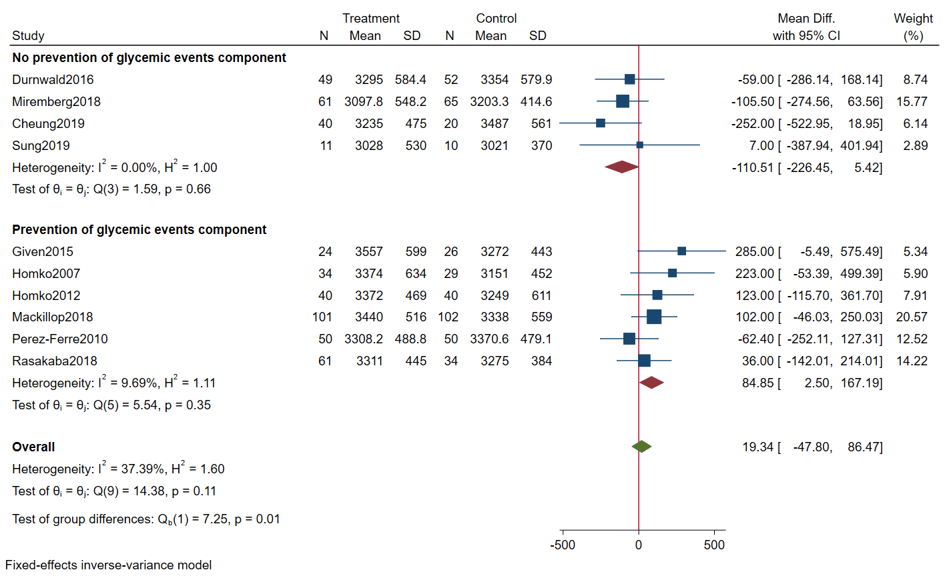
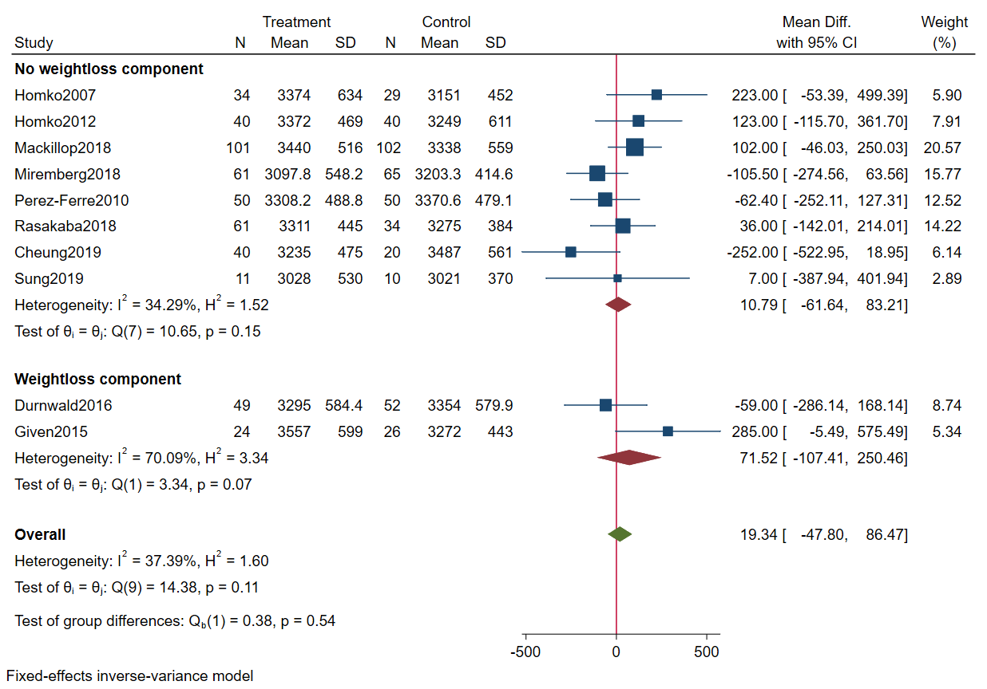

Appendix 4: Sensitivity analysis (Results excluding Given et al. and Cheung et. al.)
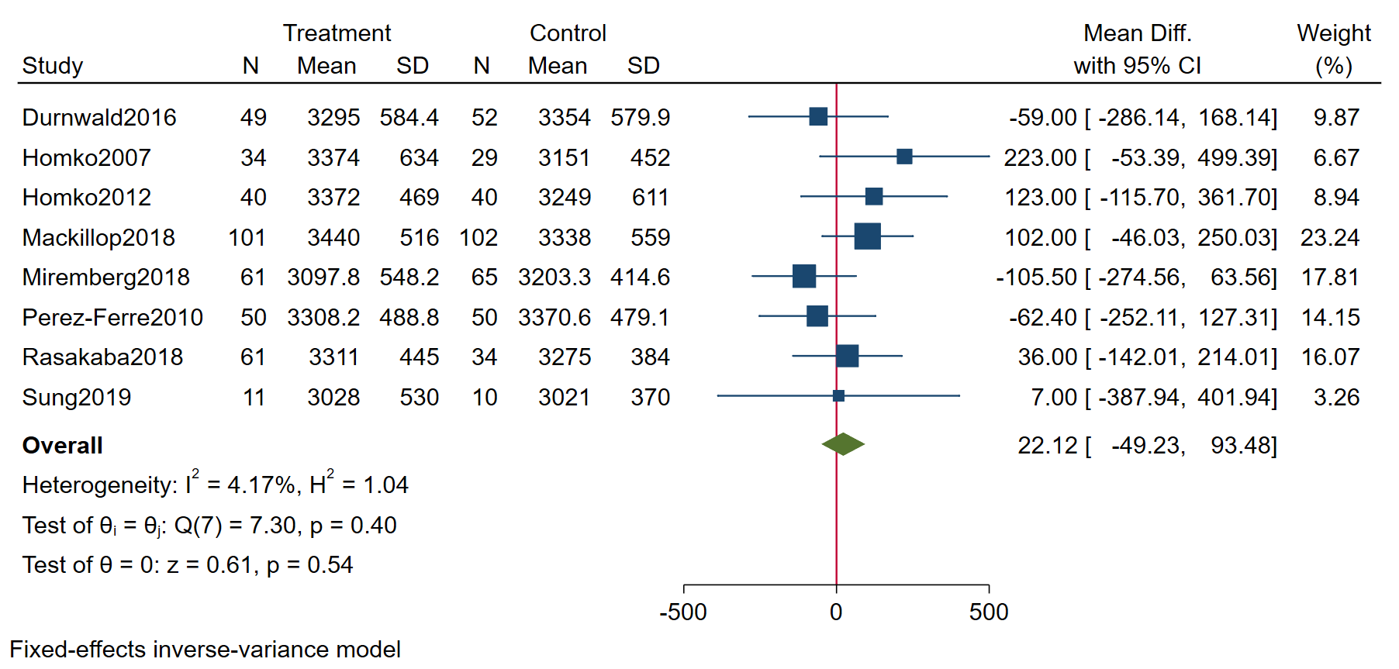

Appendix 5: Meta-analyses of secondary outcomes (maternal)
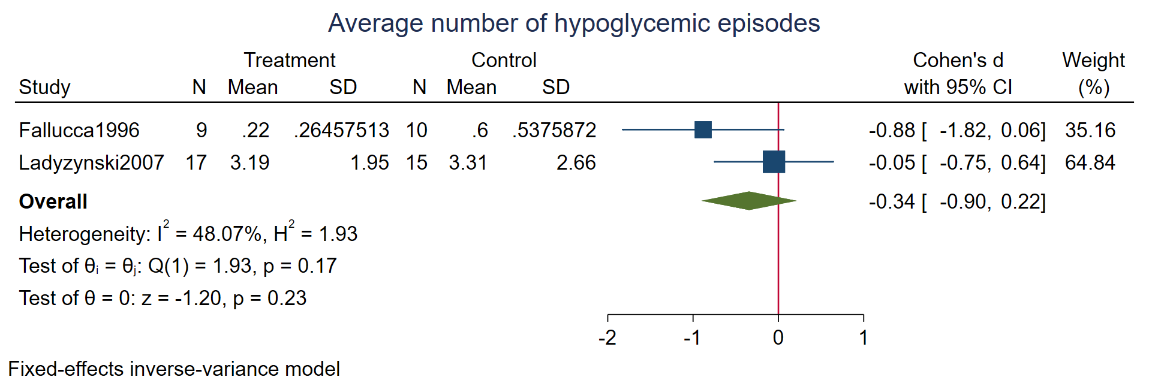

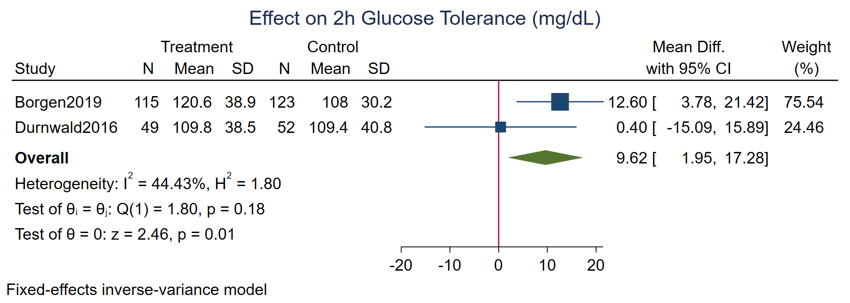

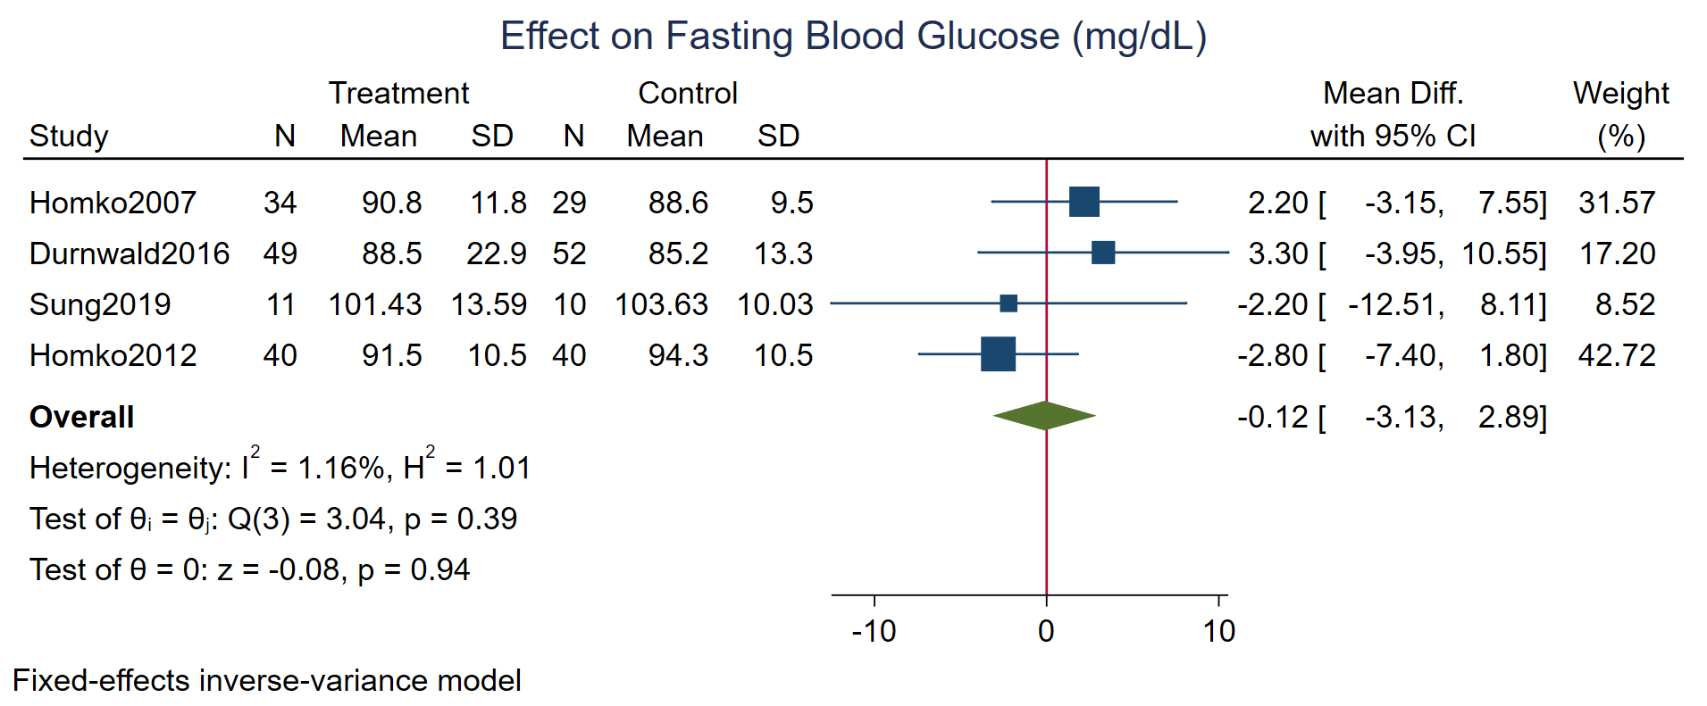

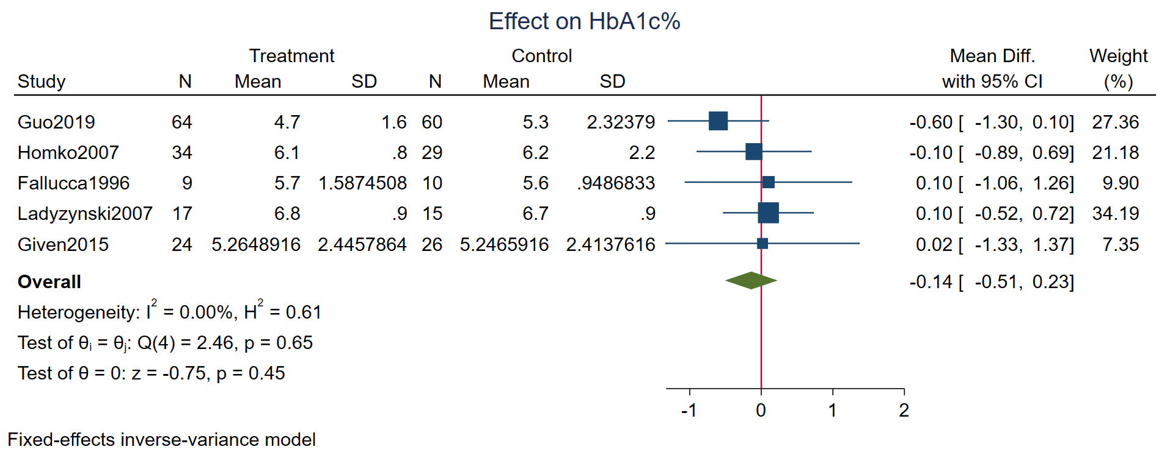
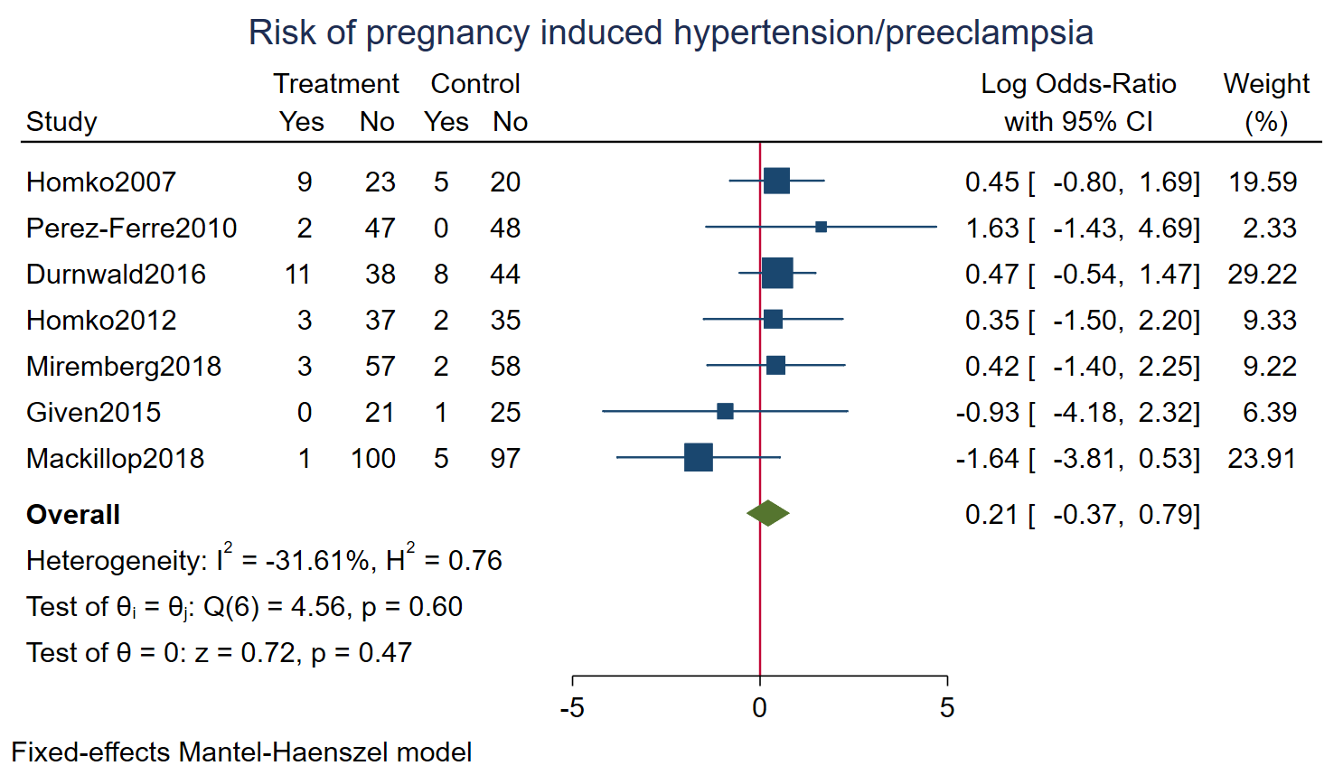

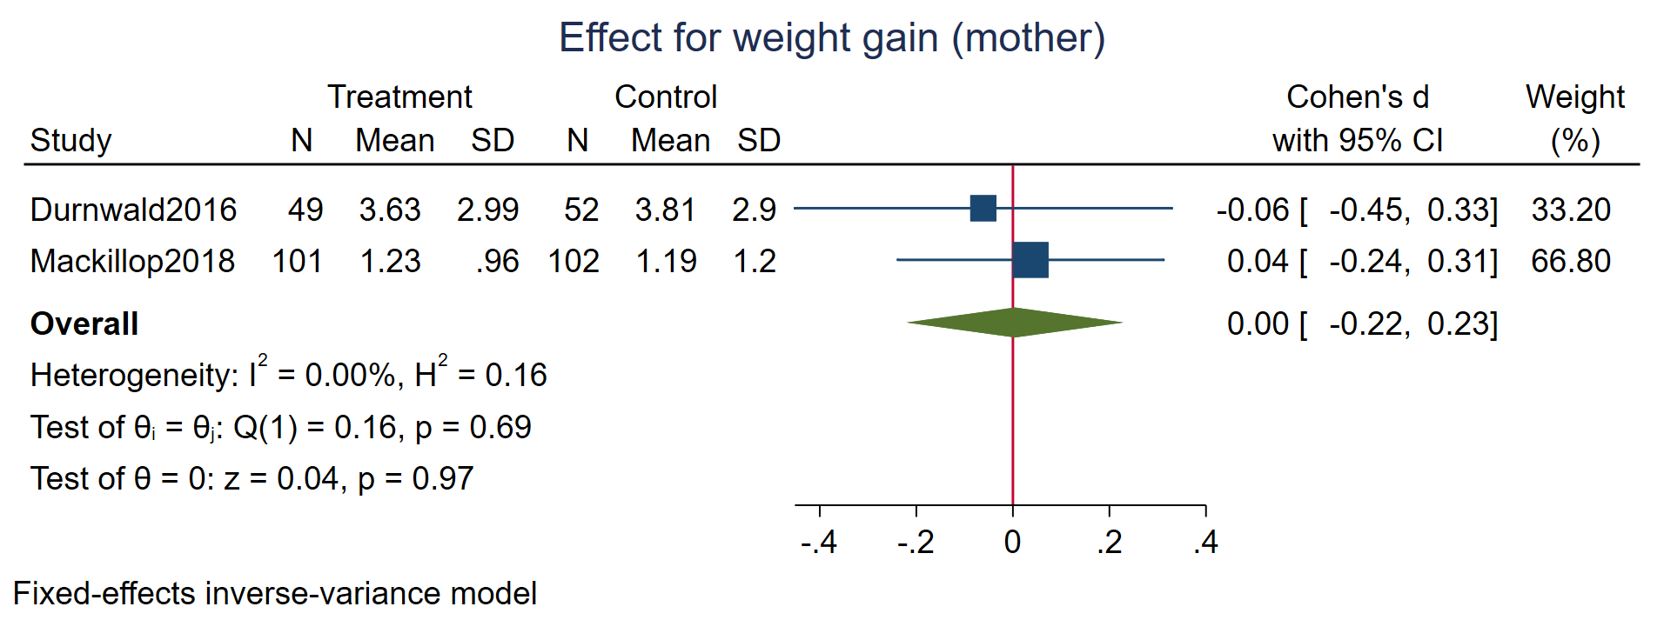

Appendix 6: Meta-analyses of secondary outcomes (delivery)
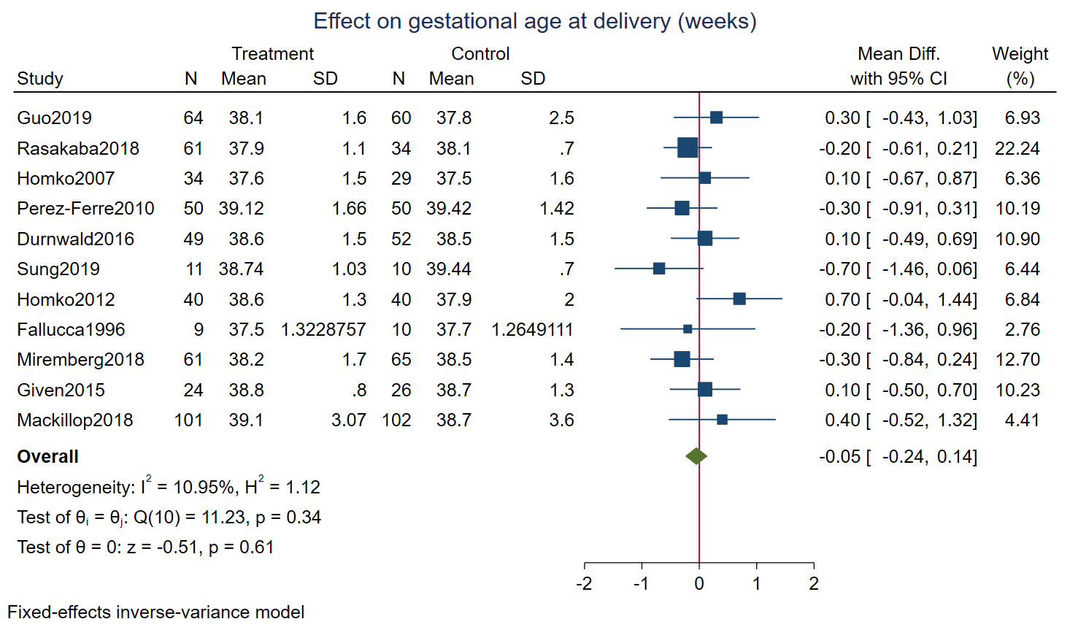
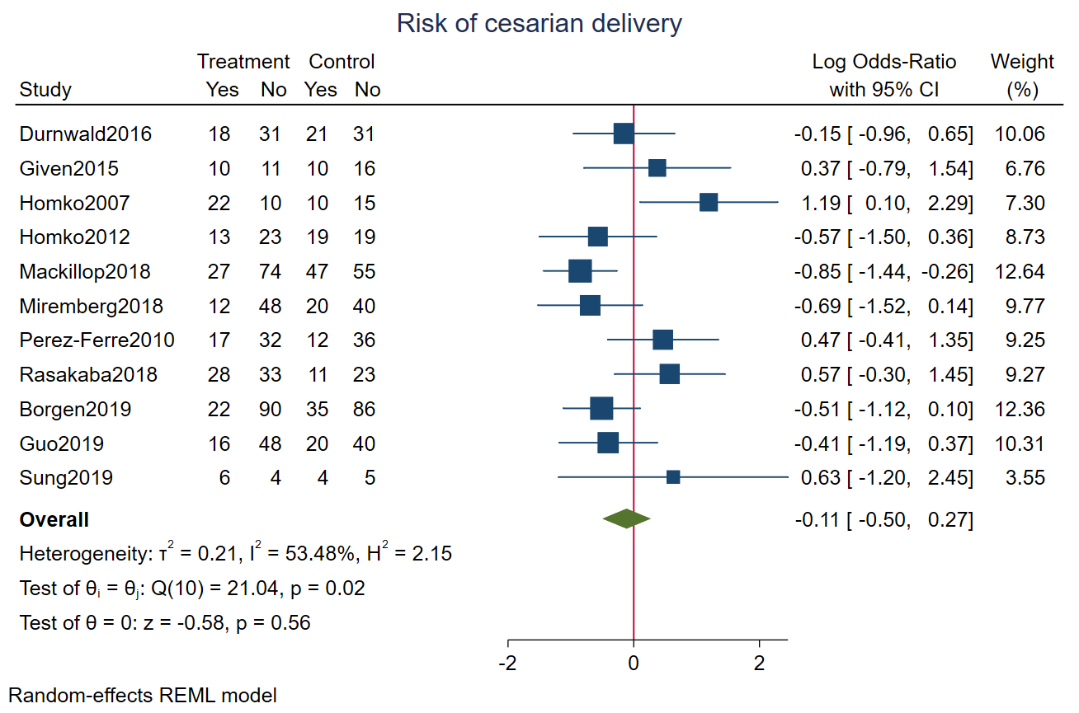
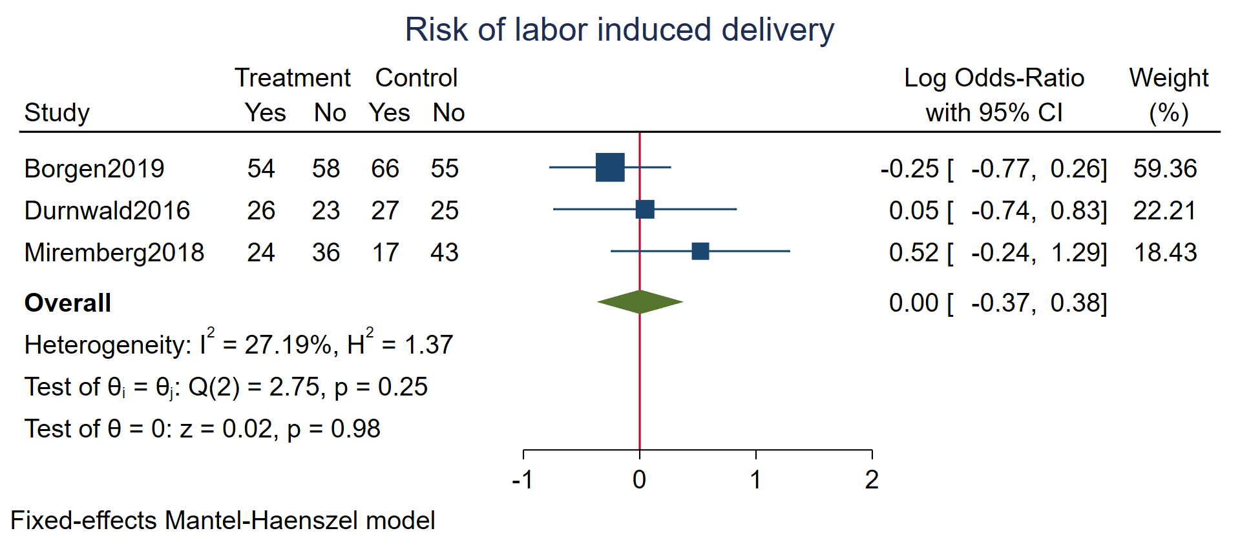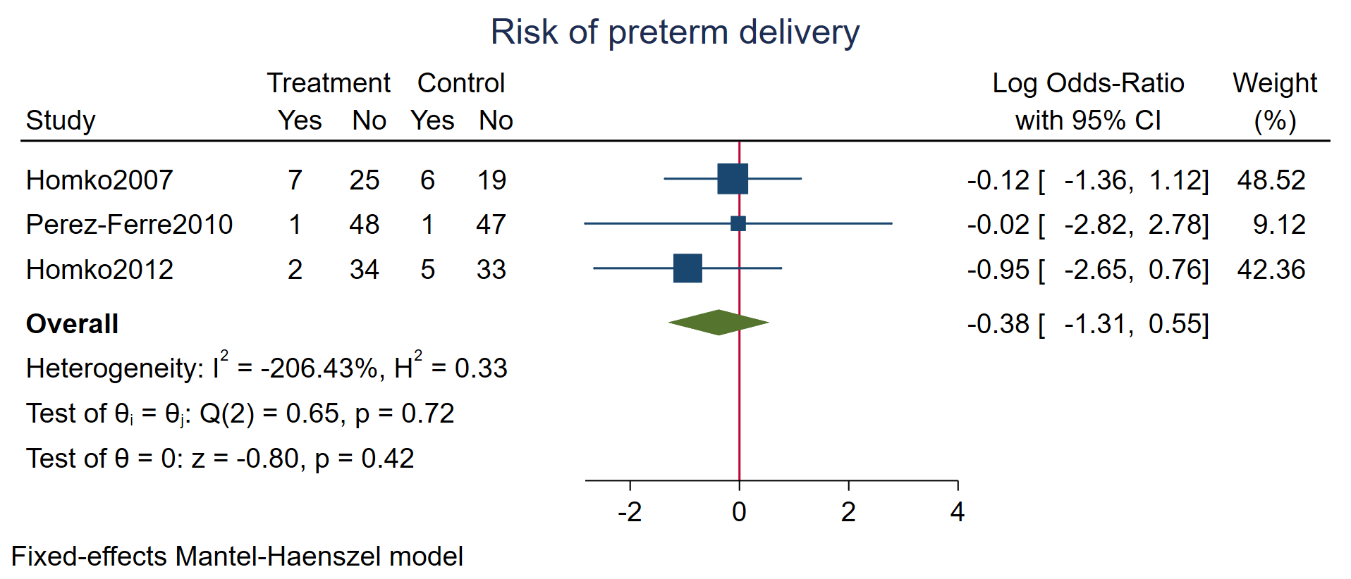

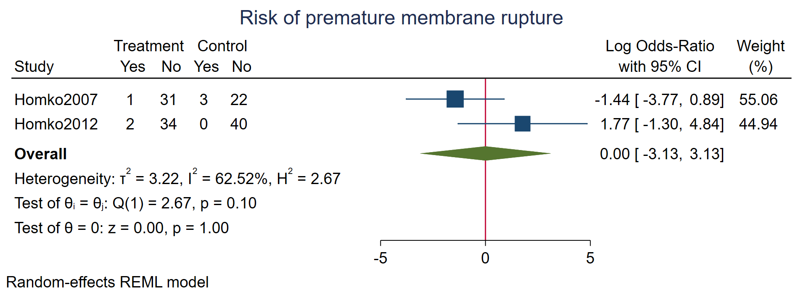

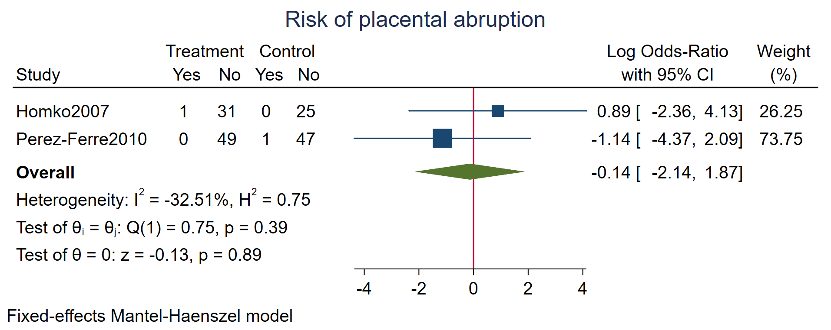

Appendix 7: Meta-analyses of secondary outcomes (neonatal)
