Supplementary Table 1. Critical appraisal of methodological quality for quantitative studies
Study | #1 | #2 | #3 | #4 | #5 | #6 | #7 | #8 | #9 | #10 | #11 | #12 | #13 | #14 | #15 | Total
Smania et al 2011¹⁵ | 1 | 1 | 1 | 1 | 0 | 1 | 1 | 0 | 1 | 1 | 1 | 0 | 1 | 1 | 1 | 12
Druzbicki et al 2013¹⁶ | 1 | 1 | 1 | 1 | 0 | 1 | 1 | 0 | 1 | 1 | 1 | 1 | 1 | 1 | 1 | 13
Wu et al 2017¹⁷ | 1 | 1 | 1 | 1 | 0 | 1 | 1 | 1 | 1 | 1 | 1 | 1 | 1 | 1 | 1 | 14
Peri et al 2017¹⁸ | 1 | 1 | 1 | 1 | 0 | 1 | 1 | 0 | 1 | 1 | 1 | 1 | 1 | 1 | 1 | 13
Wallard et al 2017¹⁹ | 1 | 1 | 1 | 1 | 0 | 1 | 1 | 0 | 1 | 1 | 1 | 1 | 1 | 1 | 1 | 13
Wallard et al 2018²⁰ | 1 | 1 | 1 | 1 | 0 | 1 | 1 | 0 | 1 | 1 | 1 | 1 | 1 | 1 | 1 | 13
Klobucka et al 2020²¹ | 1 | 1 | 1 | 1 | 0 | 1 | 1 | 1 | 1 | 1 | 1 | 1 | 1 | 1 | 1 | 14
Ammann-Reiffer et al 2020²² | 1 | 1 | 1 | 1 | 1 | 1 | 1 | 0 | 0 | 0 | 1 | 1 | 1 | 1 | 1 | 12
1 = Yes/Present
0 = No/Absent

Items
#1 Was the purpose clearly stated?
#2 Was relevant background literature reviewed?
#3 Was the design appropriate for the study question?
#4 Was the sample described in detail?
#5 Was sample size justified?
#6 Were the outcome measures reliable?
#7 Were the outcome measures valid?
#8 Was intervention described in detail?
#9 Was contamination avoided?
#10 Was cointervention avoided?
#11 Were results reported in terms of statistical significance?
#12 Were the analysis methods appropriate?
#13 Was clinical importance reported?
#14 Were dropouts reported?
#15 Were conclusions appropriate given study methods and results?

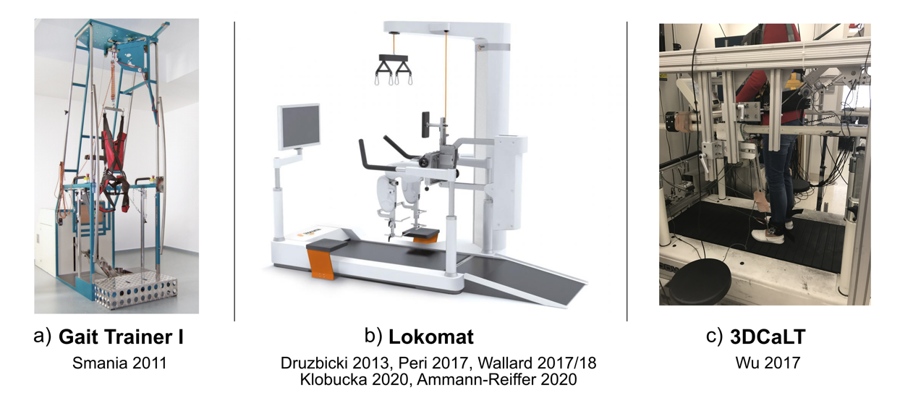
Supplementary Figure 2. Robotic gait training devices utilized in each study, including a) the Gait Trainer I, b) the Lokomat, and c) the 3DCaLT.

