Online Appendix
United or divided in diversity? The heterogeneous effects of ethnic diversity on European and national identities
Dominik Schraff and Ronja Sczepanski
European Union Politics, 2021

Content
Descriptive statistics p.2
Additional OLS regression results p.3
Map of exclusive national identity, binned means p.4
Migrant population in the Netherlands p.5
Table 1. Descriptive statistics.
Statistic | N | Mean | St. Dev. | Min | Pctl(25) | Pctl(75) | Max
Age | 1,832 | 55.158 | 17.898 | 16 | 41 | 70 | 94
Tertiary Education | 1,832 | 0.403 | 0.491 | 0 | 0 | 1 | 1
Income | 1,680 | 3,346.382 | 6,581.279 | 0.000 | 1,864.500 | 4,000.000 | 164,714.000
Migrant Background | 1,774 | 0.172 | 0.378 | 0.000 | 0.000 | 0.000 | 1.000
Satisfaction Economy | 1,808 | 6.320 | 1.780 | 0.000 | 5.000 | 8.000 | 10.000
Exclusive National Identity | 1,832 | 2.897 | 2.578 | -6 | 1 | 4 | 10
National Identity | 1,832 | 7.618 | 2.003 | 0 | 7 | 9 | 10
EU Identity | 1,832 | 4.721 | 2.518 | 0 | 3 | 7 | 10
Border Distance, thousands | 1,821 | 21.219 | 15.973 | 0.000 | 7.802 | 31.020 | 65.366
∆ Non-Western (%) | 1,811 | 1.973 | 2.289 | -11.661 | 0.936 | 2.927 | 16.000
∆ Western (%) | 1,811 | 1.088 | 1.822 | -8.000 | 0.000 | 1.776 | 15.204
Western (%) | 1,821 | 10.352 | 5.488 | 0.000 | 6.876 | 12.398 | 53.014
Non-Western (%) | 1,821 | 12.091 | 11.901 | 0.000 | 4.247 | 15.185 | 84.093
Population, thousands | 1,821 | 8.588 | 4.827 | 0.040 | 5.330 | 11.455 | 41.770
Neighboring Western (%) | 1,821 | 9.860 | 4.692 | 1.461 | 6.622 | 12.001 | 35.514
Neighboring Non-Western (%) | 1,821 | 10.825 | 9.374 | 0.200 | 4.211 | 13.825 | 60.000

Table 2. Additional OLS regression results.
 | (1) | (2) | (3) | (4)
Log Non-Western | 1.310*** | 1.167*** | 1.308*** | 1.285***
 | (0.435) | (0.441) | (0.442) | (0.442)
Log Western | 0.046 | 0.213 | 0.218 | 0.092
 | (0.362) | (0.387) | (0.419) | (0.360)
Area Wealth | 0.167** | 0.118 | 0.138* | 0.125*
 | (0.074) | (0.088) | (0.078) | (0.075)
Border Distance | 0.004 | 0.010* | 0.004 | 0.005
 | (0.004) | (0.006) | (0.004) | (0.004)
∆ Non-Western | -0.059* | -0.066** | -0.049 | -0.046
 | (0.031) | (0.031) | (0.031) | (0.031)
∆ Western | 0.061 | 0.055 | 0.056 | 0.057
 | (0.043) | (0.045) | (0.043) | (0.043)
Satisfaction with Economy | -0.084** | -0.084**
 | (0.037) | (0.037)
Log Neighboring Western |  |  | -0.209
 |  |  | (0.353)
Log Neighboring Non-Western |  |  | 0.026
 |  |  | (0.177)
Area Population |  |  |  | 0.013
 |  |  |  | (0.016)
Log Non-Western*Log Western | -0.434** | -0.420** | -0.447** | -0.455**
 | (0.178) | (0.180) | (0.183) | (0.177)
Constant | 3.105*** | 2.898*** | 2.692*** | 2.526***
 | (0.831) | (0.909) | (0.844) | (0.788)
Individual-Level Covariates | Yes | Yes | Yes | Yes
Province Fixed Effects | No | Yes | No | No
Observations | 1,584 | 1,584 | 1,605 | 1,605
R² | 0.067 | 0.089 | 0.065 | 0.065
Adjusted R² | 0.059 | 0.074 | 0.056 | 0.057
Note: *p<0.1; **p<0.05; ***p<0.01; ∆ = temporal change 2010-2019

Figure 1. Map of exclusive national identity, binned means.
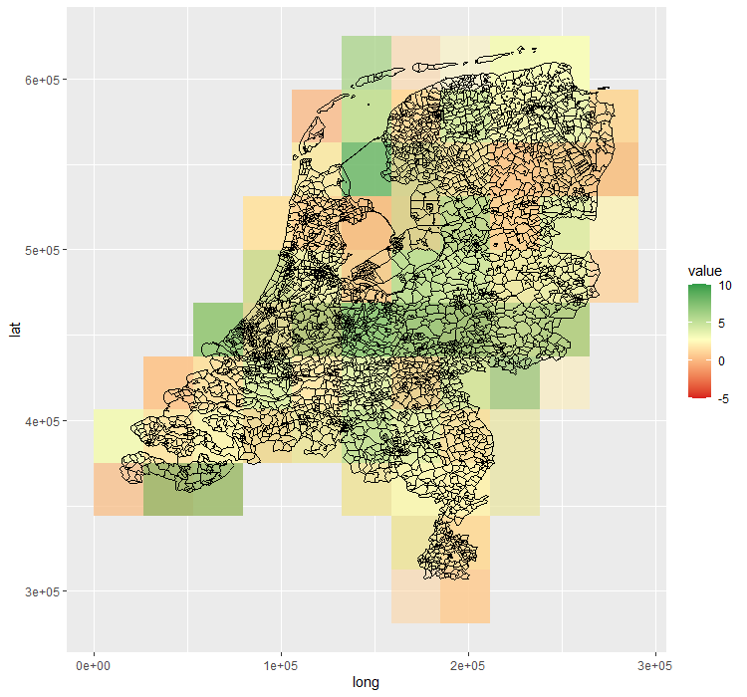

Table 3. Migrant population in the Netherlands 2020.
Total | 17,407,585
Dutch background | 13,186,880
With migration background | 4,220,705
Africa | 714,732
America | 719,601
Asia | 969,98
Europe (excluding Dutch background) | 1,791,850
Oceania | 24,542
European Union (excl. Dutch background) | 1,176,651
Caribbean Netherlands | 79
Indonesia | 356,029
Morocco | 408,864
Surinam | 356,402
Turkey | 416,864
Source: Statistics Netherlands.

