Cartagena, Colombia 2011-2014 Study Location, Methods, Sample, and Reflexive Statement

Afro-descendants in Colombia

The processes of social exclusion within Latin America originate from a history of colonial exploitation of native resources, the enslavement of Africans, and forced labor of indigenous peoples. Scholars suggest that the legacy of slavery and enduring racist ideologies and practices exacerbate the contemporary social, political, and economic marginalization of this population (Arocha 1998; Dixon 2008). Colombia has the second largest population of people of African descent in Latin America (Antón et al. 2009). Afro-descendant communities represented approximately 10.62 per cent (4,311,757 people) of the Colombian population (National Administrative Department of Statistics (DANE) of the Republic of Colombia, 2005). However, the Ombudsman’s Office considers this figure is closer to 25%, (10.5 million people) (United Nations Independent Expert on Minority Affairs 2010).
Afro-Colombian settlements are mired by poverty rates that hover around sixty per cent (United Nations Independent Expert on Minority Affairs 2010). Illiteracy and infant mortality rates are three times higher among Afro-Colombians than among the rest of the population. And nearly 80 percent of Afro-Colombians do not have their basic needs met. Thousands of Afro-Colombians continue to be displaced from their lands due to armed conflict between the Colombian government, paramilitaries and guerilla forces, and industrial economic operations driven by multinational companies promoted by the Colombian Government (ibid). While Afro-Colombians are approximately twenty-six per cent of the Colombian population, they have gained two per cent of the national territory, primarily in the Pacific region (Ng'weno 2007). The major inequities in educational attainment and access to high-status occupations between racialized groups are particularly acute in Cartagena (Viáfara and Urrea 2006).
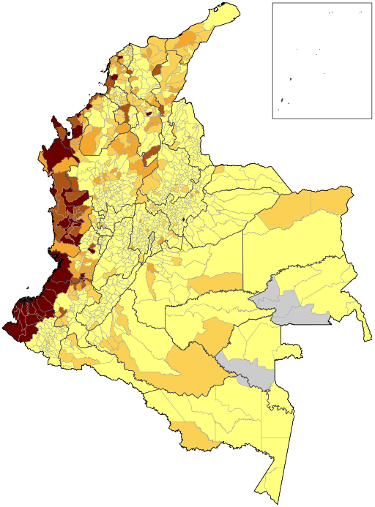
There is “a distinctive spatial pattern to the overall structure of Colombian nationhood and its racial order,” (Wade 1993:58). A de-facto regional segregation exists in Colombia, with Afro-Colombians residing in high concentrations in certain regions of the country (Barbary and Urrea 2004; Paschel 2010; Restrepo 1998) (Fig. 1).
Atlantic

Pacific

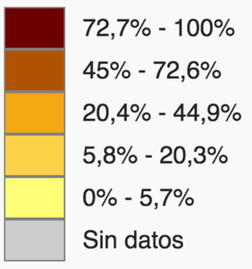

Fig. 1: Percentage of Afro-descendants by municipality (OCHA Colombia - Censo DANE 2005)

Afro-Colombian political organization began during the 1970s and grew significantly during the 1980s. Despite their ethnic, political, geographic, and economic differences, Afro-Colombians were able to concertedly mass mobilize with a common agenda, some suggest for the first and perhaps the only time, in the early 1990s (Pardo 2002:71). Through street demonstrations and other public acts of protest they rallied for a “pluriethnic and multicultural nation” (Grueso, Rosero and Escobar 1998:197) in the 1991 Constitutional reform process and succeeded through the inclusion of Transitory Article 55, which was later formalized into Law 70 in 1993 that recognized the territorial and cultural rights of Afro-Colombians (Wade 1993).

Cartagena de Indias, Colombia

In 2011, Cartagena had about 960,000 inhabitants, which makes it the fifth largest city in Colombia after Bogotá, Medellín, Cali, and Barranquilla, and the second most populous coastal Caribbean city. Cartagena’s economy in recent years has had a major boost. However, in 2014, 29.2% of Cartagena residents lived below the poverty line (down from 33% in 2007), and 5.8% lived in extreme poverty, making Cartagena the metropolitan area with the third highest incidence of poverty among Colombia’s largest cities (Pérez V. & Salazar Mejía 2007).
Beyond the absolute poverty, the relative poverty is also a major challenge in Cartagena. The spatial dimension of the distribution of extreme inequality has changed very little since the early twentieth century, with people with low incomes concentrating in the same sectors of the city (Pérez V. & Salazar Mejía 2007) (see Fig. 2).

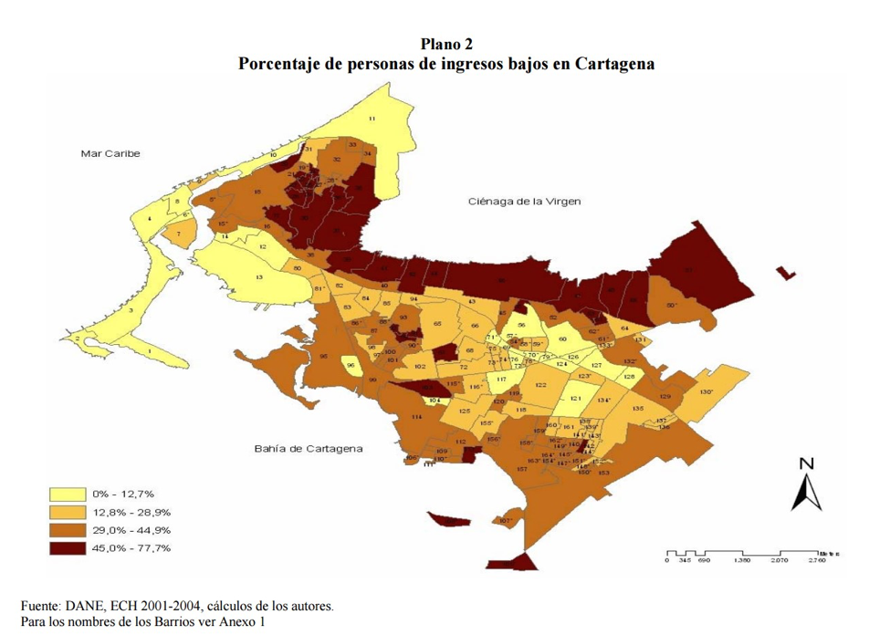
Fig. 2: Percentage of low-income people in Cartagena by neighborhood (Getsemaní #7)
Cartagena served as one of the primary enslaving ports for the influx of enslaved Africans in seventeenth century colonial Spanish America (Meisel Roca 1980). Bolívar, the state where Cartagena is located on the Atlantic coast, has the second largest Black population by percent in Colombia (27.6 per cent in 2010) (as quoted in Telles 2014). Racial and class hierarchies tremendously overlap in the region. According to the study, “Labor Discrimination or Human Capital? Determinants of Labor Income of Afro-Cartageneros” (Romero 2007) race is a significant variable explaining 15% of income differences in Cartagena. However, this figure drops to 5% when education is considered, suggesting that Afro-Cartageneros are significantly affected financially by limited educational opportunities. One model shows that, on average, Afro-Cartageneros receive less per hour worked. Cartageneros who identify themselves as black, mulatto, or Afro-Palenquero receive on average 32% less hourly earnings than those in Cartagenera who do not ethnically or racially identify with these groups. The author suggests that a maximum of 7-8% of this difference is attributable directly to discrimination resulting from the differences in the assessment of individual characteristics in each of the groups.

Locus of the Study

This study stems from twelve months of ethnographic fieldwork over the course of three years (2011-2014) in Getsemaní, a largely-Afro-descendant community in Cartagena de Indias on Colombia’s Atlantic/Caribbean Coast. Getsemaní sits within the old city walls, yet just outside those of the historic downtown city center, which national and local governments and the private sector redeveloped during the 1960s and 70s (Rojas 1999). In 2007, Getsemaní had a population of around 6,000 residents within 631 households (Pérez and Salazar 2007). Originally a neighborhood of lower-class free persons of color, artisans, seamen and enslaved Blacks (Helg 1999), it has long been considered the “popular” barrio of the lower classes and an “arrabal,” a somewhat derogatory word that expresses its suburban, peripheral status to the historic center (Guerra 2010; Meza and Gutiérrez 2005).
Getsemaní was the site of political resistance during the revolution against Spain in 1811 and continued to be home to many of the city’s poor (Rojas 1999). Despite the city’s growing reputation for tourism, Getsemaní began to deteriorate significantly, both physically and economically during the 1970s. This followed Cartagena’s economic crisis and the city government’s decision to transfer the main market from Getsemaní to another neighborhood (Díaz de Paniagua and Paniagua 1993). Getsemaní’s reputation for drugs, sex work, and danger grew significantly. During the 1980s, the public and private partnerships that urban scholars consider typical of contemporary urban development intensified (Squires 1989; Harvey [1973] 2009). UNESCO deemed The Port, Fortresses and Group of Monuments in Cartagena, which includes the Getsemaní neighborhood, a World Heritage Site in 1984.
In the last two decades, due to Getsemaní’s location and classic Spanish architecture it has become valued real estate and is becoming a product of what Smith calls “the outward diffusion of gentrification from the urban center” (2011:442). Once relatively unknown to those outside the region, tourism to the community has skyrocketed, to the extent that Forbes magazine named Getsemaní one of “The 12 Coolest Neighborhoods Around the World” in 2018. Buyers are offering those who own properties (about 30 per cent of residents in 2014) more than ten times what they would have been offered ten years prior. There is a perceived reduction in crime, which was considered rampant until recently, and an increase in access to transportation, retail, and some economic resources, but also an increase in taxes, noise, traffic, the cultural segregation of new and longstanding residents, and the displacement of the latter.

Methods

I conducted 62 semi-structured and open-ended interviews (23 women, 39 men) with primarily non-elite Getsemaní residents, as well as business owners from outside of the community, scholars, artists and government and NGO employees. I was primarily interested in the perspectives of everyday Cartagena residents; those who both have a vested interest in the neighborhood changes unfolding, but who also have no obvious financial or political investment in the continuation of the festivals used to explore notions about race, racism, and racialization. As a resident of Getsemaní, I was able to initiate interviews through the cultivation of relationships with those in the neighborhood and through subsequent referrals. Interviews were confidential and voluntary, and informed consent was requested of all participants prior to beginning. Interviews lasted an average of 30 minutes and were conducted in either Spanish (57) or English (5). All but one was audio-recorded for record keeping and accuracy of verbatim transcription. Two interview recordings were lost prior to transcription. While Spanish is a heritage language, it is not my native language. I can speak, read, and write Spanish with professional to full working proficiency. Translations were done by me or a research assistant who is a Spanish-native speaker.
Approximately 50% of interviews (14 women, 17 men) (almost all the community residents and a few of the local business owners, scholars, artists, and NGO staff) included a photo-elicitation strategy to explore the patterns emerging from the repeated use of still photographs. Table 1 lists the demographics of participants included in the photo-elicitation interviews.

Table 1: Demographics of Photo-elicitation Interview Participants

 | All Photo-Elicitation Participants | Highest level of education achieved: Some university or higher | Highest level of education achieved: High school | Highest level of education achieved: Primary/ middle school | Highest level of education achieved: Not recorded
All Photo-Elicitation Participants | 31 | 16 | 12 | 2 | 1
Rejected racial framing of images | 10 (32% | 100%) | 7 (22.5% | 70%) | 1 (3.2% | 10%) | 1 (3.2% | 10%) | 1 (3.2% |10%)
 | Female | Male | Median Age¹ | Cartagena Native
All Photo-Elicitation Participants | 14 | 17 | 45 | 24
Rejected racial framing of images | 3 (9.7% | 30%) | 7 (22.5% | 70%) | 35 | 4 (13% | 40%)
 | Racial Self-ID: Black (negra/o, afro, afrodescendiente) | Racial Self-ID: Black and Mixed (negro/a y mezlca) | Racial Self-ID: Mestizo | Racial Self-ID: White or European (blanca/o) | Racial Self-ID: Identified as White or European and are not from Colombia
All Photo-Elicitation Participants | 9 (29%) | 10 (32%) | 4 (13%) | 2 (6.4%) | 0
Rejected racial framing of images | 2 (6.4% | 20%) | 2 (6.4% | 20%) | 2 (6.4% | 20%) | 0 | 0
 | Racial Self-ID: Indigenous (indigena, india/o) | Racial Self-ID: Indigenous and Mixed (samba/o) | Racial Self-ID: Other | Racial Self-ID: Not recorded
All Photo-Elicitation Participants | 0 | 1 (3%)² | 2 (6.4%) | 3 (9.7%)
Rejected racial framing of images | 0 | 1 (3% | 10%) ² | 1 (3% | 10%) ³ | 2 (6.4% | 20%)
(% of total responses | % of those who rejected racial framing)
1- Two participants in their 50s and 60s did not self-report age.
2- One participant explicitly identified as "samba", i.e., of Indigenous and African heritage. They are included in
“Indigenous and Mixed” category.
3- Participant is from Italy, said they “had never been asked about race” and did not wish to identify as European.
The primary referents for the photo-elicitation interviews were researcher-generated photographs of the racialized festival and carnival characters, Las Negritas Puloy, Las Palenqueras/Las Negras Bollongas, and El Son de Negro. I took approximately 400 photographs of the Cartagena Independence festivals (Getsemaní youth parade, Getsemaní Cabildo, Government sponsored main parade, Las Calamares) and selected 4 that were both representative of these characters and possessed a polysemic quality that allowed for various interpretations [Figures 2-5]. I also incorporated a photograph of a Ciudad Mural festival graffiti mural in Getsemaní [Figure 6] and the packaging of Nestlé’s “Beso De Negra” [Kiss of a Black Woman] chocolate candy due to consistency with the overall iconography of Black womanhood in the region. I do not have permission from Nestlé to reproduce this image. Table 2 below is a compendium of the six figures analyzed during the interviews.

Character | Origins | Physical Attributes | Performative Attributes | Fig
El Son de Negro | Folkloric dance from the Canal del Dique region on Colombia’s Atlantic Coast. Introduced to the Barranquilla carnival in 1996 by teacher and researcher, Manuel Antonio Herrera Perez. Attire said to originate from the clothing typical of the fisherman and farmers from the Canal del Dique region, who danced around campfires, imitating the movements of certain animals. | Dancer carries a red flag and a weapon such as a machete or club. They use a mixture of the pulp of a calabash, soot, and pan honey to present ‘the look of the savage black maroon of yore’ (Pérez 2006, 8, Translation of the author). | In street parades, performers act out what they believe to be ‘African violence.’ Choreography is playful and said to stage a ritual of defense and war accompanied by the theft of flags and love affairs with satirical, exotic, and gallant dances. Use of unintelligible  jargon | 2
Las Palenqueras (also referred to as Las Negras Bollongas) | Depicts women from El Palenque de San Basilio, located 70 km from Cartagena, one of the known maroon villages established in the Atlantic region by formerly enslaved people of African descent who rebelled against slavery between the sixteenth and eighteenth centuries | Faces painted black using a mixture of oil and black charcoal; brightly colored outfits; sweet treats called “alegria” [Spanish for happiness] in a bowl atop women’s heads, which are typically wrapped in a scarf, employing head portage | Cheery subservience | 3,4
Las Negritas Puloy [Little Black Puloy Women] | Barranquilla Carnival costume created by Isabel Muñoz in 1970. It has since been incorporated into Cartagena’s independence celebrations. The word “Puloy” is derived from a popular Argentinian detergent called Puloil (Gontovnik Hobrecht 2017). | Earliest version of the costume featured a basic dress, apron, and kerchief reminiscent of the attire associated with enslaved Black women; Today, a red and white polka-dot dress, Afro wig, matching scarf, high heels, large earrings, bright red lipstick, fans or umbrellas, at times a black body suit to represent “black skin” | Throwing kisses to the audience, dancing with everyone, joy, and flirtation, spinning an umbrella, and flashing thong underwear | 5
Table 2: Figures analyzed during the interviews
“No Le Pegue a La Negra” | Mural created during first Festival Internacional de Arte Urbano de Colombia [Colombian International Festival of Urban Art] in 2013 in Getsemaní | A caricatured scantily clad Afro-descendant woman with large breasts, drawn to display the crack of her equally large posterior above her skin-tight pants. The words “No Le Pegue a La Negra” [Don’t hit the Black woman], a reference to the song “La Rebelion [The Rebellion] (No Le Pegue a La Negra)” by the famous Afro-Colombian salsa artist originally from Cartagena, Joe Arroyo, are etched near a drawing of him and a couple of small bright pink naked women dancing with a fully clothed dark brown-skinned man. | N/A | 6
Beso de Negra | Package of a Nestlé candy described by Nestlé as cookies covered in marshmallows and delicious chocolate | Front of package features a brown-skinned female cartoon character of African descent, lips pursed, wearing a head scarf and matching strapless top, partially exposing her large breasts. | N/A

Of the four festival photographs, I selected one specifically because of what I believed to be its potential to be viewed as objectively beautiful by respondents, due to the attractiveness and friendly demeanor of the subject and the fact that she was not in blackface [Figure 5]. In doing so, I attempted to allay the concerns of someone in favor of racial impersonation who might believe that I was biasedly only presenting images that could be viewed as abhorrent. It also potentially challenged someone who disapproved of the practice of racial impersonation strictly based on its aesthetically displeasing nature. All participants saw all six figures during interviews.
I asked questions about the meanings of the elements of the photographs such as the use of black face paint and the exaggerated facial expressions, as well as how the participants felt about the imagery. I also posed questions about neighborhood history and perceptions of the community to understand racialized, gendered, and classed understandings of the neighborhood by those in various positions within it. A few additional questions were added to the interview protocol because of my assessment of the initial two responses. Following the inclusion of these additions and another shift after the fourth interview, the same questions were asked of the participants, save for a few that emerged as follow-up questions and the interviews with professors and journalists that were more open-ended.

Sample
I employed a non-random selection strategy that combined sampling for range and convenience. The overall recruitment aim was for a set of participants that was diverse based upon various dimensions including: age, gender, social and economic class, physical appearance regarding racialized phenotype, and residence status within the neighborhood (e.g., native residents, newcomers (both expats and Colombian nationals)). However, I sought to oversample both Getsemaní residents and Afro-descendants given the site of the ethnographic fieldwork and the nature of the festival costuming. The majority of Getsemaní’s population, like that of Cartagena more broadly, is visibly of African descent, i.e., have ancestors, distant or proximal, who hailed from sub-Saharan Africa.
Due to the high correlation between racialized groups and class in Colombia, as you move into more elite and professional spaces the population shifts dramatically to what would be considered white or mestizo (mixed white and Indigenous). Therefore, by conducting the interviews with nonelite local inhabitants within the poor and working-class neighborhood of Getsemaní, the population interviewed was, as expected, primarily of visible Afro-descendants. Of the 39 participants who were asked to self-identify their ethnicity or racialized group, 49% (19) stated that they were either Black (negro) or some mixture that included being Black.
Where possible, physical descriptions based upon author’s observations are included to establish the potential relationships between phenotype, personal experience, social location, and disposition. Descriptions of skin complexion are intended to capture the especially broad spectrum of tints, tones, and shades of brown, which are typically elided using terms such as “dark”, “light”, and “black.”

Ethno-Racial Terminology
The question of ethno-racial terminology in Colombia is one that is debated and evaluated by scholars from abroad, Colombian, activists, scholars, politicians, those in professional organizations and many among the broader society. I tend to use the language of my interlocuters and defer to scholars who have discussed their justifications for decisions around ethno-racial terminology. For example, Aldana (2008) shares famed doctor, anthropologist and Colombian writer, Manuel Zapata Olivella’s evolving feelings regarding terminology for those of African descent in Colombia:
During our meeting, Manuel Zapata Olivella expressed his changing views on the manner he chose to refer to peoples of African descent in Colombia and the Americas in general as black. This was a necessary act, he thought at the time, to highlight the materiality of skin color, its historicity, and its status as a mark of bondage and wandering. Later, he felt that referring to himself and the descendants of enslaved Africans of the diaspora as Afro was more revealing of their history, origins, and place in their new reality. I agree with the conceptual evolution implicit in this act of re-naming and have adopted Manuel’s views and chosen term (278).

Aldana later states that she uses the terms “Afrodescendants and blacks interchangeably to highlight an argument central to [her] analysis: the materiality of blackness and its irrefutable role in the official condemnation of champeta in Cartagena” (278). She prefers “the expression ‘Afro identity’ and the term ‘Afrodescendants’” to Afro-Colombian since:
The term ‘Colombian’ also projects a sense of unity and belonging that adheres more to an imagined national community, a realm never truly articulated, nor embraced, by many Afro and indigenous communities who exist outside of the official and centralized site of power. I consider the referent ‘Afro’ a point of departure for a category that may take endless forms, and an inclusive category that highlights the multiple and complex elements in question when looking at race, particularly in the Colombian Caribbean, where this category is imbricated with region and class (270-271).

Similarly, Paschel (2016) states that she tends to use “black” rather than “Afro-Colombian” as it was not initially used by Black movement activists who “struggled to promote a sense of ‘black’ identity rather than ‘Afro-descendant identity’” (25). However, during my interviews with movement activists in the Afro-Colombian social movement in Bogotá in 2011, they frequently expressed a national identity, especially in the context of Black diversity within Colombia, and referred to themselves as Afro-Colombian. For example, the founder of Movimiento Nacional Cimarrón, Juan de Dios Mosquera Mosquera shared the following:
There is a racist view of our Afro community that we are all the same and divided. We’re not the same. There are many different Afro-Colombian ethnic groups in Colombia. The people of Cartagena, Nariño, Cauca, and Valle are totally different from those from Chocó. The Afro-Indigenous of Guajira are different from the rest of the country. We’re all African. We’re all Colombians, but we aren’t the same. We’re diverse and we begin by understanding the diversity of the Afro-Colombian community.

I, therefore, take both my experiences in the field into account, as well as the work of my predecessors conducting research in Colombia and use the term “Afro-Colombian,” but less frequently than other terms.
In my research in Cartagena, I have found people primarily using the terms negro/a, Afro and Afrodescendiente. I typically use “Black” (translated from negro/a) as has been the custom locally and in the literature, and “Afro-descendant” (translated from afrodescendiente) interchangeably, the latter category being more encompassing than the former as it can include people who would identify as “moreno” (or brown) but who might not self-identify as Black. However, when I am specifically discussing Blackness as an aesthetic, a quality for which there are symbolic associations, or a political identity around which social movements have organized, I adhere to the term “Blackness” (typically translated as negritud) and not “Afro-descendance.” I also use the term “Afro” interchangeably with “Afro-descendant” as it was frequently used by interlocutors. I translate “mezcla” to “mixed” as has been the custom locally and in the literature. This term does not imply specific racialized groups, unlike the term “mestizo,” which typically signifies mixed European and Indigenous ancestry. I leave this word in Spanish as it does not have an English equivalent.

Brief Reflexive Statement

Regarding positionality and researcher subjectivity, I am considered under most, but not all, circumstances as a light-skinned, visibly Black/Afro-descendant woman. I am highly educated and middle-class, however, the perception of these identities is often strongly contingent upon how I am understood racially. I am also of Puerto Rican descent and hail from the continental United States, leading to a variety of remarks in the field related to my ethnic, racialized, and national identities, all of which are also gendered. For example, once in Cartagena I was called a “media gringa” [half-way, sort of female gringo] by a woman from Cartagena. Being a gringo is frequently associated with both whiteness and maleness. Therefore, “gringoism” typically can only partially apply to a Black Latina from the United States, if at all. During my time in Bogotá, prior to traveling to Cartagena, I was frequently asked whether I was Costeña [a person from the Atlantic, Caribbean Coast of Colombia where Cartagena is located] due to my physical appearance. But when on the Atlantic Coast, those there did not typically confuse me for local. My clothes gave me away as a foreigner, as apparently did my gait and taller than average height. I found myself frequently answering the question, “Cuantos metros tiene?” [How tall are you?].
Being racialized and ethnicized like the majority of those of Cartagena, as a “mixed” woman of African descent, but who was also tall and dressed differently, meant that I simultaneously held both an insider and outsider position that fluctuated depending on the encounter. I was most often read by those on the Atlantic/Caribbean Coast as Brazilian or Cuban, until we began to engage in Spanish, and it was clear that my native tongue was neither Portuguese nor Spanish. White foreigners frequently read me as local until conversations were underway and they often appeared astounded that I spoke English. All the aforementioned factors potentially impacted how participants responded to my presence in the field and to questions during interviews.

References

Aldana, Ligia S. 2008. “Policing Culture: The Champeta Movement under the New
Colombian Constitution.” International Journal of Cultural Policy 14(3):265–80. doi: 10.1080/10286630802281848.
Antón, J., Bello, A., Del Popolo, F., Paixão, M. & Rangel, R. (2009). Afrodescendientes en
América Latina y el Caribe: Del reconocimiento estadístico a la realización de derechos. CEPAL. Santiago de Chile. Retrieved March 10, 2016, from http://repositorio.cepal.org/bitstream/handle/11362/7227/S0900315_es.pdf?sequence=1
Arocha, Jaime. “Inclusion of Afro-Colombians: Unreachable National Goal?” Latin American Perspectives 25: 3: 70-89.
Barbary, Olivier, Fernando Urrea Giraldo. 2004. Gente negra en Colombia: Dinámicas
sociopolíticas en Cali y el Pacífico. Cali, Colombia: Centro de Investigaciones y Documentación Socioeconómica, Facultad de Ciencias Sociales y Económicas de la Universidad del Valle. 1. edición. Cali, Colombia: CIDSE.
Díaz de Paniagua, R.A., & Paniagua Bedoya, R. (1993). Getsemaní : Historia, patrimonio y
bienestar social en Cartagena (Gethsemane: History, heritage and social welfare in Cartagena). Cartagena: COREDUCAR.
Dixon, Kwame. 2008. “Transnational Social Movements and the Struggle for Human Rights: The Case of Afro-Colombians,” In Harry Vanden and Richard Stahler-Sholk (eds.), Rethinking Social Movements: Resistance, Power and Democracy in Post Neoliberal Era: pp.181-196. Lanham, MD: Rowen and Littlefield.
Gontovnik Hobrecht, Mónica Margarita. 2017. “Performance como historia: Las negritas Puloy
en el Carnaval de Barranquilla.” Memorias 0 (32): 149–77.
Grueso, Libia, Carlos Rosero, and Arturo Escobar. 1998. “The Process of Black Community Organizing in the Southern Pacific Coast Region of Colombia,” In Sonia E Alvarez and Evelyn Dagnino (eds.), Cultures of Politics Politics of Cultures : Re-Visioning Latin American Social Movements: pp. 430-447. Boulder, Colorado: Westview Press.
Guerra, Adriano. 2010. “Getsemaní a 200 Años de Independencia: Exclusion e Inclusión de La Verdadera Cartagena.” In Cuaderno de Bitácora. Cartagena, Colombia: La Fundación Carolina Colombia y la Universidad Tecnológica de Bolívar.
Harvey, David. [1973] 2009. Social justice and the city. Revised edition. Athens, GA: University
of Georgia Press.
Helg, Aline. 1999. “The Limits of Equality: Free People of Colour and Slaves during the First Independence of Cartagena, Colombia, 1810–15.” Slavery & Abolition 20 (2): 1–30.
Ng’weno, Bettina. 2007. “Can Ethnicity Replace Race? Afro-Colombians, Indigeneity and the
Colombian Multicultural State.” The Journal of Latin American and Caribbean Anthropology 12(2):414–40. doi: 10.1525/jlat.2007.12.2.414.
Pardo, Mauricio. 2002. “Entre la Autonomía y la Institucionalización: Dilemas del Movimiento Negro Colombiano.” Journal of Latin American Anthropology 7: 2: 60-84.
Paschel, Tianna S. 2010. The right to difference: Explaining Colombia’s shift from color
Blindness to the law of black communities. American Journal of Sociology, 116(3), 729-
69.
Paschel, Tianna S. 2016. Becoming Black Political Subjects: Movements and Ethno-Racial
Rights in Colombia and Brazil. Princeton: Princeton University Press.
Pérez Herrera, Manuel Antonio. 2006. “La música son de negro y son de pajarito, punto de
convergencia de la cultura tradicional y la oralidad de las comunidades del bajo
Magdalena.” El Artista 3:108-131.
Pérez V, Gerson Javier, and Salazar Mejía, Irene. 2007. “La pobreza en Cartagena: Un análisis
por barrio” (Poverty in Cartagena: An analysis by neighborhood). Banco de la República, no. 94.
Meisel Roca, A. (1980). Esclavitud, mestizaje y haciendas en la provincia de Cartagena:
1533–1851. Desarrollo y Sociedad 4:228–277.
Meza, J.V & Gutiérrez, J.V.M. (2005). Getsemaní, oralidad en atrios y pretiles. Cartagena,
Colombia: Instituto de Patrimonio y Cultura de Cartagena de Indias.
Restrepo, Eduardo. 1998. “La construcción de la etnicidad: Comunidades negras en Colombia.”
Modernidad, identidad y desarrollo: Construcción de sociedad y recreación cultural en
contextos de modernización, M.L. Sotomayor (Ed.), Bogotá, Colombia: Instituto
Colombiano de Antropología.
Rojas, Eduardo. 1999. Old Cities, New Assets: Preserving Latin America’s Urban Heritage.
Washington, DC: Inter-American development bank.
Romero, Julio. 2007, December. “¿Discriminación laboral o capital humano? Determinantes del
ingreso laboral de los afrocartageneros.” Discrimination or Human Capital? Determinants of Labor Income of Afro-Cartageneros). Banco de la República (banco central de Colombia). Retrieved September 13, 2021 (https://www.banrep.gov.co/es/discriminacion-laboral-o-capital-humano-determinantes-del-ingreso-laboral-afrocartageneros).
Smith, Neil. 2011. “Uneven Development Redux.” New Political Economy 16(2):261–65.
Squires, Gregory D. 1989. Unequal partnerships: The political economy of urban redevelopment
in postwar America. New Brunswick, NJ: Rutgers University Press.
Telles, Edward. 2014. Pigmentocracies: Ethnicity, race, and color in Latin America. Chapel
Hill, NC: University of North Carolina Press.
United Nations Independent Expert on Minority Affairs. (2010, Feb 12). Declaración de la
Experta Independiente de las Naciones Unidas sobre Cuestiones de las Minorías, Conclusiones Preliminares de su visita oficial a Colombia. Retrieved November 19, 2013. http://www.ohchr.org/en/NewsEvents/Pages/DisplayNews.aspx?NewsID=9821& .
Viáfara López, C.A. & Giraldo, F.U. (2006). Race and gender effects in the educational
achievement and social-occupational status for three Colombian cities. Desarrollo y Sociedad 58, 115-163.
Wade, Peter. 1993. Blackness and Race Mixture: The Dynamics of Racial Identity in Colombia.
Baltimore, MD: Johns Hopkins University Press.

Prior to the most recent census 2018, the last census the last population census in Colombia was in 2005.
All interviews were confidential apart from two that were conducted separately, but in the presence of another interviewee.
The Cabildo is a Spanish medieval tradition that later became one of the colonies, in which the crown permitted a community to have a self-elected representative to support the governance of a municipality. Originally for landowners, the crown adapted this tradition to include indigenous and Black populations in its colonies.
While there is a high percentage of observed Afro-descendants in Getsemaní, no residents self-identify or are accounted for by census takers (Pérez and Salazar 2007). This ran counter to the self-identification of many of those in this study.

