Appendix I.
Recording Range and Angle
Recording Range | Recording Angle | Example
Long Shot | Eye-level | 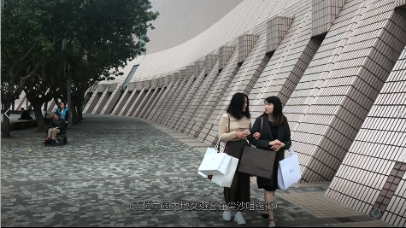
 | Low Angle | 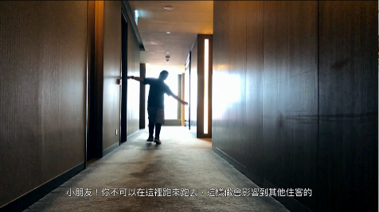
Full Shot | Eye-level | 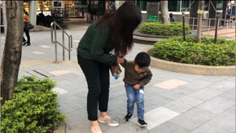
 | High Angle
Medium Full Shot | Low Angle | 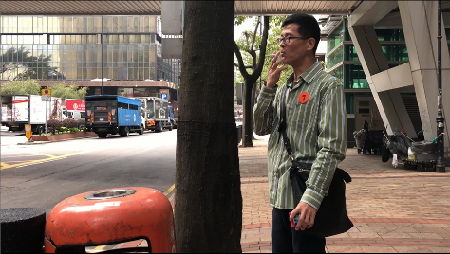
Medium Shot | Eye-level | 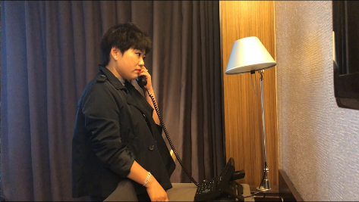
 | High Angle | 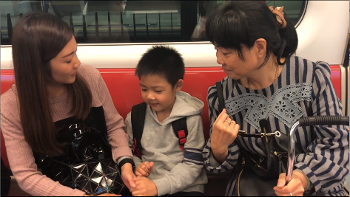
 | Low Angle | 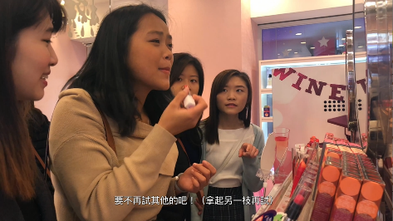
Medium Close Up | Eye-level | 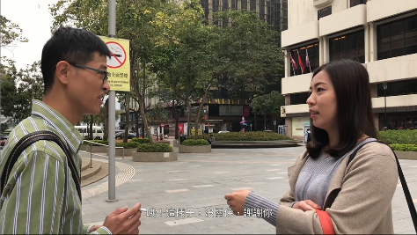
 | Cross Shot | 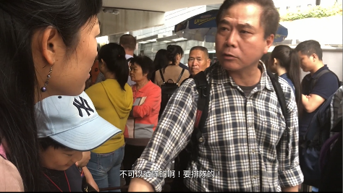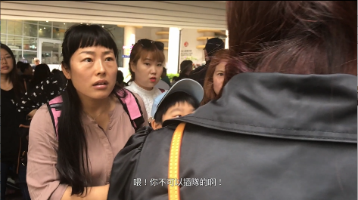
Close Up | Over-The-Shoulder | 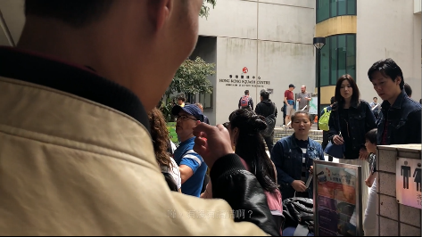
 | Eye-level | 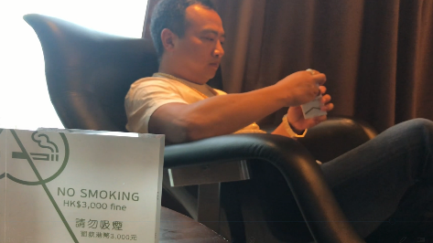
 | High Angle | 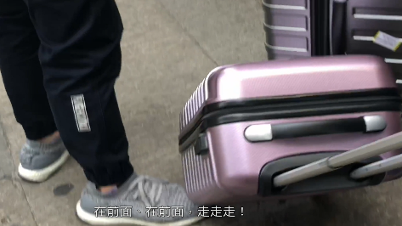

Appendix II.
ANOVA results: Credibility of Pilot Interview Videos
Measurement Items for Credibility |  | Mean  (Standard Deviation) |  |  |  |  |  |  |  |  | F-value
 |  | V1 | V2 | V3 | V4 | V5 | V6 | V7 | V8 | V9
1 | I think there are mainland Chinese travellers like this in real life. | 4.67  (2.08) | 6.33  (0.58) | 3.00  (1.00) | 7.00  (0.00) | 6.00  (1.73) | 6.33  (1.16) | 7.00  (0.00) | 6.67  (0.58) | 6.33  (0.58) | 4.27**
2 | I think there are Hong Kong people like this in real life. | 6.00  (1.00) | 5.00  (2.65) | 5.00  (2.00) | 7.00  (0.00) | 6.67  (0.58) | 5.33  (2.89) | 6.67  (0.58) | 5.33  (2.08) | 6.33  (1.16) | 0.61
3 | I think there are situations like this in real life. | 5.00  (2.00) | 6.00  (1.00) | 3.00  (1.73) | 6.67  (0.58) | 6.33  (1.16) | 6.00  (1.73) | 7.00  (0.00) | 6.33  (0.58) | 6.00  (1.00) | 2.74*
4 | The scenarios in the video are realistic. | 3.33  (1.16) | 5.33  (1.53) | 2.33  (0.58) | 7.00  (0.00) | 5.00  (1.73) | 6.33  (1.16) | 7.00  (0.00) | 6.00  (1.00) | 5.67  (1.53) | 5.85**
5 | The video is believable. | 3.00  (1.00) | 6.00  (1.00) | 3.00  (1.00) | 6.67  (0.58) | 4.33  (2.52) | 6.33  (1.16) | 7.00  (0.00) | 6.00  (1.00) | 5.33  (1.16) | 4.64**
6 | I was able to adopt the role of the Hong Kong character shown in the video. | 3.33  (1.16) | 3.67  (2.08) | 4.00  (3.00) | 5.67  (2.31) | 6.33  (0.58) | 5.67  (1.53) | 7.00  (0.00) | 5.33  (2.08) | 4.33  (0.58) | 1.58
Note: * p < .05; ** p < .01

Appendices III (English Transcripts for Videos 3 and 10):
- Transcripts for Video 3: Looking for Smoking Areas
(In a park at the Tsim Sha Tsui area, a male tourist from the Mainland is looking for a smoking area) |  | 0:00:01-04
Male Tourist | Hmmm, where can I smoke? | 0:00:05-08
(“No Smoking” notices can be seen everywhere in the park) |  | 0:00:16-20
Male Tourist | Excuse me, Miss. Do you know where can I find a smoking area? | 0:00:21-25
Local Female | Smoking? … I am not sure; I think you need to walk out of this park. | 0:00:26-32
Male Tourist | Oh I see! Never mind, thank you! | 0:00:33-34
Local Female | Or maybe you can take a look along that street. | 0:00:35-38
Male Tourist | Oh, okay, thanks! | 0:00:39-40
Local Female | You are welcome. | 0:00:40-41
(A pedestrian holding a pack of cigarette passes by) |  | 0:00:55-58
Male Tourist | Sir, excuse me… | 0:00:59-0:01:00
Local Male | Yes? | 0:01:01
Male Tourist | May I ask is there any smoking allowed area nearby? | 0:01:02-03
Local Male | Normally you can smoke where you see a trash bin on the street. | 0:01:04-07
Male Tourist | Oh … | 0:01:07
Local Male | Do you know where to find one? If not, I can take you there. | 0:01:08-10
Male Tourist | Oh, that’s great. Thank you! | 0:01:11
Local Male | Let me show you… | 0:01:11-12
Local Male | Here it is. | 0:01:18-19
Local Male | Actually, you can smoke anywhere if there is no special sign that smoking is not allowed. | 0:01:20-22
Local Male | If you see a trash bin like this with an ashtray on top, you can smoke here. | 0:01:23-26
Local Male | I'll go now. | 0:01:27
Male Tourist | Ok, thank you! | 0:01:28-29
Local Male | You are welcome! | 0:01:29-30
(The male tourist starts smoking …) |  | 0:01:31-45

- Transcripts for Video 10: Trying Cosmetics
(Two female tourists entering a cosmetic store excitedly) |  | 0:00:03-05
Shop Assistant | Welcome! Please feel free to have a look. | 0:00:06-07
Female tourist in black | Oh, thanks, thanks. | 0:00:08-09
 | （The two ladies chat happily） | 0:00:10-24
Female tourist in black | This color is so beautiful! Can I give it a try? | 0:00:25-27
Shop Assistant | Sure, please wait a moment (fetching disposable cotton pads) | 0:00:28-31
 | She cannot wait, thus applying it directly on her face using fingers | 0:00:31-34
Female tourist in black | No need, no need | 0:00:35-37
Female tourist in black | This color is quite good! | 0:00:43-45
Female tourist in beige | Really? | 0:00:45-46
Female tourist in black | Give it a try! | 0:00:47
（Trying the lipstick directly on her lips） |  | 0:00:47-48
Female tourist in black | Very nice, very nice. | 0:00:49-51
Female tourist in beige | Does it look good? | 0:00:51-52
Female tourist in black | Beautiful, beautiful, just buy this! | 0:00:53-55
Female tourist in beige | Really? | 0:00:56
 | Yes! | 0:00:56
Female tourist in beige | How about trying the others? (Picks up another one and tries it again directly on her lips) | 0:00:57-59
(Two local customers show disgusted, shake their heads and leave the store after seeing them trying on lipsticks this way) |  | 0:01:00-03

