Supplemental Material for

Poison Parasite Counter: Turning Duplicitous Communications into Self-Negating Memory Retrieval Cues

Robert Cialdini¹, Jessica Lasky-Fink^{2*}, Linda J. Demaine¹, Daniel W. Barrett³, Brad J. Sagarin⁴, and Todd Rogers⁵

Contents

Supplemental Methods 3
Ethics 3
Standard MTurk Participant Qualifications 3
Study 1 3
Study 2 4
Study 3 6
Study 4 7
Study 5 9
Study 6 11
Study 7 14
Supplemental Studies 16
Study S1 16
Study S2 17
Study S3 19
Supplemental Tables and Figures 22

Supplemental Methods

Ethics
All studies reported in the main manuscript and supplement were approved by the Harvard University Committee on the Use of Human Subjects (IRB17-1891).

Standard MTurk Participant Qualifications
All studies reported in the main paper and supplement utilized the same minimum qualifications for recruiting MTurk participants. In order to participate, a MTurk worker must:
- Be located in the United States;
- Have an approval rating of at least 95%;
- Have not participated in prior surveys as part of this study;
- Consent to participate;
- And pass an initial attention check.
Only MTurk workers who met all five criteria were eligible to participate in any study reported in this paper. For studies that employed additional exclusion criteria, this is detailed in the study description (see, e.g., Study 5).

Study 1
Procedure
All workers who consented to participate and passed the attention check were randomly assigned to one of two conditions: Traditional Counter or Poison Parasite Counter (PPC). Participants were not aware of their condition assignment. At the beginning of the survey, all participants were told that they would see a series of news article excerpts and ads for fictional political candidates, and were asked to read each carefully in order to answer questions that would follow.
In an approximately 10-minute survey, participants saw a total of 10 political ads for five fictional candidates—one pro and one counter ad for each candidate. All ads were interspersed with four excerpts from current, non-partisan news articles. Filler questions were asked after every excerpt and ad, designed to distract participants from the focus of the study and interfere with memory processes. Each ad was shown on a separate page. Participants had to wait at least five seconds to advance from one ad to the next, and 10-45 seconds to advance from one news article excerpt to the next, depending on the length of the excerpt.
The focal candidate was Walter McKinley, a Congressional candidate running on a platform of job creation. Against a backdrop of the American flag, McKinley’s original ad claimed that he had 10 years of experience as a city councilor, helped create more than 5,000 jobs, and partnered with the local school district to expand vocational training and job-readiness programs (see Figure S2). Participants who were randomly assigned to the PPC condition were shown a response ad that directly challenged the truthfulness of McKinley’s claims on an exact replica of the original ad (see Figure S3). In the Traditional Counter condition, participants viewed a response ad that did not look like or link itself to the original pro-McKinley ad, but included the exact same counter-messages as the PPC ad (see Figure S4). In the PPC ad, the counter-messages were shown against a backdrop of the original ad and inserted in-line with the statements they were intended to challenge, while in the Traditional Counter condition, the counter-messages were presented as stand-alone statements on a different background.
In order to assess immediate recall, participants were asked the following immediately after seeing the PPC or Traditional Counter ad:
- Which of the following was NOT mentioned on the previous ad?
  - School district
  - Corruption
  - Raised taxes
  - Out-of-state jobs
All participants saw the original Walter McKinley ad on the second screen, and the PPC or Traditional Counter ad on the eighth. After viewing all 10 fictional ads and answering related filler questions, participants were told that they would be re-shown one of the candidate ads from the first section, chosen arbitrarily. All participants were re-shown the original McKinley ad and were subsequently asked:
- If Walter McKinley was running in your state, how likely is it that you would vote for him? [1 = extremely unlikely; 5 = extremely likely]
- How honest do you think Walter McKinley is? [1 = extremely dishonest; 5 = extremely honest]

Study 2
Pre-registration
This study was pre-registered on OSF (https://osf.io/aps8h/). In our pre-registered plan, we aimed to recruit a sample of 800 participants, while taking precautions to ensure that no participants had recently completed other surveys that used the same focal materials. This criterion, coupled with the standard MTurk worker qualifications we employed, restricted the available MTurk universe such that, in the end, we were only able to recruit 713 participants for this study—around 180 per condition. Nevertheless, this sample is still sufficient to detect medium sized effects. As described in the manuscript, based on ex ante power calculations, we targeted a minimum of 70 participants per condition for all studies in order to yield a minimum detectable effect of d = 0.48 for each pairwise comparison.
Procedure
The materials and content for this study were identical to those used in Study 1 (see Figures S2, S3, S4), with Walter McKinley serving as the focal candidate. In a factorial design, all workers who consented to participate and passed the attention check were randomly assigned to one of four conditions:
 |  | Outcome time
 |  | Immediate | End-of-survey
Response ad type | Traditional Counter | Condition 1 | Condition 3
 | PPC | Condition 2 | Condition 4

In the Immediate Outcome conditions, participants answered the two dependent variable questions immediately after seeing the PPC or Traditional Counter ad. In the End-of-survey Outcome conditions, participants answered the two dependent variable questions at the end of the 10-minute survey, after being re-exposed to the original McKinley ad. Participants were not aware of their condition assignment.
As in Study 1, all participants were first told that they would see a series of ads for fictional political candidates and were asked to read each carefully in order to answer questions that would follow. All participants saw a total of 10 political ads for five fictional candidates—one pro and one counter ad for each candidate. All ads were interspersed with four excerpts from current, non-partisan news articles. Filler questions were asked after every excerpt and ad, designed to distract participants from the focus of the study and interfere with memory processes. Each ad was shown on a separate page. Participants had to wait at least five seconds to advance from one ad to the next, and 10-45 seconds to advance from one news article excerpt to the next, depending on the length of the excerpt.
The original McKinley ad was shown on the second screen, and the PPC or Traditional Counter ad was shown on the eighth screen. Immediately after viewing the PPC or Traditional Counter ad, participants were either asked two outcome questions (Conditions 1 and 2), or one recall question and a filler question (Conditions 3 and 4).
The two outcome questions were:
- If Walter McKinley was running in your state, how likely is it that you would vote for him? [1 = extremely unlikely; 5 = extremely likely]
- How honest do you think Walter McKinley is? [1 = extremely dishonest; 5 = extremely honest]
In Conditions 3 and 4, participants were asked the following recall and filler questions immediately after viewing the PPC or Traditional Counter ad:
- [Recall] Which of the following was NOT mentioned on the previous ad?
  - School district
  - Corruption
  - Raised taxes
  - Out-of-state jobs
- [Filler] Please rank the following policy areas in order of importance to you, with 1 being the most important and 5 being the least important.
  - Immigration
  - National security
  - Military spending
  - National debt
  - International diplomacy
At the end of the survey, participants in the End-of-survey Outcome conditions (Conditions 3 and 4) were again shown the original McKinley ad and asked the same two outcome questions.
Analyses
Table S1 shows results from our pre-registered analyses. These analyses differ from the results presented in the paper in that they do not control for participant college education. As shown in Table S1, removing college education as a covariate does not meaningfully affect the results reported in the manuscript.
Additionally, Table S1 reports results from an interaction model that interacts exposure to the PPC ad with the timing of the outcome questions, as outlined in the pre-registered analysis plan for this study. With a standardized measure of participants’ likelihood of voting for McKinley as the outcome, the interaction is highly significant (β = -0.62, t(711) = -4.28, p < .001, 95% CI = [-0.90, -0.34]), suggesting that the PPC significantly affects favorability of McKinley upon re-exposure to the original ad.

Study 3
Procedure
All workers who consented to participate and passed the attention check were randomly assigned to one of three conditions: Control, Traditional Counter, or PPC. Participants were not aware of their condition assignment. At the beginning of the survey, all participants were told that they would see a series of ads for fictional political candidates and were asked to read each carefully in order to answer questions that would follow.
The materials for this study were similar to those used in Studies 1 and 2, with Walter McKinley serving as the focal candidate. However, in Studies 1 and 2, the Traditional Counter ad and the PPC ad used identical counter-claims (see Figures S3 and S4). Study 3 tested the effect of the PPC procedure against a more externally valid Traditional Counter ad, which offered the same counterarguments as the PPC ad, but presented in a more realistic narrative form (see Figures S5, S6, S7). Study 3 also added a Control condition. In the Control condition, participants still saw the original McKinley ad, but did not see a counter ad or any counterclaims about McKinley. To ensure that all participants saw the same total number of ads, participants in the Control condition saw an ad for an unrelated fictional candidate in place of the PPC or Traditional Counter ad.
In the first section of the survey, participants were shown a series of 10 political ads for five fictional candidates—one pro and one counter ad for each candidate. Each ad was shown on a separate page, and participants had to wait at least five seconds to advance from one page to the next. Among the 10 ads shown in the first section of the survey, all participants saw the Walter McKinley ad second, and the PPC, Traditional Counter, or Control ad fourth. The other eight ads were presented in random order.
After viewing the 10 political ads, participants were asked a set of five filler questions designed to distract them from the focus of the study and interfere with memory processes. Then, in the third and final section of the survey, participants were told that they would be shown one of the candidate ads from the first section, chosen arbitrarily. All participants were re-shown the original McKinley ad and were subsequently asked:
- If Walter McKinley was running in your state, how likely is it that you would vote for him? [1 = extremely unlikely; 5 = extremely likely]
- How honest do you think Walter McKinley is? [1 = extremely dishonest; 5 = extremely honest]
Analyses
Table S2 shows results from our pre-registered analyses. The pre-registered analysis for each outcome (preference for McKinley and perceived honesty) differs from the results presented in the paper in that it only controls for party affiliation. Adding additional covariates does not meaningfully affect the results reported in the manuscript.
The pre-registered analysis plan for this study also stated that we would evaluate differences in our primary outcomes by treatment condition using Wilcoxson rank-sum tests. By this analysis, preference for McKinley was significantly lower among participants in the PPC condition than in the Traditional Counter condition (z = -3.50, p < .001), and in the Control condition (z = -7.84, p < .001). Similarly, perceptions of McKinley’s honesty were also significantly lower among participants in the PPC condition than in the Traditional Counter condition (z = -3.26, p = .001), and in the Control condition (z = -6.54, p < .001).

Study 4
Procedure
This study used the same materials as Study 3, with Walter McKinley again serving as the focal candidate. The study was run over a period of 17 days, with waves conducted on days 1, 3, 6, 9, and 16.
An initial sample of 557 participants (mean age = 37 years, SD = 11.7; 67% female) was recruited via Amazon’s MTurk. Participants were told in wave 1 (day 1) that the study entailed five separate surveys that would be conducted over a span of two weeks, and were asked to signal their intention to complete all five parts before proceeding to the survey. Each of the four follow-up surveys was open for 24 hours to all participants who had completed the preceding survey. Reminder emails were sent to all eligible workers when each follow-up survey opened, as well as at the 12-hour mark during each survey window. Of the 557 participants who completed the first day of the study, 330 completed all five days (mean age = 39 years, SD = 12.6; 69% female).
In wave 1 (day 1), all participants saw five ads for fictional political candidates: the original ad for Walter McKinley (see Figure S5), and four ads for decoy candidates. All ads were interspersed with three one to two paragraph excerpts from non-partisan news articles on unrelated topics. Participants were asked filler questions on each news article, as well as on three of the four decoy ads. Each ad was shown on a separate page. Participants had to wait at least five seconds to advance from one ad to the next, and 10-45 seconds to advance from one news article excerpt to the next, depending on the length of the excerpt. All participants saw the original Walter McKinley ad on the third survey page. The other four ads and three news article excerpts were presented in random order.
At the end of the survey, participants were told that they would be shown two arbitrarily chosen ads from the first survey section, and asked questions about each. All participants were first shown the original McKinley ad, and were subsequently asked the following two dependent variable questions:
- If Walter McKinley was running in your state, how likely is it that you would vote for him? [1 = extremely unlikely; 5 = extremely likely]
- How honest do you think Walter McKinley is? [1 = extremely dishonest; 5 = extremely honest]
All participants were then shown a randomly selected decoy ad from the first section of the survey, and were asked the same dependent variable questions about the decoy candidate. This procedure aimed to draw participants’ attention away from McKinley.
In the second wave, launched on day 3, all returning participants were randomly assigned to one of three conditions: Control, Traditional Counter, or PPC. As in Studies 1 through 3, participants in the Traditional Counter condition were shown a traditionally presented counter ad for Walter McKinley that offered strong counter-messages, but no associative links to the original ad (Figure S7). Participants in the PPC condition were shown the PPC ad that presented the counter-messages on an exact replica of the original pro-McKinley ad (Figure S6), and participants in the Control condition were shown an unrelated ad for a different candidate in a different electoral race. All participants in the Control condition had still seen the original McKinley ad in wave 1, but they did not see any counterclaims against McKinley in wave 2; the unrelated Control ad was included to ensure that all participants saw the same total number of ads.
The PPC, Traditional Counter, or Control ad was shown on the fourth survey page in wave 2, and was interspersed with four news article excerpts and related filler questions, four decoy ads, and three filler questions about the decoy ads. Each ad and news article excerpt was shown on a separate page. Participants had to wait at least five seconds to advance from one ad to the next, and 10-45 seconds to advance from one news article excerpt to the next, depending on the length of the excerpt.
At the end of the survey, participants were told that they would be shown two ads arbitrarily chosen from either the first or second survey wave, and asked questions about each. All participants were first shown an ad for a randomly chosen decoy candidate, and asked the standard dependent variable questions about this candidate. All participants were then shown the original ad and asked these questions about Walter McKinley.
The procedures in waves 3, 4, and 5 (on days 6, 9, and 16) were identical to those in waves 1 and 2, except participants did not see the Traditional Counter or PPC ads again. In each of waves 3, 4, and 5, all returning participants saw the original McKinley ad, interspersed with two decoy ads, three news article excerpts, and filler questions. The original McKinley ad was shown on the fourth survey screen in wave 3 (on day 6), and on the third survey screen in waves 4 and 5 (on days 9 and 16). In all waves, each ad and news article excerpt was shown on a separate page. Participants had to wait at least five seconds to advance from one ad to the next, and 10-45 seconds to advance from one news article excerpt to the next, depending on the length of the excerpt. At the end of each wave, participants were asked the dependent variable questions about two “arbitrarily” selected candidates—one of whom was always Walter McKinley, while the second subject differed each day.
The news articles and questions differed each day; the ads were repeated so that by the end of wave 5 (day 16), every participant had seen the original McKinley ad nine times, the PPC, Traditional Counter, or Control ad only once (in wave 2), each decoy ad three times, and 16 different news article excerpts.
Analyses
Tables S3 and S4 show the effect of the PPC on preference for McKinley and perceived honesty of McKinley for each wave separately. Tables S5 and S6 show results from our pre-registered analyses. The pre-registered analysis for each outcome (preference for McKinley and perceived honesty) differs from the results presented in the paper in that it only controls for party affiliation. As shown in Tables S3-S6, adding additional covariates does not meaningfully affect the results reported in the manuscript.
The pre-registered analysis plan for this study also stated that we would evaluate differences in our primary outcomes by treatment condition using Wilcoxson rank-sum tests. By this analysis, in wave 2, preference for McKinley was significantly lower among participants in the PPC condition than in the Traditional Counter condition (z = -5.29, p < .001). Similar results are seen in wave 3 (z = -4.08, p < .001); wave 4 (z = -3.93, p < .001); and wave 5 (z = -4.81, p < .001). Relatedly, in wave 2 perceptions of McKinley’s honesty were significantly lower among participants in the PPC condition than in the Traditional Counter condition (z = -5.42, p < .001). Again, similar results are seen in wave 3 (z = -4.07, p < .001); wave 4 (z = -3.08, p < .001); and wave 5 (z = -3.29, p < .001).

Study 5
Procedure
This study used real campaign ads from Gretchen Whitmer, the leading gubernatorial candidate in the Michigan Democratic primary election, which was held on August 7, 2018. Whitmer, a former Michigan state senator, ran against two opponents for the Democratic gubernatorial nomination in a highly contested and expensive race. This study was run prior to the election.
The original ad for this study was political mailer circulated by Whitmer’s campaign that focused on her commitment to and track record of expanding access to affordable health care coverage (Figure S8). The Traditional Counter ad was a mailer released by Whitmer’s primary opponent, Shri Thanedar, that attacked Whitmer’s record on health insurance (Figure S9). Specifically, it claimed that her campaign was being funded by Blue Cross Blue Shield, a major health insurance company, which was also responsible for increasing health insurance. Thanedar’s ad provided strong and explicit counter-messages, but no associative links to the original Whitmer ad.
We designed two counter ads that employed the PPC procedure in slightly different ways. In the first, the “full” application, we placed the original Whitmer ad and the Traditional Counter ad side-by-side with a line down the middle and the respective headers: “Typical Gretchen Whitmer ad” and “Here’s what we say in our ad” (Figure S10). In the second, the “tailored” application, we took the exact counter-messages from Thanedar’s response ad and embedded them in the original Whitmer ad (Figure S11). Both ads were created purely for research purposes; neither was actually used in the campaign or circulated to prospective voters. We had no a priori hypothesis as to which manifestation of the PPC would be more effective, and thus tested each relative to the real (traditional) counter ad.
In a single-day study, all workers who consented to participate and passed the attention check were randomly assigned to one of three conditions: Control, Traditional Counter, or PPC. Participants were not aware of their condition assignment. At the beginning of the survey, all participants were told that they would see a series of ads for real political candidates currently running for office, as well as excerpts from actual news articles. They were told to read each ad and article carefully in order to answer the questions that followed.
In a 15-minute survey, all participants saw the original Whitmer ad on the third survey page and then, depending on condition assignment, either one of the PPC ads, the Traditional Counter ad, or a Control ad for a different candidate in a different election on the twelfth survey page. The purpose of the Control ad was to ensure all participants saw the same total number of ads; participants in the Control condition still saw the original Whitmer ad, but they were not exposed to any counterclaims against Whitmer.
The Whitmer ad and the counter ads were interspersed with eight decoy ads, five of which were followed by associated filler questions, and four news article excerpts with related filler questions. All decoy ads were also real campaign ads from 2018 Democratic primary elections across the country. Each ad and news article excerpt was shown on a separate page. Participants had to wait at least five seconds to advance from one ad to the next, and 10-45 seconds to advance from one news article excerpt to the next, depending on the length of the excerpt.
At the end of the survey, all participants were told that they would be shown one “arbitrarily” chosen ad from the survey to answer questions about. All participants were shown the original Whitmer ad and asked the following three dependent variable questions:
- If you lived in Michigan, how likely would you be to vote for Gretchen Whitmer in the upcoming Democratic primary election?
- How honest do you think Gretchen Whitmer is?
- You have a chance to allocate real resources. We are donating $0.10 on behalf of every worker who takes our survey. We can either donate this $0.10 to Gretchen Whitmer’s campaign or to the campaign of Shri Thanedar, her opponent. Who would you like us to donate this $0.10 to?

Study 6
Procedure
The previous studies relied on static ads because they readily lent themselves to experimental control. Study 6 builds upon previous studies by implementing the PPC procedure using video ads in a real-world setting. During the 2020 Super Bowl, TurboTax ad ran a 45-second ad highlighting the simplicity and benefits of their tax preparation software. They released the ad five days before the game, which afforded a unique opportunity to test the PPC procedure knowing that participants who watched the game would be subsequently re-exposed to the original TurboTax communication. Prior to the game, we developed three response ads. The PPC ad overlaid a counter message on the exact TurboTax ad that was to run during the Super Bowl. This message stated: “TurboTax says they work to make filing taxes easy for us. Yet, they’ve spent $10 million lobbying lawmakers to prevent free automatic filing. This makes filing harder and more expensive for us, so they can make money.” In the PPC ad, this text scrolled across the screen during the 45-second video twice, and then ended with a static screen that displayed this message for an additional three seconds. In the Poison Only Counter ad, the same scrolling text was overlaid on a different TurboTax commercial, which was of an equivalent length. And in the Pure Counterargument condition, the same scrolling text was presented with a solid black screen as the background. All ads are available at https://bit.ly/poisonparasite.
On the Friday before the 2020 Super Bowl, an initial sample of 2,429 participants (mean age = 41 years, SD = 12.8; 50% female) was recruited via Amazon’s MTurk for a three-wave study that was run over nine days. Participants were told in wave 1 (day 1) that the study would entail three surveys, and were asked to signal their intention to complete all surveys before proceeding to the survey. The second wave opened on the Monday after the Super Bowl (day 3) and was open for 24 hours. The third wave opened one week later on day 9, and was also open for 24 hours. Reminder emails were sent to all eligible workers when each follow-up survey opened, as well as at the 12-hour mark during each survey window.
In wave 1 (day 1), which ran for 24 hours prior to the Super Bowl on February 2, 2020, all participants were randomly assigned to one of three conditions corresponding with the counter ad: PPC, Poison Only Counter, or Pure Counterargument. Participants were not aware of their condition assignment.
Wave 1 was a 15-minute survey during which participants viewed the original TurboTax ad, six real commercials that served as filler, and three filler counter ads that were created for research purposes. The six decoy filler ads were actual TV ads for AT&T, Amazon, Hyundai, Neutrogena, and Verizon. For three of these companies—AT&T, Amazon, and Verizon—we also created “Poison Only Counter” ads in order to draw attention away from the TurboTax counter ads. These ads were also interspersed throughout the survey in a random order. None of the decoy counter ads utilized the PPC procedure. Participants were asked one or two filler questions after every ad. Page timers were used so that participants were required to stay on each ad page until the ad finished playing. To help ensure that participants watched all ads in their entirety, all ads were also programmed to play automatically and could not be controlled by viewers. The second ad shown was the TurboTax ad that was going to run during the Super Bowl. The fifth ad shown was either the PPC, Poison Only Counter, or Pure Counterargument ad described above.
At the end of the survey, participants were told that they would be shown two arbitrarily chosen ads from the previous section to answer questions about. The first ad shown was the TurboTax Super Bowl ad, after which all participants were subsequently asked the following four dependent variable questions:
- How positively or negatively do you view TurboTax? [1 = extremely negatively, 5 = extremely positively]
- If you were to use an online tax filing service, how likely would you be to use TurboTax? [1 = extremely unlikely, 5 = extremely likely]
- There are many competing tax preparation companies. Imagine they all offer tax filing for the same price. Would you choose to file your taxes through TurboTax or one of its comparable competitors? [Binary response: TurboTax or a comparable competitor]
- If a friend asked you for a recommendation on online tax filing services, which company would you be most likely to recommend? [Choice of five tax preparation companies, including TurboTax]
In the second wave (day 3), which was launched on the Monday after the Super Bowl, participants were asked a series of questions about products that they had previously seen ads for in the first survey. In the first section of the survey, participants were not re-shown any ads. Instead, on the first page they were asked three questions about a randomly chosen product for which they had seen ads during wave 1. The second page then asked the same four TurboTax dependent variable questions as asked in wave 1.
At the end of the second wave, all participants were asked the following series of questions about the Super Bowl:
- Did you watch any part of the Super Bowl yesterday? [Yes/No]
- [If “yes” to Q1]: Which quarters of the Super Bowl did you watch? [Choose all: Q1, Q2, Q3, Q4]
- [If “yes” to Q1]: How closely did you watch the game? [Extremely closely, somewhat closely, not very closely, not at all closely]
- [If “yes” to Q1]: Did you watch the commercials? [Yes, all of them; Yes, some of them; No]
- [If “yes” to Q1]: How closely did you watch the commercials? [Extremely closely, somewhat closely, not very closely, not at all closely]
Subsequently, participants who reported watching any part of the Super Bowl were re-shown the original TurboTax Super Bowl ad, and asked:
- Did you see this ad during the Super Bowl yesterday? [Yes, No, Unsure]
- How confident are you that you [saw/did not see] this ad during the game yesterday? [Extremely confident, somewhat confident, not very confident, not at all confident]
- Which of the following claims against this ad do you recall seeing in the first part of this study? [Choose all]
  - TurboTax tricked consumers into buying more expensive versions of its products
  - TurboTax has been accused of miscalculating users’ refund amounts
  - TurboTax has spent over $10 million lobbying against free automatic tax filing
  - TurboTax has compromised millions of users’ security and privacy
  - None of the above
The third and final wave ran one week after the second wave (on day 9). Participation in the third wave was limited to only those participants who had completed the second wave and reported watching the Super Bowl. In this wave, participants were initially told that they would be re-shown two arbitrarily chosen ads from the first survey wave, and asked related questions. All participants were first shown an ad for Facebook, and asked five filler questions about the company and their perceptions of the ad. Next, all participants were re-shown the original TurboTax ad, after which the same four dependent variable questions were asked.
Analyses
The main results from Study 6, as presented in the primary manuscript, focus on the effect of condition assignment on a standardized aggregate index of TurboTax favorability. The standardized index is comprised of the first two dependent variable questions detailed above. Table S8 presents results on each unstandardized outcome measure separately.
Table S9 presents results on two secondary outcome measures: the third and fourth dependent variable questions detailed above. Across all three survey waves, participants in the PPC condition are significantly less likely to choose TurboTax over a comparable competitor and significantly less likely to recommend TurboTax to a friend than participants in the Poison Only Counter condition. Participants in the PPC condition are also significantly less likely to choose TurboTax over a comparable competitor and significantly less likely to recommend TurboTax to a friend than participants in the Pure Counterargument condition. It is possible that by presenting counterclaims against TurboTax without the distraction and interference caused by the underlying ad, the Pure Counterargument condition led to better encoding of the counterclaims, which made them more resistant to decay over time compared to the Poison Only Counter ad. Future studies should explore this further.
During the second wave of Study 6, after answering the four dependent variable questions, all respondents who reported having watched the Super Bowl were re-shown the original TurboTax Super Bowl ad and asked (1) if they recalled seeing the ad during the game; and (2) to identify which counterclaims they had seen against TurboTax in the first study. The first recall question serves as a manipulation check to determine whether participants who had watched the Super Bowl were actually re-exposed to the original TurboTax ad as we intended. Overall, 67% of participants included in the final analytic universe reported seeing the ad during the game. This was not balanced across conditions, with 72% of participants in the Pure Counterargument condition recalling seeing the ad versus 64% in the PPC condition and 66% in the Poison Only Counter condition (χ²(2) = 6.93, p = .03). Although self-reported measures are noisy, any error in this measure should be unbiased across condition assignment.
Next, if the PPC procedure induces cue-based recall as hypothesized, we would expect recall of the counterclaims after subsequent re-exposure to the original ad to be highest among participants in the PPC condition. As shown in Table S10, 74% of participants in the PPC condition correctly identified the counterclaim they had seen against TurboTax in wave 1, versus only 53% in the Poison Only Counter condition and 76% in the Pure Counterargument condition. False alarm rates in the PPC and Pure Counterargument conditions were 8% and 7%, respectively, and nearly 14% in the Poison Only Counter condition. Although not our main focus in this paper, future studies should examine the effect of presenting counterarguments with limited or no distraction (as in the Pure Counterargument condition) on memory formation and recall.

Study 7
Procedure
All workers who consented to participate and passed the attention check were randomly assigned to one of three conditions: Control, Traditional Counter, or PPC. Participants were not aware of their condition assignment. At the beginning of the survey, all participants were told that they would see a series of ads for fictional political candidates and were asked to read each carefully in order to answer questions that would follow.
Study 7 used the same materials as Studies 3 and 4 (Figure S5, S6, S7), with Walter McKinley serving as the focal candidate. In the approximately 10-minute survey, participants saw a total of 10 political ads for five fictional candidates—one pro and one counter ad for each candidate. One of these ads was the original pro-McKinley ad (Figure S5), and one was either the PPC, Traditional Counter, or Control ad. All ads were interspersed with four excerpts from current, non-partisan news articles. Filler questions were asked after every excerpt and ad. Each ad was shown on a separate page. Participants had to wait at least five seconds to advance from one ad to the next, and 10-45 seconds to advance from one news article excerpt to the next, depending on the length of the excerpt.
All participants saw the original Walter McKinley ad on the third survey page, and the PPC or Traditional Counter ad on the thirteenth. After viewing all 10 fictional ads and answering related filler questions, participants were told that they would be asked questions about one of the candidate ads from the first section, chosen arbitrarily. All participants were re-shown the original McKinley ad and were subsequently asked:
- If Walter McKinley was running in your state, how likely is it that you would vote for him? [1 = extremely unlikely; 5 = extremely likely]
- When you see the claims in McKinley’s ad, how clearly do you recall the specifics of any arguments you may have viewed against those claims? [1 = not at all clearly; 4 = extremely clearly]
- How honest do you think Walter McKinley is? [1 = extremely dishonest; 5 = extremely honest]
- Which of the following anti-McKinley claims do you recall seeing, if any? [Choose all]
  - McKinley supported union workers
  - 95% of the jobs he created were located out of state
  - He has been accused of taking money from big banks and corporate interests
  - McKinley has supported legislation to repeal popular environmental protection measures
  - He opposed a bill to increase funding for public education
  - McKinley resigned as city councilman after corruption allegations
  - The district he partnered with on job training denied the partnership
  - He put forth a proposal that would raise taxes for his poorest constituents
  - None of the above

Supplemental Studies

Study S1
This study tests the efficacy of the PPC procedure in the presence of large information asymmetries during an extended single-day study.
Participants. Participants were 425 Amazon MTurk workers (mean age = 36 years, SD = 11.0; 52% female). Participants received $3.00 for completing the survey. Standard participant qualifications were applied.
Procedure. All workers who consented to participate and passed the attention check were randomly assigned to one of two conditions: Traditional Counter (N = 215) or PPC (N = 210). Participants were not aware of their condition assignment. At the beginning of the survey, all participants were told that they would see a series of news article excerpts and ads for fictional political candidates, and were asked to read each carefully in order to answer questions that would follow.
This study was designed to take 25 to 30 minutes to complete, and used the same materials as Study 3, with Walter McKinley serving as the focal candidate. In the first section of the survey, all participants saw the original pro-McKinley ad and either the PPC or Traditional Counter ad, interspersed with a series of eight decoy ads for other fictional political candidates, filler questions about four decoy ads, and five news article excerpts, each with an associated filler question. The original McKinley ad was shown on the fifth screen, and the PPC or Traditional Counter ad was shown on the 24th screen. Each ad was shown on a separate page. Participants had to wait at least five seconds to advance from one ad to the next, and 10-45 seconds to advance from one news article excerpt to the next, depending on the length of the excerpt.
At the end of the first section, participants were told that they would be re-shown one of the candidate ads from the first section, chosen arbitrarily. All participants were re-shown the original McKinley ad and were subsequently asked:
- If Walter McKinley was running in your state, how likely is it that you would vote for him? [1 = extremely unlikely; 5 = extremely likely]
- How honest do you think Walter McKinley is? [1 = extremely dishonest; 5 = extremely honest]
The second section of the study replicated the first with one exception: participants were not shown the PPC or Traditional Counter ad again. All participants were shown 12 new excerpts from non-partisan news articles, each with an associated filler question. Interspersed among the excerpts, we told participants that they would again be shown and asked questions about one of the political ads from the first survey section. In order to produce memory interference and distraction, we asked the same dependent variable questions as above about two decoy political candidates and ads at different points in the second section of the survey. In addition, on the 32nd survey screen and on the last (54th) survey screen, we re-exposed participants to the original McKinley ad, and asked the standard dependent variable questions regarding their likelihood of voting for McKinley and perceived honesty. By the end of the survey, each participant had seen the original ad four times, the PPC or Traditional Counter ad once, and answered the dependent variable questions three times.
Analysis and Results
In an extended single-day study, the PPC repeatedly undermined the original pro-McKinley communication compared to presenting the same counterarguments in a traditional form. Each outcome measure was collected approximately five minutes apart, and effect sizes were similar across all three points in time. The PPC ad reduced participants’ likelihood of voting for McKinley compared to the Traditional Counter ad at the first point in time by 0.63 SD, t(424) = 6.87, p < .001, 95% CI = [0.45, 0.81], at the second point in time by 0.66 SD, t(424) = 7.25, p < .001, 95% CI = [0.48, 0.84], and at the third point in time by 0.65 SD, t(424) = 7.07, p < .001, 95% CI = [0.47, 0.83].
Similarly, the PPC reduced participants’ perceptions of McKinley’s honesty relative to the Traditional Counter ad at the first point in time by 0.58 SD, t(424) = 6.25, p < .001, 95% CI = [0.40, 0.76], at the second point in time by 0.65 SD, t(424) = 7.08, p < .001, 95% CI = [0.47, 0.84], and at the third point in time by 0.65 SD, t(424) = 7.04, p < .001, 95% CI = [0.47, 0.83].

Study S2
Study S2 tested the durability of the PPC procedure over a three-day period with intense initial exposure to both the original message and counter messages.
Participants. Participants were 447 MTurk workers (mean age = 40 years, SD = 13.3; 59% female) who were recruited to complete a three-wave study over the course of three days. Standard participant qualifications were applied. Of the 447 workers who took completed the first wave, 355 participants (mean age = 42 years, SD = 13.4; 59% female) completed all three waves. Attrition was balanced evenly across condition (χ²(1) = 0.13, p = .72). A joint significance test shows that attrition was not balanced across all covariates (χ²(6) = 34.66, p < .001), with older participants and those whose party affiliation is Independent being less likely to attrit. All analyses control for all available covariates.
Participants received $1.80 for completing the first survey, $0.50 for the second, and $0.20 for the third.
Procedure. This study used the same materials as Study 3, with Walter McKinley again serving as the focal candidate. The study was run over a period of three days, with waves conducted on days 1, 2, and 3. Participants were told in wave 1 (day 1) that the study entailed three separate surveys that would be conducted over the subsequent days, and were asked to signal their intention to complete all three parts before proceeding to the survey. Each of the two follow-up surveys was open for 24 hours to all participants who had completed the preceding survey. Reminder emails were sent to all eligible workers when each follow-up survey opened, as well as at the 12-hour mark during each survey window.
In wave 1 (day 1), all participants were randomly assigned to one of two conditions: Traditional Counter or PPC. Of the 355 participants who completed all three survey waves, 176 were assigned to the Traditional Counter condition, and 179 to the PPC condition.
In the approximately 15-minute survey, all participants saw eight ads for fictional political candidates twice, for a total of sixteen decoy ads, as well as eight excerpts from non-partisan news articles and related filler questions about each. In addition, filler questions were asked after four of the sixteen decoy ads. Interspersed among this filler material, all participants saw the original ad for Walter McKinley three times, on survey pages 3, 18, and 28, and the Traditional Counter or PPC ad three times, on survey pages 12, 24, and 33. Each ad was shown on a separate page. Participants had to wait at least five seconds to advance from one ad to the next, and 10-45 seconds to advance from one news article excerpt to the next, depending on the length of the excerpt.
At the end of the survey, participants were told that they would be asked questions about an arbitrarily chosen ad from the first survey section. All participants were first shown the original McKinley ad, and were subsequently asked the following two dependent variable questions:
- If Walter McKinley was running in your state, how likely is it that you would vote for him? [1 = extremely unlikely; 5 = extremely likely]
- How honest do you think Walter McKinley is? [1 = extremely dishonest; 5 = extremely honest]
In the second wave, launched on day 2, all returning participants were shown two excerpts from news articles and asked related filler questions about each. In between this filler material, participants were told that they would be asked questions about an arbitrarily chosen ad from the first survey wave (on day 1). First, all participants were asked the standard dependent variable questions about a decoy fictional candidate. At the end of the survey, on page seven, all participants were re-shown the original McKinley ad and asked the standard dependent variable questions.
Finally, in wave 3, launched on day 3, all returning participants were shown a single news article excerpt and related filler question. Thereafter, on page three, all participants were told that they would be asked questions about an arbitrarily chosen ad from the first wave of the survey. All participants were re-shown the original McKinley ad, and again asked the standard dependent variable questions.
In both waves 2 and 3, each ad and news article excerpt was shown on a separate page. Participants had to wait at least five seconds to advance from one ad to the next, and 10-45 seconds to advance from one news article excerpt to the next, depending on the length of the excerpt. By the end of the three-day study, all participants had seen the original McKinley ad six times, and the Traditional Counter or PPC ad three times (only in wave 1).
Analysis and Results
The analytic universe is defined as the 355 participants who completed all three survey waves. In wave 1, the PPC reduced participants’ likelihood of voting for McKinley by 0.55 SD, t(354) = 5.34, p < .001, 95% CI = [0.35, 0.75]. The PPC continued to undercut the original communication relative to the Traditional Counter ad in wave 2 (0.44 SD, t(354) = 4.28, p < .001, 95% CI = [0.24, 0.64]) and wave 3 (0.37 SD, t(354) = 3.61, p < .001, 95% CI = [0.17, 0.57]).
Similarly, the PPC reduced participants’ perceptions of McKinley’s honesty relative to the Traditional Counter ad in the first wave by 0.43 SD, t(354) = 4.12, p < .001, 95% CI = [0.22, 0.63], in the second wave by 0.47 SD, t(354) = 4.64, p < .001, 95% CI = [0.27, 0.66], and in the third wave by 0.45 SD, t(354) = 4.33, p < .001, 95% CI = [0.24, 0.65].

Study S3
Study S3 aimed to extend the results of Study 3 by testing the durability of the PPC procedure over a one-week period.
Method
Participants. An initial sample of 499 participants (mean age = 36 years, SD = 10.8; 57% female) was recruited via Amazon’s MTurk to complete three surveys over an eight-day period. Standard participant qualifications were applied. Sixty-nine percent of initial participants (N = 346; mean age = 37 years, SD = 11.1; 55% female) completed all three surveys that were conducted as part of this study. Attrition was balanced across condition assignment (χ²(2) = 0.13, p = .94). Older participants were significantly less likely to attrit (χ²(1) = 12.44, p < .001); all analyses control for age, as well as other covariates.
Participants received $1.20 for completing the first survey, $0.50 for the second, and $0.30 for the third.
Procedure. This study used the same materials as Study 3, with Walter McKinley again serving as the focal candidate. The study was run over a period of eight days, with waves conducted on days 1, 3, and 7. Participants were told in wave 1 (day 1) that the study entailed three separate surveys that would be conducted over the subsequent week, and were asked to signal their intention to complete all three parts before proceeding to the survey. Each of the two follow-up surveys was open for 24 hours to all participants who had completed the preceding survey. Reminder emails were sent to all eligible workers when each follow-up survey opened, as well as at the 12-hour mark during each survey window.
In wave 1 (day 1), all participants were randomly assigned to one of three conditions: Control, Traditional Counter, or PPC. Of the 346 participants who completed all three survey waves, 115 were assigned to the Control condition, 114 to the Traditional Counter condition, and 117 to the PPC condition.
In the approximately 10-minute wave 1 survey, all participants saw eight ads for fictional political candidates, as well as five excerpts from non-partisan news articles and related filler questions about each. In addition, filler questions were asked after three of the eight decoy ads. Interspersed among this filler material, all participants saw the original ad for Walter McKinley on the third survey page, and either the Control ad, Traditional Counter ad, or PPC ad on survey page 12. Each ad was shown on a separate page. Participants had to wait at least five seconds to advance from one ad to the next, and 10-45 seconds to advance from one news article excerpt to the next, depending on the length of the excerpt.
At the end of the survey, participants were told that they would be asked questions about an arbitrarily chosen ad from the first survey section. All participants were first shown the original McKinley ad, and were subsequently asked the following two dependent variable questions:
- If Walter McKinley was running in your state, how likely is it that you would vote for him? [1 = extremely unlikely; 5 = extremely likely]
- How honest do you think Walter McKinley is? [1 = extremely dishonest; 5 = extremely honest]
In the second wave, launched on day 3, all returning participants were shown two excerpts from news articles and asked related filler questions about each. In between this filler material, participants were told that they would be asked questions about an arbitrarily chosen ad from the first survey wave (on day 1). First, all participants were asked the standard dependent variable questions about a decoy fictional candidate. At the end of the survey, on page seven, all participants were re-shown the original McKinley ad and asked the standard dependent variable questions.
Finally, in wave 3, launched on day 7, all returning participants were shown a single news article excerpt and related filler question. Thereafter, on page 3, all participants were told that they would be asked questions about an arbitrarily chosen ad from the first wave of the survey. All participants were re-shown the original McKinley ad, and again asked the standard dependent variable questions.
In both waves 2 and 3, each ad and news article excerpt was shown on a separate page. Participants had to wait at least five seconds to advance from one ad to the next, and 10-45 seconds to advance from one news article excerpt to the next, depending on the length of the excerpt. By the end of the three-day study, all participants had seen the original McKinley ad four times, and the Traditional Counter or PPC ad one time (only in wave 1).
Analyses and Results
The analytic sample is comprised of 346 participants who completed all three surveys. In wave 1 (day 1), participants who saw the PPC ad were significantly less likely to vote for McKinley than participants who had seen the Control ad (-0.86 SD, t(345) = -6.85, p < .001, 95% CI = [-1.10, -0.61]) or the Traditional Counter ad (-0.55 SD, t(345) = -4.41, p < .001, 95% CI = [-0.79, -0.30]). Similarly, participants in the PPC condition rated McKinley as significantly less honest than participants in both the Control condition (-0.75 SD, t(345) = -5.75, p < .001, 95% CI = [-1.00, -0.49]), and the Traditional Counter condition (-0.60 SD, t(345) = -4.67, p < .001, 95% CI = [-0.86, -0.35]).
The effect of the PPC endured across waves 2 and 3 (day 3 and day 7). Relative to participants who had seen the Traditional Counter ad, participants who saw the PPC ad in wave 1 were less likely to vote for McKinley in both wave 2 (-0.48 SD, t(345) = -3.71, p < .001, 95% CI = [-0.73, -0.22]) and wave 3 (-0.42 SD, t(345) = -3.34, p = .001, 95% CI = [-0.67, -0.17]). Compared to the Control condition, participants in the PPC condition were also significantly less likely to vote for McKinley in wave 2 (-0.70 SD, t(345) = -5.42, p < .001, 95% CI = [-0.95, -0.45]) and wave 3 (-0.72 SD, t(345) = -5.66, p < .001, 95% CI = [-0.98, -0.47]).
Similar trends across can be seen for the effect of the PPC on perceptions of McKinley’s honesty across time. Participants who saw the PPC ad in wave 1 viewed McKinley as significantly less honest than participants who saw the Traditional Counter ad in both wave 2 (-0.46 SD, t(345) = -3.51, p = .001, 95% CI = [-0.71, -0.20]), and wave 3 (-0.46 SD, t(345) = -3.57, p < .001, 95% CI = [-0.71, -0.21]). Exposure to the PPC ad also significantly reduced perceptions of McKinley’s honestly relative to the Control condition in both wave 2 (-0.59 SD, t(345) = -4.53, p < .001, 95% CI = [-0.85, -0.33]), and wave 3 (-0.58 SD, t(345) = -4.49, p < .001, 95% CI = [-0.83, -0.33]).

Supplemental Tables and Figures
Table S1. Study 2: pre-registered analyses
 | (1) | (2) | (3) | (4) | (5) | (6)
 | Interaction model |  | Immediate outcome |  | End-of-survey outcome
VARIABLES | Std. voting | Std. honesty | Std. voting | Std. honesty | Std. voting | Std. honesty
Traditional Counter | 0.007 | -0.120 | 0.024 | -0.098 | 0.633*** | 0.414***
 | (0.101) | (0.102) | (0.106) | (0.105) | (0.095) | (0.098)
End DV | -0.287** | -0.321**
 | (0.101) | (0.102)
Trad. Counter X End outcome | 0.624*** | 0.529***
 | (0.142) | (0.145)
Republican | 0.316*** | 0.320*** | 0.296* | 0.308* | 0.331** | 0.325**
 | (0.086) | (0.088) | (0.126) | (0.126) | (0.118) | (0.121)
Independent | 0.030 | 0.062 | 0.129 | 0.250 | -0.065 | -0.111
 | (0.090) | (0.092) | (0.138) | (0.138) | (0.118) | (0.121)
Other party | -0.173 | 0.042 | 0.018 | 0.218 | -0.404 | -0.174
 | (0.198) | (0.201) | (0.281) | (0.280) | (0.280) | (0.288)
Female | -0.041 | 0.017 | -0.167 | -0.128 | 0.088 | 0.161
 | (0.072) | (0.073) | (0.107) | (0.107) | (0.096) | (0.099)
Age | -0.005 | -0.005 | -0.010* | -0.009 | 0.001 | 0.002
 | (0.003) | (0.003) | (0.005) | (0.005) | (0.005) | (0.005)
Observations | 712 | 712 | 356 | 356 | 356 | 356
R-squared | 0.073 | 0.043 | 0.035 | 0.037 | 0.141 | 0.085
PPC mean | -0.006 | 0.059 | -0.012 | 0.050 | -0.296 | -0.267
Notes: OLS estimates of the effect of condition assignment on preference for McKinley and perceived honesty. Columns (1) and (2) interact treatment with the timing of the outcome questions (immediate or end-of-survey). In columns (3) and (4) the outcomes were collected immediately after viewing the PPC or Traditional Counter ad; in columns (5) and (6) the outcomes were collected at the end of the survey after re-exposure to the original ad. Outcomes are standardized continuous scales, measured on 1-5 scales where 5 indicates “extremely likely to vote” or “extremely honest,” respectively. Covariates include self-reported party affiliation, gender, and age. Reference groups are assignment to the Traditional Counter condition; Democrat; and male. Standard errors in parentheses. *** p < 0.001, ** p < 0.01, * p < 0.05

Table S2. Study 3: pre-registered analyses
 | (1) | (2) | (3) | (4)
VARIABLES | Std. voting | Std. honesty | Voting | Honesty
Traditional Counter | 0.374*** | 0.294** | 0.409*** | 0.207**
 | (0.093) | (0.095) | (0.102) | (0.067)
Control | 0.833*** | 0.673*** | 0.909*** | 0.473***
 | (0.094) | (0.096) | (0.103) | (0.068)
Republican | 0.292** | 0.125 | 0.318** | 0.088
 | (0.100) | (0.103) | (0.110) | (0.072)
Independent | -0.134 | -0.240** | -0.146 | -0.169**
 | (0.090) | (0.092) | (0.098) | (0.065)
Other party | -0.384* | -0.451* | -0.419* | -0.317*
 | (0.184) | (0.188) | (0.200) | (0.132)
Observations | 602 | 602 | 602 | 602
R-squared | 0.134 | 0.095 | 0.134 | 0.095
PPC mean | -0.398 | -0.319 | 2.556 | 2.723
Notes: OLS estimates of the effect of condition assignment on preference for McKinley and perceived honesty in Study 3. In columns (1) and (2), outcomes are standardized continuous scales, measured on a 1-5 scale where 5 indicates “extremely likely to vote” or “extremely honest,” respectively. In columns (3) and (4), outcomes are raw continuous measures of participants’ likelihood of voting for and perceived honesty of McKinley. Covariates include self-reported party affiliation. Reference groups are assignment to the PPC condition and Democrat. Standard errors in parentheses. *** p < 0.001, ** p < 0.01, * p < 0.05

Table S3. Study 4: preference for McKinley over time
 | (1) | (2) | (3) | (4) | (5) | (6)
 | Standardized outcomes
VARIABLES | Day 1 | Day 3 | Day 6 | Day 9 | Day 16 | Day 6-16 avg
Traditional Counter | -0.105 | 0.746*** | 0.640*** | 0.565*** | 0.735*** | 0.711***
 | (0.136) | (0.119) | (0.127) | (0.127) | (0.126) | (0.125)
Control | 0.033 | 1.179*** | 0.790*** | 0.758*** | 0.876*** | 0.889***
 | (0.136) | (0.119) | (0.127) | (0.127) | (0.126) | (0.125)
Republican | 0.112 | 0.291* | 0.334* | 0.321* | 0.130 | 0.287*
 | (0.156) | (0.136) | (0.145) | (0.146) | (0.145) | (0.143)
Independent | -0.013 | -0.096 | -0.188 | -0.159 | -0.146 | -0.181
 | (0.130) | (0.114) | (0.121) | (0.122) | (0.121) | (0.119)
Other party | -0.233 | 0.181 | -0.049 | -0.027 | 0.061 | -0.005
 | (0.258) | (0.226) | (0.240) | (0.241) | (0.239) | (0.236)
Female | 0.314* | 0.005 | 0.021 | 0.196 | 0.131 | 0.128
 | (0.121) | (0.106) | (0.113) | (0.114) | (0.113) | (0.111)
Age | -0.001 | -0.006 | -0.006 | -0.002 | -0.004 | -0.004
 | (0.005) | (0.004) | (0.004) | (0.004) | (0.004) | (0.004)
College educated | 0.037 | -0.142 | -0.213* | -0.176 | -0.177 | -0.207
 | (0.116) | (0.101) | (0.108) | (0.108) | (0.107) | (0.106)
Observations | 330 | 330 | 330 | 330 | 330 | 330
R-squared | 0.030 | 0.258 | 0.158 | 0.150 | 0.167 | 0.186
PPC mean | 0.024 | -0.654 | -0.486 | -0.450 | -0.547 | -0.544
Notes: OLS estimates of the effect of condition assignment on preference for McKinley in each wave in Study 4. Column 6 shows the average for days 6, 9, and 16. Voting is a standardized continuous scale, measured on a 1-5 scale where 5 indicates “extremely likely to vote.” Covariates include self-reported party affiliation, gender, age, and an indicator for college-educated. Reference groups are assignment to the PPC condition; Democrat; male; and non-college educated. Standard errors in parentheses. *** p < 0.001, ** p < 0.01, * p < 0.05

Table S4. Study 4: perceived honesty of McKinley over time
 | (1) | (2) | (3) | (4) | (5) | (6)
 | Standardized outcomes
VARIABLES | Day 1 | Day 3 | Day 6 | Day 9 | Day 16 | Day 6-16 avg
Traditional Counter | -0.015 | 0.751*** | 0.573*** | 0.519*** | 0.431** | 0.566***
 | (0.136) | (0.121) | (0.129) | (0.130) | (0.132) | (0.128)
Control | -0.033 | 1.126*** | 0.757*** | 0.699*** | 0.645*** | 0.781***
 | (0.137) | (0.121) | (0.129) | (0.130) | (0.132) | (0.129)
Republican | 0.068 | 0.145 | -0.017 | 0.209 | 0.157 | 0.133
 | (0.156) | (0.139) | (0.148) | (0.149) | (0.151) | (0.147)
Independent | -0.094 | -0.175 | -0.207 | -0.194 | -0.167 | -0.211
 | (0.131) | (0.116) | (0.124) | (0.124) | (0.126) | (0.123)
Other party | -0.317 | 0.009 | 0.025 | -0.137 | 0.073 | -0.016
 | (0.259) | (0.230) | (0.245) | (0.246) | (0.249) | (0.244)
Female | 0.264* | -0.024 | -0.033 | 0.086 | 0.144 | 0.075
 | (0.122) | (0.108) | (0.115) | (0.116) | (0.117) | (0.115)
Age | -0.001 | -0.004 | -0.004 | -0.004 | -0.004 | -0.005
 | (0.005) | (0.004) | (0.004) | (0.004) | (0.004) | (0.004)
College educated | 0.034 | -0.058 | -0.253* | -0.209 | -0.107 | -0.210
 | (0.116) | (0.103) | (0.110) | (0.110) | (0.112) | (0.109)
Observations | 330 | 330 | 330 | 330 | 330 | 330
R-squared | 0.024 | 0.232 | 0.125 | 0.120 | 0.093 | 0.135
PPC mean | 0.0162 | -0.638 | -0.452 | -0.414 | -0.366 | -0.458
Notes: OLS estimates of the effect of condition assignment on perceived honesty of McKinley in each wave in Study 4. Column 6 shows the average across days 6, 9, and 16. Honesty is a standardized continuous scale, measured on a 1-5 scale where 5 indicates “extremely honest.” Covariates include self-reported party affiliation, gender, age, and an indicator for college-educated. Reference groups are assignment to the PPC condition; Democrat; male; and non-college educated. Standard errors in parentheses. *** p < 0.001, ** p < 0.01, * p < 0.05

Table S5. Study 4: pre-registered analysis, preference for McKinley over time
 | (1) | (2) | (3) | (4) | (5) | (6)
 | Standardized outcomes
VARIABLES | Day 1 | Day 3 | Day 6 | Day 9 | Day 16 | Day 6-16 avg
Traditional Counter | -0.106 | 0.727*** | 0.615*** | 0.545*** | 0.715*** | 0.687***
 | (0.136) | (0.119) | (0.127) | (0.128) | (0.126) | (0.125)
Control | 0.030 | 1.169*** | 0.783*** | 0.762*** | 0.875*** | 0.887***
 | (0.136) | (0.119) | (0.127) | (0.127) | (0.126) | (0.125)
Republican | 0.124 | 0.282* | 0.332* | 0.345* | 0.143 | 0.300*
 | (0.155) | (0.135) | (0.144) | (0.145) | (0.143) | (0.142)
Independent | -0.047 | -0.067 | -0.149 | -0.149 | -0.127 | -0.156
 | (0.129) | (0.112) | (0.120) | (0.121) | (0.119) | (0.118)
Other party | -0.238 | 0.243 | 0.031 | 0.025 | 0.121 | 0.065
 | (0.257) | (0.224) | (0.239) | (0.240) | (0.237) | (0.235)
Observations | 330 | 330 | 330 | 330 | 330 | 330
R-squared | 0.010 | 0.249 | 0.143 | 0.134 | 0.154 | 0.171
PPC mean | 0.0254 | -0.645 | -0.475 | -0.444 | -0.540 | -0.535
Notes: OLS estimates of the effect of condition assignment on preference for McKinley in each wave in Study 4. Column 6 shows the average for days 6, 9, and 16. Voting is a standardized continuous scale, measured on a 1-5 scale where 5 indicates “extremely likely to vote.” Covariates include self-reported party affiliation. Reference groups are assignment to the PPC condition; Democrat; male; and non-college educated. Standard errors in parentheses. *** p < 0.001, ** p < 0.01, * p < 0.05

Table S6. Study 4: pre-registered analysis, perceived honesty of McKinley over time
 | (1) | (2) | (3) | (4) | (5) | (6)
 | Standardized outcomes
VARIABLES | Day 1 | Day 3 | Day 6 | Day 9 | Day 16 | Day 6-16 avg
Traditional Counter | -0.016 | 0.742*** | 0.547*** | 0.496*** | 0.415** | 0.542***
 | (0.136) | (0.120) | (0.129) | (0.130) | (0.131) | (0.128)
Control | -0.036 | 1.118*** | 0.758*** | 0.699*** | 0.639*** | 0.779***
 | (0.136) | (0.120) | (0.129) | (0.129) | (0.131) | (0.128)
Republican | 0.077 | 0.134 | -0.008 | 0.221 | 0.160 | 0.142
 | (0.155) | (0.137) | (0.147) | (0.147) | (0.149) | (0.146)
Independent | -0.123 | -0.158 | -0.160 | -0.165 | -0.159 | -0.180
 | (0.129) | (0.114) | (0.122) | (0.123) | (0.124) | (0.122)
Other party | -0.322 | 0.041 | 0.106 | -0.067 | 0.119 | 0.057
 | (0.257) | (0.227) | (0.244) | (0.244) | (0.247) | (0.242)
Observations | 330 | 330 | 330 | 330 | 330 | 330
R-squared | 0.009 | 0.229 | 0.108 | 0.107 | 0.084 | 0.121
PPC mean | 0.0175 | -0.633 | -0.444 | -0.406 | -0.358 | -0.449
Notes: OLS estimates of the effect of condition assignment on perceived honesty of McKinley in each wave in Study 4. Column 6 shows the average across days 6, 9, and 16. Honesty is a standardized continuous scale, measured on a 1-5 scale where 5 indicates “extremely honest.” Covariates include self-reported party affiliation, gender, age, and an indicator for college-educated. Reference groups are assignment to the PPC condition; Democrat; male; and non-college educated. Standard errors in parentheses. *** p < 0.001, ** p < 0.01, * p < 0.05

Table S7. Study 5: preference for and perceived honesty of Whitmer
 | (1) | (2) | (3) | (4)
 | Full treatment indicator |  | Pooled treatment indicator
VARIABLES | Std. Voting | Std. Honesty | Std. Voting | Std. Honesty
Tailored PPC | 0.201 | 0.241
 | (0.160) | (0.161)
Traditional Counter | 0.596*** | 0.622*** | 0.498*** | 0.505***
 | (0.158) | (0.159) | (0.137) | (0.138)
Control | 0.705*** | 0.670*** | 0.607*** | 0.553***
 | (0.157) | (0.158) | (0.137) | (0.138)
Independent | -0.151 | -0.114 | -0.156 | -0.122
 | (0.115) | (0.116) | (0.115) | (0.116)
Female | 0.142 | 0.032 | 0.139 | 0.028
 | (0.115) | (0.116) | (0.115) | (0.116)
Age | 0.001 | 0.005 | 0.001 | 0.005
 | (0.005) | (0.005) | (0.005) | (0.005)
College educated | -0.038 | -0.047 | -0.042 | -0.052
 | (0.112) | (0.112) | (0.112) | (0.113)
Observations | 299 | 299 | 299 | 299
R-squared | 0.095 | 0.084 | 0.090 | 0.077
PPC mean | -0.179 | -0.147 | -0.283 | -0.271
Notes: OLS estimates of the effect of condition assignment on preference for Whitmer and perceived honesty of Whitmer. Columns 3-4 regress outcome on pooled treatment indicator in which the full PPC and tailored PPC conditions are combined and treated as the reference group. Voting and honesty are standardized continuous scales, measured on a 1-5 scale where 5 indicates “extremely likely to vote” or “extremely honest,” respectively. Covariates include self-reported party affiliation, gender, age, and an indicator for college-educated. Reference groups are assignment to the Full PPC condition (columns 1-2); Democrat; male; and non-college educated. Standard errors in parentheses. *** p < 0.001, ** p < 0.01, * p < 0.05

Table S8. Study 6: unstandardized perceptions of TurboTax and likelihood of use
 | (1) | (2) | (3) | (4) | (5) | (6)
 | How positively do you view TT? |  |  | How likely would you be to use TT?
VARIABLES | Day 1 | Day 3 | Day 9 | Day 1 | Day 3 | Day 9
Poison Only | 0.420*** | 0.365*** | 0.368*** | 0.328*** | 0.391*** | 0.383***
 | (0.079) | (0.077) | (0.081) | (0.088) | (0.092) | (0.096)
Pure Counterargument | 0.383*** | 0.257*** | 0.297*** | 0.313*** | 0.250** | 0.304**
 | (0.079) | (0.077) | (0.081) | (0.088) | (0.093) | (0.096)
Prior TT use – no | 0.490*** | 0.500*** | 0.472*** | 1.052*** | 1.071*** | 1.049***
 | (0.069) | (0.067) | (0.071) | (0.077) | (0.081) | (0.084)
Prior TT use – unsure | 0.385 | 0.084 | 0.207 | 0.761** | 0.316 | 0.349
 | (0.252) | (0.246) | (0.260) | (0.282) | (0.296) | (0.307)
Age | 0.006* | 0.007** | 0.011*** | 0.002 | 0.001 | 0.002
 | (0.003) | (0.003) | (0.003) | (0.003) | (0.003) | (0.003)
Republican | 0.398*** | 0.462*** | 0.342*** | 0.262** | 0.299** | 0.257**
 | (0.081) | (0.079) | (0.083) | (0.090) | (0.095) | (0.098)
Independent | -0.087 | -0.097 | -0.213** | -0.199* | -0.161 | -0.246*
 | (0.079) | (0.077) | (0.081) | (0.088) | (0.093) | (0.096)
Other Party | -0.109 | 0.118 | 0.111 | -0.010 | 0.015 | 0.043
 | (0.253) | (0.246) | (0.261) | (0.283) | (0.297) | (0.307)
College educated | -0.037 | -0.014 | -0.020 | 0.011 | -0.082 | -0.060
 | (0.071) | (0.070) | (0.074) | (0.080) | (0.084) | (0.087)
Female | 0.368*** | 0.209** | 0.290*** | 0.288*** | 0.288*** | 0.266***
 | (0.066) | (0.064) | (0.068) | (0.074) | (0.077) | (0.080)
Observations | 1,172 | 1,172 | 1,172 | 1,172 | 1,172 | 1,172
R-squared | 0.150 | 0.142 | 0.143 | 0.198 | 0.193 | 0.178
PPC mean | 2.849 | 2.917 | 2.999 | 3.031 | 2.985 | 2.993
Notes: OLS estimates of the effect of condition assignment on the first two outcome measures in Study 6: (1) How positively or negatively do you view TurboTax? (2) If you were looking for an online tax filing program, how likely would you be to use TurboTax? Outcome measures are continuous on a 1-5 scale, where 5 indicates “extremely positively” or “extremely likely to use,” respectively. Covariates include self-reported party affiliation, gender, age, an indicator for college-educated, an indicator for prior use of TurboTax, income level, race/ethnicity, and an indicator for watching above the sample median number of hours of media watched. Reference groups are assignment to the PPC condition; prior TurboTax use; Democrat; male; non-college educated; White; income less than $20,000 per year; and below median number of hours watched. Standard errors in parentheses. *** p < 0.001, ** p < 0.01, * p < 0.05

Table S9. Study 6: unstandardized willingness to use and recommend TurboTax
 | Would you use TT or competitor? |  |  | Would you recommend TT to a friend?
 | (1) | (2) | (3) | (4) | (5) | (6)
VARIABLES | Day 1 | Day 3 | Day 9 | Day 1 | Day 3 | Day 9
Poison Only | 0.717*** | 0.567*** | 0.671*** | 0.539*** | 0.568*** | 0.617***
 | (0.155) | (0.155) | (0.155) | (0.153) | (0.154) | (0.153)
Pure Counterargument | 0.383* | 0.289 | 0.330* | 0.364* | 0.306* | 0.302*
 | (0.153) | (0.154) | (0.154) | (0.153) | (0.154) | (0.153)
Prior TT use – no | 1.188*** | 1.241*** | 1.260*** | 1.134*** | 1.245*** | 1.157***
 | (0.135) | (0.135) | (0.136) | (0.136) | (0.137) | (0.136)
Prior TT use – unsure | 0.038 | 0.100 | 0.293 | -0.030 | -0.158 | 0.181
 | (0.480) | (0.480) | (0.474) | (0.491) | (0.510) | (0.480)
Age | 0.002 | 0.001 | 0.001 | 0.008 | 0.006 | 0.009
 | (0.005) | (0.005) | (0.005) | (0.005) | (0.005) | (0.005)
Republican | 0.338* | 0.417** | 0.361* | 0.320* | 0.267 | 0.255
 | (0.161) | (0.161) | (0.161) | (0.158) | (0.158) | (0.158)
Independent | -0.274 | -0.198 | -0.302* | -0.205 | -0.283 | -0.263
 | (0.153) | (0.153) | (0.153) | (0.153) | (0.154) | (0.153)
Other Party | -0.013 | -0.176 | -0.542 | -0.306 | -0.539 | -0.647
 | (0.483) | (0.493) | (0.506) | (0.504) | (0.524) | (0.520)
College educated | 0.047 | -0.000 | -0.088 | -0.209 | -0.142 | -0.165
 | (0.140) | (0.140) | (0.140) | (0.140) | (0.140) | (0.139)
Female | 0.402** | 0.350** | 0.236 | 0.400** | 0.309* | 0.314*
 | (0.129) | (0.129) | (0.129) | (0.127) | (0.128) | (0.127)
Observations | 1,172 | 1,172 | 1,172 | 1,172 | 1,172 | 1,172
PPC mean | 0.453 | 0.474 | 0.467 | 0.424 | 0.424 | 0.435
Notes: Logistic estimates of the effect of condition assignment on the second two outcome measures in Study 6: (1) Would you choose to file your taxes through TurboTax or one of its comparable competitors? (2) If a friend asked you for a recommendation on online tax filing services, which company would you be most likely to recommend? Outcome measures are binary, with 1 indicating willingness to use or willingness to recommend, respectively. Covariates include self-reported party affiliation, gender, age, an indicator for college-educated, an indicator for prior use of TurboTax, income level, race/ethnicity, and an indicator for watching above the sample median number of hours of media watched. Reference groups are assignment to the PPC condition; prior TurboTax use; Democrat; male; non-college educated; White; income less than $20,000 per year; and below median number of hours watched. Standard errors in parentheses. *** p < 0.001, ** p < 0.01, * p < 0.05

Table S10. Study 6: recall of counterclaims
 | N | Hit rate | p-value | False alarm rate | p-value
PPC | 385 | 74.0% | < .001 | 7.5% | < .001
Poison Only | 398 | 52.8% |  | 13.5%
Pure Counterargument | 389 | 76.4% |  | 7.2%
Notes: Regression-adjusted means of the hit rates and false alarm rates, by condition, when participants were asked to identify which of five TurboTax counterclaims they had previously seen in wave 2 of Study 6. p-value from post-estimation Chi-squared test of joint significance. Covariates include self-reported party affiliation, gender, age, an indicator for college-educated, an indicator for prior use of TurboTax, income level, race/ethnicity, and an indicator for watching above the sample median number of hours of media watched.

Table S11. Study 7: preference for and perceived honesty of McKinley
 | (1) | (2) | (3) | (4)
 | Raw units (1-5 scale) |  | Standardized units
VARIABLES | Voting | Honesty | Std. Voting | Std. Honesty
Traditional Counter | 0.414** | 0.321** | 0.435** | 0.434**
 | (0.135) | (0.106) | (0.142) | (0.144)
Control | 0.667*** | 0.455*** | 0.701*** | 0.615***
 | (0.133) | (0.105) | (0.140) | (0.141)
Republican | 0.123 | 0.292** | 0.129 | 0.395**
 | (0.137) | (0.108) | (0.144) | (0.146)
Independent | -0.179 | -0.026 | -0.188 | -0.035
 | (0.135) | (0.107) | (0.142) | (0.144)
Other party | -0.798** | -0.363 | -0.838** | -0.491
 | (0.266) | (0.209) | (0.279) | (0.283)
Female | 0.247* | 0.045 | 0.259* | 0.061
 | (0.110) | (0.086) | (0.115) | (0.117)
Age | -0.003 | -0.002 | -0.003 | -0.003
 | (0.005) | (0.004) | (0.005) | (0.005)
College educated | 0.092 | 0.155 | 0.097 | 0.209
 | (0.115) | (0.091) | (0.121) | (0.122)
Observations | 267 | 267 | 267 | 267
R-squared | 0.166 | 0.143 | 0.166 | 0.143
PPC mean | 2.835 | 2.699 | -0.374 | -0.346
Notes: OLS estimates of the effect of condition assignment on preference for McKinley and perceived honesty of McKinley. Voting and honesty are both continuous, measured on a 1-5 scale where 5 indicates “extremely likely to vote” or “extremely honest,” respectively. Columns 3 and 4 report standardized outcome measures. Covariates include self-reported party affiliation, gender, age, an indicator for missing age, and an indicator for college-educated. Reference groups are Democrat; male; and non-college educated. Standard errors in parentheses. *** p < 0.001, ** p < 0.01, * p < 0.05

Figure S1. TurboTax favorability in Study 6.
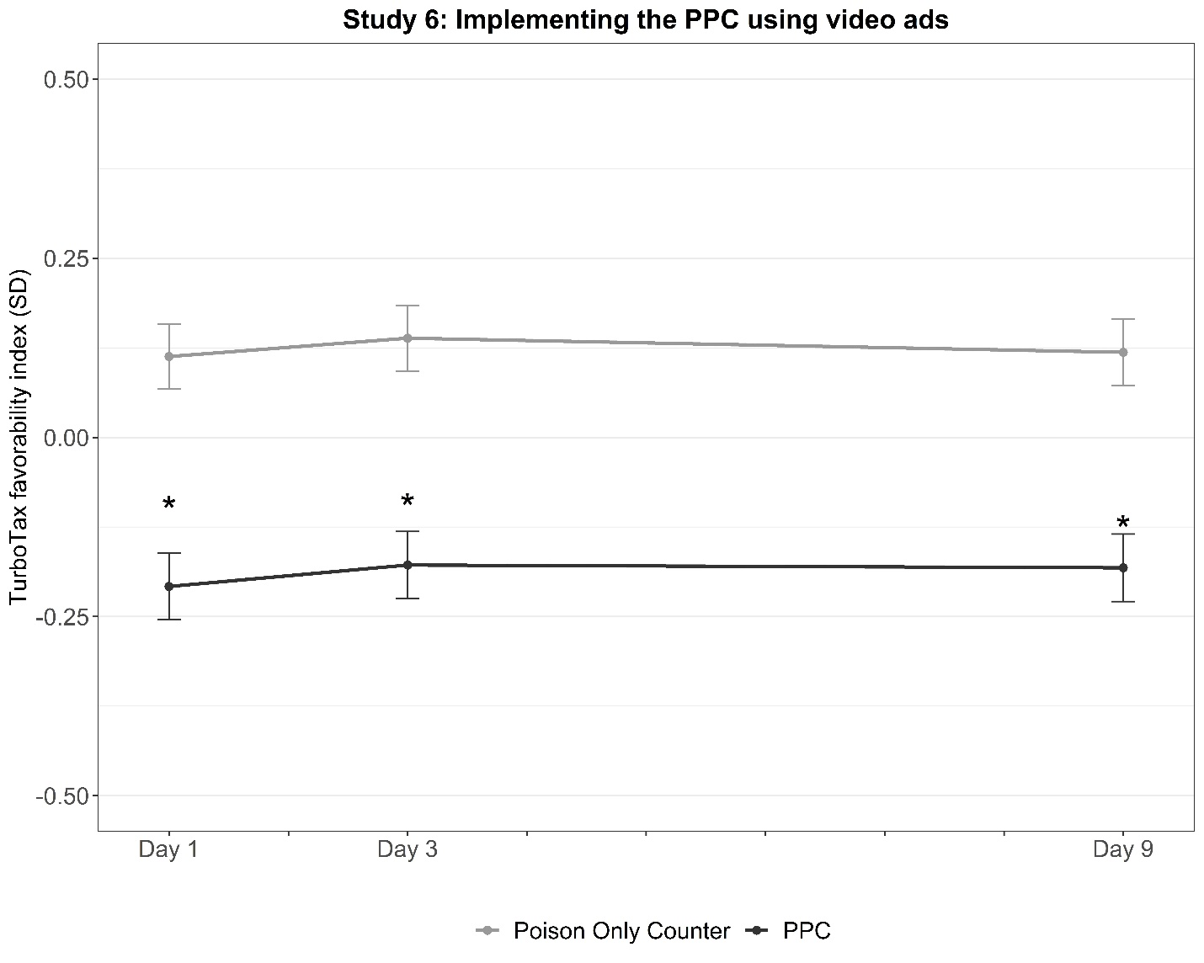
Notes: Outcome reflects regression-adjusted means of the TurboTax favorability index, calculated as the standardized aggregate measure of two outcome questions: (1) How positively or negatively do you view TurboTax? (2) If you were to use an online tax filing service, how likely would you be to use TurboTax? Study 6 included a third condition (the Pure Counterargument condition), which is not central to the main results and thus is not presented here. Additional details on this condition and the study procedure are available in online supplement. Error bars reflect ±1 standard error. * reflects differences significant at p < .01 compared to Poison Only Counter condition.

Figure S2. Original pro-McKinley ad, Studies 1 & 2
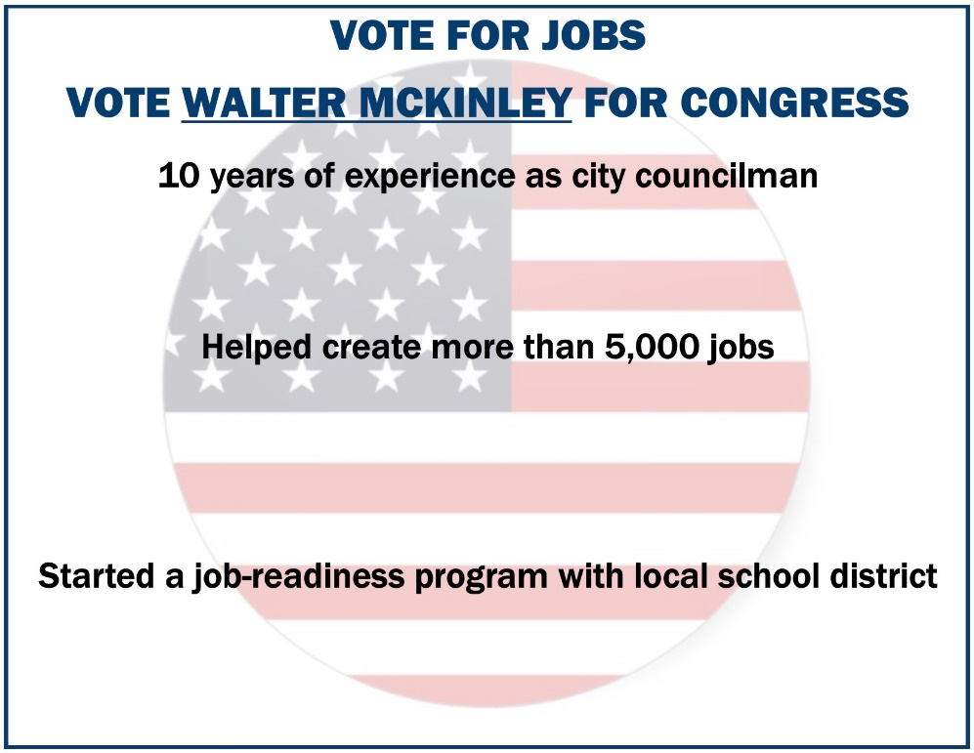

Figure S3. PPC ad, Studies 1 & 2
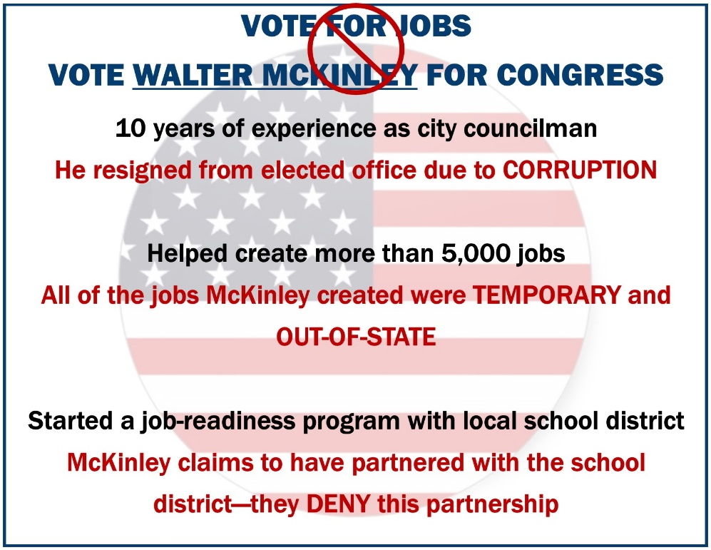

Figure S4. Traditional Counter ad, Studies 1 & 2
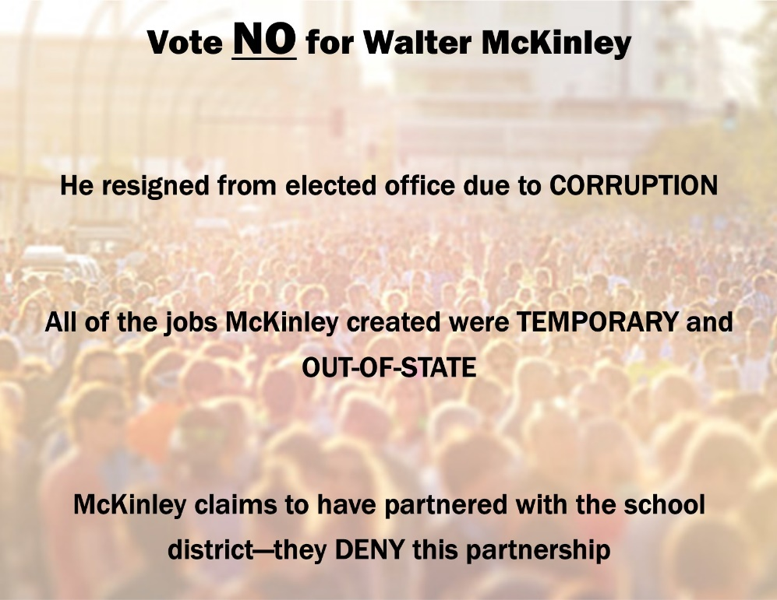
Figure S5. Original pro-McKinley ad, Studies 3, 4, & 7
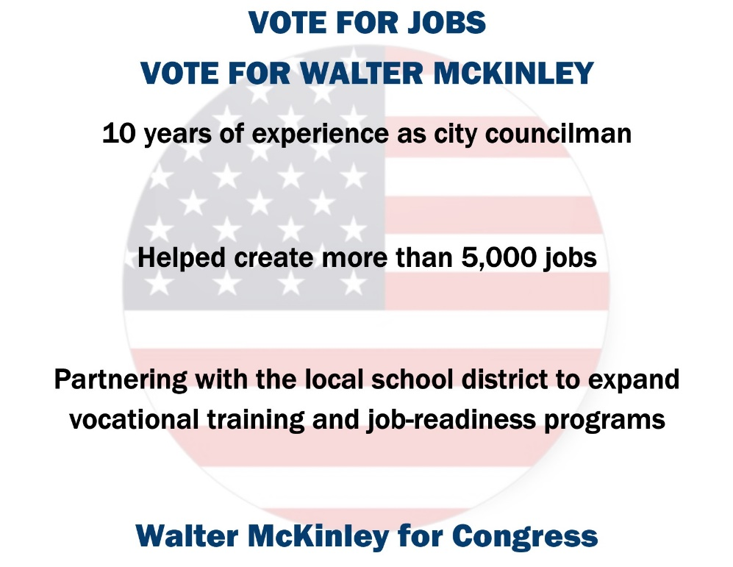

Figure S6. PPC ad, Studies 3, 4, & 7
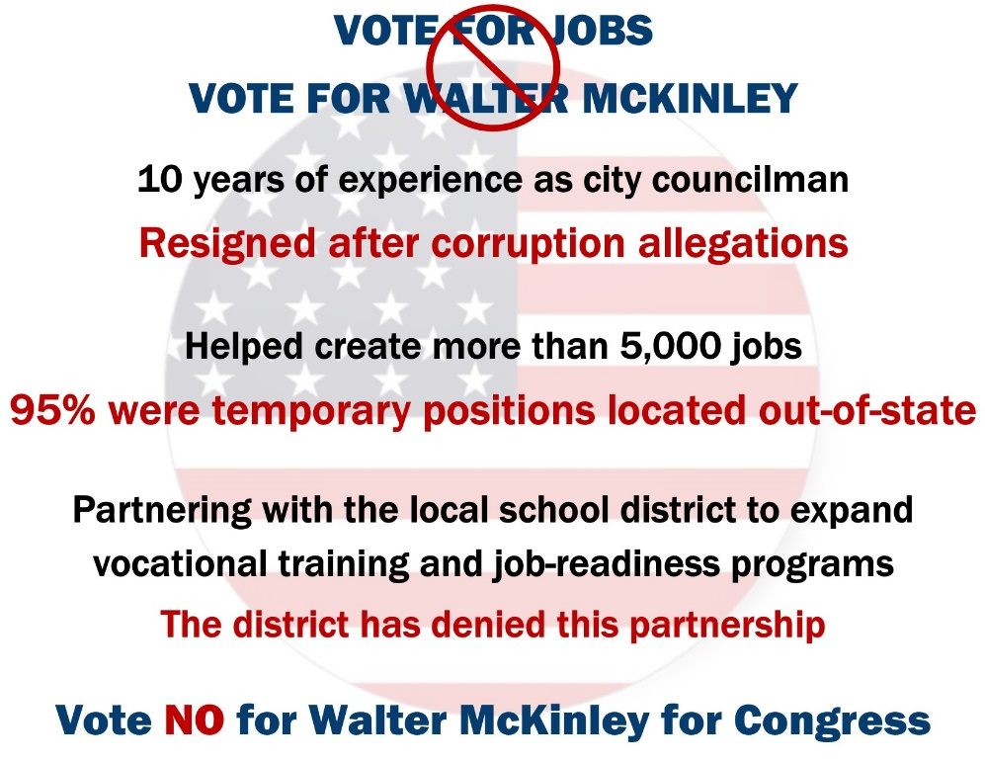
Figure S7. Traditional Counter ad, Studies 3, 4, & 7
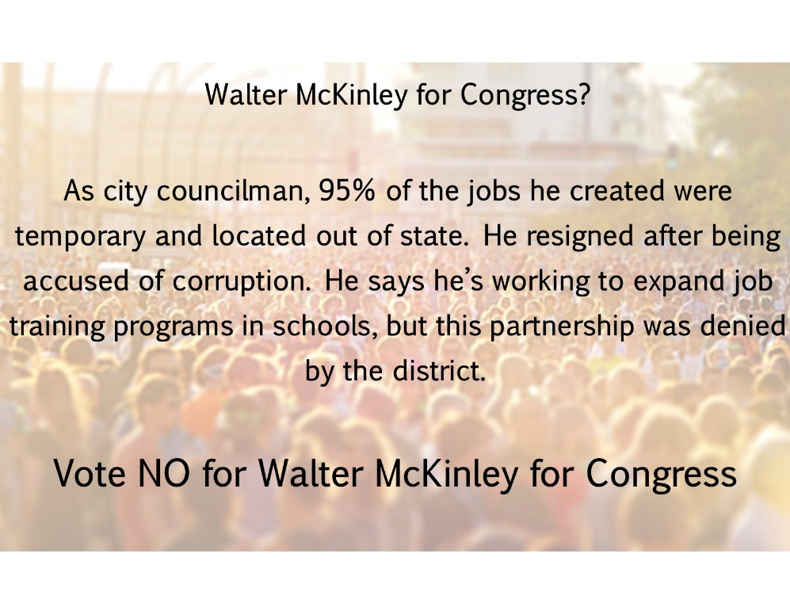

Figure S8. Original pro-Whitmer ad, Study 5
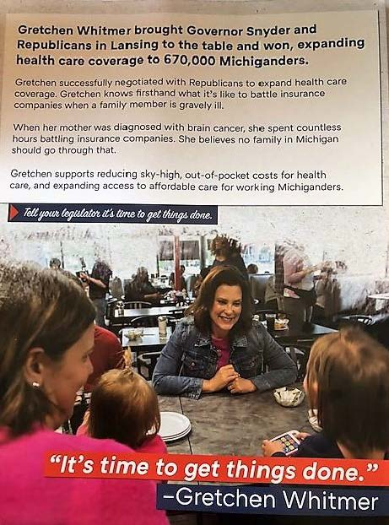

Figure S9. Traditional Counter ad, Study 5
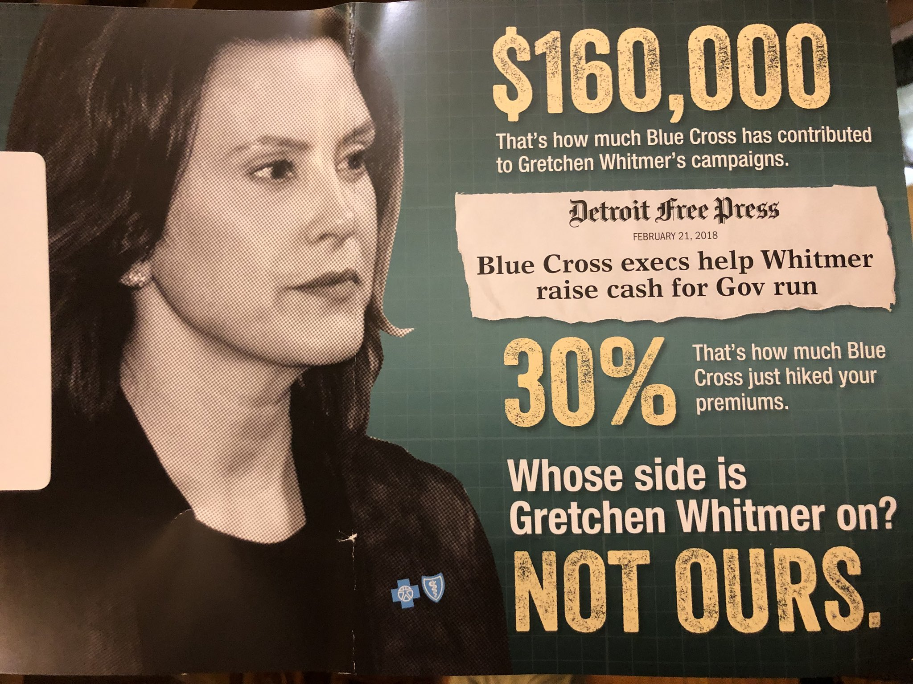

Figure S10. Full PPC ad, Study 5
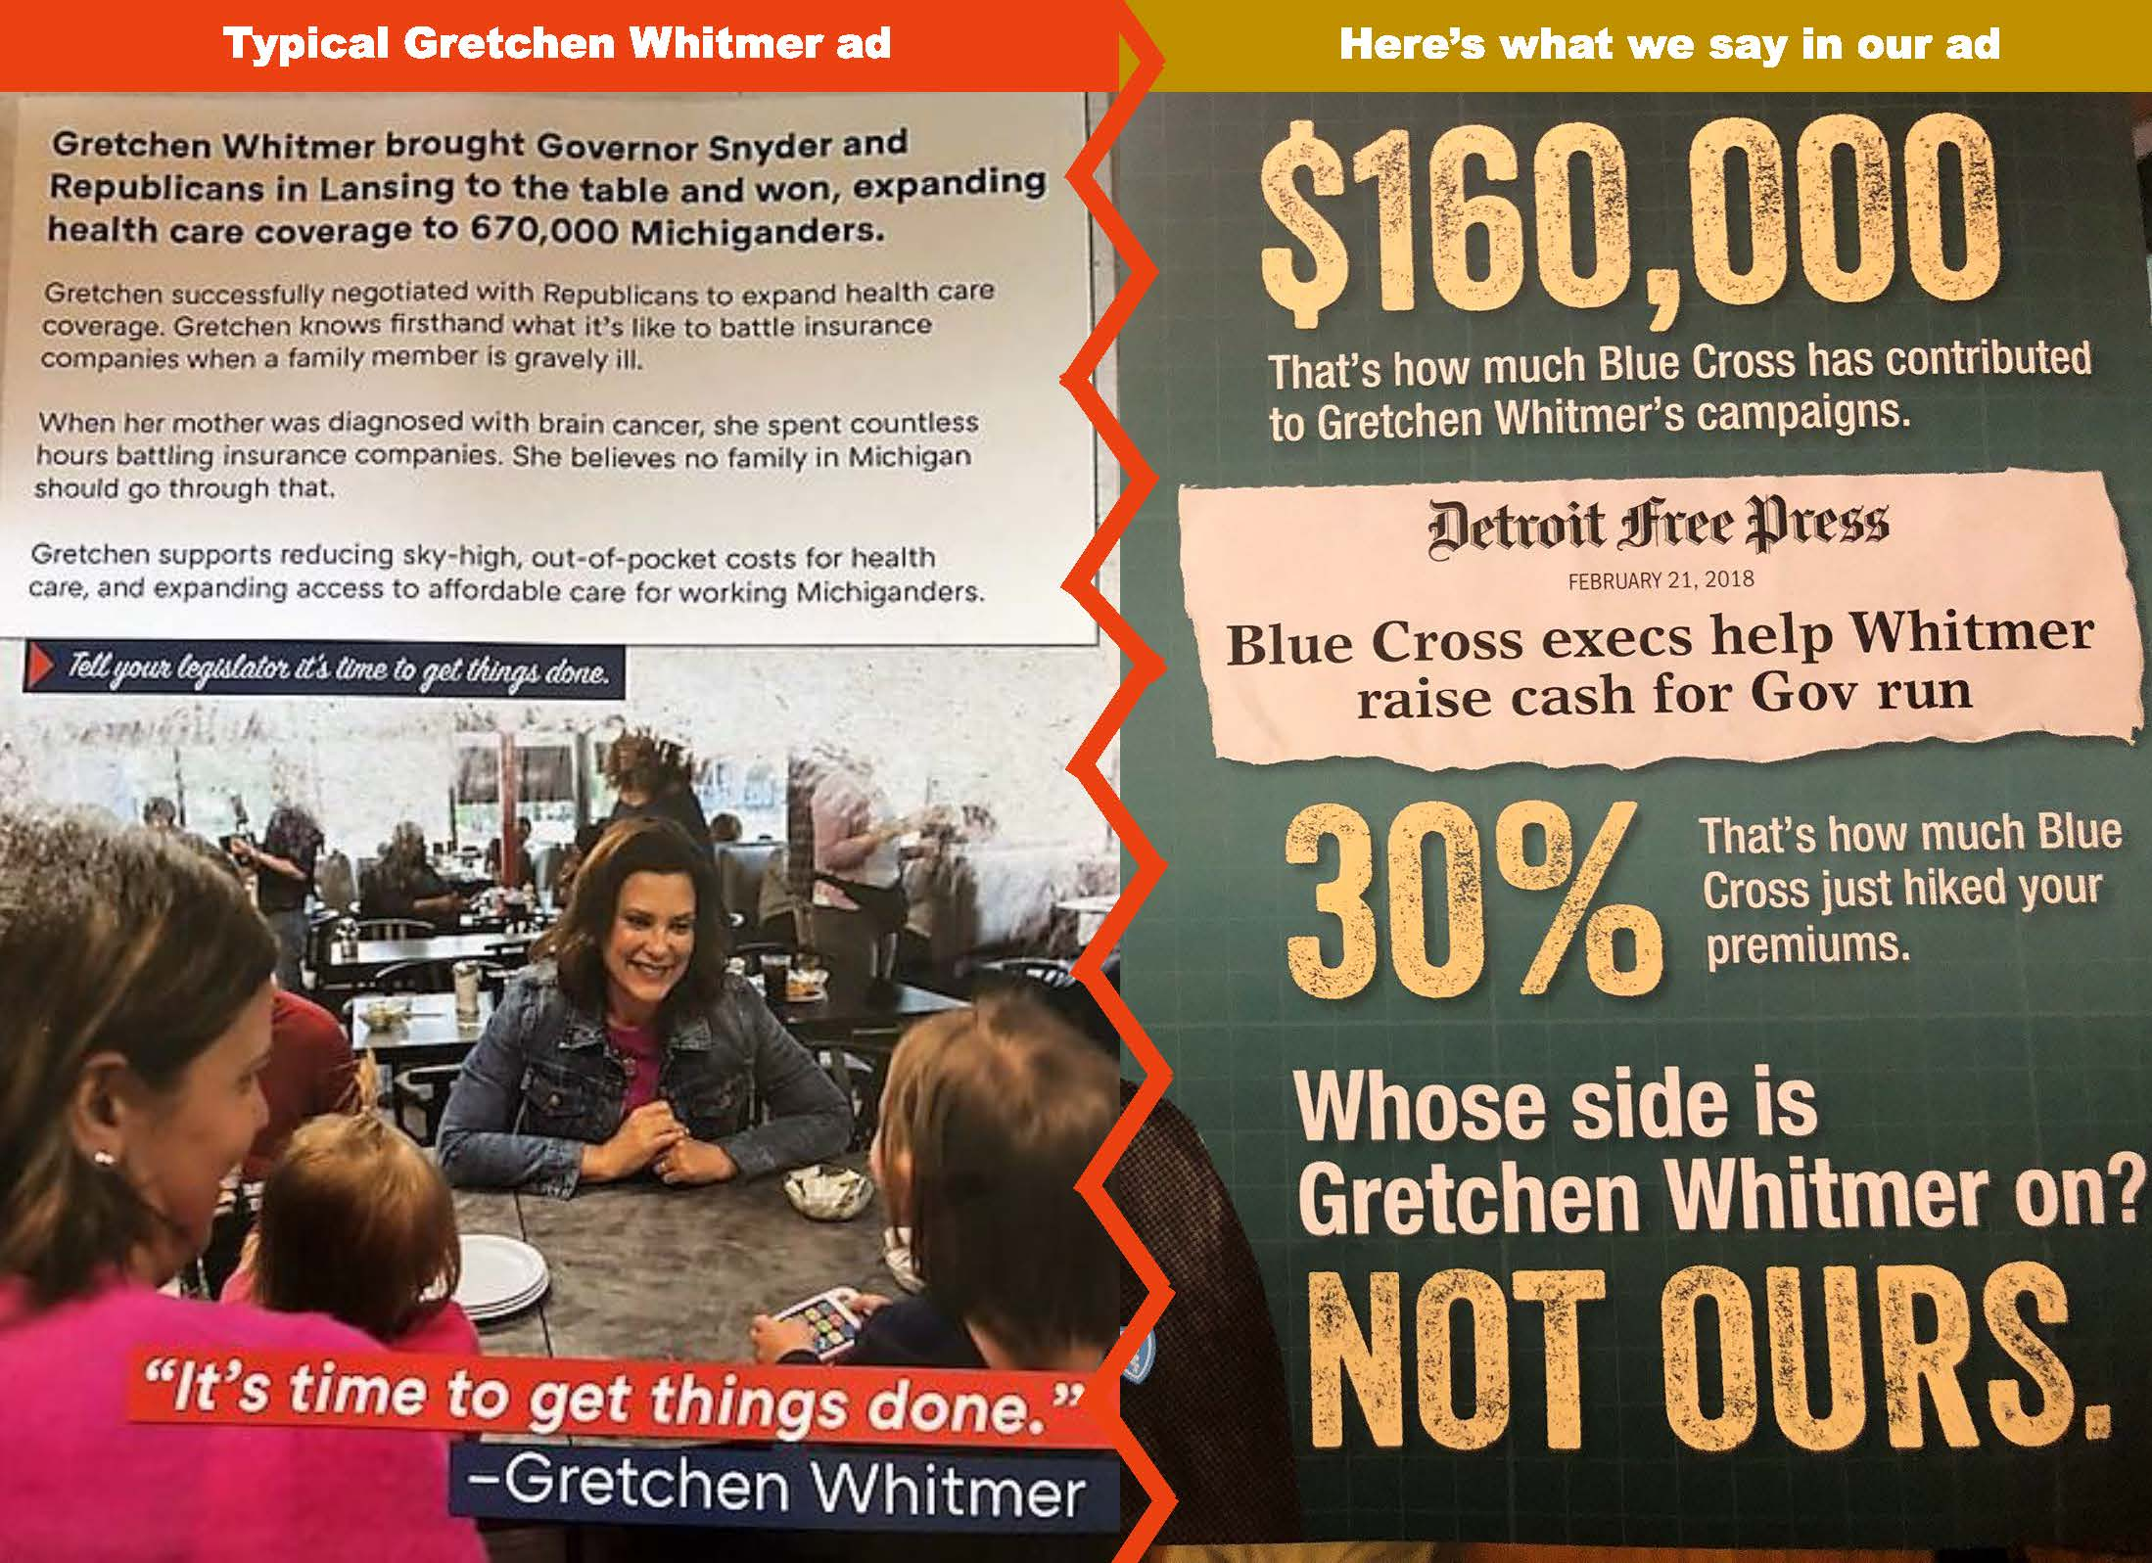

Figure S11. Tailored PPC ad, Study 5
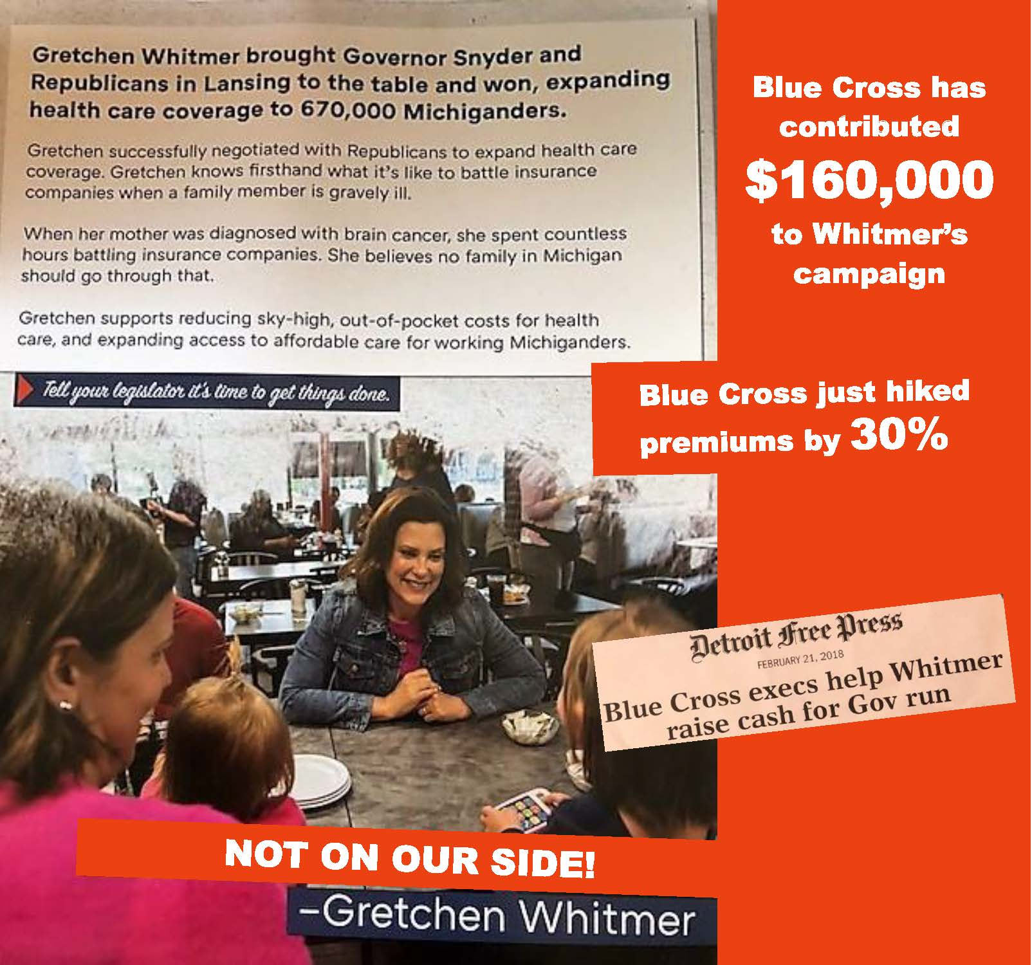

See, e.g., Eggert, D. (2018, July 27). Thanedar is big spender, Whitmer top raiser in governor race. US News & World Report. https://www.usnews.com/news/best-states/michigan/articles/2018-07-27/thanedar-pumps-millions-more-into-race-whitmer-raises-38m.

