Supplemental Material
Table S1.
Episodic and Semantic Memory
Patient | WAIS- Information | WAIS- Vocab | WAIS- Comprehension | WRAT-Reading | Famous Faces (Items) | Famous Faces (Familiar) | Famous Faces (Recognition) | Famous Faces (Named) | IAMQ (0-18) | IAMQ (19-39)
1846 | 8 | 8 | 9 | 102 | 155 | 99 | 84 (85%) | 73 (87%) | 73 | 59
1951 | 11 | 10 | 14 | 105 | 155 | 83 | 34 (41%) | 32 (94%) | 96 | 68
2308 | 8 | 11 | 8 | 105 | 133 | 109 | 36 (33%) | 29 (81%) | 83 | 49
2363 | 13 | 12 | 16 | 90 | 155 | 103 | 89 (86%) | 66 (87%) | 78 | 77
2367 | 10 | 9 | 13 | 100 | 155 | 154 | 106 (69%) | 69 (65%) | − | −
2563 | 12 | 9 | 9 | 92 | 155 | 154 | 142 (93%) | 138 (97%) | − | −
3139 | 13 | 11 | 11 | 96 | 155 | 152 | 118 (78%) | 100 (85%) | − | −
Note. WAIS = Wechsler Adult Intelligence Scale-III Full Scale IQ (Wechsler, 1997a). WRAT-Reading = Wide Range Achievement Test-Reading subtest. Across the WAIS subtests and WRAT-Reading, the patients in this sample generally performed in the average range, suggesting that many aspects of retrograde semantic memory are intact. Famous Faces (Familiar) = the number of items the patients rated as "familiar" (out of 155 total items except for patient 2308, who was administered only 133 items). “Recognition” indicates the number of items for which the patient indicated recognition either by naming or providing specific, unique identifying information of the person. The percentage is the number of faces "recognized" divided by the number of items the patient rated as "familiar." “Named” refers to the number of items the patient named accurately. The percentage is the number of faces "named" accurately divided by the number of faces "recognized." For a healthy (neurotypical) sample of 90 participants, these indices are (mean and SD): Recognition = 93% +/- 7; Naming = 85% +/- 11.1 (Tranel, 2006). Recognition scores on Famous Faces showed impairment, with most patients performing at least 1 SD below healthy comparisons. Patients 1951, 2308, and 2367 had the most substantial deficits in recognition, though naming skills on the Famous Faces Test were largely intact across the sample (with the exception of below average performance by 2367). IAMQ = Iowa Autobiographical Memory Questionnaire (Jones et al., 1998). Items on the IAMQ are separated by phases of life—childhood and adolescence (0 –18 years of age) and young adulthood (19 – 39 years of age). Scores represent the percent correct (number of correct responses divided by the number of possible correct responses). Available data suggests varying degrees of retrograde memory loss, which is supported by previous work in samples of patients with MTL damage (Feinstein et al., 2010; Tranel & Jones, 2005).

Table S2.

Caregiver Stability Coefficients
Patient | Rater | 2 months
1846 | Husband | 0.68 _{[.48-.81]}
1951 | Sister | 0.78 _{[.63-.87]}
 | Mother | 0.66 _{[.45-.80]}
2308 | Mother | 0.50 _{[.23-.69]}
 | Father | 0.49 _{[.23-.69]}
2363 | Sister-in-law | 0.75 _{[.59-.86]}
 | Son | 0.85 _{[.75-.92]}
2367 | Wife | 0.85 _{[.74-.91]}
2563 | Brother | 0.75 _{[.58-.85]}
3139 | Wife | 0.77 _{[.61-.87]}
 | Mean | 0.73
 | Median | 0.75
Note. All Pearson’s r correlations are significant at p<.01. 95% confidence intervals are denoted in brackets. Means reflect averages using Fisher's z-transformation.

Table S3.

Concurrent and Retrospective Self-Other Agreement Correlations
Patient | Rater | Baseline Concurrent Ratings | 2-month Concurrent Ratings | Retrospective Ratings
1846 | Husband | 0.54 _{[.29-.72]} | 0.39 _{[.11-.62]} | 0.50 _{[.24-.69]}
1951 | Sister | 0.14 _{[-.17-.42]} | 0.22 _{[-.08-.49]} | 0.52 _{[.27-.71]}
 | Mother | 0.12 _{[-.19-.40]} | 0.46 _{[.18-.66]} | 0.54 _{[.28-.72]}
2308 | Mother | 0.17 _{[-.13-.45]} | 0.54 _{[.28-.72]} | 0.65 _{[.44-.80]}
 | Father | 0.35 _{[.05-.58]} | 0.20 _{[-.10-.47]} | 0.76 _{[.59-.86]}
2363 | Sister-in-law | 0.09 _{[-.22-.37]} | 0.04 _{[-.26-.33]} | 0.67 _{[.47-.81]}
 | Son | -0.03 _{[-.32-.27]} | 0.05 _{[-.25-.34]} | −
2367 | Wife | 0.36 _{[.07-.59]} | 0.52 _{[.27-.71]} | 0.48 _{[.21-.68]}
2563 | Brother | -0.31 _{[-.56--.01]} | -0.30 _{[-.55--.01]} | 0.56 _{[.32-.74]}
3139 | Wife | 0.34 _{[.05-.58]} | 0.04 _{[-.26-.33]} | 0.41 _{[.13-.63]}
Mean |  | 0.21 | 0.22 | 0.58
Median |  | 0.16 | 0.21 | 0.54
Note. Correlations were computed using item-level BFI data (n=44). Retrospective ratings are item-level correlations between self-report ratings at 1-year and caregiver retrospective ratings at 1-year appointment. Correlations in bold are significant at p < .05. 2363 did not have a 2nd caregiver provide retrospective ratings.

Table S4.
Multiple Rater Agreement
 |  | Rater-Rater Correlation
Patient | Rater | Baseline Concurrent | 2-month Concurrent | Retrospective
1951 | Sister-Mother | 0.56 _{[.32-.74]} | 0.60 _{[.36-.76]} | 0.59 _{[.36-.76]}
2308 | Mother-Father | 0.63 _{[.41-.78]} | 0.75 _{[.58-.86]} | 0.70 _{[.51-.83]}
2363 | Sister-in-law-Son | 0.59 _{[.35-.75]} | 0.70 _{[.51-.83]} | −
Mean |  | 0.59 | 0.69 | 0.65
Median |  | 0.59 | 0.70 | 0.65
Note. All Pearson’s r correlations are significant at p < .05. Means reflect averages using Fisher's z-transformation. Patient 2363 did not have a 2nd rater provide retrospective correlations.

Figures S1-S7.
Big Five Inventory Ratings—Self and caregiver personality ratings across all time points measured. Raw scores were transformed into z-scores based on available age normative data (Srivastava et al., 2003). *Note, we acknowledge we are connecting discrete, rather than continuous data with lines in this graph.
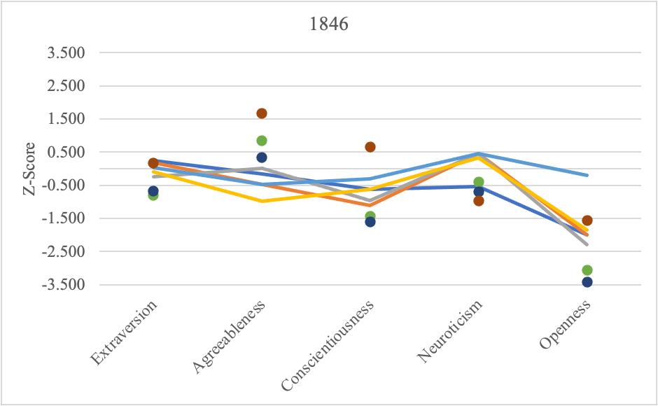

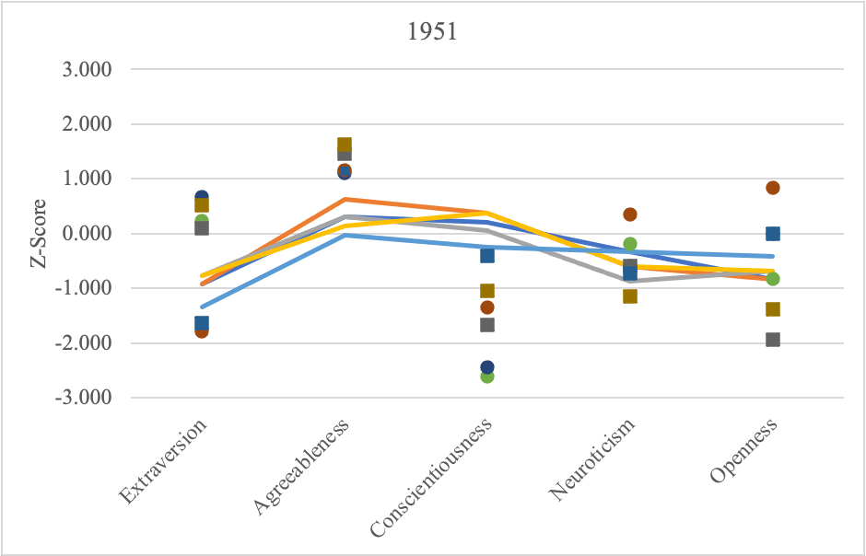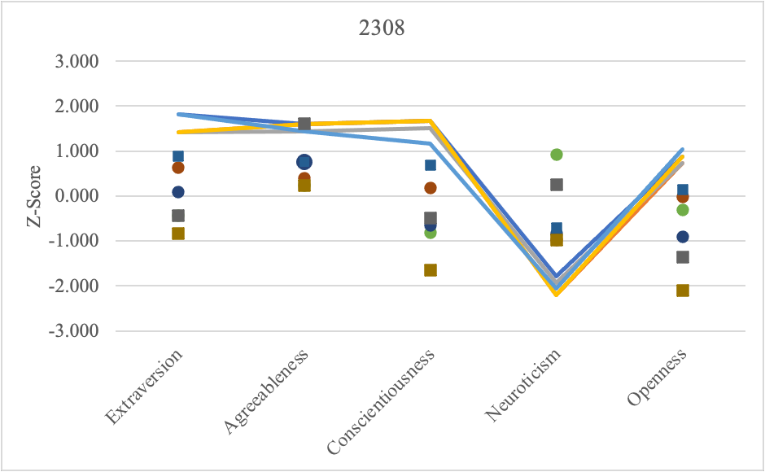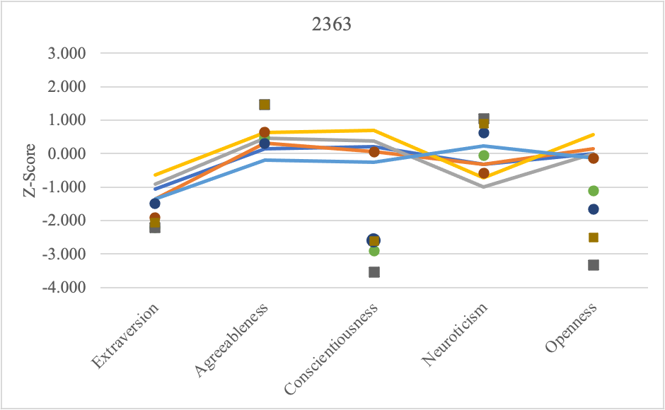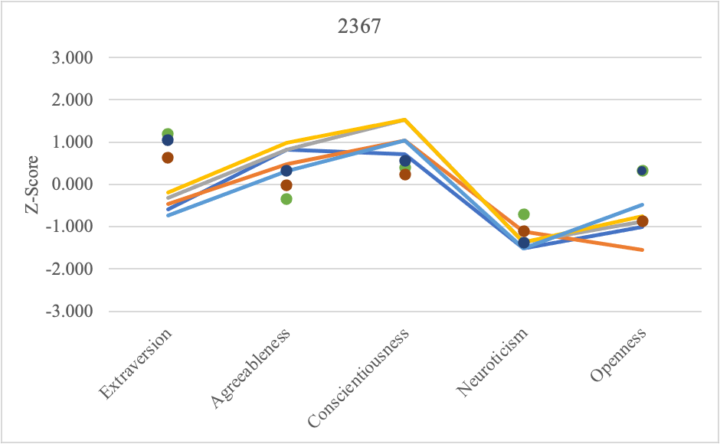

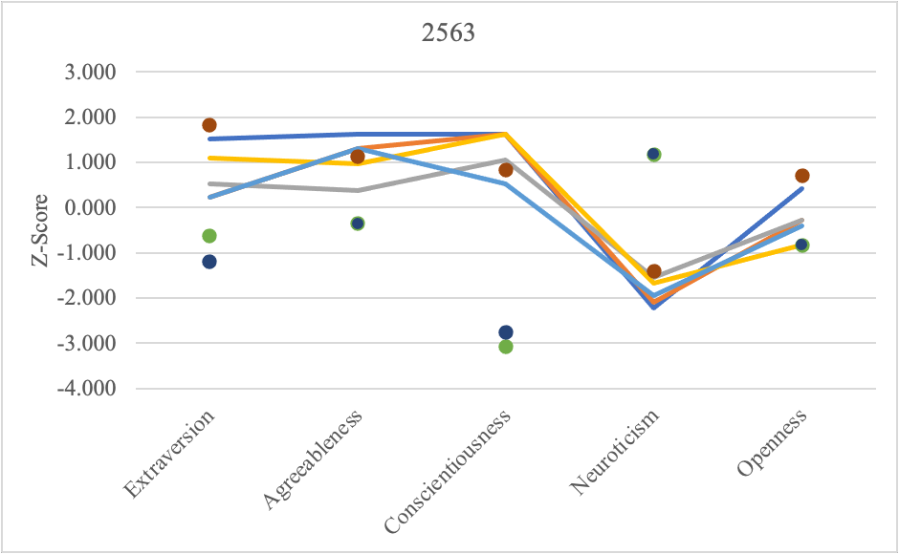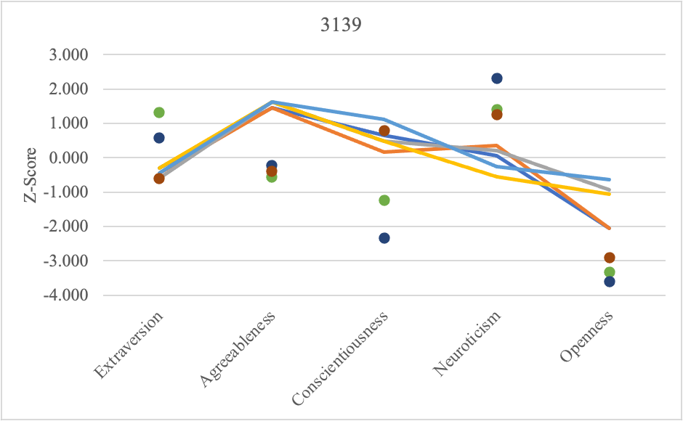

References
Feinstein, J. S., Rudrauf, D., Khalsa, S. S., Cassell, M. D., Bruss, J., Grabowski, T. J., & Tranel, D. (2010). Bilateral limbic system destruction in man. Journal of Clinical and Experimental Neuropsychology, 32(1), 88-106. https://doi.org/10.1080/13803390903066873
Jones, R. D., Grabowski, T. J., & Tranel, D. (1998). The neural basis of retrograde memory: evidence from positron emission tomography for the role of non-mesial temporal lobe structures. Neurocase, 4(6), 471-479. https://doi.org/10.1080/13554799808410640
Srivastava, S., John, O. P., Gosling, S. D., & Potter, J. (2003). Development of personality in early and middle adulthood: Set like plaster or persistent change?. Journal of Personality and Social Psychology, 84(5), 1041. https://doi.org/10.1037/0022-3514.84.5.1041
Tranel, D. (2006). Impaired naming of unique landmarks is associated with left temporal polar damage. Neuropsychology, 20(1), 1–10. https://doi.org/10.1037/0894-4105.20.1.1
Tranel, D., & Jones, R. D. (2006). Knowing “what” and knowing “when”. Journal of Clinical and Experimental Neuropsychology, 28(1), 43-66. https://doi.org/10.1080/13803390490919344

