Supplementary Materials

Quantification of potsherds and grinding stones
The densities of potsherds and grinding stones (Figure.6) were calculated with the formula: density = artifact quantity/excavation volume. Density data were obtained from published site reports and chronologically assigned by 23 ¹⁴C dates. The sites include Shizitan Locality 29(CHCSU(College of History and Culture of Shanxi University) and SPIA(Shanxi Provincial Institute of Archaeology), 2017), Shizitan Locality 14 (Shizitan Archaeology Team, 2002), Shizitan Locality 9(Shizitan Archaeology Team, 2010), Longwangchan(Zhang et al., 2011), Donghulin(Cui, 2010), Shangshan(Zhejiang Provincial Institute of Cultural Relics and Archaeology, 2016), Beifudi(Duan, 2007), Hehuashan(Jiang and Lei, 2018), Nanzhuangtou(Li et al., 2010), Xianrendong(Peking University and JPICRA, 2014).

Reconstructing plant processing history from Pleistocene to early Holocene China
Archaeobotanical data for reconstructing plant processing history in China (Figure 6) come microbotanical studies at the following sites: Shuidonggou CL1 and CL2 (Guan et al., 2014), Shizitan Locality 14 (Liu et al., 2013), Shizitan Locality 29 and Locality 5 (Liu et al., 2018), Shizitan Locality 19 (Liu et al., 2011), Nanzhuangtou (Yang et al., 2014), Donghulin (Liu et al., 2010a; Yang et al., 2012), and multiple Shangshan culture sites (this study and Liu et al., 2010b; Yang et al., 2015; Yao et al., 2016).

Acorn starch identification
There are 43 oak species in the Zhejiang province (Flora of China, n.d.). Our reference collection contains 17 samples collected from the study region, including five species of Quercus (Q. fabri, Q. variabilis, Q. acutissima, Q. aliena, and Q. dentata), six species of Lithocarpus (L. glaber, L. pachyhyllus, L. fenestratus, L.leucodermis, L. brevicaudatus, and L. craibianus), four species of Cyclobalanopsis (C. glauca, C. gracilisi, C. nubium, and C. jenseniana), and two species of Castanopsis (C. jucunda, C. sclerophylla).
Morphological analysis of archaeological samples identified two starch morphotypes consistent with the oak species in our reference collection (Table S1). Type 1 starch granules (size range= 9.3-33.44 μm) are triangular or water drop-shaped, exhibiting centric or slightly eccentric hila, extinction crosses with bent arms, indistinct lamellae, and linear fissures (Figure S3, 1-4). This morphotype is commonly found in all Quercus and occasionally present in Castanopsis and Cyclobalanopsis in our references. Type 2 starch granules (size range= 5.2- 38.3 μm) are spherical, some with pressure facets (Figure S3, 5-8). They have mostly centric hila, distinct lamellae, and linear fissures. This morphotype is present in Lithocarpus, Castanopsis, and Cyclobalanopsis species in our reference collection. The archaeological acorn starch granules are similar in size range to Q. fabri, Q. variabilis, L. pachyhyllus, L. fenestratus, L. craibianus, C. jucunda, and C. sclerophylla (Figure S3, 9).

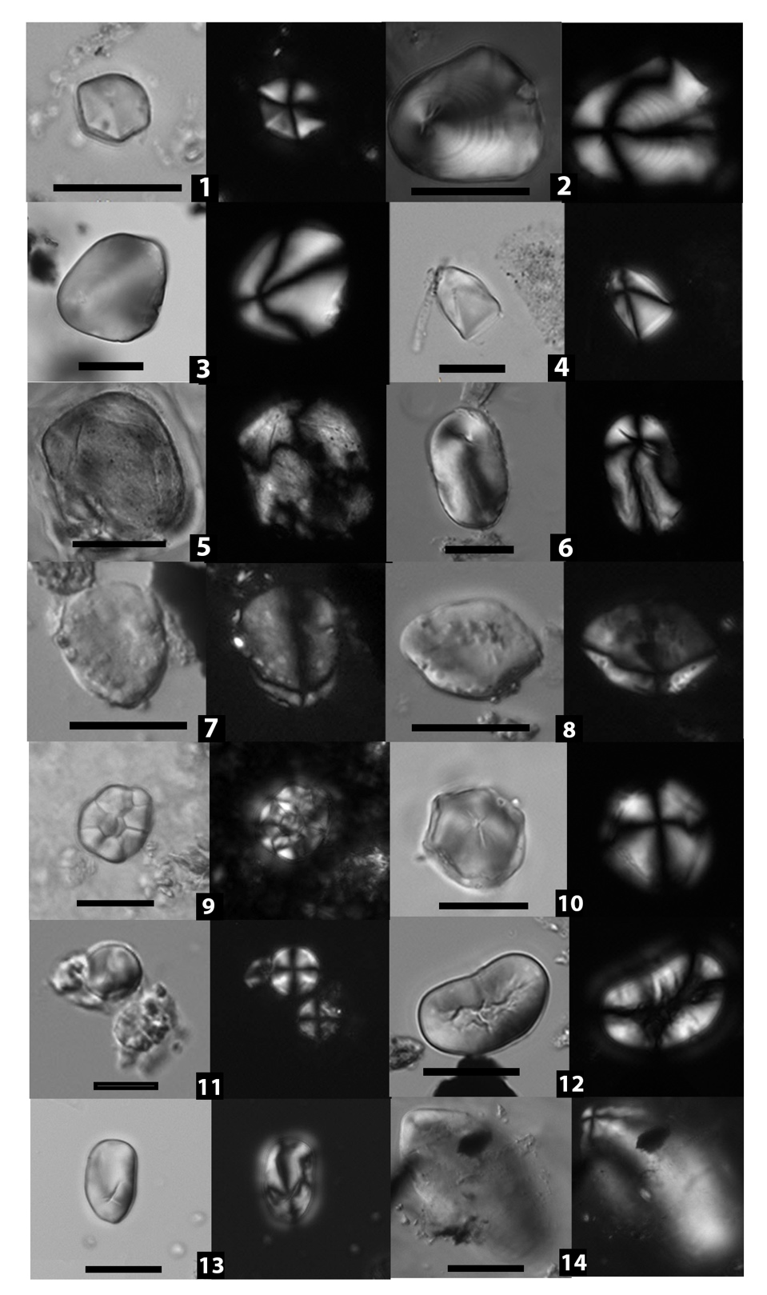

Fig. S1. Other starch types from Shangshan culture. 1. Kudzu vine root; 2. Snakegourd root; 3. Lily bulb; 4. Yam; 5. Fern root; 6. Lotus root; 7 and 8. cf. Ginger; 9. Rice; 10. Job’s tears; 11. Barnyard grass; 12. bean; 13 and 14. unidentified USOs (scale bars: 20 μm).

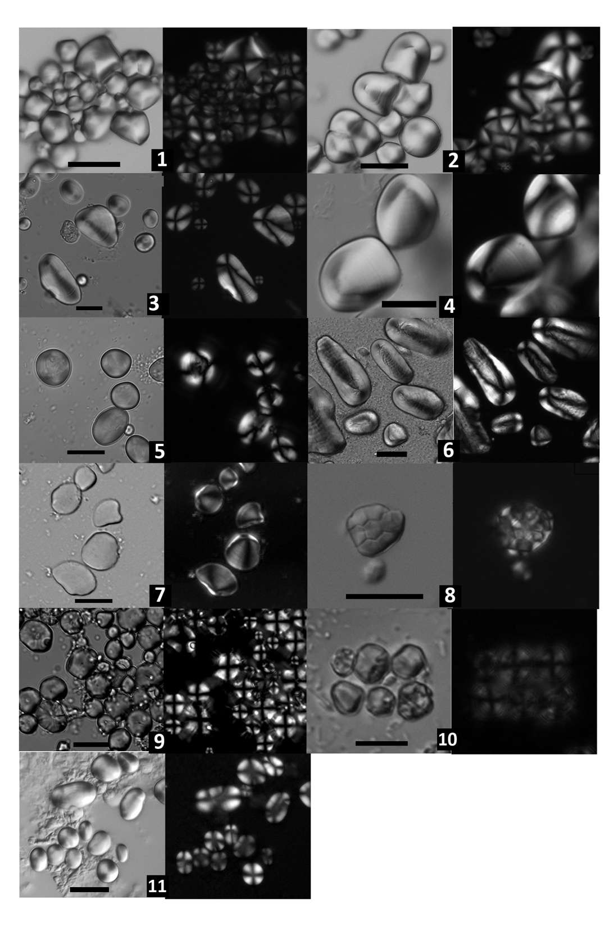
Fig. S2. Modern starch references. 1. Kudzu vine root (Pueraria lobata, from Jiangxi); 2. Snake gourd root (Trichosanthes kirilowii); 3. Lily bulb (Lilium pumilum); 4. Yam (Dioscorea polystachya); 5. Fern root (Pteridium aquilinum, from Zhejiang); 6. Lotus root (Nelumbo nucifera); 7. Ginger (Zingiber officinale); 8. Wild rice (Oryza rufipogon, from Jiangxi); 9. Wild Job’s tears (Coix lacryma-jobi, from Yunnan); 10. Barnyard grass (Echinochloa crus-galli); 11. Bean (Vigna sp.) (scale bars: 20 μm).

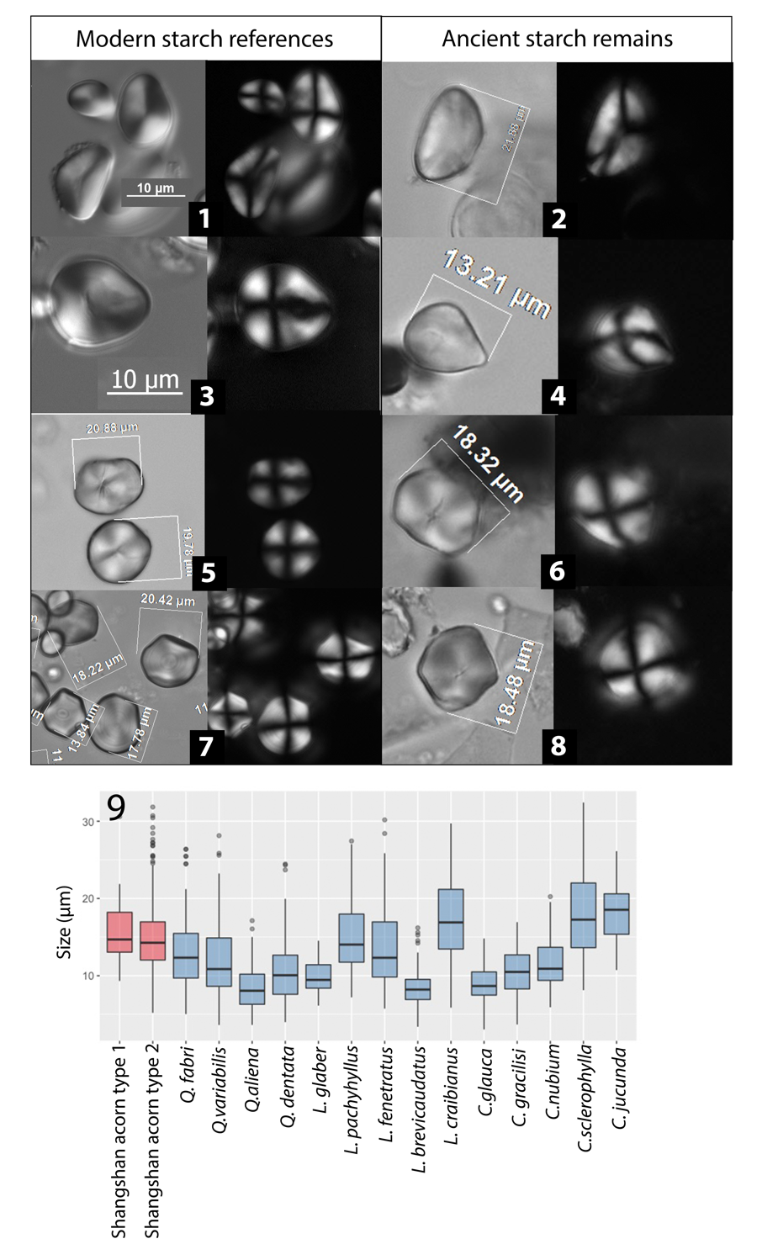

Fig. S3. Acorn starch granules from Shangshan and modern references. 1. triangular starch from Quercus fabri; 2. triangular acorn starch from Shangshan basin 24; 3. water drop-shaped starch from Quercus variabilis; 4. water drop-shaped acorn starch from Shangshan GS 1; 5. spherical starch from Lithocarpus craibianus; 6. spherical starch granules from Shangshan GS 3;7. spherical starch granules with facets from Cyclobanopsis glauca; 8. spherical starch granule with facets from Shangshan GS1; 9. Shangshan acorn starch size compared with modern references.

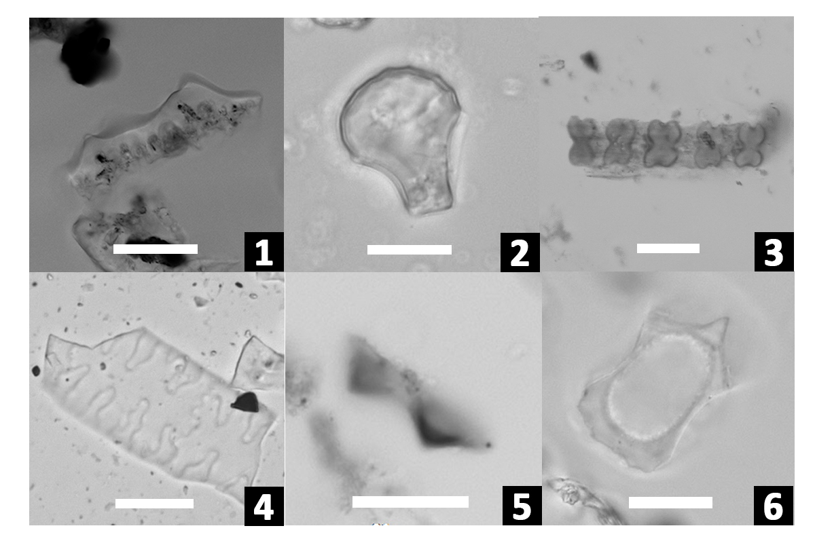

Fig. S4. Selective phytolith types from residue samples. 1. Double peak (Oryza, rice); 2. Oryza-type bulliform (Oryza, rice); 3. Parallel scooped bilobate (Ehrhartoideae); 4. Articulated quadrilobate (Panicoideae); 5. Tabular conical (Cyperaceae, sedge); 6. Phragmites bulliform (Phragmites) (scale bars: 20 μm).

References

CHCSU(College of History and Culture of Shanxi University), SPIA(Shanxi Provincial Institute of Archaeology), 2017. Shanxi jixian shizitan yizhi S29 didian fajue jianbao (Brief excavation report on Shizitan Locality 29, Shanxi). Kaogu 35–51.
Cui, T., 2010. The Study of Donghulin site’s Lithic Assemblage (PhD Dissertation). Peking University.
Duan, H., 2007. Beifudi. Wenwu Chubanshe, Beijing.
Flora of China [WWW Document], n.d. URL http://www.efloras.org/flora_page.aspx?flora_id=2 (accessed 6.8.18).
Guan, Y., Pearsall, D.M., Gao, X., Chen, F., Pei, S., Zhou, Z., 2014. Plant use activities during the Upper Paleolithic in East Eurasia: Evidence from the Shuidonggou Site, Northwest China. Quaternary International, Recent advances in studies of the late Pleistocene and Paleolithic of Northeast Asia 347, 74–83. doi:10.1016/j.quaint.2014.04.007
Jiang, L., Lei, D., 2018. Wan Nian Long You: Longyou Shiqian Wenhua Tanyuan (Longyou: Ten-thousand-year preshistic cultural history). zhongguo wenshi chubanshe (Chinese Literature and History Press).
Li, J., Qiao, Q., Ren, X., 2010. 1997 nian Hebei Xushui Nanzhuangtou yizhi fajue baogao (1997 Excavation report of Nanzhuangtou, Xushui, Hebei). Kaogu Xuebao 361–85.
Liu, L., Field, J., Fullagar, R., Zhao, C., Chen, X., Yu, J., 2010a. A functional analysis of grinding stones from an early Holocene site at Donghulin, North China. Journal of Archaeological Science 37, 2630–2639. doi:10.1016/j.jas.2010.05.023
Liu, L., Field, J., Weisskopf, A., Webb, J., Jiang, L., Huang, H., Chen, X., 2010b. The exploitation of acorn and rice in early Holocene lower Yangtze River, China. Acta Anthropologica Sinica 29, 317–36.
Liu, L., Ge, W., Bestel, S., Jones, D., Shi, J., Song, Y., Chen, X., 2011. Plant exploitation of the last foragers at Shizitan in the Middle Yellow River Valley China: evidence from grinding stones. Journal of Archaeological Science 38, 3524–3532. doi:10.1016/j.jas.2011.08.015
Liu, L., Bestel, S., Shi, J., Song, Y., Chen, X., 2013. Paleolithic human exploitation of plant foods during the last glacial maximum in North China. Proceedings of the National Academy of Sciences 201217864. doi:10.1073/pnas.1217864110
Liu, L., Levin, M.J., Bonomo, M.F., Wang, J., Shi, J., Han, J., Song, Y., 2018. Harvesting and processing wild millet in the Upper Paleolithic Yellow River Valley, China: A pathway to domestication. Antiquity 92, 603–619.
Peking University, JPICRA, (Jiangxi Provincial Institute of Cultural Relics and Archaeology), 2014. Xianrendong yu diaotonghuan. Wenwu Chubanshe, Beijing.
Shizitan Archaeology Team, 2002. Shanxi Jixian Shizitan jiushiqi shidai yizhi S14 didian 2002-2005 fajue jianbao(Paleolithic Locality S14 at Shizitan in Jixian, Shanxi). Kaogu 15–28.
Shizitan Archaeology Team, 2010. Shanxi jixian shizitan yizhi di 9 didian fajue jianbao (Brief excavation report on Shizitan Locality 9, Shanxi). Kaogu 7–17.
Yang, X., Wan, Z., Perry, L., Lu, H., Wang, Q., Zhao, C., Li, J., Xie, F., Yu, J., Cui, T., Wang, T., Li, M., Ge, Q., 2012. Early millet use in northern China. Proceedings of the National Academy of Sciences 109, 3726–3730. doi:10.1073/pnas.1115430109
Yang, X., Ma, Z., Wang, T., Perry, L., Li, Q., Huan, X., Yu, J., 2014. Starch grain evidence reveals early pottery function cooking plant foods in North China. Chinese Science Bulletin 32, 4352–4358. doi:10.1007/s11434-014-0500-6
Yang, X., Ma, Z., Li, J., Yu, J., Stevens, C., Zhuang, Y., 2015. Comparing subsistence strategies in different landscapes of North China 10,000 years ago. The Holocene 0959683615596833. doi:10.1177/0959683615596833
Yao, L., Yang, Y., Sun, Y., Cui, Q., Zhang, J., Wang, H., 2016. Early Neolithic human exploitation and processing of plant foods in the Lower Yangtze River, China. Quaternary International, Domestication East Asia 426, 56–64. doi:10.1016/j.quaint.2016.03.009
Zhang, J.-F., Wang, X.-Q., Qiu, W.-L., Shelach, G., Hu, G., Fu, X., Zhuang, M.-G., Zhou, L.-P., 2011. The paleolithic site of Longwangchan in the middle Yellow River, China: chronology, paleoenvironment and implications. Journal of Archaeological Science 38, 1537–1550. doi:10.1016/j.jas.2011.02.019
Zhejiang Provincial Institute of Cultural Relics and Archaeology, 2016. Pujiang Shangshan, Archaeological Report of Puyang River Valley. Wenwu chubanshe, Beijing.

