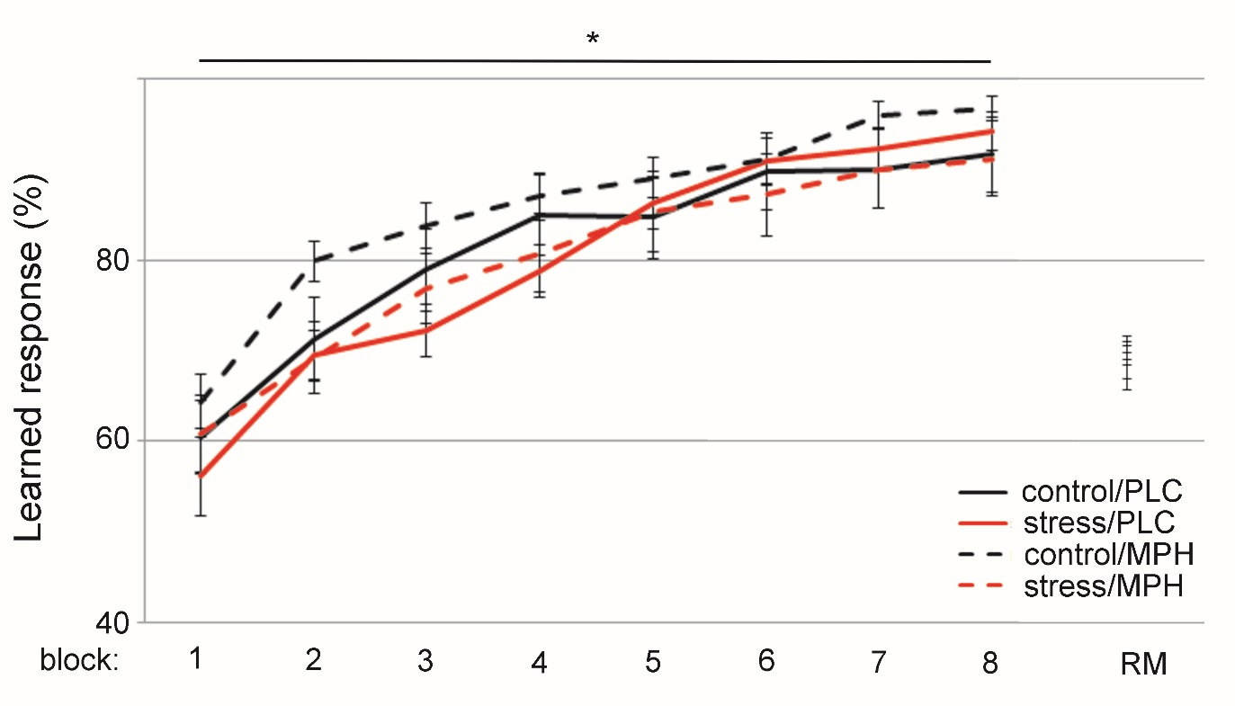
Figure S1: Performance on the instrumental learning task during training and reminder phase
Performance on the instrumental learning task significantly increased over blocks during the learning phase (*F(3.763,334.882) = 111.76, p < .001, η_{p}² = .557), reaching high level of performance during the final blocks. No group differences were observed across and between time points, nor during the reminder phase.

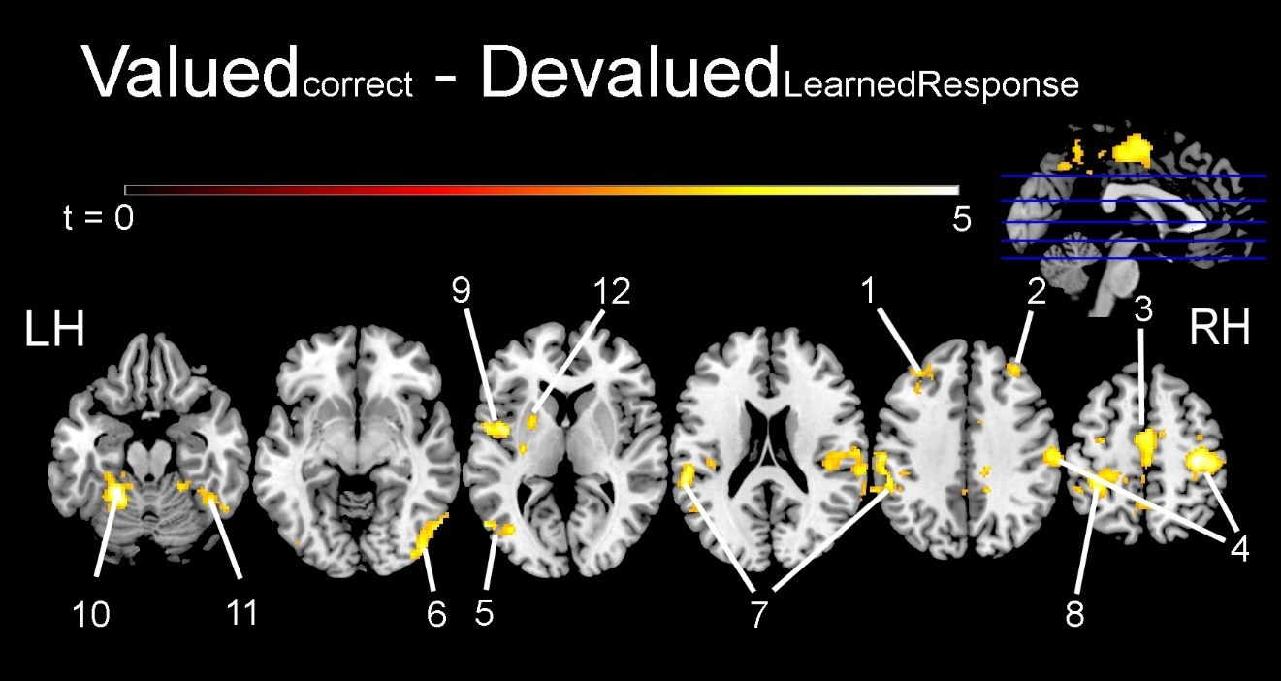
Figure S2: Brain activation associated with making a goal-directed response.
The contrast between brain activation associated with making a learned response on valuable trails (Valuable_{correct}) and learned responses (i.e. incorrect responses) to obtain devalued rewards (Devalued_{learned-response}), which we considered a measure of brain activation associated with goal-directed behaviour. Brain areas in among others sensorimotor and executive control networks were identified. The numbers correspond to the numbers in table S1 that provides descriptive statistics of the clusters.

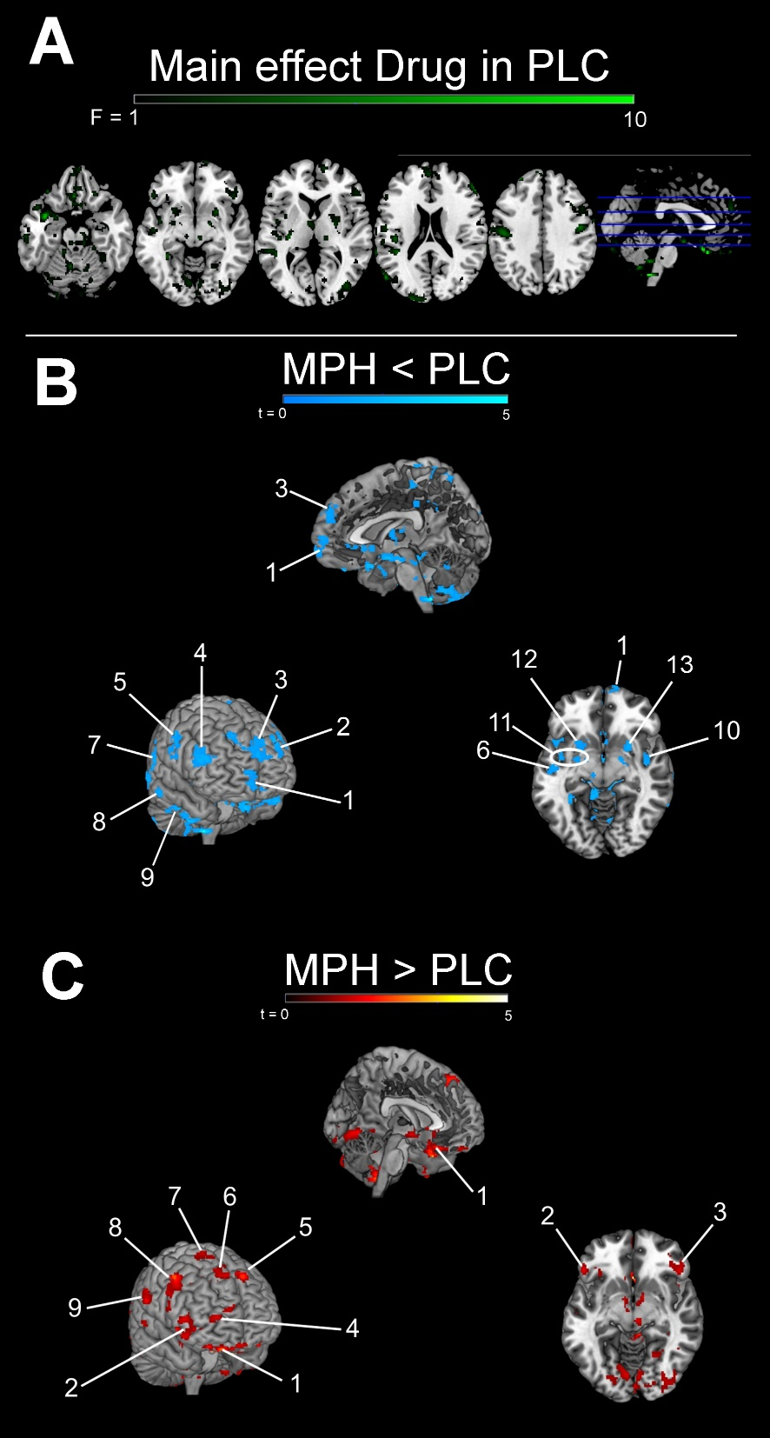
Figure S3: Effects of MPH on brain activation associated with goal-directed behaviour in the MAST control condition. Panel A: Bidirectional F-statistics for the effects of MPH on brain activation differences between Valued_{correct} and Devalued_{LearnedResponse} trials representing goal-directed behaviour associated brain activation. Panel B: MPH-induced decreases in activation difference between task conditions. The numbers correspond to the numbers in table S3 that provides descriptive statistics of the clusters.Panel C: MPH-induced increases in the difference between task conditions.

Area  Number  Figure S2 |  |  |  | Cluster size (voxels) | Peak p-value  (FWE corrected) | Peak coordinates (MNI)
 | Brain area | Lat. | BA |  |  | X | Y | Z
Goal-directed behaviour associated activation (Valuable_{correct} – Devalued_{Learned Response})
1 | Middle frontal gyrus | L | 9/46 | 246 | .001 | -36 | 30 | 46
2 | Frontal pole | R | 9/46 | 177 | .008 | 34 | 40 | 32
3 | Anterior cingulate | R | 24 | 685 | <.001 | 6 | 4 | 42
4 | Primary motor cortex | R | 4 | 2896 | <.001 | 34 | -24 | 56
5 | Lateral occipital cortex | L | 37 | 138 | .025 | -56 | -68 | 4
6 |  | R | 19 | 432 | <.001 | 44 | -84 | -6
7 | Inferior parietal lobule | L | 48 | 2402 | <.001 | -58 | -20 | 30
8 | Precuneous | L | 5 | 398 | <.001 | -4 | -52 | 48
9 | Insula | L | 48 | 301 | <.001 | -42 | -2 | 6
10 | Cerebellum V | L | - | 852 | <.001 | -22 | -46 | -20
11 |  | R | - | 186 | .006 | 20 | -42 | -18
12 | Putamen | L | - | 182 | .007 | -24 | 4 | 4
Table S1: Brain regions displaying activation associated with goal-directed behaviour. Brain areas showing significantly more activation on Valuable_{correct} trails compared with Devalued_{learned response} trials and corrected for effects of MAST, Drug and their interaction.

Table S2: Drug dependent effects of stress on brain activation
A comprehensive overview of all peak voxels within clusters of activation showing MPH-dependent activation differences between MAST-induced stress and control differences. Section A lists clusters in which stress reduced brain activation associated with goal-directed behaviour (i.e. Valuable_{correct}-Devalued_{learned-response} contrast), both after placebo administration only and in conjunction with effects of stress following MPH. Section B lists clusters in which stress increased activation associated with goal-directed behaviour, both after placebo only and in conjunction with effects of stress after MPH administration. Areas of interest are presented in the main paper, not here. L = left R = right Lat. = laterality BA = Brodmann area FWE = familywise error MNI = Montreal Neurological Institute PLC = placebo MPH = methylphenidate
 |  |  | Cluster size (voxels) | Peak p-value  (FWE corrected) | Peak coordinates (MNI)
Brain area | Lat. | BA |  |  | X | Y | Z
A | Stress reduced activation after PLC
Middle frontal gyrus | L | 46 | 33 | .041 | -42 | 32 | 42
Superior parietal lobule 5Ci | L | - | 33 | .012 | -14 | -34 | 48
7A | R | 7 | 119 | .005 | 14 | -60 | 66
Inferior parietal lobule PFcm | L | 41 | 191 | <.001 | -48 | -36 | 14
Somatosensori cortex | R | 3 | 82 | .012 | 20 | -34 | 66
Temporal pole | L | 38 | 186 | <.001 | -36 | 4 | -22
 |  |  | 97 | .012 | -50 | 14 | -24
Primary auditory cortex | R | 20 | 286 | <.001 | 44 | 0 | -46
Entorhinal cortex | L | 35 | 106 | <.001 | -14 | -14 | -28
 | R | 36 | 80 | <.001 | 28 | 4 | -28
Hippocampus | L | 37 | 74 | .005 | -26 | -36 | 0
Dentate gyrus | R | 20 | 49 | .005 | 30 | -22 | -10
Fusiform cortex | L | 14 | 62 | .005 | -32 | -44 | -14
Lateral occipital cortex | L | 39 | 116 | .002 | -54 | -70 | 20
 | R | 19 | 80 | .005 | 40 | -84 | 28
Cerebellum Crus I | R | - | 36 | .002 | 40 | -82 | -26
Crus II | L | - | 84 | <.001 | -18 | -90 | -32
VIIIb | R | - | 364 | <.001 | 24 | -46 | -52
I-IV | L | 30 | 116 | <.001 | -10 | -42 | -12
VI | R | - | 50 | .005 | 14 | -68 | -28
VIIIa | R | - | 57 | <.001 | 6 | -68 | -52
IX | R | - | 28 | .012 | 8 | -46 | -36
Putamen | L | 48 | 35 | .002 | -22 | 18 | -2
Thalamus | L/R | - | 47 | .012 | 0 | -6 | 10
Brain stem | L | - | 169 | .012 | -10 | -36 | -48
 | R | - | 42 | <.001 | 2 | -46 | -56
Mamillary bodies | L | - | 90 | .002 | -6 | -10 | -16
Stress reduced activation after PLC and affected activation after MPH
Superior parietal lobule 7A | R | 7 | 80 | .005 | 12 | -60 | 66
Inferior parietal lobule PGp | L | 39 | 28 | .002 | -50 | -70 | 32
PGa | L | 19 | 27 | .021 | -38 | -70 | 32
Lateral occipital cortex | R | 19 | 65 | .005 | 38 | -84 | 28
Angular gyrus | R | 21 | 54 | .003 | 64 | -56 | 22
Superior temporal gyrus | L | 20 | 117 | <.001 | -44 | -12 | -14
Middle temporal gyrus | L | 21 | 79 | .012 | -48 | -40 | 2
Inferior temporal gyrus | R | 20 | 77 | <.001 | 42 | 0 | -46
Temporal pole | L | 38 | 63 | .021 | -44 | 20 | -34
 | R | 38 | 103 | <.001 | 36 | 22 | -32
Cerebellum crus II | L | - | 61 | .002 | -18 | -88 | -32
VIIIb | R | - | 251 | <.001 | 24 | -46 | -52
Parahippocampal gyrus | L | 29 | 120 | <.001 | -8 | -40 | -12
 |  | 35 | 52 | <.001 | -12 | -12 | -26
 | R | 36 | 53 | <.001 | 24 | -12 | -36
Dentate gyrus | L | 37 | 61 | .012 | -24 | -34 | 0
Hippocampus | R | 20 | 35 | .005 | 30 | -22 | -10
Mamillary bodies | L | - | 73 | .003 | -6 | -6 | -16
Thalamus | L | - | 33 | .012 | -2 | -6 | 10
Brain stem | L | - | 122 | .012 | -10 | -36 | -48
B | Stress increased activation after PLC
Occipital pole | R | 18 | 55 | <.001 | 4 | -92 | -14
Cerebellum I-IV | R | - | 45 | <.001 | 4 | -42 | -26
Stress both increased activation after PLC and affected activation after MPH
Lingual gyrus | R | 18 | 31 | .003 | 6 | -86 | -16

Table S3: MPH effects on brain activation associated with goal-directed behaviour
Section A lists clusters in which MPH decreased activation associated with goal-directed behaviour during the MAST control condition. Section B lists clusters in which MPH increased brain activation associated with goal-directed behaviour (i.e. Valuable_{correct}-Devalued_{Learned-response} contrast) in the MAST control condition.

Area  Number  Figure S3 |  |  |  | Cluster size (voxels) | Peak p-value  (FWE corrected) | Peak coordinates (MNI)
 | Brain area | Lat. | BA |  |  | X | Y | Z
A |  | MPH decreased activation
 | Subcallosal cortex | R | 25 | 45 | <.001 | 0 | 22 | -6
 | Orbitofrontal cortex | R | 25 | 71 | <.001 | 12 | 16 | -22
 | Medial frontal cortex | R | 11 | 73 | <.001 | 2 | 26 | -30
 |  |  | 11 | 55 | <.001 | 4 | 42 | -32
1 | Frontal pole | R | 11 | 126 | <.001 | 14 | 70 | -8
2 |  |  | 46 | 87 | <.001 | -28 | 50 | 36
 |  |  | 9 | 36 | <.001 | 24 | 50 | 42
3 | Superior frontal gyrus (medial) | L | 10 | 331 | <.001 | -2 | 54 | 24
4 | Middle frontal gyrus | R | 45 | 162 | <.001 | 54 | 36 | 20
 |  |  | 9 | 50 | <.001 | -44 | 24 | 46
 | Inferior frontal gyrus | R | 45 | 60 | <.001 | -56 | 30 | 12
 | Anterior cingulate | R | 11 | 36 | <.001 | -2 | 32 | -6
 | Premotor cortex | L | 4/6 | 29 | <.001 | -6 | -18 | 60
 |  |  | 6 |  | <.001 | -10 | -14 | 74
 | Precentral gyrus | L | 6 | 26 | <.001 | -32 | -12 | 50
 | Primary motor cortex | L | 48 | 778 | <.001 | -66 | -16 | 24
 |  |  | 4 | 39 | <.001 | 8 | -26 | 56
5 |  | R | 4 | 243 | <.001 | 46 | -10 | 34
 |  |  | 4 | 136 | <.001 | 14 | -30 | 74
 | Posterior cingulate | L | 23 | 78 | <.001 | -2 | -30 | 38
 |  |  | - | 37 | <.001 | 14 | -42 | 38
 | Primary somatosensori cortex | L | 5 | 78 | <.001 | -16 | -46 | 56
 |  |  | 4 | 73 | <.001 | -20 | -36 | 74
 | Superior parietal lobule 7A | L | 5 | 113 | <.001 | 16 | -58 | 70
 | Inferior parietal lobule PGp | L | 19 | 125 | <.001 | 42 | -80 | 32
 | PFcm |  | 41 | 97 | <.001 | -40 | -38 | 20
 | Precuneous | L | 30 | 34 | 0.001 | -12 | -54 | 10
 | Lateral occipital cortex | L | 39 | 258 | <.001 | -54 | -70 | 22
 |  |  | 37 | 40 | 0.001 | 58 | -66 | 0
 | Temporal fusiform cortex | L | 37 | 142 | <.001 | -34 | -44 | -8
 | Supramarginal gyrus | L | 22 | 35 | <.001 | -66 | -38 | 22
6 | Superior temporal gyrus | L | 48 | 70 | <.001 | -48 | -12 | -10
7 |  | R | 22 | 64 | <.001 | 70 | -34 | 16
 | Superior/Middle temporal gyrus | L | 21 | 131 | <.001 | -46 | -40 | 2
 | Middle temporal gyrus | L | 21 | 48 | <.001 | -64 | -54 | 0
8 | Middle temporal gyrus | R | 21 | 44 | <.001 | 70 | -44 | -2
 |  |  | 21 | 28 | 0.001 | 70 | -20 | -16
 |  |  | 21 | 26 | <.001 | -60 | -2 | -32
9 |  |  | 20 | 92 | <.001 | 52 | -14 | -32
 |  |  | 20 | 33 | <.001 | -50 | -20 | -34
 |  |  | 20 | 26 | <.001 | 44 | -16 | -40
 | Inferior temporal gyrus | R | 20 | 104 | <.001 | 46 | 8 | -46
 | Temporal pole/amygdala | L | 38 | 366 | <.001 | -36 | 4 | -22
 | Insula | L | 48 | 36 | <.001 | -32 | -14 | 14
10 |  |  | 48 | 29 | 0.001 | 44 | -8 | -8
 | Cerebellum crus I | L | - | 39 | <.001 | 42 | -40 | -36
 | crus II | L | - | 58 | <.001 | 38 | -80 | -42
 | IX | L/R | - | 242 | <.001 | 0 | -56 | -46
11 | Insula/Putamen | L | - | 183 | <.001 | -42 | -2 | -10
12 | Putamen | R | - | 120 | <.001 | -24 | 12 | -6
13 |  |  | - | 97 | <.001 | 26 | 10 | -10
 | Brain stem/cerebellum | R | - | 1693 | <.001 | 4 | -2 | -16
 |  |  | - | 426 | <.001 | 4 | -44 | -56
 | Brain stem | R | - | 129 | <.001 | 4 | -42 | -32
 | Thalamus | L | - | 127 | <.001 | -4 | -6 | 6
B |  | MPH increased activation
 | Subcallosal cortex | L | 11 | 27 | <.001 | -8 | 20 | -10
1 | Orbitofrontal cortex | L | 11 | 462 | <.001 | -16 | 12 | -28
2 |  |  | 38/47 | 128 | <.001 | -48 | 24 | -14
 |  |  | 47 | 71 | <.001 | -34 | 32 | -20
 |  | R | 47 | 44 | <.001 | 26 | 28 | -12
3 | Frontal pole | R | 47 | 269 | <.001 | 50 | 34 | -14
4 |  |  | 10 | 56 | <.001 | 34 | 56 | 4
 |  |  | 10 | 25 | <.001 | 22 | 62 | 14
5 | Superior frontal gyrus | L | 8/9 | 149 | <.001 | -8 | 36 | 42
 |  |  | 6 | 30 | <.001 | -24 | 4 | 58
6 |  | R | 32 | 146 | <.001 | 18 | 38 | 40
7 |  |  | 6 | 62 | <.001 | 22 | 10 | 66
 |  |  | 8 | 35 | <.001 | 22 | 8 | 48
 | Middle frontal gyrus | L | 44 | 68 | <.001 | -42 | 10 | 40
8 |  | R | 44 | 422 | <.001 | 48 | 8 | 26
 | Inferior frontal gyrus | R | 6 | 26 | <.001 | 56 | 10 | 14
 | Postcentral gyrus | R | 2 | 78 | <.001 | 66 | -22 | 22
 | Secondary somatosensory cortex | L | 48 | 65 | <.001 | -42 | -24 | 14
 | Inferior parietal lobule | L | 42 | 57 | <.001 | -58 | -32 | 14
 | Lateral occipital cortex | R | 19 | 545 | <.001 | 40 | -84 | -20
9 |  |  | 39 | 30 | <.001 | 54 | -64 | 20
 | Occipital pole | L | 18 | 308 | <.001 | -28 | -88 | 4
 | Lingual gyrus | L | 19 | 26 | <.001 | -20 | -60 | -4
 | Temporal/occipital fusiform cortex | R | 19/37 | 59 | <.001 | 24 | -58 | -14
 | Temporal fusiform cortex | L | 20 | 134 | <.001 | -34 | -6 | -50
 | Middle temporal gyrus/angular gyrus | R | 21 | 134 | <.001 | 48 | -52 | 2
 | Middle temporal gyrus | R | 21 | 27 | <.001 | 60 | -30 | -2
 |  | L | 20 | 379 | <.001 | -50 | -14 | -38
 |  |  | 37 | 37 | <.001 | 54 | -64 | -20
 | Temporal pole | R | 38 | 71 | <.001 | 40 | 12 | -22
 | Insula | L | 48 | 81 | <.001 | -44 | -10 | -4
 |  |  | 20 | 27 | <.001 | -36 | -10 | -14
 | Cerebellum crus I | R | - | 298 | <.001 | 50 | -58 | -30
 |  | L | - | 42 | <.001 | -50 | -52 | -34
 | crus II | L | - | 28 | <.001 | -44 | -68 | -54
 |  | L | - | 25 | <.001 | -40 | -44 | -46
 |  | R | - | 40 | <.001 | 20 | -90 | -38
 | Lingual gyrus/Cerebellum crus II | L | - | 743 | <.001 | -22 | -90 | -40
 | Cerebellum I-IV | R | - | 123 | <.001 | 14 | -44 | -34
 | Cerebellum VI | L | - | 81 | <.001 | -26 | -72 | -22
 | Cerebellum VIIIb/IX | R | - | 54 | <.001 | 10 | -62 | -60
 | Cerebellum IX | L | - | 161 | <.001 | -4 | -46 | -54
 | Thalamus | R | - | 53 | <.001 | 16 | -24 | 2
 |  |  | - | 36 | <.001 | 16 | -14 | 14
 | Fornix | L | - | 34 | <.001 | -4 | -12 | -8
 |  | R | - | 41 | <.001 | 6 | -6 | -10
 | Brain stem | R | - | 41 | <.001 | 8 | -24 | -12
 |  | R | - | 28 | <.001 | 10 | -44 | -48
 | Hippocampal complex | R | 47 | 378 | <.001 | 32 | -10 | -48

