Supplementary Figure 1 – XXXX hospital ground floor – Main Building and Outpatient Building – Identified Hotspot Areas
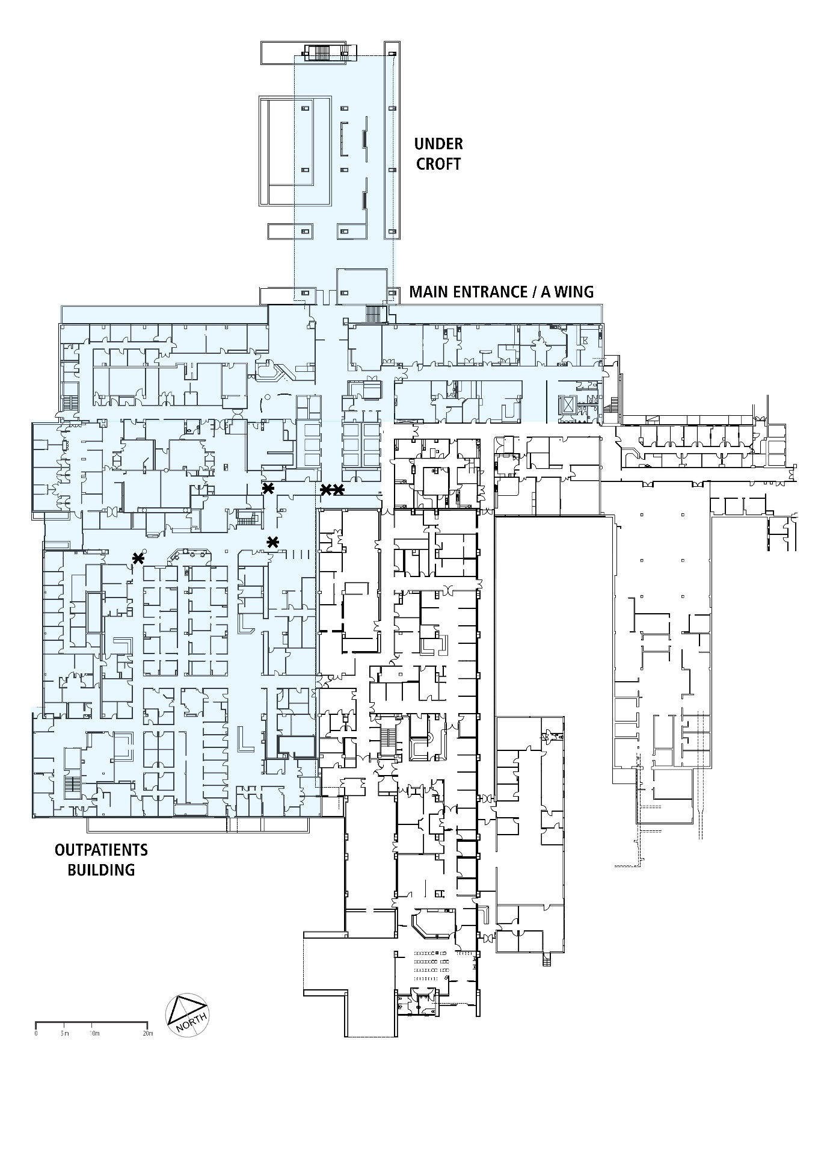
* Hotspot areas identified in the Main Building and Outpatient Building ground floors: end of corridor and in front of a round columns
** Hot spot area identified at Main Building upper floor at the end of corridor coming out of the elevators

