Supplemental Materials for
Assessment of hydration status changes by bioimpedance spectroscopy in children on peritoneal dialysis
Vasiliki Karava¹, Stella Stabouli¹, John Dotis¹, Vassilios Liakopoulos², Fotios Papachristou¹, Nikoleta Printza¹

Supplemental Material File Listing
3 Figures

Vasiliki Karava
1st Department of Pediatrics, Aristotle University of Thessaloniki, Hippokratio General Hospital, 49
Konstantinoupoleos Street, 54642, Thessaloniki, Greece
e-mail: vasilikikarava@hotmail.fr
tel: +306976674306

Supplementary Figure 1
Distribution of bioimpedance spectroscopy (BIS) parameters including : (A) extracellular to total body water ratio (ECW/TBW), (B) extracellular to intracellular ratio body water ratio (E/I) and (C) difference between actual body weight (ABW) and body weight estimated by BIS (BW [BIS]) according to BIS-based hydration status
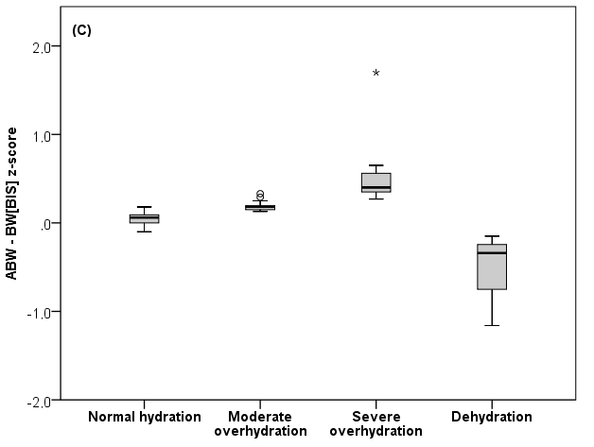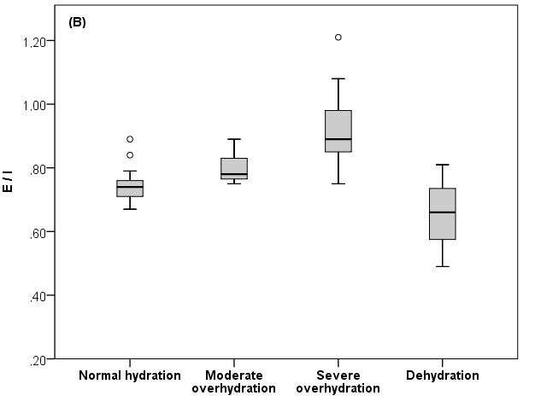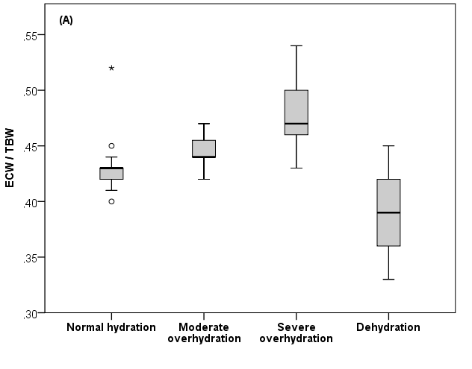

Supplementary Figure 2
Scatter plot analysis of the visit-to-visit changes in relative overhydration (Re-OH), assessed by bioimpedance spectroscopy (BIS), and the changes in systolic blood pressure (SBP) z-score colored according to the number of Re-OH changes per patient
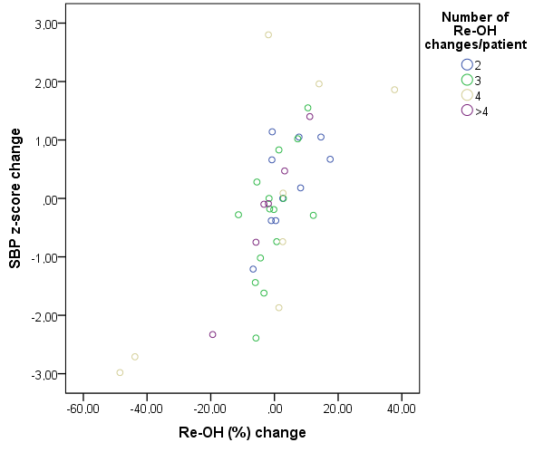

Supplementary Figure 3
Scatter plot analysis of the visit-to-visit changes in relative overhydration (Re-OH), assessed by bioimpedance spectroscopy (BIS), and the changes in systolic blood pressure (SBP) z-score after a two-step cluster analysis
