Study 1 materials:
See pre-registration at https://osf.io/85djf?view_only=f05eb0fed727430bb1d9ade8b100d310

Measured variables
Independent variables: Participants’ fear of falling is the measured independent variable. Fear of falling: As in our previous studies, we will measure fear of falling by asking whether participants expect a decline in personal wealth in the future: “In 10 years’ time, do you expect to be much poorer, about the same as now or much wealthier?” (1 = Much poorer, 7 = Much wealthier). We will also add one new fear of falling item to the study: “In 10 years’ time, do you expect Australia to be much poorer, about the same as now or much wealthier?” (1 = Much poorer, 7 = Much wealthier). The second item is added for us to study the effects of fear of falling personally and collectively separately. Lower scores on both items is indicative of higher fear of falling. We will also measure personal wealth by asking participants to respond to the item “Relative to others in your country, how would you classify your own wealth?” (1 = Very poor, 7 = Very wealthy).
Dependent Variables:
Opposition to immigration is the main dependent variable. Opposition to immigration: We will ask participants to respond to 6 items. The items are: 1) Immigrants take resources and employment opportunities away from Australia. 2) In school where there are too many children of immigrants, the quality of education will suffer. 3) Immigrants abuse the system of social benefits. 4) Australian norms and values are being threatened by the presence of immigrants. 5) The cultural practices of immigrants threaten the Australian way of life. 6) Immigrants are a threat to Australian identity. Participants respond to 7-point scales, where 1=Strong disagree to 7=Strongly agree.

Study 2 materials

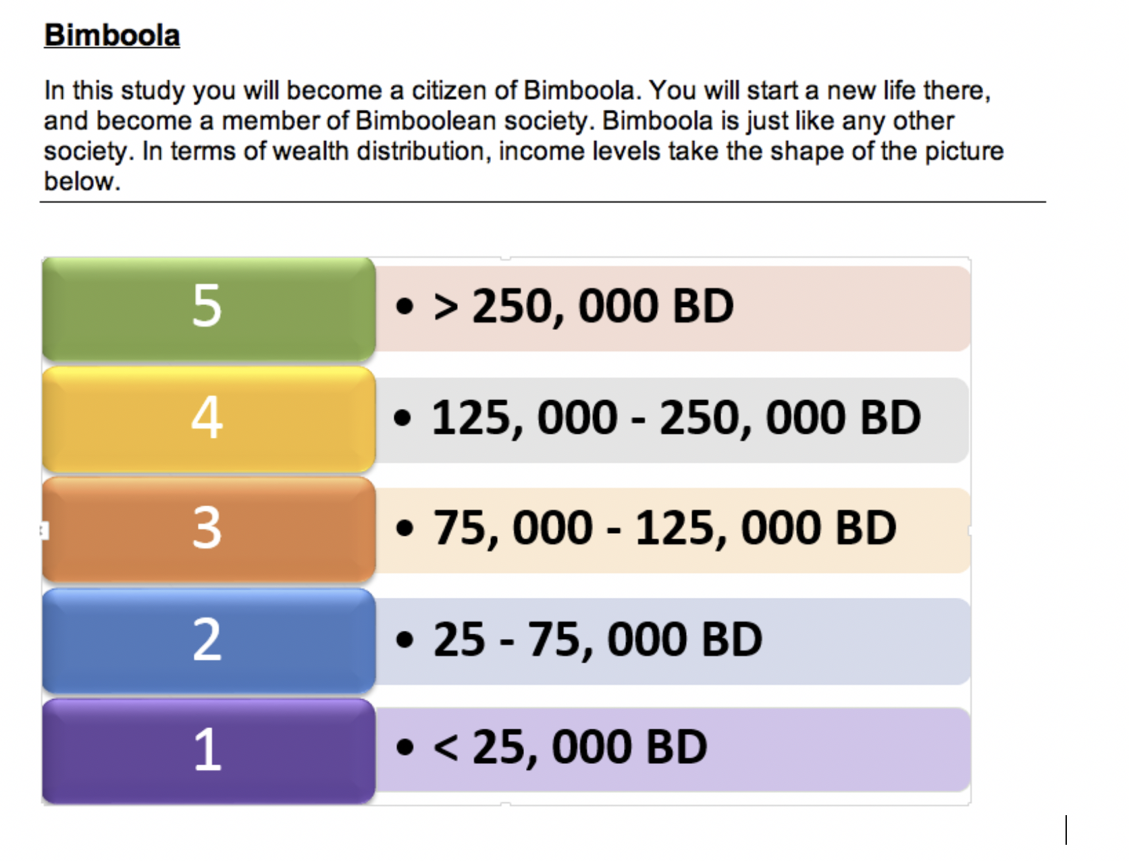

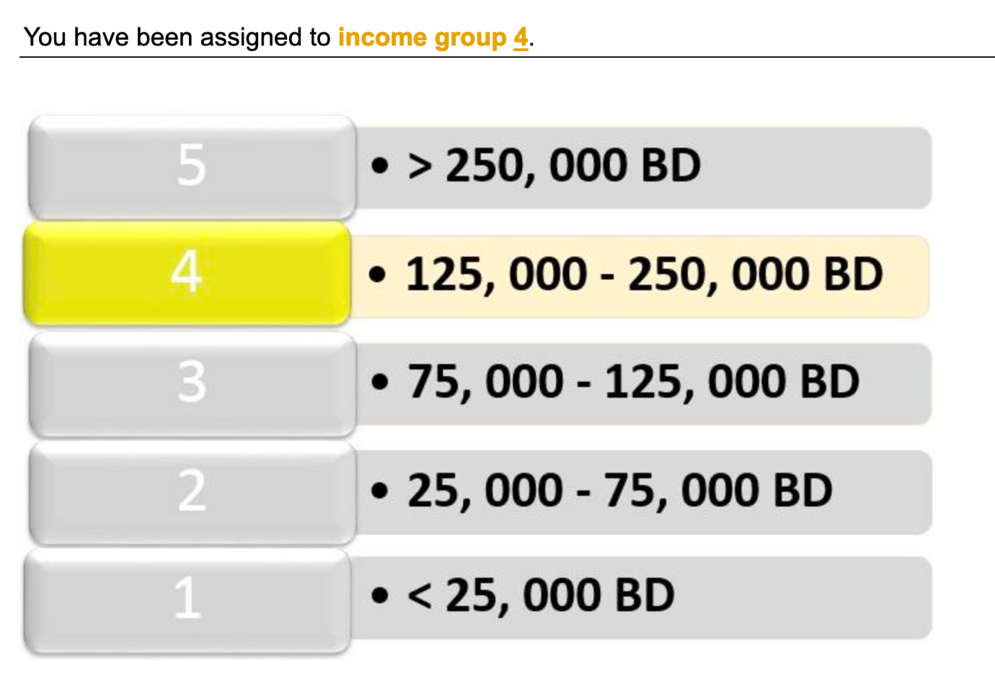

Manipulation check wealth
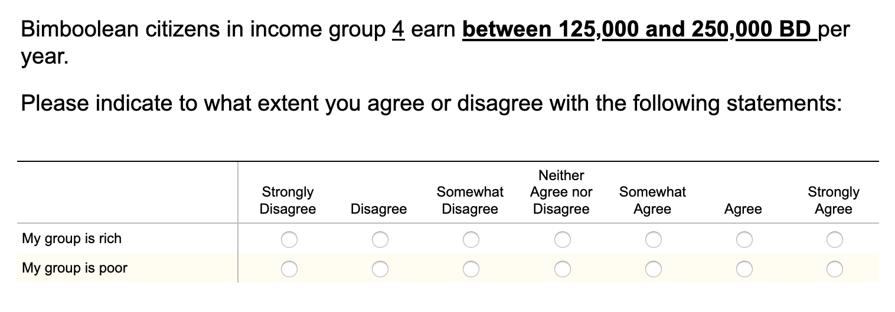

Building a life in Bimboola

< participants were invited to purchase the essentials in life such as a house, mode of transport and holiday to get their life started. Participants could only select and purchase items that their income group or a lower wealth income group could afford, but not the more expensive items that were shown but displayed as ‘beyond the financial means of your income category’. While the houses, cars and holidays open to the wealthier income groups in Bimboola were luxurious and extravagant (large mansions, top of the range cars and expensive holidays) the items that people from the less wealthy group could purchase were of much poorer quality, including substandard houses, old and damaged cars or less expensive holidays (Jetten et al., 2015).>

Permeable Group Boundaries Condition

Impermeable Group Boundaries Condition

Collective angst

Opposition to immigration

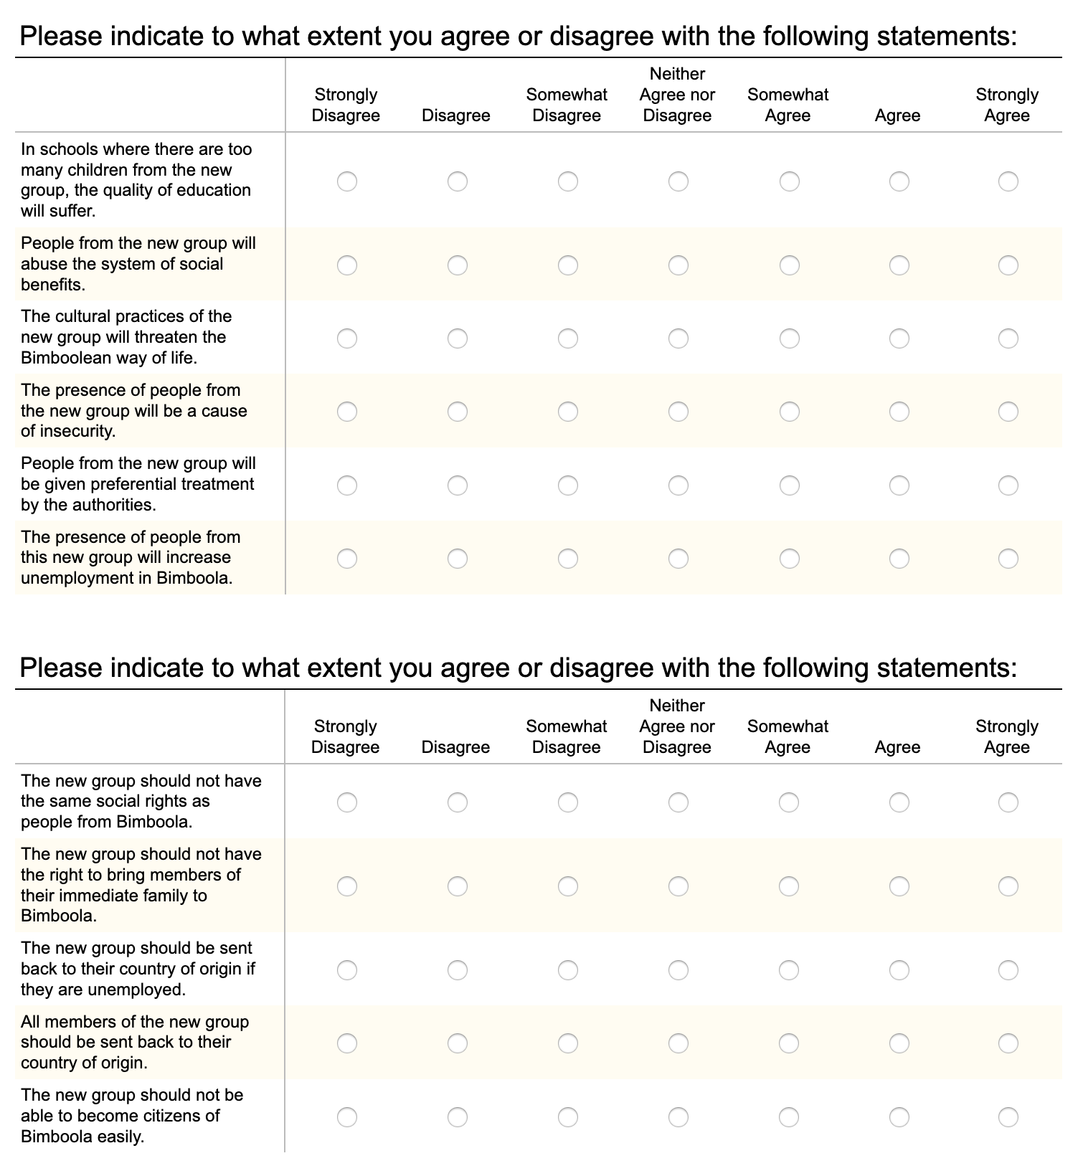

Study 3 materials: Materials were identical to Study 2. Below an example whereby participants are initially assigned to wealth group 4 and they ‘fall’ to wealth group 3

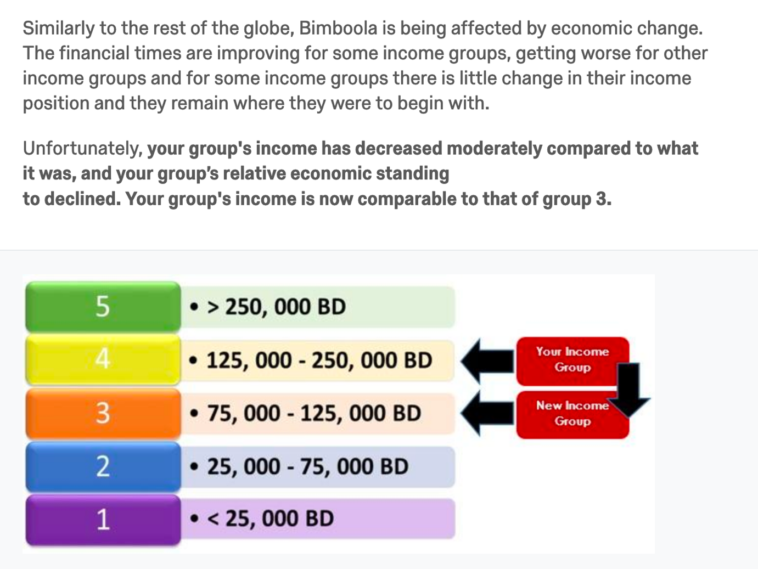

Collective angst and opposition to immigration. The same measures as used in Study 1 were used to assess collective angst (α=.94) and opposition to immigration (α=.96). Responses to both scales were measured on a 7-point scale from 1= Strongly disagree to 7=Strongly agree.

Study 4 materials:
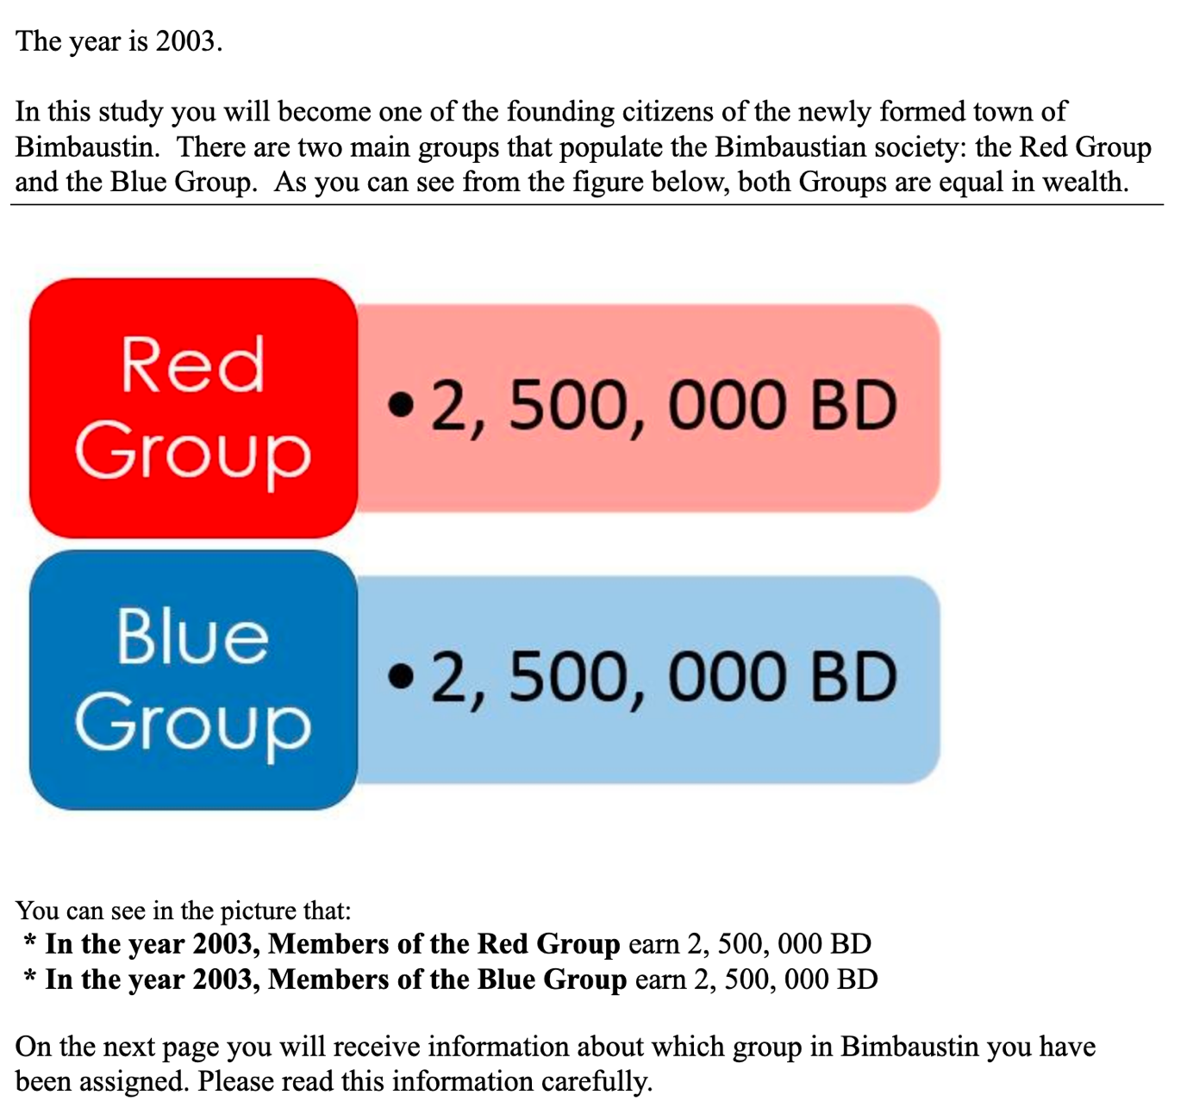

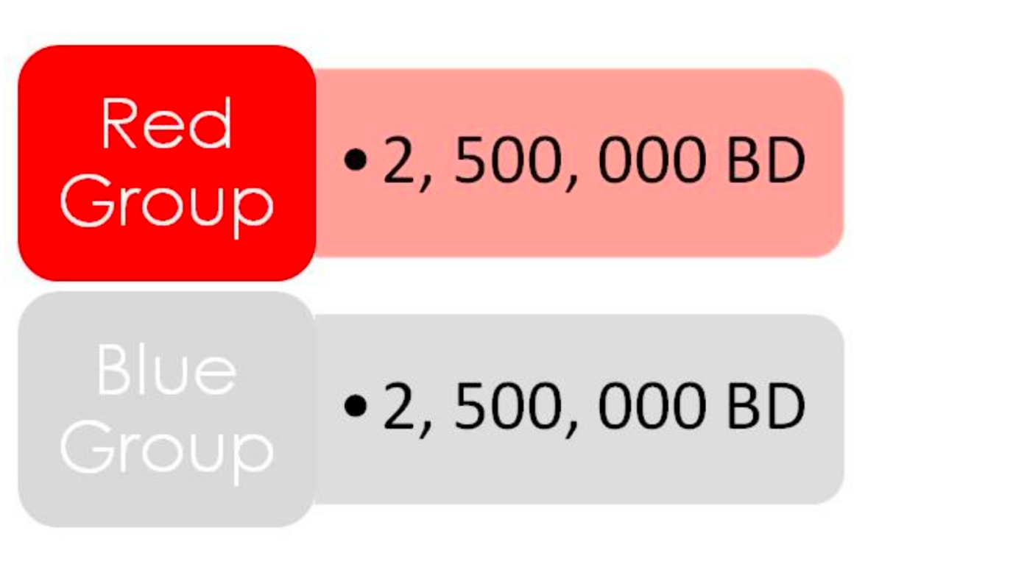

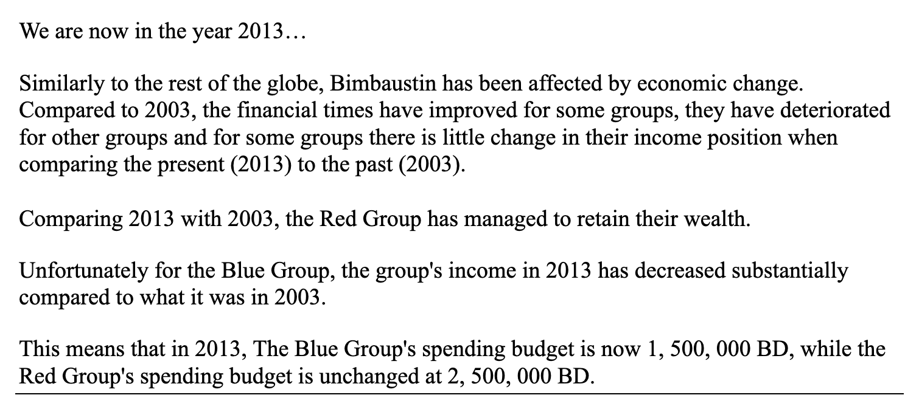

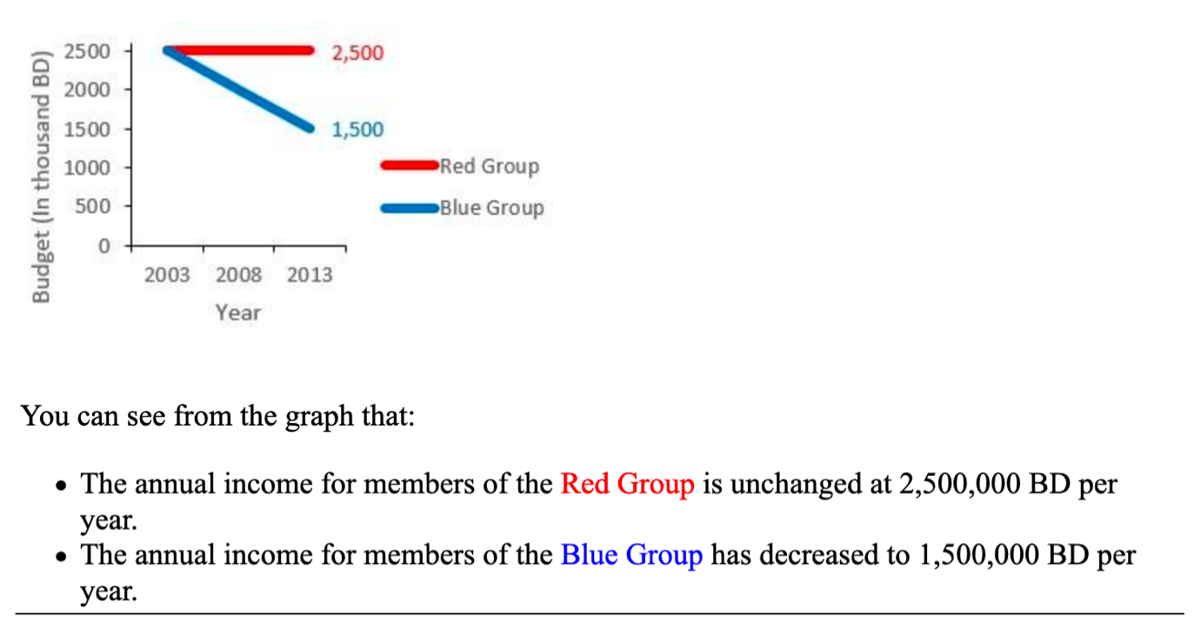

Collective Angst measure

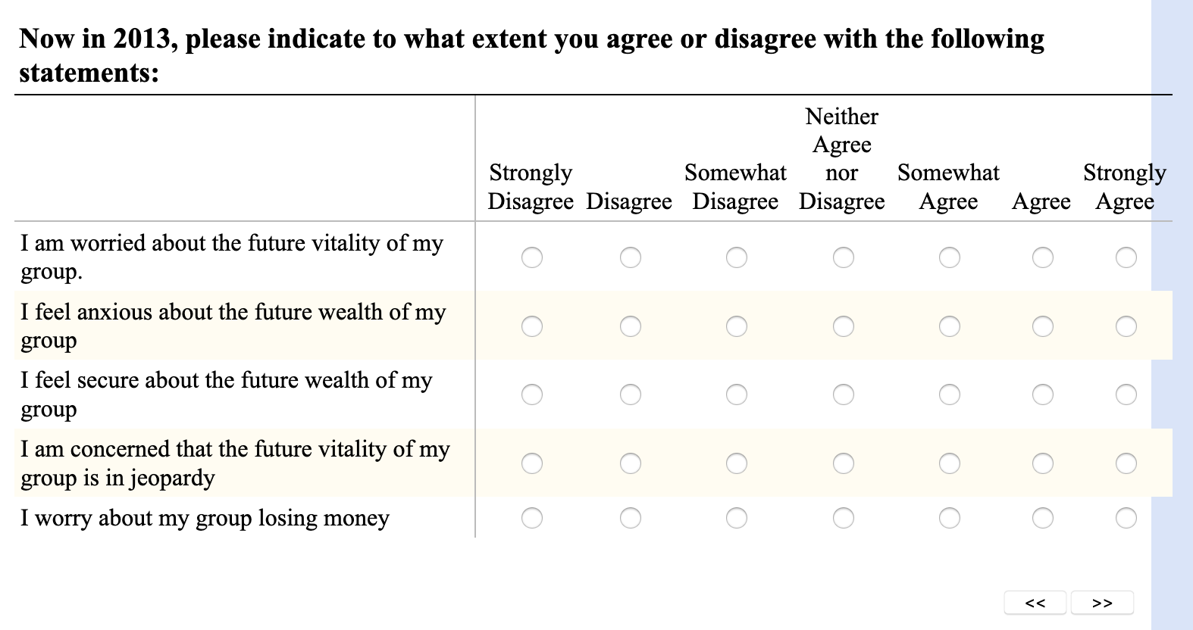
Opposition to Immigration measure

