Appendix

Table A. Shrubs selected for simulation and their appearance in CityEngine® with respective dimensions.
Conditions | Botanical name | Size reference | Appearance in CE | Size in CE | Number in CE*
Shrub-  regular | Buxus sempervirens | Medium shrub:  5-8 feet (1.5-2.5 meters);  Small shrub:  3-5 feet (1-1.5 meters);  Low-growing shrub:  < 3 feet (< 1 meter) | 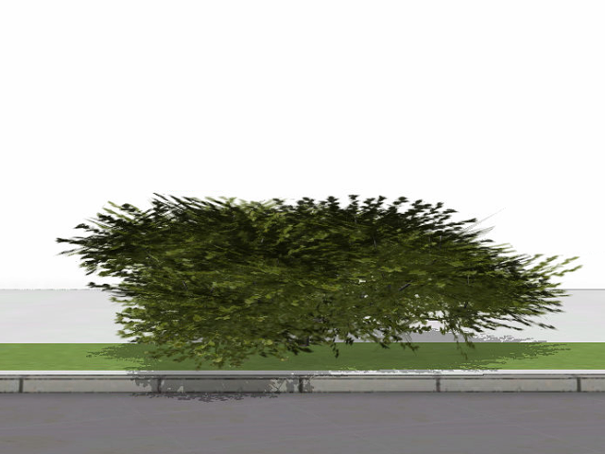 | H1, R0.75 | 16000
Shrub-  random | Buxus sempervirens | Medium shrub:  5-8 feet (1.5-2.5 meters);  Small shrub:  3-5 feet (1-1.5 meters);  Low-growing shrub:  < 3 feet (< 1 meter) |  | (1) H0.5, R0.4  (2) H1, R0.75  (3) H1.5, R1 | (1) 532  (2) 534  (3) 534
 | Forsythia x intermedia | Large shrub:  > 8 feet (> 2.5 meters);  Medium shrub:  5-8 feet (1.5-2.5 meters);  Small shrub:  3-5 feet (1-1.5 meters); | 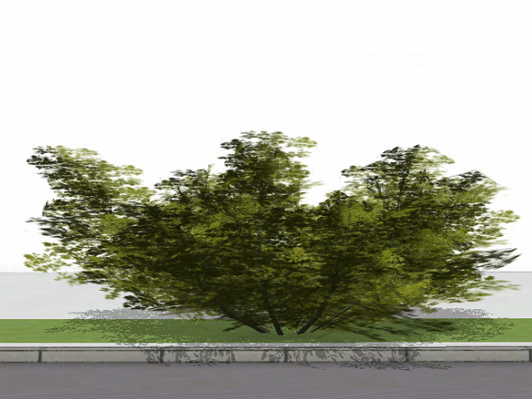 | (1) H1, R0.5  (2) H1.5, R0.8  (3) H2, R1 | (1) 532  (2) 534  (3) 534
 | Juniperus chinensis | Large shrub:  > 8 feet (> 2.5 meters);  Medium shrub:  5-8 feet (1.5-2.5 meters);  Small shrub:  3-5 feet (1-1.5 meters);  Low-growing shrub:  < 3 feet (< 1 meter) | 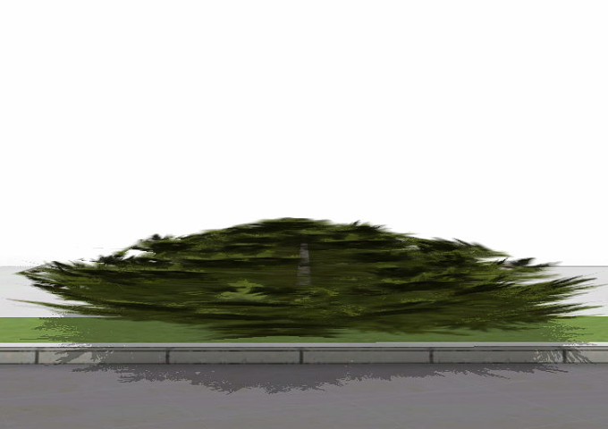 | (1) H0.5, R0.75  (2) H0.8, R1.5  (3) H1.7, R2 | (1) 532  (2) 534  (3) 534
 | Cornus pumila | Low-growing shrub:  < 3 feet (< 1 meter) | 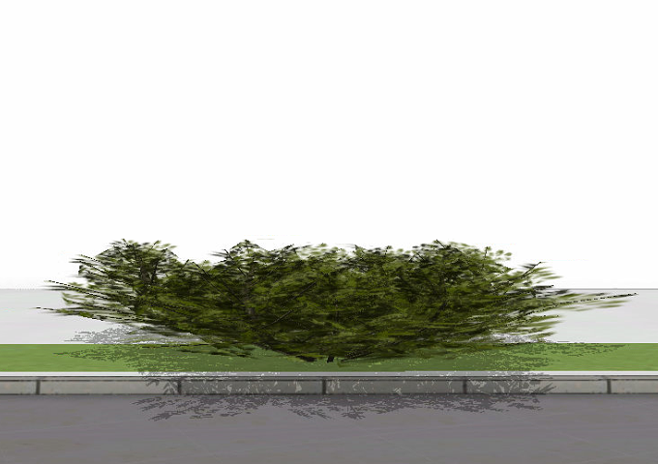 | (1) H0.3, R0.3  (2) H0.5, R0.5  (3) H0.9, R1 | (1) 532  (2) 534  (3) 534
 | Buxus microphylla var. koreana | Small shrub:  3-5 feet (1-1.5 meters);  Low-growing shrub:  < 3 feet (< 1 meter) | 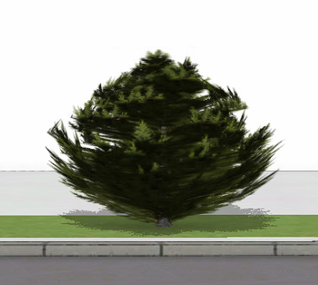 | (1) H0.9, R0.3  (2) H1.4, R0.5  (3) H1.8, R0.6 | (1) 532  (2) 534  (3) 534
 | Metasequoia glyptostroboides 'Miss Grace' | Large shrub:  > 8 feet (> 2.5 meters);  Medium shrub:  5-8 feet (1.5-2.5 meters);  Small shrub:  3-5 feet (1-1.5 meters) | 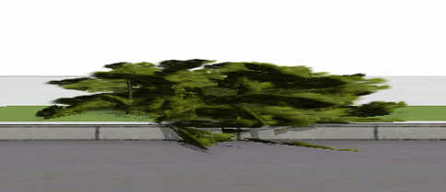 | (1) H0.4, R0.3  (2) H0.7, R0.5  (3) H1.2, R1 | (1) 532  (2) 534  (3) 534
 | Diervilla rivularis | Medium shrub:  5-8 feet (1.5-2.5 meters);  Small shrub:  3-5 feet (1-1.5 meters) | 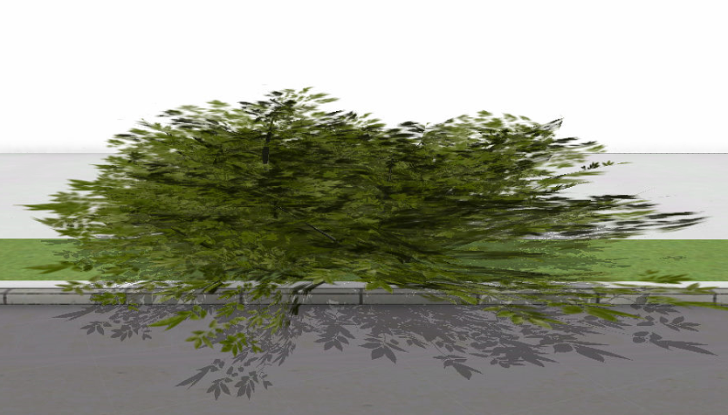 | (1) H1, R0.6  (2) H1.5, R0.85  (3) H1.8, R1.5 | (1) 532  (2) 534  (3) 534
 | Berberis thunbergii | Medium shrub:  5-8 feet (1.5-2.5 meters);  Small shrub:  3-5 feet (1-1.5 meters) | 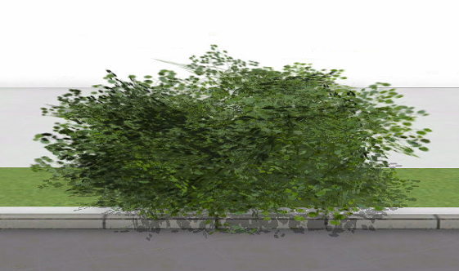 | (1) H1.5, R0.75  (2) H1.8, R0.9  (3) H2, R2 | (1) 532  (2) 534  (3) 534
 | Hypericum kalmianum | Small shrub:  3-5 feet (1-1.5 meters);  Low-growing shrub:  < 3 feet (< 1 meter) | 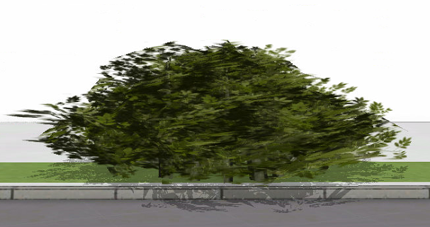 | (1) H0.7, R0.5  (2) H1.2, R0.8  (3) H1.6, R1 | (1) 532  (2) 534  (3) 534
 | Fothergilla major | Large shrub:  > 8 feet (> 2.5 meters);  Medium shrub:  5-8 feet (1.5-2.5 meters);  Small shrub:  3-5 feet (1-1.5 meters) | 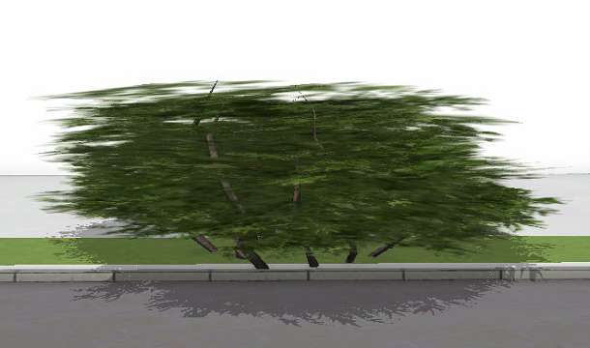 | (1) H1, R0.5  (2) H1.5, R0.75  (3) H2, R1.5 | (1) 532  (2) 534  (3) 534
Note: CE stands for CityEngine; H stands for Height; R stands for radius; *: Each type of shrub in shrub-random scene has 3 different size settings, the total number of shrubs of each size setting is noted separately.
Table B. Trees selected for simulation and their appearance in CityEngine® with respective dimensions.
Conditions | Botanical name | Size reference | Appearance in CE | Size in CE | Number in CE*
Tree-  regular | Aesculus hippocastanum | Mature Height:  50-75 feet (15-23 meters)  Mature width:  40-65 feet (12-20 meters) | 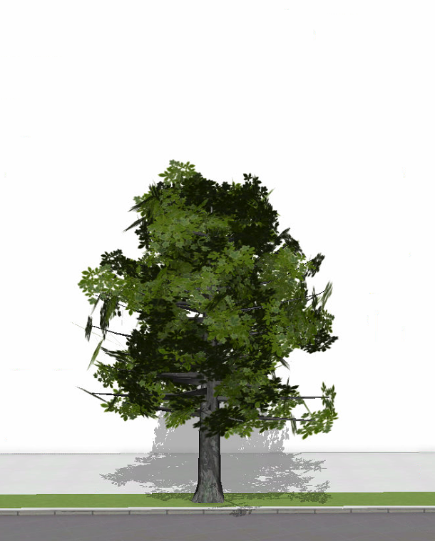 | H10, R2 | 4053
Tree-  random | Aesculus hippocastanum | Mature Height:  50-75 feet (15-23 meters)  Mature width:  40-65 feet (12-20 meters) |  | (1) H5, R1  (2) H10, R2  (3) H15, R2.5 | (1) 135  (2) 135  (3) 135
 | Aesculus flava | Mature Height:  60-80 feet (18-24 meters)  Mature width:  25-35 feet (8-10 meters) | 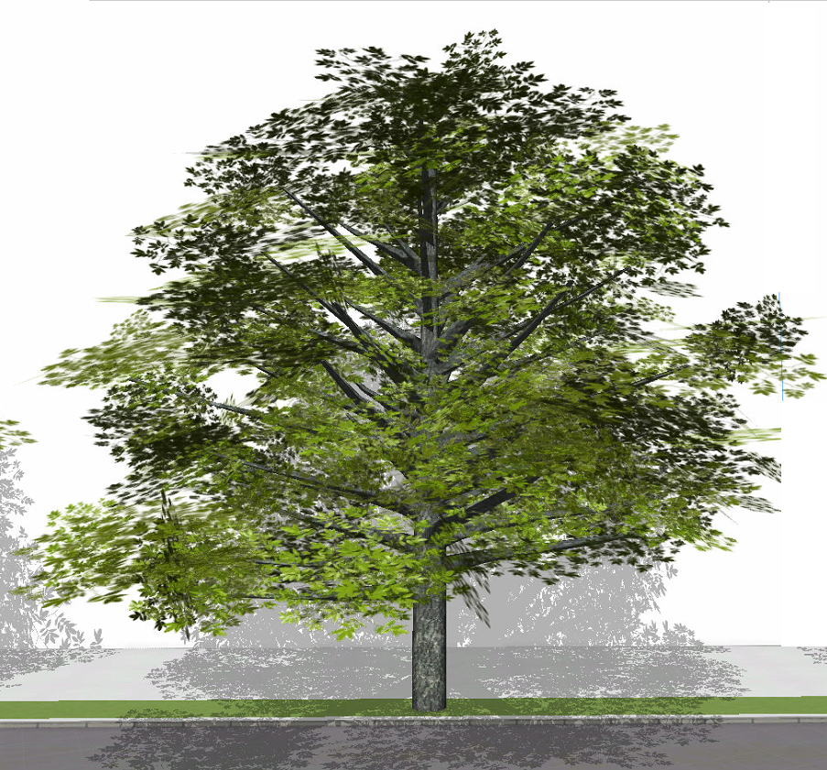 | (1) H15, R3  (2) H18, R4  (3) H23, R5 | (1) 135  (2) 135  (3) 135
 | Quercus shumardii | Mature Height:  40-60 feet (12-18 meters)  Mature width:  40-60 feet (12-18 meters) | 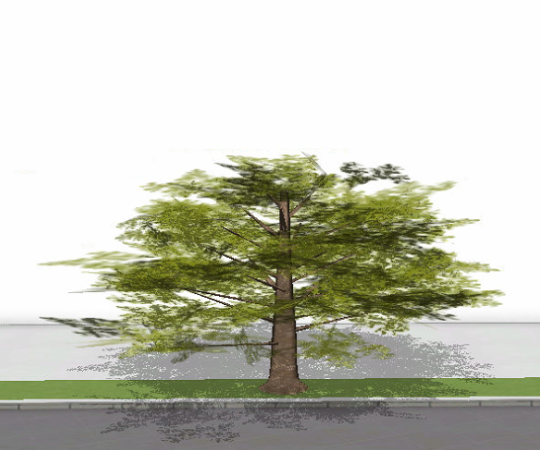 | (1) H5, R2  (2) H11, R4  (3) H14, R5 | (1) 135  (2) 135  (3) 135
 | Taxodium distichum | Mature Height:  50-70 feet (15-21 meters)  Mature width:  20-30 feet (6-9 meters) | 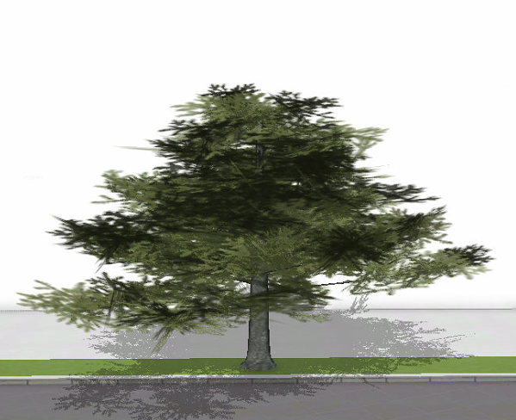 | (1) H7, R2  (2) H12, R3.5  (3) H15, R4.5 | (1) 135  (2) 135  (3) 136
 | Nyssa sylvatica | Mature Height:  30-50 feet (9-15 meters)  Mature width:  20-30 feet (6-9 meters) | 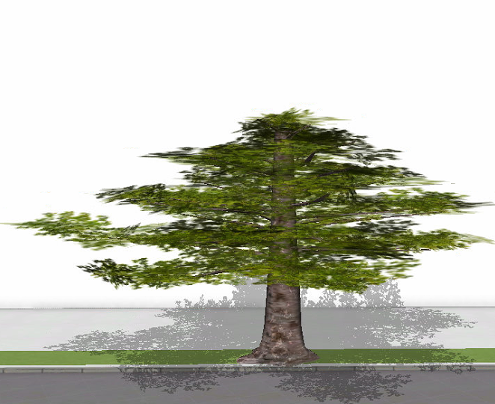 | (1) H7, R2.5  (2) H9, R3  (3) H15, R4.5 | (1) 135  (2) 135  (3) 135
 | Metasequoia glyptostroboides | Mature Height:  70-100 feet (21-30 meters)  Mature width:  15-25 feet (5-8 meters) | 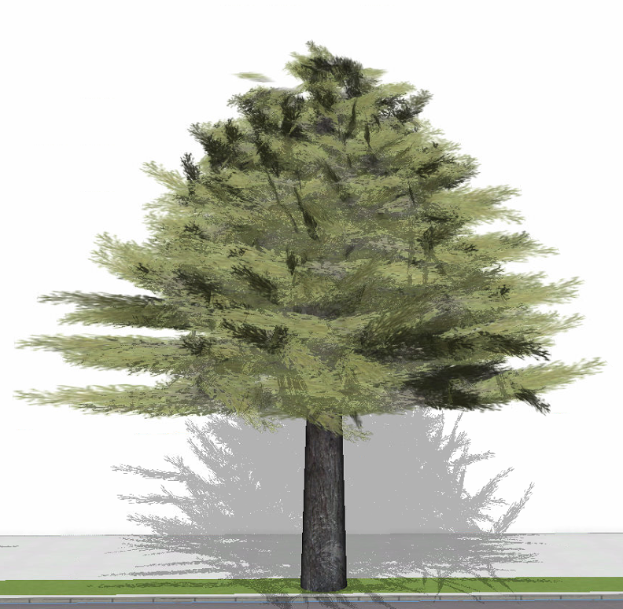 | (1) H15, R3.5  (2) H20, R4  (3) H23, R4 | (1) 135  (2) 135  (3) 135
 | Betula nigra | Mature Height:  30-40 feet (9-12 meters)  Mature width:  20-30 feet (6-9 meters) | 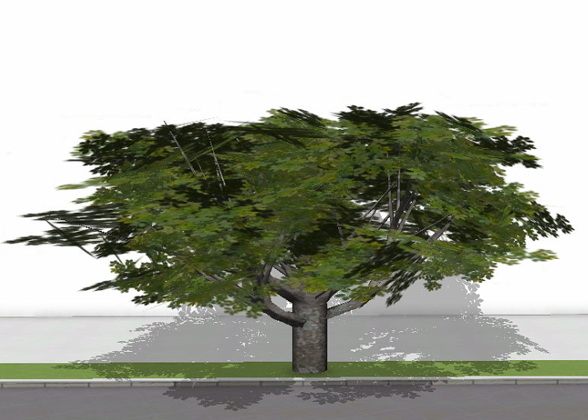 | (1) H7, R3  (2) H10, R4.5  (3) H12, R5 | (1) 135  (2) 136  (3) 135
 | Quercus alba | Mature Height:  50-80 feet (15-24 meters)  Mature width:  50-80 feet (15-24 meters) | 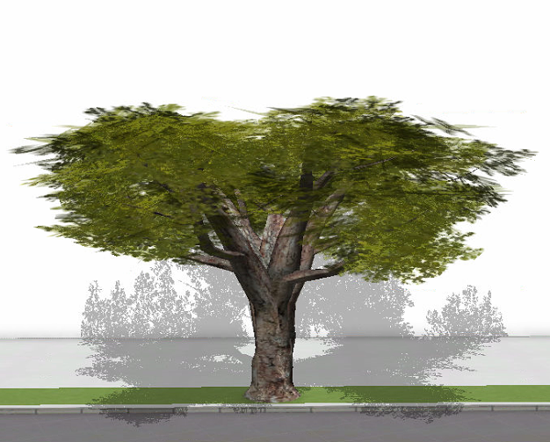 | (1) H5, R2.5  (2) H7, R3.5  (3) H9, R4.5 | (1) 135  (2) 135  (3) 135
 | Tilia cordata | Mature Height:  60-70 feet (12-21 meters)  Mature width:  30-40 feet (9-12 meters) | 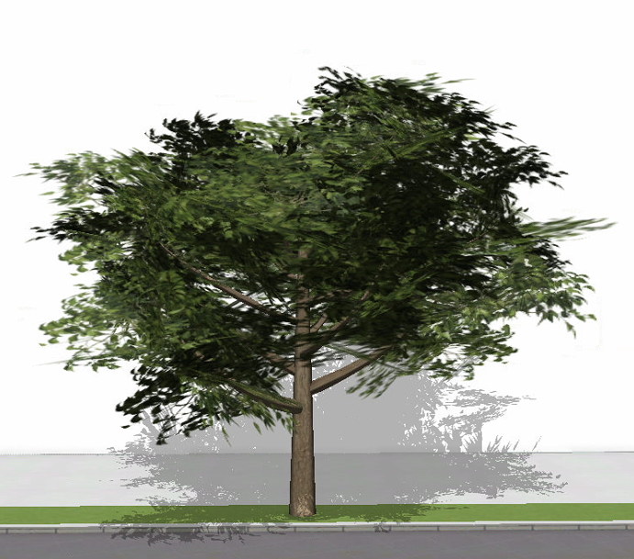 | (1) H10, R3  (2) H15, R4.5  (3) H17, R5 | (1) 135  (2) 135  (3) 135
 | Quercus robur | Mature Height:  75-100 feet (22.5-30 meters)  Mature width:  75-100 feet (22.5-30 meters) | 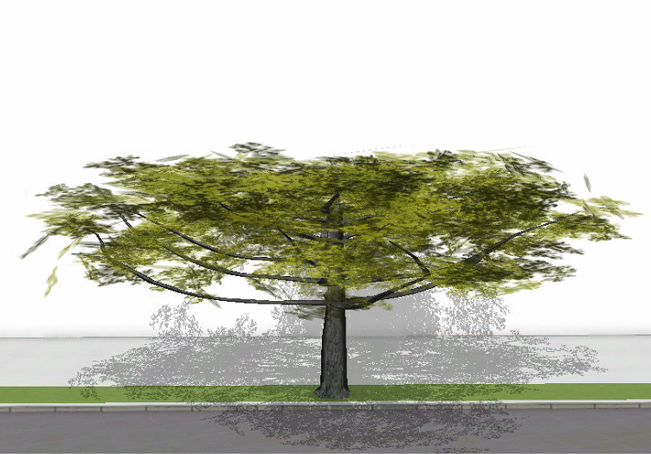 | (1) H6, R3  (2) H8, R4  (3) H12, R5 | (1) 135  (2) 135  (3) 136
Note: CE stands for CityEngine; H stands for Height; R stands for radius; *: Each type of tree in tree-random scene has 3 different size settings, the total number of trees of each size setting is noted separately.

Information retrieved from The Morton Arboretum. (n.d.). (https://www.mortonarb.org/)
Information retrieved from The Morton Arboretum. (n.d.). (https://www.mortonarb.org/)
Information retrieved from The Morton Arboretum. (n.d.). (https://www.mortonarb.org/)
Information retrieved from The Morton Arboretum. (n.d.). (https://www.mortonarb.org/)

