**Web Appendix A: Tables**

**Table A1.** Expert Interviewees

|  |  |  |
| --- | --- | --- |
| **No.** | **Title** | **Organization** |
| 1 | Vice President, Network Revenue Management | Leading full-service airline in Asia |
| 2 | Manager in charge of handling customer service in offloading situations | Leading full-service airline in Asia |
| 3 | Senior Director, First Class Service and Lounges of a large European hub | Leading full-service airline in Europe |
| 4 | CEO | Global airline consulting company based in North America; serves leading airlines around the world |
| 5 | CEO | Global overbooking solutions provider based in North America; serves leading airlines around the world |
| 6 | Business school academic | Airline expert with revenue management and overbooking expertise based in Asia |

**Table A2.** Text of Vignettes

|  |  |
| --- | --- |
| **Study 1 & 2a Intro (T1)** | You had planned to go on a holiday after a busy period and you were looking forward to get away and relax for a few days. On the day of your flight, you pack your bags and then browse the internet to find some good restaurants to eat in during your visit in your destination. Later on, you find out that the flight is overbooked and you are on a waiting list to be rebooked on a flight at a later date. But you have already paid for your accommodation in full and cannot get a refund. In addition, you will miss your next day’s tour that you had booked and paid for in advance. It would be very expensive to buy a last minute one-way ticket – certainly a lot more that the $500 for the one-way fare that you originally paid. |
| T2 Proactive-Home | You were still at home when you received a call from the airline customer service team 8 hours before your flight. The airline representative informed you that, unfortunately, the flight is overbooked and you need to travel at a later date. The airline representative apologized for any inconvenience this may have caused and assured you that they would do their best to resolve this issue as soon as possible. Later on, the airline representative informs you that the next available flight is tomorrow afternoon. |
| T2 Default Reactive-Gate | You had already left home and were at the airport 3 hours before your flight. You went straight to the check-in counter to drop off your baggage. You passed the busy security check and arrived at the boarding gate an hour before the flight when an airline representative informed you that, unfortunately, the flight is overbooked and you need to travel at a later date. The airline representative apologized for any inconvenience this may have caused and assured you that they would do their best to resolve this issue as soon as possible. Later on, the airline representative informs you that the next available flight is tomorrow afternoon. |
| T2 Very Reactive-Plane | You had already left home and were at the airport 3 hours before your flight. You went straight to the check-in counter to drop off your baggage. You passed the busy security check and arrived at the boarding gate an hour before the flight. A short while after you boarded the plane, an airline representative informed you that, unfortunately, the flight is overbooked and you need to travel at a later date. When you complained, you were escorted out of the plane. The airline representative apologized for any inconvenience this may have caused and assured you that they would do their best to resolve this issue as soon as possible. Later on, the airline representative informs you that the next available flight is tomorrow afternoon. |
| T2 Ending (Study 2a only) | The airline offers $675; $1,350; $2,700; $10,000 as monetary compensation for your inconvenience. |
| **Study 3a** | Imagine, you booked a holiday and are excited about your trip. You are at home when you receive a call from the airline 5/24/48 hours before your flight departure. The airline representative informs you that, unfortunately, the flight is overbooked and that they are looking for volunteers to travel on a later flight. You decide to volunteer to be bumped in exchange for $75/$150 compensation. The airline representative apologizes for the inconvenience this may cause and confirms that you have your seat on the same flight the following day. |
| **Study 3b Intro** | Imagine, you booked a holiday and are excited about your trip. You are already at the airport 3 hours before your flight. You go straight to the check-in counter to drop off your baggage. You pass the busy security check and arrive at the boarding gate. |
| Involuntary bumping | Later, an airline representative informs you that, unfortunately, the flight is overbooked *and you have been selected to be bumped*; and therefore, you must travel on a later flight. You are offered $675/$1,350 as monetary compensation. The airline representative apologizes for the inconvenience this may cause and confirms that you have your seat on the same flight the following day. |
| Voluntary bumping | Later, an airline representative informs you that, unfortunately, the flight is overbooked and that they are looking for volunteers to travel on a later flight. *You decide to volunteer to be bumped* in exchange for $675/$1,350 compensation. The airline representative apologizes for the inconvenience this may cause and confirms that you have your seat on the same flight the following day. |
| **Study 3c Intro** | Imagine, you booked a holiday and are excited about your trip. You are already at the airport 3 hours before your flight. You go straight to the check-in counter to drop off your baggage. You pass the busy security check and arrive at the boarding gate. |
| Involuntary bumping | A short while after you board the plane, an airline representative informs you that, unfortunately, the flight is overbooked and you have been selected to be bumped; and therefore, you must leave the plane and travel on a later flight. You are offered $1,350/$2,700/$5,400 as monetary compensation. The airline representative apologizes for the inconvenience this may cause and confirms that you have your seat on the same flight the following day. |
| Voluntary bumping | A short while after you board the plane, an airline representative informs you that, unfortunately, the flight is overbooked and that they are looking for volunteers to travel on a later flight. You decide to volunteer to be bumped in exchange for $1,350/$2,700/$5,400 compensation. The airline representative apologizes for the inconvenience this may cause and confirms that you have your seat on the same flight the following day. |

**Table A3.** Constructs, Measures, and Sources

|  |
| --- |
| **Perceived Justice** adapted from Roschk and Gelbrich (2017) and Grégoire et al. (2010)  Study 1: M = 4.34, SD = 1.53, α = .92. |
| The outcome I received was fair. |
| I did not get what I deserved. (R) |
| The outcome I received was right. |
| I believe the airline has fair policies and practices to handle problems. |
| With respect to its procedures, the airline handled the problem in a fair manner. |
| The airline representative's communication was polite. |
| The airline representative treated me with respect. |
| **Perceived Betrayal** adapted from Grégoire and Fisher (2008)  Study 1: M = 3.94. SD = 1.74, α = .93.  I would feel... |
| ... cheated. |
| ... betrayed |
| ... lied to |
| ... the airline intended to take advantage of me. |
| ... the airline tried to abuse me. |
| **Negative Electronic Word of Mouth (NeWoM)** adapted from Grégoire, Laufer, and Tripp (2010)  Study 1: M = 4.33, SD = 1.90, α = .94;  Study 2a-T1: M = 5.07, SD = 1.58, α = .91; Study 2a-T2: M = 3.94, SD = 1.88, α = .94;  Study 2b-T1: M = 5.16, SD = 1.54, α = .88; Study 2b-T2: M = 3.87, SD = 1.76, α = .94;  Study 2c-T1: M = 5.06, SD = 1.43, α = .86; Study 2c-T2: M = 3.80, SD = 1.78, α = .91;  Study 3a: M = 3.25, SD = 1.76, α = .93;  Study 3b: M = 3.42, SD = 1.87, α = .92;  Study 3c: M = 3.45, SD = 1.73, α = .88.  I would complain about the issue through social media... |
| ... to make public the behaviors and practices of the airline. |
| ... to report my experience to other consumers |
| .. to spread the word about my misadventure. |
| **Complaint Intention** adapted from Maute and Forrester Jr (1993)  Study 3a: M = 3.36, SD = 1.52, α = .89;  Study 3b: M = 3.47, SD = 1.67, α = .90;  Study 3c: M = 3.49, SD = 1.69, α = .90. |
| I would ask to speak to the manager on duty. |
| I would argue with the airline employee. |
| I would communicate the reasons for my dissatisfaction to the airline employee. |
| I would write to the airline management to complain. |
| I would complain to a consumer organization, government agency or newspaper. |
| **Perceived Severity** taken from Hess et al. (2003)  Study 1: M = 5.50, SD = 1.36, α = .92;  Study 2a: M = 5.62, SD = 1.28, α = .91;  Study 2b: M = 5.26, SD = 1.25, α = .90;  Study 2c: M = 5.75, SD = 1.34, α = .96;  Study 3a: M = 4.17, SD = 1.71, α = .91;  Study 3b: M = 4.42, SD = 1.84, α = .93;  Study 3c: M = 4.46, SD = 1.65, α = .88. |
| Mild issue : Severe issue |
| Minor issue : Major issue |
| Insignificant issue : Significant issue |
| **Blame Attribution** adapted from Gelbrich et al. (2015)  Study 1: M = 5.69, SD = 1.36, α = .91;  Study 2a: M = 5.73, SD = 1.34, α = .90;  Study 2b: M = 5.41, SD = 1.44, α = .91;  Study 2c: M = 5.97, SD = 1.11, α = .84;  Study 3a: M = 4.81, SD = 1.50, α = .86;  Study 3b: M = 5.26, SD = 1.53, α = .89;  Study 3c: M = 5.08, SD = 1.59, α = .89. |
| The reason for the failure is something the airline had control over. |
| The airline was responsible for the failure. |
| The failure was completely the airline's fault. |

Note: M = Mean; SD = Standard Deviation; α = Cronbach’s alpha; R = Reverse-coded item.

**Table A4.** Factor Correlation Matrix

|  |  |  |  |  |  |
| --- | --- | --- | --- | --- | --- |
| **Study 1** | NeWOM | Failure severity | Blame attribution | Justice | Betrayal |
| NeWOM | - |  |  |  |  |
| Failure severity | .34 | - |  |  |  |
| Blame attribution | .43 | .40 | - |  |  |
| Justice | -.55 | -.43 | -.36 | - |  |
| Betrayal | .70 | .49 | .47 | -.66 | - |
| **Study 2a** | NeWOM | Failure severity | Blame attribution |  |  |
| NeWOM | - |  |  |  |  |
| Failure severity | .21 | - |  |  |  |
| Blame attribution | .33 | .39 | - |  |  |
| **Study 2b** | NeWOM | Failure severity | Blame attribution |  |  |
| NeWOM | - |  |  |  |  |
| Failure severity | .37 | - |  |  |  |
| Blame attribution | .34 | .41 | - |  |  |
| **Study 2c** | NeWOM | Failure severity | Blame attribution |  |  |
| NeWOM | - |  |  |  |  |
| Failure severity | .50 | - |  |  |  |
| Blame attribution | .40 | .25 | - |  |  |
| **Study 3a** | NeWOM | Failure severity | Blame attribution | Complaint |  |
| NeWOM | - |  |  |  |  |
| Failure severity | .42 | - |  |  |  |
| Blame attribution | .33 | .38 | - |  |  |
| Complaint | .73 | .45 | .32 | - |  |
| **Study 3b** | NeWOM | Failure severity | Blame attribution | Complaint |  |
| NeWOM | - |  |  |  |  |
| Failure severity | .42 | - |  |  |  |
| Blame attribution | .37 | .44 | - |  |  |
| Complaint | .71 | .50 | .44 | - |  |
| **Study 3c** | NeWOM | Failure severity | Blame attribution | Complaint |  |
| NeWOM | - |  |  |  |  |
| Failure severity | .33 | - |  |  |  |
| Blame attribution | .40 | .50 | - |  |  |
| Complaint | .72 | .39 | .45 | - |  |

**Table A5.** NeWOM Estimated Means in Study Set 2

|  |  |  |  |  |  |
| --- | --- | --- | --- | --- | --- |
| **Study 2a** | Condition | Compensation level | M (T1) | M (T2) | p-value |
|  | Proactive-Home | $675 | 5.46 | 3.46 | <.001 |
|  | $1,350 | 5.07 | 3.65 | <.001 |
|  | $2,700 | 4.96 | 3.38 | <.001 |
|  | $10,000 | 5.54 | 3.47 | <.001 |
|  | Default Reactive-Gate | $675 | 5.38 | 4.99 | .22 |
|  | $1,350 | 4.86 | 3.76 | <.01 |
|  | $2,700 | 4.77 | 3.56 | <.001 |
|  | $10,000 | 5.14 | 3.47 | <.001 |
|  | Very Reactive-Plane | $675 | 5.03 | 4.83 | .56 |
|  | $1,350 | 4.96 | 4.78 | .60 |
|  | $2,700 | 4.79 | 4.49 | .43 |
|  | $10,000 | 4.91 | 3.50 | <.001 |
| **Study 2b** | Condition | Compensation level | M (T1) | M (T2) | p-value |
|  | Proactive-Home | $150 | 5.31 | 3.98 | <.001 |
|  | $325 | 5.17 | 4.01 | <.001 |
|  | $500 | 5.14 | 3.88 | <.001 |
|  | $675 | 5.02 | 3.61 | <.001 |
| **Study 2c** | Condition | Compensation level | M (T1) | M (T2) | p-value |
|  | Very Reactive-Plane | $2,700 | 4.98 | 4.75 | .48 |
|  | $4,200 | 5.03 | 4.59 | .18 |
|  | $5,700 | 4.88 | 4.17 | <.05 |
|  | $7,200 | 5.09 | 3.25 | <.001 |
|  | $8,700 | 5.24 | 3.05 | <.001 |
|  | $10,000 | 5.13 | 2.97 | <.001 |
| Covariates: service importance, failure severity, and blame attribution. | | | | | |

**Web Appendix B: Figures**

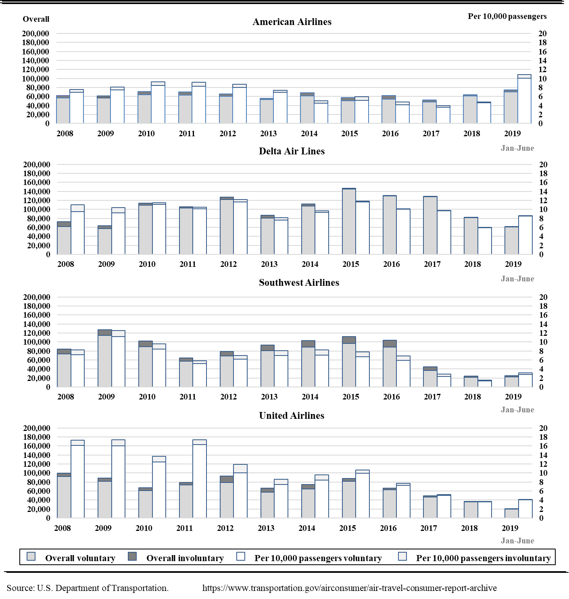

**Figure B1.** Denied Boarding for the Four Largest U.S. Airlines (2007 – 2019)

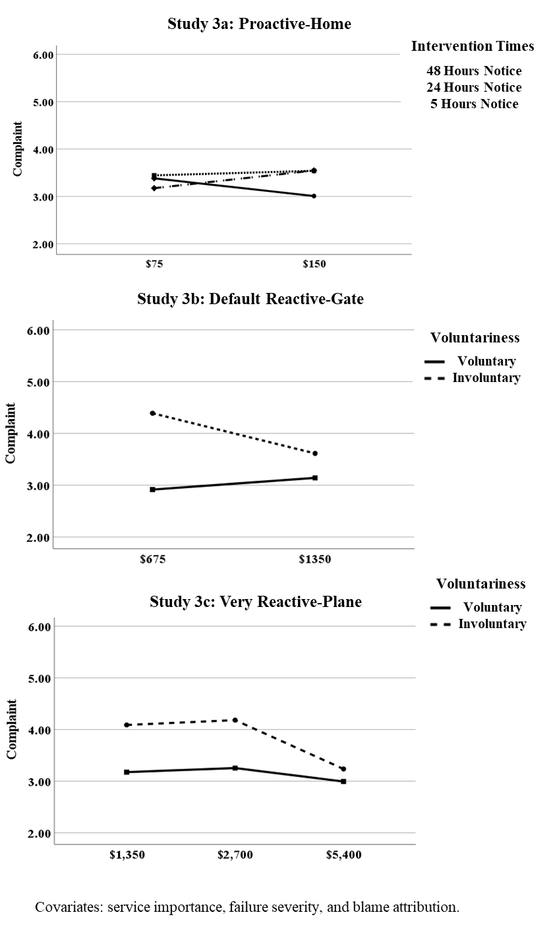

**Figure B2.** Complaint Intention Estimated Means in Study Set 3



**Figure B3.** Expected Number of Bumped Customers (Study 4)