- There was significant improvement in cognition of the CALM group compared with the control group before and after treatment.
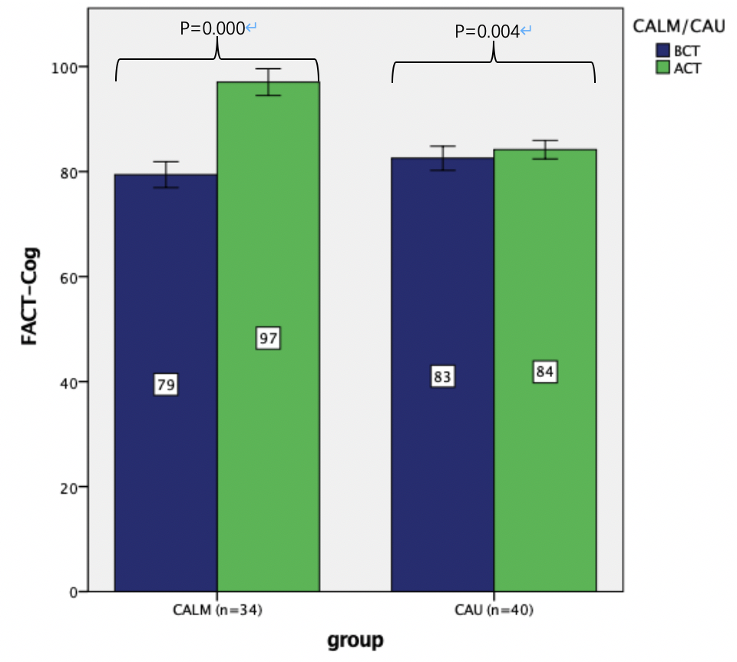

2.There were significant improvement in QOL of the CALM group compared with the control group before and after treatment.
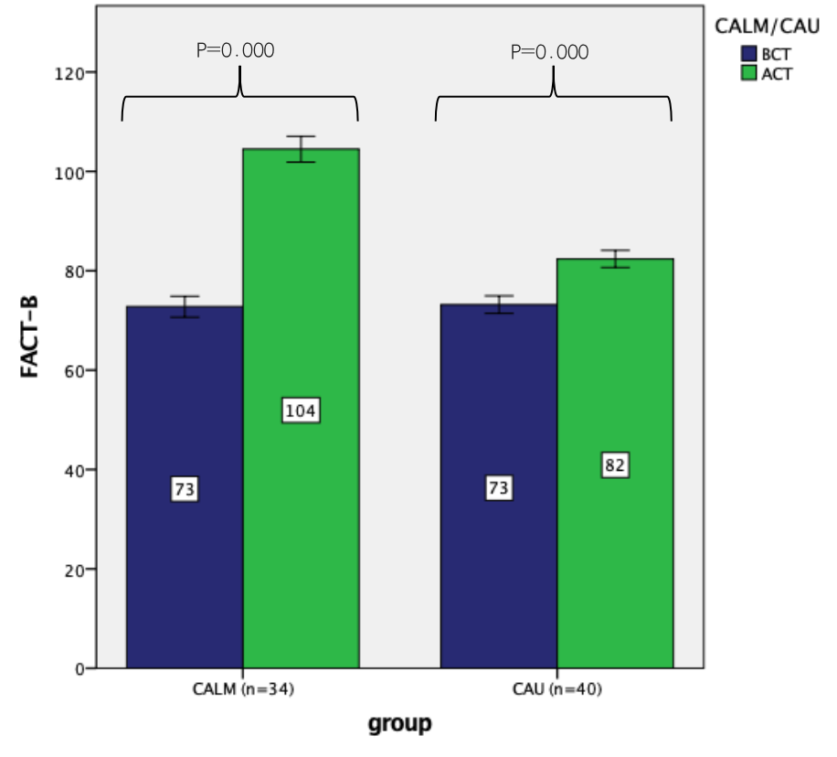

3.There were significant improvement in RM of the CALM group compared with the control group before and after treatment.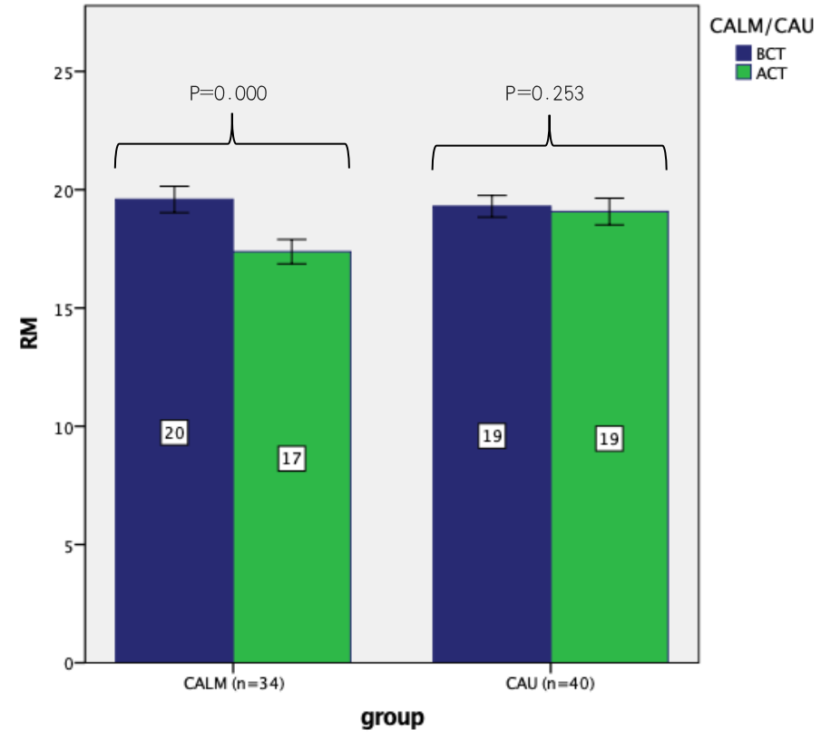

4.There were significant improvement in PM of the CALM group compared with the control group before and after treatment.
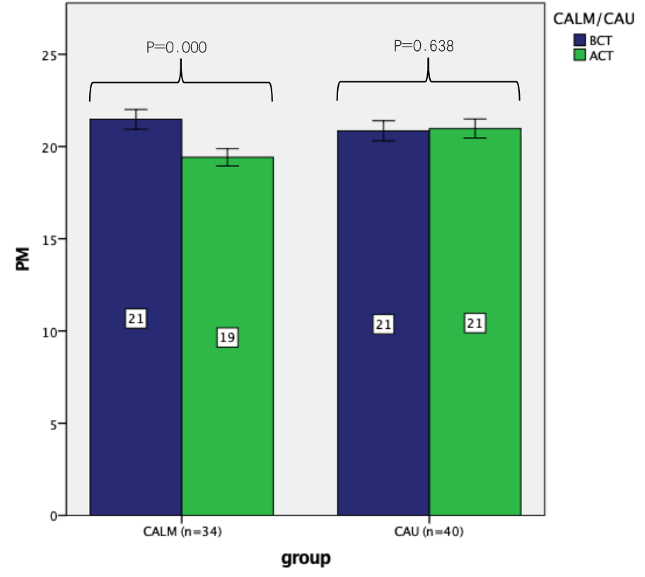

5.There were significant improvement in psychological distress of the CALM group compared with the control group before and after treatment.
