Exploring the Impact of Mindfulness on False-Memory Susceptibility

Supplementary Material

Contents:

Supplementary Material A (Page 1) — Power Sensitivity Analysis
Supplementary Material B (Page 2) — Pre-Registered Follow-Up Analyses
Supplementary Material C (Page 6) — Non Pre-Registered Exploratory Analysis

Supplementary Material A: Power Sensitivity Analysis

We conducted a power sensitivity analysis using the pwr package in R. Given our final sample size of N = 287 (n per group = 95, rounding down), we explored the smallest effect size detectable given a range of power criteria (from 0.75 to 1.0). The code for the sensitivity analysis can be found in the main analysis file of the manuscript, and the results of the analysis can be seen in Figure A1. As can be seen, our final sample size had 80% power to detect an effect size as small as f = 0.235, 90% power to detect an effect as small as f = 0.212, and 80% power to detect an effect as small as f = 0.185.

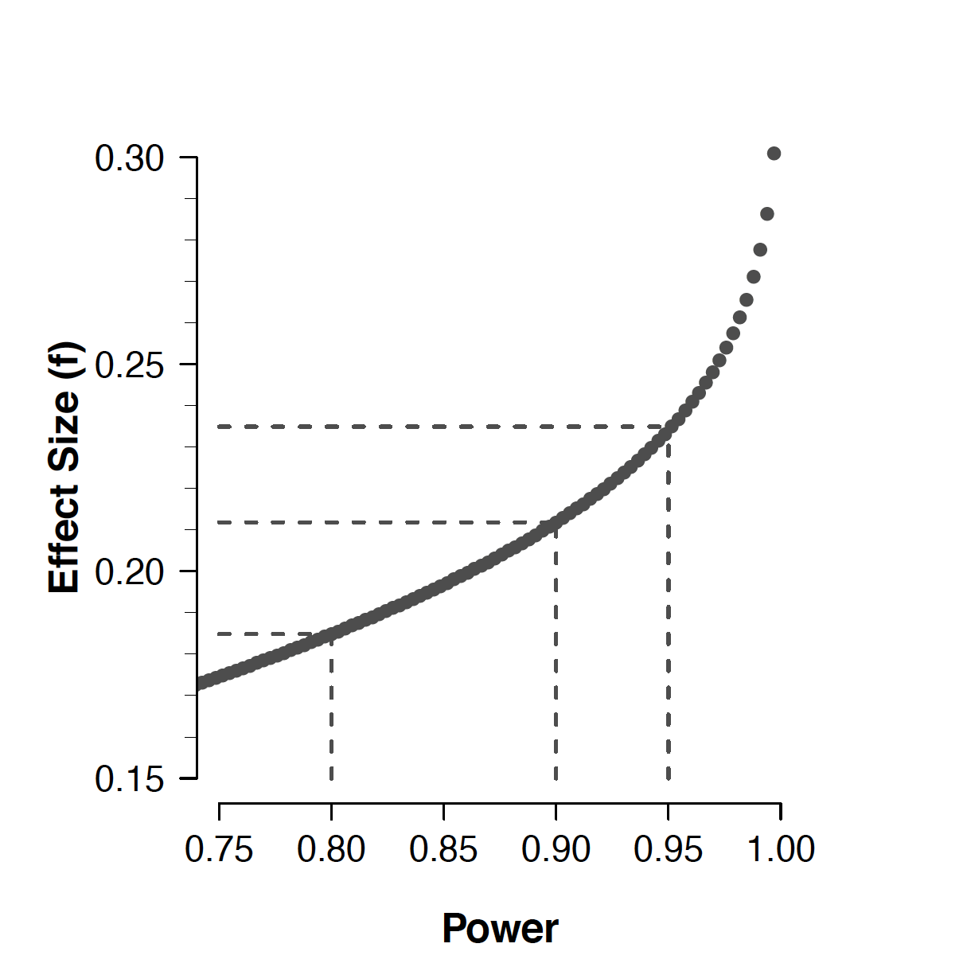
Figure S1. Plot of the power sensitivity analysis. Dotted lines show detectable effect sizes for power criteria of 80%, 90%, and 95%.
Supplementary Material B: Pre-Registered Follow-Up Analyses

In this section we report supplementary analyses that formed part of our original pre-registration (see Section 20 of pre-registration document). These analyses were not central to our main research questions, but were additional analyses that we thought would be interesting to conduct (and hence to pre-register).

Omnibus Tests Adding Change in Mindfulness and Mind-Wandering as Covariate
We repeated our omnibus frequentist tests of the effect of mind-states on memory whilst entering individual measures of mind-states as covariates. Specifically, in a first re-analysis we entered individual participants’ change in mindfulness scores (i.e., post-induction SMS total score minus pre-induction SMS total score) as a covariate. In a second set of re-analyses, we entered individual measures of mind-wandering (as measured by the TRI and the TUT, analysed separately) as covariates.
The analysis consisted of a set of linear regressions (one for each measure of memory performance) with the dependent variable predicted from condition (i.e., mind-manipulation) and the relevant covariate. The results of these analyses are shown in Table B1 overleaf.
None of these analyses produced results that qualitatively differed from those reported in the main manuscript.

Table S1. Beta estimates from regression analyses for the effect of state-of-mind (condition) on different measures of memory with change in mindfulness (as assessed by the SMS Total; i.e., post-induction score minus pre-induction score) as a covariate and mind-wandering score as covariate.
Memory Measure | Mindfulness Change as Covariate | Mind-Wandering (TRI)  as Covariate | Mind-Wandering (TUT)  as Covariate
Total  Correct Recognition | β Condition = 0.262,  t = 0.659, p=.510 | β Condition = 0.485,  t = 1.256, p=.210 | β Condition = 0.089,  t = 0.238, p=.812
Total  False Recognition | β Condition = 0.178,  t = 0.860, p=.391 | β Condition = 0.168,  t = 0.820, p=.413 | β Condition = 0.115,  t = 0.589, p=.556
Total Filler | β Condition = 0.087,  t = 0.334, p=.738 | β Condition = 0.006,  t = 0.023, p=.982 | β Condition = 0.057,  t = 0.236, p=.813
Remember Correct Recognition | β Condition = -0.195,  t = -0.403, p=.688 | β Condition = 0.176,  t = 0.370, p=.712 | β Condition = -0.056,  t = -0.123, p=.902
Remember False Recognition | β Condition = -0.158,  t = -0.650, p=.516 | β Condition = -0.094,  t = -0.393, p=.695 | β Condition = -0.142,  t = -0.619, p=.536
Remember Filler | β Condition = 0.042,  t = 0.307, p=.759 | β Condition = 0.065,  t = 0.481, p=.631 | β Condition = 0.119,  t = 0.928, p=.354
Know Correct Recognition | β Condition = 0.389,  t = 1.270, p=.205 | β Condition = 0.381,  t = 1.263, p=.208 | β Condition = 0.215,  t = 0.746, p=.456
Know  False Recognition | β Condition = 0.124,  t = 0.757, p=.450 | β Condition = 0.128,  t = 0.793, p=.428 | β Condition = 0.147,  t = 0.964, p=.336
Know  Filler Recognition | β Condition = 0.054,  t = 0.339, p=.735 | β Condition = -0.035,  t =-0.222, p=.825 | β Condition = -0.025,  t = -0.166, p=.868
Correct Recall | β Condition = -0.362,  t = -0.250, p=.803 | β Condition = 1.056,  t = 0.745, p=.457 | β Condition = -0.252,  t = -0.185, p=.853
False Recall | β Condition = -0.252,  t = -1.308, p=.192 | β Condition = -0.225,  t = -1.186, p=.236 | β Condition = -0.296,  t = -1.639, p=.102
Note. M = Mindfulness; MW = Mind-wandering; JtD = join-the-dots.

Removal of Participants Showing No Effect of Induction
In this analysis, we were interested in exploring what effect removing participants who do not show the expected change in mindfulness score after the induction phase would have on our analyses. Specifically, we repeated our omnibus frequentist tests of the effect of mind-states on memory, but removed participants who did not show a change in mindfulness score in the expected direction; that is, removing participants in the mindfulness condition who showed no change or a decrease in mindfulness, and removing participants in the mind-wandering & control conditions who showed an increase in mindfulness.
In the mindfulness condition, 7 participants showed either no change in mindfulness after induction, or reduced measures of mindfulness after induction. In the other two conditions, there were 128 participants who showed an increase in mindfulness after a non-mindfulness induction. The range of these changes in mindfulness was 1–71 (Mean = 15.59, Median = 13.00, SD = 11.99). As suggested in the main manuscript, the vast majority of these participants (N = 81, 63.28%) were in the mind-wandering condition, suggesting mind-wandering also induced mindfulness to some degree.
Note that our pre-registered analysis is likely not informative to perform in hindsight as removal of almost all participants from the mind-wandering condition due to the above exclusion plan would leave us with a severely unbalanced design. We therefore decided not to conduct this planned analysis.

Assessing Longevity of Induction
In our pre-registration document, we stated that we would attempt to assess the longevity of any impact of the mind manipulations. To do this, we stated that we would:
...compare performance on early lists (lists 1-3) to late lists (10-12). This will be achieved by conducting a 2 (mean correct recall on lists 1-3, mean correct recall on lists 10-12) x 3 (mind-wandering, mindfulness, neutral) ANOVA followed with orthogonal planned contrasts if omnibus ANOVA suggests this is required. If the effect of the mind manipulations is wearing off we would expect correct recall to decrease from lists 1-3 to lists 10-12 in the mindfulness condition, to stay the same in the neutral condition and to either stay the same or increase in the mind-wandering condition.

However, we were unfortunately unable to complete this analysis. The order of list presentation was counterbalanced in our study, and we mistakenly didn’t add a marker to indicate which list order participants were exposed to, and hence cannot identify in the raw data early and late lists.

Supplementary Material C: ExploratoryAnalysis
In non-pre-registered analysis we wished to explore the extent to which an individual’s score on the state of mind measures—regardless of manipulation condition they were in—predicted their memory performance for both correct and false memories in recognition and recall for the total scores. We therefore performed a series of linear regressions predicting memory performance from questionnaire scores. For the SMS scales, we used the post-induction score as the predictor. The outcome of these regressions are shown in Table C1.
We found that TRI negatively predicted correct recognition (p=.005). False recognition was positively predicted by both SMS-Total (p=.040) and SMS-Mind (p=.040) scores. For recall data, correct recognition was predicted by TRI scores (p=.048). False recall was negatively predicted by SMS-Total (p=.045) and SMS-Body (p=.015) scores.
Although some caution is required around strong interpretations of these findings—after all, we have not controlled for multiple tests, some of the p-values are only just beneath the classical criterion for significance, and the analysis was not pre-registered—that we find a similar pattern across both measures of memory (i.e., recognition and recall) provides a tentative suggestion that—regardless of the manipulation—one’s state of mind is related to memory performance: higher levels of mindfulness tend to be associated with higher levels of false memory; higher levels of mind-wandering (as measured by the TRI, at least) are associated with lower levels of correct memory.

Table S2. Regressions exploring the relationship between questionnaire scores (post-induction scores for the SMS) and correct (list total) and false (lure total) memories for both recognition and free recall response data.
Memory Task | Model | β_{MEASURE} | t | p
Recognition | List Total ~ SMS Total | 0.002 | 0.105 | 0.917
 | List Total ~ SMS Mind | 0.020 | 0.753 | 0.452
 | List Total ~ SMS Body | -0.072 | -1.277 | 0.203
 | List Total ~ TRI | -0.118 | -2.815 | 0.005
 | List Total ~ TUT | 0.006 | 0.168 | 0.867
 | Lure Total ~ SMS Total | 0.021 | 2.067 | 0.040
 | Lure Total ~ SMS Mind | 0.029 | 2.063 | 0.040
 | Lure Total ~ SMS Body | 0.047 | 1.577 | 0.116
 | Lure Total ~ TRI | -0.019 | -0.854 | 0.394
 | Lure Total ~ TUT | 0.011 | 0.588 | 0.557
Recall | List Total ~ SMS Total | -0.069 | -0.957 | 0.339
 | List Total ~ SMS Mind | -0.064 | -0.643 | 0.521
 | List Total ~ SMS Body | -0.286 | -1.388 | 0.166
 | List Total ~ TRI | -0.304 | -1.982 | 0.048
 | List Total ~ TUT | -0.151 | -1.118 | 0.265
 | Lure Total ~ SMS Total | 0.019 | 2.010 | 0.045
 | Lure Total ~ SMS Mind | 0.026 | 1.572 | 0.117
 | Lure Total ~ SMS Body | 0.067 | 2.445 | 0.015
 | Lure Total ~ TRI | -0.018 | -0.885 | 0.377
 | Lure Total ~ TUT | -0.019 | -1.066 | 0.287
Note. SMS = State Mindfulness Scale; TRI = Task-related interference scale; TUT = Task-unrelated thoughts scale. “~” can be read as “predicted by”; the response variable in each model is on the left of each tilde, and the independent (predictor) variable is on the right.

