Supplementary Fig. 1. Total annual precipitation from 1946 to 2016 and average annual air temperature from the 1888 to 2016 (no data for 1908-1910, 1916,1918-1921, 1924, 1935 and 1941-1944) for Smolensk based on climate data from the Smolensk Meteorological Observatory (Weather and climate, 2016)
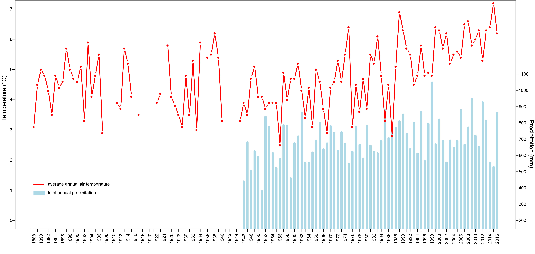

 | Land-use category | Indicator taxa
Human  indicators | Cultivated land | Secale cereale, Triticum t., Cerealia undiff., Zea mays, Centaurea cyanus, Cannabis sativa, Fagopyrum
 | Ruderals  (minor and major) | Artemisia, Chenopodiaceae, Rumex acetosa/acetosella, Plantago lanceolata, Plantago media, Plantago major, Urtica, Polygonum aviculare, Brassicaceae,
Supplementary Table 1. List of herbaceous pollen taxa included in the diagram curves

