Supporting information
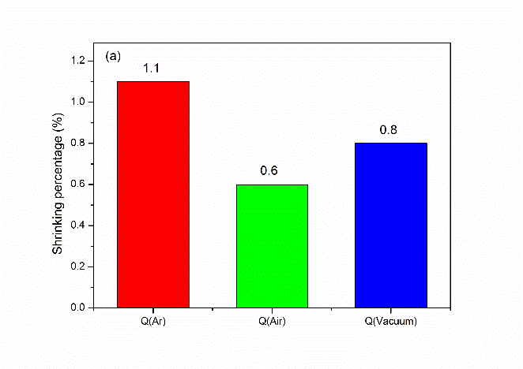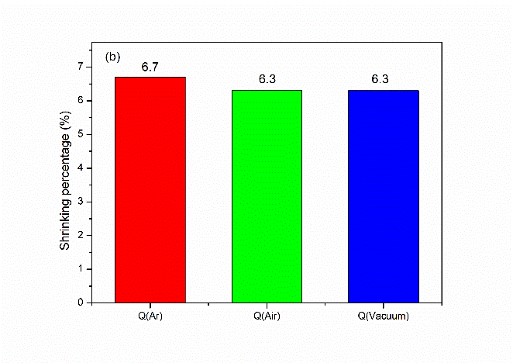
Fig. S1. Shrinking percentage of the specimens debinded or sintered under different atmospheres: (a) debinded and (b) sintered.

