Supplementary text for
A Soft Manipulator for Efficient Delicate Grasping in Shallow Water: Modelling, Control, and Real-world Experiments

Zheyuan Gong¹, Xi Fang¹, Xingyu Chen², Jiahui Cheng¹, Zhexin Xie¹, Jiaqi Liu¹, Bohan Chen¹, Hui Yang¹, Shihan Kong², Yufei Hao¹, Tianmiao Wang¹, Junzhi Yu², and Li Wen^{1,3}*

¹School of Mechanical Engineering and Automation, Beihang University, Beijing, 100191, People’s Republic of China
²State Key Laboratory of Management and Control for Complex Systems, Institute of Automation, Chinese Academy of Sciences, Beijing 100190, People’s Republic of China
³Beijing Advanced Innovation Center for Biomedical Engineering, Beihang University, Beijing 100191, People’s Republic of China.

* Corresponding author: Li Wen (liwen@buaa.edu.cn)
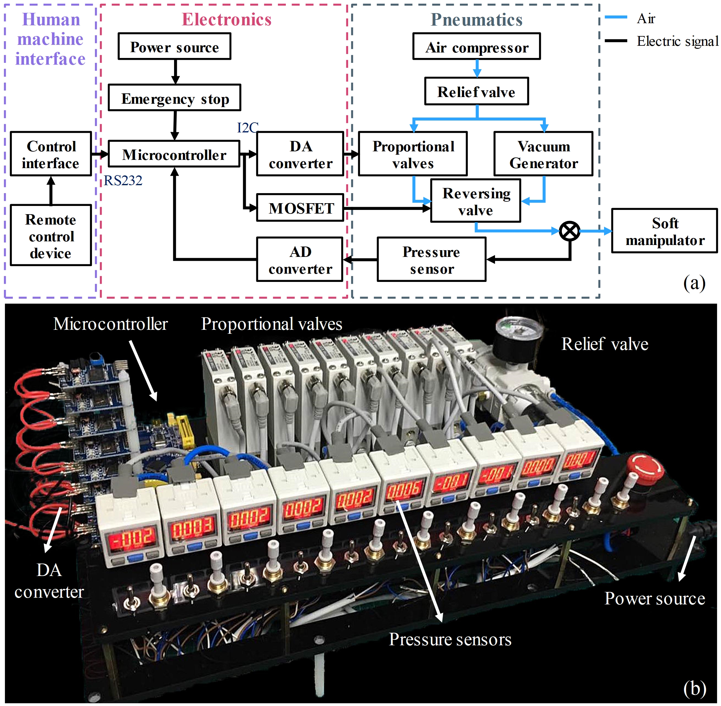
Fig. S1. Multi-channel pneumatic control system for the soft manipulator. (a) The framework of the system. (b) The hardware of the system, which contains a microcontroller, power source, DA converter, ten proportional valves, and ten air pressure sensors.

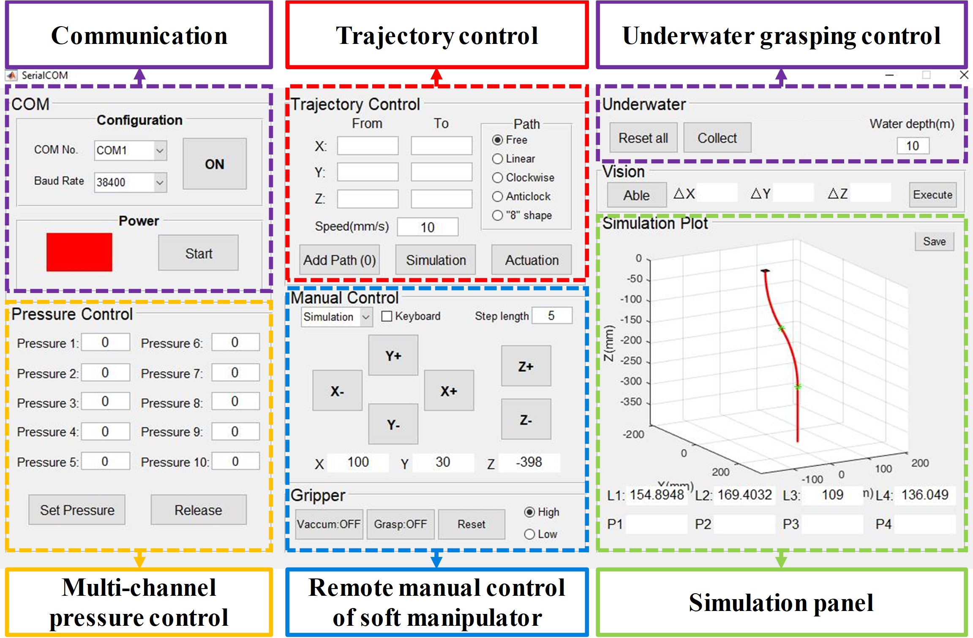
Fig. S2. The control interface of the soft manipulator. The software can control multi-channel pressure with inverse kinematics, and enable the trajectory tracing, underwater remote control and grasping as well.

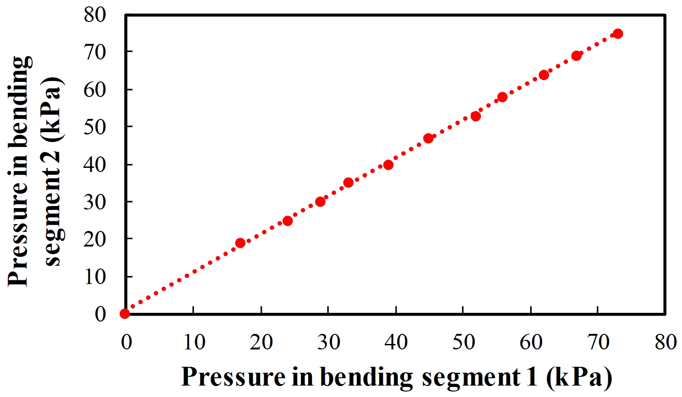
Fig. S3. Pressure calibration in bending segments 1 and 2 when the end effector is maintained vertical to the ground.

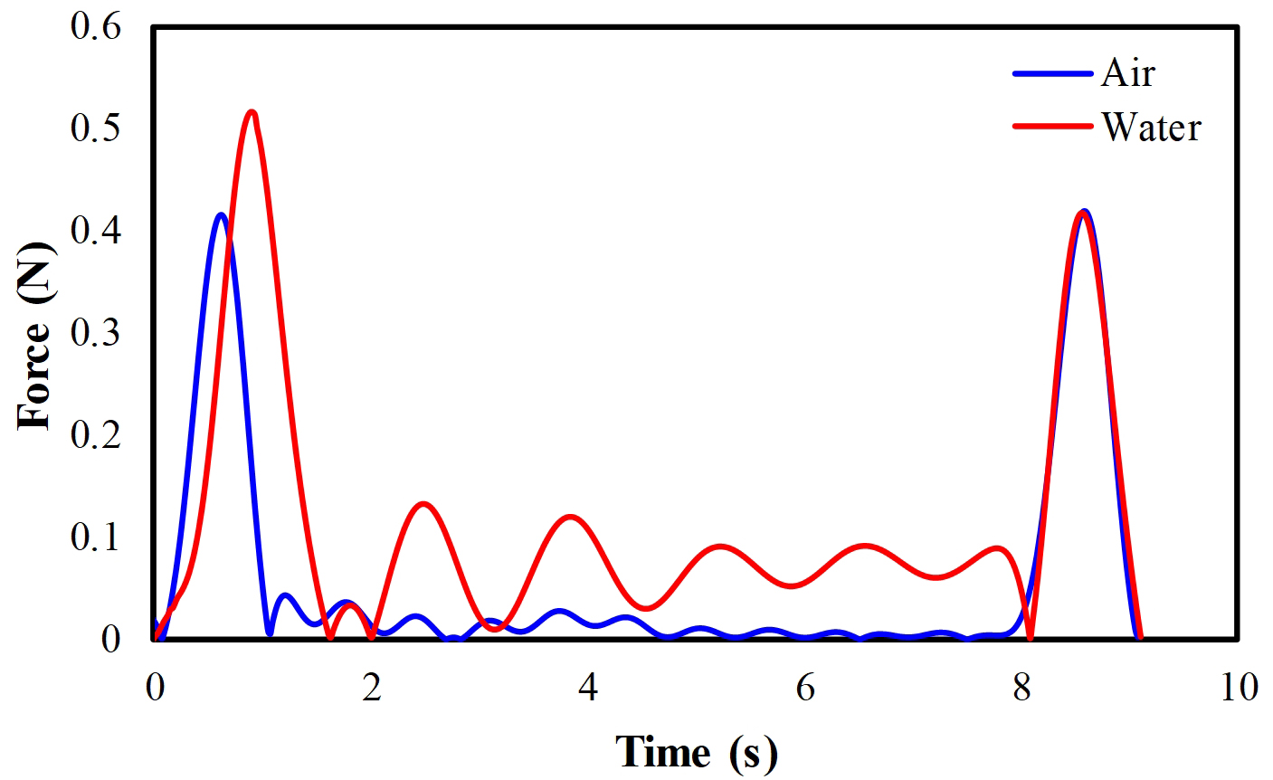
Fig. S4. Force measurements (both air and water) during the straight-line movements. The soft manipulator is controlled to move at the velocity of 50 mm/s with a total distance of 400 mm following a linear trajectory.

