Supplementary material

Table A1: Logistic regression models (see table 4 in manuscript).
 | Dependent variable: Positive callback
 | Model 1 |  | Model 2 | Model 3 | Model 4 | Model 5
Asian Minority | -0.346***  (-0.487, -0.204) |  | -0.287***  (-0.489, -0.085) | -0.342***  (-0.484, -0.200) | -0.292**  (-0.579, -0.005) | -0.282  (-0.697, 0.133)
Black Minority | -0.650***  (-0.783, -0.517) |  | -0.730***  (-0.923, -0.538) | -0.655***  (-0.788, -0.521) | -0.744***  (-1.013, -0.476) | -1.030***  (-1.407, -0.653)
MENA+P Minority | -0.650***  (-0.763, -0.536) |  | -0.589***  (-0.752, -0.426) | -0.650***  (-0.764, -0.537) | -0.787***  (-1.008, -0.566) | -0.912***  (-1.229, -0.595)
White Minority | -0.187***  (-0.285, -0.089) |  | -0.113  (-0.253, 0.027) | -0.191***  (-0.289, -0.092) | -0.289***  (-0.489, -0.088) | -0.206  (-0.490, 0.077)
Female | 0.157***  (0.080, 0.234) |  | 0.212***  (0.080, 0.344) | -0.152*  (-0.306, 0.001) | 0.156***  (0.079, 0.233) | -0.222  (-0.499, 0.056)
% Female | -1.462***  (-1.611, -1.313) |  | -1.464***  (-1.613, -1.315) | -1.800***  (-2.010, -1.590) | -1.589***  (-1.843, -1.335) | -2.041***  (-2.402, -1.679)
Asian Minority * Female |  |  | -0.115  (-0.399, 0.168) |  |  | 0.00004  (-0.575, 0.575)
Black Minority * Female |  |  | 0.153  (-0.112, 0.417) |  |  | 0.585**  (0.048, 1.122)
MENA+P Minority * Female |  |  | -0.118  (-0.344, 0.107) |  |  | 0.257  (-0.186, 0.699)
White Minority * Female |  |  | -0.146  (-0.342, 0.050) |  |  | -0.165  (-0.566, 0.236)
Female * % Female |  |  |  | 0.658***  (0.375, 0.942) |  | 0.891***  (0.391, 1.392)
Asian Minority * Female * % Female |  |  |  |  |  | -0.226  (-1.281, 0.830)
Black Minority * Female * % Female |  |  |  |  |  | -0.892*  (-1.879, 0.095)
MENA+P Minority * Female * % Female |  |  |  |  |  | -0.760*  (-1.585, 0.065)
White Minority * Female * % Female |  |  |  |  |  | 0.072  (-0.661, 0.805)
Asian Minority * % Female |  |  |  |  | -0.119  (-0.646, 0.408) | -0.014  (-0.771, 0.744)
Black Minority * % Female |  |  |  |  | 0.198  (-0.294, 0.690) | 0.627*  (-0.080, 1.334)
MENA+P Minority * % Female |  |  |  |  | 0.298  (-0.114, 0.710) | 0.680**  (0.084, 1.276)
White Minority * % Female |  |  |  |  | 0.212  (-0.153, 0.577) | 0.171  (-0.358, 0.699)
Constant | 1.002***  (0.862, 1.143) |  | 0.975***  (0.824, 1.126) | 1.160***  (1.004, 1.317) | 1.067***  (0.893, 1.241) | 1.257***  (1.037, 1.477)
Observations |  | 14,307 | 14,307 | 14,307 | 14,307 | 14,307
Note * |  | *p**p***p<0.01

Table A2: Linear probability models, strict callback definition (table 4 in manuscript).
 | Dependent variable: Interview invitation
 | Model 1 | Model 2 | Model 3 |  | Model 4 |  | Model 5
Asian Minority | -0.043***  (-0.068, -0.019) | -0.040**  (-0.075, -0.006) |  | -0.043***  (-0.068, -0.018) |  | -0.070**  (-0.132, -0.007) | -0.082*  (-0.171, 0.007)
Black Minority | -0.084***  (-0.105, -0.064) | -0.091***  (-0.118, -0.063) |  | -0.085***  (-0.105, -0.064) |  | -0.148***  (-0.200, -0.096) | -0.190***  (-0.260, -0.120)
MENA+P Minority | -0.098***  (-0.117, -0.080) | -0.092***  (-0.118, -0.066) |  | -0.098***  (-0.117, -0.080) |  | -0.169***  (-0.214, -0.124) | -0.199***  (-0.263, -0.135)
White Minority | -0.024***  (-0.042, -0.006) | -0.016  (-0.041, 0.009) |  | -0.025***  (-0.043, -0.007) |  | -0.057**  (-0.101, -0.012) | -0.040  (-0.102, 0.022)
Female | 0.018***  (0.005, 0.031) | 0.024*  (-0.001, 0.049) |  | -0.015  (-0.048, 0.017) |  | 0.018***  (0.005, 0.031) | -0.032  (-0.093, 0.030)
% Female | -0.222***  (-0.250, -0.194) | -0.222***  (-0.250, -0.194) |  | -0.255***  (-0.293, -0.216) |  | -0.288***  (-0.341, -0.236) | -0.340***  (-0.412, -0.268)
Asian Minority * Female |  | -0.006  (-0.056, 0.043) |  |  |  |  | 0.026  (-0.100, 0.151)
Black Minority * Female |  | 0.013  (-0.027, 0.053) |  |  |  |  | 0.088*  (-0.016, 0.192)
MENA+P Minority * Female |  | -0.012  (-0.049, 0.024) |  |  |  |  | 0.062  (-0.029, 0.152)
White Minority * Female |  | -0.016  (-0.052, 0.020) |  |  |  |  | -0.033  (-0.121, 0.056)
Female * % Female |  |  |  | 0.065**  (0.011, 0.119) |  |  | 0.107**  (0.003, 0.210)
Asian Minority * Female * % Female |  |  |  |  |  |  | -0.062  (-0.269, 0.145)
Black Minority * Female * % Female |  |  |  |  |  |  | -0.145*  (-0.314, 0.024)
MENA+P Minority * Female * % Female |  |  |  |  |  |  | -0.142*  (-0.292, 0.007)
White Minority * Female * % Female |  |  |  |  |  |  | 0.036  (-0.113, 0.184)
Asian Minority * % Female |  |  |  |  |  | 0.051  (-0.052, 0.155) | 0.080  (-0.064, 0.225)
Black Minority * % Female |  |  |  |  |  | 0.123***  (0.039, 0.207) | 0.192***  (0.078, 0.305)
MENA+P Minority * % Female |  |  |  |  |  | 0.139***  (0.064, 0.213) | 0.209***  (0.103, 0.314)
White Minority * % Female |  |  |  |  |  | 0.062  (-0.012, 0.137) | 0.043  (-0.061, 0.147)
Constant | 0.505***  (0.476, 0.534) | 0.502***  (0.471, 0.533) |  | 0.522***  (0.489, 0.554) |  | 0.540***  (0.502, 0.578) | 0.564***  (0.516, 0.612)
Observations | 14,307 | 14,307 |  | 14,307 |  | 14,307 | 14,307
Note * | *p**p***p<0.01

Figures A1-A5: Country specific versions of figure 2 in the main text, for robustness. Note that sample sizes are too low to detect significant interactions per country, and that occupations used differ between countries.
Figure A1: Germany.
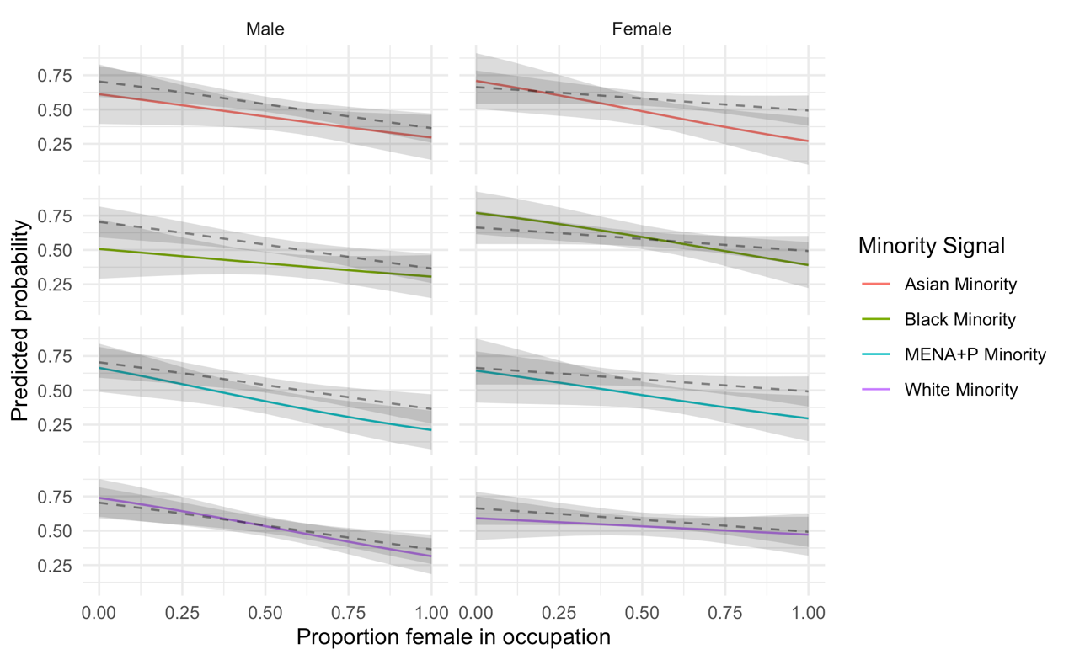
Figure A2: Netherlands.
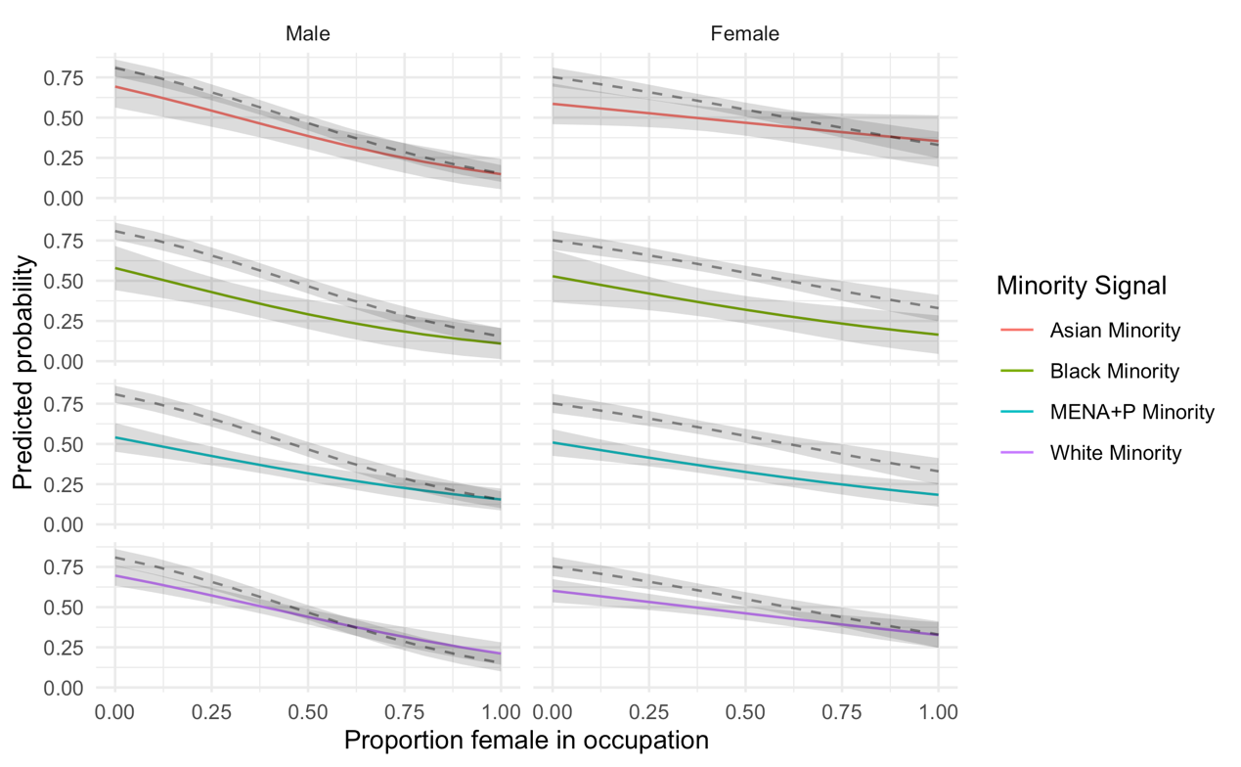
Figure A3: Spain.
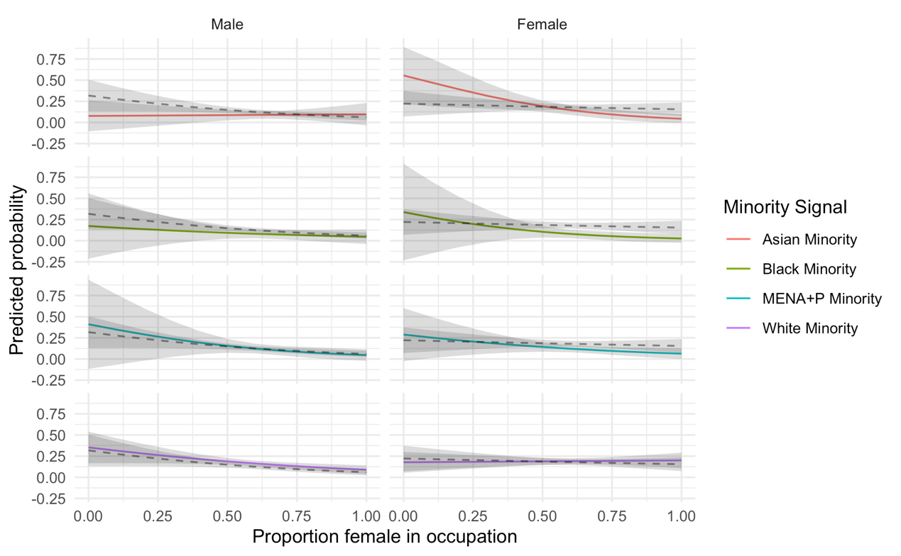
Figure A4: Norway.
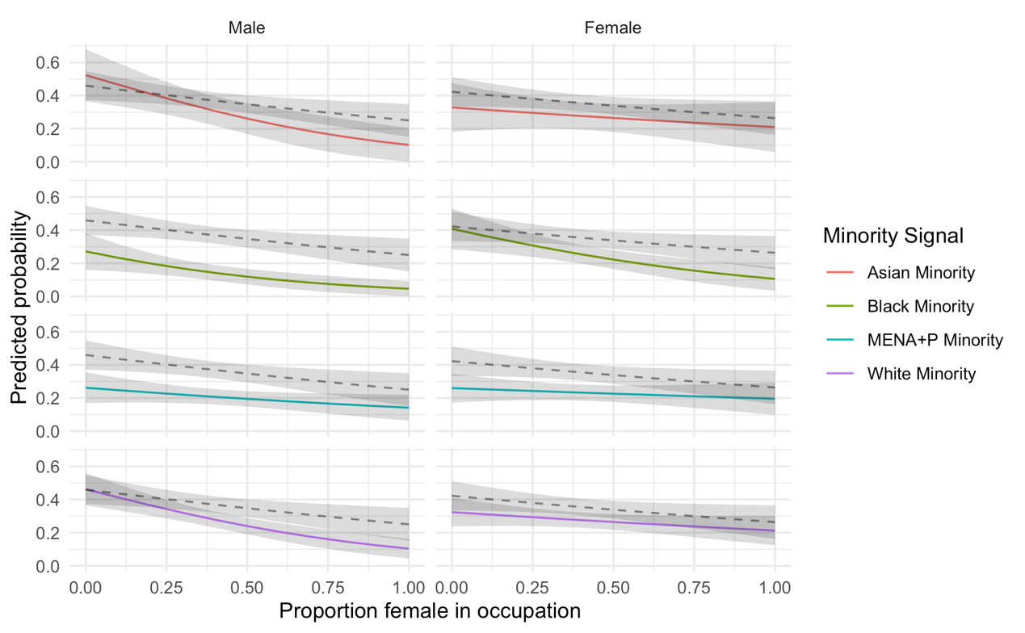

Figure A5: United Kingdom.
