Addressing Challenging Grade-Level Mathematics Standards with At-Risk Learners:
A Randomized Controlled Trial on the Effects of Fractions Intervention at Third Grade

Supplemental File

Lynn S. Fuchs, Amber Y. Wang, Kristopher J. Preacher,
Amelia S. Malone, Douglas Fuchs, and Rachel Pachmayr
Vanderbilt University

Inquiries should be sent to Lynn S. Fuchs, 228 Peabody, Vanderbilt University, Nashville, TN 37203; lynn.fuchs@vanderbilt.edu.
This research was supported by Grant R324D130003 from the National Center on Special Education Research within the Institute on Education Sciences in the U.S. Department of Education to Vanderbilt University. The content is solely the responsibility of the authors and does not necessarily represent the official views of the National Center on Special Education Research, the Institute of Education Sciences, or the U.S. Department of Education.

In this Supplemental File, we first provide Supplemental File Tables and Figures that are referred to in the Exceptional Children published report to which this supplemental file is linked. Supplemental File Table 1 provides performance and achievement gap information on not-at-risk follow-along measures. Supplemental File Table 2 summarizes programmatic changes between Wang et al. (2019) and the present study’s intervention. Supplemental File Table 3 summarizes fraction intervention instruction versus teacher survey data on the nature of classroom. Supplemental File Table 4 provides intra-class correlations (ICCs) for school, classroom, and tutoring dyad.
Supplemental File Figure 1 provides the study’s transfer measure (released fraction items from the National Assessment of Educational Progress; this includes a subset of easy, medium, and hard fourth-grade items and easy eighth-grade easy items). Supplemental File Figure 2 depicts the fraction intervention skill and sequence. Supplemental File Figure 3 summarizes self-regulated and growth mindset component’s (SR-GM’s) sequence of topics and lesson content. Supplemental File Figure 4 shows a sample comic from Brain Boost Adventures. Supplemental File Figure 5 shows a sample Super Challenge (CBM) Graph.
Next, we describe the study’s fraction measures completed by not-at-risk classmates. Finally, we provide more detailed information activities and instructional methods for the fractions intervention (FRAX, which is common to both intervention conditions) and for SR-GM.
To obtain the manual and supporting materials, contact the first author or go to https://frg.vkcsites.org/.

Supplemental File Table 1
Means, Standard Deviations (SDs), and Effect Sizes by Risk and Intervention Status on Fraction Variables Collected across Not-At-Risk and At-Risk Samples

 |  |  |  |  |  | At-Risk
 |  |  | Not-At-Risk |  |  | Control (n=29) |  |  |  | Intervention (n=55)
Variable | Max Score |  | X | (SD) |  | X | (SD) | ESª |  | X | (SD) | ESª
Pretest
Addition/Subtraction | 14 |  | 2.91 | (1.80) |  | 0.76 | (0.91) | 1.19$↓$ |  | 1.55 | (1.36) | 0.75$↓$
NAEP | 13 |  | 3.52 | (2.03) |  | 2.33 | (1.63) | 0.59$↓$ |  | 2.40 | (1.29) | 0.55$↓$
Posttest
Ordering^{b} | 6 |  | 2.04 | (1.79) |  | 1.21 | (0.88) | 0.46$↓$ |  | 2.47 | (1.61) | 0.24$↑$
Word Problems^{b} | 8 |  | 2.44 | (1.75) |  | 1.03 | (1.57) | 0.80$↓$ |  | 2.60 | (1.80) | 0.09$↓$
Addition/Subtraction | 14 |  | 6.14 | (3.62) |  | 3.66 | (2.51) | 0.69$↓$ |  | 7.25 | (4.03) | 0.31$↑$
NAEP | 13 |  | 7.39 | (2.99) |  | 3.98 | (2.22) | 1.44$↓$ |  | 6.05 | (2.30) | 0.49$↓$
ªES is difference between means divided by not-at-risk SD.
^{b}These variables comprise a subset of items from the measure.
Note. $↓$ indicates achievement gap below not-at-risk performance; $↑$indicates higher performance than not-at-risk sample.

Supplemental File Table 2
Programmatic Changes between Wang et al. (2019) and Present Study’s Intervention
 | Topic | Wang et al. (2091) content | Present study content
FRAX | Multiplication | - Limited opportunities for speeded practice; speeded activity alternated weekly between multiplication and FM content | - More opportunities for speeded practice across lessons; speeded with multiplication separated from FM speeded  - Stronger emphasis on skip-counting
 | FM instruction on Comparing, Ordering, and Number Line | - Strategies for comparing, ordering, and placing fractions on number line taught separately  - Practice problem sets were not interleaved | - Strategies consolidated as an integrated problem-solving process  - Practice problem sets are interleaved.
 | FM Speeded  Word Problems  Controlling for  Instructional  Time¹ | - Limited FM speeded practice  - Included compare, change, and splitting problems  - Missing quantities represented by x  - Extra FM problems in FRAX condition completed | - More FM speeded practice via Fraction Flash  - Includes compare and change problems  - Missing quantities represented by S (start), C (change), E (end) to reduce working memory demands  - Extra time for independent practice and, as of lesson 22, extra word problems in FRAX
SR-GM | Goal-Setting,  Perseverance, and Mindset | - SR-GM instruction based on tutor-led discussions conducted without the comic series Brain Boost Adventures | - SR-GM instruction based on tutor-led discussions conducted with the comic series Brain Boost Adventures  - Added SR-GM focus on learning from mistakes, evaluating sources of errors, and checking for misunderstanding of FM ideas
 | Controlling Instructional Time¹ | - FRAX intervention condition completed extra FM problems | - FRAX intervention students solve an extra word problem
Note. FRAX is fraction magnitude intervention. FM is magnitude understanding. SR-GM is the self-regulated learning component.
¹We made this change because extra word problems accounted better controlled for the difference in instructional time between intervention conditions.

Supplemental File Table 3
Fractions Instruction: Classroom versus Intervention
Domain | Dimension | Method | Classroom (%) | Intervention (%)
Fractions | Fraction Interpretation | Part-Whole | 90.43 | 25.00
 |  | Measurement | 9.57 | 75.00
 | Fraction Representation | Fraction Tiles | 18.26 | 20.00
 |  | Fraction Circles | 11.30 | 10.00
 |  | Pictures with Shaded Regions | 31.74 | 10.00
 |  | Blocks | 28.70 | 0.00
 |  | Number Lines | 9.57 | 60.00
 |  | Other | 0.43 | 0.00
 | Fraction Magnitude | Number Lines | 26.96 | 20.00
 |  | Drawing Pictures | 24.35 | 0.00
 |  | Referencing Manipulatives | 10.43 | 10.00
 |  | Benchmark Fractions | 12.61 | 25.00
 |  | Understanding Numerator and Denominator | 15.22 | 25.00
 |  | Finding Common Denominator | 4.78 | 20.00
 |  | Cross-Multiplying | 5.65 | 0.00
 |  | Other | 0.00 | 0.00
Multiplication |  | Manipulatives | 10.43 | 0.00
 |  | Graph Paper | 5.22 | 0.00
 |  | Drawing | 19.13 | 0.00
 |  | Skip Counting | 18.70 | 50.00
 |  | Decomposition | 11.74 | 0.00
 |  | Memorization | 12.17 | 15.00
 |  | Trick | 6.52 | 20.00
 |  | Fact Families | 15.22 | 10.00
 |  | Other | 0.87 | 0.00
Word Problems |  | Identifying Problem Type | 13.18 | 70.00
 |  | Operational Procedures | 44.83 | 20.00
 |  | Writing an Equation | 18.64 | 10.00
 |  | Keywords | 15.91 | 0.00
 |  | Drawing Pictures | 33.18 | 0.00
 |  | Making a Table | 2.73 | 0.00
Note. Intervention refers to the content of FRAX content in both intervention conditions. Percentages within each domain sum to 100.

Supplemental File Table 4
ICCs for School, Classroom, and Tutoring Dyads
 |  | ICC (School) | ICC2  (Classroom) | ICC2  (dyad)
NAEP | FRAX | 0.480 | 0.067 | 0.102
 | FRAX+SR-GM | 0.291 | 0.155 | 0.341
 | Control | 0.494 | 0.145
Multiplication | FRAX | 0.288 | 0.132 | 0.255
 | FRAX+SR-GM | 0.309 | 0.104 | 0.240
 | Control | 0.360 | 0.233
Word Problems Problem | FRAX | 0.456 | 0.087 | 0.113
 | FRAX+SR-GM | 0.354 | 0.168 | 0.212
 | Control | 0.475 | 0.166
Ordering¹ | FRAX | 0.157 | 0.195 | 0.187
 | FRAX+SR-GM | 0.131 | 0.206 | 0.278
 | Control | 0.235 | 0.077
Fraction Addition and Subtraction | FRAX | 0.194 | 0.126 | 0.264
 | FRAX+SR-GM | 0.174 | 0.138 | 0.316
 | Control | 0.283 | 0.114
Number Line | FRAX | 0.206 | 0.135 | 0.258
 | FRAX+SR-GM | 0.222 | 0.111 | 0.234
 | Control | 0.299 | 0.117
Note. ICC is intraclass correlation. FRAX is intervention without the self-regulated learning component (SR-GM); FRAX+SR-GM is intervention with SR-GM. Number Lines, Word Problems, Multiplication, Ordering, and Fraction Addition and Subtraction are from the Fraction Battery-revised (Malone & Fuchs, 2017). NAEP is NAEP-revised, 13 released fraction items from the National Assessment of Educational Progress.
¹For Ordering, pretest is comparing fractions with the Fraction Battery-revised Comparing (Malone & Fuchs, 2017).

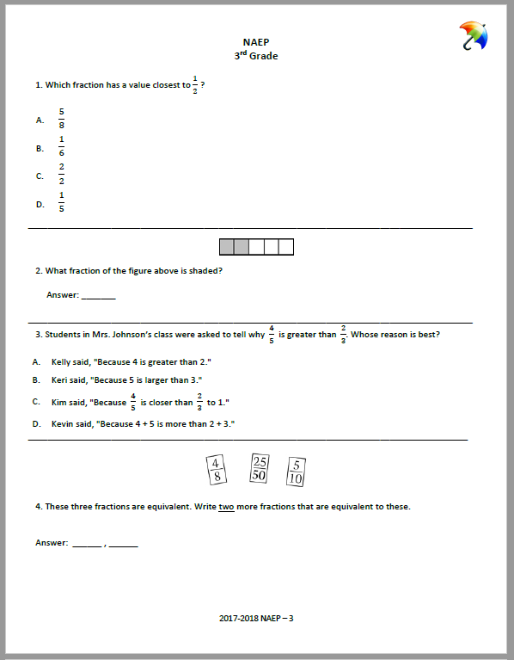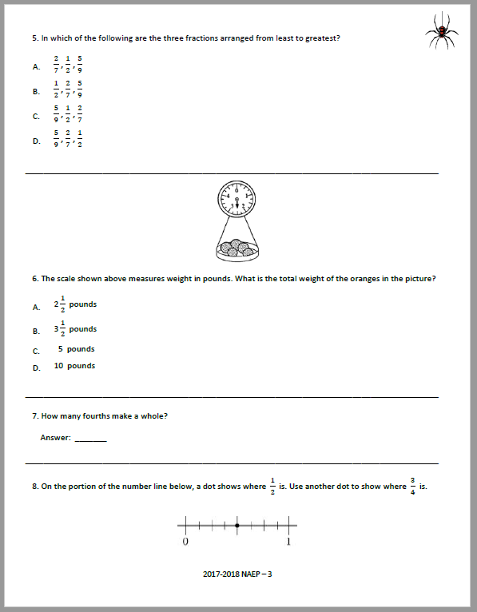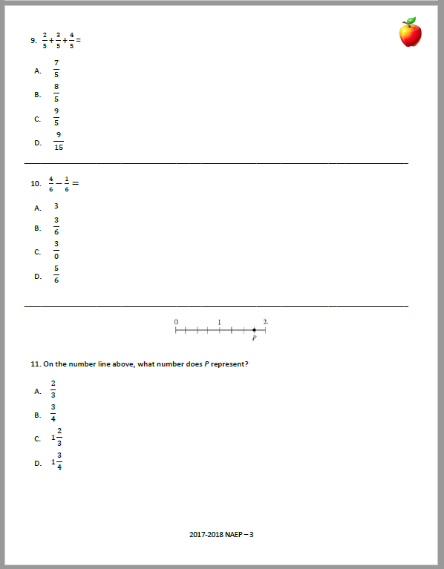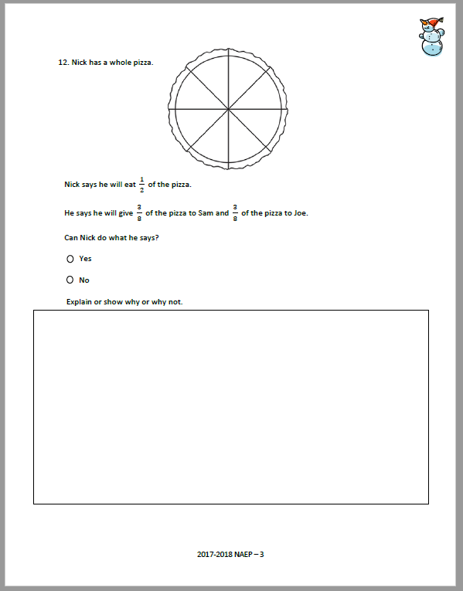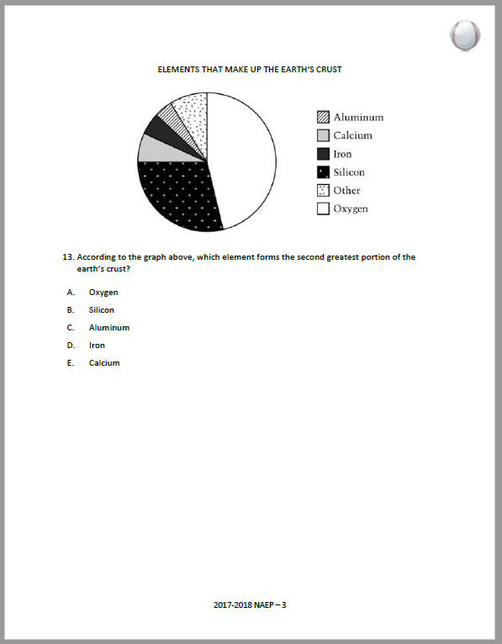
Supplemental File Figure 1. Study transfer measure: Released items from the National Assessment of Educational Progress (NAEP; including a subset of easy, medium, and hard fourth-grade items and easy eighth-grade easy items).
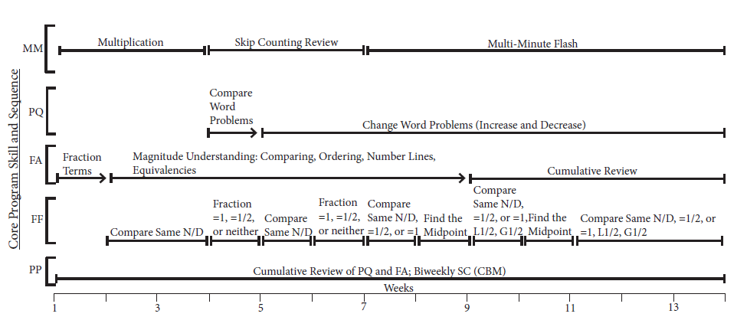
Supplemental File Figure 2. Fraction Intervention Skill and Sequence

 | Week (W)
Key Topic: Synopsis | W1 | W2 | W3* | W4 | W5* | W6 | W7* | W8 | W9* | W10 | W11* | W12 | W13*
Brain Power: Malleability of the brain; working harder makes the brain stronger | I | R |  |  |  |  |  |  |  |  |  |  | R
Train the Brain: Learning and practicing skills form new and stronger neural connections |  | I |  |  |  |  | R
Learn from Mistakes**: Brain power grows when you learn from mistakes |  | I | R | R |  |  |  |  | R
Grow from Mistakes**: Overview of common mistakes made when comparing fractions |  |  | I
Track Progress**: Track and monitor progress using graphs |  |  | I |  | R |  | R |  | R |  | R |  | R
Types of Mistakes: Careless mistakes; importance of think aloud for checking work |  |  |  | I
Apply Fractions: Real-life applications of using fractions and math skills in daily life |  |  |  |  | I |  |  | R | R |  | R
Perseverance: Persist through challenging problems or situations |  |  |  |  | I | R | R | R | R | R | R | R | R
Set Goals**: Set SMART goals and work to achieve them; linked to CBM |  |  |  |  |  | I | R |  |  |  |  | R
Self-Regulation: Importance of monitoring thoughts to make progress |  |  |  |  |  |  |  |  | I
Set Priorities: Importance of prioritizing goals and tasks |  |  |  |  |  |  |  |  |  |  |  | I
Note. I = introduced in Brain Boost Adventures story; R = reviewed in Brain Boost Adventures story; *Weeks that end with administration of the Super Challenge CBM. **Tutors review these topics during review of student’s performance on the CBM when applicable (even if the comic story did not address that topic for that lesson). Note that tutors review SR-GM concepts from all previously taught material as applicable throughout lessons to boost students’ understanding of SR-GM.
Supplemental File Figure 3. Brain Boost Adventures: Topic and Lesson Sequence

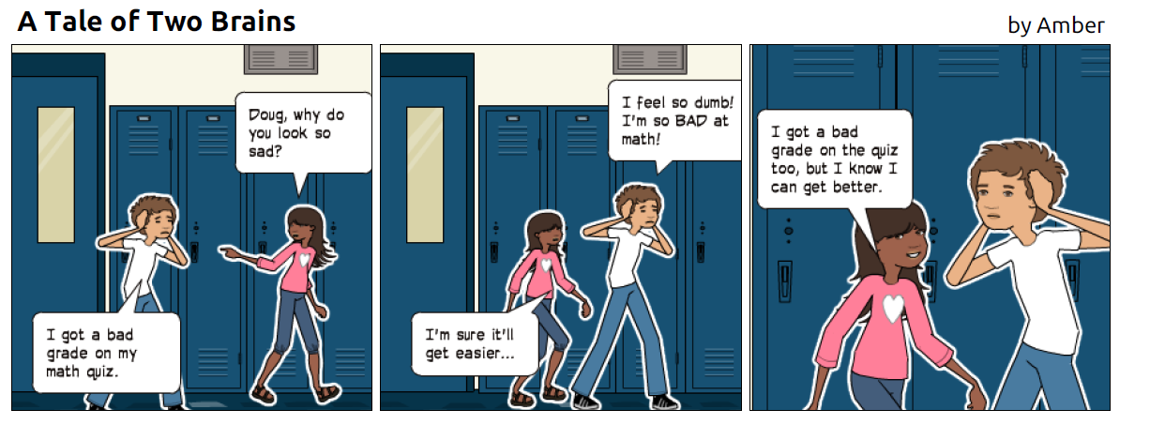
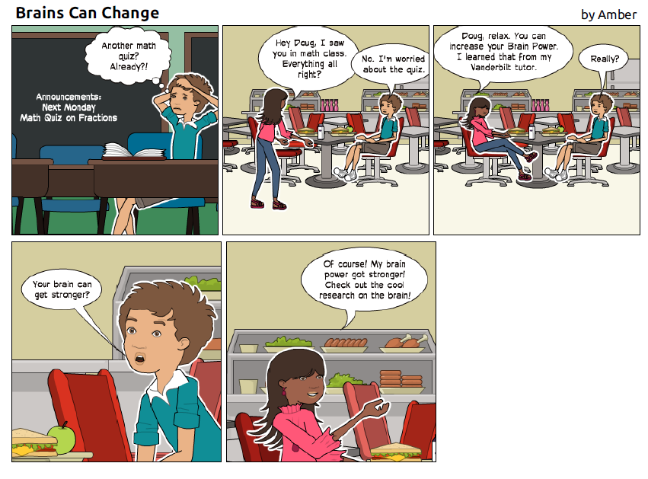
Supplemental File Figure 4. Sample comics from Brain Boost Adventures

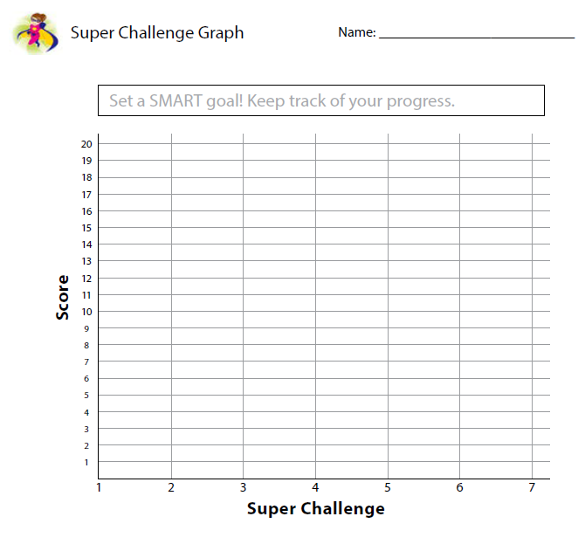
Supplemental File Figure 5. Super Challenge CBM Graph
Information on the Subset of the Study’s Fraction Measures
Completed by Not-At-Risk Classmates
Due to limited access to not-at-risk classmates, they completed a subset of the study’s fraction measures: 4 of 18 word problems at posttest (two compare word problems, a math change decrease word problem; and a math change increase word problem; maximum score = 8), 6 of 12 ordering problems at posttest (maximum score = 6; ordering was not indexed in at-risk or not-at-risk students at pretest because we expected a floor effect), the complete set of addition and subtraction problems at pre- and posttest (maximum score = 14), and the complete set of NAEP items at pre- and posttest (maximum score = 13). (Word problems and ordering were not indexed at pretest.)
Additional Details on Fraction Lesson Activities and Instructional Strategies
(Common to Both Intervention Conditions)
In the present study, Super Solvers-3rd grade (revised; Fuchs et al., 2019) was delivered to pairs of students three times per week for 13 weeks in 35-min sessions. The program relies explicit, structured instructional principles, as illustrated in the following. Tutors introduce new topics with worked examples by modeling efficient solution strategies using simple, direct language to explain and think aloud each step of strategies. Efficient solutions capture the essential ideas underpinning a problem type and lead to accurate solutions in as few steps as possible. Tutors fade worked examples as students gradually assume responsibility for applying and explaining strategies. Guided and independent practice is distributed, with cumulative review systematically woven through lessons, and with interleaved problem sets requiring students to discriminate among problem types. Tutors provide corrective feedback for incorrect responses and incorrect student explanations.
The focus in the fractions intervention (FRAX) is fraction magnitude (FM), with comparing, ordering, and placing fractions on number lines, all which involve proficiency with fraction equivalencies, as well as word problems (WPs) to contextualize fractions as number in everyday contexts. WP instruction, which is schema based (Fuchs et al., 2016), focuses on compare fraction WPs and change fraction WPs (see Measures for definitions sand examples of these WP types). Each 35-min lesson includes up to five activities: Multi-Minute (1-2 min), Problem Quest (7-12 min), Fraction Action (10-18 min), Fraction Flash (2-3 min), and Power Practice (5-7 min).
During Multi-Minute (Weeks 1-3), students practice whole-number multiplication. Students learn strategies for solving basic facts (1s, 2s, 3s, 4s, 5s, 6s, 7s, 8s, 9s, 10s). First, they learn rules for multiplying by 1 and by 10, then they learn to skip count by 10s. Next, they apply skip counting to solve times 2 and 5 problems. They then learn a commonly taught “trick” for solving times 9 problems. (Students number their fingers one through 10, from left to right. They then fold down the finger they are multiplying nine by. Then, they count the number of fingers to the left of the folded finger; this number is assigned the 10s spot in the answer. Last, students count the number of fingers to the right of the folded finger; this number is assigned the 1s spot in the answer.) For remaining facts, students practice skip-counting sequences with the assistance of a skip-counting mat. (Note that in earlier iterations of multiplication instruction, we relied extensively on a conceptual decomposition strategy for deriving multiplication fact answers. However, the third-grade at-risk students struggled and produced error-prone work. Since our purpose in teaching multiplication in the fractions program was quick access for finding fraction equivalencies, we decided to rely on this trick for the 9s tables.)
In Weeks 4-6, students practice one skip-counting sequence (e.g., skip-counting by 4) per lesson. Tutors and students recite each sequence twice; once with and once without the mat (to encourage fact memorization). In Week 7, tutors introduce Multi-Minute Flash, a speeded activity that lasts through Lesson 39 designed to build fluency in executing procedural strategies to find correct multiplication fact answers, with the eventual goal of establishing long-term representations of multiplication facts for automatic retrieval. Tutors present basic multiplication facts on cards. Students alternate with their partner to provide as many correct responses as possible in 1 min. When an error occurs, the tutor immediately requires a correct response using skip-counting before the next card is revealed. The timer continues to run to discourage careless responding. Pairs try to beat their previous session’s score.
Fraction Action addresses FM. In Weeks 1-8, students extend prior part-whole and equal-sharing understanding with more sophisticated concepts about magnitude and strategies for evaluating magnitude. Activities include comparing, ordering, placing fractions on number lines, and finding equivalencies. Lessons incorporate fraction tiles, fraction circles, and number lines to introduce and review concepts throughout the program. The Compare Card represents the integrated problem-solving process for compare, the order, and number line problem types.
Students first learn to compare same denominator and same numerator fractions. They learn that denominators indicate how many equal parts the unit is divided into and therefore represent the size of each equal part; when denominators are the same, students look to the numerator to assess which fraction has more same-size parts. When numerators are the same, students look to the denominator to assess the relative size of each unit’s parts. Thus, for fractions with the same denominators, students identify the bigger fraction by determining which fraction has more parts; for same numerator problems, by thinking about which fraction has bigger parts.
Then, comparing fractions with different denominators or different numerators is introduced. Tutors teach strategies for identifying fractions equal to 1 whole (when the numerator and the denominator are the same) and fractions equal to ½ (double the numerator should equal the denominator or, the numerator is half the denominator). Then benchmarking instruction begins, with assistance of subsequent problem-solving strategies on the Compare Card. They practice comparing the following combinations of fractions: (a) one fraction =1 and the other L1 or G1; (b) both fractions =1; (c) one fraction L1 and the other G1; (d) both fractions G1 which requires rewriting both G1 fractions as mixed numbers; (e) both fractions =1/2; (f) one fraction =½ and the other L½ or G½; (g) one fraction L1/2 and the other G/12; (h) one fraction L½ and the other G½; and (i) both fractions L½ or G½, which require finding an equivalent fraction (introduced in Week 8). We rely on benchmarking to ½ at third grade because it enjoys a privileged representational status due to early and repeated exposure to ½ in authentic situations (Miller, 1984; Singer-Freeman & Goswami, 2001) and because it is easily visualized as one of two equal parts (cf. Faulkenberry, & Pierce, 2011).
These problem subtypes are the same subtypes taught for ordering and number line. Tutors introduce fraction placement on a 0-1 number line. We use this problem subtype to illustrate what we mean by efficient solution strategies and by instruction to support students who may have working memory limitations. First, students use their growing understanding of fraction ideas to decide if the fraction is L1 or =1. If 1, they place the fraction on the number line immediately. If not, they immediately label the fraction as =1. They notate their paper to remember decisions in the strategic decision tree as they formulate those decision, instead of holding them in working memory while they work on subsequent steps. They next benchmark to decide if each fraction is L½, G½, or =½ and label the fraction as such immediately. Then, they place the fraction on the correct side of ½ using a tic mark and write the fraction below their mark. They notate in parallel ways when placing two fractions on the 0-1 number line; this includes placing them on the correct side(s) of 1/2 and ordering them. Practice is interleaved with previously taught content. Eventually, students learn to place two fractions on a number, using a similar but more complex strategic decision tree, as they notate the series of required decisions on paper (rather than holding information in working memory).
Tutors lead discussions about similarities and differences in comparing, ordering, and placing fractions on a number line to promote understanding of the Compare Card strategies and why the same strategies apply across all fraction magnitude (FM) activities. To facilitate discussions, they present examples with compare, ordering, and number line problems including the same fractions (e.g., ½, 2/8, ¼).
Fraction Flash is designed to build speed and flexibility on essential foundational skills embedded with larger strategies. Stimuli are presented on cards. Students alternate with partners to provide as many correct responses as possible in 2 min. When an error occurs, the tutor immediately requires a correct response with an explanation for that correct response before revealing the next card. The timer continues to run to discourage careless responding. Pairs try to beat their previous session’s score. In Weeks 2-3, 5, 7, 9, and 11-13, students compare fractions and state which is bigger (the mix of fractions gradually increases across weeks). In Weeks 4 and 6, students identify if fractions are =½, =1, or neither. In Weeks 8 and 10, flashcards present students point to ½ on a number line, identify if the fraction is L½, G½, or =½, and then point to which side of ½ the fraction goes.
Problem Quest, which addresses WP instruction, begins in Week 4-13. Relying on schema-based instruction (Fuchs et al., 2016), tutors teach students to categorize WPs as belonging to a problem type based on its underlying mathematical structure; use the RUN mnemonic to identify the problem type: Read the problem, Underline the question, and Name the problem type.
Tutors introduce each WP type (compare WPs; change WPs) with an intact story (no unknown quantity to solve for; no question), while explaining and demonstrating the WP type’s central mathematical event with fraction tiles. Next, tutors present the same mathematical story in the form of a WP, with an unknown and a question. Then, students learn a systematic strategy for processing and solving this problem type. To execute the strategy, students initially use a help card, which is faded as quickly as possible.
Compare WPs (e.g., In art class, Maria used 5/12 of a bottle of blue paint and ¾ of a bottle of red paint. What paint color did she use more of?) are taught first. In Lesson 20, ordering WPs (with three fractions to order) are taught as a subtype of compare WPs. For compare WPs (see examples below), students (a) circle the compare word and the fractions to compare; (b) circle and connect these fractions; (c) cross out irrelevant amounts; (d) set up work; (e) compare or order the fractions; and (f) answer the question (check label). In Lesson 21, tutors introduce compare WPs with irrelevant information. Strategic presentation of compare WP variations encourages students to distinguish between ordering WPs versus WPs with irrelevant fractions in the cover story.
In Week 5, tutors introduce change WPs. First, students learn how to recognize and solve increase and decrease WPs using whole numbers with the end amount missing (to facilitate understanding without the complication of fractions). Then, students learn how to solve fraction increase and decrease WPs with the end amount missing (e.g., Dyshawn had 2/6 of a liter of water in his water bottle. Then, his friend poured another 3/6 of a liter of water into his bottle. How much water does he have now?). Students learn to write label; write the equation, S + C = E or S – C = E; circle amounts and label S, C, E; cross out irrelevant amounts; write amounts in the equation; solve for missing number; and answer question and check their label. Students solve change word WPs with irrelevant information starting in Week 8.
In the other two Week 8 lessons, tutors provide review and encourage careful attention to distinguish between the two WP types. They present a list of WPs and prompt students to identify the WP type, think hard about what the question is asking, and explain their thinking. In Week 9, tutors introduce change WPs with the change amount missing; first with whole numbers, then with fractions (e.g., Sarah ran 3/9 of a mile at the gym. After lifting weights, she ran some more. Now she has run 7/9 of a mile. How many miles did Sarah run after lifting weights?). In Week 10, they introduce problems with the start amount missing using whole numbers, then with fractions (e.g., Willie has some water in a bottle. Then, he fills his bottle with another 2/10 of a liter at the water fountain. Now, he has 7/10 of a liter of water. How much water did Willie start with?). Change problem subtypes, with and without irrelevant information, are spiraled and reviewed throughout the lessons.
In Power Practice, the final activity in each lesson, students complete problems independently, with systematic distributed review of previously taught compare, ordering, and number line problems. Starting in Week 4, practice also includes one WP.
Additional Details on SR-GM Lesson Activities and Instructional Strategies
With the SR-GM component, students receive the same fractions intervention but with the SR-GM component that integrates instruction on growth mindset with self-assessment and goal setting. This includes feedback and goal-directed discussion after each Super Challenge CBM, as well as a Brain Boost Adventures episode with growth mindset discussion at the start of each lesson.
The Brain Boost Adventures comics address the key SR-GM concepts shown in Supplemental File Figure 3. We operationalize the idea of growth mindset as “brain power can grow” and referred in the lessons to supporting research. During Weeks 1-3, Brain Boost Adventures comics focus on teaching students about “brain power,” its malleability, how to train the brain like an athlete, how mistakes can help the brain grow, and tracking progress and goal setting. Students are explicitly taught how to graph and interpret their graphs (see Supplemental File Figure 5 for a sample graph) and to how to set goals to beat their highest score to date. In Week 4, Brain Boost extends discussion to learning from mistakes. Students follow Brain Boost Adventures comic stories to examine and discuss careless mistakes and apply this thinking in their first Super Challenge.
In Lesson 10 (completed in Week 4), students review their previous CBM (completed in Lesson 9) to identify mistakes. Tutors prompt students to think, “Why did I get this type of problem wrong?” and “What can I do to get it right?” They assist students in identifying the cause of their mistakes (e.g., forgetting a strategy vs. making a careless mistake). Within this question-answer format, students verbally follow the relevant FRAX strategy and self-identify the source of error. They then use this talk-aloud strategy as they solve problems on their own. Students are explicitly taught to assess whether their answer makes sense (e.g., that the answer to an addition problem is greater than the two addends). If it does not make sense, they must redo the problem and assess the source of error. These strategies are used to focus practice following each Super Challenge. After correcting the CBM, tutors review each student’s strengths and weaknesses by problem type. Students work with tutors to identify and verbally explain sources of error and how to remediate them. Students set a goal to improve performance on the problem types they struggle with most. During individual practice, students focus their practice on these problem types. Tutors ask students to verbally explain a focus problem after solving it on individual practice. The Brain Boost Adventures comics support these strategies with stories and scenarios related to checking thinking and errors.
See Supplemental File Figure 3 for a summary of the SR-GM topic and lesson sequence; see Supplemental File Figure 4 for a sample Brain Boost Adventures episode; and see Supplemental File Figure 5 for a sample Super Challenge CBM graph.
Changes to Fractions Intervention and the SR-GM Component
As explained in the introduction to this article’s main file, in response to the Wang et al. (2019) study, we made changes to the FRAX intervention and the SR-GM component (also see Supplemental File Table 1).
FRAX Intervention Changes
For FRAX intervention, we slowed the pace for introducing new content to provide more time to promote depth of understanding and mastery.
Second, for comparing, ordering, and placing fractions on a number line, we consolidated strategies to improve FM understanding and facilitate strategy use. In Wang et al. (2019), we had introduced strategies for these FM problem types separately, each with its own strategy card. In the revision, problem-solving strategies are consolidated and represented on an integrated card to emphasize conceptual and strategic similarities and differences across activities.
Third and relatedly, we added four lessons highlighting similarities and differences in the thought processes among the three activities. Fourth and also relatedly, we added interleaved (mixed) practice on the three FM activities during tutor-led and independent practice to provide students support for distinguishing among the activities.
Fifth, we excluded splitting WPs (which describe a unit or units being cut, divided, or split into equal parts) to provide more time to master complexities involved in compare and change WPs. This included isolating the unknown on one side of the equal sign to find start, change, or end amounts in change problems.
SR-GM Changes
For SR-GM, we made two changes explained in the introduction to this article’s main file. We added Brain Boost Adventures comics and introduced strategies for students to find and consider how to use errors productively.

