Supplementary material

**Table S1:** Raw data offire event characteristics sorted by site, year and zone. The two last columns refer to respectively distance between fire and site, and lake surface area. Burned areas and lake surface area are expressed in hectares; distances are expressed in meter and cumulated severity is dimensionless. This table has then been modified as explained in the methodology (see section Database architecture). Fire characteristics (columns 4 to 8) were accumulated according to the year (column 2) considering the lag of up to five years with charcoal records and within each zone (column 3).

|  |  |  |  |  |  |  |  |  |  |  |  |  |
| --- | --- | --- | --- | --- | --- | --- | --- | --- | --- | --- | --- | --- |
| name | year | number | zone | burned_ | unburned | low_sev | med_sev | high_sev | cumul | fire_lake | lake_ | human (0) or ligthning (1) induced fire |
| of fire | area | _area | _area | _area | _area | _sev | _dist | surface_area |  |
| dave | 2006 | 1 | 30 | 4.01 | 0 | 0 | 0.59 | 3.42 | 25.91 | 29.3 | 5.26 | 1 |
| dave | 2007 | 1 | 30 | 40.54 | 40.54 | 0 | 0 | 0 | 0 | 26.1 | 5.26 | 0 |
| dave | 2009 | 2 | 30 | 3043.11 | 3.06 | 22.29 | 463.91 | 2553.86 | 12281.53 | 11.6 | 5.26 | 1 |
| dave | 2009 | 2 | 15 | 793.81 | 0.87 | 3.65 | 112.97 | 676.31 | 5854.58 | 11.6 | 5.26 | 1 |
| dave | 2010 | 1 | 30 | 269.64 | 0 | 0.63 | 21.78 | 247.23 | 1520.34 | 27.01 | 5.26 | 1 |
| dave | 2013 | 4 | 30 | 3819.75 | 0.21 | 24.74 | 3629.86 | 164.93 | 4412.96 | 27.8 | 5.26 | 1 |
| dave | 2013 | 4 | 15 | 3601.8 | 0.21 | 21.26 | 3413.54 | 166.78 | 4197.19 | 27.8 | 5.26 | 1 |
| dave | 2013 | 4 | 3 | 12.13 | 0 | 0 | 12.13 | 0 | 10.34 | 27.8 | 5.26 | 1 |
| dave | 2012 | 1 | 30 | 27.7 | 0.09 | 1.44 | 17 | 9.17 | 51.38 | 12.6 | 5.26 | 1 |
| dave | 2012 | 1 | 15 | 27.7 | 0.09 | 1.44 | 17 | 9.17 | 51.38 | 12.6 | 5.26 | 1 |
| dave | 2011 | 1 | 30 | 306.44 | 6.95 | 4.27 | 29.3 | 265.92 | 141.02 | 26.2 | 5.26 | 1 |
| garot | 2011 | 1 | 30 | 1675.37 | 38.6 | 0 | 2.09 | 1634.69 | 9616.38 | 0.5 | 5.62 | 1 |
| garot | 2011 | 1 | 15 | 1675.37 | 38.6 | 0 | 2.09 | 1634.69 | 9616.38 | 0.5 | 5.62 | 1 |
| garot | 2011 | 1 | 3 | 615.78 | 13.53 | 0 | 0.6 | 601.65 | 4029.81 | 0.5 | 5.62 | 1 |
| garot | 2014 | 1 | 30 | 388.99 | 26.45 | 53.53 | 309.02 | 0 | 199.43 | 10.2 | 5.62 | 1 |
| garot | 2014 | 1 | 15 | 388.99 | 26.45 | 53.53 | 309.02 | 0 | 199.43 | 10.2 | 5.62 | 1 |
| garot | 2009 | 1 | 30 | 31.94 | 0.63 | 8.19 | 18.26 | 4.86 | 33.52 | 24.8 | 5.62 | 1 |
| loup | 2013 | 1 | 30 | 5.8 | 0 | 0.26 | 5.54 | 0 | 3.78 | 16.3 | 1.66 | 0 |
| nano | 2013 | 1 | 30 | 5.8 | 0 | 0.26 | 5.54 | 0 | 3.78 | 12.04 | 0.57 | 0 |
| nano | 2013 | 1 | 15 | 5.8 | 0 | 0.26 | 5.54 | 0 | 3.78 | 12.04 | 0.57 | 0 |
| pessiere | 2007 | 1 | 30 | 45.11 | 36.25 | 1.88 | 2.6 | 4.39 | 18.23 | 14.6 | 5.29 | 1 |
| pessiere | 2007 | 1 | 15 | 12.63 | 12.01 | 0.31 | 0.1 | 0.21 | 1.33 | 14.6 | 5.29 | 1 |
| pessiere | 2015 | 1 | 30 | 1 | 0 | 0 | 1 | 0 | 1 | 15.3 | 5.29 | 1 |
| schon | 2006 | 1 | 30 | 560.19 | 2.7 | 12.79 | 50.25 | 494.44 | 3350.35 | 8.8 | 3.04 | 1 |
| schon | 2006 | 1 | 15 | 560.19 | 2.7 | 12.79 | 50.25 | 494.44 | 3350.35 | 8.8 | 3.04 | 1 |
| schon | 2013 | 1 | 30 | 29.63 | 0 | 0 | 22.41 | 7.22 | 52.88 | 14.4 | 3.04 | 1 |
| schon | 2013 | 1 | 15 | 18.9 | 0 | 0 | 13.66 | 5.24 | 37.75 | 14.4 | 3.04 | 1 |
| schon | 2014 | 1 | 30 | 1.44 | 0 | 0 | 1.44 | 0 | 0.65 | 17.1 | 3.04 | 1 |
| schon | 2015 | 1 | 30 | 116.35 | 0 | 8.72 | 107.16 | 0.47 | 87.33 | 15.6 | 3.04 | 1 |
| walt | 2013 | 2 | 30 | 5052.32 | 0.18 | 1396.29 | 3655.76 | 0.09 | 1358.54 | 24.1 | 2.12 | 1 |

**Table S3:** Lakes coordinates

|  |  |  |
| --- | --- | --- |
| name | longitude | latitude |
| pessiere | -79.240 | 49.509 |
| schon | -77.568 | 50.595 |
| garot | -77.554 | 51.100 |
| nano | -77.364 | 53.024 |
| loup | -77.401 | 53.055 |
| dave | -76.152 | 52.062 |
| walt | -76.043 | 51.852 |

../../figureS1.pdf

**Figure S1:** (A) Picture of the actual trap device used to collect charcoal particles and (B) the corresponding design schema of the trap device.

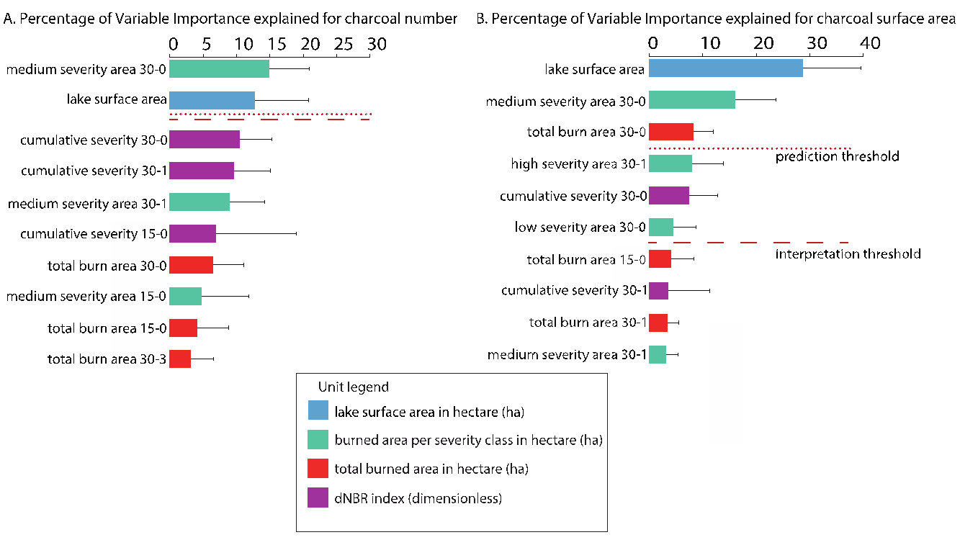

**Figure S2:** Ten first explanatory variables of charcoal number (**A**) and charcoal surface (**B**) expressed in percentage; the variables were selected based on the method of Genuer et al. (2010). Colours refer to the categories of environmental variables linked to charcoal: fire severity (purple), burned area per fire severity class (green), total burned area (red), and lake size (blue). Dotted lines refer to the prediction threshold and dashed lines refer to the interpretation threshold (see Material and Methods, Genuer et al. 2015). In panel (**A**), both thresholds are identical. Nomenclature of variable shows in first the type of variable, then the zone in which it has been measured and the delay (lag) between the fire trait measurements and the charcoal record.

Both for charcoal number (Fig S2A) and surface (Fig S2B), all types of variable are among the most explanatory variables of the dataset. Seven out of ten variables are common for the two charcoal measurements. Respectively 3 and 1 variables out of ten describe fire characteristics within the 15 km zone for charcoal number and surface, as they are 6 and 8 out of ten for fire characteristics within the 30 km zone. Likewise, variables that describe a lag of 0 year between the fire events and the charcoal record represent 6 and 5 variables out of ten for charcoal number and area, as lag 1 variables represent 2 and 4 variables out of ten. Yet, only two variables were significant in terms of both interpretation and prediction for charcoal number: the medium severity area within the 30-km zone and the lake size (Fig S2A). In the case of charcoal surface, three and six variables were significant respectively to the prediction and the interpretation thresholds (Fig S2B). Lake size is the second and the first variable selected for charcoal number and surface, respectively, thus stressing the function of lake size characteristics in explaining those two indices. The medium severity area within the 30 km zone is the other most important variable for explaining both charcoal number and surface, highlighting the role of fire severity relative to burned area to explain charcoal pattern. Concerning charcoal surface solely, total burned area within the 30 km zone during the year of charcoal record is one out of the three most significant variables contributing to predict the charcoal pattern.

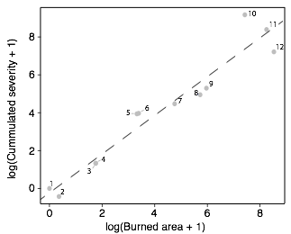

**Figure S3:** Linear regression between fire cumulative severity and burned area (dotted line). Each of the twelve dots corresponds to one fire characteristics (burned area and cumulated severity) measured in one year. Large and severe fires will tend to be on the upper right part of the graph as small and not severe fires, that can be classified as surface fires, will be in the lower left part of the graph. Fire events above the dotted line will tend to be more severe than large as fires below the dotted line will tend to be larger than severe.