Supplemental Information:

Rapid Neoglaciation on Ellesmere Island Promoted by Enhanced Summer Snowfall in a Transient Climate Model Simulation of the Middle-Late Holocene

Stephen J. Vavrus, Feng He, John E. Kutzbach, William F. Ruddiman

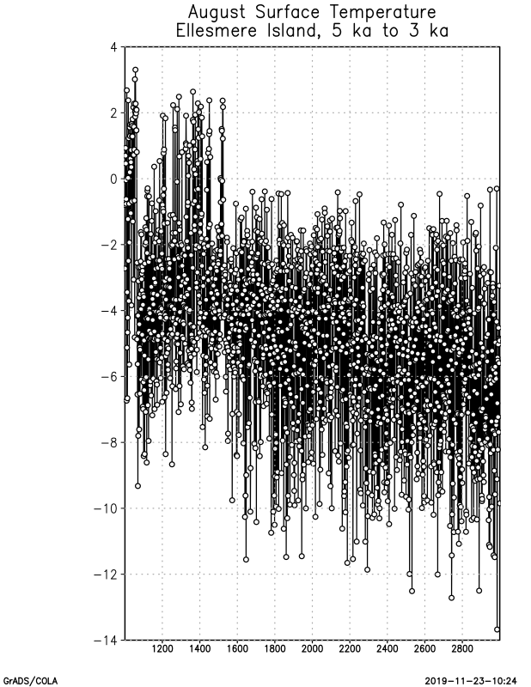
5 4.8 4.6 4.4 4.2 4 3.8 3.6 3.4 3.2 3

Figure S3. August surface temperature (ºC) on Ellesmere Island (78ºN, 80ºW) from
5 ka to 3 ka.

