Appendix A. Primary literature search.

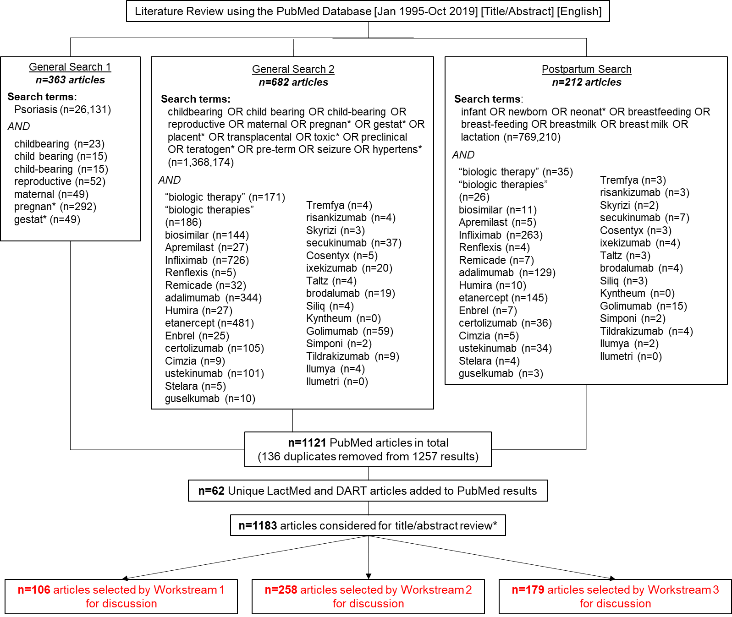
Literature search methodology, search terms, and article selection. Articles published between January 1995 and October 2019 were taken into consideration. A PubMed filter was applied to capture English language studies only. Workstream 1 considered articles that pertained to the effect of PsO on pregnancy and the effect of pregnancy on PsO; Workstream 2 considered articles that pertained to pharmacological information, human and animal data, and treatment considerations during pregnancy; and Workstream 3 considered articles that pertained to newborn/infant and maternal considerations postpartum. After title/abstract review, articles were categorized for relevancy into one or multiple sections, and individual articles could be considered by multiple workstream groups.

*Articles were filtered for relevance based on title and abstract review and irrelevant articles were excluded.
Appendix B. Secondary literature search.
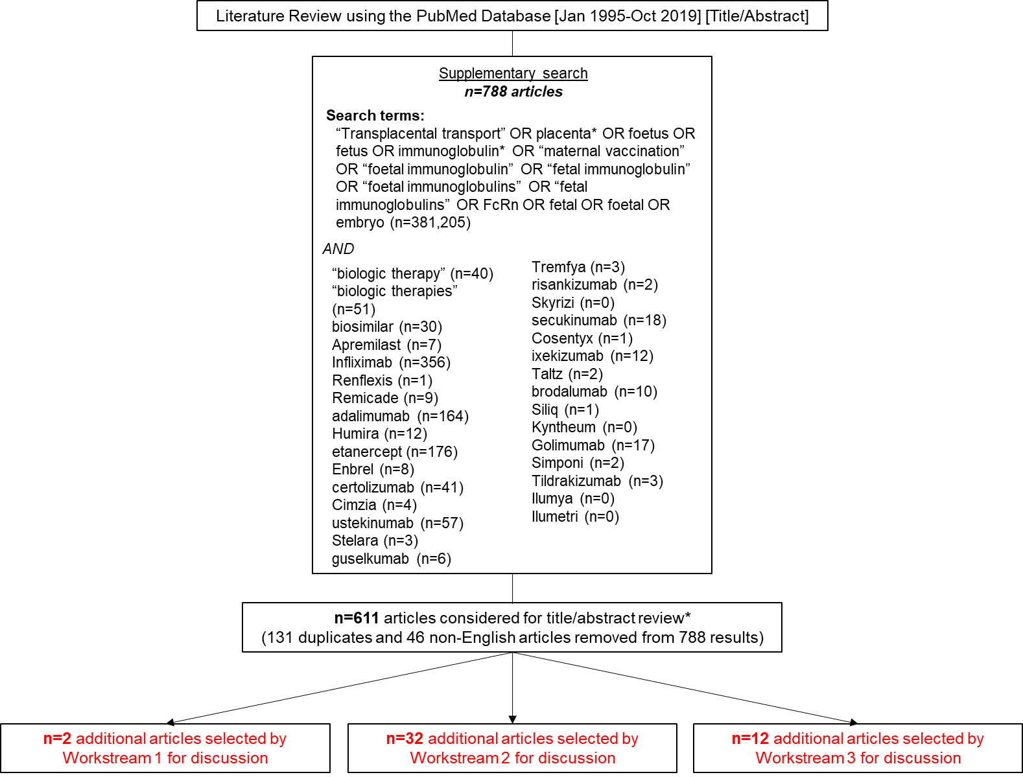
Literature search methodology, search terms, and article selection. Articles published between January 1995 and October 2019 were taken into consideration. Workstream 1 considered articles that pertained to the effect of PsO on pregnancy and the effect of pregnancy on PsO; Workstream 2 considered articles that pertained to pharmacological information, human and animal data, and treatment considerations during pregnancy; and Workstream 3 considered articles that pertained to newborn/infant and maternal considerations postpartum. After title/abstract review, articles were categorized for relevancy into one or multiple sections, and individual articles could be considered by multiple workstream groups.

*Articles were filtered for relevance based on title and abstract review and irrelevant/duplicate articles from the original PubMed/LactMed/DART results, along with non-English articles, were manually excluded.

Appendix C. Statements failing to achieve consensus.
Statement | Voting Result
Although the evidence is not definitive, many studies show that psoriasis may be associated with adverse maternal-fetal outcomes, as an independent risk factor and due to the presence of comorbid diseases such as diabetes and hypertension. | 1,4,2,2,0
Women of child-bearing potential should be counselled on appropriate contraception and family planning. Pre-conception counselling and optimized psoriasis management during pregnancy are encouraged to improve maternal and birth outcomes. | 3,3,2,1,0
HCPs should be aware of the rare, but potentially life threatening, condition of pustular psoriasis of pregnancy and its appropriate management. | 2,3,3,1,0
Biologic therapies do not cross the placental barrier in the first trimester. | 3,0,1,3,2
Certolizumab lacks a functioning Fc portion and cannot cross the placental barrier. | 3,0,4,2,0
Molecular engineering may alter the transport characteristics of biological therapeutics. | 2,0,4,1,2
Biologics used to treat psoriasis do not appear to be teratogenic based on limited data from animal studies; however, these results should be interpreted with caution as some of these studies have reported cases of neonatal deaths and fetal losses with ixekizumab, guselkumab, and risankizumab. | 2,0,3,4,0
Apremilast is a small molecule (not a biologic) that is contra-indicated during pregnancy, by product monograph. Apremilast does not appear to be teratogenic but increased prenatal losses and decreased viability of offspring were observed in animal models. | 2,0,4,3,0
When a pregnant patient with psoriasis is continuing a biologic therapy, multi-disciplinary management with primary care, obstetrics and dermatology is essential for optimal outcomes for mother and child. | 1,1,5,2,0
The use of biologic therapies for the treatment of psoriasis in pregnant women has not been studied, with the exception of certolizumab. Based on the animal toxicology data and limited clinical experience, TNF-alpha and IL12/23 inhibitors appear to have no significantly increased risk of negative maternal-fetal outcomes. The clinical experience with IL-17 inhibitors, IL-23 inhibitors and apremilast in pregnancy is very limited. | 2,1,4,2,0
Of the available biologic therapies used to treat PsO, certolizumab is acceptable throughout the duration of pregnancy. It is the only biologic that has data demonstrating minimal to no transplacental transfer. | 3,0,3,3,0
Psoriasis patients who administer biologics during their pregnancy, and especially through the last trimester, should be advised of the possible risk for a lowered immune response in their newborns. | 2,1,4,2,0
Administration of live vaccines to infants exposed to biologics in utero is not recommended for several months after the last injection during pregnancy. The duration varies with the biologic the mother was exposed to. | 2,1,4,2,0
Psoriasis exacerbations are common in the postpartum period. In addition, psoriasis comorbidities such as psoriatic arthritis, anxiety and depression may also worsen postpartum. Physicians are encouraged to consider patient counselling during pregnancy and postpartum, and referral to appropriate HCPs for further management when required. | 4,2,2,1,0
Based on real-world experience and animal toxicology data, TNF-alpha and IL12/23 inhibitors have not demonstrated teratogenicity or increased risk of negative maternal-fetal outcomes. Experience with IL-17 inhibitors, IL-23 inhibitors, and apremilast in pregnancy is limited.* | 1,6,0,2,0
Voting results reflect number of authors voting Strongly Agree, Agree, Neither Agree nor Disagree, Disagree, or Strongly Disagree, respectively.
Fc, fragment crystallizable region; HCP, health care practitioner; IL, interleukin; PsO, plaque psoriasis; QOL, quality of life; TNF, tumour necrosis factor.
*Although this statement initially passed consensus voting, upon drafting the paper it was later decided by the authors that apremilast would be removed. As such, this statement was cast out, and anonymous digital voting took place on the revised statement that appears in the manuscript (Table 1; Statement 8).

Appendix D. Summary of evidence related to use of biologic therapies in WOCBP.
Information in this table comes from the Product Monograph of each drug, unless otherwise stated.

Drug | Structure | IgG Type | Half-Life | Placental Transport  * No human data, only animal studies or pre-clinical data  ** No data cited | Presence in Breast Milk | Human - Maternal Pregnancy Risk e.g., preeclampsia, thrombosis | Human - Fetal/Newborn Risk  e.g., Congenital Malformations (CM), Miscarriage (MC), prematurity, infection | Animal Toxicology
TNF-alpha Inhibitors
Adalimumab | Fully human mAb | IgG1 | 2 weeks (10 – 20 days) | Presumed to cross placenta** | May be present in breast milk at concentrations of 0.1% to 1% of the maternal serum level. Undetectable in infant serum. | Use in pregnant women has not been studied, no known effects on labor and delivery.  No signals specific to pregnancy, labor or delivery (based on author review of relevant safety databases, registries, cohorts, case control studies and case reports) | Limited data.  Based on review of safety database, registries, cohorts, case control studies (Tsao 2019, Broms 2016, Chaparro 2018, Nielsen 2013):  - No increased risk of miscarriage or congenital malformations  - No increased risk of infection in the first year of life  - No cognitive or developmental impairment  CM: 24/350† (6.9%) (Götestam Skorpen 2016)  MC: 23/191 (12.0%)  No significant difference MC.  Increased rate CM in one study, no increase compared with disease-matched controls. | No evidence of fetal harm in monkeys
Certolizumab pegol | Recombinant humanized Ab PEGylated Fab' fragment | IgG1 | 14 days | No to minimal placental transport (Mariette 2018) | May be present in breast milk at concentrations up to 0.15% of maternal serum levels (Clowse 2017) | No signals specific to pregnancy, labor or delivery  Maternal pregnancy risks are consistent with known safety profile in general population (Clowse 2017) | Limited data.  Based on review of safety database, registries, and small studies (Clowse 2017, Mariette 2018, Clowse 2018):  - No increased risk of miscarriage, congenital malformations or fetal death  - No increased risk of infection in the first year of life  - No developmental impairment  CM: 12/267† (4.5%) (Götestam Skorpen 2016)  MC: 52/339 (15.3%)  No increased rate MC or CM. No studies with control group available. | No evidence of impaired fertility or harm to the fetus in rats
Etanercept | Human TNF receptor p75 Fc fusion protein | IgG1 | 102 (±30) hours | Crosses placenta and has been detected in serum of infants born to women treated during pregnancy | May be present in breast milk. Undetectable in infant serum | Use in pregnant women has not been studied  No signals specific to pregnancy, labor or delivery (based on author review of relevant safety databases, registries, cohorts, case control studies and case reports) (MotherToBaby Etanercept 2019) | Limited data. Available data from observational studies with use of etanercept during pregnancy do not reliably support an association between etanercept and major birth defects.  Increased risk of birth defects has been reported. This has not been supported due to the lack of specific pattern of defects and low placental transfer in early pregnancy.  Administration of live vaccines not recommended for 16 weeks after mother’s last dose.  CM: 9/251† (3.6%) (Götestam Skorpen 2016)  MC: 12/74 (16.2%)  No difference MC or CM compared to controls. | No evidence of adverse events in pregnant rats or rabbits or their offspring
Golimumab | Fully human mAb | IgG1κ | 11 – 12 (±3) days | Crosses placenta and has been detected in serum of infants born to women treated during pregnancy for up to 6 months | May be present in breast milk. Detected at concentrations approximately 350-fold lower than maternal serum concentration | Use in pregnant women has not been studied.  No signals specific to pregnancy, labor or delivery (based on author review of relevant safety databases, registries, cohorts, case control studies and case reports) | Limited data.  Available data from post-marketing surveillance, cohort study and case report reveal no increased risk of birth defects or adverse fetal outcomes compared to general population (Benoit 2018, Lau 203)  CM: 0/26† With concomitant MTX exposure (Götestam Skorpen 2016)  MC: 13/47 (27.7%)  High rate MC (with concomitant MTX exposure), no indication of an increased rate CM. No studies with control group available. | No evidence of significant effects on fertility (mice), embryo-fetal, pre-and post-natal development (mice, monkeys)  Exposure during lactation in monkeys showed no developmental defects
Infliximab | chimeric human-murine mAb | IgG1 | 7.7 – 10 days | Crosses placenta and has been detected in serum of infants born to women treated during pregnancy for up to 6 months | May be present in breast milk | The use of infliximab in pregnant women has not been studied.  No signals specific to pregnancy, labor or delivery (based on author review of relevant safety databases, registries, cohorts, case control studies and case reports) | Limited data.  Based on review of IFX safety database, registries, cohorts, case control studies (Nielsen 2013, Broms 2016, Cheent 2010):  - No increased risk of miscarriage or congenital malformations  - No increased risk of infection in the first year of life (1 infant death after BCG vaccination at 3 months of age)  - No cognitive or developmental impairment  Some small studies suggest a higher chance of miscarriage among women treated with infliximab early in pregnancy, other studies do not (MotherToBaby. Infliximab 2019).  CM: 20/756† (2.6%) (Götestam Skorpen 2016)  MC: 64/676 (9.5%)  No difference MC or CM compared to control. | No evidence of maternal toxicity, embryotoxicity or teratogenicity in mice
IL12/23 Inhibitors
Ustekinumab | Fully human mAb | IgG1 | 3 weeks (15 – 32 days) | Presumed to cross placenta* | May be present in breast milk | Use in pregnant women has not been studied (MotherToBaby. Ustekinumab 2019)  No signals specific to pregnancy, labor or delivery (based on author review of relevant safety databases, registries, cohorts, case control studies and case reports) | Limited data  Available data from registries, case reports and small case series reveals no increased risk of birth defects or adverse fetal outcomes compared to general population (Schaufelberg 2014)  CM: 1/58 (1.7%) (Götestam Skorpen 2016)  MC: 15/108 (13.9%)  No increased rate MC or CM. No studies with control group available. | There is no evidence from monkey studies of teratogenicity, birth defects or developmental delays.
IL23 Inhibitors
Guselkumab | Fully human mAb | IgG1_{L} | 15 – 18 days | Presumed to cross placenta* | May be present in breast milk | Use in pregnant women has not been studied  No signals specific to pregnancy, labor or delivery (based on author review of relevant safety databases, registries, cohorts, case control studies and case reports) | No human data available (MotherToBaby. Guselkumab 2019) | No effects on fertility or early embryonic development or maternal-fetal outcomes in guinea pigs.  Possibility of stillbirths and spontaneous abortions in monkeys.
Risankizumab | Fully human mAb | IgG1κ | 28 days | Presumed to cross placenta* | May be present in breast milk | Use in pregnant women has not been studied.  No signals specific to pregnancy, labor or delivery (based on author review of relevant safety databases, registries, cohorts, case control studies and case reports) | No human data available. | Possibility of fetal losses and neonatal deaths in monkeys.
Tildrakizumab | Fully human mAb | IgG1 | 23 days | Presumed to cross placenta* | May be present in breast milk | Use in pregnant women has not been studied.  No signals specific to pregnancy, labor or delivery (based on author review of relevant safety databases, registries, cohorts, case control studies and case reports) | No human data available (MotherToBaby, Tildrakizumab 2019) | No effects on fertility or embryofetal or newborn toxicity in monkeys.  Possibility of neonatal deaths in monkeys.
IL17 Inhibitors
Brodalumab | Fully human mAb | IgG2 | 10.9 days ( | Not known if crosses placenta** | May be present in breast milk | Use in pregnant women has not been studied.  No signals specific to pregnancy, labor or delivery (based on author review of relevant safety databases, registries, cohorts, case control studies and case reports) | No human data available. | No effects on embryo-fetal development, fetal toxicity or post-natal development were observed in monkeys.
Ixekizumab | Fully human mAb | IgG4 | 13 days | Presumed to cross placenta* | May be present in breast milk | Use in pregnant women has not been studied.  No signals specific to pregnancy, labor or delivery (based on author review of relevant safety databases, registries, cohorts, case control studies and case reports) | Limited data.  Lilly safety database (Feldman 2017):  - No congenital malformations  - Pregnancy outcomes consistent with general population | No effects on embryo-fetal development were observed in monkeys.  Possibility of neonatal deaths in monkeys.
Secukinumab | Fully human mAb | IgG1κ | 27 days (22 – 31 days) | Not known if crosses placenta** | May be present in breast milk | Use in pregnant women has not been studied.  No signals specific to pregnancy, labor or delivery (based on author review of relevant safety databases, registries, cohorts, case control studies and case reports) | Limited data.  Novartis safety database:  - No increased risk of spontaneous abortions or congenital malformations (Warren 2018) | Studies in mice and monkeys did not find embryofetal toxicity, or adverse effects on parturition or postnatal development.
†Nominator represents exposed pregnancies with MC as outcome. Denominator represents the total number of exposed pregnancies where MC is reported

Table References:
- Götestam Skorpen C, et.al. Ann Rheum Dis 2016;75:795–810.
- Mariette X, et al. Ann Rheum Dis 2018;77:228–233. CRIB
- Abbvie Corporation. HUMIRA (adalimumab) Product Monograph. June 2019.
- UCB Canada Inc. CIMZIA (certolizumab pegol) Product Monograph. August 2019.
- aMotherToBaby. Etanercept (Enbrel®). Retrieved from https://mothertobaby.org/fact-sheets/etanercept-enbrel-pregnancy/ (accessed January 15, 2019).
- bMotherToBaby. Infliximab (Remicade®). Retrieved from https://mothertobaby.org/fact-sheets/infliximab-remicade-pregnancy/ (accessed January 15, 2019).
- cMotherToBaby. Ustekinumab (Stelara®). Retrieved from https://mothertobaby.org/fact-sheets/ustekinumab-pregnancy/ (accessed January 15, 2019).
- dMotherToBaby. Guselkumab (Tremfya®). Retrieved from https://mothertobaby.org/fact-sheets/guselkumab-tremfya/ (accessed January 15, 2019).
- eMotherToBaby. Tildrakizumab (Ilumya™). Retrieved from https://mothertobaby.org/fact-sheets/tildrakizumab-ilumya/ (accessed January 15, 2019).
- fMotherToBaby. Apremilast (Otezla®). Retrieved from https://mothertobaby.org/fact-sheets/apremilast/ (accessed January 15, 2019).
- Immunex Corporation. ENBREL (etanercept) Product Monograph. October 2018.
- Janssen Inc. SIMPONI (Golimumab). Product Monograph. June 2019.
- Janssen Inc. REMICADE (infliximab) Product Monograph. June 2019.
- Janssen Inc. STELARA (ustekinumab) Product Monograph. November 2018.
- Janssen Inc. TREMFYA (guselkumab) Product Monograph. April 2019.
- Abbvie Corporation. SKYRIZI (risankizumab) Product Monograph. April 2019
- Merck & Co., Inc. ILUMYA (tildrakizumab) United States FDA Prescribing Information. March 2018.
- Bausch Health, Canada Inc. SILIQ (brodalumab) Product Monograph. June 2019.
- Eli Lilly Canada Inc. TALTZ (ixekizumab) Product Monograph. March 2018.
- Novartis Pharmaceuticals Canada Inc. COSENTYX (secukinumab) Product Monograph. July 2019.
- Celgene Inc. OTEZLA (apremilast) Product Monograph. November 2017.
- Warren RB et al. Secukinumab in pregnancy: outcomes in psoriasis, psoriatic arthritis and ankylosing spondylitis from the global safety database. Br J Dermatol. 2018 Nov;179(5):1205-1207
- Feldman S et al. Ixekizumab and pregnancy outcome. J Am Acad Dermatol. 2017 June;76(6): Suppl1 AB419
- Schaufelberg BW et al. Pregnancy outcomes in women exposed to ustekinumab in the psoriasis clinical development program. J Am Acad Dermatol. 2014 May;70(5): Suppl1 AB178
- Benoit L et al. Treating ulcerative colitis during pregnancy: evidence of materno-fetal transfer of golimumab. J Crohns Colitis. 2019 Apr;13(5): 669-670
- Lau AG, Clark M, Harrison DD, Geldho A, Nissinen R, Sanders M. Pregnancy outcomes in women exposed to golimumab. Arthritis Rheum. 2013;65:S870–S871
- Broms G et al. Low Risk of Birth Defects for Infants Whose Mothers Are Treated With Anti-Tumor Necrosis Factor Agents During Pregnancy. Clin Gastroenterol Hepatol. 2016 Feb;14(2):234-41.e1-5
- Tsao et al. Use of biologics during pregnancy and risk of serious infections in the mother and baby: a Canadian population based cohort study. BMJ open 2019: 9(2) e023714
- Chaparro M et al. Long-Term Safety of In Utero Exposure to Anti-TNFα Drugs for the Treatment of Inflammatory Bowel Disease: Results from the Multicenter European TEDDY Study. Am J Gastroenterol. 2018 Mar;113(3):396-403
- Nielsen OH et al. Safety of TNF-α inhibitors during IBD pregnancy: a systematic review. BMC Med. 2013 Jul 31;11:174.
- Cheent K et al. Case Report: Fatal case of disseminated BCG infection in an infant born to a mother taking infliximab for Crohn's disease. J Crohns Colitis. 2010 Nov;4(5):603-605
- Clowse ME et al. Minimal to no transfer of certolizumab pegol into breast milk: results from CRADLE, a prospective, postmarketing, multicentre, pharmacokinetic study. Ann Rheum Dis. 2017 Nov;76(11):1890-1896
- Mariette X et al. Lack of placental transfer of certolizumab pegol during pregnancy: results from CRIB, a prospective, postmarketing, pharmacokinetic study. Ann Rheum Dis. 2018 Feb;77(2):228-233
- Clowse MEB, Scheuerle AE, Chambers C, et al. Pregnancy outcomes after exposure to certolizumab pegol: updated results from a pharmacovigilance safety database. Arthritis Rheumatol. 2018;70(9):1399–1407

