Figure 1. Forest plot of the difference in cervical range-of-motion between baseline and follow-up.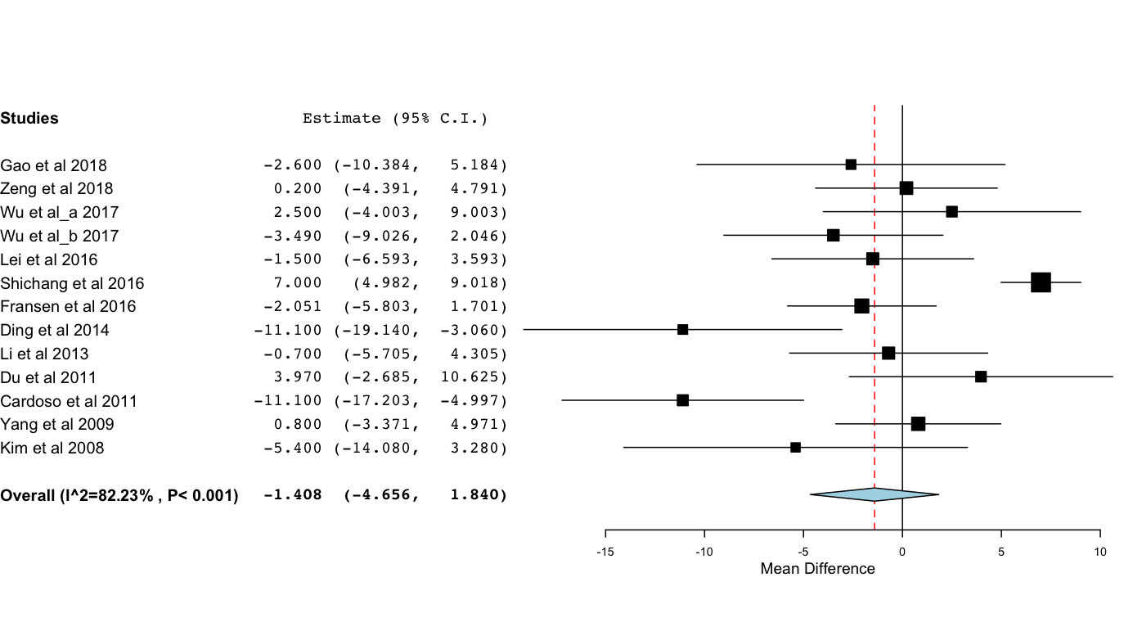

Figure 2. Forest plot of the difference in C2/C7 Cobb angle between baseline and follow-up.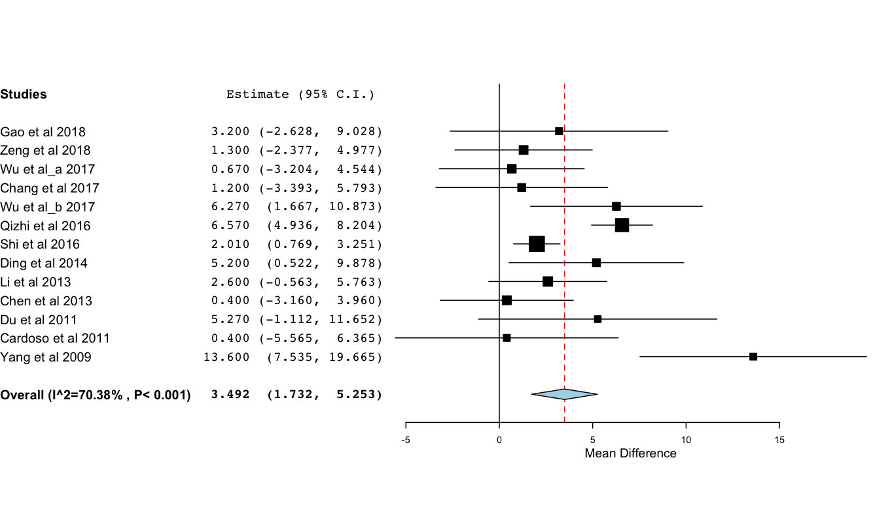

Figure 3. Forest plot of the difference in functional spinal unit angle between baseline and follow-up.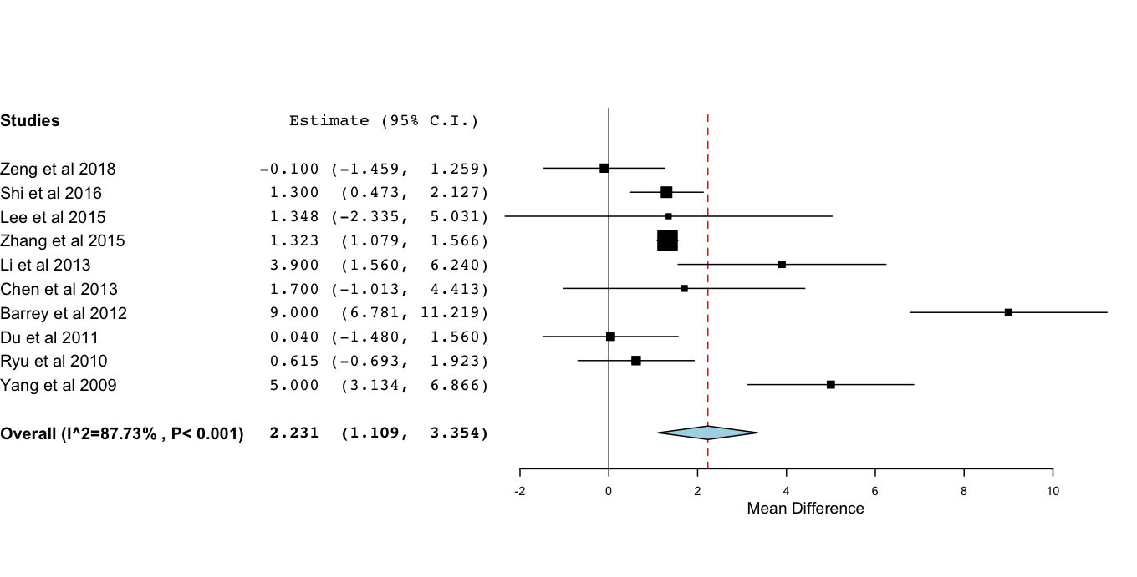

Figure 4. Forest plot of the difference in functional spinal unit range-of-motion between baseline and follow-up.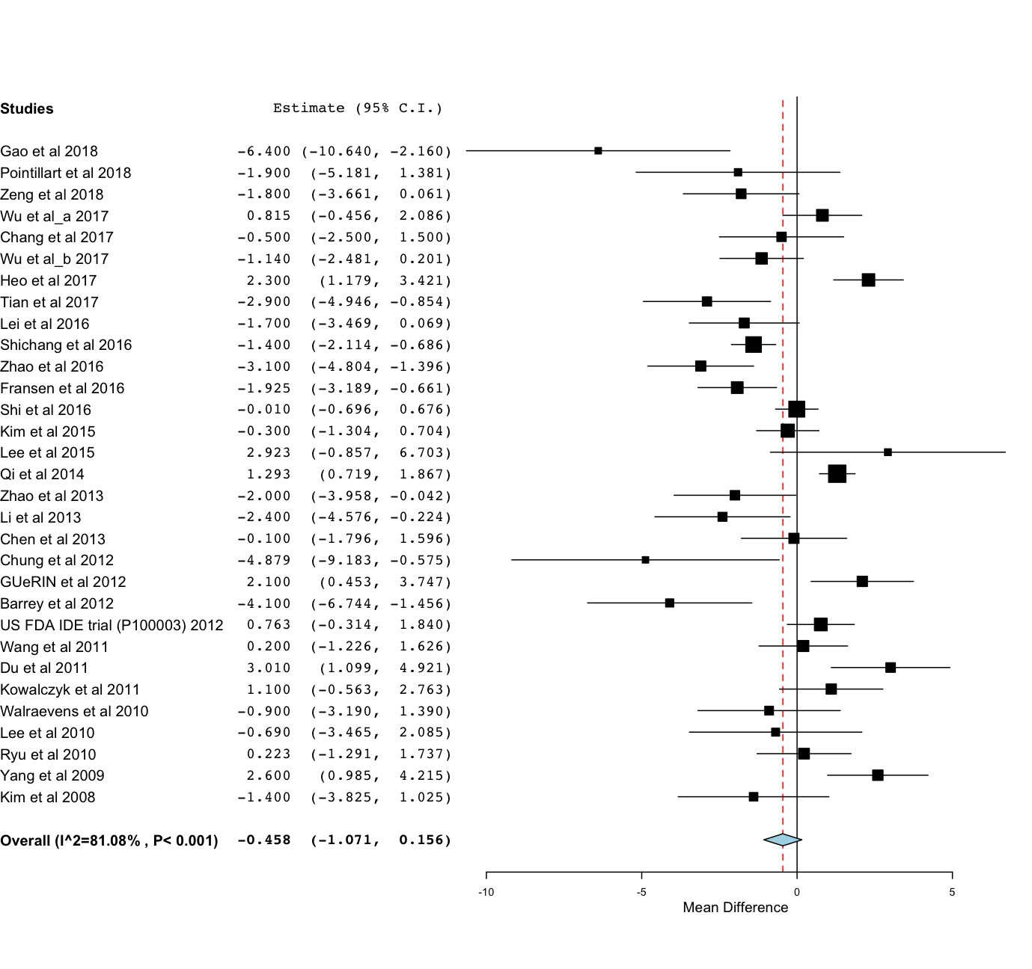

Figure 5. Forest plot of the difference in range-of-motion of the inferior spinal segment between baseline and follow-up.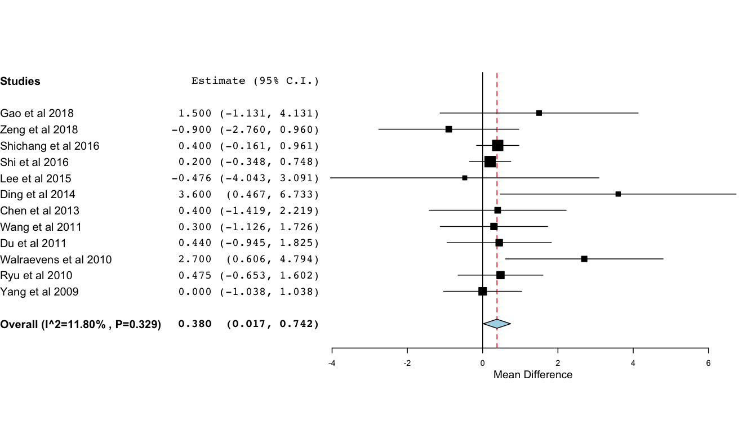

Figure 6. Forest plot of the difference in range-of-motion of the superior spinal segment between baseline and follow-up.