Figure 1. Forest plot of the cervical range-of-motion at follow-up.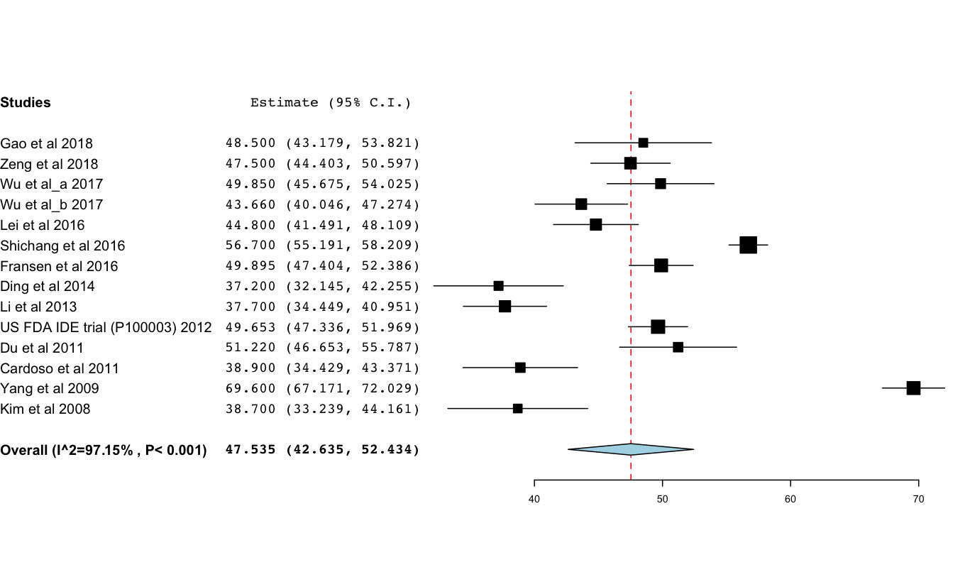

Figure 2. Forest plot of the C2/C7 Cobb angle at follow-up.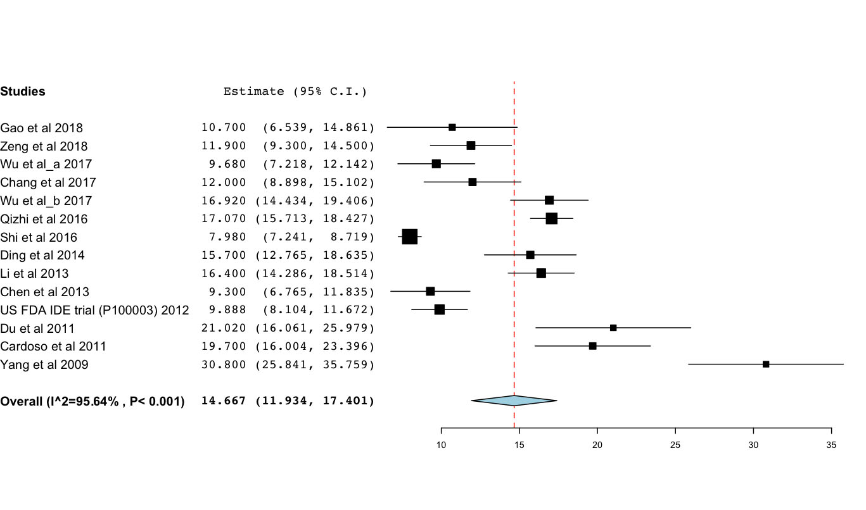

Figure 3. Forest plot of the functional spinal unit angle at follow-up.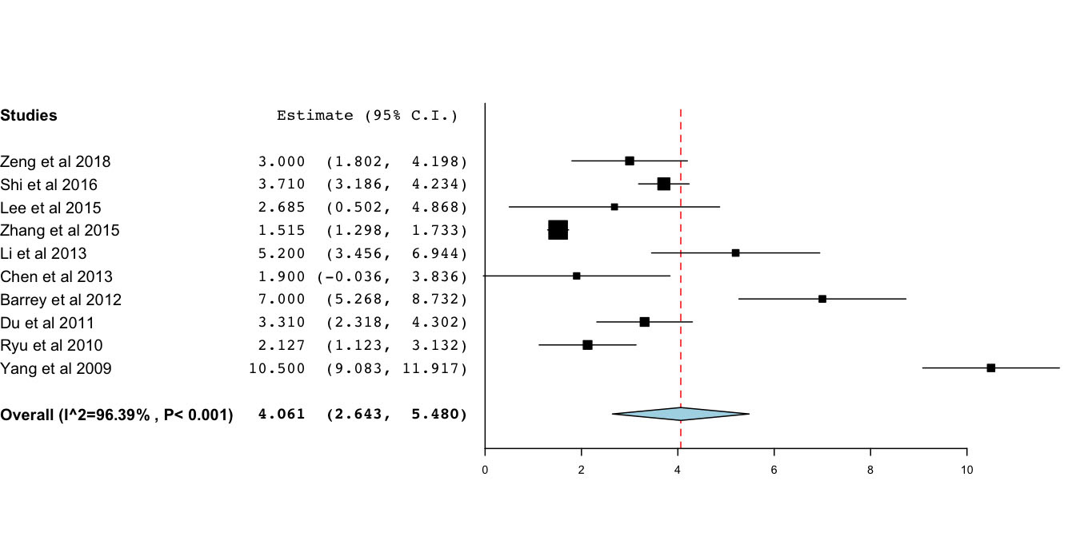

Figure 4. Forest plot of the functional spinal unit range-of-motion at follow-up.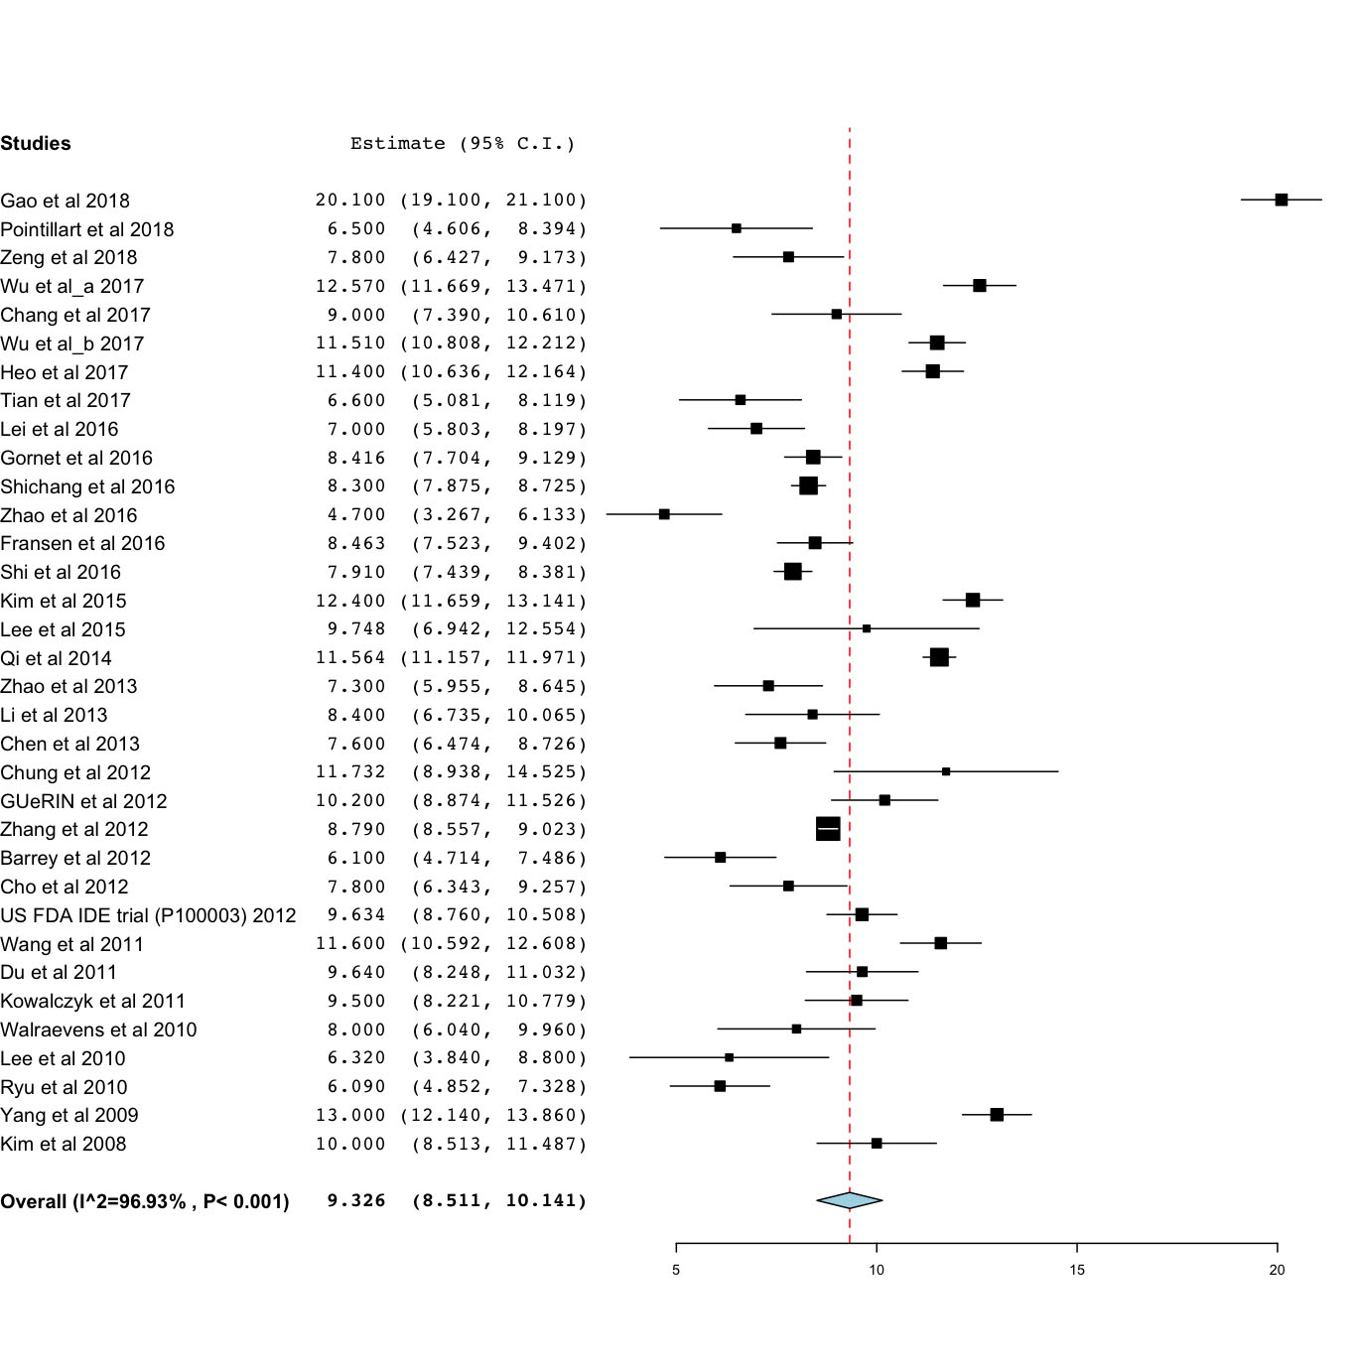

Figure 5. Forest plot of the range-of-motion of the inferior spinal segment at follow-up.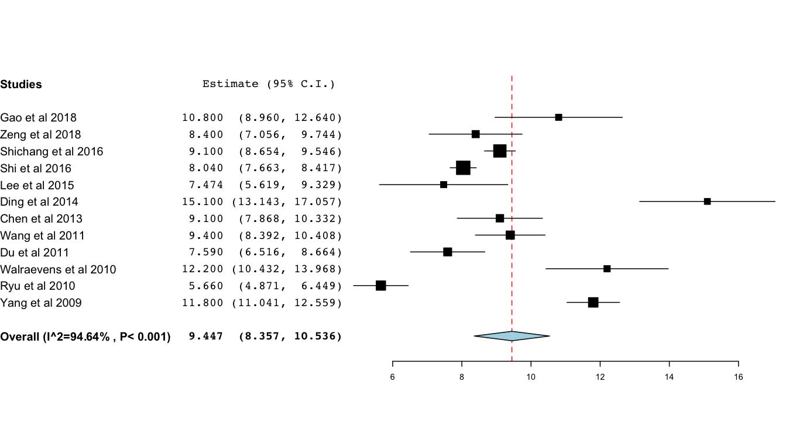

Figure 6. Forest plot of the range-of-motion of the superior spinal segment at follow-up.