Online Appendix

Diversity and Perceptions of Immigration:
How the Past Influences the Present

Table of Contents

A1: Descriptive Results of Macro Variables……………………………………………………………………. | 2
A2: Descriptive Results: Average immigration attitudes by birth cohorts and foreign-  born population………………………………………………………………………………………………………. | 3
A3: Smoothing Functions in GAM…………………………………………………………………………………... | 4
A4: Additional Results - GAM………………………………………..……………………………………………….. | 5
A5: HAPC Models Explained…………………………………………………………………………………………… | 7
A6: Additional results main HAPC models…………………………………..…………………………………. | 9
A7: Coefficients of Interaction Effects (Figure 3 in Manuscript)……………………………………… | 11
A8: Robustness Tests - Different Samples………………………………………………………………………. | 12
A9: Robustness Tests - Using different Measures to test Immigration Effect…………………. | 13
A10: Robustness Tests - Single Items of Immigration Attitude Index…………………………….. | 14
A11: Robustness Tests - Changing Cohort Specifications……………….……………………..……….. | 16
A12: Robustness Tests - Changing Age Specifications……………….……………………..……….. | 18
A13: Civil Society Organisation Environment and Diversity…………………………………………… | 19
References……………………………………………………………………………………………………………………. | 23

Appendix 1: Descriptive Results of Macro Variables
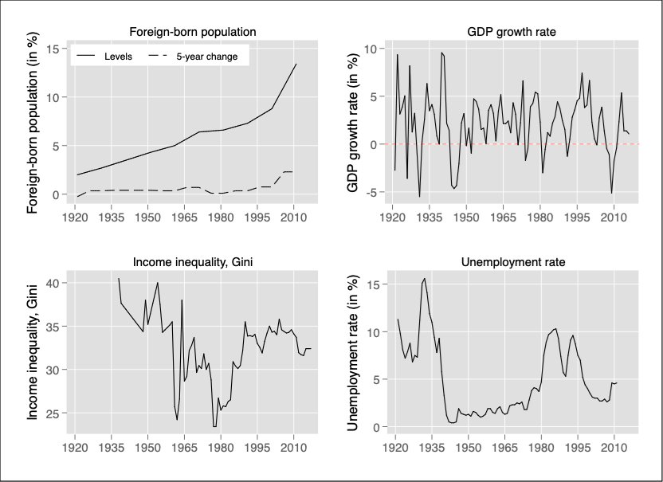
Sources: Foreign-born population: UK census (1921-2011); GDP growth rate: Maddison-Project (2013); Income inequality: UNU-WIDER (2017); Unemployment rate: based on ONS claimant count back to 1965, and Mitchell (1988: 124) data before 1965.

Appendix 2: Descriptive results: Average immigration attitudes by birth cohorts and foreign-born population

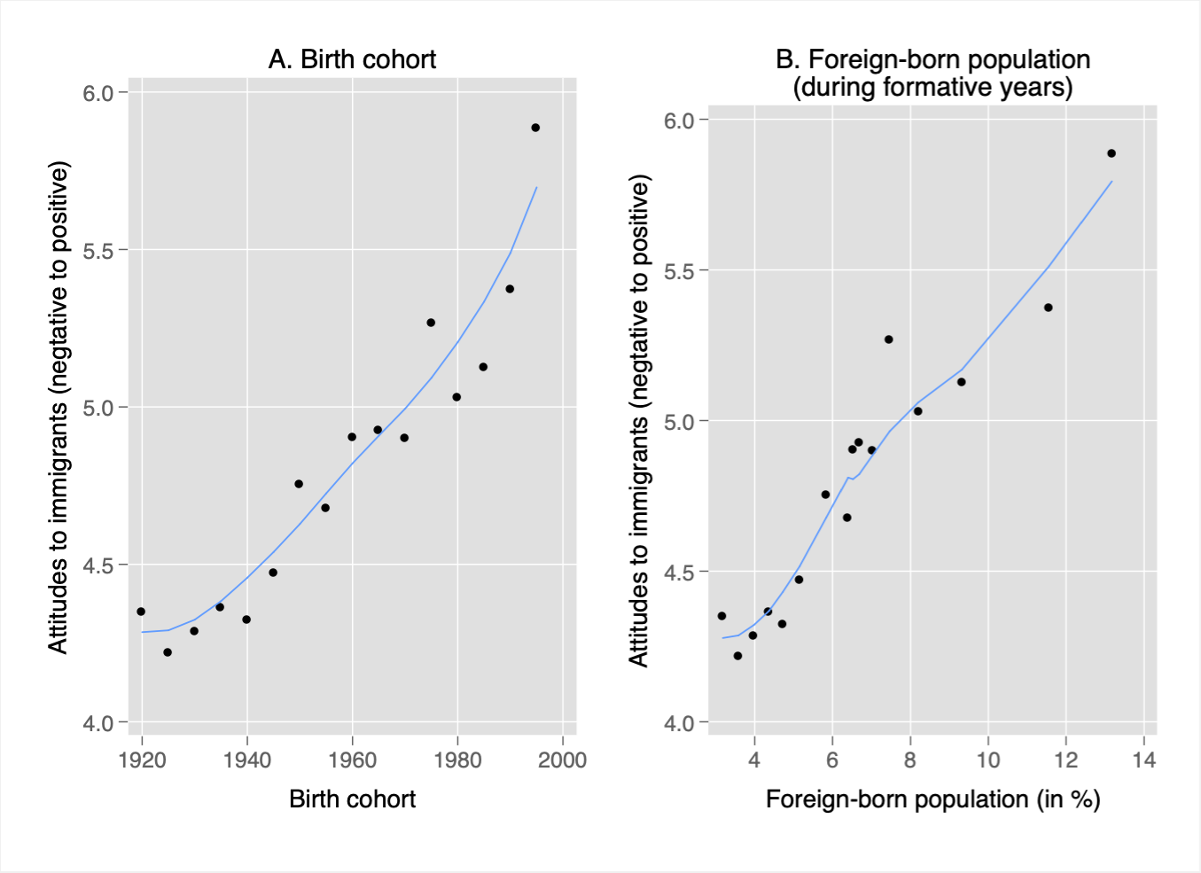
Source: ESS, UK Census (UK). Note: Smoothed lowess line to capture trends in data (see Bischof 2017).

Appendix 3: Smoothing Functions in GAM
Generally, we can distinguish between three different types of smoothers: kernel smoothers, local polynomial regression (e.g. lowess), and splines. Especially the latter one receives substantial attention in previous econometric work (Wood 2006). Keele (2008) shows in simulations that automatic smoothing splines have the best fitting properties. He therefore concludes that “barring theoretical concerns, analysts are often better of letting the amount of smoothing be estimated from the data. Automatic smoothing removes any hint of art from the process, and more importantly provides confidence bands that more accurately reflect our uncertainty about the level of smoothness” (Keele 2008: 85). In this paper, we specifically use penalised regression smoothing splines as the automatic smooth function s_{j}(·). An important advantage of these types of splines is their ‘knot-free’ estimation. Using knots is highly constraining, as it is very difficult to find the optimum number of knots. Consequently, the crucial property of our smooth functions refrains from making subjective and even speculative assumptions about the number of knots (Wood 2006). Our GAM model can be expressed as:
$$γ_{i}= α+ s\left(x_{i}\right)+\sum_{l=1}^{m}{β_{l }(z_{i, l})}+ ε_{i}$$ | [1]
where $γ_{i}$ is the immigration attitude for respondent i, $α$ represents the intercept. The second part of the equation signifies the standard linear regression with m as the numbers of independent variables or covariates $z$ that are weighted with parameter $β_{l }$, while $ε_{i}$ represents the stochastic disturbance, which is independent from $x_{i}$, E($ε_{i}$) = 0, and var($ε_{i}$) = σ², and i=1,…,n. The most important part of this model [1] is the inclusion of the smoothing function $s_{ }$($x_{i}$) for every value of $x_{i}$, e.g., the birth year, age and survey year of each respondent. ‘Smoothing is an important tool for non-parametric regression, addressing one of the simplest yet most fundamental questions in data analysis: ‘what is our best guess of $γ$, given $x$?’ (Beck and Jackman 1998, 602).

Appendix 4: Additional results - GAM

Table A4: Coefficients of Generalised Additive Models (presented in Figure 1a)
 | Coef |  | s.e.
Intercept | 3.242 | *** | 0.136
Period (ref: 2002)
2004 | 0.193 | ** | 0.072
2006 | -0.315 | *** | 0.073
2008 | -0.247 | ** | 0.082
2010 | -0.150 |  | 0.092
2012 | -0.131 |  | 0.106
2014 | -0.108 |  | 0.120
2016 | 0.640 | *** | 0.134
Age (ref: 50-56)
15-21 | -0.141 |  | 0.307
22-28 | -0.288 |  | 0.250
29-35 | -0.138 |  | 0.194
36-42 | 0.188 |  | 0.141
43-49 | 0.059 |  | 0.094
57-63 | 0.058 |  | 0.094
64-70 | 0.016 |  | 0.143
71-77 | 0.037 |  | 0.200
78-84 | 0.139 |  | 0.261
85+ | -0.003 |  | 0.335
Education (ref: primary)
Lower Secondary | 0.190 | *** | 0.053
Upper Secondary | 0.440 | *** | 0.054
Non-Tertiary | 0.725 | *** | 0.104
Degree | 1.493 | *** | 0.048
Female | -0.234 | *** | 0.033
Unemployed | 0.126 |  | 0.079
Sub. Income | 0.325 | *** | 0.022
 | edf | REF.df
s(Birth Year) | 4.000 | 5.162 | ***
N of Obs | 16,132
R-Sqr (adj) | 0.138

Figure A4: Additional Smooth Functions of economic socialisation context on today’s immigration attitudes
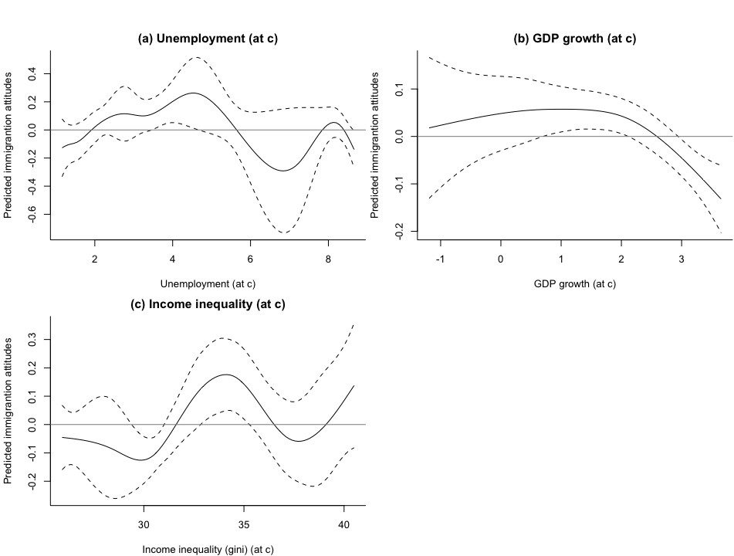

Appendix 5: HAPC Models Explained
The rationale behind the cross-classified random intercepts of cohort and period effects is as follows. As citizens who came of age at roughly the same time share common circumstances, we can assume the errors in a model explaining their immigration attitudes are dependent; random intercept models make it possible to account for this error correlation. Moreover, cohorts are clustered within the same survey year. In repeated cross-sectional surveys such as the ESS used in this research, ‘individuals are nested within cells created by the cross-classification of two types of social context: birth cohorts and survey years’ (Yang and Land 2006: 86). Hence the models presented below estimate fixed effects for age and other individual-level covariates as well as cross-classified random effects for period and cohort. Once we have taken into account the nested character of the data it is possible to evaluate the influence of context-specific variables – such as levels of diversity – during a respondent’s formative years.
Such a hierarchical age-period-cohort (HAPC) regression model for the index measuring immigration attitudes (IA) of the respondent i (for $i=1,...,n_{jt}$) within the cohort j (for $j=1,...,15)$ socialisation cohorts and the time period t (or survey year; for $T=1,...,8)$ can be specified as follows:
${IA}_{ijt}=α_{0jt}+β_{1}*Age_{it}+\sum_{m=2}^{M}{‍}β_{m}*X_{mi}+ε_{ijt}, ε_{ijt}\sim N(0,σ^{2})$ [2]

where we include controls for the age of the respondent as well as for m individual characteristics ($m=2,..,M$) X such as subjective income, education and others described in the manuscript. Most importantly, model 2 includes a random intercept $α_{0jt}$, which specifies whether the overall mean immigration attitude varies significantly from cohort to cohort and from period to period. These hierarchical models allow us to capture the contextual effects of period and cohort; they can reveal the extent to which individuals' attitudes are shaped by both the current immigration environment and the environment during their formative years. Consider:
$α_{0jt}=γ_{0}+\sum_{l=1}^{L}{‍}γ_{l}*Z_{lj}+\sum_{k=1}^{K}{‍}δ_{k}*P_{kt}+u_{0j0}+ν_{00t}$ [3]

where $γ_{0}$ is the mean effect of all time periods across all cohorts. $u_{0j0}$ denotes a cohort specific error term ($u_{0j0}\sim N(0,τ_{u})$) and $ν_{00t}$ a time specific error ($ν_{00t}\sim N(0,τ_{ν})$). This model includes l ($l=1,..,L$) covariates Z that account for immigration and economic context during the formative years of respondent i. These are assumed to explain inter-cohort variation in immigration attitudes. The model also includes k ($k=1,..,K$) covariates P that take into account the current economic and sociatal situation.

There are several issues related to this model, which might cause concern:
- Degrees of freedom: Given that low number of observations on the higher level, one might worry about the degrees of freedom. This is especially the case for the period effects. Here we have eight observations and five parameters, four variables and the period random intercept. It is important to note that there is only one random intercept because cross-classified models – as used here – assume an identity covariance structure. This means that all parameters for each period are assumed to be equal.
If one follows Elff et al (2019) approach, in the present paper, the appropriate degrees of freedom for statistical reference based on a t-distribution should be 8-1-4=3 for period level effects and 15-1-4=11 for cohort level effects

- Co-linearity between age and cohort effects: Bell and Jones (2014) have argued the HAPC model might be sensitive if we assume an underlying linear cohort trend, which is the case here, given the linear increase in immigration over time. We deal with this issue in two ways. Firstly, we triangulate our results using GAM (see above). Secondly, we change the key covariate of diversity from proportions to 5-year changes, which does not follow a linear trend, but rather fluctuates (see Figure A1). However, we acknowledge that this remains a potential issue of the identification of the age, period, and cohort effects and interpret our findings accordingly (i.e., in terms of the likelihood of diversity eventually producing more positive attitudes to immigration).

Appendix 6: Additional results main HAPC models

Figure A6: Random Cohort and Period Effects (based on M1 in Table 1)
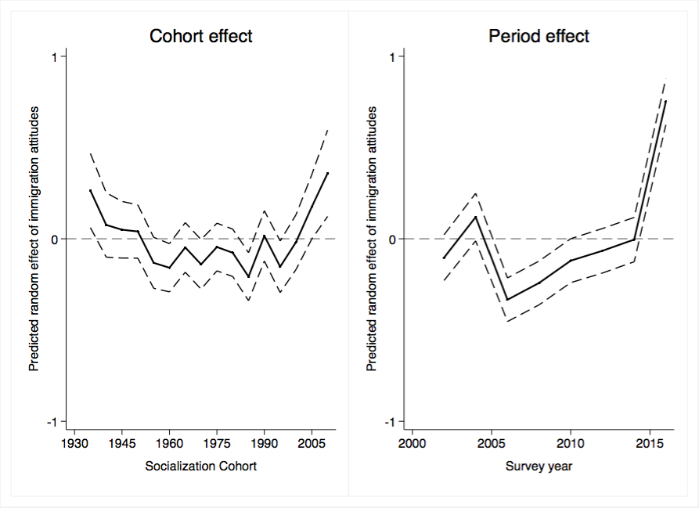

Table A6: Coefficients of control variables (based on M4 in Table 1)
 | M4 (b/se)
Age | 0.014*** | (0.005)
Individual-level controls
Female | -0.207*** | (0.036)
Education (ref: primary)
Lower secondary | 0.378*** | (0.057)
Upper secondary | 0.571*** | (0.059)
Non-tertiary | 0.796*** | (0.150)
Degree | 1.527*** | (0.052)
Unemployed | 0.113 | (0.090)
Sub. Income | 0.376*** | (0.024)
Socialisation context
Foreign-born pop. | 0.203*** | (0.044)
Unemployment | 0.016 | (0.011)
GDP Growth | -0.011 | (0.017)
Income inequality (gini) | 0.009 | (0.007)
Current context
Foreign-born pop. | 0.128* | (0.069)
Unemployment | -0.084 | (0.065)
GDP Growth | 0.076 | (0.051)
Income inequality (gini) | 0.146 | (0.101)
Intercept | -5.447 | (4.271)
Variance Components
Cohort (1935-2015) | 0.058*** | (0.026)
Period (2002-2017) | 0.169*** | (0.046)
N | 13,081
AIC | 56,077
Significance: * p<0.1; ** p<0.05; *** P<0.01. Data ESS, round1-8. Note: Entries are regression coefficients and their standard errors of a HAPC model. The dependent variable is an index on immigration attitudes where 0=‘negative’ and 10=‘positive’.

Appendix 7: Coefficients of Interaction Effects (Figure 2 in Manuscript)
 | M5.A (b/se) | M5.B (b/se) | M5.C (b/se)
 | Unempl. | GDP growth | Inc. inequality
Age | 0.017*** | 0.012*** | 0.010**
 | -0.005 | -0.005 | -0.004
Socialisation Context
Foreign-born pop. | 0.226*** | 0.187*** | 0.665***
 | (0.041) | (0.039) | (0.234)
Unemployment | 0.016
 | (0.039)
GDP Growth |  | -0.009
 |  | (0.056)
Income inequality (gini) |  |  | 0.095**
 |  |  | (0.042)
Interaction: Foreign-born x
Unemployment | 0.000
 | (0.007)
GDP Growth |  | -0.001
 |  | -0.008
Income inequality (gini) |  |  | -0.014**
 |  |  | (0.007)
Current context econ. Controls | yes | yes | yes
Individual-level controls | yes | yes | yes
Intercept | -5.387 | -4.909 | -8.124*
 | (4.276) | (4.262) | (4.458)
Variance Components
Cohort (1935-2015) | 0.062*** | 0.068*** | 0.061***
 | (0.026) | (0.028) | (0.026)
Period (2002-2017) | 0.169*** | 0.169*** | 0.168***
 | (0.046) | (0.046) | (0.046)
N | 13,081 | 13,081 | 13,081
AIC | 56,077 | 56,078 | 56,073
Significance: * p<0.1; ** p<0.05; *** P<0.01. Data ESS, round1-8. Note: Entries are regression coefficients and their standard errors of a HAPC model. The dependent variable is an index on immigration attitudes where 0=”negative” and 10=”positive”.

Appendix 8: Robustness Tests - Different Samples
 | Dropping…
 | Last cohort | First cohort | Age>20
Age | 0.009 | 0.010 | 0.007
 | (0.006) | (0.007) | (0.006)
Socialisation Context
Foreign-born pop. | 0.143** | 0.173*** | 0.115*
 | (0.056) | (0.052) | (0.061)
Socialisation economic controls | Yes | Yes | Yes
Current Context
Foreign-born pop. | 0.144** | 0.142** | 0.157**
 | (0.069) | (0.070) | (0.071)
Current economic controls | Yes | Yes | Yes
Individual-level controls | Yes | Yes | Yes
Intercept | -5.073 | -5.287 | -5.240
 | (4.265) | (4.286) | (4.360)
Variance Components
Cohort (1935-2015) | 0.059*** | 0.059*** | 0.058***
 | (0.026) | (0.027) | (0.027)
Period (2002-2016) | 0.168*** | 0.169*** | 0.172***
 | (0.046) | (0.046) | (0.047)
N | 12,947 | 12,784 | 12,469
AIC | 55,525 | 54,851 | 53,525
Significance: * p<0.1; ** p<0.05; *** P<0.01. Data ESS, round1-8. Note: Entries are regression coefficients and their standard errors of a HAPC model. The dependent variable is an index on immigration attitudes where 0=”negative” and 10=”positive”.

Appendix 9: Robustness Tests - Using different measures to test period immigration effect
 | Current immigration
 | 5-year change | 10-year change | Net migration+ | Ethn. Diversity^
 | b/se | b/se | b/se | b/se
Age | 0.015*** | 0.014*** | 0.016*** | 0.014***
 | (0.005) | (0.005) | (0.005) | (0.005)
Socialisation Context
Levels of foreign-born | 0.207*** | 0.203*** | 0.216*** | 0.203***
 | (0.044) | (0.044) | (0.044) | (0.044)
Socialisation economic controls | yes | yes | yes | yes
Current Context
Levels of foreign-born
5-year change in foreign-born | 0.405
 | (0.263)
10-year change in foreign-born |  | 0.233**
 |  | (0.116)
Net migration |  |  | -0.001
 |  |  | (0.002)
Ethnic diversity |  |  |  | 0.118**
 |  |  |  | (0.050)
Current context econ. controls | yes | yes | yes | yes
Individual-level controls | yes | yes | yes | yes
Intercept | -2.099 | -4.580 | 1.741 | -6.336*
 | (3.229) | (3.663) | (2.808) | (3.838)
Variance Components
Cohort (1935-2015) | 0.058*** | 0.058*** | 0.058*** | 0.0058***
 | (0.026) | (0.045) | (0.054) | (0.043)
Period (2002-2017) | 0.178*** | 0.165*** | 0.202*** | 0.154***
 | (0.048) | (0.045) | (0.054) | (0.043)
N | 13,081 | 13,081 | 13,081 | 13,081
AIC | 56,077 | 56,076 | 56,080 | 56,075
Significance: * p<0.1; ** p<0.05; *** P<0.01. Data ESS, round1-8. Note: Entries are regression coefficients and their standard errors of a HAPC model.
+ Data on Net Migration: Data for the years 2002-2017 were taken from the UK Office of National Statistics data on ‘Long-Term International Migration (LTIM) estimate'’ available at www.ons.gov.uk/peoplepopulationandcommunity/populationandmigration/internationalmigration.
^ Data on ethnic diversity: Following the work of Gorodzeisky and Semyonov (2018), we compute the level of ethnic diversity in the year of the survey as the percent per ESS round whose father or mother was not born in a European country. Similar ethnic diversity measures for respondents’ formative years are not available and so the re-estimated model still relies on percent foreign-born in the cohorts’ formative years to estimate overall levels of diversity in the UK during these years. Also, we do not use indicators of ethnic diversity from the UK census as period effects because only two censuses are available for this purpose (2001 and 2011).

Appendix 10: Robustness Tests - Single Items of Immigration Attitude Index + Placebo test

Table A10: HAPC Results Using Single Items of Immigration Attitudes + placebo test with gay rights attitudes
 | Immigration items: |  |  |  |  |  | Placebo item
 | Good for econ. |  | Good for culture |  | Make better place |  | Gay rights*
Age | 0.016*** |  | 0.012** |  | 0.013** |  | -0.010***
 | (0.005) |  | (0.006) |  | (0.005) |  | (0.002)
Socialisation context
Foreign-born pop. | 0.165*** |  | 0.214*** |  | 0.208*** |  | -0.005
 | (0.047) |  | (0.053) |  | (0.043) |  | (0.015)
Socialisation econ. Controls | yes |  | yes |  | yes |  | yes
Current context
Foreign-born pop. | 0.199*** |  | 0.064 |  | 0.120* |  | 0.108***
 | (0.051) |  | (0.092) |  | (0.061) |  | (0.010)
Current econ. Controls | yes |  | yes |  | yes |  | yes
Individual-level controls | yes |  | yes |  | yes
Intercept | -6.412** |  | -3.931 |  | -5.763 |  | 1.350**
 | (3.137) |  | (5.714) |  | (3.808) |  | (0.609)
Variance Components
Cohort (1935-2015) | 0.057*** |  | 0.080*** |  | 0.023* |  | 0.000***
 | (0.028) |  | (0.031) |  | (0.048) |  | (0.000)
Period (2002-2016) | 0.116*** |  | 0.229*** |  | 0.147*** |  | 0.013***
 | (0.036) |  | (0.061) |  | (0.042) |  | (0.010)
N | 13,401 |  | 13,342 |  | 13,441 |  | 13,569
aic | 60,032 |  | 61,384 |  | 59,934 |  | 33,063
Significance: * p<0.1; ** p<0.05; *** P<0.01. Data ESS, round1-8. Note: Entries are regression coefficients and their standard errors of a HAPC model. The dependent variables measures varying aspects of immigration attitudes where 0=”negative” and 10=”positive”. Gay rights are measured with agreement to the item “Gays and lesbians free to live life as they wish” (1=absolutely disagree; 5=absolutely agree).
* Measuring gay rights: The ESS item asks whether ‘gays and lesbians should be free to live their own life as they wish’ (1=absolutely disagree; 5=absolutely agree).

Figure A10: Marginal Effects of Foreign-Born Population by Income Inequality (at c)

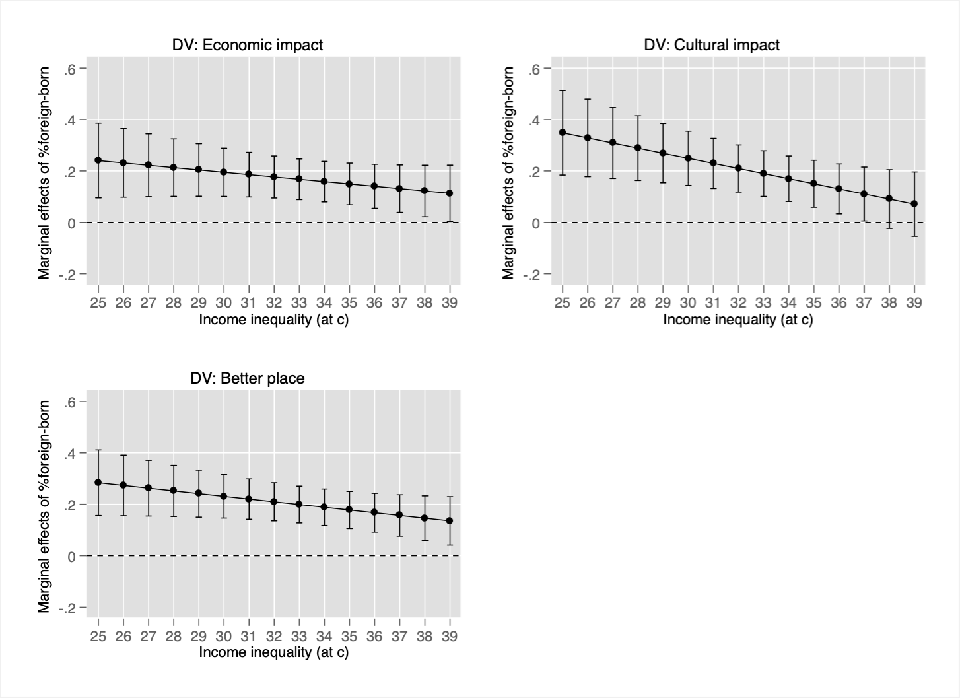

Appendix 11: Robustness Tests - Changing Cohort Specifications

Figure A11: Average Immigration Attitudes by Birth Cohorts and Foreign-Born Population
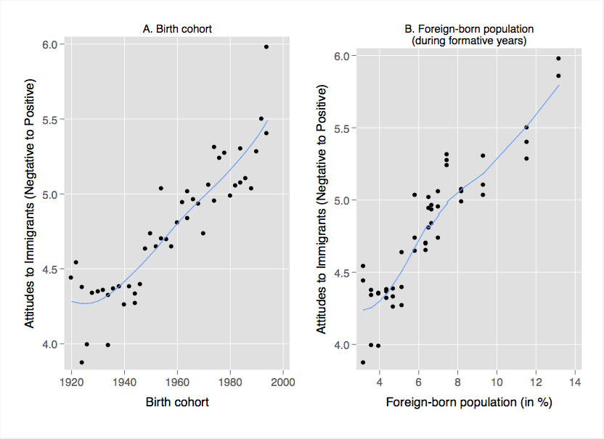
Source: ESS, UK Census (UK). Note: Smoothed lowess line to capture trends in data.

Table A11: HAPC Results Using Different Specification of the Cohort Variable

 | 2-year |  | Socialisation Age
 | Birth cohorts |  | 10 – 15 | 20 – 25 | 30 – 35
 | b/se |  | b/se | b/se | b/se
Age | 0.014*** |  | 0.014** | 0.010* | 0.000
 | (0.005) |  | (0.007) | (0.006) | (0.007)
Socialisation context
Foreign-born pop. | 0.187*** |  | 0.257*** | 0.114** | 0.009
 | -0.043 |  | (0.068) | (0.047) | (0.051)
Socialisation econ. Controls | Yes |  | Yes | Yes | Yes
Current context
Foreign-born pop. | 0.130* |  | 0.133* | 0.149** | 0.182***
 | -0.069 |  | (0.070) | (0.070) | (0.067)
Current econ. Controls | Yes |  | Yes | Yes | Yes
Individual-level controls | Yes |  | Yes | Yes | Yes
Intercept | -5.387 |  | -6.180 | -5.458 | -5.372
 | (4.246) |  | (4.296) | (4.358) | (4.140)
Variance Components
Cohort (1935-2015) | 0.000 |  | 0.064*** | 0.041*** | 0.051***
 | (0.002) |  | (0.028) | (0.030) | (0.030)
Period (2002-2016) | 0.168*** |  | 0.169*** | 0.172*** | 0.159***
 | (0.046) |  | (0.046) | (0.047) | (0.045)
N | 12,877 |  | 12,784 | 12,461 | 10,898
aic | 55,217 |  | 54,852 | 53,492 | 46,856
Significance: * p<0.1; ** p<0.05; *** P<0.01. Data ESS, round1-8. Note: Entries are regression coefficients and their standard errors of a HAPC model. The dependent variable is an index on immigration attitudes where 0=”negative” and 10=”positive”.

Appendix 12: Robustness Tests - Changing Age Specifications

 | No age |  |  | Non-linear age |  |  | Age categories
Socialisation context
Foreign-born pop. | 0.088*** | (0.014) |  | 0.173*** | (0.047 | ) | 0.171*** | (0.043)
Socialisation economic controls | yes |  |  | yes |  |  | yes
Current context
Foreign-born pop. | 0.161** | (0.068) |  | 0.134* | (0.069) |  | 0.139** | (0.069)
Current economic controls
Specifying age effect
Age |  |  |  | -0.003 | (0.012)
Age^2 |  |  |  | 0.000 | (0.000)
Age cat (ref: 15-21)
22-28 |  |  |  |  |  |  | -0.091 | (0.122)
29-35 |  |  |  |  |  |  | 0.038 | (0.153)
36-42 |  |  |  |  |  |  | 0.365** | (0.179)
43-49 |  |  |  |  |  |  | 0.258 | (0.201)
50-56 |  |  |  |  |  |  | 0.192 | (0.222)
57-63 |  |  |  |  |  |  | 0.328 | (0.248)
64-70 |  |  |  |  |  |  | 0.337 | (0.277)
71-78 |  |  |  |  |  |  | 0.46 | (0.307)
78-84 |  |  |  |  |  |  | 0.651** | (0.326)
85+ |  |  |  |  |  |  | 0.715** | (0.360)
Individual-level controls | Yes |  |  | Yes |  |  | Yes
Intercept | -4.444 | (4.260) |  | -4.544 | (4.301) |  | -4.930 | (4.329)
Variance Components
Cohort (1935-2015) | 0.086*** | (0.031) |  | 0.044*** | (0.029) |  | 0.053*** | (0.028)
Period (2002-2016) | 0.169*** | (0.046) |  | 0.169*** | (0.046) |  | 0.171*** | (0.047)
N | 13,095 |  |  | 13,081 |  |  | 13,081
AIC | 56,138 |  |  | 56,076 |  |  | 56,074
Significance: * p<0.1; ** p<0.05; *** P<0.01. Data ESS, round1-8. Note: Entries are regression coefficients and their standard errors of a HAPC model. The dependent variable is an index on immigration attitudes where 0=”negative” and 10=”positive”.

Appendix 13: Civil Society Organisation Environment and Diversity
The penultimate section of the main paper suggested one possible explanation for the relationship between high levels of early-years diversity and current attitudes to immigration—that younger generations growing up with such diversity may have experienced more regular contact with immigrant-origin minorities. We are unable to fully test this proposition due to the lack of cross-time data for contact. However, footnote 26 of the paper summarises the findings from a potential macro-level proxy variable—the level of permeation of civil society organisations (CSO). Increased participation in civil society organisations is likely to increase contact with other people generally, and this may also include people from immigrant-origin minority groups.
In order to use the CSO environment as a proxy for cohort contact, we must first establish whether people who are active in CSOs are also more likely to have contact with immigrant-origin minorities. To answer this question, we used the first wave of the ESS (2002-3), which includes measures of whether respondents participated in any activities of the following organisations: Sports club, cultural organisation, trade union, professional association, automobile club, humanitarian organisation, environmental organisation, religious organisation, political party, science/education organisation, social club, or any other voluntary organisation. Based on this list, we created a dummy variable for ‘participation’, with 48% of British respondents participating in at least one of these organisations. We then tabulated this variable with the survey question asking whether respondents have any immigrant-origin friends (45% report having friends from immigrant-origin minority groups). Table A13.1 shows these results: 37% of those not active in any CSO have immigrant-origin friends versus 54% of those that are active in CSOs. Thus, there is a moderate relationship between CSO activity and having immigrant-origin friends at the individual level.

Table A13.1: Civil Society Organisation Participation and Immigrant-Origin Contact
 | No CSO participation | Participate in at least one CSO
No immigrant friends | 62.5% | 46.0%
Some immigrant friends | 37.5% | 54.0%
N | 1051 | 997

We also investigated whether this relationship holds even after controlling for potential confounding factors such as age and education. Table A13.2 provides the logistic regression results for this multivariate model: participation in CSOs is still significantly related to contact with immigrant-origin minorities in the form of friendships.

Table A13.2: Civil Society Organisation Participation and Immigrant-Origin Contact
 | Coef. | SE | Sig
Participation in CSOs | 0.252 | 0.048 | ***
Age | -0.012 | 0.003 | ***
Education
Lower Secondary | 0.253 | 0.158
Upper Secondary | 0.676 | 0.194 | ***
Tertiary Competed | 1.072 | 0.149 | ***
Unemployed | 0.501 | 0.263
Female | -0.233 | 0.107 | **
Subjective Income | -0.016 | 0.076
Religiosity | -0.007 | 0.020
Constant | -0.330 | 0.323
Log-likelihood |  | -1047.137
Pseudo R2 |  | 0.082
N |  | 1691
Significance: ** p<0.05; *** P<0.01.
Figure A13.1 provides the descriptive distribution of the immigrant friends variable over the birth cohorts used in our analyses.

Figure A13.1. Have Immigrant Friends by Birth Cohort
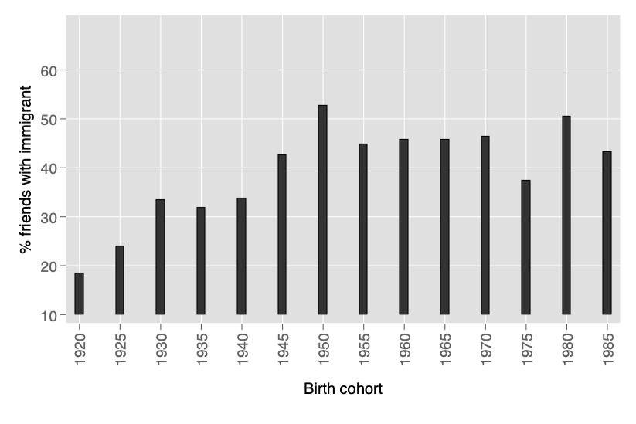

Using a macro-level indicator of CSO environment as our proxy for cohorts’ level of contact with immigrant-origin minorities, we next investigate the impact of this macro-level variable using all rounds of the ESS (1-8). The macro-level variable is compiled by the Varieties of Democracy (V-Dem) team (Coppedge et al. 2017) based on the question put to experts: Which of these best describes the involvement of people in civil society organizations (CSOs)? Possible responses:
0: Most associations are state-sponsored, and although a large number of people may be active in them, their participation is not purely voluntary.
1: Voluntary CSOs exist but few people are active in them.
2: There are many diverse CSOs, but popular involvement is minimal.
3: There are many diverse CSOs and it is considered normal for people to be at least occasionally active in at least one of them.
Figure A13.2 shows the development of this variable in the UK in the past 100 years. Though the variation on this variable is somewhat limited (between 2.1 and 3), there is indeed still some variation in this variable, including toward the end of the series when ESS Rounds 1-8 occurred.

Figure A13.2: CSO Participatory Environment in the UK, 1920-2017
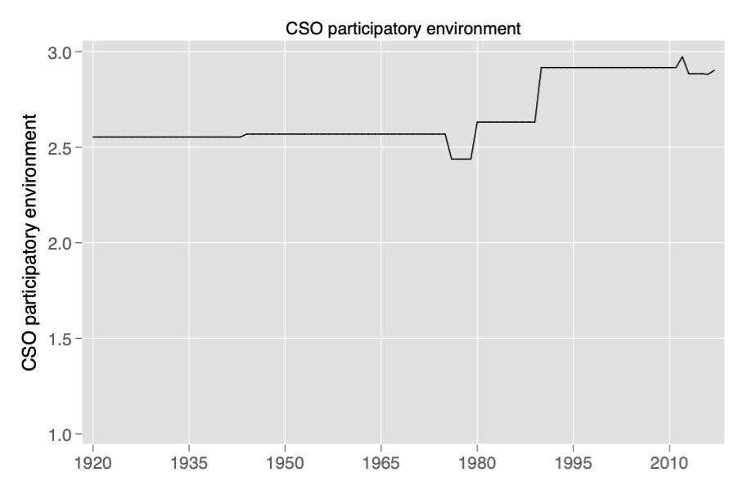
Note: The annual values are based on a Bayesian Item Response Model, which takes into account the uncertainly of expert ratings. The variable then linearly translated the measurement model point estimates back to the original ordinal scale.

Figure A13.3: Interaction: foreign-born pop. and CSO environment (both measured during formative years)
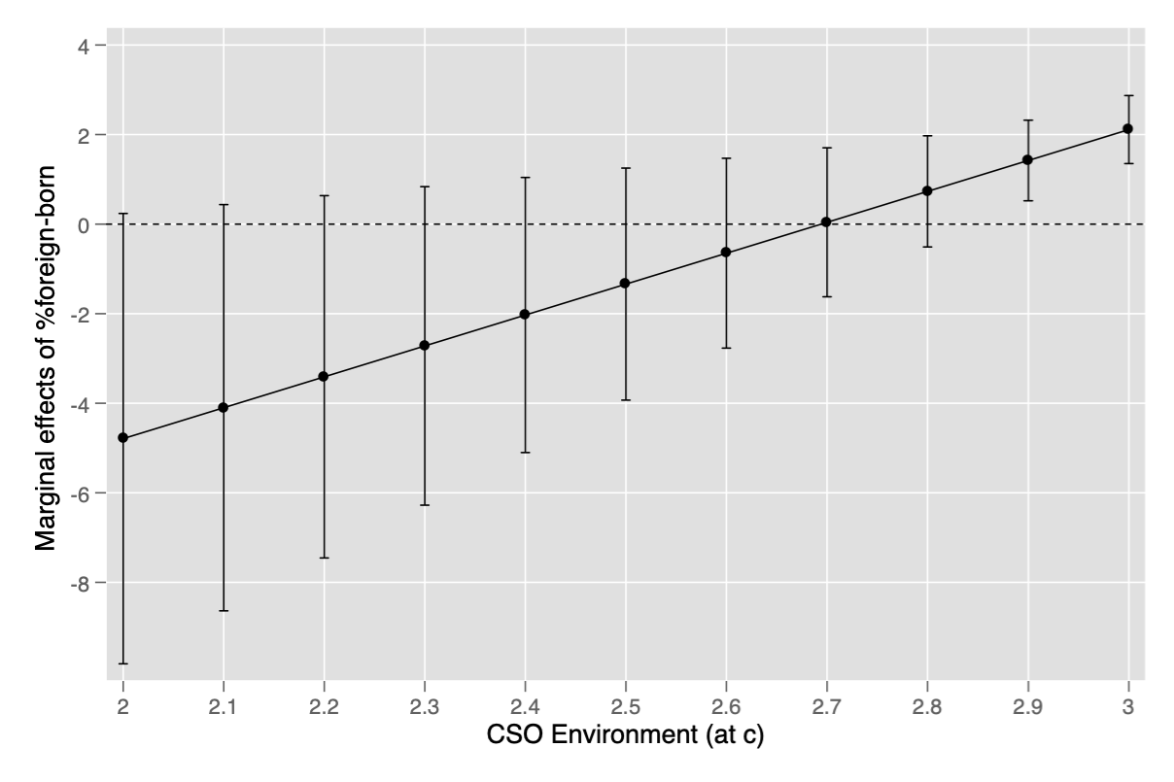

Finally, we plot the marginal effects of levels of diversity during each cohort’s formative years and the CSO environment at the time. As Figure A13.3 reveals, the positive immigration effect is only visible at very high levels of CSO activity (3). Thus, high levels of diversity in a cohort’s early years only have positive effects if levels of contact with immigrant-origin minorities (proxied with CSO environment) is also high.

References
Beck, N. and Jackman, S. (1998). Beyond Linearity by Default: Generalized Additive Models. American Journal of Political Science 42(2): 596-627.
Bell, A. and Jones, K. (2014). Another “Futile Quest”? a Simulation Study of Yang and Land’s Hierarchical Age-Period-Cohort Model, Demographic Research 30: 333–360.
Bischof, Daniel (2017) New Graphic Schemes for Stata: plotplain & plotting. Stata Journal. 17(3): 748-759.
Coppedge, M et al. (2017). V-Dem Country Coding Units v7.1. Varieties of Democracy (V-Dem) Project.
Elff, M., Heisig, J.P., Schaeffer, M. and Shikano, S. (2019). Multilevel Analysis with Few Clusters: Improving Likelihood-based Methods to Provide Unbiased Estimates and Accurate Inference. British Journal of Political Science, forthcoming.
Gorodzeisky, A. and Semyonov, M. (2018). Competitive threat and temporal change in anti-immigrant sentiment: Insights from a hierarchical age-period-cohort model. Social Science Research 73(1): 31-44.
Keele, L. (2008). Semiparametric Regression for the Social Sciences. London: Wiley and Sons.
Snijders, T.A.B. and Bosker, R.B. (1999). Multilevel Analysis: An Introduction to Basic and Advanced Multilevel Modeling. London: Sage.
Yang, Y. and Land, K.C. (2006). A Mixed Models Approach to Age-Period-Cohort Analysis of Repeated Cross-Section Surveys: Trends in Verbal Test Scores. Sociological Methodology 36(1): 75-97.
Wood, S. (2006). Generalized Additive Models: An Introduction with R. CRC Press.

See Snijders and Bosker (1999: 155-165) for a general introductory discussion of these cross-classified random models. See also a new paper by Elff et al (2019) on the effectiveness of linear multi-level models with few upper-level observations.
The exact question is: ‘Do you have any close friends who are of a different race or ethnic group from most British people?’.

