Supplementary File 3: Test points and reference points
We recorded the 3D-coordinates of three predefined test-points on the femur (P1–P3), two test-points on the tibia and fibula (P4–P5), and three reference points in the limb press (R1–R3). (See Figure and
Table)
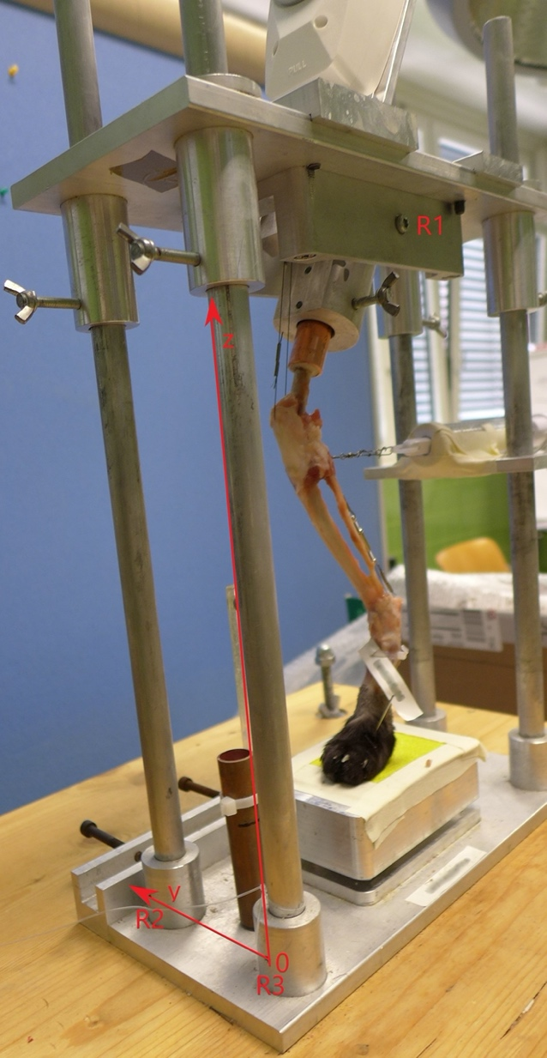
Table
Location | Description
R1 | Screw center
R2 | Point on cranial column in the back of the limb press
R3 | Point on cranial column in the front of the limb press
P1 | Center of patella
P2 | Origin of lateral collateral ligament
P3 | Origin medial collateral ligament
P4 | Tibial tuberosity
P5 | Fibular head
Test and reference points: R1–R3 = reference points on the limb press, P1–P5 = test-points on the femur and tibia

