WEB APPENDICES

Appendix A Selected Empirical Studies on Country-of-Manufacture (COM) in International Marketing
Study | Samples | Research Context | COM aspects | Independent variables | Dependent variables | Methodology | Theoretical/ Conceptual Perspective(s) Employed | Major Findings
This study | Study 1a: 215 U.S. consumers  Study 1b: 145 U.S. consumers  Study 2: 184 Indian consumers and 185 U.S. consumers | Eco-innovative products: Electric cars, smart TVs, wireless speakers, and smartphones | Ecological aspects/Sustainable reputation of a country | Ecological (in)congruence between ecological COM and product eco-friendliness | Adoption intentions | Online experiments | Schema Theory | The results demonstrate that consumers express more preferential evaluations when there is the ecological incongruence for privately consumed products while preferring ecological congruence for products consumed in public settings (Study 1a and Study 1b). Furthermore, in emerging markets with highly embedded, hierarchical, and high-harmony cultures, consumers require ecological congruence to justify their adoption decisions, while in developed markets with highly autonomous, egalitarian, and high-mastery cultures, consumers are more likely to adopt eco-innovations with ecological incongruence (Study 2).
Bartikowski, Fastoso, and Gierl (2019) | 177 prospective Chinese premium car buyers | Luxury cars | Innovativeness  Attractiveness  Prestige  Workmanship | COM, Brand origin, consumer culture positioning (CCP) strategies | Brand attitude | Online experiments | The construal-level theory | Made-in-China acts as a primary cue that overrides both the effect of consumer culture positioning strategies and the effect of the foreign brand's country-of-origin image on consumer attitudes.  Consumer-culture positioning strategies differ in their effects on brand attitudes only when advertising does not signal Made-in-China
Garrett, Lee, and Chu (2017) | 270 young Korean adults | A puffer jacket (or digital camera) | Manufacturing quality | Country of design, country-of-technology, COM, story image  Regulatory focus | Product evaluation  Purchase intention | A large-scale survey | The cue utilization and regulatory focus theory | By COO dimensions, COM does not affect product evaluation and purchase intention. Prevention-focused consumers are more likely to use COM as a utilitarian cue than promotion-focused consumers.
Helgeson et al. (2017) | 224 Norwegian consumers and  272 U.S. consumers | Apparel and footwear, food and drink, health and beauty types, furniture and housewares, | Made-in information | Ethnocentrism | COM awareness  Perceived COM importance  Purchase decisions | Field survey | The cue utilization theory | Norwegian respondents expressed less ethnocentrism and were less aware of COM. There was no significant difference in the rating of COM importance between Norwegian and U.S. respondents. COM is rarely used by the studied consumers in actual purchase decisions with little difference found between Norwegian and U.S. respondents.
Allman et al. (2016) | 530 U.S. consumers | Automobile | Prestige of the products | COM, Vertical line extension (VLE) type, and brand concept | Brand image | Online experiments | Schema congruity | The effects of COM on brand image should be considered in conjunction with the type of VLE strategy and the intended conceptual meaning of a brand.  For functional brands, firms can improve their image with an upward VLE regardless of the COM; however, if these brands pursue a downward VLE, the COM has little to no effect.  For prestige brands, downward VLEs result in lower post-extension brand image regardless of the COM
Arora et al. (2016) | Study 1: 172 French adults  Study 2: 208 French adults  Study 3: 76 French students  Study 4: 210 French adults | Parent brands and their corresponding diffusion brands | Innovativeness  Attractiveness  Prestige  Workmanship | Conflicting versus Matching COO-COM | Authenticity  Contagion  Purchase intentions | Online experiments | Multiple cue utilization  scenario-based theory | Due to contagion (i.e., the notion that objects may acquire a special aura or essence or charisma) beliefs of consumers, consumers viewed parent brands as more contagious and authentic over diffusion brands during conflicting COO-COM situations; while they preferred diffusion brands over parents during matching COO-COM situations
Coskun and Burnaz (2016) | Interviews: 18 consumers  Survey: 200 women in Turkey | A leather shoe brand | Innovativeness  Attractiveness  Prestige  Workmanship | Country of brand, COM, price, material, and brand name | Product choice | Interviews and conjoint analysis | The cue utilization theory | The level of importance placed on COM is higher than that on COB. However, when consumers evaluate COO and brand name knowledge as single cues, the results are in the opposite direction.
Johnson, Tian, and Lee (2016) | Study 1: 179 U.S. consumers  Study 2: 248 U.S. consumers | Cellphones and washing machines | Favorability of a country in a product category | Congruence between COM and brand origin | Product evaluation | Online experiments | A dual coding theory perspective | A lack of fit between brand origin and COM can reduce consumers’ new product evaluations, even when the brand origin and COM are equally capable. When brands introduce products lacking COO fit, consumers’ product evaluations are more favorable when the company’s COO information is positioned in a broad, global perspective. When there is a fit between brand origin and COM, messages promoting the company’s brand origin will lead to more favorable product evaluations.
Dekhili and Achabou (2015) | Study 1: 153 French consumers  Study 2: 145 French consumers | Washing up liquids and TVs | Made-in information | Ecological image | Product evaluation | Experiments | Cue consistency theory | COM with a favorable ecological image has no effect on the evaluation of an ecolabelled product COM with unfavorable ecological image negatively influences the product’s evaluation, especially when there is no information about the brand.
Arora et al. (2015) | Study 1: 144 graduate students  Study 2: 164 working graduate students  Study 3: 43 U.S. students | Parent and diffusion handbag and perfume brands | Hedonism versus utilitarianism  Innovativeness  Attractiveness  Prestige  Workmanship | (In)Congruence between COO and COM | Purchase intentions | Online experiments | Categorization theory and Cue utilization theory | When there is congruence between COO and COM, diffusion brands are preferred more than parent brands; in contrast, when there is incongruence between COO and COM, parent brands are preferred more than diffusion brands. This COO-COM congruence effect is stronger for hedonic products than for utilitarian products
Carvalho, Muralidharan, and Bapuji (2015) | 153 undergraduate students | Laptop batteries | Product category-country  Association | COM, reason for product defect, and brand familiarity | Attribution of blame to the manufacturing company | Lab experiments | The attribution theory | In a hybrid product crisis, consumers show a bias in favor of the brand company and against the manufacturing company. This bias is more pronounced when COM has an unfavorable image or when consumers lack familiarity with the recalled brand.
Carvalho, Samu, and Sivaramakrishnan (2011) | Study 1; 91 students  Study 2: 261 students | DVD players  Plasma TV | Perception of product quality | Moderate vs. Extreme congruence between COO and COM, and product attributes | Brand attitude (unfamiliar brands) | Lab experiments | Schema congruity | The moderate incongruity case of strong brand origin-strong COM led to the most positive attitude. The extreme incongruity (strong brand origin with a weak COM) results in significantly lower brand attitude. COM does not matter for weak brand origin brands due to extreme incongruity.  The information on tangible product attributes is available to resolve the incongruity between country of brand origin and COM.
Hamzaoui-Essoussi, Merunka, and Bartikowski (2011) | 376 Tunisian consumers | Cars and television sets | Levels of manufacturing capabilities | Country macro and micro images associated with both brand origin (brand origin) and country of manufacture (COM) | Brand equity (brand image and brand quality) | Field survey | Memory network theory | Whereas brand origin images relate positively to both brand quality and brand image, COM images influences brand quality, not on brand image.
Hamzaoui-Essoussi and Merunka (2007) | 389 Tunisian consumers | Automobiles and television sets | Global country image | Fit among product category, COD, COM | Perceived product quality | Experiment | Categorization theory | The fit among country-of-design and COM, and product category significantly impact product evaluation. Consumers are more sensitive to country-of-design when buying products with status symbolic meanings than when buying private products. COM and its congruence with product attributes are more prevalent in consumer purchase decisions for private products.
Hui and Zhou (2003) | 192 U.S. undergraduate students | Electronic products | Favorability of a country in a particular product category Product quality | Congruence between COM and brand origin | Global product attitude | Experiment | Halo effects | When there is congruence between brand origin and COM, COM has no significant effect on product beliefs and global product attitude. When COM indicates that a branded product is made in a country with a less reputable image than that of the brand origin, COM produces more negative effects on product evaluations for low equity brands than high equity bran

Appendix B Pretests: Selection of the Product Categories, ecological COM, and Eco-Friendly Attributes
Product categories. We selected product categories based on the five criteria: (a) the product categories are commonly used by consumers in general, (b) the product categories are different in consumption contexts, (c) there is the dominance of hybrid or bi-national products, which are designed and branded in one nation but manufactured or assembled in another, in the product categories, (d) eco-innovations based on advanced technologies (i.e., smart features) have been increasingly developed in the product categories, (e) companies often have freedom to change their manufacturing locations of the product categories over time.
Several product categories with bi-nationalities were initially considered, including automobiles, TV sets, smartphones, speakers, light bulbs, and bicycles. We conducted a pretest with 44 consumers (56.4% men; M_{age} = 30.25, SD = 10.51) in a shopping mall in a major French city to investigate the familiarity of eco-innovations in these product categories. The results revealed that the majority of the respondents (over 70%) were mostly aware of the introduction of electric cars, eco-smart TVs, eco-smartphones, and wireless speakers. Therefore, these product categories were selected for main studies; specifically, eco-smart TVs – private products consumed inside houses while electric cars – symbolic products expressing the owners’ status in the public (Hamzaoui-Essoussi and Merunka 2007) in Study 1a, wireless speakers in Study 1b, and smartphones in Study 2.
Favorable versus unfavorable ecological COMs. The second pre-test was conducted with 60 consumers from a closed environmental group on Facebook, called “Eco-friendly products” (43.30% men; M_{age} = 31.69, SD = 4.99). Respondents expressed the relatively high importance of COM in their adoption decisions in each product category (M_{car} = 4.93, M_{TV} = 4.56, M_{smartphone} = 4.11) on a one-item and seven-point scale (1 = not at all important, and 7 = extremely important). Participants were then asked to evaluate the ecological image/sustainable reputation of the ten popular manufacturing countries in each product category on a one-item and 100-point scale (1= extremely low, and 100 = extremely high). For cars, France (M = 63.45) and India (M = 34.43, F = 362.90, p < .000) were identified as countries with the most/least favorable COMs in terms of sustainable development. This aligns with recent reports showing that France is named as one of the greenest countries for making and driving electric cars, whereas India is perceived as producing lower-green cars (Sedghi 2013). For TVs, Japan (M = 74.50) and South Africa (M = 31.93, F = 591.86, p < .000) were reported to be the most and least favorable ecological COMs, respectively. Japan is famous for its state-of-art technologies and environmental protection solutions for manufacturing TVs whereas South Africa is believed to use environmentally unfriendly materials to compensate for low prices. For eco-smartphones, South Korea (M = 74.10) and Slovakia (M = 25.33, F = 646.89, p < .000) were regarded as favorable/unfavorable ecological COMs. In the third pre-test, 46 U.S. participants recruited via MTurk to assess the ecological image/sustainable reputation of the ten popular manufacturing countries in the speaker category. Participants thought that the Canada (M = 52.44) is eco-friendlier than India (M = 25.89, F = 45.81, p < .000) in manufacturing speakers. Apart from the ecological aspects, all the selected countries present clear and homogeneous images for respondents based on the levels of their economic and technological development, as well as distinct levels of perceived capacity to manufacture cars, TVs, smartphones, and speakers.
Eco-friendly attributes. For each product category, we identified a list of ten new eco-friendly product attributes from product descriptions of various international manufacturers in the car, TV, smartphone, and speaker categories. The product descriptions were collected from diverse sources such as advertisements, brochures, relevant magazines, and Consumer Reports. Average attribute functionality values and eco-friendliness scores of these attributes were calculated and reviewed by two independent professional marketers and one product designer on validity and correspondence to reality. We selected the attributes with equal functionality values but vary significantly in terms of their eco-friendliness. Based on the data analysis of the pre-test, we created two manipulations (high vs. low product eco-friendliness) for each product category in cooperation with a professional advertiser.

Appendix C Experimental Stimuli
STUDY 1a: A 2 (ecological COM: unfavorable vs. favorable) × 2 (product eco-friendliness: low vs. high) × 2 (observability of product consumption: public vs. private) between-subjects design.

Electric cars

Congruent unfavorable ecological COM  [Low product eco-friendliness – Unfavorable ecological COM]  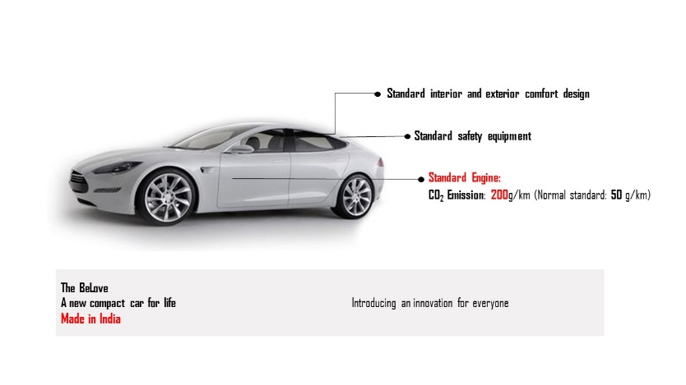 | Congruent favorable ecological COM  [High product eco-friendliness – Favorable ecological COM]  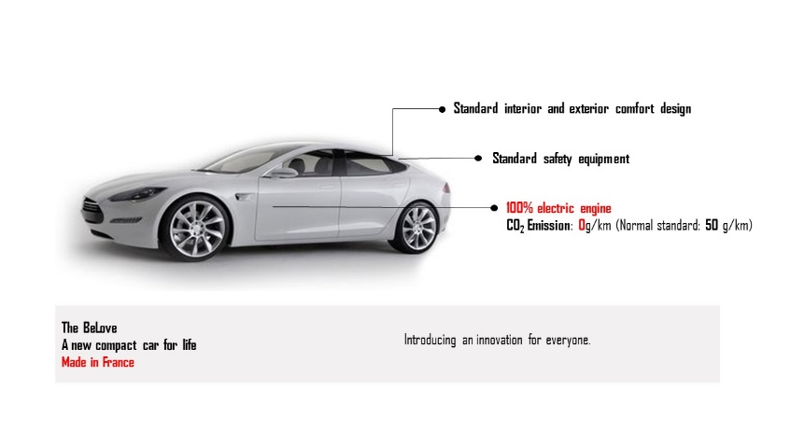
Incongruent unfavorable ecological COM  [High product eco-friendliness – Unfavorable ecological COM] 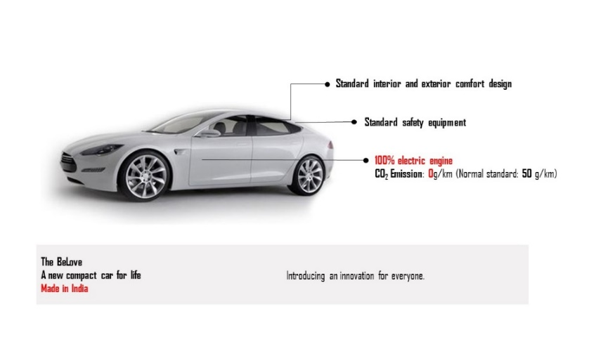 | Incongruent favorable ecological COM  [Low product eco-friendliness – Favorable ecological COM]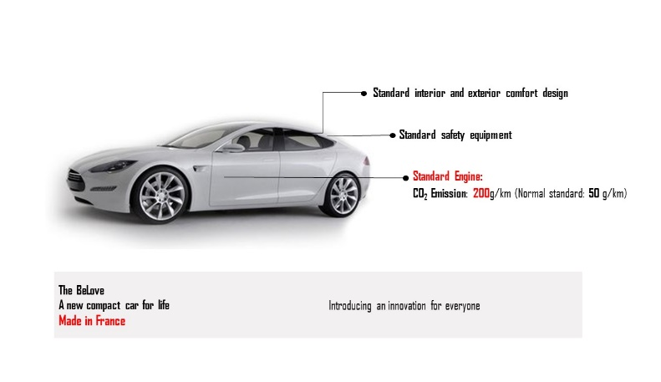

Eco-smart TVs

Congruent unfavorable ecological COM  [Low product eco-friendliness – Unfavorable ecological COM]  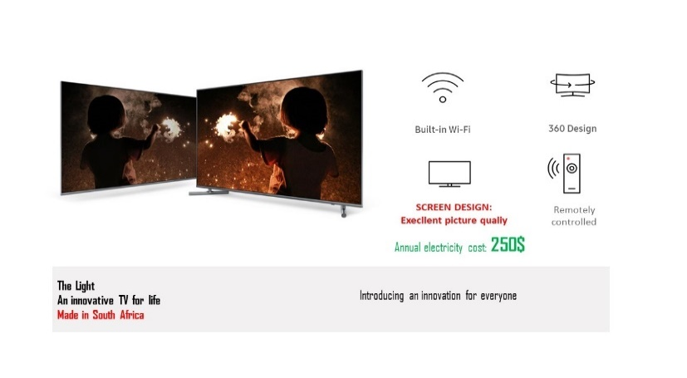 | Congruent favorable ecological COM  [High product eco-friendliness – Favorable ecological COM]  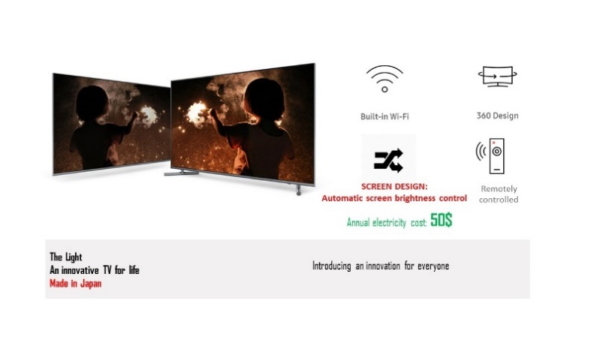
Incongruent unfavorable ecological COM  [High product eco-friendliness – Unfavorable ecological COM] 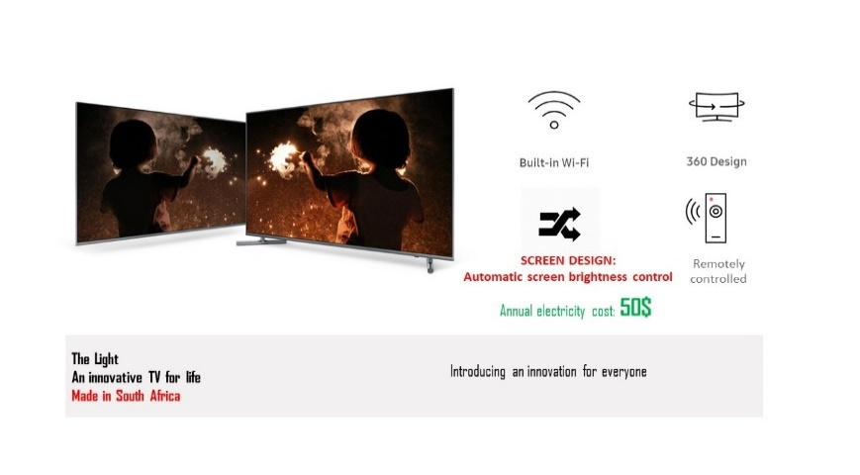 | Incongruent favorable ecological COM  [Low product eco-friendliness – Favorable ecological COM]  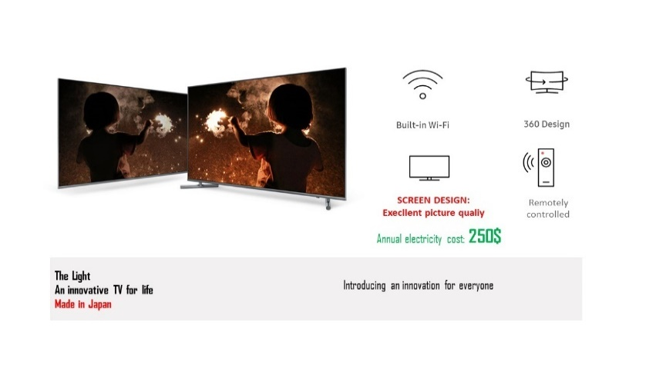

STUDY 1b: A 2 (ecological COM: unfavorable vs. favorable) × 2 (product eco-friendliness: low vs. high) × 2 (observability of product consumption: public vs. private) between-subjects design.

Consumption contexts
Public consumption

Take to the picnic that you want to make a good impression on your significant ones (close friends). Whatever choice you make will come under scrutiny by your family, friends, and even acquaintances who are likely to want to see and learn more about this new product.
Private consumption

Use at home in your own garden or bedroom for relaxing after work. You just use the product for yourself without sharing it with anybody else.

Solar powered wireless speakers

Congruent unfavorable ecological COM  [Low product eco-friendliness – Unfavorable ecological COM]  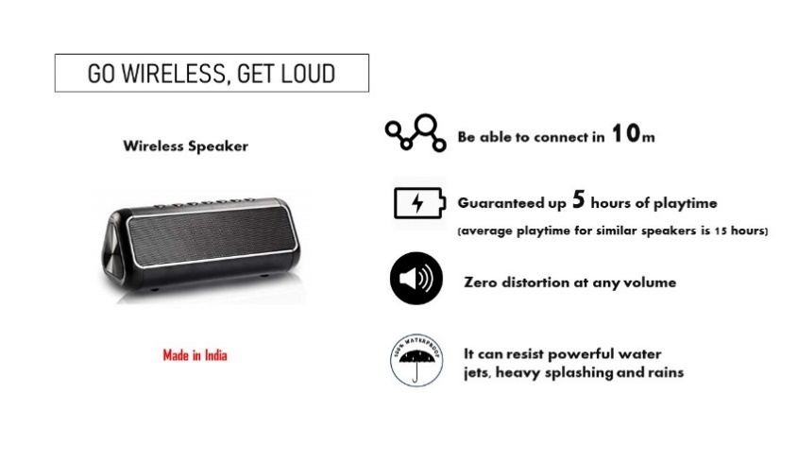 | Congruent favorable ecological COM  [High product eco-friendliness – Favorable ecological COM]  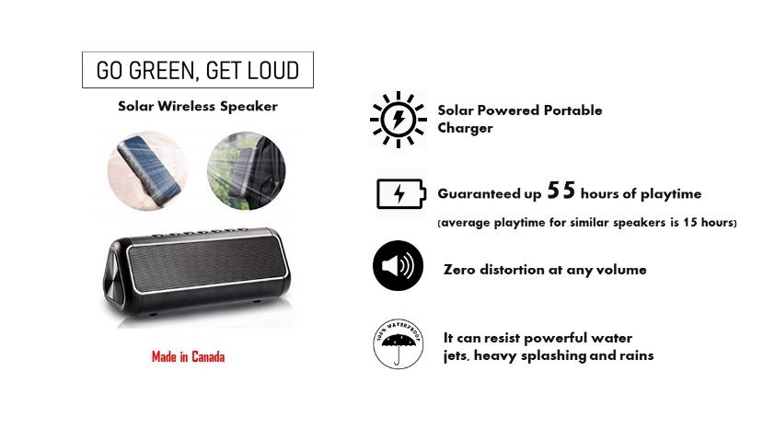
Incongruent unfavorable ecological COM  [High product eco-friendliness – Unfavorable ecological COM] 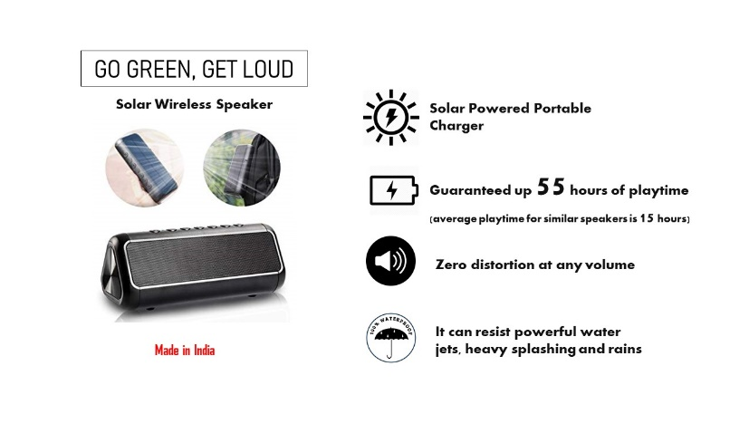 | Incongruent favorable ecological COM  [Low product eco-friendliness – Favorable ecological COM] 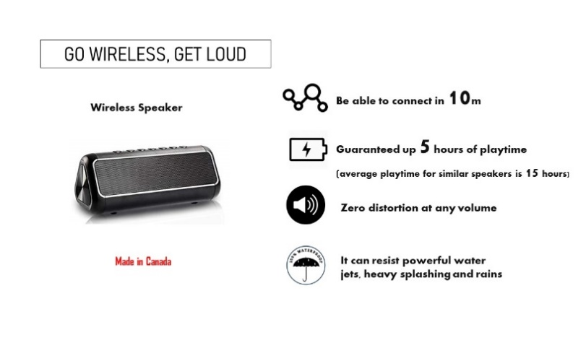

STUDY 2: A 2 (ecological COM: unfavorable vs. favorable) × 2 (product eco-friendliness: low vs. high) × 2 (national context: emerging vs. developed) between-subjects design.

Eco-smartphones

Congruent unfavorable ecological COM  [Low product eco-friendliness – Unfavorable ecological COM] 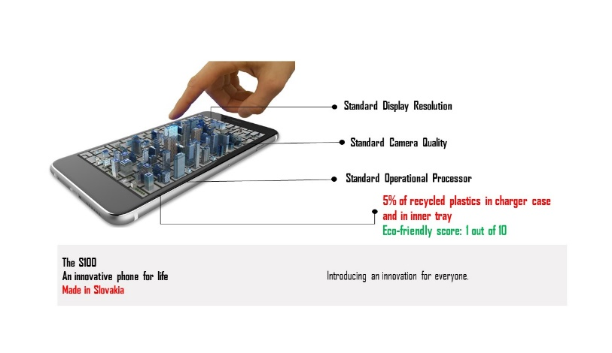 | Congruent favorable ecological COM  [High product eco-friendliness – Favorable ecological COM]  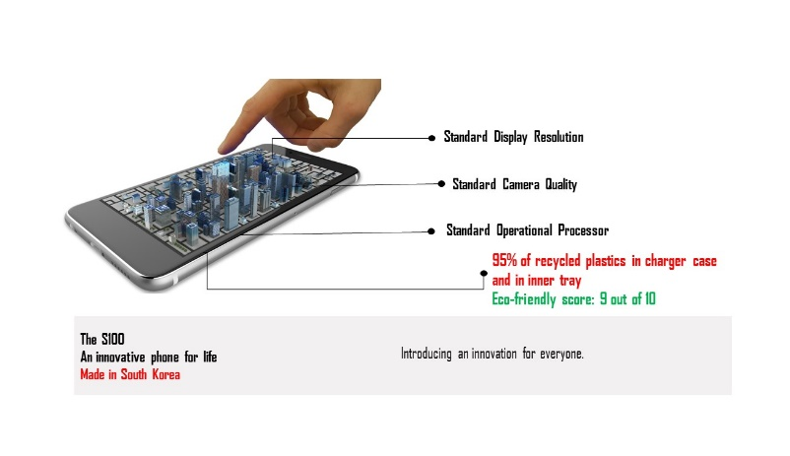
Incongruent unfavorable ecological COM  [High product eco-friendliness – Unfavorable ecological COM] 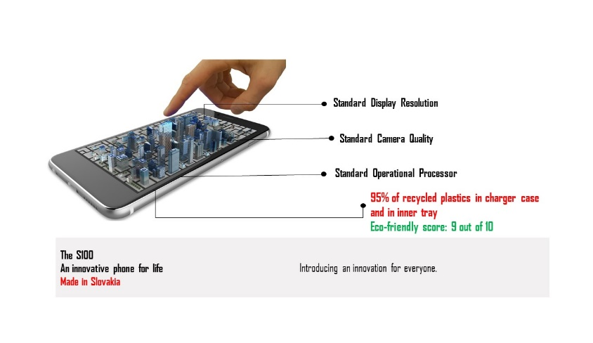 | Incongruent favorable ecological COM  [Low product eco-friendliness – Favorable ecological COM]  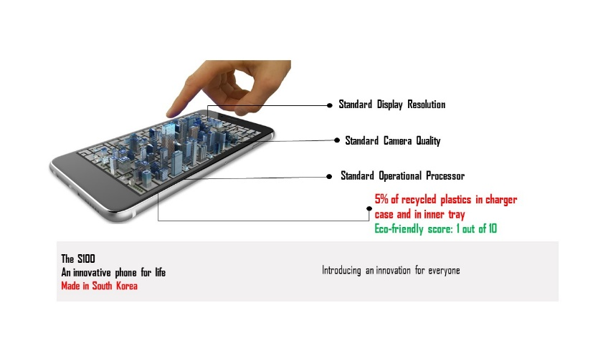

Appendix D Construct measurements
Construct | Items | Measurement (Source)
Adoption intentions  Study 1a: α = .94  Study 1b: α = .98 | To me, adopting this product is…  - Improbable/ Probable  - Unlikely/Very likely  - Impossible/Possible | Three-bipolar 7-point semantic differentials adopted from Kulviwat et al. (2007)
Study 2: α = .70 | - I will consider the product my first choice to buy  - I will buy the product in the next few years | Two 7-point items, anchored by “not at all likely” [1] and “extremely likely” [7] adopted from Müller-Stewens et al. (2017)
Control variables
Product category interest | Overall, I am very interested in electric cars [eco-smart TVs] | Single 7-point item, anchored by “strongly disagree” [1] and “strongly agree” [7] adapted from Melnyk, Klein, and Völckner (2012)
General country image  Study 1a: α = .96  Study 1b: α = .96  Study 2: α = .95 | To what degree do you associate each of the following attributes with [country name]?  - Nice  - Friendly  - Pleasant  - Peaceful  - Competent  - Reliable  - State-of-the-art  - Successful | Eight 7-point items, anchored by “not at all” [1] and “completely” [7] adopted from Häubl (1996)
Product category knowledge  Study 1a: α = .73  Study 1b: α = .90  Study 2: α = .75 | - Compared to the average person, I know a lot about [product name]  - I like to work on [product name] myself  - I don’t understand very much of my [product name] workings  - I know how an internal [product name] system works  - My friends consider me an expert on [product name] | Five 7-point items, anchored by “strongly disagree” [1] and “strongly agree” [7] adapted from Sambandam and Lord (1995)
Economic threats from foreign countries  Study 1a: α = .71  Study 1b: α = .87  Study 2: α = .81 | - The present recession is due to the extensive amount of foreign competition  - The security of my job/business is heavily influenced by foreign competitors  - Economic problems are mainly due to excessive foreign competitors | Three 7-point items, anchored by “strongly disagree” [1] and “strongly agree” [7] adapted from Sharma, Shimp, and Shin (1994)
Openness to new culture  Study 1a: α = .75  Study 1b: α = .83  Study 2: α = .78 | - I would like to have opportunities to meet people from different countries  - I am very interested in trying things from different countries | Two 7-point items, anchored by “strongly disagree” [1] and “strongly agree” [7] adapted from Sharma, Shimp, and Shin (1994)
Perceived COM importance  Study 1a: α = .96  Study 1b: α = .96  Study 2: α = .95 | - A product's country of manufacture is important to me.  - The country of manufacture has an impact on my evaluations.  - Within the [product name] product category, a product's country of manufacture is important to me. | Three 7-point items, anchored by “strongly disagree” [1] and “strongly agree” [7] adapted from Herz and Diamantopoulos (2017)
Prior experience | How many smartphones do you have/own? | Measured by a number of smartphones owned
Perceived product quality | How do your rate the overall quality of this product? | Single 7-point item, anchored by “very low quality” [1 star] and “very high quality” [7 stars]
Manipulation check variables
Perceived product eco-friendliness | How do you rate the product in terms of its product eco-friendliness? | Single 7-point item, anchored by “not at all eco-friendly” [1 star] and “very eco-friendly” [7 stars]
General ecological COM | [Country name] is an environmentally friendly country. | Single 7-point item, anchored by “strongly disagree” [1] and “strongly agree” [7]
Product-specific ecological COM | [Product name] made in [country name] are superior in terms of eco-friendliness | Single 7-point item, anchored by “strongly disagree” [1] and “strongly agree” [7]

Appendix E Tukey HSD post hoc test for adoption intentions in Study 1a and Study 1b
Observability of product consumption | (In)congruence between product eco-friendliness and ecological COM  (A) | (In)congruence between product eco-friendliness and ecological COM  (B) | Study 1a |  |  | Study 1b
 |  |  | Mean difference (A-B) | SD | p | Mean difference (A-B) | SD | p
Public | Congruent Unfavorable ecological COM | Congruent Favorable ecological COM | -2.32 | .45 | .00 | -2.04 | .56 | .00
 |  | Incongruent Unfavorable ecological COM | -1.13 | .45 | .06 | -1.69 | .55 | .02
 |  | Incongruent Favorable ecological COM | -1.17 | .45 | .05 | -.43 | .57 | .87
 | Congruent Favorable ecological COM | Congruent Unfavorable ecological COM | 2.32 | .45 | .00 | 2.04 | .56 | .00
 |  | Incongruent Unfavorable ecological COM | 1.19 | .45 | .05 | .35 | .57 | .93
 |  | Incongruent Favorable ecological COM | 1.15 | .45 | .06 | 1.61 | .59 | .04
 | Incongruent Unfavorable ecological COM | Congruent Unfavorable ecological COM | 1.13 | .45 | .06 | 1.69 | .55 | .02
 |  | Congruent Favorable ecological COM | -1.19 | .45 | .05 | -.35 | .57 | .93
 |  | Incongruent Favorable ecological COM | -.04 | .45 | 1.00 | 1.26 | .58 | .14
 | Incongruent Favorable ecological COM | Congruent Favorable ecological COM | 1.17 | .45 | .05 | .43 | .57 | .87
 |  | Incongruent Unfavorable ecological COM | -1.15 | .45 | .06 | -1.61 | .59 | .04
 |  | Incongruent Favorable ecological COM | .04 | .45 | 1.00 | -1.26 | .58 | .14
Private | Congruent Unfavorable ecological COM | Congruent Favorable ecological COM | -.94 | .40 | .10 | -1.75 | .52 | .01
 |  | Incongruent Unfavorable ecological COM | -1.08 | .40 | .04 | -3.55 | .54 | .00
 |  | Incongruent Favorable ecological COM | -2.44 | .41 | .00 | -2.05 | .52 | .00
 | Congruent Favorable ecological COM | Congruent Unfavorable ecological COM | .94 | .40 | .10 | 1.75 | .52 | .01
 |  | Incongruent Unfavorable ecological COM | -.13 | .40 | .99 | -1.80 | .52 | .01
 |  | Incongruent Favorable ecological COM | -1.50 | .40 | .00 | -.30 | .50 | .93
 | Incongruent Unfavorable ecological COM | Congruent Unfavorable ecological COM | 1.08 | .40 | .04 | 3.55 | .54 | .00
 |  | Congruent Favorable ecological COM | .13 | .40 | .99 | 1.80 | .52 | .01
 |  | Incongruent Favorable ecological COM | -1.37 | .40 | .01 | 1.50 | .52 | .03
 | Incongruent Favorable ecological COM | Congruent Favorable ecological COM | 2.44 | .41 | .00 | 2.05 | .52 | .00
 |  | Incongruent Unfavorable ecological COM | 1.50 | .40 | .00 | .30 | .50 | .93
 |  | Incongruent Favorable ecological COM | 1.37 | .40 | .01 | -1.50 | .52 | .03

Appendix F Tukey HSD post hoc test for adoption intentions in India and the USA
National markets | (In)congruence between product eco-friendliness and ecological COM  (A) | (In)congruence between product eco-friendliness and ecological COM  (B) | Adoption intentions
 |  |  | Mean difference (A-B) | SD | p
India | Congruent Unfavorable ecological COM | Congruent Favorable ecological COM | -.63 | .22 | .02
 |  | Incongruent Unfavorable ecological COM | -.10 | .22 | .97
 |  | Incongruent Favorable ecological COM | -.05 | .22 | 1.00
 | Congruent Favorable ecological COM | Congruent Unfavorable ecological COM | .63 | .22 | .02
 |  | Incongruent Unfavorable ecological COM | .53 | .22 | .07
 |  | Incongruent Favorable ecological COM | .58 | .22 | .04
 | Incongruent Unfavorable ecological COM | Congruent Unfavorable ecological COM | .10 | .22 | .97
 |  | Congruent Favorable ecological COM | -.53 | .22 | .07
 |  | Incongruent Favorable ecological COM | .05 | .22 | 1.00
 | Incongruent Favorable ecological COM | Congruent Favorable ecological COM | .05 | .22 | 1.00
 |  | Incongruent Unfavorable ecological COM | -.58 | .22 | .04
 |  | Incongruent Favorable ecological COM | -.05 | .22 | 1.00
USA | Congruent Unfavorable ecological COM | Congruent Favorable ecological COM | -.34 | .26 | .55
 |  | Incongruent Unfavorable ecological COM | -.54 | .26 | .15
 |  | Incongruent Favorable ecological COM | -1.00 | .26 | .00
 | Congruent Favorable ecological COM | Congruent Unfavorable ecological COM | .34 | .26 | .55
 |  | Incongruent Unfavorable ecological COM | -.20 | .26 | .87
 |  | Incongruent Favorable ecological COM | -.66 | .26 | .06
 | Incongruent Unfavorable ecological COM | Congruent Unfavorable ecological COM | .54 | .26 | .15
 |  | Congruent Favorable ecological COM | .20 | .26 | .87
 |  | Incongruent Favorable ecological COM | -.46 | .26 | .29
 | Incongruent Favorable ecological COM | Congruent Favorable ecological COM | 1.00 | .26 | .00
 |  | Incongruent Unfavorable ecological COM | .66 | .26 | .06
 |  | Incongruent Favorable ecological COM | .46 | .26 | .29

References
Allman, Helena F., Anton P. Fenik, Kelly Hewett, and Felicia N. Morgan (2016), "Brand Image Evaluations: The Interactive Roles of Country of Manufacture, Brand Concept, and Vertical Line Extension Type," Journal of International Marketing, 24 (2), 40–61.
Arora, Anshu Saxena, John R. McIntyre, Jun Wu, and Amit Arora (2015), "Consumer Response to Diffusion Brands and Luxury Brands: The Role of Country of Origin and Country of Manufacture," Journal of International Consumer Marketing, 27 (1), 3–26.
Arora, Anshu Saxena, Jun Wu, Amit Arora, Sabine Bacouël-Jentjens, and John McIntyre (2016), "Miu Miu Diffuses Prada: Coupling Country-of-Origin Versus Country-of-Manufacture Effects with Brand Authenticity and Contagion," Journal of International Consumer Marketing, 28 (4), 228–50.
Bartikowski, Boris, Fernando Fastoso, and Heribert Gierl (2019), "Luxury Cars Made-in-China: Consequences for Brand Positioning," Journal of Business Research, 102, 288–97
Carvalho, Sergio W., Etayankara Muralidharan, and Hari Bapuji (2015), "Corporate Social ‘Irresponsibility’: Are Consumers’ Biases in Attribution of Blame Helping Companies in Product–Harm Crises Involving Hybrid Products?," Journal of Business Ethics, 130 (3), 651–63.
Carvalho, Sergio W., Sridhar Samu, and Subramanian Sivaramakrishnan (2011), "The Effect of Country-Related Brand Associations and Product Attributes on Attitude toward Unfamiliar Foreign Brands: A Schema Congruity Perspective," Journal of International Consumer Marketing, 23 (2), 135–50.
Coskun, Merve, and Sebnem Burnaz (2016), "Exploring the Literal Effect of Coo for a New Brand: A Conjoint Analysis Approach," Journal of International Consumer Marketing, 28 (2), 106–20.
Dekhili, Sihem, and Mohamed Akli Achabou (2015), "The Influence of the Country-of-Origin Ecological Image on Ecolabelled Product Evaluation: An Experimental Approach to the Case of the European Ecolabel," Journal of Business Ethics, 131 (1), 89–106.
Garrett, Tony C., Sungkyu Lee, and Kyounghee Chu (2017), "A Store Brand’s Country-of-Origin or Store Image: What Matters to Consumers?," International Marketing Review, 34 (2), 272–92.
Hamzaoui-Essoussi, Leila, and Dwight Merunka (2007), "Consumers' Product Evaluations in Emerging Markets: Does Country of Design, Country of Manufacture, or Brand Image Matter?," International Marketing Review, 24 (4), 409–26.
Hamzaoui-Essoussi, Leila, Dwight Merunka, and Boris Bartikowski (2011), "Brand Origin and Country of Manufacture Influences on Brand Equity and the Moderating Role of Brand Typicality," Journal of Business Research, 64 (9), 973–78.
Häubl, Gerald (1996), "A Cross-National Investigation of the Effects of Country of Origin and Brand Name on the Evaluation of a New Car," International Marketing Review, 13 (5), 76–97.
Helgeson, James G., Lada Helen V. Kurpis, Magne Supphellen, and Ahmet Ekici (2017), "Consumers' Use of Country-of-Manufacture Information? Norway and the United States: Ethnocentric, Economic, and Cultural Differences," Journal of International Consumer Marketing, 29 (3), 179–93.
Herz, Marc, and Adamantios Diamantopoulos (2017), "I Use It but Will Tell You That I Don’t: Consumers’ Country-of-Origin Cue Usage Denial," Journal of International Marketing, 25 (2), 52–71.
Hui, Michael K., and Lianxi Zhou (2003), "Country-of-Manufacture Effects for Known Brands," European Journal of Marketing, 37 (1/2), 133–53.
Johnson, Zachary S., Yichao Tian, and Sangwon Lee (2016), "Country-of-Origin Fit: When Does a Discrepancy between Brand Origin and Country of Manufacture Reduce Consumers’ Product Evaluations?," Journal of Brand Management, 23 (4), 403–18.
Kulviwat, Songpol, Gordon C. Bruner II, Anand Kumar, Suzanne A. Nasco, and Terry Clark (2007), "Toward a Unified Theory of Consumer Acceptance Technology," Psychology & Marketing, 24 (12), 1059–84.
Melnyk, Valentyna, Kristina Klein, and Franziska Völckner (2012), "The Double-Edged Sword of Foreign Brand Names for Companies from Emerging Countries," Journal of Marketing, 76 (6), 21–37.
Müller-Stewens, Jessica, Tobias Schlager, Gerald Häubl, and Andreas Herrmann (2017), "Gamified Information Presentation and Consumer Adoption of Product Innovations," Journal of Marketing, 81 (2), 8–24.
Sambandam, Rajan, and Kenneth R. Lord (1995), "Switching Behavior in Automobile Markets: A Consideration-Sets Model," Journal of the Academy of Marketing Science, 23 (1), 57–65.
Sedghi, Ami. (2013). "India Named Least Green Country for Electric Cars," The Guardian, https://www.theguardian.com/environment/blog/2013/feb/07/india-green-country-electric-cars.
Sharma, Subhash, Terence A. Shimp, and Jeongshin Shin (1994), "Consumer Ethnocentrism: A Test of Antecedents and Moderators," Journal of the Academy of Marketing Science, 23 (1), 26–37.

