 | Duration | Other data collected (not included in article) | Data analysed in this article
Phase 1: New strategy team proposed and approved | 6 months | Semi-structured interviews with 51 interviews with Directors and Senior Managers  Work shadowing: 5-8 days in length of 2 managers and 1 director  Collection of documents  Participant observation of informal & formal settings | Tape recording of meeting of consultant with project sponsor to discuss the presentation of the research findings  Tape recording of meeting of consultant and project sponsor and academic lead with Managing Director to present research findings and make recommendations for change
Phases 2 & 3:  Strategy team and consultant are called into question | 10 months | Semi-structured interviews: 35 interviews with Directors and Senior Managers  Collection of documents | Tape recordings of monthly strategy team meetings of middle managers (3-5 hours each)  Tape recording of meeting of consultant with project sponsor and Managing Director to provide project update [“Showdown meeting”]  Fieldnote of meeting between second researcher [Jeremy] and two Directors [“Espionage plot”]
Phase 4: Strategy team is contested and disbanded | 2 months | Participant observation of informal & formal settings | Tape recordings of last two strategy team meetings [“Final showdown”]

Table 1 Data sources

Pseudonym | Role
Barry | Lead researcher and (unpaid) change consultant
Giles | Professor of Marketing and academic project lead
Derek | Managing Director
Daniel | Customer Operations Director and company project sponsor
Joan | Customer Operations Manager (reporting to Daniel)
Jeremy | Second researcher (doctoral student jointly funded by company)
Andrew | Logistics Director
Mark | Sales Director
Adam | Marketing Director (promoted from Marketing Manager during Phase 2)
Neil | Sales Manager (reporting to Mark)

Table 2 – Key actors and roles

When Daniel took his seat, nearest me, he quietly thanked me for my time and suggested he wanted to use this meeting as a means of ‘catching up with the progress you and Barry are making with the [strategy team]’. He continued by saying he had been a little concerned as to not knowing what Barry was ‘plotting and planning’ with the team and the plans for the key accounts.
Daniel: ‘The trouble is, Jeremy, as am sure you understand, with Barry not being ‘on the books’ so to speak and doing this work for free effectively, it’s kinda tricky for us to manage him. So, that’s sort of what we’d like to talk to you about today’.
I got a little nervous and asked him what he wanted to discuss.
Daniel: ‘Well perhaps you could bring us up to speed on what’s been happening with the team? We just feel he is making some significant changes to the structure of our business, and well, we just need to know what’s happening, you understand’.
He then went on to reiterate what I took later to be a warning shot:
Daniel: ‘As you know, we really want to be able to help you with your part of the project and the access which you need for the PhD, and so, we’d sort of therefore be really grateful if you could do us a favour and keep an eye on Barry and report back to Joan.’
I replied by agreeing that I would be only too happy to help with this, and then went to describe the work Barry and I had been doing with the team. …
After five or so minutes, Daniel stopped me, put his hand up, and said:
Daniel: ‘OK, OK, that’s good to hear. It’s just that we were getting a little nervous of the speed of the changes he has been planning and incorporating, so if we are kinda on the same page, it would be great if we could rely on you to be the link between us as a senior management team, and Barry and his work with our middle managers on the project.’
I said sure, no problem, I’d be happy to help out. The meeting finished with Joan thanking me again for the time, and then she ushered me through the glass door of Daniel’s office and back to the Operations Department where I had a desk assigned.
(Fieldnote written by Jeremy, quotations based on same-day personal recollection [not tape recording])

Phase | Main events | Backstage Practices | Frontstage Practices
Phase 1 | The consultant and project sponsor present the findings of the research and propose a change to the strategy arrangement (a new cross-functional strategy team led by middle managers). | Rehearsing of pitch for change by consultant and project sponsor  Conspiring about research findings by consultant and project sponsor | Performing by consultant to Managing Director to secure approval for change
Phase 2 | The new strategy team expand their remit, triggering censure and closer monitoring by the Managing Director. | Rehearsing by middle managers in strategy team and consultant  Rehearsing (absence of) lack of foresight by consultant about Managing Director’s concerns about the activity of middle managers | Repairing by consultant to Managing Director to secure continued existence of team
Phase 3 | Two senior managers become suspicious of the change consultant and seek to monitor his activity. | Conspiring by two Directors against consultant  Conspiring by second researcher and consultant | Performing display of loyalty by second researcher to two Directors
Phase 4 | The existence of the team is contested by the incoming Sales Director and the team is subsequently disbanded. | Rehearsing (absence of) lack of foresight by consultant about Sales Director’s concerns regarding the strategy team | (Failure of) repairing consultant was unable to allay Sales Director’s concerns about strategy team

Table 3 Backstage and frontstage practices observed during phases of change to strategy arrangement

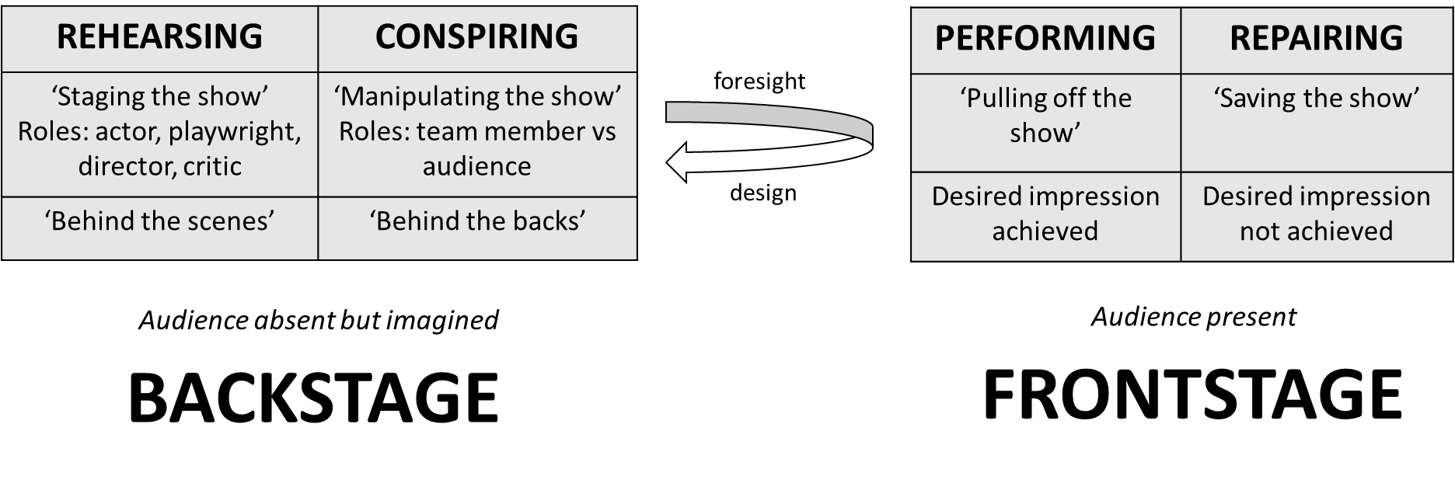
Figure 1 The Art of Stage-Craft

