*Range, Item-Level Means, Standard Deviations, and Zero-Order Correlations among the Covariates, Strong Black Woman Schema, Maladaptive Perfectionism, Self-compassion, Collective Coping, Spiritual Coping, Depression, Anxiety, Loneliness, and 23 Indicators*

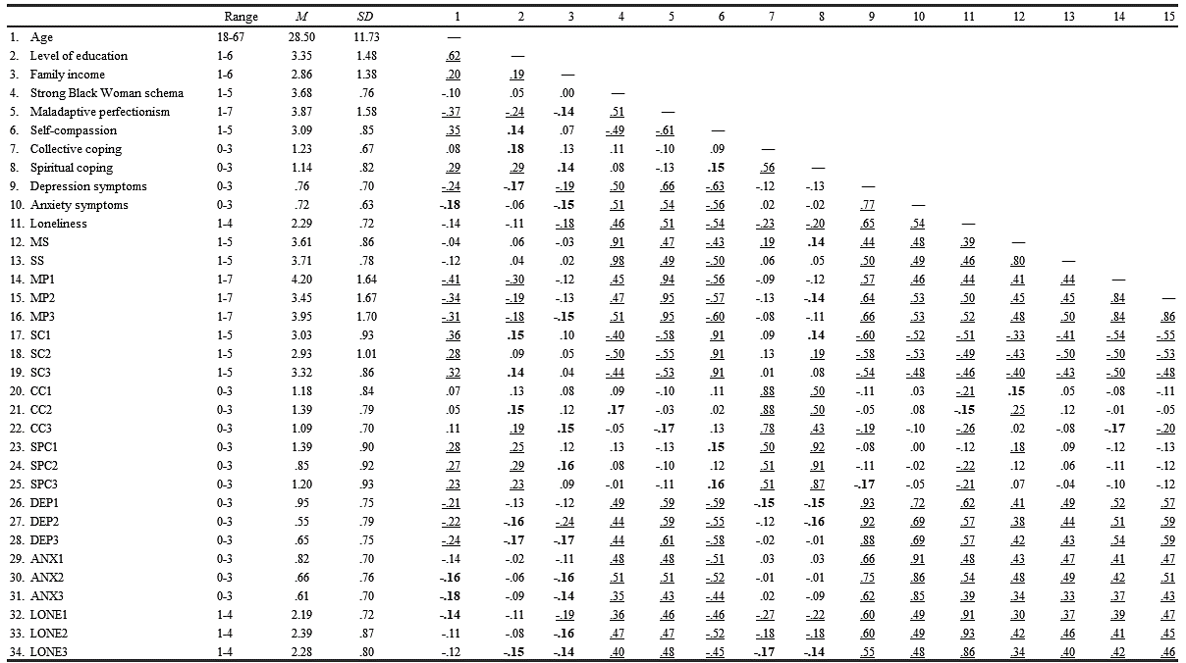

*Range, Item-Level Means, Standard Deviations, and Zero-Order Correlations among the Covariate, Strong Black Women Schema, Maladaptive Perfectionism, Self-compassion, Collective Coping, Spiritual Coping, Depression, Anxiety, Loneliness, and 23 Indicators*

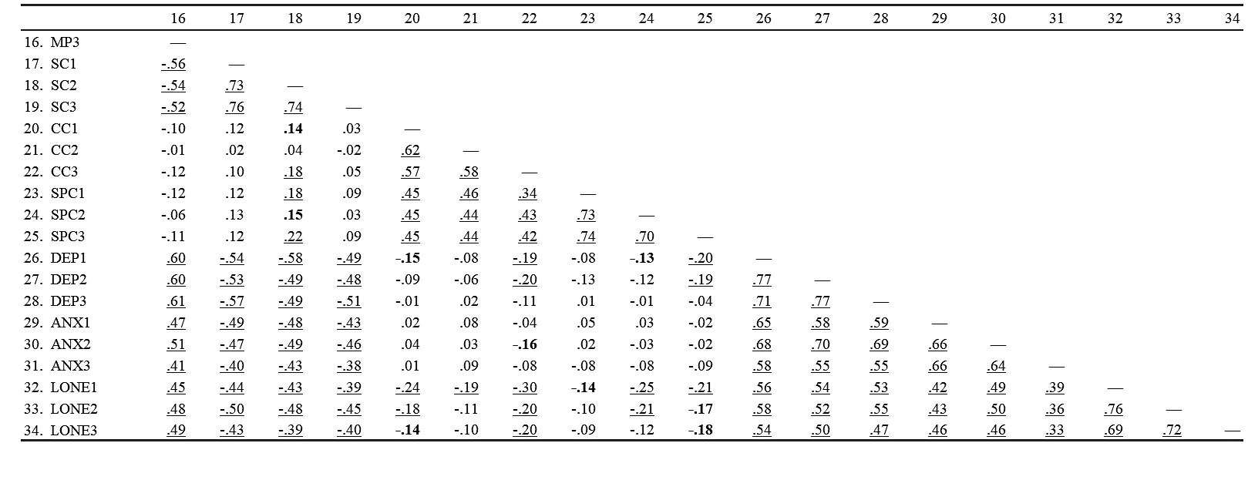

*Note.* *N* = 222. Level of education: 1 = Freshman; 2 = Sophomore; 3 = Junior; 4 = Senior, 5 = Master's Student; 6 = Doctoral Student. Family income: 1 = $10,000-20,000; 2 = $20,000 – 30,000; 3 = $30,000 – 60,000; 4 = $60,000 – 90,000; 5 = $90,000 – 110,000; 6 = $110,000 and above. MS = Mammy subscale of the Stereotypical Roles for Black Women Scale (SBRWS); SW = Superwoman subscale of the SBRWS; MP1, MP2, and MP3 = three parcels from the Discrepancy scale from the Almost Perfect Scale-Revised; SC1, SC2, and SC3 = three parcels from three parcels from the Self-Compassion Scale –short form; CC1, CC2, and CC3 = three parcels from the Collective Coping scale of the Africulural Coping Systems Inventory (ACSI); SPC1, SPC2, and SPC3 = three parcels from the Spiritual Coping scale of the ACSI; DEP1, DEP2, and DEP3 = three parcels from the Depression subscale of the Depression, Anxiety, and Stress Scale –short version (DASS-short version); ANX1, ANX2, and ANX3 = three parcels from the Anxiety subscale of the DASS-short version; and LONE1, LONE2, and LONE3 = three parcels from the UCLA Loneliness Scale short form. Numbers that are bolded represent significant correlations at *p* < .05. Numbers that are underlined represent significant correlations at *p* < .01.

*Factor Loadings for the Measurement Model*

**

*Note.* *N* = 222. MS = Mammy subscale of the Stereotypical Roles for Black Women Scale (SBRWS); SS = Superwoman subscale of the SBRWS; MP1, MP2, and MP3 = three parcels from the Discrepancy scale from the Almost Perfect Scale-Revised; SC1, SC2, and SC3 = three parcels from the Self-Compassion Scale –short form; CC1, CC2, and CC3 = three parcels from the Collective Coping scale of the Africulural Coping Systems Inventory (ACSI); SPC1, SPC2, and SPC3 = three parcels from the Spiritual Coping scale of the ACSI; DEP1, DEP2, and DEP3 = three parcels from the Depression subscale of the Depression, Anxiety, and Stress Scale –short version (DASS-short version); ANX1, ANX2, and ANX3 = three parcels from the Anxiety subscale of the DASS-short version; and LONE1, LONE2, and LONE3 = three parcels from the UCLA Loneliness Scale short form. \*\*\* *p* < .001. (for two-tailed test)