Appendix A: Invitation letter wording by treatment (own translation from the German original)
Questionnaire only:
Subject: Job search survey of the University of Vienna
Dear Sir or Madam,
In collaboration with the Ministry for Social Affairs we are conducting a survey on the subject of job search.
It takes about 5 minutes to fill in the questionnaire. Your answers are very important to us!
Your data will be treated as strictly confidential.
Please click on the following link for the questionnaire:
- To the questionnaire
Thank you very much for your support,
Prof. Bernhard Kittel, University of Vienna – Department of Economic Sociology
--------
This email has been sent to randomly selected (former) AMS-Clients in strict accordance with the data protection regulations. Please do not reply to this email directly. If you have any questions please contact [email].
Questionnaire and video:
Subject: Job search survey of the University of Vienna
Dear Sir or Madam,
In collaboration with the Ministry for Social Affairs we are conducting a survey on the subject of job search.
It takes about 5 minutes to fill in the questionnaire. Subsequently there is a 2-minute video. Please take some time to fill in the survey and watch the video. Your answers and your opinion of the video are very important to us!
Your data will be treated as strictly confidential.
Please click on the following link for the questionnaire and the video:
- To the questionnaire and the video
Thank you very much for your support,
Prof. Bernhard Kittel, University of Vienna – Department of Economic Sociology
--------
This email has been sent to randomly selected (former) AMS-Clients in strict accordance with the data protection regulations. Please do not reply to this email directly. If you have any questions please contact [email].
Video and questionnaire:
Subject: Job search video of the University of Vienna
Dear Sir or Madam,
In collaboration with the Ministry for Social Affairs we created a video on the subject of job search.
It takes 2 minutes. Subsequently there is a 5-minute questionnaire. Please take some time to watch the video and fill in the survey. Your opinion of the video and your answers are very important to us!
Your data will be treated as strictly confidential.
Please click on the following link for the video and the questionnaire:
- To the video and the questionnaire
Thank you very much for your support,
Prof. Bernhard Kittel, University of Vienna – Department of Economic Sociology
--------
This email has been sent to randomly selected (former) AMS-Clients in strict accordance with the data protection regulations. Please do not reply to this email directly. If you have any questions please contact [email].

Video only:
Subject: Job search video of the University of Vienna
Dear Sir or Madam,
In collaboration with the Ministry for Social Affairs we created a video on the subject of job search.
It takes 2 minutes. Please take some time to watch the video and tell us what you think about it. Your opinion is very important to us!
Your data will be treated as strictly confidential.
Please click on the following link for the video:
- To the video
Thank you very much for your support,
Prof. Bernhard Kittel, University of Vienna – Department of Economic Sociology
--------
This email has been sent to randomly selected (former) AMS-clients in strict accordance with the data protection regulations. Please do not reply to this email directly. If you have any questions please contact [email].
Appendix B: Screenshots of the invitation letter on a mobile device (using Android E-Mail)
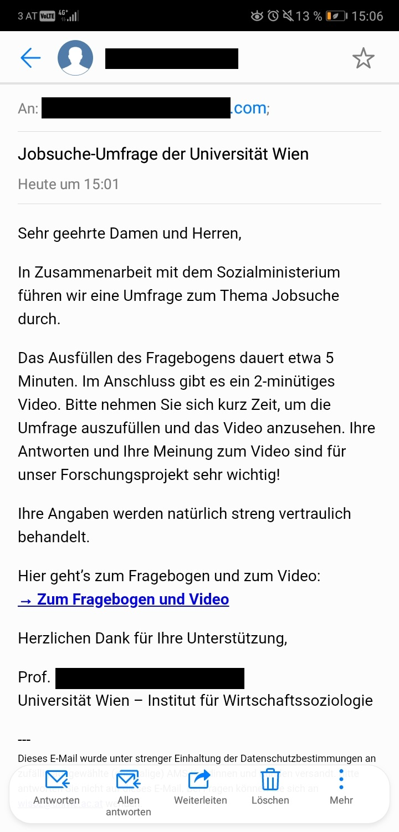
Questionnaire only: Questionnaire and video:
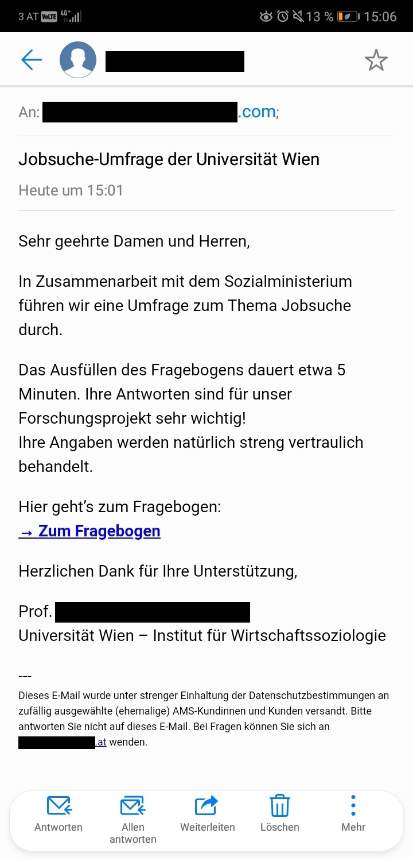
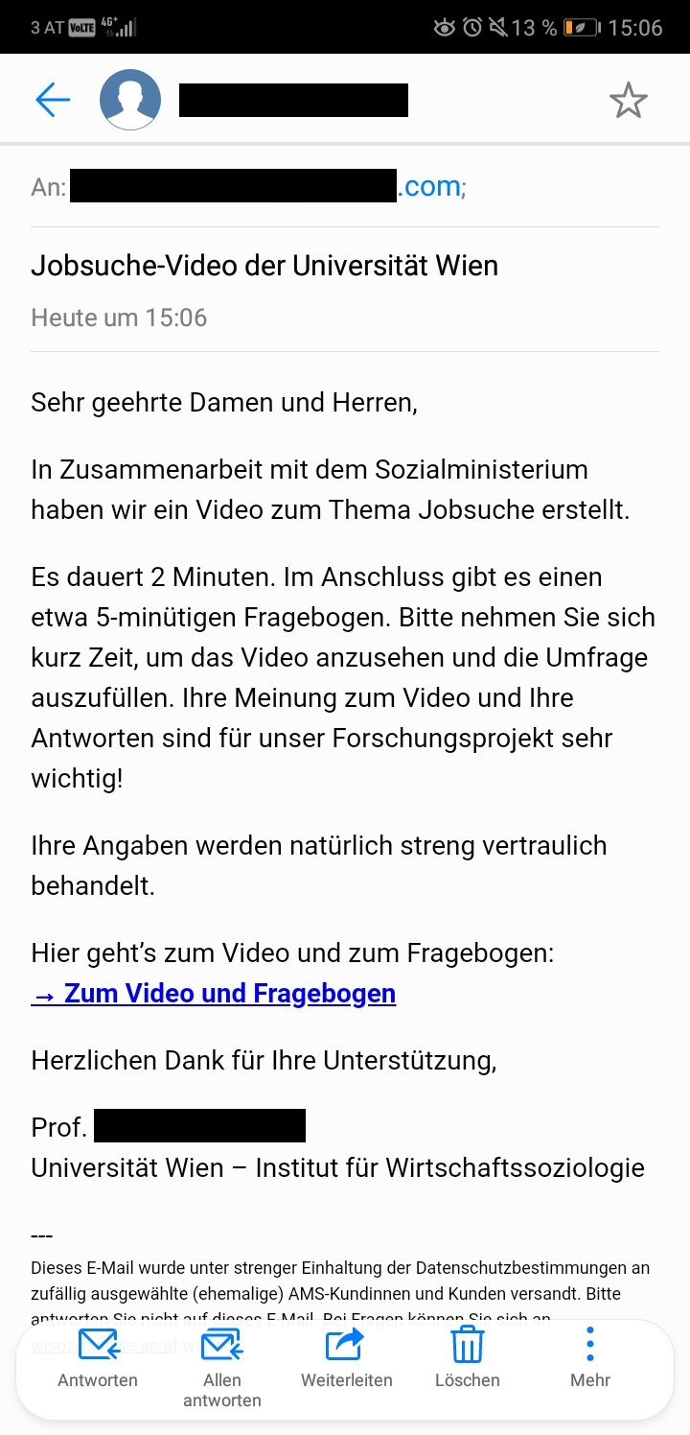
Video and questionnaire: Video only:
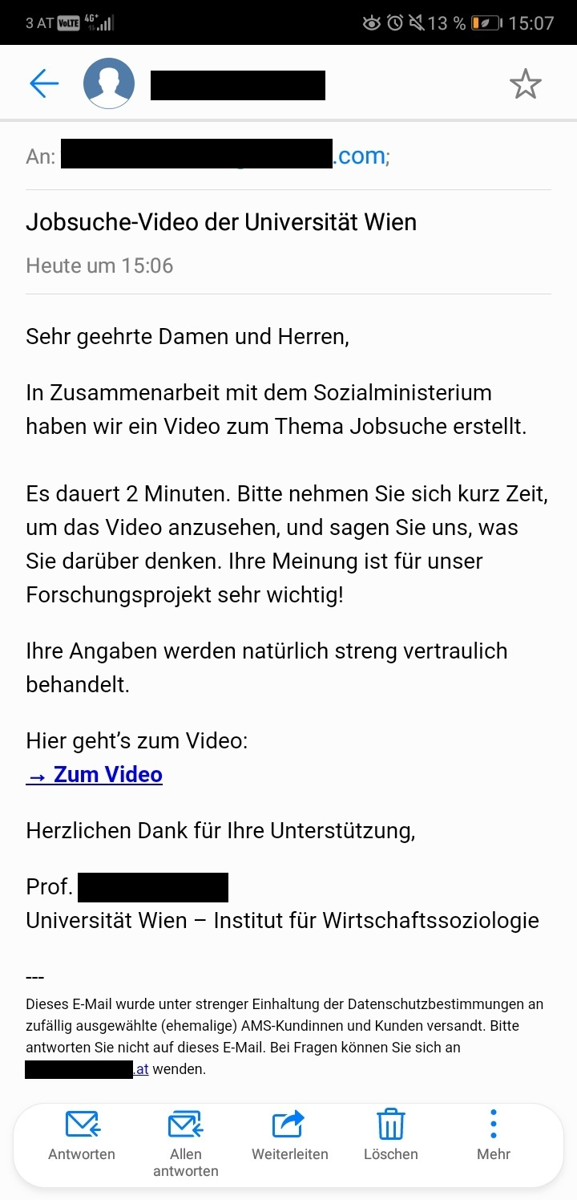
Appendix C:
Table 1: Click Rates, by Experimental Group and Respondent Characteristics; Unit (%)
 | Experimental Groups
 | Questionnaire | Questionnaire + Video | Video + Questionnaire | Video | Total | n
Female | 17.74 | 10.89 | 8.53 | 10.34 | 11.9 | 13,847
Male | 14.47 | 9.88 | 8.84 | 13.32 | 11.6 | 14,153
Austrian | 15.77 | 9.49 | 7.30 | 10.01 | 10.6 | 16,763
Non-Austrian | 16.59 | 11.65 | 10.79 | 14.61 | 13.4 | 11,237
Unemployed | 13.98 | 6.82 | 4.80 | 9.45 | 12.3 | 22,989
Employed | 16.59 | 11.00 | 9.41 | 12.32 | 8.79 | 4,333
Primary | 14.42 | 9.74 | 8.74 | 10.98 | 11.1 | 9,683
Lower Secondary | 15.44 | 9.38 | 6.78 | 10.16 | 10.5 | 10,743
Higher Secondary | 17.56 | 10.86 | 9.87 | 14.30 | 13.1 | 4,497
Tertiary | 22.13 | 15.11 | 13.53 | 16.91 | 16.9 | 2,954
Total | 16.10 | 10.37 | 8.69 | 11.84 | 11.7 | 28,000

Table 2: Response Rates, by Experimental Group and Respondent Characteristics; Unit (%)
 | Experimental Groups
 | Questionnaire | Questionnaire + Video | Video + Questionnaire | Video | Total | n
Female | 13.21 | 8.39 | 5.39 |  | 9.01 | 10,367
Male | 9.20 | 6.26 | 4.39 |  | 6.61 | 10,633
Austrian | 12.47 | 7.54 | 4.76 |  | 8.25 | 12,548
Non-Austrian | 9.32 | 6.95 | 5.07 |  | 7.12 | 8,452
Unemployed | 11.66 | 7.71 | 5.31 |  | 8.22 | 17,217
Employed | 9.20 | 4.95 | 2.49 |  | 5.58 | 3,264
Primary | 8.58 | 5.96 | 3.49 |  | 6.00 | 7,270
Lower Secondary | 11.08 | 6.99 | 3.93 |  | 7.37 | 8,055
Higher Secondary | 12.85 | 8.04 | 6.16 |  | 9.00 | 3,378
Tertiary | 18.07 | 11.61 | 10.74 |  | 13.40 | 2,209
Total | 11.20 | 7.30 | 4.89 |  | 7.80 | 21,000

Appendix D:
Table 1: Full logistic regression estimates of click and response (log-odds)
 | Click |  | Response
 | (1) | (2) | (3) | (4)
Questionnaire-Video (Ref: Questionnaire) | -0.527*** | -0.762*** | -0.490*** | -0.654**
 | (0.052) | (0.184) | (0.061) | (0.219)
Video-Questionnaire | -0.716*** | -1.108*** | -0.930*** | -1.575***
 | (0.054) | (0.202) | (0.069) | (0.272)
Video | -0.367*** | -0.385*
 | (0.050) | (0.172)
Female (Ref: male) | -0.008 | 0.203** | 0.276*** | 0.329***
 | (0.038) | (0.067) | (0.054) | (0.079)
Age | 0.004 | 0.004 | 0.002 | 0.002
 | (0.004) | (0.004) | (0.006) | (0.006)
Lower Secondary (ISCED 3) (Ref: Primary ISCED 1-2) | 0.011 | 0.078 | 0.170* | 0.199*
 | (0.047) | (0.081) | (0.068) | (0.098)
Higher Secondary (ISCED 4-5) | 0.237*** | 0.197* | 0.389*** | 0.367**
 | (0.057) | (0.100) | (0.080) | (0.119)
Tertiary (ISCED 6-8) | 0.526*** | 0.481*** | 0.836*** | 0.765***
 | (0.064) | (0.111) | (0.086) | (0.127)
Non-Austrian (Ref. Austrian) | 0.266*** | 0.079 | -0.151** | -0.304***
 | (0.039) | (0.069) | (0.056) | (0.083)
Unemployed (Ref. employed) | 0.368*** | 0.191* | 0.427*** | 0.270*
 | (0.058) | (0.094) | (0.082) | (0.113)
Questionnaire-Video * female |  | -0.111 |  | -0.047
 |  | (0.105) |  | (0.123)
Video-Questionnaire * female |  | -0.262* |  | -0.171
 |  | (0.110) |  | (0.139)
Video * female |  | -0.545***
 |  | (0.102)
Questionnaire-Video * Lower Secondary |  | -0.067 |  | -0.072
 |  | (0.129) |  | (0.154)
Video-Questionnaire * Lower Secondary |  | -0.236⁺ |  | -0.030
 |  | (0.136) |  | (0.183)
Video * Lower Secondary |  | -0.042
 |  | (0.125)
Questionnaire-Video * Higher Secondary |  | -0.042 |  | -0.079
 |  | (0.155) |  | (0.183)
Video-Questionnaire * Higher Secondary |  | -0.014 |  | 0.233
 |  | (0.162) |  | (0.208)
Video * Higher Secondary |  | 0.208
 |  | (0.148)
Questionnaire-video * Tertiary |  | 0.013 |  | -0.120
 |  | (0.167) |  | (0.192)
Video-Questionnaire* Tertiary |  | 0.076 |  | 0.468*
 |  | (0.171) |  | (0.207)
Video * Tertiary |  | 0.116
 |  | (0.163)
Questionnaire-Video * non-Austrian |  | 0.142 |  | 0.219⁺
 |  | (0.107) |  | (0.129)
Video-Questionnaire* non-Austrian |  | 0.326** |  | 0.383**
 |  | (0.112) |  | (0.144)
Video * non-Austrian |  | 0.356***
 |  | (0.103)
Questionnaire-Video * Unemployed |  | 0.305⁺ |  | 0.199
 |  | (0.160) |  | (0.188)
Video-Questionnaire * Unemployed |  | 0.514** |  | 0.529*
 |  | (0.177) |  | (0.234)
Video * Unemployed |  | 0.106
 |  | (0.147)
Constant | -2.295*** | -2.186*** | -2.811*** | -2.641***
 | (0.130) | (0.155) | (0.183) | (0.203)
Observations | 27,201 | 27,201 | 20,394 | 20,394
Akaike Inf. Crit. | 19,332.870 | 19,301.670 | 10,798.370 | 10,796.520
Note: | +p<0.1,*p<0.05,**p<0.01,***p<0.001
Appendix D
Figure 1: Predicted response probabilities for different treatments by employment status (indicating topic interest), gender, citizenship, and education
A B
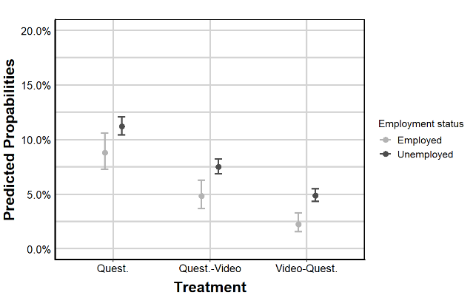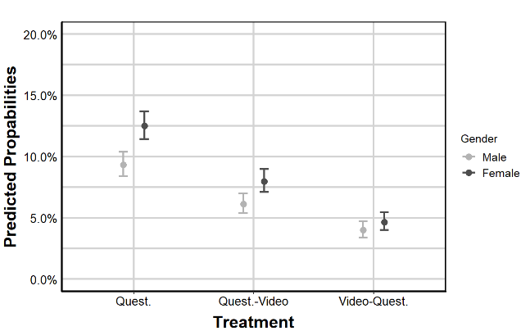
C D
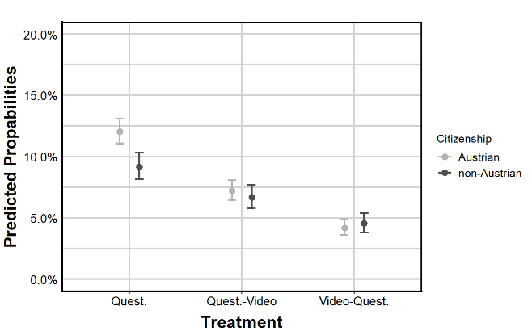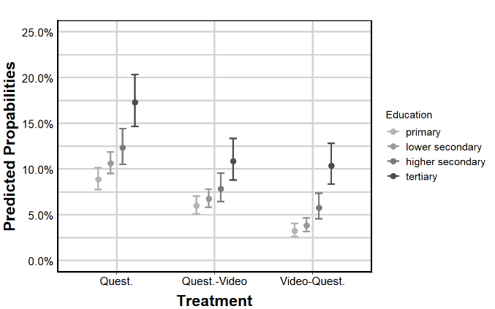
Note: Estimates are based on Model 4 in Table 1. Predicted probabilities with 95% confidence intervals are calculated holding other variables at their mean.
Appendix E: Share of devices used by respondents
 | Desktop/Tablet | Smartphone | Chi-squared test
Questionnaire | 30.3% | 69.7% | χ² = .57, p=.45
Video | 32.0% | 68.0% | χ² = .57, p=.45
Questionnaire-video | 32.0% | 68.0% | χ² = .28, p=.60
Video-questionnaire | 33.6% | 66.4% | χ² = .28, p=.60
N= 3257

