Figure 1 Supplement. Average City Total Capital Outlay 1988-2012 (2012 Dollar)
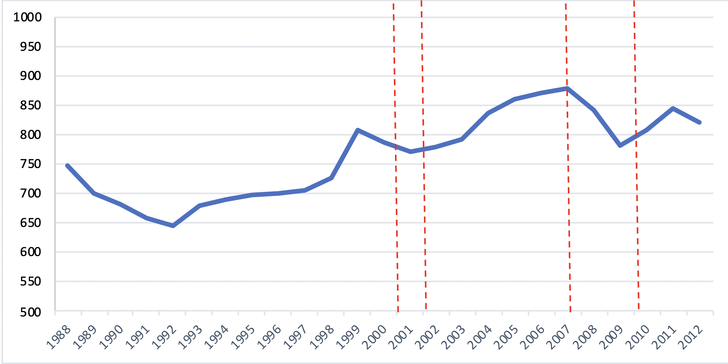
Data source: US Census Bureau

