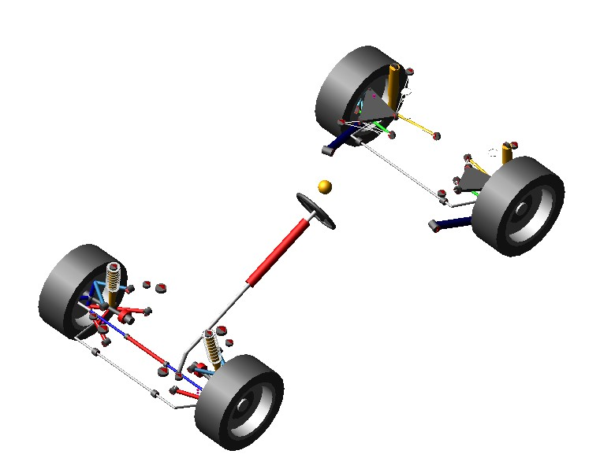
Figure1. Entire vehicle model

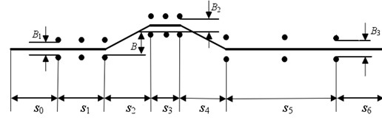
Figure2. The double lane test site
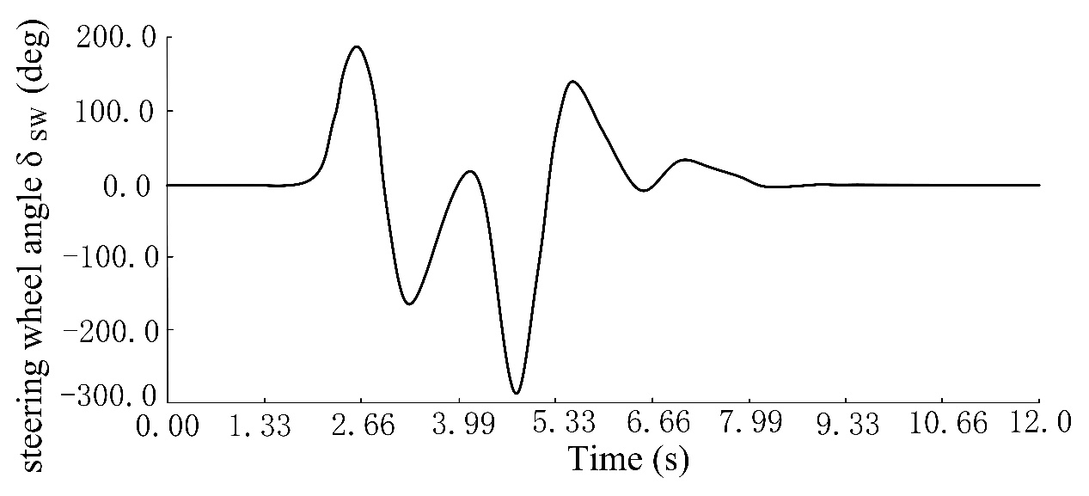
Figure3. Steering wheel angle

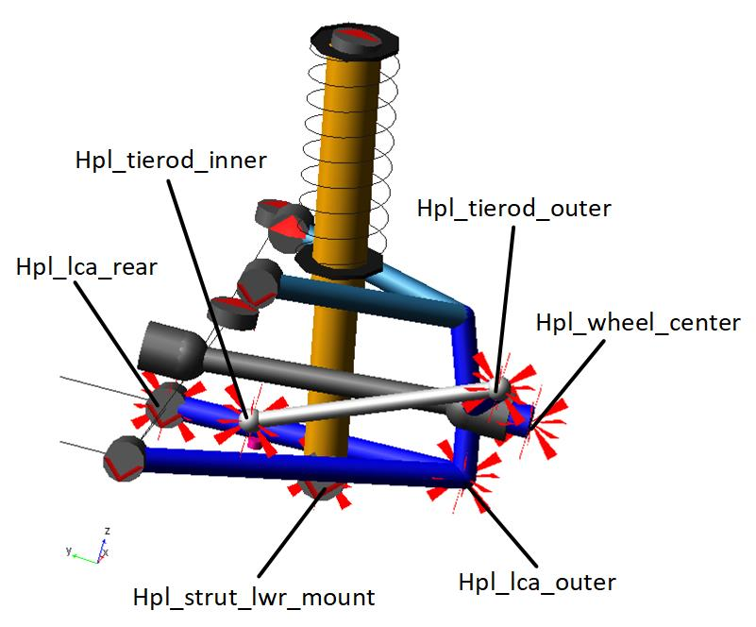
Figure4. The hard points before optimization
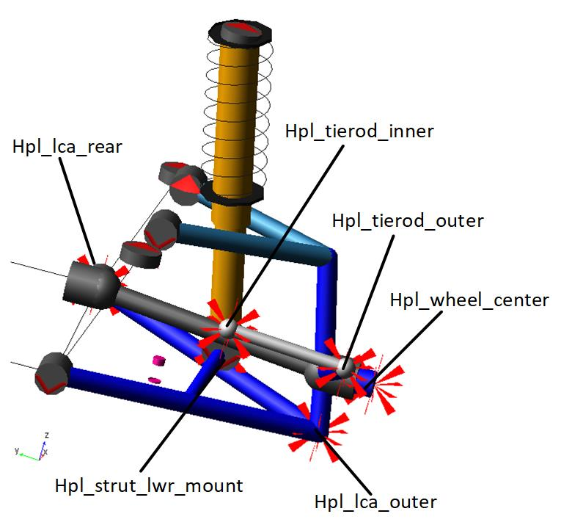
Figure5. The hard points after optimization

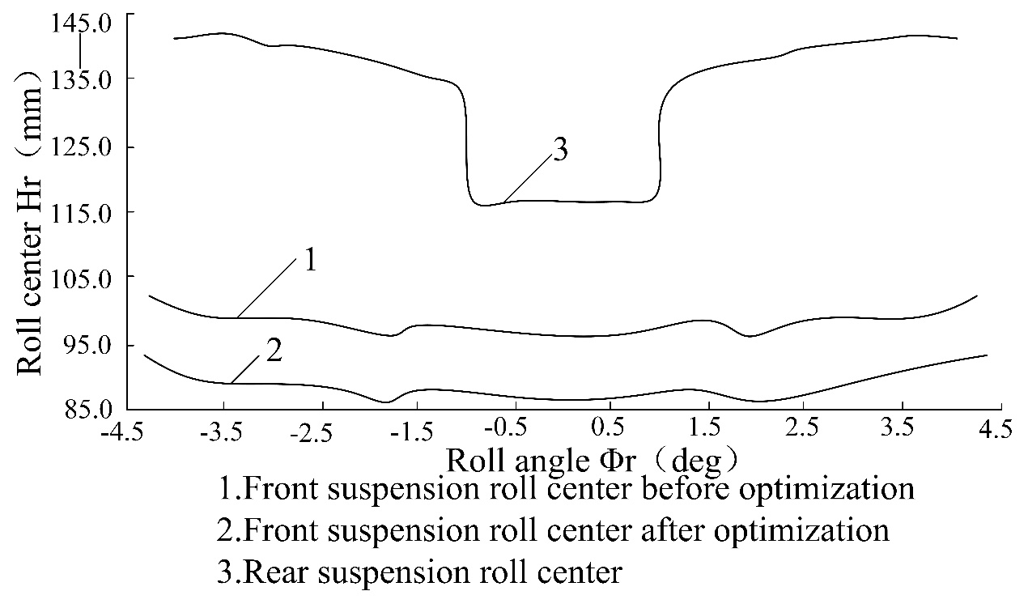
Figure6. Comparison of roll center before and after optimization

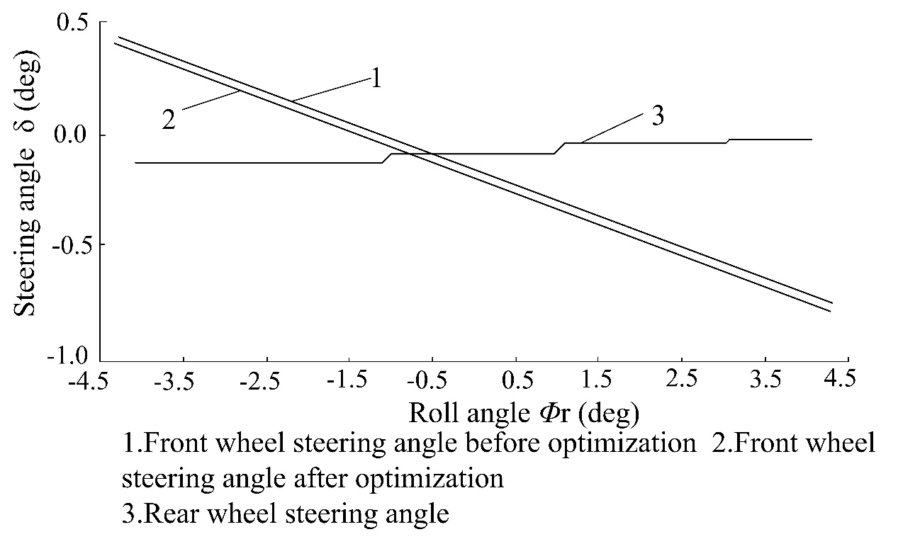
Figure7. Comparison of steering angle with roll angle before and after optimization
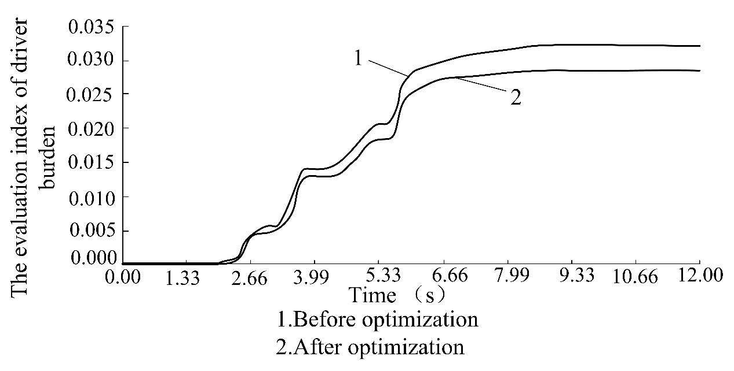
Figure8. Comparison of the evaluation index of driver burden before and after optimization

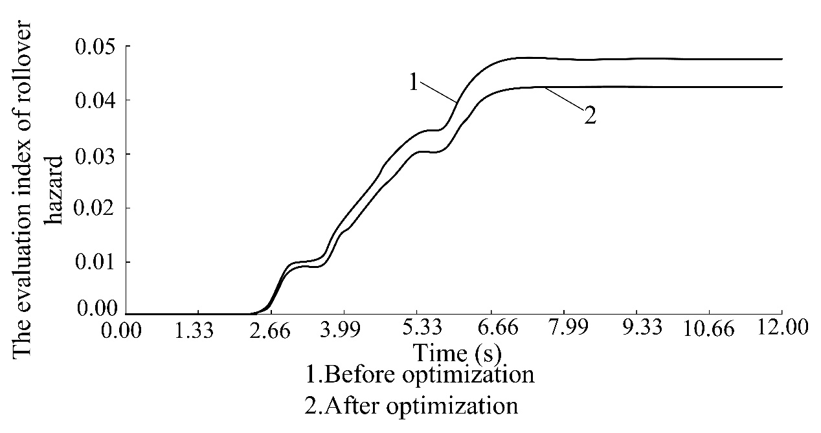
Figure9. Comparison of the evaluation index of rollover hazard before and after optimization
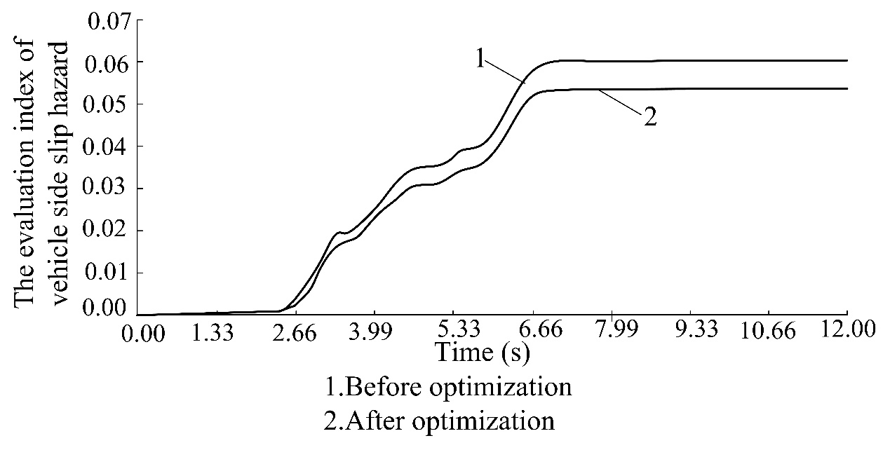
Figure10. Comparison of the evaluation index of vehicle side slip hazard before and after optimization

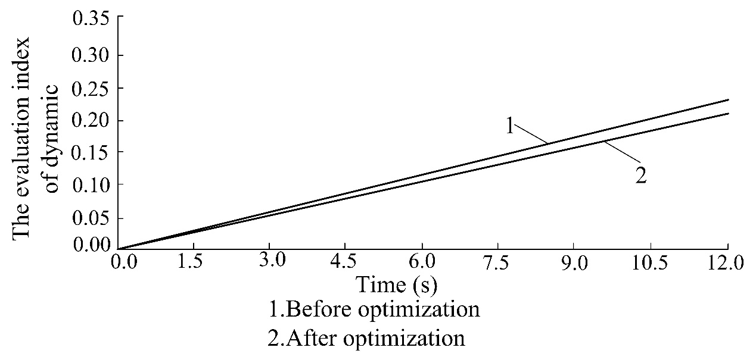
Figure11. Comparison of the evaluation index of dynamic before and after optimization
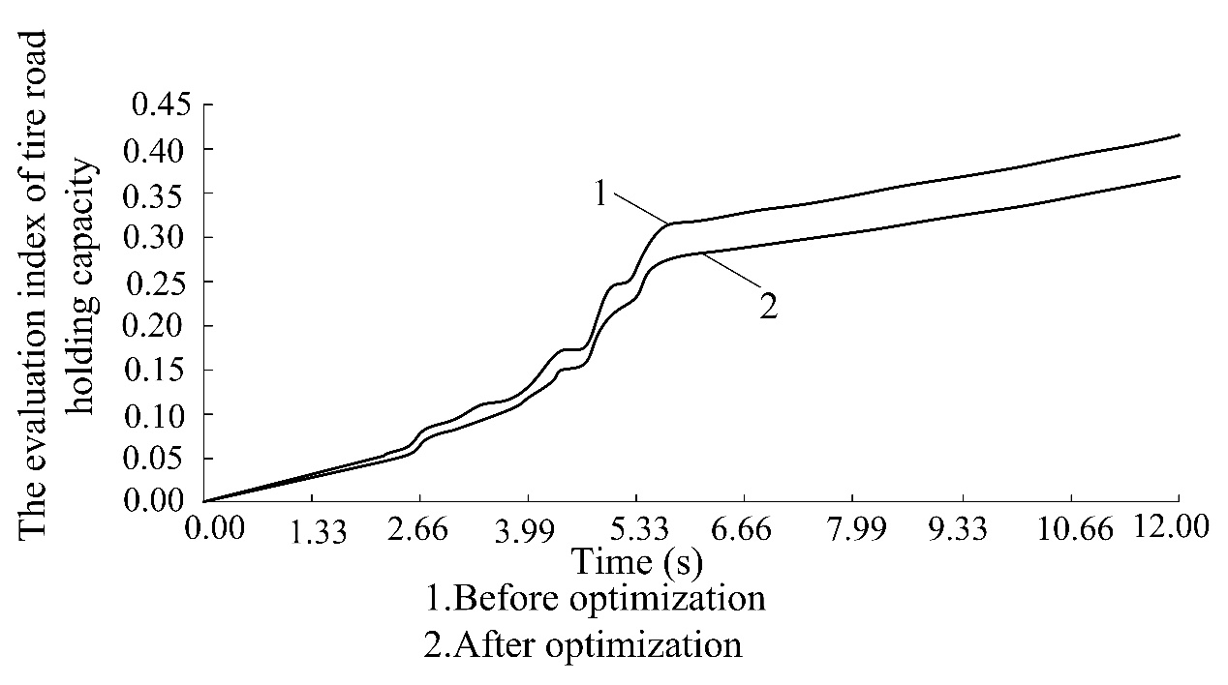
Figure12. Comparison of the evaluation index of tire road holding capacity before and after optimization

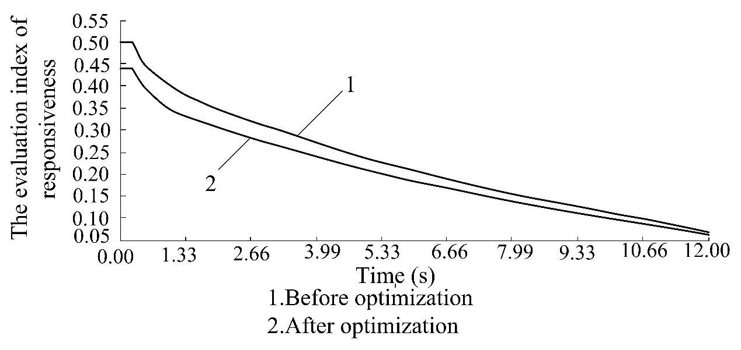
Figure13. Comparison of the evaluation index of responsiveness before and after optimization
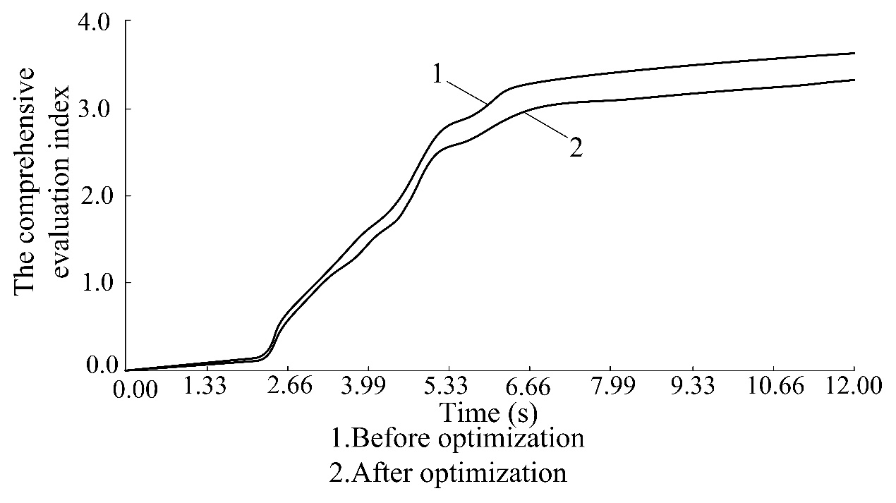
Figure14. Comparison of the comprehensive evaluation index before and after optimization

