Supplementary Online Materials
Note: full materials and data for all experiments are available at https://osf.io/wt4e5/.
- Theoretical Elaboration – The statistical relations between the irrelevant attribute (i.e., suppressor variable), the selection test score and the expected performance.
Consider a simple classical suppressor situation involving 3 variables:
Y = Criterion, X = Predictor and S = Suppressor.
Without any loss of generality, assume all variables are standardized (means = 0 and SDs = 1). Assume r_{sy} = 0.
Applying the usual formulas with this notation we get:
β_{x} = r_{xy} / D
β_{s} = -r_{xy} *r_{xs} / D
R² = (r_{xy})²/D
Where D = (1 - r_{xs}²).
A “naïve” expectation (ignoring suppression effect) would be that:
β_{x} = r_{xy} / D, and
R² = (r_{xy})²
To illustrate the effect of suppression we plot below:
(1) RS ratio ((R² - (r_{xy})²) / (r_{xy})²) – the relation between R² and (r_{xy})² as function of r_{xs}.
(2) β_{x} ratio (β_{x} / r_{xy}) – the relation between β_{x} and r_{xy} as function of r_{xs}.
Under the naïve assumptions these should always be 1. However, taking the suppressor effect into account demonstrate its importance to the model – an increase in R² and in β_{x.}
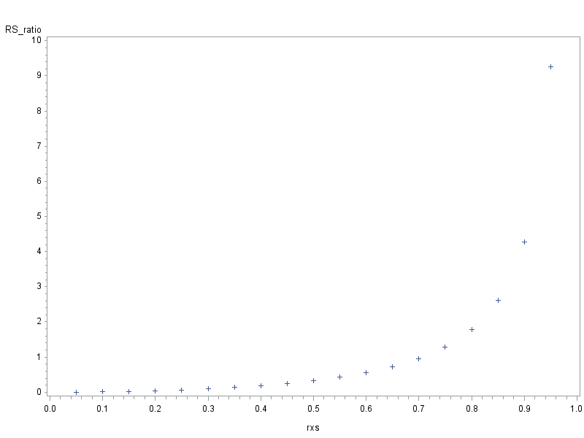
Figure S1: The relation between R² and r_{xy}² as function of r_{xs.}
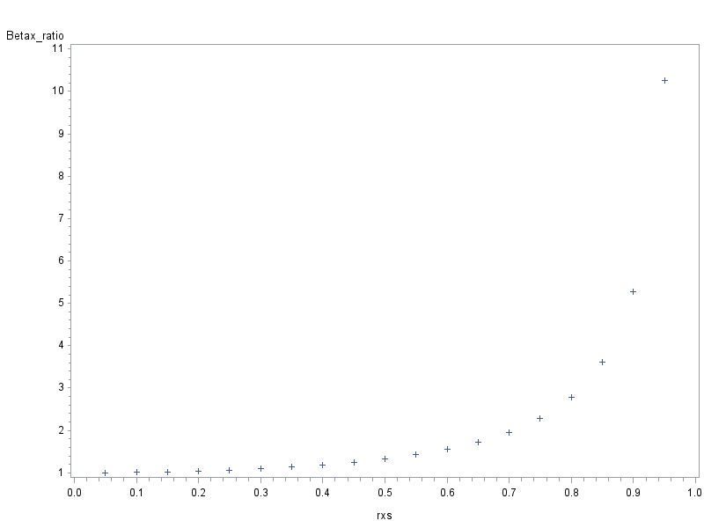
Figure S2: the relation between β_{x} and r_{xy} as function of r_{xs}.
We also include plots of β_{s} for a few values of r_{xy}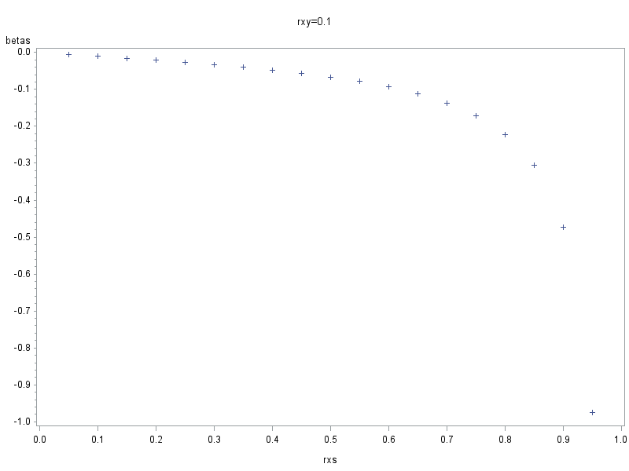
Figure S3: β_{s} as function of r_{xs}, for r_{xy} = .10..
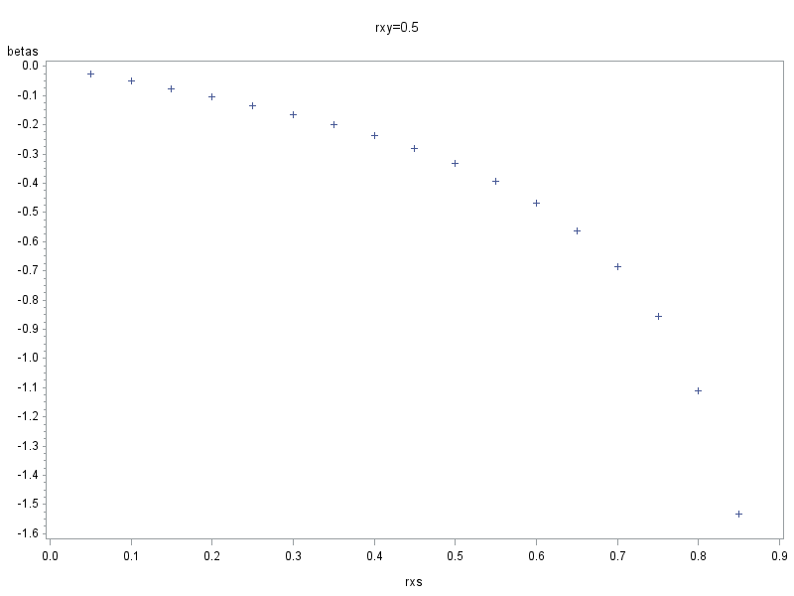
Figure S4: β_{s} as function of r_{xs}, for r_{xy} = .50..

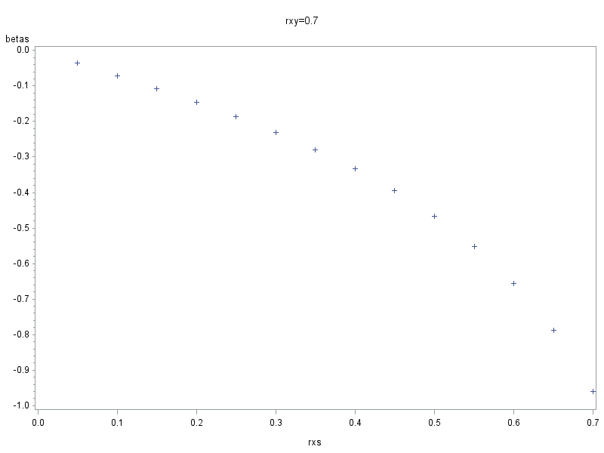
Figure S5: β_{s} as function of r_{xs}, for r_{xy} = .70..

- Supplemental Method Materials
Full materials for all Experiments are available at https://osf.io/wt4e5/.

  - Variables used in Experiment 1's scenarios
Scenario | Selection test | Irrelevant attribute | Criterion
Managerial position | Computer simulation | Previous experience w/computers | Managerial capabilities
Truck driver | Written test | Native language | Driving and road safety knowledge
Online desk operator | Frontal interview | Height of candidate | Support and communication skills
Table S1: Variables used in each Scenario in Experiment 1.

  - Example for a scenario used in Experiment 2, weak suppression
You are looking for candidates for a managerial position in your company. As part of the screening process you use a computer simulation to measure their managerial capabilities. The simulation slightly favors those candidates who have previous experience working with computers. You have to choose between two candidates with identical scores in the simulation: John, who has a lot of experience working with computers, and Mark who has almost no experience working with computers. Assuming the ability to work with computers plays no role in being a successful manager, who would you prefer?
Note: In the 'strong suppression' condition the word slightly was replaced by the word strongly. In the 'no suppression' condition it was mention that: Importantly, the simulation does not favor those who have experience with computers.

  - Example for a Scenario used in Experiment 3, weak suppression
You are looking for candidates for a managerial position in your company. As part of the screening process you use a computer simulation to measure their managerial capabilities. You have to choose between two candidates who achieved identical scores: John and Mark. During Mark's simulation there was a background noise from the next room, which slightly affects performance in this kind of simulation. Based on the description you have read, who would you prefer?
Note: In the 'strong suppression' condition the word slightly was replaced by the word strongly. In the 'no suppression' condition it was mention that: noise doesn't affect performance in this kind of simulation test.
  - Variables used in Experiment 3's other scenarios
Scenario | Selection test | Irrelevant attribute | Criterion
Managerial position | Computer simulation | Background noise | Managerial capabilities
Truck driver | Written test | Time limitation | Driving and road safety knowledge
Online desk operator | Frontal interview | Candidate LOS had fever | support and communication skills
Table S2: Variables used in each Scenario in Experiment 3.

- Supplemental Results Materials
Full data for all Experiments are available at https://osf.io/wt4e5/.
  - Experiment 1 – candidate selection – detailed analysis
    - A generalized linear mixed model (GLLM) multinomial logistic regression was performed to compare the percentage of participants choosing C_HOS and C_LOS in each condition separately: b = -1.22, SE = .29 p < .001, 95% CI [-1.8, -.64]; b = -2.5, SE = .39 p < .001, 95% CI [-3.29, -1.7]; b = .97, SE = .24, p < .001, 95% CI [.49, 1.44]; b = -2.6, SE = .39, p < .001, 95% CI [-3.38, -1.8], for conditions A-D, respectively).
    - The normative model in Condition D:
In Condition D we have:
Y = criterion, X = predictor and S = Suppressor.
Assume standardization Means = 0 and SD = 1, then:
$Y= β_{x}X+ β_{s}$S.
Consider two cases: A, with scores X,S1 and B, with scores X,S2, and assume that S1 > S2 (as described under this Condition). The difference between the two predicted scores in independent of X (both scored the same on X):
$$Y_{A}-Y_{B}= β_{s}(S_{A}-S_{B})$$
Where:
$$β_{S}=\frac{r_{ys}- r_{yx}r_{sx}}{(1-r_{sx}^{2})}$$
So, the difference between the two predictions is positive (negative) if
$(r_{ys}- {r_{sx}r}_{yx })$ is positive (negative). In other words, HOS would be predicted a higher score as long as S has a unique contribution to Y, over X.
  - Additional Results of Experiment 2
    - Candidate selection – detailed analysis
A GLMM multinomial logistic regression was performed to compare the percentage of participants choosing C_LOS over C_HOS and C_LOS over 'no preference' in each condition separately. Results are presented in Table S3.
 | C_LOS over C_HOS |  |  |  | C_LOS over 'no preference'
 | b | SE | p | 95% CI | b | SE | p | 95% CI
No suppression | -1.39 | .34 | < .001 | [-2.05, -.71] | -1.84 | .33 | < .001 | [-2.25, -1.19]
Weak suppression | -.74 | .25 | .004 | [-1.24, -.23] | -.84 | .25 | .001 | [-1.33, -.34]
Strong suppression | -.85 | .27 | .002 | [-1.38, -.33] | -1.05 | .26 | < .001 | [-1.56, .53]
Table S3: Results of multinomial logistic regressions predicting choosing C_LOS over C_HOS and C_LOS over 'no preference' in Experiment 2.

Furthermore, there was no difference in the preference for C_HOS over C_LOS as a function of condition, (ꭓ²(4, N = 124) = 6.8, p = .15), which suggests there was no 'Suppression Strength' X 'Candidate' interaction.
    - Individual differences analyses
      - Descriptive statistics, Reliabilities and Correlations for REI and
Numeracy Scales
Scale | No. of items | Mean | SD | Range | Cronbach's α | 2 | 3
1. FI | 5 | 3.27 | 1.03 | 1-5 | .93 | .05 | -.16
2. NFC | 5 | 2.54 | 1.09 | 1-5 | .88 |  | -.14
3. Numeracy | 8 | 3.64 | 1.42 | 0-8 | .61
Table S4: Means, Standard Deviations, Reliabilities and Correlations for REI and numeracy scales. REI scores (FI and NFC) were calculated as the mean of each participant answers; numeracy score was calculated as the sum of correct answers. All correlations presented are non-significant.

      - Effect of FI, NFC and Numeracy
Table S5 shows the results of a GLMM multinomial logistic regression predicting participants chances of choosing C_LOS over C_HOS, for the 'no suppression' and 'weak' and 'strong suppression':
 | No suppression |  |  |  | Weak and Strong suppression
 | b | SE | p | 95% CI | b | SE | p | 95% CI
FI | .18 | .36 | .62 | [-.53, .88] | -.39 | .22 | .075 | [-.82, .04]
NFC | -.01 | .32 | .98 | [-.65, .66] | .16 | .20 | .44 | [-.24, .55]
Numeracy | -.11 | .23 | .62 | [-.57, .34] | .10 | .16 | .52 | [-.21, .42]
Table S5: Results of multinomial logistic regressions predicting choosing C_LOS over C_HOS according to FI, NFC and numeracy scores. Reference category: C_HOS.

  - Additional results of Experiment 3
    - Candidate selection – detailed analysis
A GLMM multinomial logistic regression was performed to compare the percent of participants choosing C_LOS over C_HOS and C_LOS over 'no preference', for each condition separately. Results are presented in Table S6:
 | C_LOS over C_HOS |  |  |  | C_LOS over 'no preference'
 | b | SE | p | 95% CI | b | SE | p | 95% CI
No suppression | .88 | .31 | .002 | [.27, 1.49] | -.53 | .21 | .014 | [-.94, -.11]
Weak suppression | .71 | .25 | .005 | [.22, 1.21] | .23 | .22 | .29 | [-.20, .65]
Strong suppression | .40 | .23 | .08 | [-.05, .84] | .49 | .23 | .04 | [.03, .95]
Table S6: Results of multinomial logistic regressions predicting choosing C_LOS over C_HOS and C_LOS over 'no preference' in Experiment 3.

    - Individual differences
      - Descriptive statistics, Reliabilities and Correlations for REI and
Numeracy Scales
Scale | No. of items | Mean | SD | Range | Cronbach's α | 2 | 3
1. FI | 5 | 3.52 | .72 | 1-5 | .79 | -.06 | -.08
2. NFC | 5 | 3.48 | .73 | 1-5 | .67 |  | .22**
3. Numeracy | 8 | 4.83 | 2.24 | 0-8 | .73
Table S7: Means, Standard Deviations, Reliabilities and Correlations for REI and numeracy scales. REI scores (FI and NFC) were calculated as the mean of each participant answers; numeracy score was calculated as the sum of correct answers. **p < .01.

      - Effects of REI and Numeracy scales on participants'
choices
Table S8 shows the results of a GLMM multinomial logistic regression predicting participants chances of choosing C_LOS over C_HOS, for the 'no suppression' and 'weak' and 'strong suppression':
 | No suppression |  |  |  | Weak and Strong suppression
 | b | SE | p | 95% CI | b | SE | p | 95% CI
FI | -.55 | .46 | .24 | [-1.47, .38] | -.38 | .29 | .18 | [-.95, .18]
NFC | .66 | .46 | .15 | [-.25, 1.57] | .88 | .30 | .003 | [.30, 1.47]
Numeracy | .14 | .15 | .34 | [-.15, .44] | .20 | .09 | .04 | [.01, .38]
Table S8: Results of multinomial logistic regressions predictions choosing C_LOS over C_HOS according to FI, NFC and numeracy scores. Reference category: C_HOS.

