Supplemental Online Material for

The Scent of a Good Night’s Sleep: Olfactory Cues of a Romantic Partner Improve Sleep Efficiency

Marlise K. Hofer† and Frances S. Chen

†To whom correspondence should be addressed

E-mail: hofer@psych.ubc.ca

Table of Contents
Exclusion Criteria (Table S1) 3
Sample 1 4
Sample 2 4
Sample 3 6
Exploratory Analysis on Pleasantness 7
Number of Exclusions by Sample (Table S2) 8
Exploratory Tests of Moderation
Forward Stepping Sleep Efficiency (Tables S3-S13 & Figure S1) 9
Forward Stepping Perceived Sleep Quality (Tables S14-S25) 13
Backward Stepping Sleep Efficiency (Table S26 & Figure S2) 16
Backward Stepping Perceived Sleep Quality (Table S27) 18
Final Model Including all Predictors Simultaneously (Tables S28 & S29) 19
Three Level Model (Couple as a Third Level) 20
Results Removing Sample 1 Data 21
Further Sleep Outcomes (Onset Latency & WASO) 22
Distribution of Relationship Quality & Attachment Style Data 23
Belief Accuracy about Scent Exposure (Table S30) 24

Exclusion Criteria
Table S1. Exclusion criteria
Criteria | Sleepers | Scent Donors
- Living outside the Vancouver area | X | X
- Cigarette smoker | X
- History of chronic medical/psychiatric disorders | X
- Psychiatric treatment within past 6 months | X
- Anosmia (inability to smell) | X
- Self rated ability to smell of “1” on 5 point scale (1=Extremely Below Average) | X
- Use of “hard” drugs within past 3 months | X
- Use of prescription medications screened on an individual basis for influence on sleep | X

Means and paired sample t-tests are presented separately for each sample below. Means represent the average of the two nights spent with a specific shirt. Two-tailed tests are used unless otherwise specified (when preregistration specified the use of one-tailed tests). Analyses presented below are all as preregistered, with one exception (see Footnote 1).

Sample 1
Forty heterosexual couples participated. After exclusions (SOM-U Table S3), data from 37 women were analyzed (M_{relationship length}=22.34 months, SD=15.46; M_{age}=20.59 years, SD=2.31). Women primarily identified as Asian (62%, including South Asian) or Caucasian (30%).
Women’s sleep efficiency was higher on nights spent with a partner’s shirt than an unworn shirt (91.61% and 84.67%, respectively). This difference was statistically significant; t(36)=3.39, p=.002.
One woman was given the wrong sleep diary and is not included in the perceived sleep quality analyses. Women’s perceived sleep quality was not significantly different on nights spent with a partner’s shirt versus an unworn shirt (4.59 and 4.68, respectively; t(35)=0.51, p=.61).

Sample 2
In Sample 2 we sought to replicate these results of Sample 1 and expand the examination to men. Forty-nine couples participated. After exclusions (SOM-U Table S3), 40 women and 38 men remained (M_{relationship length}=23.01 months, SD=19.02; M_{age}=20.71 years, SD=2.81). Participants primarily identified as Asian (48%) or Caucasian (33%).
Overall Results
Sleep efficiency was higher on nights spent with a partner’s shirt than an unworn shirt (86.92% and 85.45%, respectively). This increase did not reach conventional standards of statistical significance; t(77)=1.347, p=.091, one-tailed.
Perceived sleep quality was higher on nights spent with a partner’s shirt than an unworn shirt (4.73 and 4.59, respectively). This increase was not statistically significant; t(77)=1.31, p=.196.
Results - Women
Women’s sleep efficiency was higher on nights spent with a partner’s shirt than an unworn shirt (88.42% and 85.78%, respectively). This increase did not reach conventional standards of statistical significance; t(39)=1.34, p=.094,, one-tailed.
Women’s perceived sleep quality was higher on nights spent with a partner’s shirt than an unworn shirt (4.85 and 4.52, respectively). This increase was statistically significant; t(39)=2.36, p=.023.
Results - Men Only
Men’s sleep efficiency was higher on nights spent with a partner’s shirt than an unworn shirt (85.34% and 85.10%, respectively). This increase did not reach conventional standards of statistical significance; t(37)=0.28, p=.78.
Men’s perceived sleep quality was lower on nights spent with a partner’s shirt than an unworn shirt (4.60 and 4.67, respectively). This difference was not statistically significant, t(37)=0.49, p=.63.

Sample 3
In Sample 3 we compared a partner’s scent to a gender-matched stranger’s scent. However, because data collection for Sample 3 began before Sample 2 was analyzed, the same (potentially underpowered) sample size of 40 was used.
Forty-five couples participated. As in Sample 1, Sample 3 used women as sleepers and men as scent donors. After exclusions (SOM-U Table S3), 40 women remained (M_{relationship length}=24.53 months, SD=27.01; M_{age}=20.98 years, SD=4.57). Women primarily identified as Asian (65%) or Caucasian (23%).
Women’s sleep efficiency was higher on nights spent with a partner’s shirt than an unworn shirt (86.88% and 85.78%, respectively); this difference was not statistically significant; t(39)=0.82, p=.21, one-tailed.
Women’s perceived sleep quality was higher on nights spent with a partner’s shirt than an unworn shirt (4.88 and 4.53, respectively). This difference was statistically significant; t(39)=2.03, p=.049.

Exploratory Analysis on Pleasantness
We used data from Sample 3 (where a stranger scent was used as a control condition) to explore the effect of exposure to a stranger’s scent. A multilevel model predicting sleep efficiency from scent, perceived scent pleasantness (grand mean centered), and their interaction, showed a significant interaction between scent and pleasantness (b=3.21, SE=1.10, p=0.005, 95% CI [1.12; 5.52]). Simple slope analyses revealed that pleasantness negatively predicted sleep efficiency on nights spent with the stranger’s scent (b=-2.31, SE=0.82, p=.007, 95% CI [-0.71; -4.00]), but not partner’s scent (b=0.90, SE=0.72, p=.22, 95% CI [-0.48; 2.25]), indicating that scents from particularly pleasant-smelling strangers may inhibit sleep. Though exploratory, these analyses suggest that a stranger’s scent may create its own manipulation, making it a problematic control condition.

Table S2. Number of exclusions by sample
 | Sample 1 | Sample  2 Women | Sample  2 Men | Sample 3
Slept in the same bed as partner | 2 | 2 | 2
Relationship ended | 1
Did not adhere to cigarette and marijuana restrictions during scent collection |  | 1 | 1
Did not follow protocol (either did not sleep with partner’s shirt on any night or could not remember order) |  | 2 | 1 | 3
Did not fit eligibility requirements regarding smoking and/or drug usage |  |  | 5
Sleep watch malfunction resulting in no data in at least one scent condition |  | 4 | 2 | 2

Exploratory Tests of Moderation

Forward Stepping Sleep Efficiency. To detect potential moderators, additional multilevel models were computed using a forward stepwise approach as recommended for MLM by Nezlek (2008). We began with the initial model predicting sleep from scent and added predictors one at a time, along with their interactions with scent, testing for significance at each step. If the interaction was not significant (at a relaxed threshold of p=.10), the interaction was removed and the model was tested again. Predictors that were not statistically significant at p=.10 in any model were removed from the model before new predictors were added. This forward stepwise approach kept the number of predictors in a model low in order to avoid surpassing the carrying capacity of the data (which happens especially quickly in MLM to the nonlinear increase in parameters; Nezlek, 2008). Results using a backwards stepwise approach were also examined (in which all predictors were included at once and nonsignificant ones were removed in a stepwise fashion; see below). This alternate method had no effect on the direction or significance of the effect of scent on either sleep outcome variable.

First, variables measured at Level 1 were added one by one along with their interactions with scent (daily perceived stress, scent duration & weeknight, in that order). Scent Duration was effect coded (-1=first night; 1=second night). The study spanned from Monday to Thursday night, so Monday and Wednesday were always the first night with a new scent (-1) and Tuesday and Thursday the second night (1). Perceived stress was cluster centered within person. Weeknight (scored as 1-4 representing Monday through Thursday) was centered by subtracting by the mean (2.5).

Next, variables measured at Level 2 were added one by one along with their interactions with scent (In the following order: Control Scent, Avoidant & Ambivalent Attachment, Sex, Relationship Length, Relationship Quality, and Order). Avoidant & Ambivalent Attachment were added together within one model. All continuous control variables measured at the person level (level 2) were centered around their grand mean (these include: Relationship Quality, Relationship Length, Avoidant Attachment style, and Ambivalent Attachment style). The dummy coded variable control scent indicates which control scent a participant slept with (unworn shirt=0; stranger’s shirt=1). The mean perceived stress level for each person across all four days was included as a measure of average perceived stress (Level 2) and grand mean centered. The final model (Results in table S13) had five predictors: Scent, Scent Duration, Sex, Scent Duration x Scent & Sex x Scent.

Tables for each model tested are displayed in Tables S3-S12. If the interaction was not significant at p = .10, the interaction was removed and the model was tested again. We do not show results with the interaction removed, except in the one instance when that model yielded a new significant predictor (weeknight predicting perceived sleep quality).

Table S3. Two-Level HLM Predicting Sleep Efficiency from Scent Type, Daily Perceived Stress and their interaction
 | b (SE) | p | 95% CI
Scent | 2.60 (0.77) | < .001 | 1.14, 4.07
Daily Perceived Stress | 0.24 (0.67) | .72 | -1.06, 1.56
Scent*Daily Perceived Stress | 0.23 (0.93) | .81 | -1.61, 1.96

Table S4. Two-Level HLM adding Scent Duration
 | b (SE) | p | 95% CI
Scent | 2.48 (0.69) | < .001 | 1.16, 3.81
Scent Duration | -2.12 (0.48) | < .001 | -3.10, -1.25
Scent*Scent Duration | 2.24 (0.69) | .001 | 0.90, 3.66

Table S5. Two-Level HLM adding Weeknight
 | b (SE) | p | 95% CI
Scent | 2.52 (0.76) | .001 | 1.02, 4.07
Scent Duration | -2.45 (0.59) | < .001 | -3.61, -1.29
Weeknight | 0.72 (0.75) | .34 | -0.77, 2.23
Scent*Scent Duration | 2.61 (0.82) | .002 | -0.94, 4.29
Scent*Weeknight | -0.79 (1.04) | .45 | -2.91, 1.39

Table S6. Two-Level HLM adding Control Scent
 | b (SE) | p | 95% CI
Scent | 3.05 (0.88) | < .001 | 1.21, 4.72
Scent Duration | -2.10 (0.45) | < .001 | -3.01, -1.24
Control Scent | 0.32 (1.71) | 0.85 | -2.82, 3.64
Scent*Scent Duration | 2.22 (0.64) | < .001 | 1.02, 3.53
Scent*Control Scent | -1.92 (1.75) | 0.27 | -5.52, 1.43

Table S7. Two-Level HLM adding Attachment Style
 | b (SE) | p | 95% CI
Scent | 2.56 (0.76) | .001 | 1.10, 4.04
Scent Duration | -2.09 (0.45) | < .001 | -3.00, 1.17
Ambivalent | 0.16 (0.79) | 0.84 | -1.41, 1.57
Avoidant | 0.68 (1.13) | 0.55 | -1.44, 3.01
Scent*Scent Duration | 2.21 (0.64) | < .001 | -1.03, 3.41
Scent*Ambivalent | 0.62 (0.81) | 0.44 | -0.87, 2.20
Scent*Avoidant | -1.13 (1.16) | 0.33 | -3.35, 0.97

Table S8. Two-Level HLM adding Sex
 | b (SE) | p | 95% CI
Scent | 3.33 (0.87) | < .001 | 1.66, 5.14
Scent Duration | -2.09 (0.45) | < .001 | -3.02, -1.21
Sex | -0.37 (1.74) | 0.83 | -3.62, 3.00
Scent*Scent Duration | 2.21 (0.64) | < .001 | 0.90, 3.52
Scent*Sex | -3.10 (1.76) | 0.081 | -6.51, 0.21
Table S9. Two-Level HLM adding Relationship Length
 | b (SE) | p | 95% CI
Scent | 3.37 (0.87) | < .001 | 1.64, 5.10
Scent Duration | -2.09 (0.45) | < .001 | -3.01, 1.24
Sex | -0.33 (1.74) | 0.85 | -3.83, 3.34
Relationship Length | -0.03 (0.04) | 0.45 | -0.10, 0.04
Scent*Scent Duration | -2.22 (0.64) | < .001 | -0.98, 3.48
Scent*Sex | -3.18 (1.75) | 0.07 | -6.77, 0.45
Scent*Relationship Length | 0.06 (0.04) | 0.11 | -0.01, 0.14

Table S10. Two-Level HLM adding Relationship Quality
 | b (SE) | p | 95% CI
Scent | 3.31 (0.87) | < .001 | 1.62, 5.00
Scent Duration | -2.09 (0.45) | < .001 | -2.95, -1.22
Sex | -0.64 (1.74) | 0.71 | -4.12, 2.47
Relationship Quality | -1.91 (1.26) | 0.13 | -4.40, 0.35
Scent*Scent Duration | -2.20 (0.64) | < .001 | 1.00, 3.44
Scent*Sex | -2.99 (1.78) | 0.09 | -6.43, 0.65
Scent*Relationship Quality | 0.78 (1.29) | 0.55 | -1.68, 3.50

Table S11. Two-Level HLM adding Order
 | b (SE) | p | 95% CI
Scent | 4.06 (1.15) | < .001 | 1.74, 6.23
Scent Duration | -2.09 (0.45) | < .001 | -2.96, -1.24
Sex | -0.26 (1.74) | 0.88 | -3.35, 3.11
Order | 1.43 (1.50) | 0.34 | -1.70, 4.21
Scent*Scent Duration | 2.21 (0.64) | < .001 | 0.98, 3.48
Scent*Sex | -3.21 (1.77) | 0.07 | -6.66, 0.08
Scent*Order | -1.50 (1.52) | 0.33 | -4.39, 1.64

Table S12. Two-Level HLM adding Average Perceived Stress
 | b (SE) | p | 95% CI
Scent | 3.31 (0.87) | < .001 | 1.69, 5.07
Scent Duration | -2.09 (0.45) | < .001 | -3.00, -1.22
Sex | -0.56 (1.74) | 0.75 | -3.86, 2.64
Average Perceived Stress | -0.99 (0.74) | 0.18 | -2.36, 0.42
Scent*Scent Duration | 2.21 (0.64) | < .001 | 1.02, 3.48
Scent*Sex | -3.02 (1.77) | 0.09 | -6.44, 0.38
Scent*Average Perceived Stress | 0.33 (0.76) | 0.66 | -1.18, 1.78

Table S13. Two-Level HLM final model with interactions
 | b (SE) | p | 95% CI
Scent | 3.33 (0.87) | <.001 | 1.71, 5.00
Scent Duration | -0.37 (1.74) | .83 | -3.93, 2.99
Sex | -2.09 (0.45) | <.001 | -3.00, -1.25
Scent*Scent Duration | -3.10 (1.76) | .081 | -6.38, 0.42
Scent*Sex | 2.21 (0.64) | <.001 | 0.89, 3.42
This analysis highlighted two potential moderators of the relationship between scent and sleep efficiency (interactions between scent duration and scent, and sex and scent).

The interaction between scent and scent duration was examined on an exploratory basis. Sleep efficiency was relatively stable across the two nights exposed to a partner’s scent (First Night M=87.97, SD=7.39; Second Night M=88.22, SD=7.76). However, sleep efficiency decreased on the second night spent away from a partner’s scent (First Night M=87.81, SD=7.98; Second Night M=83.57, SD=13.75). Thus, participants sleep got worse on the second night they were exposed to no scent. Speculatively, this result could indicate that a longer separation from one’s partner negatively impacts sleep. It is equally possible that a partner’s scent initially lingers in participant’s bedrooms.

A non-significant interaction between scent and sex also emerged. Even though the interaction did not reach the traditional standard of statistical significance (p = .081), we explored it further by conducting post-hoc simple slope analyses. These analyses revealed that scent predicted sleep efficiency among women (b=3.32, SE=0.87, p<.001, 95% CI [1.55; 4.96]), but not men (b=0.23, SE=1.53, p=.88, 95% CI [-3.39; 3.86]; Figure S1). This result could indicate that the beneficial effect of exposure to a partner’s scent are specific to females, or it could indicate a failure in the strength of the manipulation (i.e., that female participants’ scent was not strong enough to be detected by males).

Given that our study was not designed to test these effects, and because these moderation analyses may be underpowered, it is worth emphasizing that future research will be required to confirm these findings.

Figure S1. Sleep efficiency for males and females by scent type. Error bars represent ±1 SEM.

Forward Stepping Perceived Sleep Quality. An identical method was used to test for moderation in perceived sleep quality. No moderators emerged. Results of models tested are shown below.

Table S14. Two- Level HLM Predicting Perceived Sleep Quality from Scent Type, Daily Perceived Stress and their interactions
 | b (SE) | p | 95% CI
Scent | 0.19 (0.08) | .024 | 0.02, 0.36
Daily Perceived Stress | -0.26 (0.04) | < .001 | -0.41, 0.13
Scent*Daily Perceived Stress | 0.12 (0.10) | .23 | -0.07, 0.34

Table S15. Two-Level HLM adding Scent Duration
 | b (SE) | p | 95% CI
Scent | 0.19 (0.08) | .017 | 0.04, 0.33
Daily Perceived Stress | -0.19 (0.04) | < .001 | -0.27; -0.09
Scent Duration | 0.00 (0.06) | .99 | -0.11, 0.11
Scent*Scent Duration | -0.04 (0.08) | .64 | -0.18, 0.12

Table S16. Two-Level HLM adding Weeknight
 | b (SE) | p | 95% CI
Scent | 0.18 (0.08) | .030 | 0.02, 0.34
Daily Perceived Stress | -0.18 (0.05) | < .001 | -0.27, -0.10
Weeknight | 0.08 (0.06) | .18 | -0.03, 0.20
Scent*Weeknight | -0.03 (0.09) | .76 | -0.20, 0.16

Table S17. Two-Level HLM removing Weeknight*Scent interaction
 | b (SE) | p | 95% CI
Scent | 0.18 (0.08) | .030 | 0.02, 0.34
Daily Perceived Stress | -0.19 (0.05) | < .001 | -0.27, -0.09
Weeknight | 0.06 (0.04) | .078 | -0.01, 0.14

Table S18. Two-Level HLM adding Control Scent
 | b (SE) | p | 95% CI
Scent | 0.11 (0.09) | .25 | -0.08, 0.29
Daily Perceived Stress | -0.18 (0.05) | < .001 | -0.27, 0.09
Weeknight | 0.07 (0.04) | .068 | -0.01, 0.14
Control Scent | -0.09 (0.16) | .56 | -0.40, 0.21
Scent*Control Scent | 0.26 (0.19) | .16 | -0.08, 0.62

Table S19. Two-Level HLM adding Attachment Style
 | b (SE) | p | 95% CI
Scent | 0.18 (0.08) | .030 | 0.03, 0.34
Daily Perceived Stress | -0.18 (0.05) | < .001 | -0.27, -0.10
Weeknight | 0.06 (0.04) | .088 | -0.01, 0.13
Ambivalent | -0.10 (0.07) | .19 | -0.23, 0.05
Avoidant | 0.05 (0.11) | .63 | -0.14, 0.25
Scent*Ambivalent | 0.05 (0.09) | .53 | -0.12, 0.22
Scent*Avoidant | -0.19 (0.12) | .12 | -0.43, 0.05

Table S20. Two-Level HLM adding Sex
 | b (SE) | p | 95% CI
Scent | 0.25 (0.09) | .009 | 0.06, 0.42
Daily Perceived Stress | -0.18 (0.05) | < .001 | -0.28, -0.09
Weeknight | 0.07 (0.04) | .064 | -0.01, 0.14
Sex | 0.09 (0.16) | .57 | -0.21, 0.40
Scent*Sex | -0.28 (0.19) | .15 | -0.62, 0.10

Table S21. Two-Level HLM adding Relationship Length
 | b (SE) | p | 95% CI
Scent | 0.18 (0.08) | .031 | 0.02, 0.35
Daily Perceived Stress | -0.19 (0.05) | < .001 | -0.28, -0.10
Weeknight | 0.06 (0.04) | .077 | -0.01, 0.14
Relationship Length | -0.00 (0.00) | .69 | -0.01, 0.00
Scent*Relationship Length | -0.00 (0.00) | .76 | -0.01, 0.01

Table S22. Two-Level HLM adding Relationship Quality
 | b (SE) | p | 95% CI
Scent | 0.18 (0.08) | .029 | 0.02, 0.34
Daily Perceived Stress | -0.19 (0.05) | < .001 | -0.28, -0.09
Weeknight | -0.06 (0.04) | .10 | -0.01, 0.14
Relationship Quality | 0.00 (0.12) | .99 | -0.24, 0.24
Scent*Relationship Quality | 0.14 (0.14) | .33 | -0.12, 0.40

Table S23. Two-Level HLM adding Order
 | b (SE) | p | 95% CI
Scent | 0.43 (0.19) | .023 | 0.07, 0.80
Daily Perceived Stress | -0.19 (0.05) | < .001 | -0.27, -0.09
Weeknight | -0.03 (0.08) | .66 | -0.19, 0.11
Order | 0.25 (0.20) | .22 | -0.14, 0.69
Scent*Order | -0.50 (0.34) | .14 | -1.19, 0.15

Table S24. Two-Level HLM adding Average Perceived Stress
 | b (SE) | p | 95% CI
Scent | 0.18 (0.08) | .031 | 0.02, 0.35
Daily Perceived Stress | -0.18 (0.05) | < .001 | -0.28, -0.10
Weeknight | 0.06 (0.04) | .079 | -0.01, 0.14
Average Perceived Stress | -0.03 (0.07) | .70 | -0.16, 0.11
Scent*Average Perceived Stress | 0.03 (0.08) | .70 | -0.13, 0.19

Table S25. Two-Level HLM final model with interactions
 | b (SE) | p | 95% CI
Scent | 0.18 (0.08) | .030 | 0.02, 0.33
Daily Perceived Stress | 0.06 (0.04) | .078 | -0.01, 0.14
Weeknight | -0.19 (0.05) | < .001 | -0.27, -0.10

This model is identical to the one reported in the main manuscript because no interactions were significant.

Exploratory Tests of Moderation

Backward Stepping Sleep Efficiency. All variables, and their interactions with scent, were added simultaneously to the model (these include: Scent Duration, Perceived Stress, Control Scent, Sex, Avoidant & Ambivalent Attachment, Relationship Length, Relationship Quality, and Order). Weeknight is omitted because it is a combination of Scent Duration and Order, and is therefore is not linearly independent of these two other predictors. All three could not be included in the same model. Models omitting a different variable and including weeknight do not result in weeknight being a significant predictor. All measures over p = .10 were removed one by one (unless they were part of an interaction remaining in the model). Results from the final model containing predictors significant at p < .10 are displayed below. These results highlight two additional potential moderating variables: Relationship Length and Control Scent.

Table S26. Two-Level HLM predicting Sleep Efficiency
 | b (SE) | p | 95% CI
Scent | 4.52 (1.06) | < .001 | 2.43, 6.42
Scent Duration | -2.10 (0.45) | < .001 | -2.98, -1.18
Sex | -0.23 (1.86) | 0.90 | -3.87, 3.57
Relationship Length | -0.03 (0.04) | 0.45 | -0.10, 0.05
Control Scent | 0.29 (1.82) | 0.87 | -3.31, 3.95
Scent * Scent Duration | 2.23 (0.64) | < .001 | 0.96, 3.48
Scent * Sex | -4.33 (1.85) | 0.02 | -8.17, -0.83
Scent * Relationship Length | 0.06 (0.04) | 0.09 | -0.02, 0.14
Scent * Control Scent | -3.42 (1.82) | 0.06 | -7.03, 0.30

The marginal interaction involving control scent indicates that the improvement in sleep efficiency on nights spent with a partner’s scent may not be the equal across the two types of control scent (stranger vs. unworn shirt). From analyses described in the SOM-R, we know the direction of this difference: people exposed to the unworn shirt (instead of a stranger’s shirt) have a more pronounced increase in sleep efficiency when sleeping with their partner’s scent.

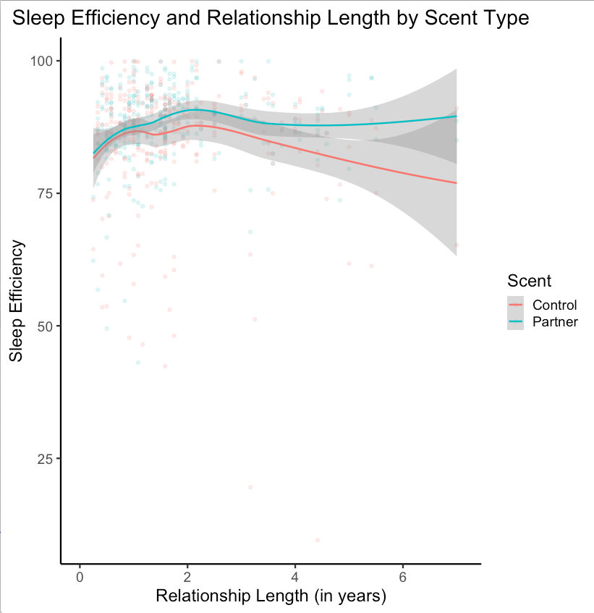
Figure S2. Sleep efficiency across relationship length separated by scent type.

The marginal interaction involving Relationship Length indicates that the improvement in sleep efficiency on nights spent with a partner’s scent may be moderated by how long the couple has been in a relationship. The graph above sheds light on the direction of the interaction. Since all participants are contributing data to both the control and the partner scent groups, the meaningful difference in the graph above is the distance between the red and blue lines. For relationships less than one year long, there are very small differences between sleep on nights spent with control and partner scents. However, in longer relationships (between 1 and 7 years) there is a more pronounced difference. Participants with relationships longer than 7.1 years are outliers on relationship length (more than 3 SDs above the mean in our sample of 1.94 years; four people were outliers by this definition) and are not shown on the graph. These results provide initial evidence that people in longer relationships may have a stronger positive effect from exposure to their partner’s scent.

While these exploratory results are thought provoking, they should be interpreted with caution. Many potential moderators were tested, and the results outlined above were neither large nor statistically significant. They are presented to aid in hypothesis generation for future studies.

Backward Stepping Perceived Sleep Quality. The same procedure backwards-stepping procedure as above (including all predictors simultaneously and removing significant predictors one by one) was followed for sleep quality.

Table S27. Two Level HLM predicting Perceived Sleep Quality
 | b (SE) | p | 95% CI
Scent | 0.36 (0.11) | .002 | 0.13, 0.58
Order | 0.19 (0.14) | .19 | -0.10, 0.46
Daily Perceived Stress | -0.19 (0.05) | < .001 | -0.28, -0.10
Scent * Order | -0.37 (0.16) | .025 | -0.69, -0.06

While this alternate method does not change the effect of scent on sleep, it does highlight an interaction between order and scent (Table S27). Simple slopes analyses indicate that scent predicts sleep efficiency among those who first smelled the control scent and then their partner’s scent (b = 0.36, SE = 0.11, p = .002, 95% CI [0.13; 0.58]), but not among those who slept with the scents in the opposite order (b = -0.09, SE = 0.12, p = .44, 95% CI [-0.33; 0.14]). However, since this interaction was not anticipated, the finding is best regarded with caution.

Final Model Including all Predictors Simultaneously

The following two tables display results from models including control variables described in the main manuscript. No interactions are included. These results represent interim models which were used to arrive at the final models presented in the main manuscript.

Table S28. Two-Level HLM predicting Sleep Efficiency from scent and all control variables simultaneously (no interactions).
 | b (SE) | p | 95% CI
Scent | 2.66 (0.78) | < .001 | 1.12, 4.32
Weeknight | -0.25 (0.34) | .47 | -0.90, 0.52
Daily Perceived Stress | 0.31 (0.40) | .44 | -0.46, 1.08
Average Perceived Stress | -0.76 (0.49) | .13 | -1.76, 0.14
Sex | -3.67 (1.20) | .003 | -5.96, -1.35
Relationship Length | 0.02 (0.02) | .52 | -0.03, 0.06
Relationship Quality | -0.97 (0.92) | .29 | -2.82, 0.86
Ambivalent Attachment | 0.37 (0.53) | .49 | -0.68, 1.38
Avoidant Attachment | -0.01 (0.78) | .99 | -1.52, 1.57
Control Scent | -1.80 (1.19) | .13 | -4.08, 0.59
Order | -0.17 (1.04) | .87 | -2.16, 1.92

Table S29. Two-Level HLM predicting Perceived Sleep Quality from scent and all control variables simultaneously (no interactions).
 | b (SE) | p | 95% CI
Scent | 0.18 (0.08) | .031 | 0.02, 0.33
Weeknight | 0.06 (0.04) | .079 | -0.01, 0.13
Daily Perceived Stress | -0.18 (0.05) | < .001 | -0.27, -0.09
Average Perceived Stress | 0.00 (0.06) | .96 | -0.11, 0.12
Sex | -0.06 (0.14) | .70 | -0.32, 0.22
Relationship Length | -0.00 (0.00) | .34 | -0.01, 0.00
Relationship Quality | -0.01 (0.11) | .93 | -0.23, 0.21
Ambivalent Attachment | -0.08 (0.06) | .19 | -0.21, 0.04
Avoidant Attachment | -0.05 (0.09) | .62 | -0.23, 0.14
Control Scent | -0.01 (0.14) | .94 | -0.27, 0.27
Order | -0.00 (0.12) | .97 | -0.24, 0.23

Results for Three-Level Model (Couple at Level Three)

Initial three-level model
Level 1 (night): Sleep_{tij =} b_{0ij} + b_{1ij}(Scent_{tij}) + e_{tij}
Level 2 (person): b_{0ij} = γ_{00j} + u_{0ij}
b_{1ij} = γ_{10j} + u_{1ij}
Level 3 (couple): γ_{00j} = β₀₀₀ + r_{00j}

Sleep Efficiency. The couple level ICC was 0.00, indicating that 0% of the variance in sleep efficiency can be attributed to the couple level. The initial three-level model (using equations described above) indicated that scent type was a significant predictor of sleep efficiency (b = 2.58, SE = 0.76, p < .001, 95% CI [1.10; 4.05]), and when rounded to the second decimal place this result is identical to the result from the two-level model reported in the main manuscript. To control for other variables and detect potential moderators, the identical series of multilevel models were performed predicting sleep from scent and other control variables. These variables and their interaction with scent were added in a stepwise fashion (using the method described in the main paper). When rounded to the second decimal place, these results are identical those using a two-level model reported in the section directly above. Thus, these results are not duplicated here.

Perceived Sleep Quality. The couple level ICC was 0.13, indicating that 13% of the variance in sleep efficiency can be attributed to the couple level. The initial three-level model (using equations described above) indicated that scent type was not a significant predictor of sleep efficiency (b = 0.15, SE = 0.08, p = .074, 95% CI [-0.02; 0.31]). As with sleep efficiency, when rounded to the second decimal place, results of the model predicting perceived sleep quality from scent type are identical to results from the two-level model. Thus, these results are not duplicated here.

Results Removing Sample 1 Data

When only data from sample 2 & 3 are analyzed (sample 1 data is removed), mean sleep efficiency is descriptively higher on nights spent with a partner’s shirt than a control shirt (86.91% and 85.56%, respectively, d = 0.16). However, the initial multilevel model (predicting sleep efficiency from scent type) indicates that scent type is not a significant predictor of sleep efficiency (b = 1.24, SE = 0.76, p = .052, 95% CI [-0.16; 2.73]), though the direction of the result is consistent with the complete dataset.

Sleep Efficiency Components

We did not have a priori hypotheses about how individual components of sleep efficiency (Onset Latency, Wake After Sleep Onset) would relate to scent. On an exploratory basis, we examined each component separately.

Onset Latency. Onset latency is the amount of time taken to fall asleep for the first time on a given night. Results indicate that onset latency was lower on nights spent with a partner’s shirt than a control shirt (10.60 and 18.69 respectively; t(154) = 4.14, p < .001, mean difference = 8.09, 95% CI [4.23; 11.96]). The initial multilevel model (using equations identical to those used for sleep efficiency in the main manuscript) also indicated that scent type was a significant predictor of onset latency (b = -8.11, SE = 2.18, p < .001, 95% CI [-12.35; -3.48]).

Upon visual inspection, it was apparent that three values for onset latency were extreme outliers (179, 198 & 215 minutes; these numbers were over 6 SDs above the mean). Removal of these three data points did not change the direction or inferential implications of the results (b = -6.37, SE = 1.97, p = .001, 95% CI [-10.34; -2.13]).

WASO. Wake after sleep onset, or WASO, is the amount of time an individual is awake during the night after they have initially fallen asleep. Results indicate that WASO was lower on nights spent with a partner’s shirt than a control shirt (31.33 and 33.80 respectively; t(154) = 1.41, p = .16, mean difference = 2.47, 95% CI [-0.99; 5.94]). The initial multilevel model (using equations identical to those used above) indicated that results are in the same direction as onset latency but are not statistically significant (b = -2.68, SE = 2.14, p = 0.21, 95% CI [-6.61; 1.54]).

Upon visual inspection, it was apparent that one value for WASO was an extreme outlier (307 minutes – the next highest number was 172.5; this value was over 6 SDs from the mean). Removal of this one night did not change the direction of results, but it did cause scent type to become a significant predictor of WASO (b = -3.66, SE = 1.64, p = .026, 95% CI [-6.72; -0.31]).

Distribution of Relationship Quality & Attachment Style Data

The three boxplots below show the distribution of scores for the relationship quality and attachment variables (all three were measured on 7-point Likert scales). It is apparent that the participants in this dataset rate their relationship quality highly. They are also, for the most part, below the midpoint of the scale on both avoidant and ambivalent attachment, indicating that they are relatively secure in their romantic relationships. Thus, the current dataset has range restriction when examining interactions with these variables and scent (for example, since no participants report being unhappy in their relationships, it is not possible with these data to examine if people who are unhappy in their relationship respond to their partner’s scent differently).
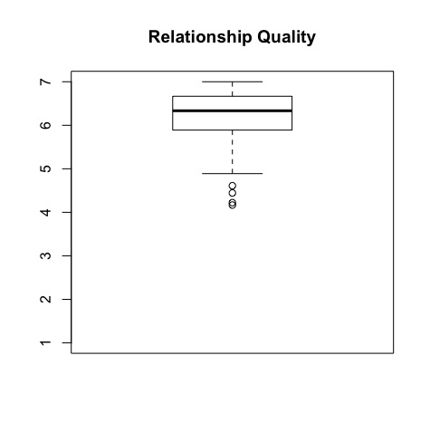
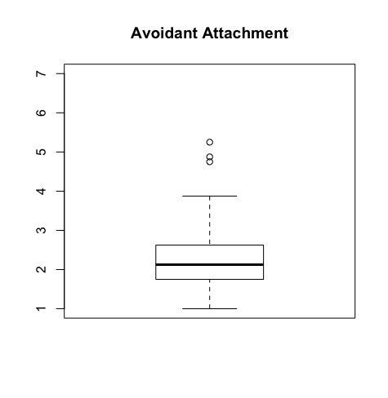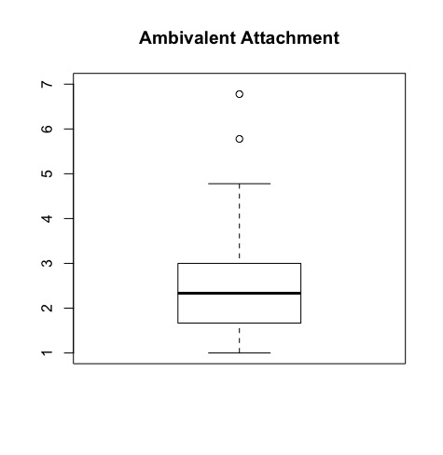
Belief Accuracy about Scent Exposure
We also examined the accuracy of people’s beliefs about what they were smelling. Outside of a lab experiment, participants are likely to have knowledge about the origin of the scents they encounter (e.g. partner scents are encountered when sleeping on a partner’s side of the bed; stranger scents are encountered in novel settings). Thus, data from nights when participants accurately identified the scent to which they were exposed arguably have the most external validity. Table S30 shows that on 436 of the 619 total nights, participants identified the scent accurately. Results shown below are on this subset of 436 nights.
Table S30. Accuracy in participants’ beliefs about scent exposure
 | Accuracy
Scent Exposure | Accurate | Inaccurate |  | Total (n)
Partner Scent | 204 | 105 |  | 309
Control Scent | 232 | 78 |  | 310
Total (n) | 436 | 183 |  | 619

Belief Accuracy
Sleep Efficiency. For the 436 nights when participants accurately identified the scent to which they were exposed, an MLM model was computed predicting sleep efficiency from scent, employing the following equations:
Level 1: Sleep_{ij =} b_{0j} + b_{1j}(Scent_{ij}) + e_{ij}
Level 2: b_{0j} = γ₀₀ + u_{0j}
b_{1j} = γ₁₀ + u_{1j}
Results indicated that scent significantly predicted sleep efficiency (b = 2.89, SE = 1.00, p = .004, 95% CI [0.79; 4.92]). The magnitude of this relationship was similar to that of the whole sample (the coefficient for the whole sample was b = 2.58).

Perceived Sleep Quality. A second analysis was computed predicting perceived sleep quality using the MLM model described above. Results indicated that a partner’s scent predicted higher sleep quality than a control scent in participants who had an accurate belief of the scent to which they were exposed (b = 0.29, SE = 0.09, p = .002, 95% CI [0.11; 0.48]). This relationship was not significant in the entire sample (though it was trending in this direction).

Our preregistration stated that “We are not likely to have missing data. However, if data is missing from the sleep watch for any night, that participant will be excluded from analyses.” We made this statement because we anticipated that missing data would indicate non-compliance with study protocols. We did not, however, anticipate sleep watches failing on some nights at no fault of the participant. Thus, we decided to retain four participants with one night of missing data (i.e., for whom paired sample t-tests were still possible) who would have been excluded using the original decision rule. Exclusion of these four participants does not significantly alter our results or their inferential implications. In fact, their exclusion decreases the mean difference between partner and stranger nights.
We screened for smoking and drug use prior to data collection for women but neglected to do so for men.
Unlike sample 1, we preregistered the use of a one-tailed t-test for sample 2 and sample 3. Therefore, we report results using a one-tailed test.
At the end of the experiment, participants were asked about their beliefs. In Study 1, participants were asked “Do you think this item belongs to your partner?” in regard to both shirts. In Study 2, participants were asked “Do you think one of the shirts was worn by your partner?” and “If you had to choose, which shirt do you think was worn by your partner?” In Study 3, participants were asked “Do you think this shirt was worn by: your partner, another person, unworn, other” in regard to both shirts. On nights spent with a partner’s shirt, if participants accurately identified the shirt belonging to their partner, they were coded 1; otherwise 0. On nights spent with the control shirt, if participants accurately identified the shirt as not belonging to their partner they were coded as 1, otherwise 0.

