SUPPLEMENTARY MATERIAL FOR:

2500-year cultural sequence in the Massim region of eastern Papua New Guinea reflects adaptive strategies to small islands and changing climate regimes since Lapita settlement.

Authors:
Ben Shaw, Simon Coxe, Vincent Kewibu, Jemina Haro, Emily Hull, Stuart Hawkins

A video of the Malakai site excavation and can be found at:
https://www.youtube.com/watch?v=WR_6rwAuwio

Table S1: Radiocarbon AMS dates from the Malakai site, arranged by oldest to youngest. Calibrated ranges are rounded to 10 years. The highest probability range is bolded. CRA = Conventional Radiocarbon Age. Calibrations undertaken using OxCal4.3, with the IntCal13 curve for charcoal and Marine13 curve for shell samples. A mixed terrestrial/marine curve (20 ± 10% marine) was used for the human bone sample. A ΔR correction of 38 ± 14 was applied to shell dates.
Sample | Lab code | Unit | Spit | Layer | Depth | Sample | CRA | Error | δ13C | δ18O | 68.2% range | 95.4% range | Median age
 |  |  |  |  |  |  |  |  |  |  |  |  | Cal. BP | Cal. AD/BC
1 | Beta-479380 | C | 23 | 10 | 169cm | Shell (Anadara antiquita); perforated umbo | 2720 | 30 | 0.2 | -0.92 | 2420 (68.2%) 2320 | 2490 (95.4%) 2290 | 2370 | 430 BC
2 | Beta-479375 | B | 16 | 8 | 170-180cm | Shell (Mytilidae); burnt | 2450 | 30 | 4 | -1.9 | 2100 (68.2%) 1990 | 2150 (95.4%) 1940 | 2050 | 100 BC
3 | Beta-479379 | C | 22 | 9 | 160cm | Shell (Tridacna crocea); utilised edges | 2320 | 30 | 4.5 | -0.53 | 1940 (68.2%) 1840 | 1990 (95.4%) 1800 | 1890 | 60 AD
4 | Beta-479378 | C | 19 | 7 | 120cm | Shell (Tridacna crocea); utilised edges | 2170 | 30 | 2.4 | -0.74 | 1790 (68.2%) 1670 | 1820 (95.4%) 1610 | 1720 | 230 AD
5 | ANU-32536 | A | 8 | 6 | 83cm | Charcoal | 1405 | 20 | -35 |  | 1330 (68.2%) 1290 | 1350 (95.4%) 1290 | 1310 | 640 AD
6 | Beta-487396 | C | 17 | 5b (F1) | 94cm | Charcoal | 420 | 30 | -27 |  | 520 (68.2%) 470 | 530 (87.9%) 430 360 (7.5%) 330 | 490 | 1460 AD
7 | Beta-487398 | B | 14 | 7 | 146cm | Charcoal | 420 | 30 | -26 |  | 520 (68.2%) 470 | 530 (87.9%) 430 360 (7.5%) 330 | 490 | 1460 AD
8 | Beta-479374 | B | 2 | 4 | 60cm | Charcoal | 420 | 30 | -25 |  | 520 (68.2%) 470 | 530 (87.9%) 430 360 (7.5%) 330 | 490 | 1460 AD
9 | Beta-479377 | C | 15b | 5b | 79cm | Charcoal | 360 | 30 | -30 |  | 490 (37.5%) 420 380 (30.7%) 320 | 500 (47.7%) 420 410 (47.7%) 310 | 410 | 1540 AD
10 | Beta-487397 | B | 11 | 6 | 120cm | Charcoal | 280 | 30 | -27 |  | 430 (38.7%) 370 320 (29.5%) 290 | 460 (93.3%) 280 170 (2.1%) 150 | 370 | 1580 AD
11 | ANU-33532 | A | Burial fill | 3/4 | ~50cm | Human bone (collagen) | 325 | 35 | -18 |  | 430 (17.1%) 370 330 (35.3%) 260 190 (9.2%) 140 10 (0.9%) 0 | 470 (68.1%) 240 230 (24.3%) 130 20 (3.0%) 0 | 290 | 1660 AD
12 | ANU-33529 | A | 3 | 2/3 | 25cm | Charcoal | 230 | 35 | -24 |  | 310 (34.8%) 270 180 (24.3%) 150 10 (9.2%) 0 | 430 (4.1%) 390 320 (40.2%) 260 220 (39.0%) 140 30 (12.1%) 0 | 210 | 1740 AD
13 | Beta-479376 | C | 7 | 3 | 40cm | Charcoal | 140 | 30 | -24 |  | 280 (9.6%) 250 230 (19.5%) 180 150 (7.3%) 130 120 (19.8%) 70 40 (12.0%) 10 | 290 (43.1%) 170 160 (52.3%) 0 | 140 | 1810 AD

Table S2: Correlation of excavated spits with identified layers, sediment volume and sieved fraction in Unit C.
Spit | Layer | spit depth | Depth range | Excavated area (m²) | Spit volume (m³) | Sediment Weight (kg) | Sediment Volume (L) | Kg/L ratio | Sieved detritus (Kg) | % detritus in sediment | Stone (Kg)
1 | 1a | 10cm | 0-10cm | 1 | 0.1 | 166 | 144 | 1.15 | 14.6 | 8.8 | 2
2 | 1b | 5cm | 10-15cm |  | 0.05 | 88.8 | 75 | 1.18 | 10.2 | 11.5 | 1.4
3 |  | 4cm | 15-19cm |  | 0.04 | 46 | 37 | 1.24 | 5 | 10.9 | 0.5
4a |  | 7cm | 19-26cm |  | 0.07 | 26.8 | 21 | 1.28 | 3.2 | 11.9 | 0.8
4b | 2 |  |  |  |  | 84.8 | 66 | 1.29 | 8.1 | 9.6 | 1.4
5 |  | 4cm | 26-30cm |  | 0.04 | 55.4 | 42.5 | 1.30 | 6.2 | 11.2 | 1.1
6a |  | 6cm | 30-36cm |  | 0.06 | 35.6 | 25.5 | 1.40 | 4.8 | 13.5 | 0.7
6b | 3 |  |  |  |  | 40 | 28.5 | 1.40 | 4.8 | 12.0 | 0.9
7 |  | 4cm | 36-40cm |  | 0.04 | 56 | 42 | 1.33 | 6.8 | 12.1 | 1.1
8 |  | 6cm | 40-46cm |  | 0.06 | 77.4 | 60 | 1.29 | 8.2 | 10.6 | 1.2
9a |  | 5cm | 46-51cm |  | 0.05 | 44.6 | 33 | 1.35 | 2.9 | 6.5 | 0.3
9b | 4 |  |  |  |  | 27 | 19 | 1.42 | 2.5 | 9.3 | 0.4
10 |  | 6cm | 51-57cm |  | 0.06 | 84.6 | 61.5 | 1.38 | 5.9 | 7.0 | 1
11 |  | 5cm | 57-62cm |  | 0.05 | 53.6 | 39 | 1.37 | 5 | 9.3 | 0.9
12 | 5a | 4cm | 62-66cm |  | 0.04 | 69.6 | 52 | 1.34 | 10.2 | 14.7 | 3.9
13 |  | 4cm | 66-70cm |  | 0.04 | 66.8 | 52 | 1.29 | 5.4 | 8.1 | 1.2
15a | Disturbed feature? | 6cm | 75-81cm |  | 0.06 | 25.6 | 21.5 | 1.19 | 1 | 3.9 | 0.4
14 | 5b | 5cm | 70-75cm |  | 0.05 | 82.6 | 59.5 | 1.39 | 6.1 | 7.4 | 1.9
15b |  | 6cm | 75-81cm |  | 0.06 | 68.8 | 50 | 1.38 | 2.4 | 3.5 | 1
16 |  | 5cm | 81-86cm |  | 0.05 | 79.2 | 62 | 1.28 | 6.8 | 8.6 | 3.4
17 | F1 | 10cm | 86-96cm |  | 0.1 | 17.2 | 13 | 1.32 | 1.2 | 7.0 | 0.1
 | F2 |  |  |  |  | 12.8 | 11 | 1.16 | 0.1 | 0.8 | 0.1
 | F3 |  |  |  |  | 60.8 | 46 | 1.32 | - | - | -
17 | 6 |  |  |  |  | 28.2 | 23 | 1.23 | 4.9 | 17.4 | 1
18 |  | 4cm | 96-100cm |  | 0.04 | 95.8 | 80.5 | 1.19 | 8.3 | 8.7 | 2.5
19 | 7 | 40cm | 100-140cm |  | 0.4 | Concreted sand
20 | 8 | 6cm | 140-146cm |  | 0.06 | Sediment wet, not weighed | 59 | - | 42.1 | - | 5.4
21 |  | 4cm | 146-150cm |  | 0.04 |  | 42.5 |  | 33.5 |  | 4.7
22 | 9 | 11cm | 150-161cm | 0.5 | 0.06 |  | 68.6 |  | 29.2 |  | 1.6
23 | 10 | 8cm | 161-169cm |  | 0.04 | Below water table
Total |  |  |  |  | 1.66 | 1494 | 1334.6 | 1.30 av | 239.4 | 9.3 av | 40.9

Table S3: Correlation of excavated spits with identified layers, sediment volume and sieved fraction in Unit B.
Spit | Layer | spit depth | Depth range | Excavated area (m²) | Spit volume (m³) | Sediment Weight (kg) | Sediment Volume (L) | Kg/L ratio | Sieved detritus (Kg) | % detritus in sediment | Stone (Kg)
1 | 1-3 | 55 | 0-55 | 1 | 0.55 | Sediment removed by shovel. Not quantified.
2 | 4 | 4 | 55-59 |  | 0.04 | 81.7 | 76.5 | 1.07 | 1.5 | 1.8 | 0.5
3a |  | 5 | 59-64 |  | 0.05 | 66 | 63 | 1.05 | 1.3 | 2 | 0.4
3b-d | 5 |  |  |  |  | 22.2 | 21 | 1.06 | 2.2 | 9.9 | 1.1
4a | 4 | 4 | 64-68 |  | 0.04 | 48.4 | 46 | 1.05 | 1.5 | 3.1 | 0.6
4b-d | 5 |  |  |  |  | 28.2 | 27.4 | 1.03 | 1.8 | 6.4 | 0.6
5a | 4 | 5 | 68-73 |  | 0.05 | 26.6 | 24 | 1.11 | 1.5 | 5.6 | 0.6
5b | 5 |  |  |  |  | 46.8 | 47.2 | 0.99 | 2.9 | 6.2 | 1
6a | 4 + crab holes | 5 | 73-78 |  | 0.05 | 9.4 | 8 | 1.18 | 0.4 | 4.3 | 0.1
6b | 5 |  |  |  |  | 64.4 | 61 | 1.06 | 4.9 | 7.6 | 2.2
7a | 4 + crab holes | 4 | 78-82 |  | 0.04 | 13.4 | 13 | 1.03 | 0.9 | 6.7 | 0.5
7b | 5 |  |  |  |  | 82.4 | 80 | 1.03 | 4.3 | 5.2 | 1.9
8 | 5 + 6 | 12 | 82-94 |  | 0.12 | 191.2 | 176 | 1.09 | 8.6 | 4.5 | 2.4
9 | 6 | 9 | 94-103 | 0.5 | 0.05 | 87.1 | 72 | 1.21 | 3.4 | 3.9 | 1
10 |  | 11 | 103-114 |  | 0.06 | 100.3 | 88 | 1.14 | 3.3 | 3.3 | 1
11 |  | 12 | 114-126 |  | 0.06 | 118.1 | 91 | 1.30 | 4.4 | 3.7 | 1.4
12 | 6 + 7 | 10 | 126-136 |  | 0.05 | 74.6 | 59 | 1.26 | 3.6 | 4.8 | 1.1
13 | 7 | 6 | 136-142 |  | 0.03 | 49.7 | 38 | 1.31 | 3.3 | 6.6 | 0.8
14 |  | 9 | 142-151 |  | 0.05 | 94.2 | 62 | 1.52 | 6.9 | 7.3 | 1.8
15 |  | 8 | 151-159 |  | 0.04 | 75.9 | 40 | 1.90 | 9.3 | 12.3 | 4
16 | 8 | 22 | 159-181 |  | 0.11 | - | - | - | - | - | 13.7
Total |  |  |  |  | 1.39 | 1364.1 | 1093.1 | 1.18 av | 66 | 5.5 av | 36.7

Table S4: Sediment characteristics of identified layers in Units B and C. Organic % determined by Loss on ignition analysis. Clay, silt and sand % determined by Particle size analysis.

Unit | Layer | pH | Munsell | Colour | Organic % | Clay % | Silt % | Sand %
B | 1 | 6 | 10YR 6/4 | Light yellowish brown | 7.0 | 6 | 84 | 10
 | 2 | 5.5 | 10YR 6/4 | Light yellowish brown | 5.4 | 8 | 82 | 10
 | 3 | 6.5 | 2.5Y 6/4 | Light yellowish brown | 4.6 | 7 | 81 | 12
 | 4 | 6.5 | 2.5Y 6/4 | Light yellowish brown | 5 | 7 | 85 | 8
 | 5 | 7 | 10YR 4/3 | Brown | 4.1 | 4 | 64 | 32
 | 6 | 9 | 2.5Y 5/3 | Light olive brown | 2.3 | 4 | 44 | 52
 | 7 | 9 | 2.5Y 5/2 | Grayish brown | 2.2 | 3 | 39 | 58
 | 8 | 9 | 10YR 4/2 | Dark grayish brown | 2.2 | 3 | 39 | 58
C | 1a | 8.5 | 10YR 3/2 | Very dark grayish brown | 6.8 | 4 | 24 | 72
 | 1b | 9 | 10YR 4/2 | Dark grayish brown | 4.5 | 3 | 18 | 79
 | 2 | 9 | 10YR 5/2 | Grayish brown | 3.2 | 2 | 14 | 84
 | 3 | 9 | 2.5YR 4/2 | Dark grayish brown | 3.7 | 2 | 13 | 85
 | 4 | 9 | 10YR 6/2 | Lightish brownish gray | 3.2 | 1 | 9 | 90
 | 5a | 9 | 10YR 5/1 | gray | 3.6 | 6 | 35 | 59
 | 5b | 9 | 10YR 5/2 | Grayish brown | 3.5 | 4 | 30 | 66
 | 6 | 9 | 10YR 8/2 | Very pale brown | 2.3 | 1 | 5 | 94
 | 7 | 9 | 2.5YR 8/1 | White | 1.8 | 4 | 13 | 83
 | 8 | 9 | 2.5YR 8/1 | White | 1.2 | 3 | 15 | 83
 | 9 | 9 | 2.5YR 8/1 | White | 2.1 | 1 | 8 | 91
 | 10 | 9 | 2.5YR 8/1 | White | - | - | - | -

Table S5: Measurements and attributes of excavated pottery from Unit B, Malakai.
Provenance |  |  |  | Metrics |  | Averages |  |  |  | Decoration |  |  |  | Sherd type |  |  |  |  |  |  |  | Surface treatment |  |  |  |  |  |  |  | Decoration method
Spit | Depth | Layer | Age range | No. | weight | average weight | Average length | Min thickness | Max thickness | Decorated |  | Plain |  | Rims |  | Body |  | Neck |  | Carination |  | worn |  | smoothed |  | burnished |  | slipped |  | Incision |  | Impression |  | applied | notching
2 | 55-59cm | 4-5 | 530-330 BP | 17 | 52.4 | 3.1 | 22.9 | 5.7 | 6.3 | 4 |  | 13 |  | 1 |  | 15 |  | 1 |  | 0 |  | 15 |  | 0 |  | 2 |  | 0 |  | 4 |  | 0 |  | 0 | 0
3 | 59-64cm | 5 |  | 25 | 77 | 3.1 | 22.1 | 5.8 | 6.3 | 8 |  | 17 |  | 3 |  | 18 |  | 3 |  | 1 |  | 14 |  | 4 |  | 4 |  | 3 |  | 8 |  | 0 |  | 1 | 0
4 | 64-68cm |  |  | 26 | 88.7 | 3.4 | 24.8 | 5.9 | 6.4 | 5 |  | 21 |  | 0 |  | 23 |  | 3 |  | 0 |  | 17 |  | 5 |  | 2 |  | 2 |  | 5 |  | 0 |  | 0 | 0
5 | 68-73cm |  |  | 39 | 267.3 | 6.9 | 30.5 | 5.8 | 6.8 | 12 |  | 27 |  | 5 |  | 28 |  | 2 |  | 4 |  | 21 |  | 11 |  | 5 |  | 2 |  | 11 |  | 0 |  | 2 | 0
6 | 73-78cm |  |  | 31 | 128.5 | 4.1 | 26.5 | 6.3 | 6.8 | 4 |  | 27 |  | 1 |  | 26 |  | 2 |  | 2 |  | 20 |  | 4 |  | 7 |  | 0 |  | 4 |  | 0 |  | 0 | 0
7 | 78-82 cm |  |  | 14 | 62.8 | 4.5 | 27.8 | 5.8 | 6.6 | 1 |  | 13 |  | 2 |  | 11 |  | 1 |  | 0 |  | 10 |  | 2 |  | 1 |  | 1 |  | 1 |  | 0 |  | 0 | 0
8 | 82-94cm | 5-6 |  | 14 | 82.3 | 5.9 | 31.4 | 6.3 | 7.1 | 4 |  | 10 |  | 2 |  | 12 |  | 0 |  | 0 |  | 6 |  | 3 |  | 5 |  | 0 |  | 4 |  | 0 |  | 0 | 0
Sub total |  |  |  | 166 | 759 | 4.6 av | 26.7 av | 5.9 av | 6.6 av | 38 | 23% | 128 | 77% | 14 | 8% | 133 | 80% | 12 | 7% | 7 | 4% | 103 | 62% | 29 | 17% | 26 | 16% | 8 | 5% | 37 | 97% | 0 | 0% | 3 | 8% | 0 | 0%
9 | 94-103 cm | 6 | 530-330 BP | 6 | 20.1 | 3.4 | 25 | 5.5 | 6.4 | 0 |  | 6 |  | 1 |  | 5 |  | 0 |  | 0 |  | 4 |  | 1 |  | 1 |  | 0
10 | 94-114cm |  |  | 3 | 7 | 2.3 | 25 | 5.1 | 6.3 | 2 |  | 1 |  | 0 |  | 2 |  | 1 |  | 0 |  | 3 |  | 0 |  | 0 |  | 0 |  | 2 |  | 0 |  | 0 | 0
11 | 114-126cm |  |  | 1 | 10.5 | - |  |  |  | 1 |  | 0 |  | 1 |  | 0 |  | 0 |  | 0 |  | 0 |  | 1 |  | 0 |  | 0 |  | 1 |  | 0 |  | 0 | 0
12 | 126-136cm |  |  | 3 | 16.8 | 5.6 | 34 | 6.3 | 7.2 | 0 |  | 3 |  | 0 |  | 3 |  | 0 |  | 0 |  | 2 |  | 0 |  | 1 |  | 0
13 | 136-142cm | 7 |  | 1 | 1.8 | - |  |  |  | 0 |  | 1 |  | 0 |  | 1 |  | 0 |  | 0 |  | 0 |  | 1 |  | 0 |  | 0
14 | 142-151cm |  |  | 1 | 2.3 | - |  |  |  | 0 |  | 1 |  | 0 |  | 1 |  | 0 |  | 0 |  | 0 |  | 0 |  | 0 |  | 1
15 | 151-159cm |  |  | 2 | 22.2 | 11.1 | 44.7 | 4.6 | 6.1 | 2 |  | 0 |  | 1 |  | 0 |  | 1 |  | 0 |  | 2 |  | 0 |  | 0 |  | 0 |  | 2 |  | 0 |  | 0 | 0
Sub total |  |  |  | 17 | 80.7 | 4.7 av | 29.2 av | 5.5 av | 6.5 av | 5 | 29% | 12 | 71% | 3 | 18% | 12 | 71% | 2 | 12% | 0 | 0% | 11 | 65% | 3 | 18% | 2 | 12% | 1 | 6% | 5 | 100% | 0 | 0% | 0 | 0% | 0 | 0%
16 | 159-181cm | 8 | 2150-1940 BP | 1 | 17.4 | - |  |  |  | 0 |  | 1 |  | 1 |  | 0 |  | 0 |  | 0 |  | 1 |  | 0 |  | 0 |  | 0
Sub total |  |  |  | 1 | 17.4 | - |  |  |  | 0 | 0% | 1 | 100% | 1 | 100% | 0 | 0% | 0 | 0% | 0 | 0% | 1 | 100% | 0 | 0% | 0 | 0% | 0 | 0% | 0 | 0% | 0 | 0% | 0 | 0% | 0 | 0%
Grand Total |  |  |  | 184 | 857.1 | 4.7 av | 27.0 av | 5.9 av | 6.6 av | 43 | 23% | 141 | 77% | 18 | 10% | 145 | 79% | 14 | 8% | 7 | 4% | 115 | 63% | 32 | 17% | 28 | 15% | 9 | 5% | 42 | 98% | 0 | 0% | 3 | 7% | 0 | 0%

Table S6: Measurements and attributes of excavated pottery from Unit C, Malakai.
Provenance |  |  |  | Metrics |  |  |  | Averages |  |  |  | Decoration |  |  |  | Sherd type |  |  |  |  |  |  |  | Surface treatment |  |  |  |  |  |  |  | Decoration method
Spit | Depth | Layer | Age range | No. |  | weight |  | average weight | average length | min thickness | max thickness | decorated |  | plain |  | Rims |  | Body |  | Neck |  | Carination |  | worn |  | smoothed |  | burnished |  | slipped |  | Incision |  | Impression |  | applied |  | notching
1 | 0-10cm | 1a/1b | >150 BP | 202 |  | 455.5 |  | 2.3 | 22.1 | 5 | 5.6 | 85 |  | 117 |  | 17 |  | 154 |  | 23 |  | 8 |  | 63 |  | 139 |  | 0 |  | 0 |  | 78 |  | 10 |  | 5 |  | 7
2 | 10-15cm |  |  | 87 |  | 371 |  | 4.3 | 27.6 | 4.9 | 5.6 | 41 |  | 46 |  | 10 |  | 60 |  | 8 |  | 9 |  | 12 |  | 75 |  | 0 |  | 0 |  | 31 |  | 11 |  | 3 |  | 1
3 | 15-19cm |  |  | 38 |  | 126.6 |  | 3.3 | 27.5 | 4.5 | 5.3 | 22 |  | 16 |  | 7 |  | 21 |  | 7 |  | 3 |  | 4 |  | 34 |  | 0 |  | 0 |  | 22 |  | 4 |  | 1 |  | 0
4a-b | 19-26cm |  |  | 45 |  | 178.9 |  | 4 | 28.7 | 5 | 5.6 | 13 |  | 32 |  | 0 |  | 36 |  | 6 |  | 3 |  | 8 |  | 37 |  | 0 |  | 0 |  | 12 |  | 2 |  | 1 |  | 0
5 | 26-30cm | 2 |  | 20 |  | 64.7 |  | 3.2 | 25.4 | 4.9 | 5.6 | 8 |  | 12 |  | 1 |  | 14 |  | 4 |  | 1 |  | 5 |  | 15 |  | 0 |  | 0 |  | 7 |  | 1 |  | 0 |  | 0
Sub total |  |  |  | 392 | 49% | 1196.7 | 33% | 3.1 av | 24.7 av | 5.0 av | 5.5 av | 169 | 43% | 223 | 57% | 35 | 9% | 285 | 73% | 48 | 12% | 24 | 6% | 92 | 23.5% | 300 | 76.5% | 0 | 0.0% | 0 | 0.0% | 150 | 89% | 28 | 17% | 10 | 6% | 8 | 5%
6a-b | 30-36cm | 3 | 320-150 BP | 40 |  | 134.8 |  | 3.4 | 26.5 | 4.8 | 5.4 | 15 |  | 25 |  | 5 |  | 29 |  | 5 |  | 1 |  | 8 |  | 32 |  | 0 |  | 0 |  | 14 |  | 1 |  | 1 |  | 1
7 | 36-40cm |  |  | 40 |  | 443.4 |  | 10.6 | 37.7 | 5 | 5.7 | 14 |  | 26 |  | 5 |  | 28 |  | 2 |  | 5 |  | 0 |  | 38 |  | 2 |  | 0 |  | 13 |  | 5 |  | 6 |  | 2
8 | 40-46cm |  |  | 50 |  | 223.6 |  | 4.5 | 30.3 | 5 | 5.7 | 17 |  | 33 |  | 3 |  | 38 |  | 7 |  | 2 |  | 6 |  | 43 |  | 0 |  | 1 |  | 15 |  | 1 |  | 0 |  | 1
9a-b | 46-51cm |  |  | 23 |  | 96.4 |  | 4.2 | 29.2 | 4.9 | 5.4 | 8 |  | 15 |  | 0 |  | 17 |  | 1 |  | 5 |  | 0 |  | 23 |  | 0 |  | 0 |  | 6 |  | 3 |  | 0 |  | 0
10 | 51-57cm | 4 |  | 27 |  | 101.8 |  | 3.8 | 27 | 5.1 | 5.7 | 10 |  | 17 |  | 1 |  | 21 |  | 2 |  | 3 |  | 2 |  | 25 |  | 0 |  | 0 |  | 10 |  | 1 |  | 1 |  | 0
11 | 57-62cm |  |  | 35 |  | 136.3 |  | 3.9 | 29.6 | 4.9 | 5.6 | 22 |  | 13 |  | 3 |  | 20 |  | 9 |  | 3 |  | 1 |  | 34 |  | 0 |  | 0 |  | 21 |  | 3 |  | 1 |  | 1
Sub total |  |  |  | 215 | 27% | 1136.3 | 31% | 5.3 av | 30.3 av | 4.9 av | 5.6 av | 86 | 40% | 129 | 60% | 17 | 8% | 153 | 71% | 26 | 12% | 19 | 9% | 17 | 7.9% | 195 | 90.7% | 2 | 0.9% | 1 | 0.5% | 79 | 92% | 14 | 16% | 9 | 10% | 5 | 6%
12 | 62-66cm | 5a | 530-310 BP | 82 |  | 448.6 |  | 5.5 | 31.8 | 5.2 | 6.1 | 41 |  | 41 |  | 11 |  | 51 |  | 16 |  | 4 |  | 5 |  | 75 |  | 1 |  | 1 |  | 41 |  | 2 |  | 0 |  | 4
13 | 66-70cm |  |  | 37 |  | 321.8 |  | 8.3 | 33.9 | 5.7 | 6.5 | 14 |  | 23 |  | 1 |  | 26 |  | 6 |  | 4 |  | 2 |  | 32 |  | 3 |  | 0 |  | 14 |  | 2 |  | 0 |  | 0
14 | 70-75cm | 5b |  | 20 |  | 81.9 |  | 4.1 | 27.3 | 5.3 | 6.6 | 9 |  | 11 |  | 4 |  | 12 |  | 1 |  | 3 |  | 1 |  | 18 |  | 1 |  | 0 |  | 9 |  | 1 |  | 0 |  | 0
15a-15b | 75-81cm |  |  | 10 |  | 168.9 |  | 13 | 40.8 | 5.8 | 6.4 | 1 |  | 9 |  | 0 |  | 9 |  | 0 |  | 1 |  | 0 |  | 10 |  | 0 |  | 0 |  | 1 |  | 1 |  | 0 |  | 0
16 | 81-86cm |  |  | 18 |  | 170.6 |  | 9.5 | 40.8 | 6 | 7 | 8 |  | 10 |  | 2 |  | 9 |  | 2 |  | 5 |  | 1 |  | 17 |  | 0 |  | 0 |  | 7 |  | 4 |  | 0 |  | 0
17 | 86-96cm | 5b features |  | 3 |  | 9.8 |  | 3.3 | 22.9 | 7.2 | 7.5 | 0 |  | 3 |  | 0 |  | 3 |  | 0 |  | 0 |  | 0 |  | 3 |  | 0 |  | 0 |  | 0 |  | 0 |  | 0 |  | 0
Sub total |  |  |  | 170 | 21% | 1201.6 | 33% | 7.1 av | 33.0 av | 5.4 av | 6.4 av | 73 | 43% | 97 | 57% | 18 | 11% | 110 | 65% | 25 | 15% | 17 | 10% | 9 | 5.3% | 155 | 91.2% | 5 | 2.9% | 1 | 0.6% | 72 | 99% | 10 | 14% | 0 | 0% | 4 | 5%
18 | 96-100cm | 6 | 1350-1290 BP | 0 |  | 0
19 | 100-140cm | 7 | 1820-1610 BP | 11 |  | 64.9 |  | 5.9 | 35.6 | 4.7 | 5.7 | 0 |  | 11 |  | 2 |  | 9 |  | 0 |  | 0 |  | 6 |  | 1 |  | 0 |  | 4
20 | 140-146cm | 8 | 1990-1800 BP | 0 |  | 0
21 | 146-150cm |  |  | 0 |  | 0
22 | 150-161cm | 9 |  | 8 |  | 15.1 |  | 1.9 | 23.4 |  |  | 0 |  | 8 |  | 1 |  | 7 |  | 0 |  | 0 |  | 7 |  | 1 |  | 0 |  | 0
23 | 161-169cm | 10 | 2490-2290 BP | 4 |  | 59.7 |  | 14.9 | 43.9 | 5.4 | 6.3 | 0 |  | 4 |  | 0 |  | 4 |  | 0 |  | 0 |  | 3 |  | 0 |  | 0 |  | 1
Sub total |  |  |  | 23 | 3% | 139.7 | 4% | 6.1 av | 32.8 av | 4.9 av | 5.9 av | 0 | 0% | 23 | 100% | 3 | 13% | 20 | 87% | 0 | 0% | 0 | 0% | 16 | 69.6% | 2 | 8.7% | 0 | 0.0% | 5 | 21.7%
Grand Total |  |  |  | 800 | 100% | 3674.3 | 100% | 4.6 av | 28.2 av | 5.0 av | 5.7 av | 328 | 41% | 472 | 59% | 73 | 9% | 568 | 71% | 99 | 12% | 60 | 8% | 134 | 16.8% | 652 | 81.5% | 7 | 0.9% | 7 | 0.9% | 301 | 92% | 52 | 16% | 19 | 6% | 17 | 5%

Table S7: Measurements and attributes of excavated rim sherds from Units B and C, Malakai.

Provenance |  |  |  |  | Rims | Rim diameter |  |  |  |  |  |  | Rim course |  |  |  | Rim profile |  |  |  |  |  |  | Lip profile |  |  | Vessel form
Unit | Spit | Depth | Layer | Age range |  | N/A | 28-29cm | 30-31cm | 32-33cm | 34-35cm | 38-39cm | 41-42cm | outcurving | direct | incurving | not determined | thinning- symmetrical | thinning- assymetrical | parallel | thickened exterior | thickened interior | divergent | thickened both | round | external swelling | flat | Unrestricted | Restricted
B | 2 | 55-59cm | 4-5 | 530-330 BP | 1 | 1 |  |  |  |  |  |  | 1 |  |  |  |  | 1 |  |  |  |  |  | 1 |  |  | 1
 | 3 | 59-64cm | 5 |  | 3 | 2 |  |  |  | 1 |  |  | 1 |  |  | 2 | 1 | 1 | 1 |  |  |  |  | 2 | 1 |  | 3
 | 5 | 68-73cm |  |  | 5 | 3 |  |  |  | 1 |  | 1 | 1 | 1 |  | 3 | 1 |  | 2 |  | 1 |  | 1 | 4 |  | 1 | 5
 | 6 | 73-78cm |  |  | 1 | 1 |  |  |  |  |  |  |  |  |  | 1 |  |  |  |  | 1 |  |  | 1 |  |  | 1
 | 7 | 78-82 cm |  |  | 2 | 2 |  |  |  |  |  |  |  | 1 |  | 1 |  | 1 |  |  |  | 1 |  | 1 |  | 1 | 2
 | 8 | 82-94cm | 5-6 |  | 2 | 2 |  |  |  |  |  |  | 1 |  |  | 1 |  |  |  | 1 | 1 |  |  | 2 |  |  | 2
 | 9 | 94-103 cm | 6 |  | 1 | 1 |  |  |  |  |  |  |  |  |  | 1 | 1 |  |  |  |  |  |  | 1 |  |  | 1
 | 11 | 114-126cm |  |  | 1 | 1 |  |  |  |  |  |  |  |  | 1 |  |  | 1 |  |  |  |  |  |  |  | 1 |  | 1
 | 15 | 151-159cm | 7 |  | 1 | 1 |  |  |  |  |  |  | 1 |  |  |  |  |  | 1 |  |  |  |  | 1 |  |  | 1
 | 16 | 159-181cm | 8 | 2150-1940 BP | 1 |  |  | 1 |  |  |  |  |  | 1 |  |  |  |  |  |  |  | 1 |  |  |  | 1 | 1
Unit B Total |  |  |  |  | 18 | 14 | 0 | 1 | 0 | 2 | 0 | 1 | 5 | 3 | 1 | 9 | 3 | 4 | 4 | 1 | 3 | 2 | 1 | 13 | 1 | 4 | 17 | 1
C | 1 | 0-10cm | 1a/1b | >150 BP | 17 | 16 | 1 |  |  |  |  |  | 2 | 3 |  | 12 | 4 | 2 | 10 | 1 |  |  |  | 17 |  |  | 17
 | 2 | 10-15cm |  |  | 10 | 8 |  |  |  | 2 |  |  | 1 | 6 |  | 3 | 4 |  | 6 |  |  |  |  | 10 |  |  | 10
 | 3 | 15-19cm |  |  | 7 | 6 |  |  |  |  |  | 1 | 3 |  |  | 4 | 3 |  | 4 |  |  |  |  | 7 |  |  | 7
 | 5 | 26-30cm | 2 |  | 1 | 1 |  |  |  |  |  |  |  |  |  | 1 |  |  | 1 |  |  |  |  | 1 |  |  | 1
 | 6a-b | 30-36cm | 3 | 320-150 BP | 5 | 5 |  |  |  |  |  |  | 1 |  |  | 4 | 1 |  | 4 |  |  |  |  | 5 |  |  | 5
 | 7 | 36-40cm |  |  | 5 | 4 |  | 1 |  |  |  |  | 4 | 1 |  |  | 1 |  | 4 |  |  |  |  | 5 |  |  | 5
 | 8 | 40-46cm |  |  | 3 | 3 |  |  |  |  |  |  | 1 | 1 |  | 1 |  |  | 3 |  |  |  |  | 3 |  |  | 3
 | 10 | 51-57cm |  |  | 1 | 1 |  |  |  |  |  |  |  |  |  | 1 |  |  | 1 |  |  |  |  | 1 |  |  | 1
 | 11 | 57-62cm |  |  | 3 | 3 |  |  |  |  |  |  | 2 |  |  | 1 | 1 | 1 | 1 |  |  |  |  | 3 |  |  | 3
 | 12 | 62-66cm | 5a | 530-310 BP | 11 | 9 |  |  | 1 |  | 1 |  | 5 |  |  | 6 | 3 | 1 | 6 |  |  |  | 1 | 10 |  | 1 | 11
 | 13 | 66-70cm |  |  | 1 | 1 |  |  |  |  |  |  | 1 |  |  |  |  |  |  |  | 1 |  |  | 1 |  |  | 1
 | 14 | 70-75cm | 5b |  | 4 | 4 |  |  |  |  |  |  |  | 1 |  | 3 | 4 |  |  |  |  |  |  | 4 |  |  | 4
 | 16 | 81-86cm |  |  | 2 | 2 |  |  |  |  |  |  |  | 1 |  | 1 | 1 |  | 1 |  |  |  |  | 2 |  |  | 2
 | 19 | 100-140cm | 7 | 1820-1610 BP | 2 | 2 |  |  |  |  |  |  | 1 | 1 |  |  |  |  |  | 1 |  | 1 |  | 1 |  | 1 | 2
Unit C Total |  |  |  |  | 72 | 65 | 1 | 1 | 1 | 2 | 1 | 1 | 21 | 14 | 0 | 37 | 22 | 4 | 41 | 2 | 1 | 1 | 1 | 70 | 0 | 2 | 72 | 0
Grand total |  |  |  |  | 90 | 79 | 1 | 2 | 1 | 4 | 1 | 2 | 26 | 17 | 1 | 46 | 25 | 8 | 45 | 3 | 4 | 3 | 2 | 83 | 1 | 6 | 89 | 1
Total % |  |  |  |  | 100% | 88% | 1% | 2% | 1% | 4% | 1% | 2% | 29% | 19% | 1% | 51% | 28% | 9% | 50% | 3% | 4% | 3% | 2% | 92% | 1% | 7% | 99% | 1%

Table S8: Measurements and attributes of the excavated Malakai obsidian artefacts.
Lab no. | Unit | Spit | Age | Depth | Mass (g) | Max dimension (mm) | Length (mm) | Width (mm) | Thickness (mm) | Weathering | Cortex | Usewear | Retouch | Artefact type | Tool
3 | B | 2 | 530-330 BP | 55-59cm | 0.26 | 11.4 | 10.9 | 8.1 | 3.1 |  |  | y |  | Angular piece
4 |  | 4a |  | 64-68cm | 0.23 | 10.9 | 10.6 | 5.9 | 4.3 |  |  |  |  | Angular piece
5 |  |  |  |  | 0.42 | 11.9 | 11.5 | 8.1 | 4.9 |  |  |  |  | Angular piece
6 |  | 4b |  |  | 0.19 | 9.8 | 9.8 | 7.8 | 2.0 |  |  | y |  | Complete flake
7 |  | 4c |  |  | 0.23 | 10.5 | 10.5 | 7.3 | 3.0 | Y |  |  |  | Angular piece
9 |  | 8 |  | 82-94cm | 0.79 | 14.2 | 12.3 | 11.4 | 6.9 | y |  |  |  | Distal flake
10 |  | 10 |  | 103-114cm | 0.32 | 13.0 | 12.8 | 7.2 | 3.2 |  |  | y |  | Complete flake
11 |  |  |  |  | 1.62 | 26.0 | 24.6 | 17.4 | 5.9 |  |  | Y | y | Medial flake | Awl
12 |  | 11 |  | 114-126cm | 0.15 | 10.3 | 10.3 | 8.0 | 1.6 | Y |  |  |  | Medial flake
13 |  |  |  |  | 0.86 | 13.7 | 13.7 | 12.1 | 7.1 |  |  |  |  | Angular piece
14 |  | 12 |  | 126-136cm | 0.24 | 11.8 | 11.8 | 6.2 | 4.0 |  |  |  |  | Medial flake
15 |  |  |  |  | 0.43 | 12.8 | 12.8 | 9.0 | 5.0 |  |  |  |  | Distal flake
16 |  | 13 |  | 136-142cm | 0.27 | 14.5 | 12.3 | 9.3 | 2.2 | Y |  |  |  | Complete flake
17 |  | 15 |  | 151-159cm | 0.21 | 12.2 | 12.2 | 6.9 | 2.3 | Y |  |  |  | Split flake (long) | point?
18 |  | 16 | 2150-1940 BP | 159-181cm | 0.46 | 16.0 | 16.0 | 9.7 | 5.9 |  |  |  |  | Split flake (long)
19 |  |  |  |  | 0.51 | 20.6 | 20.6 | 10.4 | 3.2 |  |  | y | y | Complete flake | point?
20 |  |  |  |  | 4.64 | 30.4 | 30.4 | 20.4 | 7.3 | Y |  |  |  | Complete flake
21 |  |  |  |  | 27.59 | 36.0 | 34.5 | 32.4 | 22.5 | y |  |  |  | Core
22 | C | 1 | <150 BP | 0-10cm | 0.18 | 10.9 | 10.1 | 8.5 | 2.4 | Y |  |  |  | Medial flake
23 |  | 9a | 320-150 BP | 46-51cm | 0.04 | 6.2 | 6.2 | 4.7 | 0.8 |  |  |  |  | Complete flake
24 |  | 12 | 530-310 BP | 62-66cm | 0.32 | 13.5 | 13.5 | 12.4 | 2.1 |  |  | y | y | Distal flake
25 |  |  |  |  | 0.18 | 11.7 | 11.7 | 8.4 | 1.9 |  |  | y | y | Complete flake | point?
26 |  |  |  |  | 0.14 | 7.5 | 7.5 | 5.6 | 2.8 |  |  |  |  | Angular piece
27 |  | 14 |  | 70-75cm | 0.06 | 5.6 | 5.6 | 4.9 | 2.1 |  |  |  |  | Angular piece
28 |  | 13 |  | 66-70cm | 0.16 | 10.8 | 10.8 | 4.4 | 2.8 |  |  |  |  | Angular piece
29 |  |  |  |  | 0.04 | 6.8 | 6.8 | 5.7 | 0.7 |  |  |  |  | Complete flake
30 |  | 19 | 1820-1610 BP | 100-140cm | 1.94 | 22.1 | 22.1 | 18.5 | 6.1 | Y |  |  |  | Proximal flake?
31 |  | 20 | ~1800 BP | 140-146cm | 2.58 | 24.2 | 24.2 | 16.6 | 7.8 | Y | y |  |  | Proximal flake?
Total |  |  |  |  | 45.06 | 14.5 | 14.1 av. | 10.3 av. | 4.4 av. | 10 | 1 | 7 | 4

Table S9: pXRF data (parts per million, ppm) of the excavated Malakai obsidian artefacts.
Sample no. | Unit | Spit | Metric | Mn | Fe | Zn | Rb | Sr | Y | Zr | Nb
3 | B | 2 | Average | 391.9 | 9808.9 | 41.1 | 133.8 | 80.6 | 28.6 | 330.0 | 9.3
 |  |  | SD | 1.7 | 54.8 | 1.1 | 0.9 | 0.5 | 0.4 | 0.5 | 0.3
4 | B | 4a | Average | 417.7 | 10459.3 | 41.3 | 132.8 | 83.0 | 28.6 | 326.3 | 8.4
 |  |  | SD | 20.7 | 22.9 | 1.0 | 1.9 | 0.0 | 0.6 | 1.0 | 0.8
5 | B | 4a | Average | 378.2 | 9568.3 | 38.6 | 129.5 | 79.3 | 28.2 | 336.8 | 7.9
 |  |  | SD | 3.8 | 380.4 | 0.7 | 0.4 | 0.2 | 0.6 | 5.3 | 0.6
6 | B | 4b | Average | 478.1 | 12598.1 | 48.8 | 148.6 | 88.3 | 32.5 | 339.0 | 11.4
 |  |  | SD | 12.9 | 710.6 | 3.0 | 3.2 | 2.3 | 1.0 | 1.9 | 0.5
7 | B | 4c | Average | 755.2 | 22997.4 | 107.1 | 127.3 | 3.0 | 89.8 | 1115.3 | 22.9
 |  |  | SD | 17.0 | 84.0 | 1.3 | 1.0 | 0.2 | 0.3 | 5.2 | 0.7
9 | B | 8 | Average | 717.7 | 26801.3 | 95.7 | 114.0 | 9.6 | 82.1 | 1030.4 | 21.6
 |  |  | SD | 23.0 | 612.5 | 3.1 | 2.5 | 1.0 | 1.7 | 12.5 | 0.8
10 | B | 10 | Average | 521.1 | 14281.3 | 48.7 | 141.8 | 87.6 | 31.8 | 394.0 | 10.8
 |  |  | SD | 19.7 | 875.6 | 2.3 | 3.5 | 2.6 | 0.7 | 42.1 | 0.8
11 | B | 10 | Average | 707.8 | 22167.5 | 94.7 | 117.1 | 5.7 | 84.9 | 1057.0 | 22.4
 |  |  | SD | 35.3 | 898.6 | 4.5 | 1.1 | 1.9 | 1.5 | 14.3 | 0.5
12 | B | 11 | Average | 368.9 | 8437.7 | 29.7 | 167.0 | 80.9 | 17.6 | 142.4 | 11.0
 |  |  | SD | 12.3 | 155.3 | 0.6 | 1.1 | 0.4 | 1.0 | 6.0 | 0.9
13 | B | 11 | Average | 766.7 | 23522.0 | 98.4 | 120.8 | 4.2 | 86.1 | 1075.8 | 21.9
 |  |  | SD | 30.3 | 487.1 | 2.6 | 1.7 | 0.2 | 0.5 | 9.6 | 0.5
14 | B | 12 | Average | 768.1 | 24123.0 | 98.4 | 119.6 | 4.6 | 84.5 | 1063.9 | 22.4
 |  |  | SD | 18.5 | 80.4 | 1.3 | 0.9 | 0.2 | 0.3 | 1.0 | 0.5
15 | B | 12 | Average | 410.2 | 9816.9 | 41.3 | 134.4 | 80.8 | 29.0 | 335.0 | 8.3
 |  |  | SD | 2.0 | 85.6 | 1.0 | 0.3 | 0.9 | 0.5 | 0.9 | 0.9
16 | B | 13 | Average | 408.1 | 10548.8 | 44.9 | 138.2 | 84.3 | 30.7 | 364.1 | 10.5
 |  |  | SD | 6.8 | 240.4 | 1.2 | 2.0 | 1.2 | 1.2 | 1.8 | 0.6
17 | B | 15 | Average | 466.5 | 14367.2 | 49.1 | 144.9 | 91.6 | 32.3 | 338.9 | 11.9
 |  |  | SD | 5.3 | 249.0 | 0.5 | 1.5 | 1.2 | 1.1 | 0.2 | 0.2
18 | B | 16 | Average | 403.2 | 9709.7 | 40.5 | 132.1 | 79.2 | 29.0 | 331.8 | 9.4
 |  |  | SD | 10.1 | 125.0 | 0.4 | 0.8 | 0.4 | 0.8 | 2.5 | 0.3
19 | B | 16 | Average | 409.9 | 10421.8 | 43.0 | 139.8 | 84.2 | 31.3 | 344.7 | 12.3
 |  |  | SD | 32.4 | 631.7 | 2.6 | 4.4 | 2.3 | 1.1 | 14.5 | 0.8
20 | B | 16 | Average | 395.6 | 9821.4 | 44.2 | 128.5 | 79.0 | 28.7 | 331.0 | 9.3
 |  |  | SD | 10.8 | 129.1 | 2.6 | 3.7 | 1.4 | 0.1 | 6.1 | 1.1
21 | B | 16 | Average | 408.3 | 9501.7 | 40.8 | 130.0 | 79.8 | 29.2 | 333.6 | 10.7
 |  |  | SD | 17.7 | 518.8 | 2.2 | 4.2 | 1.8 | 0.4 | 7.9 | 1.4
22 | C | 1 | Average | 477.0 | 11582.5 | 48.4 | 144.1 | 89.9 | 31.8 | 341.1 | 11.3
 |  |  | SD | 33.0 | 886.6 | 4.3 | 4.3 | 4.6 | 1.3 | 1.1 | 0.1
23 | C | 9a | Average | 905.6 | 27283.1 | 145.6 | 141.7 | 11.1 | 93.5 | 1090.6 | 26.2
 |  |  | SD | 17.0 | 134.1 | 3.0 | 1.5 | 0.6 | 1.5 | 5.5 | 1.0
24 | C | 12 | Average | 405.0 | 10363.1 | 41.2 | 138.6 | 85.4 | 29.8 | 343.0 | 10.3
 |  |  | SD | 18.8 | 496.2 | 2.1 | 2.9 | 3.7 | 0.7 | 10.1 | 0.2
25 | C | 12 | Average | 415.3 | 10380.8 | 41.0 | 142.6 | 87.2 | 30.9 | 348.5 | 11.2
 |  |  | SD | 20.6 | 531.8 | 2.0 | 2.9 | 2.4 | 1.4 | 17.8 | 0.9
26 | C | 12 | Average | 778.1 | 23261.4 | 100.0 | 120.9 | 7.2 | 85.7 | 1061.8 | 22.6
 |  |  | SD | 8.2 | 190.1 | 3.2 | 0.3 | 0.6 | 1.5 | 7.2 | 0.3
27 | C | 14 | Average | 555.3 | 13988.3 | 53.7 | 152.7 | 92.0 | 32.0 | 358.4 | 12.1
 |  |  | SD | 6.1 | 95.7 | 1.1 | 2.0 | 1.5 | 0.1 | 1.5 | 0.2
28 | C | 13 | Average | 468.5 | 11792.9 | 44.8 | 141.0 | 83.8 | 29.4 | 357.6 | 9.5
 |  |  | SD | 4.2 | 50.0 | 0.9 | 1.5 | 0.6 | 0.5 | 1.7 | 0.7
29 | C | 13 | Average | 710.0 | 18066.3 | 68.3 | 172.3 | 108.7 | 38.3 | 364.7 | 15.6
 |  |  | SD | 19.6 | 49.6 | 2.2 | 1.6 | 0.9 | 0.2 | 2.5 | 0.6
30 | C | 19 | Average | 389.8 | 9445.2 | 40.2 | 129.9 | 89.7 | 28.6 | 337.3 | 8.5
 |  |  | SD | 19.0 | 465.9 | 1.9 | 2.7 | 7.9 | 1.3 | 5.6 | 0.4
31 | C | 20 | Average | 722.0 | 21957.4 | 95.1 | 117.7 | 11.3 | 85.8 | 1068.7 | 22.2
 |  |  | SD | 34.0 | 1000.5 | 5.7 | 2.5 | 3.3 | 2.0 | 14.4 | 0.9

Table S10: pXRF data (parts per million, ppm) of the NIST-278 and RGM-2 standards, analysed during sample runs.
Standard | Metric | Mn | Fe | Zn | Rb | Sr | Y | Zr | Nb
NIST278 (Obsidian) | Reported average | 403 | 14268 | 55 | 127.5 | 63.5 | 39 | 290 | 18
 | UNSW Average (n=31) | 376.2 | 12134.0 | 48.5 | 115.6 | 59.4 | 41.8 | 271.6 | 15.2
 | % difference | -6.6 | -15.0 | -11.8 | -9.3 | -6.5 | 7.2 | -6.4 | -15.8
 | UNSW Std Dev. | 14.5 | 157.8 | 2.6 | 7.1 | 9.6 | 2.4 | 5.9 | 0.7
 | UNSW RSD (%) | 3.9 | 1.3 | 5.4 | 6.2 | 16.2 | 5.8 | 2.2 | 4.4
RGM-2 (Rhyolite) | Reported average | 273 | 13000 | 33 | 147 | 108 | 24 | 222 | 9
 | UNSW Average (n=22) | 307.5 | 12529.9 | 36.3 | 153.8 | 111.4 | 29.3 | 240.8 | 11.6
 | % difference | 12.6 | -3.6 | 9.9 | 4.6 | 3.1 | 22.2 | 8.5 | 28.9
 | UNSW Std Dev. | 8.4 | 114.2 | 1.1 | 0.9 | 0.6 | 0.6 | 0.7 | 0.4
 | UNSW RSD (%) | 2.7 | 0.9 | 2.9 | 0.6 | 0.6 | 2.1 | 0.3 | 3.3

Table S11: pXRF data (parts per million, ppm) of the reference obsidian source samples.
Source Area | Sub-source | Sample | Metric | Mn | Fe | Zn | Rb | Sr | Y | Zr | Nb
Fergusson Island | East | EF 306 | Average | 761.2 | 22362.9 | 97.4 | 117.2 | 2.3 | 86.6 | 1065.2 | 24.0
 |  |  | SD | 8.6 | 425.8 | 2.1 | 2.2 | 0.3 | 1.4 | 12.9 | 0.5
 |  | EF 307 | Average | 847.2 | 28003.5 | 150.6 | 160.0 | 1.0 | 136.0 | 1758.9 | 36.5
 |  |  | SD | 13.2 | 389.0 | 4.1 | 0.7 | 0.0 | 0.9 | 19.5 | 2.0
 |  | EF 308 | Average | 792.4 | 23173.1 | 99.2 | 117.1 | 1.9 | 86.8 | 1069.8 | 23.9
 |  |  | SD | 32.4 | 479.5 | 1.8 | 2.0 | 0.2 | 0.4 | 11.4 | 0.3
 |  | Dobu 301 | Average | 799.2 | 22742.6 | 95.9 | 117.4 | 3.7 | 85.7 | 1055.5 | 23.4
 |  |  | SD | 53.7 | 1048.3 | 1.2 | 1.4 | 0.4 | 1.3 | 3.1 | 0.8
 |  | Sanaroa 310 | Average | 1073.8 | 29819.3 | 118.8 | 143.2 | 5.0 | 81.0 | 744.4 | 25.1
 |  |  | SD | 14.6 | 489.6 | 2.3 | 2.4 | 0.4 | 1.2 | 6.4 | 1.7
 |  | Sanaroa 309 | Average | 1021.7 | 26574.5 | 106.3 | 136.9 | 3.3 | 74.5 | 720.1 | 22.1
 |  |  | SD | 12.6 | 210.1 | 1.5 | 0.5 | 0.3 | 2.3 | 5.9 | 1.4
 | West | WF 302 | Average | 393.9 | 9180.1 | 39.0 | 129.3 | 78.5 | 29.1 | 330.9 | 10.7
 |  |  | SD | 11.8 | 122.2 | 0.3 | 0.8 | 1.1 | 0.9 | 8.6 | 0.9
 |  | WF 303 | Average | 353.8 | 8401.8 | 37.1 | 132.6 | 63.3 | 31.0 | 322.8 | 11.2
 |  |  | SD | 9.6 | 126.7 | 1.8 | 1.9 | 0.2 | 1.2 | 11.0 | 0.4
 |  | WF 1899 | Average | 402.4 | 9694.0 | 41.2 | 133.0 | 80.9 | 30.0 | 334.1 | 11.4
 |  |  | SD | 19.4 | 234.7 | 1.1 | 2.2 | 0.7 | 0.3 | 6.2 | 0.9
 |  | WF 304 | Average | 399.9 | 9188.0 | 38.9 | 129.5 | 79.1 | 29.8 | 333.7 | 10.5
 |  |  | SD | 14.3 | 100.7 | 1.1 | 1.3 | 1.1 | 0.6 | 9.6 | 0.6
 |  | WF 305 | Average | 437.6 | 7477.0 | 33.5 | 132.9 | 109.4 | 23.2 | 212.1 | 10.6
 |  |  | SD | 41.9 | 648.1 | 3.4 | 5.8 | 5.6 | 1.2 | 7.4 | 1.6
West New Britain | Talasea | Talasea 1880 | Average | 400.5 | 7772.9 | 28.1 | 58.9 | 154.3 | 24.9 | 148.2 | 3.6
 |  |  | SD | 5.6 | 167.6 | 0.4 | 0.8 | 1.8 | 1.4 | 1.6 | 2.6
 |  | Talasea 1879 | Average | 376.1 | 7572.1 | 28.0 | 58.1 | 151.7 | 24.6 | 147.2 | 6.2
 |  |  | SD | 11.7 | 255.1 | 0.7 | 1.3 | 1.6 | 1.0 | 1.2 | 0.2
 |  | Talasea 1875 | Average | 515.2 | 8293.7 | 36.4 | 53.0 | 203.3 | 25.0 | 149.8 | 2.3
 |  |  | SD | 5.1 | 46.9 | 1.2 | 0.3 | 1.8 | 1.4 | 1.2 | 2.0
 |  | Talasea 287 | Average | 492.3 | 7848.7 | 35.0 | 50.9 | 198.3 | 26.0 | 147.3 | 4.6
 |  |  | SD | 7.3 | 83.4 | 0.1 | 0.4 | 0.8 | 1.2 | 0.7 | 1.5
 |  | Talasea 1951 | Average | 498.4 | 7882.1 | 34.3 | 52.4 | 199.9 | 25.0 | 147.8 | 3.0
 |  |  | SD | 15.1 | 262.7 | 0.8 | 0.6 | 2.8 | 0.9 | 2.1 | 0.8
 |  | Talasea 1874 | Average | 524.3 | 8427.8 | 36.8 | 52.8 | 204.1 | 27.7 | 151.6 | 6.1
 |  |  | SD | 17.9 | 579.3 | 1.8 | 1.4 | 6.0 | 2.1 | 4.7 | 3.2
 |  | Talasea 1883 | Average | 505.3 | 8093.8 | 36.2 | 52.5 | 200.0 | 25.8 | 148.4 | 3.9
 |  |  | SD | 36.5 | 487.3 | 1.9 | 1.4 | 6.0 | 1.0 | 3.1 | 0.9
 |  | Talasea 1882 | Average | 520.3 | 8260.3 | 36.2 | 52.7 | 202.9 | 25.8 | 150.2 | 3.7
 |  |  | SD | 13.8 | 296.2 | 1.5 | 0.4 | 2.3 | 0.9 | 1.6 | 0.4
 |  | Talasea 1943 | Average | 481.3 | 7739.9 | 33.4 | 50.9 | 196.1 | 25.0 | 146.8 | 4.4
 |  |  | SD | 11.1 | 97.9 | 0.8 | 0.2 | 0.9 | 0.9 | 1.7 | 0.7
 | Baki | Baki G0001/11 | Average | 494.5 | 9501.4 | 41.1 | 55.7 | 141.6 | 35.6 | 172.7 | 3.1
 |  |  | SD | 5.0 | 63.5 | 1.0 | 0.7 | 0.4 | 0.2 | 1.1 | 0.6
 |  | Baki G0001/10 | Average | 498.6 | 9802.2 | 41.0 | 57.2 | 142.2 | 36.9 | 172.7 | 4.7
 |  |  | SD | 10.0 | 220.6 | 0.9 | 1.2 | 2.5 | 0.8 | 2.6 | 0.5
 | Hoskins | Hoskins 2372 | Average | 635.3 | 8458.3 | 46.8 | 34.1 | 188.6 | 34.7 | 139.2 | 3.9
 |  |  | SD | 16.7 | 131.9 | 0.3 | 0.4 | 0.4 | 0.4 | 1.3 | 0.2
 | Mopir | Mopir 10/8/90-1 | Average | 665.9 | 8751.7 | 49.5 | 35.0 | 191.8 | 36.2 | 140.9 | 4.0
 |  |  | SD | 34.0 | 422.1 | 2.4 | 0.8 | 5.0 | 1.9 | 3.4 | 2.0
 |  | Mopir 10/8/90-2 | Average | 648.2 | 8751.1 | 49.2 | 34.6 | 191.2 | 36.9 | 142.7 | 6.6
 |  |  | SD | 1.5 | 100.9 | 0.8 | 0.4 | 1.1 | 1.2 | 1.3 | 1.7
 |  | Mopir 13/8/90 | Average | 628.3 | 8276.9 | 46.8 | 33.6 | 186.5 | 34.8 | 137.8 | 4.1
 |  |  | SD | 2.5 | 165.8 | 1.1 | 0.5 | 2.0 | 0.5 | 1.0 | 0.3
 | Gulu | Gulu 3979 | Average | 370.0 | 7591.9 | 28.6 | 57.6 | 151.2 | 25.6 | 148.0 | 5.7
 |  |  | SD | 5.6 | 33.0 | 0.4 | 0.3 | 0.3 | 0.3 | 0.5 | 0.6
 |  | Gulu Pxroclastic flow | Average | 383.9 | 7542.7 | 28.3 | 57.6 | 150.9 | 23.3 | 146.0 | 3.5
 |  |  | SD | 7.4 | 465.7 | 1.7 | 1.1 | 3.5 | 1.4 | 3.3 | 2.5
 | Hamilton | Hamilton G023 | Average | 370.9 | 6658.0 | 26.1 | 57.0 | 143.0 | 22.6 | 145.1 | 3.9
 |  |  | SD | 18.2 | 345.6 | 0.9 | 1.6 | 2.4 | 0.5 | 4.3 | 0.3
 |  | 2362 | Average | 646.8 | 8400.5 | 48.0 | 34.0 | 186.4 | 35.3 | 139.2 | 4.4
 |  |  | SD | 19.4 | 302.2 | 1.6 | 0.6 | 3.6 | 0.8 | 1.9 | 0.4
 |  | 950 | Average | 525.1 | 10228.1 | 43.1 | 58.0 | 145.4 | 37.2 | 173.6 | 3.7
 |  |  | SD | 23.9 | 461.1 | 2.4 | 2.0 | 3.8 | 1.5 | 1.7 | 0.4
 |  | 862 | Average | 524.6 | 10181.2 | 42.9 | 57.0 | 144.5 | 37.3 | 173.2 | 3.9
 |  |  | SD | 41.6 | 896.2 | 4.5 | 2.5 | 7.1 | 0.8 | 5.7 | 3.0
 |  | 900/G019 | Average | 353.9 | 6294.3 | 25.1 | 57.4 | 136.3 | 22.2 | 144.3 | 4.6
 |  |  | SD | 3.1 | 192.8 | 1.6 | 3.0 | 4.3 | 0.5 | 3.4 | 0.2
 | Garala | Garala 380 | Average | 472.8 | 8766.9 | 37.3 | 56.7 | 122.6 | 34.0 | 149.9 | 3.4
 |  |  | SD | 23.5 | 180.2 | 2.1 | 0.7 | 0.7 | 1.3 | 2.5 | 2.3
 |  | Garala 2366 | Average | 527.9 | 10238.0 | 44.2 | 57.6 | 145.5 | 37.1 | 175.0 | 2.9
 |  |  | SD | 10.8 | 169.3 | 0.4 | 0.5 | 0.4 | 1.2 | 1.5 | 0.8
 |  | Garala 2365 | Average | 509.1 | 9612.8 | 41.3 | 55.4 | 141.2 | 35.5 | 170.2 | 2.5
 |  |  | SD | 33.0 | 528.2 | 2.6 | 2.2 | 4.1 | 0.8 | 3.6 | 1.2
 |  | Garala 1/2 | Average | 526.7 | 10095.1 | 44.3 | 57.5 | 144.4 | 39.3 | 175.8 | 7.4
 |  |  | SD | 9.7 | 61.3 | 1.0 | 0.3 | 1.3 | 1.3 | 0.3 | 2.1
 |  | Garala 2367 | Average | 520.6 | 10038.5 | 42.9 | 57.3 | 144.0 | 37.0 | 174.0 | 3.0
 |  |  | SD | 4.0 | 200.5 | 1.5 | 0.3 | 1.6 | 0.2 | 0.9 | 0.3
Admiralty Islands | Lou Island | Lou 280 | Average | 551.9 | 17468.3 | 50.3 | 145.6 | 72.7 | 46.8 | 432.3 | 49.1
 |  |  | SD | 3.8 | 106.4 | 2.7 | 1.3 | 0.6 | 0.1 | 0.6 | 1.4
 |  | Lou 1855 | Average | 560.7 | 17912.8 | 50.5 | 148.2 | 73.8 | 47.8 | 438.1 | 49.0
 |  |  | SD | 36.0 | 1210.5 | 2.5 | 5.3 | 3.0 | 2.2 | 11.3 | 3.6
 |  | Lou 1856 | Average | 559.5 | 17803.6 | 51.3 | 148.1 | 73.7 | 47.1 | 437.1 | 48.6
 |  |  | SD | 14.9 | 585.1 | 2.4 | 2.7 | 1.4 | 0.7 | 8.1 | 0.9
 |  | Lou 4919 | Average | 553.7 | 17540.7 | 51.2 | 145.8 | 72.8 | 46.5 | 432.5 | 48.5
 |  |  | SD | 23.8 | 577.0 | 1.3 | 2.2 | 1.0 | 0.9 | 6.0 | 0.8
 |  | Lou 277 | Average | 676.6 | 20796.5 | 59.7 | 131.3 | 91.1 | 51.8 | 489.3 | 51.8
 |  |  | SD | 10.2 | 423.1 | 0.7 | 0.8 | 0.4 | 0.1 | 0.5 | 0.6
 |  | Lou 5272 | Average | 558.0 | 17553.0 | 50.3 | 147.4 | 72.7 | 45.8 | 435.6 | 47.1
 |  |  | SD | 15.8 | 20.0 | 1.1 | 0.4 | 0.3 | 0.6 | 0.7 | 1.0
 |  | Lou 2000 | Average | 503.6 | 13957.4 | 44.7 | 145.1 | 68.8 | 45.9 | 347.1 | 45.9
 |  |  | SD | 23.0 | 437.3 | 1.6 | 4.3 | 1.6 | 1.0 | 5.3 | 0.1
 |  | Lou 3885 | Average | 565.5 | 17953.1 | 51.6 | 148.8 | 73.8 | 47.6 | 439.4 | 48.0
 |  |  | SD | 10.2 | 22.9 | 1.3 | 0.3 | 0.6 | 0.3 | 1.1 | 1.5
 |  | Lou 1857 | Average | 554.3 | 17457.4 | 49.3 | 145.2 | 72.8 | 48.0 | 434.2 | 49.8
 |  |  | SD | 14.7 | 397.0 | 0.3 | 1.4 | 0.7 | 0.3 | 5.4 | 0.6
 |  | Lou 1859 | Average | 559.4 | 17663.4 | 50.0 | 146.4 | 73.4 | 46.7 | 435.1 | 48.9
 |  |  | SD | 24.0 | 681.1 | 3.5 | 2.8 | 2.2 | 1.3 | 8.8 | 2.2
 |  | Lou 1131 | Average | 562.5 | 17724.5 | 51.0 | 146.7 | 73.4 | 47.9 | 435.5 | 49.5
 |  |  | SD | 7.1 | 548.1 | 1.8 | 2.4 | 1.8 | 2.3 | 7.0 | 2.9
 | Pam Lin | Pam Lin 2027 | Average | 498.3 | 13540.8 | 45.1 | 158.1 | 48.0 | 48.2 | 298.6 | 46.1
 |  |  | SD | 0.5 | 46.0 | 0.4 | 0.6 | 0.5 | 0.6 | 1.4 | 0.5
 |  | Pam Lin 283 | Average | 487.4 | 13147.0 | 44.4 | 154.3 | 46.8 | 48.0 | 296.5 | 45.9
 |  |  | SD | 14.1 | 119.8 | 1.6 | 2.2 | 0.9 | 1.2 | 5.5 | 1.9
 |  | Pam Lin 2030 | Average | 538.4 | 15022.3 | 46.7 | 159.9 | 53.2 | 48.9 | 307.5 | 46.8
 |  |  | SD | 6.5 | 293.7 | 1.2 | 0.3 | 1.0 | 0.9 | 13.2 | 0.9
 |  | Pam Lin 2024 | Average | 511.2 | 13424.8 | 45.3 | 158.4 | 47.0 | 47.8 | 299.8 | 46.1
 |  |  | SD | 4.6 | 52.5 | 1.8 | 1.0 | 0.7 | 1.5 | 5.0 | 1.9
Table S12: Shell artefacts recovered from spade pits, and Units B-C, Malakai
Unit/SP | Spit | Depth | Shell genera | Working | Tool type | Weight
SP6 | - | 40-50cm | Anodontia | bivalve with worked anterior edge | ? | 22
SP7 | - | 130-150cm | Tridacna | hinge with lateral and anterior margin flaked | adze | 1362.8
SP10 | - | 50cm | Charonia | hole for trumpet, large part of body broken | trumpet | 282.2
B | 16 | 159-181cm | Tridacna | umbo punctured, and margin worked | net weight | 16.3
 |  |  | Anadara | umbo punctured | net weight | 6.3
C | 1 | 0-10cm | Cypraea | Perforated top | bead | 3.5
 |  |  | Spondylus/Chama | drilled and polished | bagi bead | 0.06
 | 3 | 15-19cm | Spondylus/Chama | drilled and polished | bagi bead | 0.04
 |  |  | Spondylus/Chama | drilled and polished | bagi bead | 0.03
 | 4b | 19-26cm | Strombus | spire perforated and lower edges smoothed | bead | 16.4
 |  |  | Conus | partial side, flaked with spire removed | ? | 7.3
 |  |  | Pinctada | tab with all sides worked | ? | 0.5
 | 5 | 26-30cm | Anadara | umbo punctured | net weight | 15.1
 |  |  | Anadara | umbo punctured | net weight | 9.9
 |  |  | Anadara | lateral margins broken off | ? | 9.9
 |  |  | Anadara | bivalve with top of shell near umbo fragmented but not punctured |  | 19.8
 | 7 | 36-40cm | Spondylus/Chama | drilled and polished | bagi bead | 0.03
 |  |  | Tridacna | large bivalve with flaked lateral margins | ? | 288.5
 |  |  | Tridacna | single valve, flaked all round, with sharp end on posterior end | scraper | 49.9
 |  |  | Cypraea | complete base with top and internal whorl flaked off | scraper? | 71.8
 | 8 | 40-46cm | Tridacna | lateral margin ground flat and smooth, some valves broken off | scraper | 48.5
 |  |  | Trochus | lower whorl flaked off, rest of shell intact | armband blank reduction? | 90.4
 |  |  | Trochus | base fragment flaked off | ? | 13.8
 |  |  | Tridacna | partial valve, flaked on two sides, other sides lateral and anterior margins | adze? | 38.7
 |  |  | Strombus | outer whorl flaked off | ? | 47.7
 |  |  | Cypraea | double perforated shell | bead? | 2.7
 |  |  | ? | drilled and polished | bagi bead | 0.10
 | 9a | 46-51cm | Anadontia | outer edge with worked and large V-shaped edge made | pot dec. tool? | 1.9
 |  |  | Spondylus/Chama | drilled and polished | bagi bead | 0.05
 | 10 | 51-57cm | Tridacna | 1/4 valve flaked on edges and ground on outer surface | adze? | 28.1
 |  |  | Trochus | half base flaked off from body | ? | 10.3
 |  |  | Cypraea | double perforated shell | bead? | 1.9
 | 11 | 57-62cm | Pinctada | surfaces and edge ground and polished | scraper | 8.1
 |  |  | Anadara | umbo punctured and worn | net weight | 12.4
 | 12 | 62-66cm | Anadara | umbo punctured | net weight | 48.6
 |  |  | Pinctada | hinge with poss flaked edge | ? | 30.1
 |  |  | Conus | one half of shell side with spire removed | ? | 13.6
 |  |  | Tridacna | portion of bivalve, flaked edge all round | ? | 56.4
 |  |  | Pinctada | hinge with poss flaked edge | ? | 110
 |  |  | Tridacna | valve, small, flaked | scraper? | 21.8
 | 13 | 66-70cm | Tridacna | umbo punctured | net weight | 17.9
 |  |  | Spondylus/Chama | drilled and polished | bagi bead | 0.07
 | 14 | 70-75cm | Tridacna | umbo punctured | net weight | 83.3
 |  |  | Pinctada | ground edges and surfaces | scraper | 6.7
 | 15b | 75-81cm | Pinctada | polished and ground with worked edges and serations. 2 x drill marks | scraper | 8.4
 |  |  | Conus | spire flaked off from body | ? | 6.9
 |  |  | Pinctada | worked pearlshell | ? | 0.7
 | 16 | 81-86cm | Strombus | half body with top taken off. Mark where cut initiated | ? | 14.4
 |  |  | Tridacna | partial bivalve fragment, thick, poss. Flaked | ? | 37.8
 | 17 | 86-96cm | Pinctada | thin fragments, outer surface removed | ? | 5.2
 | 17 (f1) |  | Strombus | Stombus based flaked off | scraper? | 13.3
 | 17 (f2) |  | Anadara | Umbo punctured | net weight | 12.3
 | 17 (f3) |  | chicoreous | outer whorl removed and internal spiral flaked | ? | 215.3
 |  |  | Strombus | outer whorl flaked off | ? | 29.2
 |  |  | Cypraea | top deliberately removed and half base | ? | 9.5
 | 20 | 140-146cm | Strombus | Inner whorl removed from outer shell | scraper? | 15.1
 |  |  | Tridacna | umbo and back edge flaked off | net weight? | 41.7
 | 21 | 146-150cm | Strombus | top of shell broken with shaping on later margin | ? | 87.3
 | 22 | 150-161cm | Tridacna | umbo punctured | net weight | 13.8
 |  |  | Trochus | lower whorl worked on both sides | armband blank | 23.3
 | 23 | 161-169cm | Trochus | base flaked off and lower whorl punctured | armband blank reduction? | 102.4
 |  |  | Strombus | inner whorl removed from outer shell | scraper? | 19.8
 |  |  | Anadara | umbo punctured | net weight | 8
 |  |  | Cypraea | worked cowrie | ? | 3.9

Table S13: Bone, coral and pumice artefacts recovered from Unit C, Malakai
Unit | Spit | Material | Artefact | Weight | Length (mm) | Width (mm)
C | 8 | Coral | Pounder | 537.6 | 117 | 84
 | 11 | Coral | Flat disc | 153.9 | 137 | 60
 | 12 | Coral | Worked stick | 3.6 | 69 | 8
 | 11 | Dugong bone | Adze | 47.3 | 137 | 22
 | 8 | Bird bone | Bead | 0.03 | 4 | 3
 | 7 | Pumice | Large abraded block | 221.4 | 111 | 87

Environment | Taxa | Common name | Spit |  |  |  |  |  |  |  |  |  |  |  |  |  |  |  | Taxa total
 |  |  | 1 | 2 | 3a-d | 4a-d | 5a-b | 6a-b | 7a-b | 8 | 9a | 10 | 11 | 12 | 13 | 14 | 15 | 16
Domestic | Sus | Pig |  |  |  | 1 | 1 | 1 | 11 |  |  |  |  |  |  |  |  |  | 14
Domestic sub-total |  |  | 0 | 0 | 0 | 1 | 1 | 1 | 11 | 0 | 0 | 0 | 0 | 0 | 0 | 0 | 0 | 0 | 14 | 28%
Unknown | Tetrapod | - |  |  | 3 |  |  | 8 |  |  |  |  |  |  |  |  |  |  | 11
 | Medium mammal | - |  |  |  |  |  |  |  |  |  | 1 |  |  |  |  |  |  | 1
Unknown sub-total |  |  | 0 | 0 | 3 | 0 | 0 | 8 | 0 | 0 | 0 | 1 | 0 | 0 | 0 | 0 | 0 | 0 | 12 | 24%
Marine | Fish | - |  |  |  | 1 |  | 2 | 1 | 1 |  |  |  |  |  | 3 | 2 | 3 | 13
 | Scaridae | Parrotfish |  |  |  | 1 |  |  |  |  | 1 |  |  |  | 1 | 2 |  |  | 5
 | Chelonioidea | Sea Turtle |  |  |  |  |  |  |  |  |  | 1 |  | 1 |  |  | 1 |  | 3
 | Balistidae | Triggerfish |  |  |  |  | 1 |  |  |  |  |  |  |  |  |  |  | 1 | 2
 | Acanthuridae | Tangs |  |  |  |  |  |  |  |  |  |  |  |  |  |  | 1 |  | 1
Marine sub-total |  |  | 0 | 0 | 0 | 2 | 1 | 2 | 1 | 1 | 1 | 1 | 0 | 1 | 1 | 5 | 4 | 4 | 24 | 48%
Spit total |  |  | 0 | 0 | 3 | 3 | 2 | 11 | 12 | 1 | 1 | 2 | 0 | 1 | 1 | 5 | 4 | 4 | 50 | 100%
Table S14: Excavated faunal bone (Number of Specimens Present, NISP) from Unit B, Malakai.

Table S15: Excavated faunal bone weight (grams, g) from Unit B, Malakai.
Environment | Taxa | Common name | Spit |  |  |  |  |  |  |  |  |  |  |  |  |  |  |  | Taxa total
 |  |  | 1 | 2 | 3a-d | 4a-d | 5a-b | 6a-b | 7a-b | 8 | 9a | 10 | 11 | 12 | 13 | 14 | 15 | 16
Domestic | Sus | Pig |  |  |  | 3.56 | 0.93 | 2.82 | 56.6 |  |  |  |  |  |  |  |  |  | 63.94
Domestic sub-total |  |  | 0 | 0 | 0 | 3.56 | 0.93 | 2.82 | 56.6 | 0 | 0 | 0 | 0 | 0 | 0 | 0 | 0 | 0 | 63.94 | 72%
Unknown | Tetrapod | - |  |  | 0.28 |  |  | 5.62 |  |  |  |  |  |  |  |  |  |  | 5.9
 | Medium mammal | - |  |  |  |  |  |  |  |  |  | 0.38 |  |  |  |  |  |  | 0.38
Unknown sub-total |  |  | 0 | 0 | 0.28 | 0 | 0 | 5.62 | 0 | 0 | 0 | 0.38 | 0 | 0 | 0 | 0 | 0 | 0 | 6.28 | 7%
Marine | Fish | - |  |  |  | 0.13 |  | 2.07 | 0.76 | 0.32 |  |  |  |  |  | 0.88 | 0.27 | 2.78 | 7.21
 | Scaridae | Parrotfish |  |  |  | 0.33 |  |  |  |  | 0.42 |  |  |  | 0.55 | 1.56 |  |  | 2.86
 | Chelonioidea | Sea Turtle |  |  |  |  |  |  |  |  |  | 0.34 |  | 1.52 |  |  | 5.54 |  | 7.4
 | Balistidae | Triggerfish |  |  |  |  | 0.82 |  |  |  |  |  |  |  |  |  |  | 0.51 | 1.33
 | Acanthuridae | Tangs |  |  |  |  |  |  |  |  |  |  |  |  |  |  | 0.26 |  | 0.26
Marine sub-total |  |  | 0 | 0 | 0 | 0.46 | 0.82 | 2.07 | 0.76 | 0.32 | 0.42 | 0.34 | 0 | 1.52 | 0.55 | 2.44 | 6.07 | 3.29 | 19.06 | 21%
Spit total |  |  | 0 | 0 | 0.28 | 4.02 | 1.75 | 10.5 | 57.4 | 0.32 | 0.42 | 0.72 | 0 | 1.52 | 0.55 | 2.44 | 6.07 | 3.29 | 89.28 | 100%

Table S16: Excavated faunal bone (Number of Specimens Present, NISP) from Unit C, Malakai.
Environment | Taxa | Common name | Spit |  |  |  |  |  |  |  |  |  |  |  |  |  |  |  |  |  |  |  | Taxa total
 |  |  | 1 | 2 | 3 | 4a | 4b | 5 | 6a | 6b | 7 | 8 | 9a | 9b | 10 | 11 | 12 | 13 | 14 | 15 | 16 | 17
Forest | Phalangeridae | Possum/cuscus | 6 | 1 | 1 |  | 11 | 3 | 2 |  | 4 | 3 |  |  |  |  |  | 1 | 2 |  |  |  | 34
 | Murid | Rat |  | 1 |  |  | 1 |  |  |  | 1 | 1 |  |  |  |  | 1 |  |  |  |  |  | 5
 | Reptile | - |  |  |  |  |  | 2 |  | 1 |  |  |  |  |  |  |  |  |  |  |  |  | 3
 | Varanidae | Monitor Lizards | 1 |  |  |  |  | 1 |  |  |  |  |  |  |  |  |  |  |  |  |  |  | 2
 | Pteropodidae | Bat |  |  |  |  |  |  |  |  |  |  | 1 |  |  |  |  |  |  |  |  |  | 1
Forest sub-total |  |  | 7 | 2 | 1 | 0 | 12 | 6 | 2 | 1 | 5 | 4 | 1 | 0 | 0 | 0 | 1 | 1 | 2 | 0 | 0 | 0 | 45 | 2%
Domestic | Sus | Pig |  |  |  |  |  |  |  |  | 5 |  |  | 1 |  |  | 4 |  |  |  |  |  | 10
 | Canis Familaris | Dog |  | 3 |  |  | 2 | 1 |  |  | 1 |  |  |  |  |  |  |  |  |  |  |  | 7
 | Homo | Human |  |  |  |  | 1 |  |  |  |  |  | 1 |  |  |  |  |  |  |  |  |  | 2
Domestic sub-total |  |  | 0 | 3 | 0 | 0 | 3 | 1 | 0 | 0 | 6 | 0 | 1 | 1 | 0 | 0 | 4 | 0 | 0 | 0 | 0 | 0 | 19 | 1%
Unknown | Mammal | - | 19 | 7 | 5 |  |  |  |  |  | 3 |  | 3 | 1 | 3 | 2 |  | 12 | 2 |  |  |  | 57
 | Small mammal | - |  | 6 |  |  |  |  |  |  |  | 2 |  |  |  |  |  |  |  |  |  |  | 8
 | medium mammal | - |  |  |  | 1 |  | 6 |  |  |  |  |  |  |  |  | 2 |  |  |  |  | 1 | 10
 | Large mammal | - |  |  |  |  | 1 |  |  |  |  |  |  |  |  |  |  |  |  |  |  |  | 1
 | Tetrapod | - |  |  |  | 3 |  |  |  | 2 |  |  | 4 | 1 |  |  | 18 |  |  |  |  |  | 28
Unknown sub-total |  |  | 19 | 13 | 5 | 4 | 1 | 6 | 0 | 2 | 3 | 2 | 7 | 2 | 3 | 2 | 20 | 12 | 2 | 0 | 0 | 1 | 104 | 4%
Marine | Fish | - | 101 | 248 | 226 | 137 | 257 | 105 | 50 | 87 | 149 | 191 | 145 | 148 | 100 | 37 | 40 | 38 | 22 | 10 | 20 | 8 | 2119
 | Chelonioidea | Sea turtle |  | 1 |  |  |  |  |  |  |  | 2 | 7 | 35 | 30 | 3 | 2 |  | 1 |  |  |  | 81
 | Scaridae | Parrotfish | 5 | 5 | 9 | 5 | 7 | 2 | 4 | 7 | 6 | 3 | 3 | 1 | 4 | 1 | 1 | 5 | 2 | 1 | 1 |  | 72
 | Decapoda | crab/crayfish | 2 | 4 | 5 | 3 | 9 | 3 | 2 | 5 | 5 |  | 5 |  | 1 | 6 | 3 | 1 |  |  | 1 |  | 55
 | Balistidae | Triggerfish | 1 | 3 | 5 | 22 | 3 |  | 3 |  | 1 |  | 3 | 1 | 1 |  |  |  |  | 1 |  |  | 44
 | Acanthuridae | Tangs |  | 2 | 1 | 3 | 3 | 1 | 1 |  | 1 |  |  | 1 |  |  | 1 |  |  |  |  |  | 14
 | Lethrinidae | Emperors | 1 | 2 | 3 | 1 | 1 | 1 |  |  | 1 | 1 |  | 1 |  | 1 |  |  | 1 |  |  |  | 14
 | Lutjanidae | Snapper |  | 2 | 2 |  |  |  |  | 3 | 1 | 1 |  | 1 |  | 1 |  | 1 |  |  |  |  | 12
 | Elasmobranchii | Shark/Ray | 1 | 4 |  |  |  | 1 |  | 1 | 1 |  |  |  |  | 1 |  |  | 2 |  |  |  | 11
 | Serranidae | Grouper, Cod, Bass |  |  |  |  |  |  |  |  | 1 | 3 | 2 | 1 |  |  |  |  |  |  | 1 |  | 8
 | Ostraciidae | Boxfish |  | 1 |  |  | 1 |  |  |  | 1 |  |  |  |  |  |  | 3 |  |  |  |  | 6
 | Labridae | Wrasse | 1 |  |  |  | 1 | 2 | 1 |  |  |  | 1 |  |  |  |  |  |  |  |  |  | 6
 | Monotaxis grandoculus | Humpnose big-eye bream |  | 3 |  | 1 |  |  |  |  |  |  |  |  |  |  |  |  |  |  |  |  | 4
 | Diodontidae | Porcupinefish |  |  |  |  | 1 | 1 |  | 1 |  |  | 1 |  |  |  |  |  |  |  |  |  | 4
 | Carangidae | Jacks |  | 1 |  |  | 1 |  |  |  |  |  |  |  |  |  | 1 |  |  |  |  |  | 3
 | Mueranidae | Moray Eel |  | 1 |  |  |  | 1 |  |  |  |  |  |  |  |  |  |  |  |  |  |  | 2
 | Naso | Unicornfish |  |  |  |  | 1 |  |  |  |  |  | 1 |  |  |  |  |  |  |  |  |  | 2
 | Delphinidae | Dolphin |  |  |  |  |  |  |  |  |  |  |  |  |  |  | 1 |  |  |  |  |  | 1
 | Belonidae | Needlefish | 1 |  |  |  |  |  |  |  |  |  |  |  |  |  |  |  |  |  |  |  | 1
 | Holocentridae | Squirrelfish |  |  | 1 |  |  |  |  |  |  |  |  |  |  |  |  |  |  |  |  |  | 1
 | Myliobatoidei | Stingray |  |  |  |  |  |  |  | 1 |  |  |  |  |  |  |  |  |  |  |  |  | 1
 | Scombridae | Mackerel, Tuna, Bonito |  |  |  |  |  |  |  |  |  |  |  | 1 |  |  |  |  |  |  |  |  | 1
 | Selachimorpha | Shark |  |  |  |  |  |  |  |  |  |  |  |  | 1 |  |  |  |  |  |  |  | 1
Marine sub-total |  |  | 113 | 277 | 252 | 172 | 285 | 117 | 61 | 105 | 167 | 201 | 168 | 190 | 137 | 50 | 49 | 48 | 28 | 12 | 23 | 8 | 2463 | 94%
Spit total |  |  | 139 | 295 | 258 | 176 | 301 | 130 | 63 | 108 | 181 | 207 | 177 | 193 | 140 | 52 | 74 | 61 | 32 | 12 | 23 | 9 | 2631 | 100%

Table S17: Excavated faunal bone weight (grams, g) from Unit C, Malakai.
Environment | Taxa | Common name | Spit |  |  |  |  |  |  |  |  |  |  |  |  |  |  |  |  |  |  |  | Taxa total
 |  |  | 1 | 2 | 3 | 4a | 4b | 5 | 6a | 6b | 7 | 8 | 9a | 9b | 10 | 11 | 12 | 13 | 14 | 15 | 16 | 17
Forest | Phalangeridae | Possum/cuscus | 0.75 | 0.2 | 0.31 |  | 2.24 | 0.75 | 0.85 |  | 0.78 | 0.84 |  |  |  |  |  | 0.06 | 1 |  |  |  | 7.78
 | Murid | Rat |  | 0.04 |  |  | 0.06 |  |  |  | 0.17 | 0.02 |  |  |  |  | 0.02 |  |  |  |  |  | 0.31
 | Reptile | - |  |  |  |  |  | 0.71 |  | 2.15 |  |  |  |  |  |  |  |  |  |  |  |  | 2.86
 | Varanidae | Monitor Lizards | 0.08 |  |  |  |  | 0.11 |  |  |  |  |  |  |  |  |  |  |  |  |  |  | 0.19
 | Pteropodidae | Bat |  |  |  |  |  |  |  |  |  |  | 0.06 |  |  |  |  |  |  |  |  |  | 0.06
Forest sub-total |  |  | 0.83 | 0.24 | 0.31 | 0 | 2.3 | 1.57 | 0.85 | 2.15 | 0.95 | 0.86 | 0.06 | 0 | 0 | 0 | 0.02 | 0.06 | 1 | 0 | 0 | 0 | 11.2 | 2%
Domestic | Sus | Pig |  |  |  |  |  |  |  |  | 2.89 |  |  | 0.91 |  |  | 57.5 |  |  |  |  |  | 61.3
 | Canis Familaris | Dog |  | 5.21 |  |  | 4.98 | 5.15 |  |  | 0.13 |  |  |  |  |  |  |  |  |  |  |  | 15.47
 | Homo | Human |  |  |  |  | 0.3 |  |  |  |  |  | 1.63 |  |  |  |  |  |  |  |  |  | 1.93
Domestic sub-total |  |  | 0 | 5.21 | 0 | 0 | 5.28 | 5.15 | 0 | 0 | 3.02 | 0 | 1.63 | 0.91 | 0 | 0 | 57.5 | 0 | 0 | 0 | 0 | 0 | 78.7 | 17%
Unknown | Mammal | - | 5.92 | 1.95 | 0.96 |  |  |  |  |  | 0.3 |  | 2.35 | 0.33 | 0.26 | 0.7 |  | 4.21 | 0.64 |  |  |  | 17.62
 | Small mammal | - |  | 0.34 |  |  |  |  |  |  |  | 0.16 |  |  |  |  |  |  |  |  |  |  | 0.5
 | medium mammal | - |  |  |  | 0.27 |  | 1.11 |  |  |  |  |  |  |  |  | 2.56 |  |  |  |  | 2.75 | 6.69
 | Large mammal | - |  |  |  |  | 1.76 |  |  |  |  |  |  |  |  |  |  |  |  |  |  |  | 1.76
 | Tetrapod | - |  |  |  | 0.13 |  |  |  | 0.1 |  |  | 0.21 | 0.12 |  |  | 8.35 |  |  |  |  |  | 8.91
Unknown sub-total |  |  | 5.92 | 2.29 | 0.96 | 0.4 | 1.76 | 1.11 | 0 | 0.1 | 0.3 | 0.16 | 2.56 | 0.45 | 0.26 | 0.7 | 10.91 | 4.21 | 0.64 | 0 | 0 | 2.75 | 35.48 | 8%
Marine | Fish | - | 6.57 | 15.63 | 16 | 13.03 | 12.91 | 7.68 | 4.13 | 6.92 | 8.09 | 13.84 | 6.33 | 11.89 | 5.68 | 3.62 | 4.2 | 2.62 | 3.05 | 1.14 | 0.87 | 1.66 | 145.86
 | Chelonioidea | Sea turtle |  | 0.66 |  |  |  |  |  |  |  | 0.75 | 2.74 | 13.97 | 27.84 | 1.87 | 20.3 |  | 0.12 |  |  |  | 68.25
 | Scaridae | Parrotfish | 2.28 | 1.03 | 3.64 | 0.73 | 1.6 | 0.71 | 0.54 | 1.67 | 0.87 | 1.23 | 0.24 | 0.08 | 0.92 | 0.1 | 0.12 | 1.3 | 0.29 | 0.02 | 0.04 |  | 17.41
 | Decapoda | crab/crayfish | 0.32 | 1.23 | 4.92 | 4.95 | 4.31 | 0.52 | 0.09 | 3.97 | 0.39 |  | 0.75 |  | 0.02 | 2.11 | 2.7 | 1.05 |  |  | 0.19 |  | 27.52
 | Balistidae | Triggerfish | 0.19 | 1.55 | 0.97 | 5.76 | 1.7 |  | 3.47 |  | 0.2 |  | 0.87 | 0.4 | 0.28 |  |  |  |  | 0.92 |  |  | 16.31
 | Acanthuridae | Tangs |  | 0.12 | 0.29 | 0.4 | 1.83 | 0.13 | 0.15 |  | 0.24 |  | 0.3 |  |  |  | 0.11 |  |  |  |  |  | 3.57
 | Lethrinidae | Emperors | 0.6 | 0.1 | 0.19 | 0.05 | 0.15 | 0.06 |  |  | 0.07 | 0.04 |  | 0.08 |  | 0.12 |  |  | 0.05 |  |  |  | 1.51
 | Lutjanidae | Snapper |  | 0.12 | 0.08 |  |  |  |  | 0.22 | 0.05 | 0.03 |  | 0.04 |  | 0.14 |  | 0.05 |  |  |  |  | 0.73
 | Elasmobranchii | Shark/Ray | 0.01 | 0.87 |  |  |  | 0.02 |  | 0.05 | 0.03 |  |  |  |  | 0.32 |  |  | 0.2 |  |  |  | 1.5
 | Serranidae | Grouper, Cod, Bass |  |  |  |  |  |  |  |  | 0.07 | 0.8 | 0.39 | 0.14 |  |  |  |  |  |  | 0.05 |  | 1.45
 | Ostraciidae | Boxfish |  | 0.02 |  |  | 0.15 |  |  |  | 0.07 |  |  |  |  |  |  | 0.15 |  |  |  |  | 0.39
 | Labridae | Wrasse | 0.22 |  |  |  | 0.03 | 0.5 | 0.2 |  |  |  | 1.88 |  |  |  |  |  |  |  |  |  | 2.83
 | Monotaxis grandoculus | Humpnose big-eye bream |  | 1.78 |  | 0.44 |  |  |  |  |  |  |  |  |  |  |  |  |  |  |  |  | 2.22
 | Diodontidae | Porcupinefish |  |  |  |  | 0.03 | 0.09 |  | 0.18 |  |  | 0.14 |  |  |  |  |  |  |  |  |  | 0.44
 | Carangidae | Jacks |  | 0.12 |  |  | 0.1 |  |  |  |  |  |  |  |  |  | 0.04 |  |  |  |  |  | 0.26
 | Mueranidae | Moray Eel |  | 0.02 |  |  |  | 0.33 |  |  |  |  |  |  |  |  |  |  |  |  |  |  | 0.35
 | Naso | Unicornfish |  |  |  |  | 0.14 |  |  |  |  |  | 0.43 |  |  |  |  |  |  |  |  |  | 0.57
 | Delphinidae | Dolphin |  |  |  |  |  |  |  |  |  |  |  |  |  |  | 40.91 |  |  |  |  |  | 40.91
 | Belonidae | Needlefish | 0.01 |  |  |  |  |  |  |  |  |  |  |  |  |  |  |  |  |  |  |  | 0.01
 | Holocentridae | Squirrelfish |  |  | 0.08 |  |  |  |  |  |  |  |  |  |  |  |  |  |  |  |  |  | 0.08
 | Myliobatoidei | Stingray |  |  |  |  |  |  |  | 0.12 |  |  |  |  |  |  |  |  |  |  |  |  | 0.12
 | Scombridae | Mackerel, Tuna, Bonito |  |  |  |  |  |  |  |  |  |  |  | 0.17 |  |  |  |  |  |  |  |  | 0.17
 | Selachimorpha | Shark |  |  |  |  |  |  |  |  |  |  |  |  | 0.11 |  |  |  |  |  |  |  | 0.11
Marine sub-total |  |  | 10.2 | 23.25 | 26.17 | 25.36 | 22.95 | 10.04 | 8.58 | 13.13 | 10.08 | 16.69 | 14.07 | 26.77 | 34.85 | 8.28 | 68.38 | 5.17 | 3.71 | 2.08 | 1.15 | 1.66 | 332.6 | 73%
Spit total |  |  | 23.7 | 38.73 | 28.71 | 26.16 | 41.63 | 25.7 | 10.28 | 17.63 | 18.62 | 18.73 | 22.57 | 29.49 | 35.37 | 9.68 | 205.24 | 13.71 | 6.99 | 2.08 | 1.15 | 7.16 | 458 | 100%

Table S18: Excavated shell (Minimum Number of Individuals, MNI) from Unit B, Malakai.
Environment | Taxa | Common name | Spit |  |  |  |  |  |  |  |  |  |  |  |  |  |  |  | Total
 |  |  | 1 | 2 | 3a-d | 4a-d | 5a-b | 6a-b | 7a-b | 8 | 9a | 10 | 11 | 12 | 13 | 14 | 15 | 16
Rock | Turbo sp. | Turban shell | Spit removed with spade. Sediment not sieved. |  |  | 1 |  |  |  |  |  |  |  |  | 1 | 10 | 5 | 20 | 37
Sand | Periglypta | Venus clam |  |  |  |  |  |  |  |  |  |  |  | 1 |  | 1 | 5 | 7 | 14
Sand | Mactra sp. | Trough clam |  |  |  |  |  |  |  |  |  |  |  |  | 2 | 1 | 3 | 12 | 18
Rock | Nerite sp. | Nerite snail |  |  |  |  |  |  |  |  |  |  |  |  |  | 2 |  | 12 | 14
Reef | Barbartia | Bearded ark |  |  |  |  |  |  |  |  |  |  |  |  | 1 |  |  | 4 | 5
Mangrove | Gafrarium | Tumid Venus |  |  |  |  |  |  |  |  |  |  |  |  | 1 |  | 1 | 5 | 7
Mangrove | Pythia | Pythia snail |  |  |  |  |  |  |  |  |  |  |  |  |  |  |  | 1 | 1
Mangrove | Potamid | Mudwhelks |  |  |  |  |  |  |  |  |  |  |  |  |  | 1 | 1 | 8 | 10
Sand | Anadara sp. | Ark clam |  |  |  |  |  |  |  |  |  |  |  |  |  | 1 | 2 | 7 | 10
Sand | Strombus-Lambis | Conch shell |  |  |  |  |  |  |  |  |  |  |  |  |  | 1 | 1 | 3 | 5
Mangrove | Anodonita sp. | Lunine shell |  |  |  |  |  |  |  |  |  |  |  |  |  |  |  | 1 | 1
Rock | Chama sp. | Jewel box clam |  |  |  |  |  |  |  |  |  |  |  |  |  | 1 | 2 | 3 | 6
Reef | Cypraea | Cowrie |  |  |  |  |  |  |  |  |  |  |  |  |  |  | 1 |  | 1
Reef | Trochus sp. | Top shell |  |  |  |  |  |  |  |  |  |  |  |  |  | 1 |  | 8 | 9
Reef | Tridacna-Hippo sp. | Giant clam |  |  |  |  |  |  |  |  |  |  |  |  | 1 | 2 | 4 | 21 | 28
Reef | Spondylus sp. | Thorny Oyster |  |  |  |  |  |  |  |  |  |  |  |  |  |  |  | 1 | 1
Sand | Acrosterigma | Cockle |  |  |  |  |  |  |  |  |  |  |  |  | 1 |  | 1 | 3 | 5
Sand | Asaphis | Pacific Asaphis |  |  |  |  |  |  |  |  |  |  |  |  |  | 3 | 2 | 1 | 6
Sand | Conus | Cone |  |  |  |  |  |  |  |  |  |  |  |  |  | 1 |  |  | 1
Sand | Tellina | Tellin shell |  |  |  |  |  |  |  |  |  |  |  |  |  | 1 |  | 1 | 2
Land | Camaenidae | Land snail |  |  |  |  |  |  |  |  |  |  |  |  |  |  |  | 1 | 1
Spit total |  |  | 0 | 0 | 0 | 1 | 0 | 0 | 0 | 0 | 0 | 0 | 0 | 1 | 7 | 26 | 28 | 119 | 182
Total shell weight (kg) |  |  | 0 | 0 | 0 | 0.05 | 0 | 0 | 0 | 0 | 0 | 0 | 0 | 0.05 | 0.05 | 0.6 | 0.5 | 7.5 | 8.75

Table S19: Excavated shell (Minimum Number of Individuals, MNI) from Unit B, Malakai.
Environment | Taxa | Common name | Spit |  |  |  |  |  |  |  |  |  |  |  |  |  |  |  |  |  |  |  |  |  |  | Taxa total
 |  |  | 1 | 2 | 3 | 4a/b | 5 | 6a/b | 7 | 8 | 9a/b | 10 | 11 | 12 | 13 | 14 | 15a/b | 16 | 17 | 18 | 19 | 20 | 21 | 22 | 23
Sand | Mactra sp. | Trough clam | 151 | 104 | 59 | 104 | 45 | 54 | 30 | 21 | 25 | 29 | 21 | 17 | 31 | 38 | 17 | 20 | 25 | 10 | Shell not able to be collected from concreted sand | 17 | 7 | 13 | Shell not able to be collected below the water table | 838
 | Strombus/Lambis sp. | Conch shell | 11 | 6 | 4 | 6 | 2 | 3 |  | 3 | 1 |  | 4 | 7 | 2 | 3 | 2 | 3 | 5 | 2 |  |  | 4 |  |  | 68
 | Anadara sp. | Ark clam | 4 | 8 | 2 | 1 | 2 | 5 | 3 | 4 | 3 | 3 | 5 | 6 | 3 | 3 | 3 | 2 | 2 | 1 |  | 2 | 3 | 2 |  | 67
 | Periglypta sp. | Venus clam | 6 | 6 | 2 | 3 | 3 | 6 | 4 | 6 | 3 | 2 | 1 | 3 | 2 | 3 |  |  | 1 | 1 |  | 1 | 1 | 1 |  | 55
 | Cerithidae sp. | Cerith shell |  |  |  | 12 |  | 5 |  | 1 | 4 |  |  | 1 |  |  |  | 2 | 1 |  |  | 16 | 2 |  |  | 44
 | Asaphis sp. | Pacific Asaphis | 1 | 2 | 1 |  | 2 | 3 |  | 1 |  | 1 |  |  | 2 |  | 1 | 1 | 1 |  |  | 3 |  |  |  | 19
 | Acrosterigma | Cockle | 1 |  | 1 |  |  |  |  |  | 1 |  |  |  |  |  |  |  |  |  |  |  |  | 1 |  | 4
 | Conus sp. | Cone shell |  |  |  |  |  |  | 1 |  |  |  |  |  |  | 1 | 1 |  |  |  |  |  |  |  |  | 3
 | Tellina sp. | Tellin shell | 1 | 1 |  |  |  |  |  |  |  |  |  |  |  |  |  |  | 1 |  |  |  |  | 1 |  | 4
 | Lucinidae sp. | Lucina clam |  |  |  |  |  | 1 |  |  |  |  |  |  |  |  |  |  |  |  |  |  |  |  |  | 1
Sand sub-total |  |  | 175 | 127 | 69 | 126 | 54 | 77 | 38 | 36 | 37 | 35 | 31 | 34 | 40 | 48 | 24 | 28 | 36 | 14 |  | 39 | 17 | 18 |  | 1103
Rock | Nerite sp. | Nerite snail | 72 | 50 | 31 | 43 | 22 | 43 | 43 | 32 | 16 | 12 | 12 | 43 | 11 | 14 | 21 | 15 | 16 |  |  | 4 | 6 | 7 |  | 513
 | Turbo sp. | Turban shell | 88 | 31 | 3 | 15 | 5 | 14 | 18 | 13 | 8 | 8 | 7 | 12 | 8 | 10 | 13 | 18 | 16 | 1 |  | 5 | 7 |  |  | 300
 | Chama sp. | Jewel box clam |  |  |  |  | 1 |  |  |  |  | 1 |  | 1 |  | 1 |  | 1 | 1 | 3 |  | 7 | 11 | 5 |  | 32
 | Haliotidae sp. | Abalone, Paua |  |  | 1 | 1 |  |  | 1 | 1 | 1 | 1 |  |  |  |  |  |  |  |  |  |  |  |  |  | 6
 | Muricidae sp. | Muricid shell |  |  |  |  |  |  | 1 | 1 |  |  | 1 | 1 |  |  |  |  |  |  |  |  |  |  |  | 4
 | Patallidae sp. | Limpet |  |  |  | 1 | 1 | 2 |  |  |  |  |  |  |  |  |  |  |  |  |  |  |  |  |  | 4
Rock sub-total |  |  | 160 | 81 | 35 | 60 | 29 | 59 | 63 | 47 | 25 | 22 | 20 | 57 | 19 | 25 | 34 | 34 | 33 | 4 |  | 16 | 24 | 12 |  | 859
Mangrove | Gafrarium sp. | Tumid Venus | 21 | 12 | 12 | 29 | 4 | 13 | 26 | 23 | 7 | 3 | 6 | 11 | 5 | 2 | 1 | 1 | 1 | 1 |  | 9 | 10 | 10 |  | 207
 | Pythia sp. | Pythia snail | 11 | 5 | 3 | 9 | 4 | 15 | 5 | 1 | 2 | 2 | 13 | 33 | 16 | 9 | 2 | 4 | 2 |  |  |  |  | 1 |  | 137
 | Potamididae | Mudwhelks | 16 | 7 | 8 | 6 | 5 | 3 | 4 | 6 | 4 | 7 | 10 | 28 | 11 | 4 | 1 | 4 | 1 |  |  |  |  |  |  | 125
 | Anodonita sp. | Lunine shell | 2 | 4 | 3 | 3 | 1 | 5 | 1 | 2 | 3 | 2 |  | 1 |  | 1 | 1 |  |  |  |  | 2 | 2 | 2 |  | 35
Mangrove sub-total |  |  | 50 | 28 | 26 | 47 | 14 | 36 | 36 | 32 | 16 | 14 | 29 | 73 | 32 | 16 | 5 | 9 | 4 | 1 |  | 11 | 12 | 13 |  | 504
Reef | Cypraea sp. | Cowrie |  |  |  | 1 | 4 | 2 |  | 2 | 1 | 2 |  | 1 | 1 |  |  |  | 1 |  |  | 1 | 3 |  |  | 19
 | Trochus sp. | Top shell |  | 1 | 2 |  |  |  |  | 2 |  | 1 |  | 1 | 3 |  | 2 |  | 4 |  |  |  |  |  |  | 16
 | Tridacna sp. | Giant clam | 1 |  |  |  |  | 1 |  | 1 | 2 | 1 | 2 | 1 | 1 |  |  |  |  | 1 |  | 2 | 1 | 1 |  | 15
 | Spondylus sp. | Thorny Oyster |  |  |  |  |  |  |  |  |  |  |  |  |  |  |  |  |  |  |  | 1 |  |  |  | 1
 | Pinctada sp. | Pearl oyster |  |  |  |  |  |  |  |  |  |  | 1 |  |  |  |  |  |  |  |  |  |  |  |  | 1
Reef sub-total |  |  | 1 | 1 | 2 | 1 | 4 | 3 | 0 | 5 | 3 | 4 | 3 | 3 | 5 | 0 | 2 | 0 | 5 | 1 |  | 4 | 4 | 1 |  | 52
Spit total |  |  | 386 | 237 | 132 | 234 | 101 | 175 | 137 | 120 | 81 | 75 | 83 | 167 | 96 | 89 | 65 | 71 | 78 | 20 |  | 70 | 57 | 44 |  | 2518
Total shell weight (kg) |  |  | 2.6 | 2.2 | 0.8 | 1.3 | 0.6 | 1.2 | 1.4 | 1.8 | 0.8 | 0.5 | 0.9 | 1.6 | 0.8 | 0.8 | 0.5 | 0.4 | 0.8 | 0.4 |  | 0.9 | 0.9 | 0.9 |  | 22.1

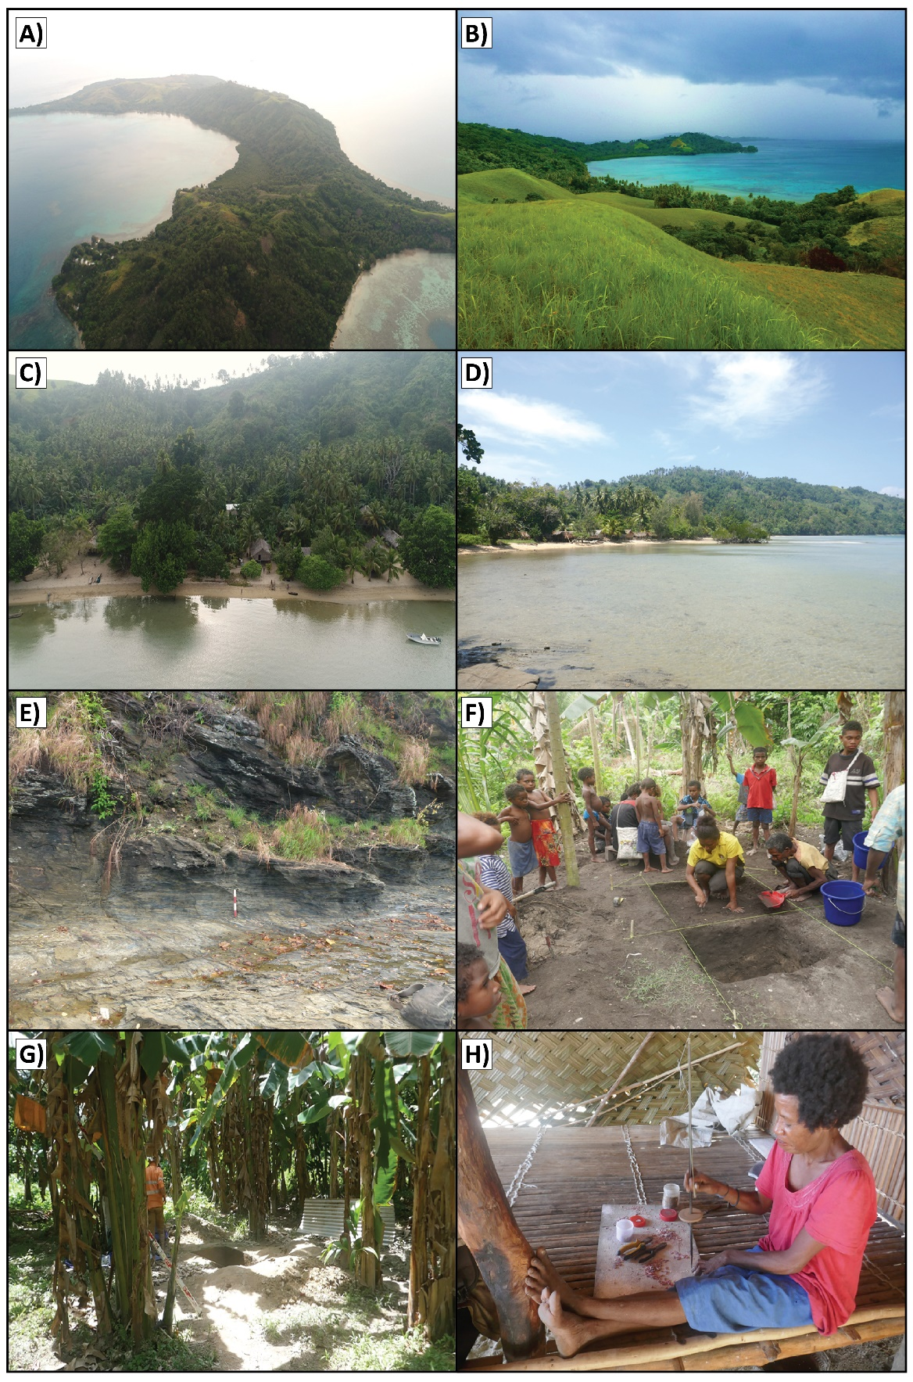
Figure S1: Nimowa Island and the Malakai site. A) Drone image of Nimowa Island, looking NE at 465m above sea level. B) Malakai bay from interior of island, looking SW at 90m above sea level. C) Drone image of Malakai beachflat where excavations were undertaken. D) Looking south across Malakai Bay showing the limited modern extent of mangrove swamp. E) Foliated schist found across Nimowa Island. F) Excavation of Unit C underway next to SP10. G) Location of Unit B, during excavation. H) Modern production of Spondylus sp. shell beads at Malakai village.

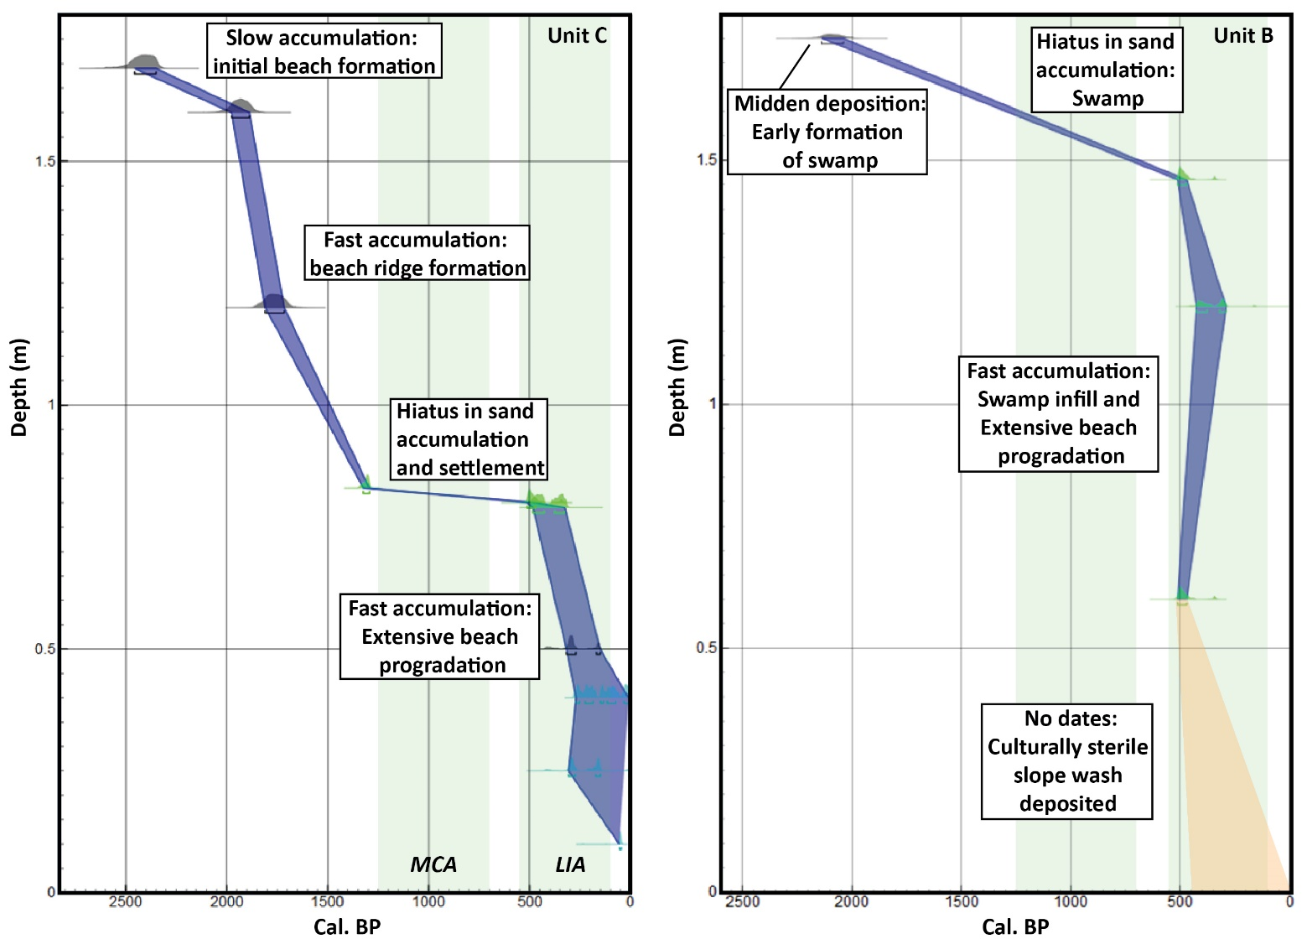
Figure S2: Calibrated radiocarbon dates by depth in Units C and B showing differential rates of sediment accumulation over time. Marine13 curve applied to shell samples, IntCal13 applied to charcoal samples and an 80-20% terrestrial-marine mixed curve used for human bone sample. ΔR correction of 38 ± 14 was applied to shell dates. Blue fill = 68.2% ranges. Orange fill = inferred range. MCA = Medieval Climate Anomaly. LIA = Little Ice Age.

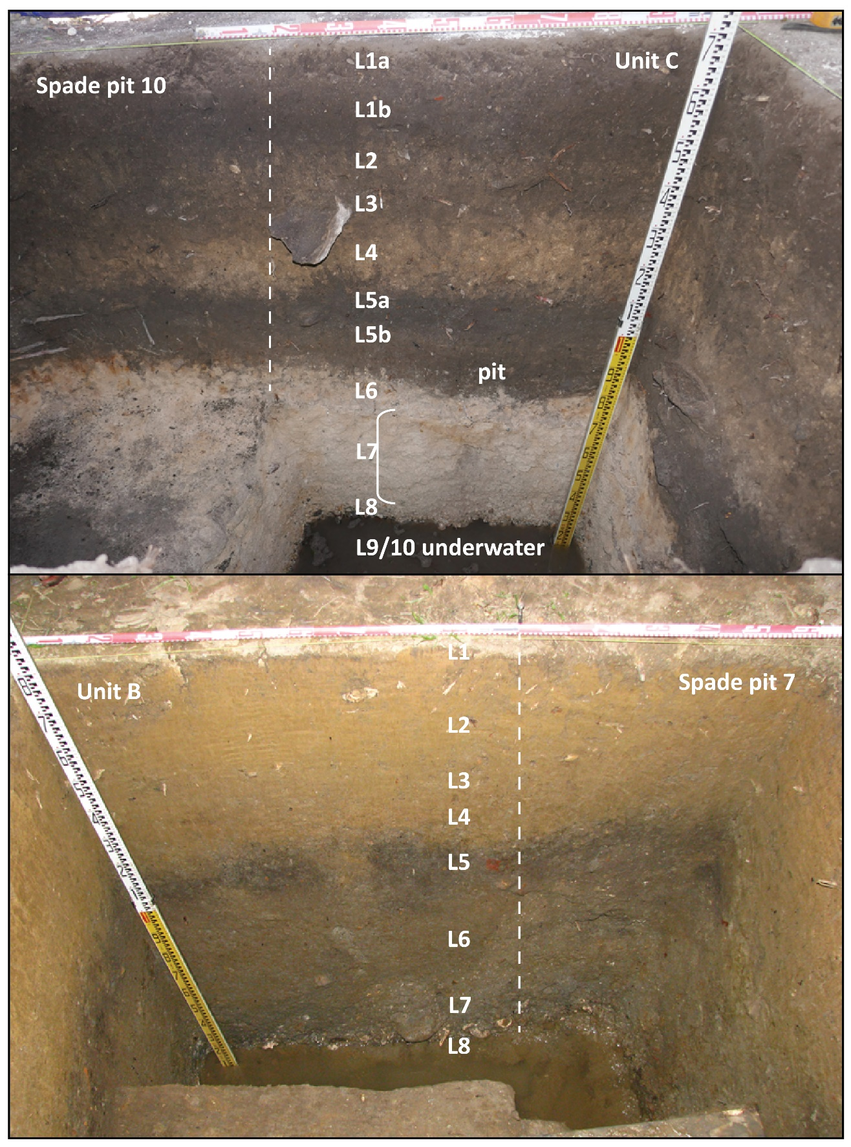
Figure S3: Annotated photos of the Unit C (Top) and Unit B (Bottom) sections with the layers marked. West section of Unit C and south section of Unit B shown.
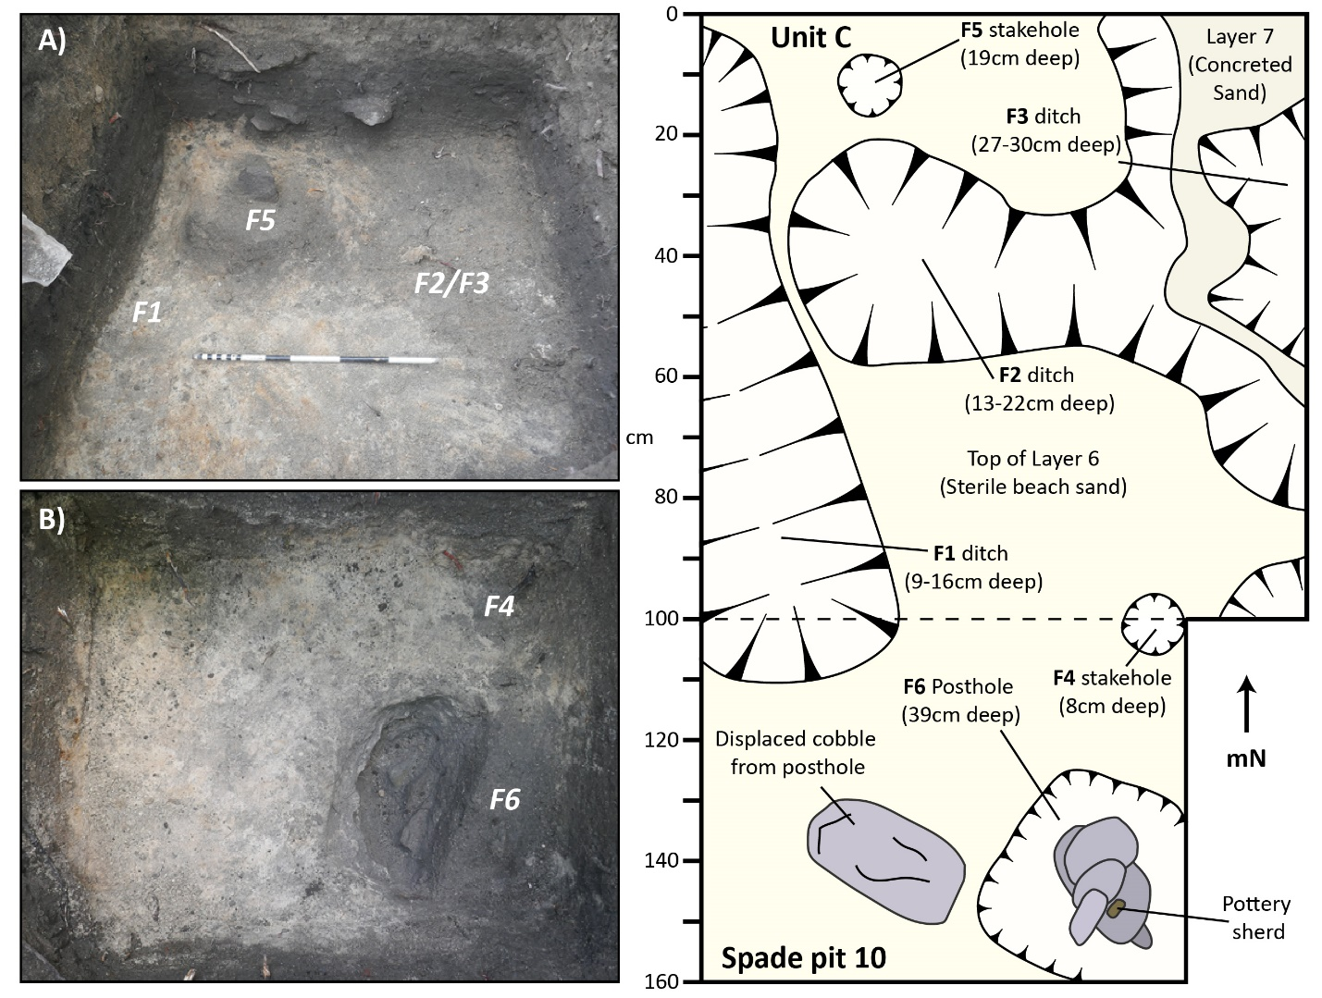
Figure S4: Structural postholes and associated ditches cutting into Layers 6-7 from Layer 5b, dating to the re-settlement of Nimowa Island 500 years ago. A) Plan view of Unit C showing features dug into Layer 6 sand. B) Plan view of SP10, immediately adjacent to Unit C, with half sectioned posthole. Right) Plan drawing of the excavated features showing their extent and spatial relationship. Feature depth was taken from the top of Layer 6 and indicates the depth of intrusion into underlying layers. Stones are indicated by grey shade.
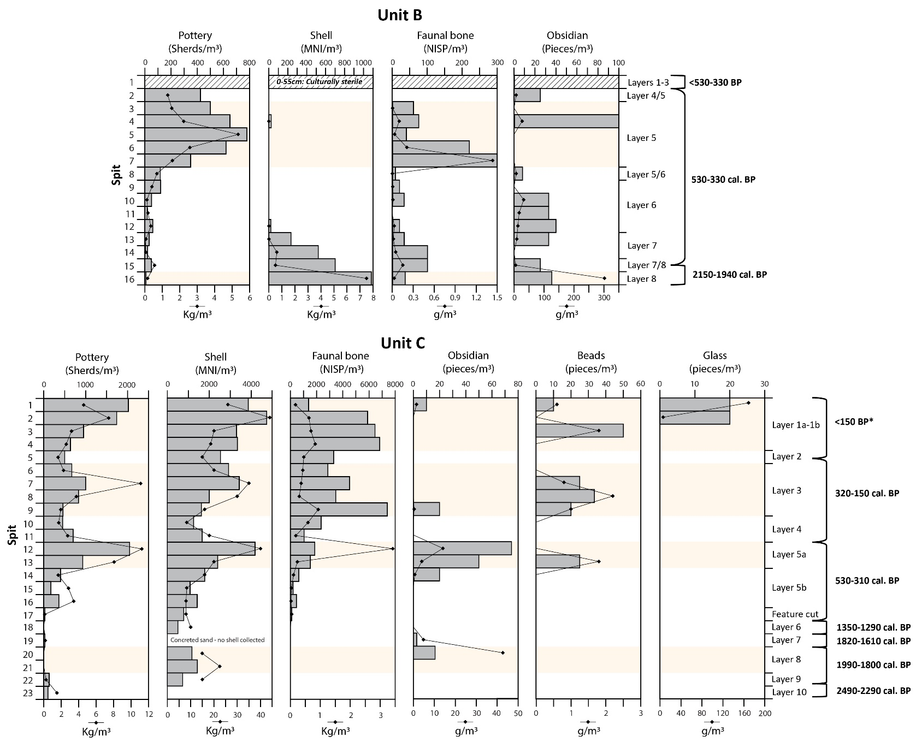
Figure S5: Number and weight of major cultural material classes recovered from Units B and C, by m³.
Age ranges are based on radiocarbon dates and presented as rounded figures. Shaded areas relate to peaks in material culture density.

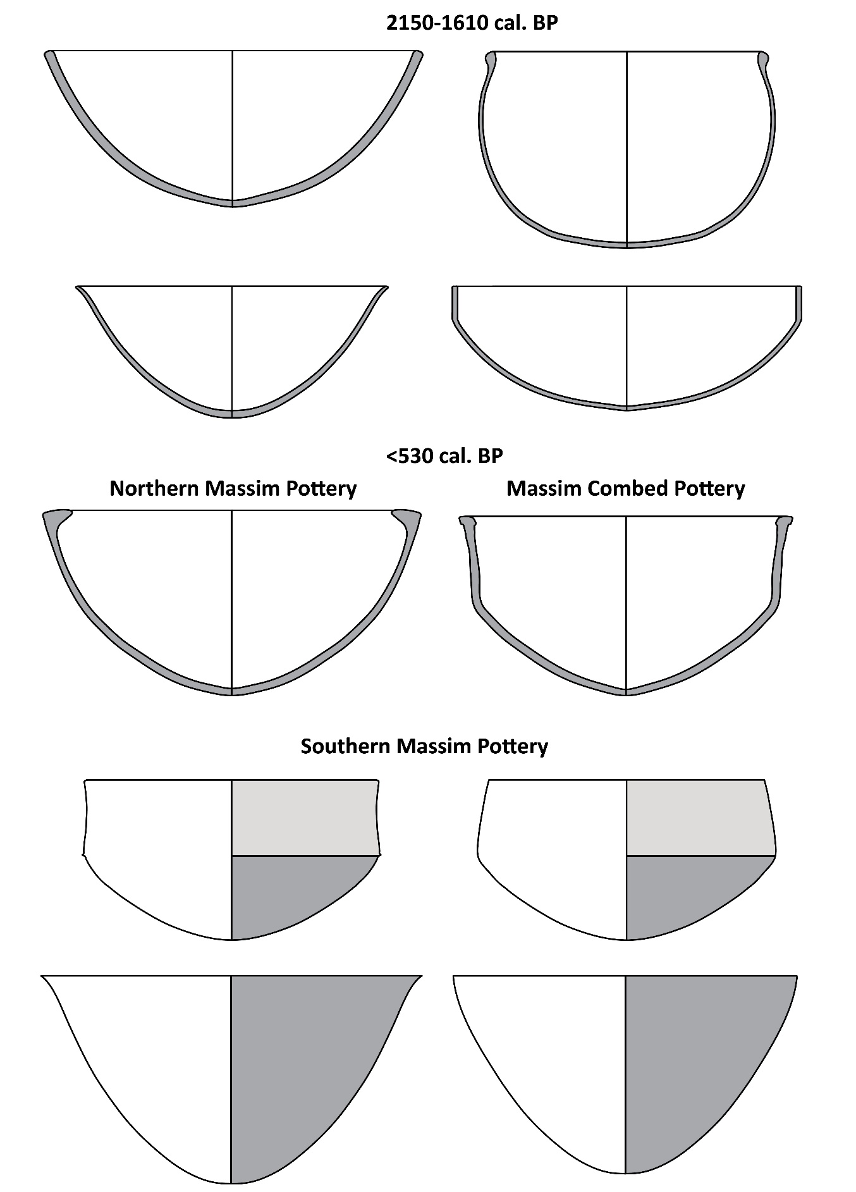
Figure S6: Vessel shapes of the excavated Malakai pottery.

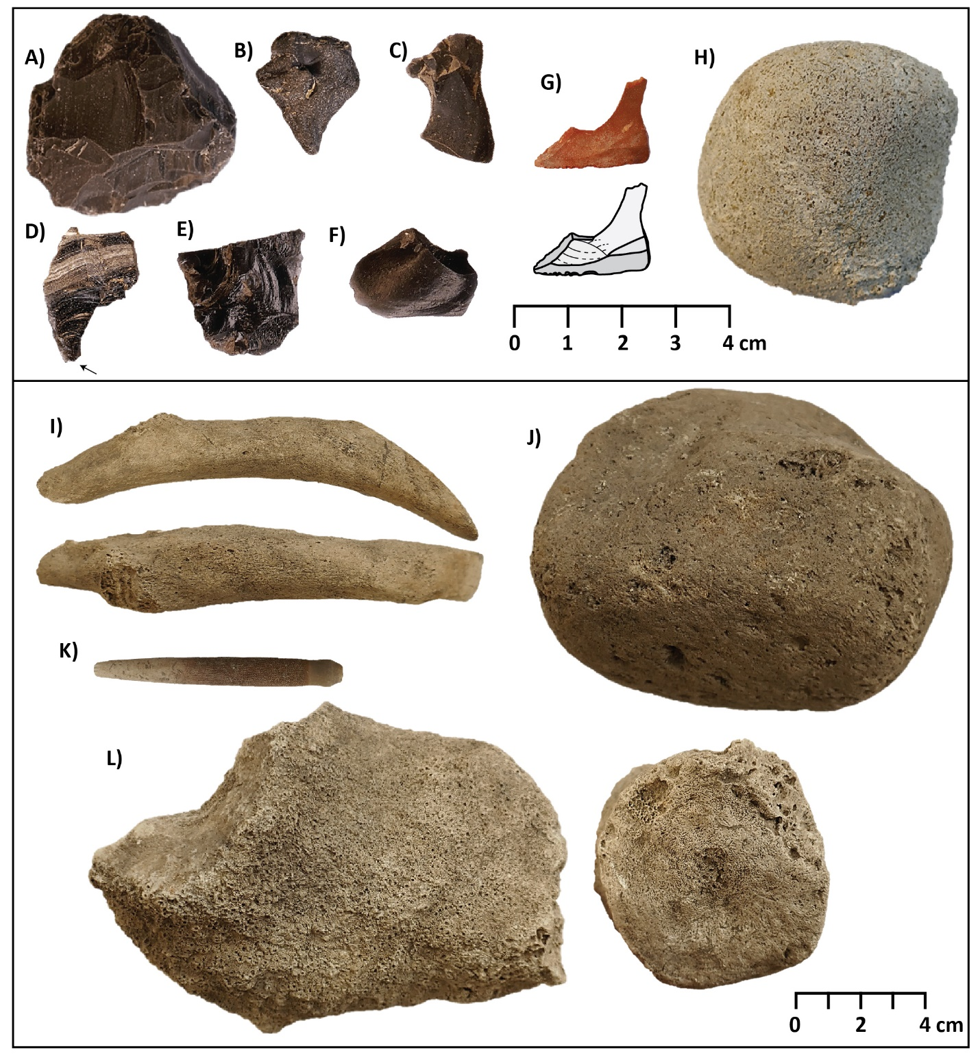
Figure S7: Excavated obsidian, lithic, bone, pumice and coral artefacts from the Malakai site. A) Multi-platform obsidian core, Unit B, Layer 8. B) Heavily water rolled obsidian, Unit C, Layers 7. C-D) Obsidian pieces, Unit B, Layers 5-7. Arrow indicates utilised point. E) Retouched obsidian, Unit C, Layer 5. F) Obsidian, Unit C, Layers 5. East Fergusson = D. G) fine-grained siltstone flaked point with use-wear, possible awl, Unit B, Layer 5. H) Water-rounded and partially ground consolidated ash pebble, Unit C, Layer 7. I) Dugong (Dugong dugon) bone adze/pounder, Unit C, top of Layer 5a. J) Pumice abrader, Unit C, Layer 3. K) Worked sea urchin (echinoid) spine, possible awl or pounder, Unit C, Layer 5a. L) Large coral pounder, Unit C, Layer 3.

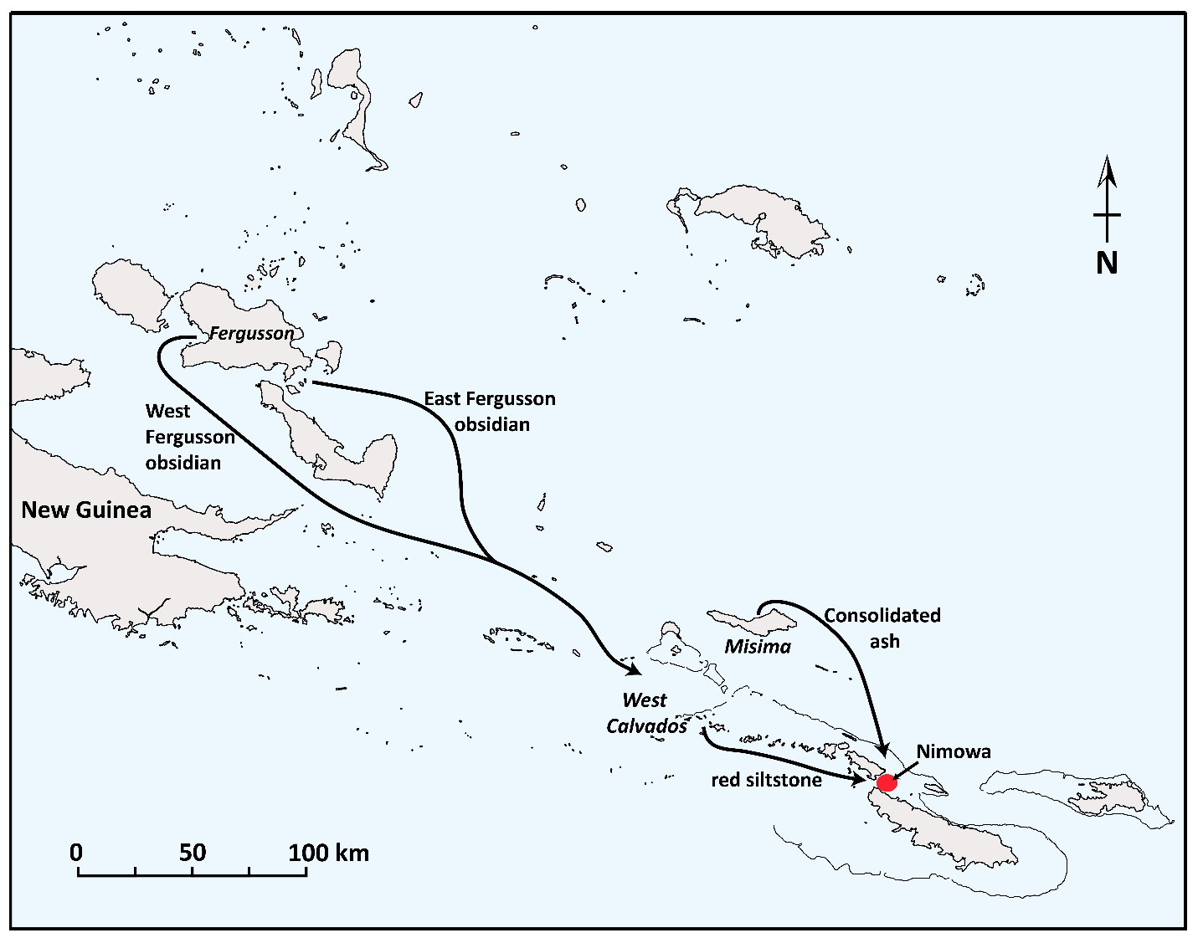
Figure S8: Inter-island interactions with Nimowa Island. Obsidian likely reached Nimowa through down the line exchange.

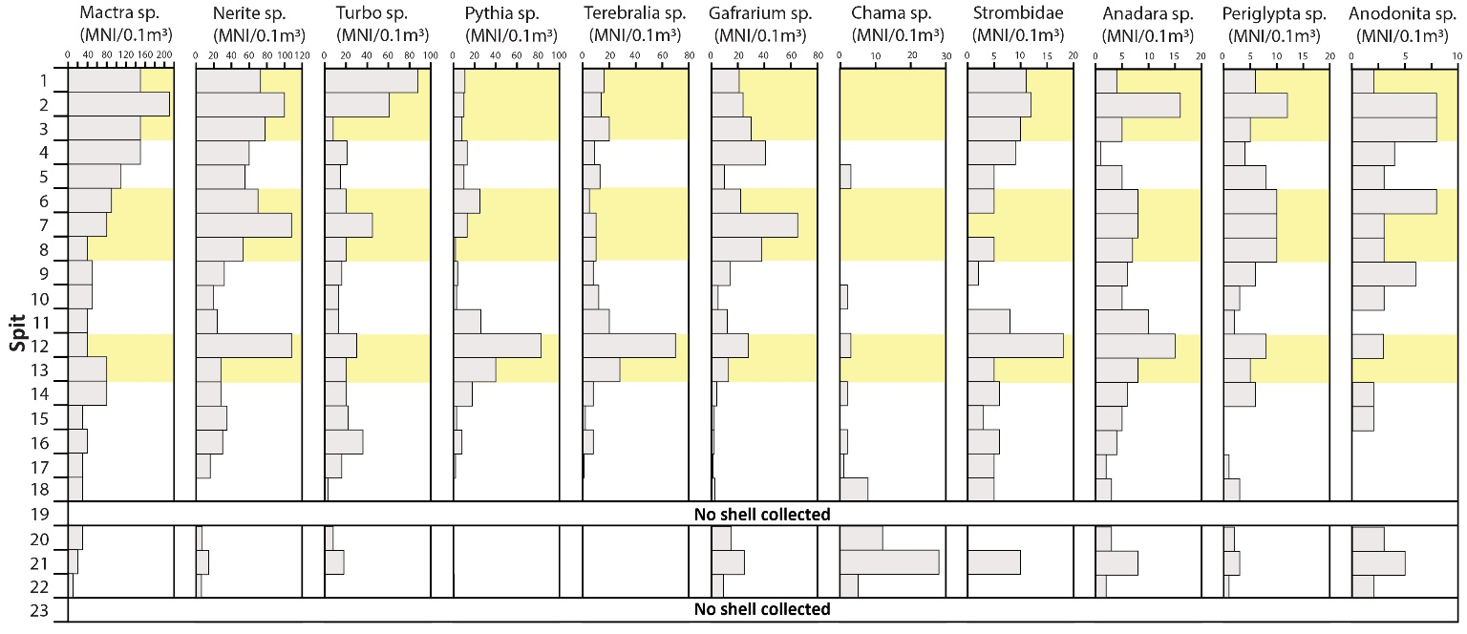
Figure S9: Frequency of shellfish species (MNI/0.1m³) recovered from Unit C at the Malakai site. Shaded areas refer to defined habitation layers
Materials and Methods
Excavation procedure
Systematic excavation was undertaken by trowel in 1m² units within apparent stratigraphic layers. Excavation proceeded in 5cm spits except where it was necessary to increase spit depth due to contact with the water table or when notable changes in sediment characteristics occurred. All sediment was wet sieved through 5mm (Unit B) and 3mm (Unit C) mesh. Inclusive of test pitting, a total of 8.3m² was excavated. Upon reaching the water table, units were reduced in size to 0.5m² and a sump dug to control the water level. Excavation proceeded until it was no longer possible to record systematically. A datum was established prior to excavation and all measurements were taken using a dumpy level, stadia rod and hand tape. In situ finds, including charcoal fragments, were bagged individually with context numbers and their location recorded in three dimensions. Postholes and pits were excavated and labelled individually as features. Feature depth was determined by measuring the horizontal and vertical position in the square where it was first identified and at its deepest point. The sieve residues were bagged, weighed and sorted. Sediment samples were collected during excavation, and all squares backfilled when excavation was completed. The site elevation profile was surveyed with a dumpy level.
Radiocarbon dating
Radiocarbon determinations were obtaining using Accelerator Mass Spectrometry (AMS) at BETA laboratory (Miami, Florida, US). All charcoal and marine shell samples were physically cleaned of sediment adhering to the surface, gently crushed then dispersed in deionized water. The samples were pretreated using the acid-base-acid method, by washing the samples with hot HCl acid to eliminate carbonates, then a wash with NaOH to remove secondary organic acids, followed by a final HCl rinse to neutralize the solution before drying. Pretreated samples were combusted to CO² gas by oxidation then reduced to graphite for analysis. All 14C determinations were calibrated using the IntCal13 calibration curve and OxCal 4.3 program.
pH and Munsell soil analyses
pH was determined on a sediment sample fraction using a Searles soil pH test kit. Several drops of indicator liquid were added to the sediment to make a paste, and the indicator powder added. The color of the powder was recorded after waiting 30 seconds. Sediment color was determined by matching dry samples with a Munsell (2000) soil chart.
Particle size analysis
Approximately 1-3g of sediment was sieved through 2000µm mesh, and pretreated with 30% NaOH heated to 80-90°C to dissolve the organic component. Reverse osmosis (RO) water and several drops of 5.5g/L sodium hexametaphosphate [(NaPO₃)₆] were added to the sample as a particle deflocculant 24hrs prior to analysis. A Malvern mastersizer 2000 laser-diffraction particle size analyzer with a Hydro2000G dispersal unit was used for the analysis. Three consecutive runs (15s; 15,000 measurements) were made for each sample, with the average reported. Obscuration was kept within the accepted range of 10-20%. Particle size parameters were calculated using GRADISTAT software using the following grain size dimensions: Clay <2µm, silt: 2-63 µm, sand: 63-2000 µm.
Loss on Ignition Analysis
Sediment samples of approximately 1cm³ were placed in a labelled and weighed crucible and weighed again. The samples were oven dried at 105°C for 24hrs and reweighed to give the dry mass. The samples were then fired in a muffle furnace at 550°C for four hours, with the remaining ash weight representing the minerogenic fraction. The percentage of mass lost between oven dry weight and ash weight represents the organic component (%) of the sediment All samples were placed in a desiccating jar to cool before being weighed on a 0.001g balance.
Obsidian and stone artefact analysis
All lithic material was assessed to identify raw material and reduction characteristics at UNSW. The following technological categories were used: tool, core, complete flake, flake fragment (medial, distal, longitudinal), and angular fragment. Retouch and usewear was also recorded, defined by deliberate flaking on the margins to create a usable edge, and chipping along an edge respectively. A tool was any artefact that has been modified through shaping for use, and often includes use wear and/or retouch. A flake is a stone artefact with a defined ventral and dorsal surface, as well as at least one of the following: a platform, bulb of percussion, ripple marks, distal termination. A flake fragment has some of the identified flake characteristics. A core is a parent piece of raw lithic material with negative flake scarring. An angular fragment is any piece of stone that has been produced during the flaking process but does not contain the attributes of a flake.
pXRF analysis of obsidian
  - The Malakai obsidian (N=28) and 53 obsidian geological samples from all main sources in Papua New Guinea were analyzed using an Olympus Delta Premium Portable XRF Spectrometer at the University of New South Wales Mark Wainwright Analytical Centre. Obsidian samples were analyzed three times each using the in-built Geo-chem mode with elemental composition recorded in parts per million (ppm). Final values were an average of the three runs. Two X-Ray beams, operating at 40keV and 10keV, were emitted from a Rhodium tube anode. Each beam was run for 90 seconds, with a total analysis time of 180 seconds per sample. The spectrometer was calibrated against the factory standard Alloy 316 Stainless Steel at the beginning of each testing period to ensure the X-Ray beams and detectors were functioning correctly.

Obsidian specific spectrometer calibration was developed using 29 pelletized geological standards with elemental concentrations and ranges spanning the known range of obsidian sources (JA-3, VS-N, DT-N104, W-2, SDC-1 2010, RGM-1, MRG-1, DNC-1, BIR-1, SCO-1, MA-N, BE-N, AN-G, SY-3, SY-2, JB-10a, JB-1, MAG-1, JR-2, GXR-6, GXR5 (2), GXR-2, JLK-1, JG-1, JB-2, JB-3, JG-2, NBS69b (2), NIM-G). Element specific calibration factors were determined using linear regression offsets between pXRF data and published values. Two obsidian geological standards (NIST278 and RGM-2) were analyzed at the beginning and end of each run, and between every four samples. Principal component analysis (PCA) was undertaken using SPSS Statistics Package Version 23.0 with Mn, Fe, Zn, Rb, Sr, Y, Zr, Nb elemental concentrations. Values were transformed using a base-10 logarithm prior to statistical analysis.

Faunal analysis
Faunal remains were identified by comparison with the ANU Archaeology and Natural History Osteology Laboratory reference collection. Skeletal elements were identified to the lowest taxonomic level possible. The assemblage was quantified using Number of Identified Specimens (NISP) as NISP typically tracks Minimum Number of Individuals (MNI) closely with respect to measuring relative abundance and avoids issues of aggregation, interdependence, and sample size (Lyman, 2008). The taphonomy of the vertebrate assemblage was assessed by observing bone surface modifications under light magnification (X10). Bone modifications examined included signs of butchery via cut marks and fracture patterns, as well as burning.

Shellfish analysis
Gastropod and bivalve shell was separated into taxa, quantified into Minimum Number of Individuals (MNI) and photographed on Nimowa Island, with total shell from each spit weighed using a Pesola spring scale. Shellfish genera was subsequently confirmed in the lab with the aid of Hinton (1975) and Cernohorsky (1972). Only diagnostic features of a shell were used to calculate MNI following criteria used in archaeological studies by Bird et al. (2002). For gastropods, MNI was determined by the presence of >50% of a columella, >50% of a top whorl, >50% of the whole shell and/or >50% of a canal termination. Opercula were used to calculate Turbo spp. MNI. Bivalve MNI was estimated by the presence of >50% of the umbo. All left and right valves of a similar size for each bivalve taxa were counted as single individuals. Four major environmental zones were used to characterise the known preferred shellfish habitats – sand inter-tidal, rock inter-tidal, reef inter-tidal and mangrove, following Wells & Kinch (2003), and Bedford (2006).

References
Bedford S. (2006) Pieces of the Vanuatu puzzle: Archaeology of the north, south and centre, Canberra: Pandanus Books.
Bird DW, Richardson JL, Veth PM, et al. (2002) Explaining shellfish variability in middens on the Meriam Islands, Torres Strait, Australia. Journal of Archaeological Science 29: 457-469.
Cernohorsky WO. (1972) Marine shells of the Pacific, Sydney: Pacific Publications.
Hinton A. (1975) Guide to shells of Papua New Guinea, Port Moresby: Robert Brown & Associates Pty. Ltd.
Lyman RL. (2008) Quantitative paleozoology, Cambridge: Cambridge University Press.
Munsell C. (2000) Munsell soil color charts, New Windsor: Gretagmacbeth.
Wells F and Kinch JP. (2003) Molluscs of Milne Bay Province, Papua New Guinea. In: Allen GR, Kinch JP, McKenna SA, et al. (eds) A rapid marine diversity assessment of Milne Bay Province, Papua New Guinea - Survey II (2000). Washington, DC: Conservation International, 39-45.

