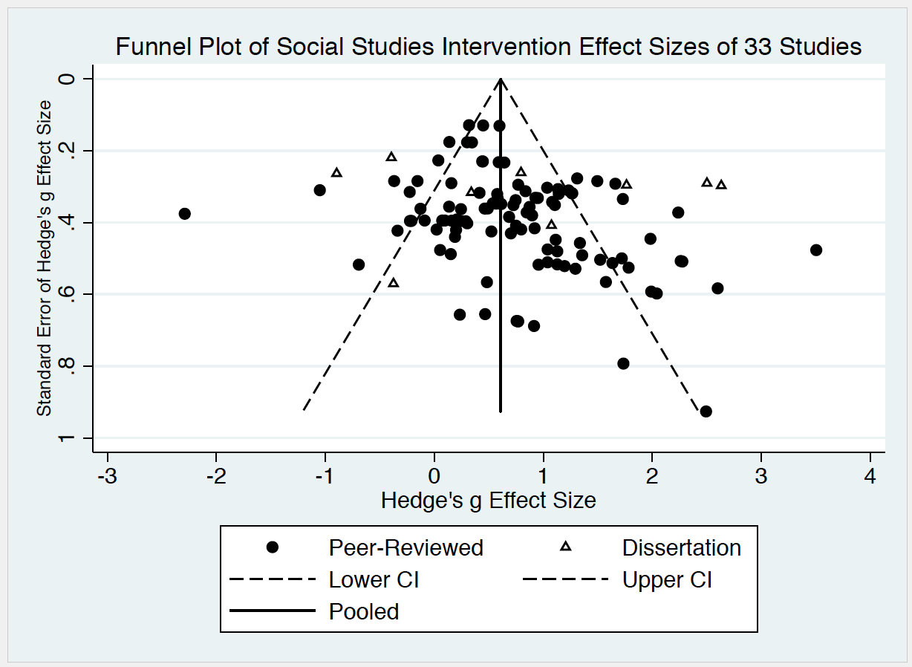

Figure 1 (Supplementary File).. Funnel plot used to explore the possibility of publication bias.

