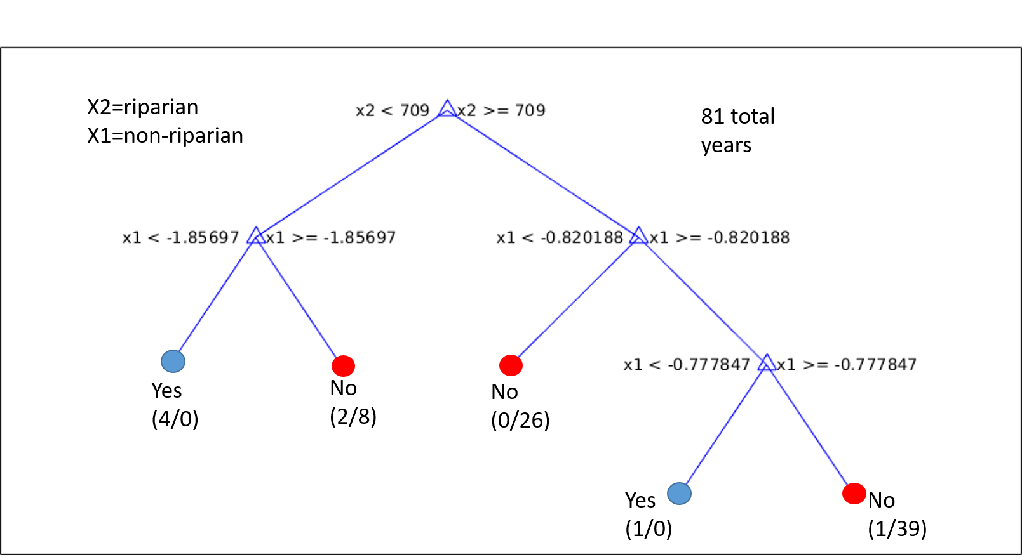
Figure S1. Example of over-fit tree for classifying high-flow years on Ob River, 1934-2014 from riparian and non-riparian tree-ring widths. Input data, calibration period, and modeling settings exactly as in analysis in main paper (Figure 9), except that model is allowed to run to four splits instead of being restricted to stop at two splits. Two additional terminal nodes result. The fourth from left terminal classifies one year (happens to be 1986) as high flood.
To fall into this high-flood node, the combination of non-riparian (x1) and riparian (x2) tree-ring series must be x2>0.709 and -0.820188 <x1<-0.777847. The scatterplots in Figure 6 of the main paper show that means 1) riparian index cannot be exceptionally low, and 2) non-riparian growth must be below normal (zero, as this is a PC score) and within a fairly narrow band of the full range of the non-riparian time series. Such a restrictive model may be highly dependent on the calibration data set, and failed to show skill of cross-validation in our analysis.

