Appendix A

A.1. Preferred SuitX™ support modes and levels

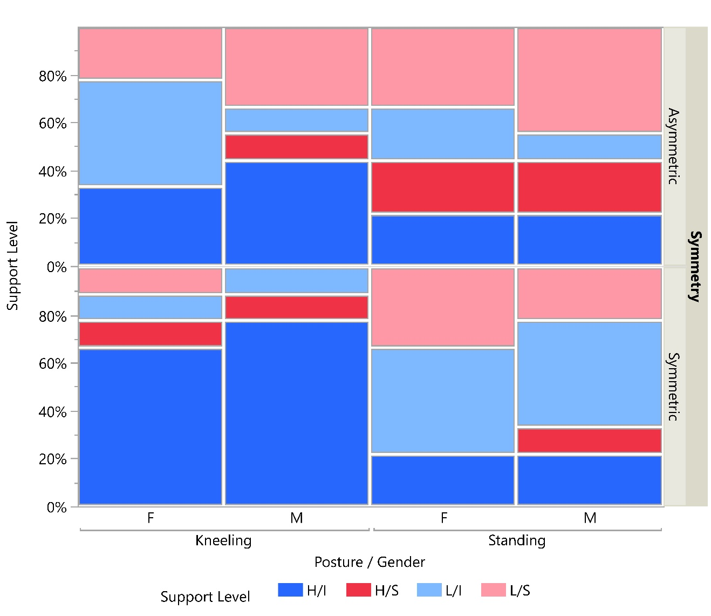

A.2. Preferred Laevo™ support modes and levels

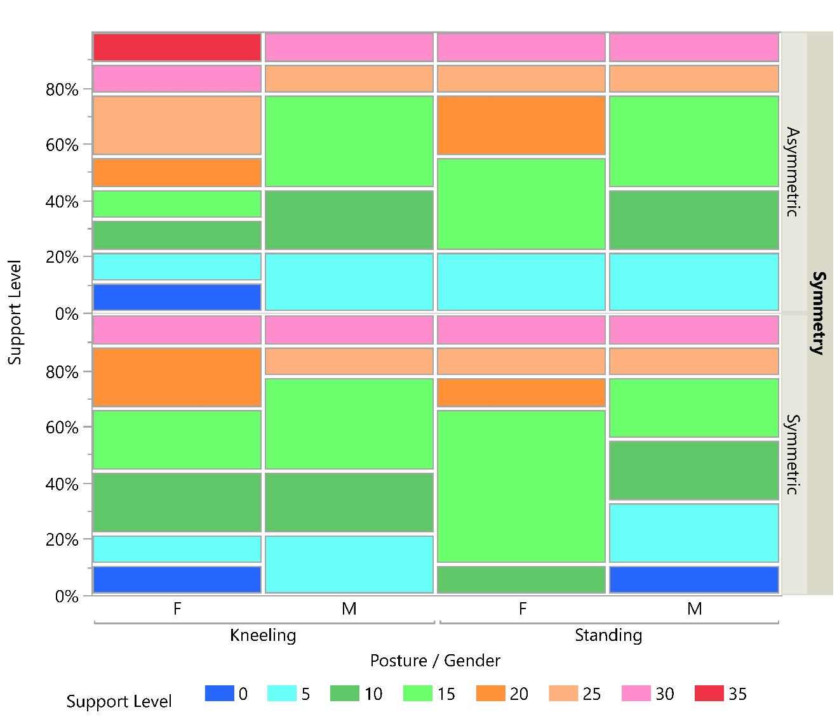

Appendix B

Mean percentage change in peak muscle activity of each muscle group for all combinations of Posture, Symmetry, and Gender for two BSEs (i.e., Laevo™ and SuitX™)

Posture | Symmetry | Intervention | Gender | TEM | AM | NM | SM | LM
Standing | Symmetric | Laevo™ | Female | -23.8 | -8.5 | -13.9 | -14.7 | -9.0
 |  |  | Male | -8.0 | 12.7 | -1.4 | -2.0 | -11.3
 |  | SuitX™ | Female | -22.0 | -9.3 | -9.8 | -12.9 | -4.6
 |  |  | Male | -15.4 | -15.5 | -8.5 | -7.4 | 0.7
 | Asymmetric | Laevo™ | Female | -12.9 | 3.9 | -5.4 | -10.5 | -4.0
 |  |  | Male | -5.6 | 11.2 | -4.8 | -3.1 | -6.3
 |  | SuitX™ | Female | -12.3 | -15.7 | -14.4 | -16.2 | -6.7
 |  |  | Male | -8.9 | -17.6 | -1.2 | -4.8 | 4.9
Kneeling | Symmetric | Laevo™ | Female | -26.8 | -3.4 | -0.8 | 0.0 | -15.5
 |  |  | Male | -11.1 | -6.7 | 4.7 | 4.0 | -1.9
 |  | SuitX™ | Female | -30.6 | -6.7 | -0.8 | -2.4 | -13.4
 |  |  | Male | -24.5 | -8.3 | 4.7 | 2.9 | 38.9
 | Asymmetric | Laevo™ | Female | -27.2 | 1.2 | 6.6 | -6.0 | -16.9
 |  |  | Male | -12.4 | 2.9 | 4.1 | 3.5 | -7.0
 |  | SuitX™ | Female | -18.4 | 1.8 | 7.8 | 1.0 | -25.7
 |  |  | Male | -12.4 | 1.9 | 8.3 | 2.5 | 14.0

Appendix C

Descriptive statistics for the percentage changes in energy expenditure for all combinations of Posture and Symmetry for two BSEs (i.e., Laevo™ and SuitX™)

Intervention | Posture | Symmetry | Minimum (%) | 25th Percentile (%) | Mean  (%) | 75th Percentile (%) | Maximum (%)
Laevo™ | Kneeling | Asymmetric | 33.0 | 2.7 | -5.3 | -12.7 | -26.8
 |  | Symmetric | 5.9 | -3.3 | -10.8 | -18.7 | -24.3
 | Standing | Asymmetric | 21.3 | -0.7 | -5.5 | -9.7 | -35.8
 |  | Symmetric | 1.8 | -0.5 | -8.9 | -14.9 | -24.0
SuitX™ | Kneeling | Asymmetric | 20.4 | -1.3 | -6.2 | -12.6 | -25.2
 |  | Symmetric | 14.3 | -5.2 | -9.1 | -15.5 | -19.4
 | Standing | Asymmetric | 25.1 | 0.8 | -3.7 | -8.2 | -25.3
 |  | Symmetric | 13.5 | 1.9 | -12.6 | -23.8 | -26.3

Appendix D
Distribution of responses to usability questions regarding fit, comfort, and body movement restrictions. Note that [0,1) = strongly disagree, [3,4) = moderately agree, and [6,7] = strongly agree.

