Supporting Information
Survivability of Wild-Type and Genetically Engineered Thermosynechococcus elongatus BP1 with Different Temperature Conditions

The figures (Figure S1-S35) presented here (pages S2-S36) are additional data on the growth study experiments as well as the survivability assays. The figures include the different transgene DNA constructs used for the genetic transformation of the cyanobacteria, photographs of the culture flasks and multi-well plates used for the survivability study with graphs of their absorbance measurements and colony counting.

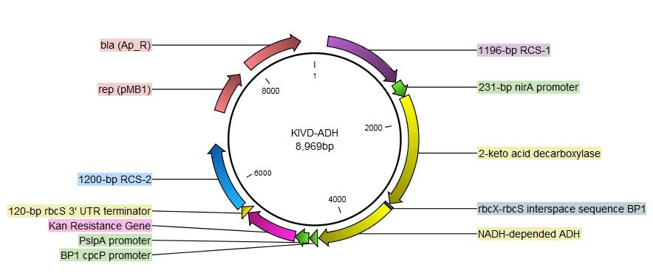
Figure S1: Gene map of the KDC-ADH (pKA) construct visualized with CLC bio software. The DNA construct includes an upstream (1196 bp) and downstream (1200 bp) recombination sites, Synechocystis PCC 6803 nirA inducible promoter, T. elongatus BP1 nirA inducible promoter (231 bp), keto-acid decarboxylase gene (1644 bp), NADH dependent alcohol dehydrogenase (1115 bp), T. elongatus BP1 cpcP continuous promoter (116 bp), Thermus thermophilus PslpA continuous promoter (199 bp), and kanamycin resistance gene (762 bp). The designer construct is within the pUC-57 vector containing the ampicillin resistance gene (861 bp). This figure is adapted from Nguyen TH, Barnes CL, Agola JP, Sherazi S, Greene LH, Lee JW. Demonstration of horizontal gene transfer from genetically engineered Thermosynechococcus elongatus BP1 to wild-type E. coli DH5alpha. Gene. 2019;704:49-58.

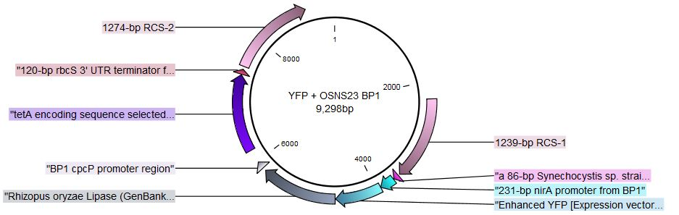
Figure S2: Gene map of the YFP-ST-R-Lipase construct visualized with CLC bio software. The DNA construct includes an upstream (1239 bp) and downstream (1274 bp) recombination sites, Synechocystis PCC 6803 nirA inducible promoter (89 bp), T. elongatus BP1 nirA inducible promoter (231 bp), yellow fluorescent protein molecular tag (717 bp), Rhizopus oryzae lipase gene (1176 bp), T. elongatus BP1 cpcP continuous promoter (116 bp), Thermus thermophilus PslpA continuous promoter (199 bp) and tetracycline resistance gene (1200 bp). The designer construct is within the pUC-SP vector containing the ampicillin resistance gene (861 bp).

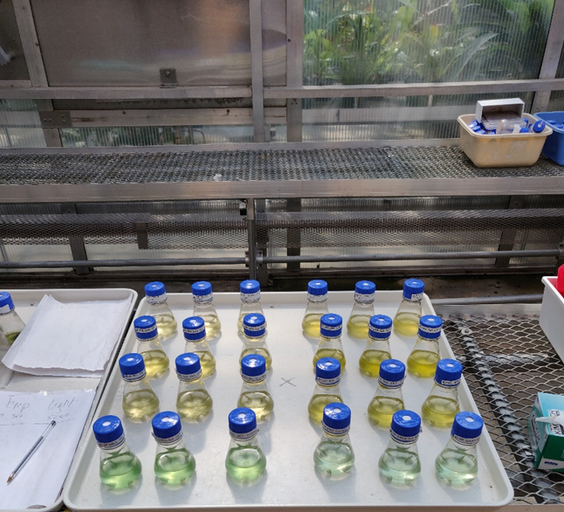
Figure S3: Photograph of the flasks set up in the Arthur & Phyllis Kaplan Orchid Conservatory greenhouse of Old Dominion University in Norfolk VA, USA.

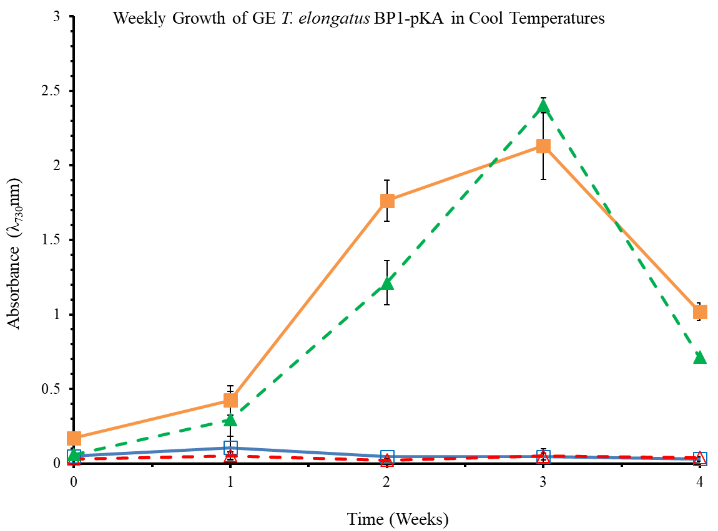
Figure S4: Optical Density of wild-type and GE T. elongatus BP1 (BP1-pKA) cultures at 5 x 10⁶ cells/mL during cool temperatures (15.44 °C to 25.30 °C) were monitored weekly during a 4-week period in the greenhouse. Control cultures were grown in Percival environmental chamber (~42.2ºC) in Percival incubator. The results shown here are liquid culture absorbance measurements at 730 nm in duplicates for each replicate (n=6). The error bars denote the standard deviation (n=6). The graph is displayed as follows: ( ) is wild-type T. elongatus BP1in Percival, ( ) is wild-type T. elongatus BP1 in Greenhouse, ( ) is the GE T. elongatus BP1-pKA in Percival, and ( ) is the GE T. elongatus BP1-pKA in Greenhouse. Wild-type T. elongatus BP1 = solid lines, BP1-pKA = dashed lines, closed symbols = control set and open symbols = greenhouse set.

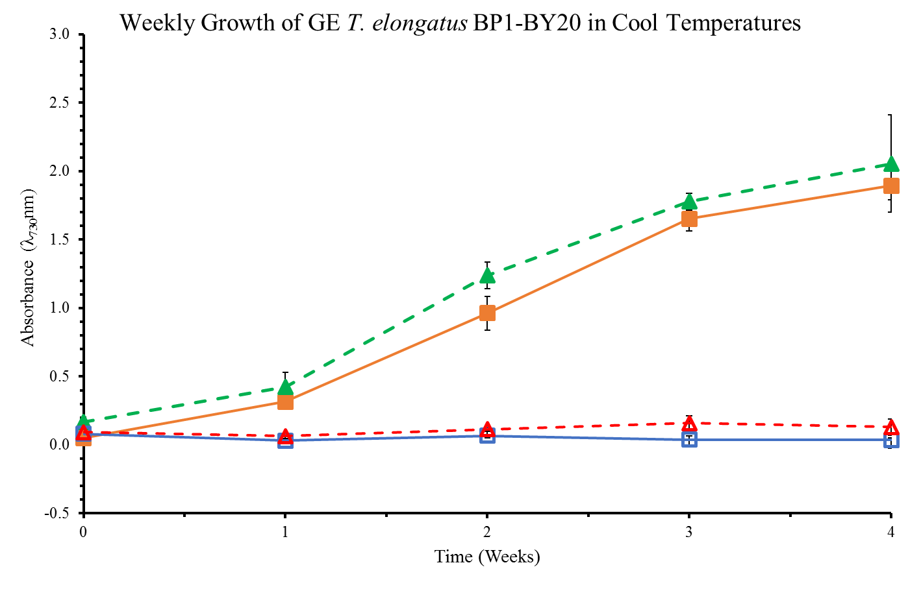Figure S5: Optical Density of wild-type and GE T. elongatus BP1 (BP1-BY20) cultures at 5 x 10⁶ cells/mL during cool temperatures (15.44 ºC to 25.30 ºC) were monitored weekly during a 4-week period in the greenhouse. Control cultures were grown in the Percival environmental chamber (~42.2ºC). The results shown here are liquid culture absorbance measurements at 730 nm in duplicates for each replicate (n=6). The graph is displayed as follows: ( ) is wild-type T. elongatus BP1 in Percival, ( ) is wild-type T. elongatus BP1 in greenhouse, ( ) is the GE T. elongatus BP1-BY20 in Percival, and ( ) is the GE T. elongatus BP1-BY20 in greenhouse. Wild-type T. elongatus BP1 = solid lines, BP1-BY20 = dashed lines, closed symbols = control set and open symbols = greenhouse set.

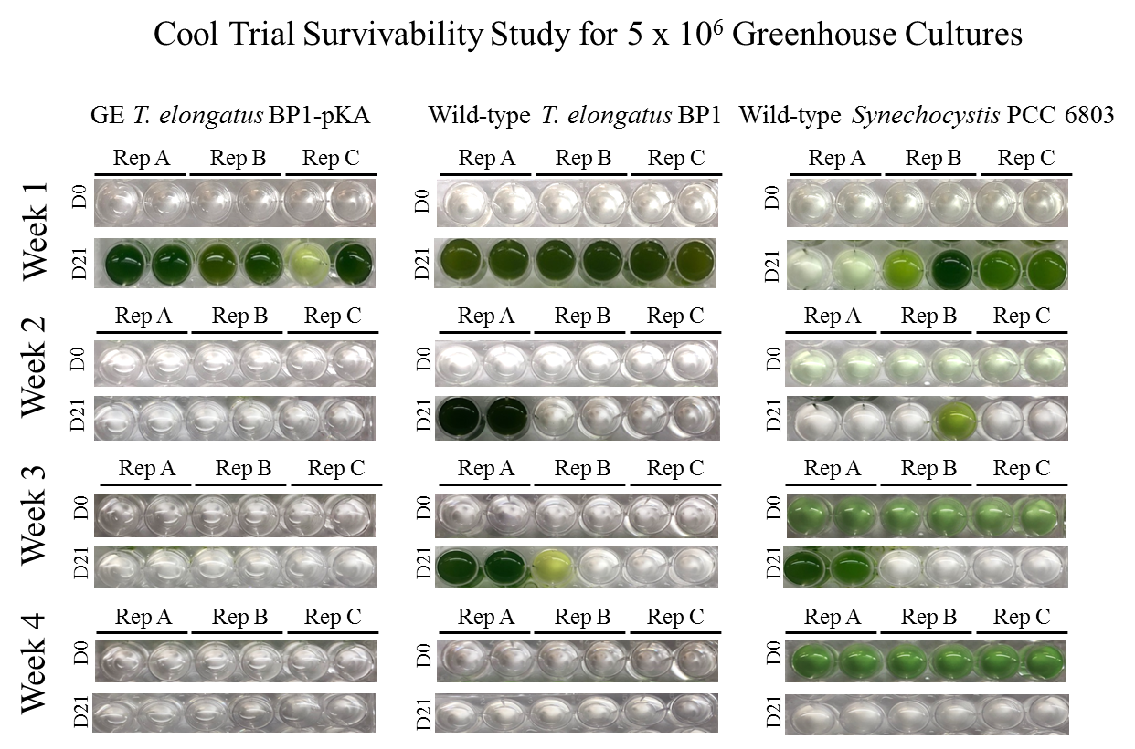
Figure S6: Survivability assay for wild-type T. elongatus BP1, wild-type Synechocystis PCC 6803 and GE T. elongatus BP1-pKA cultures at 5 x 10⁶ cells/mL during cool temperatures (15.44 °C to 25.30 °C) in the greenhouse. A sample of each replicate was inoculated in fresh BG-11 media after 1, 2, 3 and 4 weeks in greenhouse in duplicates and placed in the Percival environmental chamber (~42.2 ºC) for 21 days. The pictures of the multi-well plates were taken on day 0 and after 21 days in the Percival environmental chamber (~42.2 ºC).

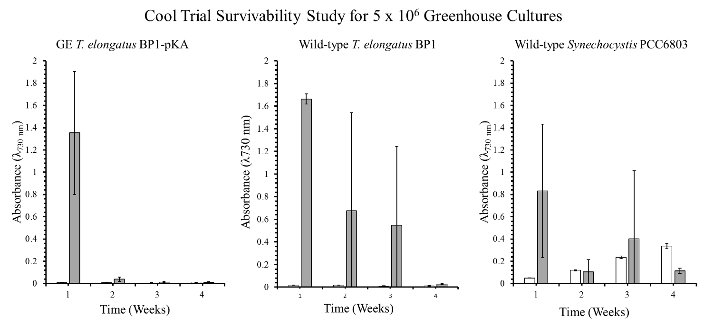
Figure S7: Optical density (λ=730 nm) of survivability assay for wild-type T. elongatus BP1, wild-type Synechocystis PCC6803 and GE T. elongatus BP1-pKA cultures at 5 x 10⁶ cells/mL during cold temperatures (15.44 °C to 25.30 °C) in greenhouse conditions. A sample of culture after 1, 2, 3 and 4 weeks in greenhouse was inoculated in fresh BG-11 media and placed in the Percival environmental chamber (~42.2 ºC) for 21 days. The growth was monitored by measuring the optical density (λ=730 nm) weekly. The results are shown as the mean value of duplicate measurements of each replicate culture (n=6). The error bars denote the standard deviation (n=6). The graph is displayed as follows: white bar ( ) = OD₇₃₀ before placed in Percival chamber and grey bar ( ) = OD₇₃₀ after 21 days in Percival chamber.

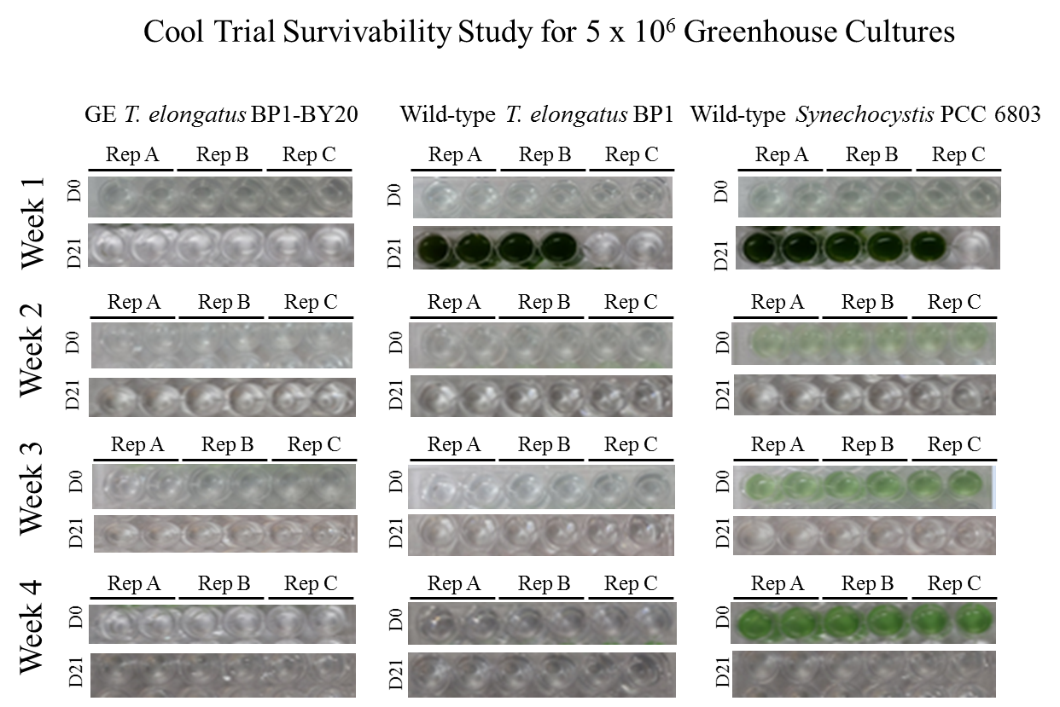
Figure S8: Survivability assay for wild-type T. elongatus BP1, wild-type Synechocystis PCC 6803 and GE T. elongatus BP1-BY20 cultures at 5 x 10⁶ cells/mL during cool temperatures (15.44 ºC to 25.30 ºC) in the greenhouse. A sample of each replicate was inoculated in fresh BG-11 media after 1, 2, 3 and 4 weeks in greenhouse in duplicates and placed in the Percival environmental chamber (~42.2 ºC) for 21 days. The pictures of the multi-well plates were taken on day 0 and after 21 days in the Percival environmental chamber (~42.2 ºC).

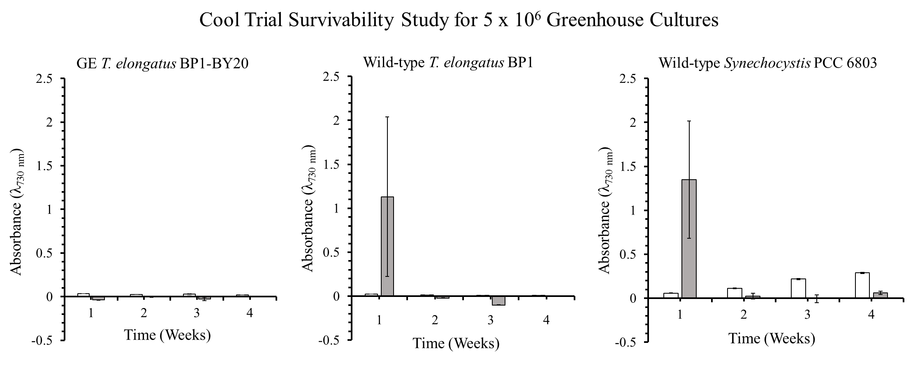
Figure S9: Optical density (λ=730 nm) of survivability assay for wild-type T. elongatus BP1, wild-type Synechocystis PCC6803 and GE T. elongatus BP1-BY20 cultures at 5 x 10⁶ cells/mL during cool temperatures (15.44 ºC to 25.30 ºC) in greenhouse conditions. A sample of culture after 1, 2, 3 and 4 weeks in greenhouse was inoculated in fresh BG-11 media and placed in the Percival environmental chamber (~42.2 ºC) for 21 days. The growth was monitored by measuring the optical density (λ=730 nm) weekly. The results are shown as the mean value of duplicate measurements of each replicate culture (n=6). The error bars denote the standard deviation (n=6). The graph is displayed as follows: white bar ( ) = OD₇₃₀ before placed in Percival chamber and grey bar ( ) = OD₇₃₀ after 21 days in Percival chamber.

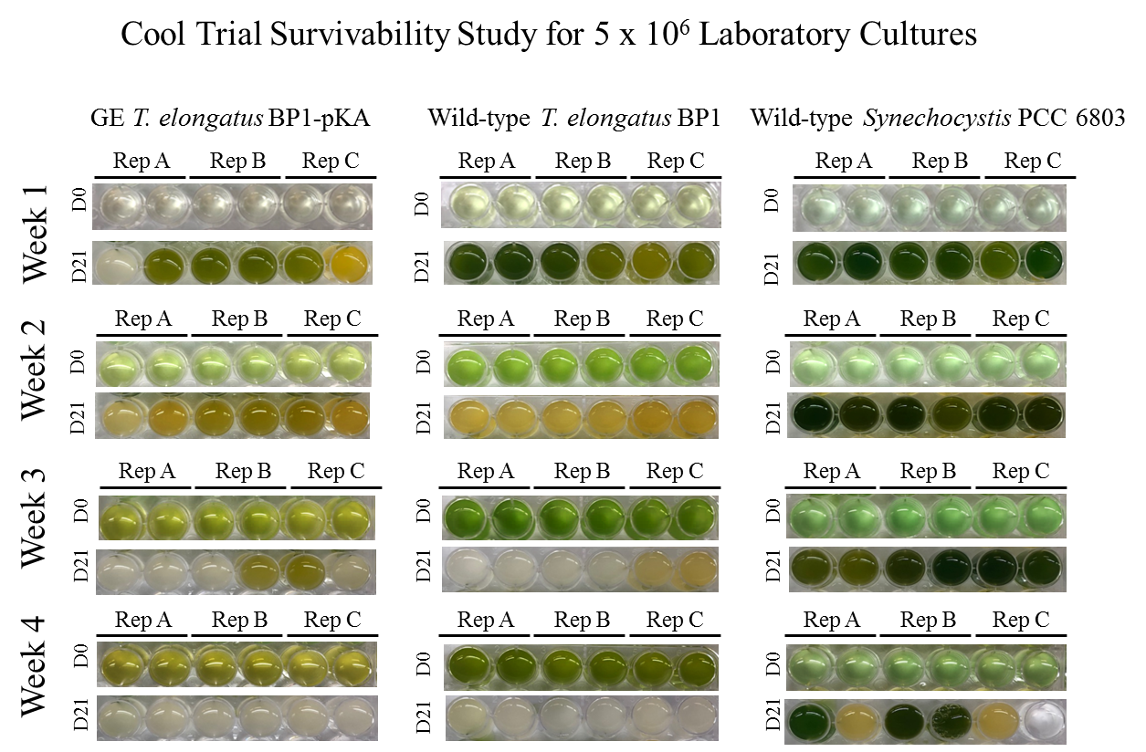
Figure S10: Survivability assay for wild-type T. elongatus BP1, wild-type Synechocystis PCC 6803 and GE T. elongatus BP1-pKA cultures at 5 x 10⁶ cells/mL incubated in laboratory conditions (~42.2 ºC for the GE and wild-type T. elongatus BP1 and room temperature for the wild-type Synechocystis PCC 6803) serving as control for the cool temperatures study. A sample of each replicate was inoculated in fresh BG-11 media after 1, 2, 3 and 4 weeks in laboratory conditions in duplicates and placed in the Percival environmental chamber (~42.2 ºC) for 21 days. The pictures of the multi-well plates were taken on day 0 and after 21 days in the Percival environmental chamber (~42.2 ºC).

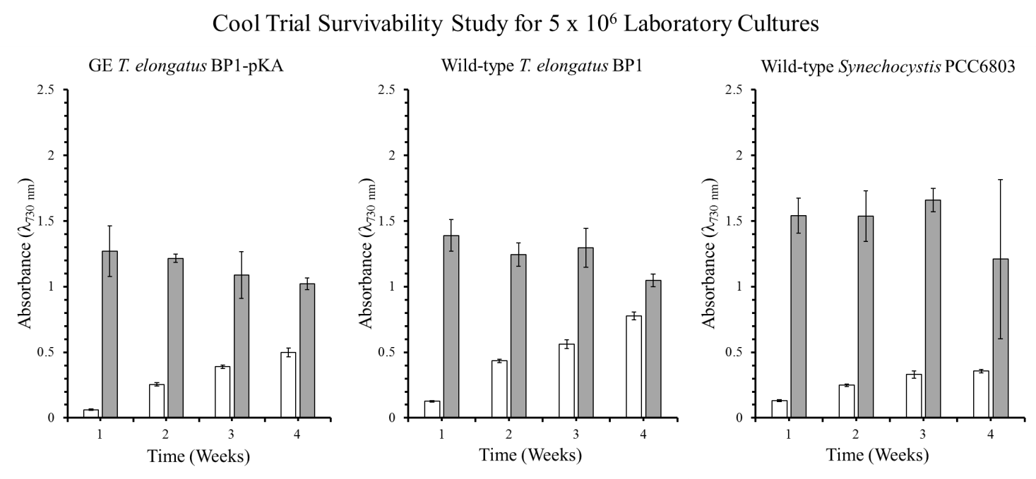
Figure S11: Optical density (λ=730 nm) of survivability assay for wild-type T. elongatus BP1, wild-type Synechocystis PCC6803 and GE T. elongatus BP1-pKA cultures at 5 x 10⁶ cells/mL incubated in laboratory conditions (~42.2 ºC for the GE and wild-type T. elongatus BP1 and room temperature for the wild-type Synechocystis PCC 6803) serving as control for the cool temperatures study. A sample of culture after 1, 2, 3 and 4 weeks in laboratory conditions was inoculated in fresh BG-11 media and placed in the Percival environmental chamber (~42.2 ºC) for 3 weeks. The growth was monitored by measuring the optical density (λ=730 nm) weekly. The results are shown as the mean value of duplicate measurements of each replicate culture (n=6). The error bars denote the standard deviation (n=6). The graph is displayed as follows: white bar ( ) = OD₇₃₀ before placed in Percival chamber and grey bar ( ) = OD₇₃₀ after 21 days in Percival chamber.

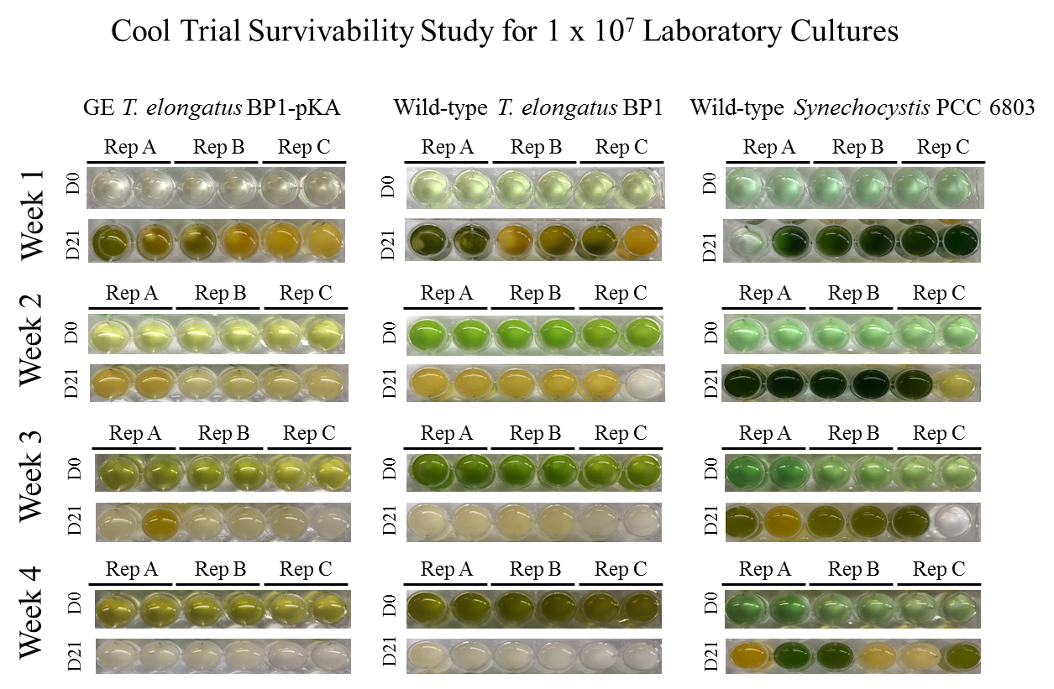
Figure S12: Survivability assay for wild-type T. elongatus BP1, wild-type Synechocystis PCC 6803 and GE T. elongatus BP1-pKA cultures at 1 x 10⁷ cells/mL incubated in laboratory conditions (~42.2 ºC for the GE and wild-type T. elongatus BP1 and room temperature for the wild-type Synechocystis PCC 6803) serving as control for the cool temperatures study. A sample of each replicate was inoculated in fresh BG-11 media after 1, 2, 3 and 4 weeks in laboratory conditions in duplicates and placed in the Percival environmental chamber (~42.2 ºC) for 21 days. The pictures of the multi-well plates were taken on day 0 and after 21 days in the Percival environmental chamber (~42.2 ºC).

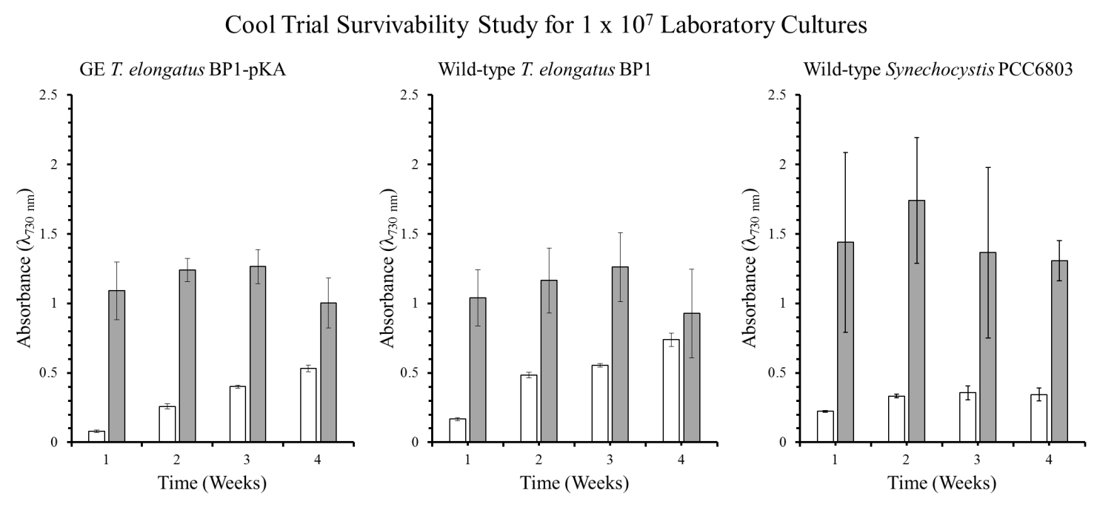
Figure S13: Optical density (λ=730 nm) of survivability assay for wild-type T. elongatus BP1, wild-type Synechocystis PCC6803 and GE T. elongatus BP1-pKA cultures at 1 x 10⁷ cells/mL incubated in laboratory conditions (~42.2 ºC for the GE and wild-type T. elongatus BP1 and room temperature for the wild-type Synechocystis PCC 6803) serving as control for the cool temperatures study. A sample of culture after 1, 2, 3 and 4 weeks in laboratory conditions was inoculated in fresh BG-11 media and placed in the Percival environmental chamber (~42.2 ºC) for 3 weeks. The growth was monitored by measuring the optical density (λ=730 nm) weekly. The results are shown as the mean value of duplicate measurements of each replicate culture (n=6). The error bars denote the standard deviation (n=6). The graph is displayed as follows: white bar ( ) = OD₇₃₀ before placed in Percival chamber and grey bar ( ) = OD₇₃₀ after 21 days in Percival chamber.

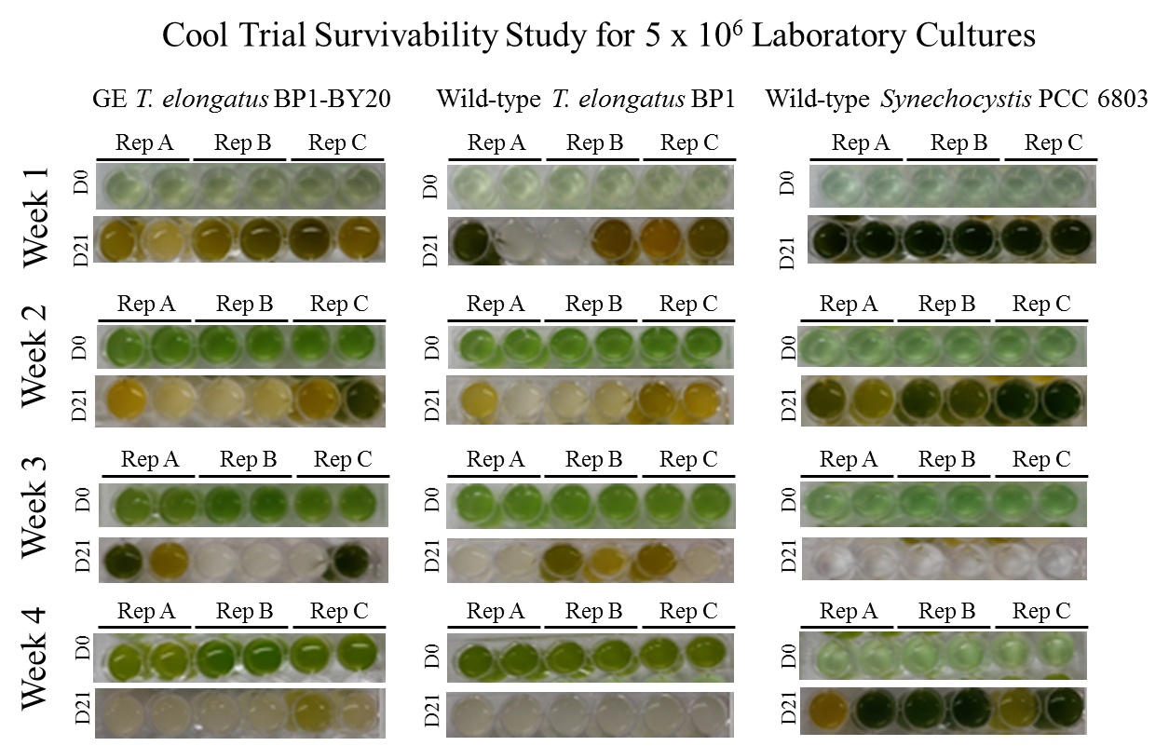
Figure S14: Survivability assay for wild-type T. elongatus BP1, wild-type Synechocystis PCC 6803 and GE T. elongatus BP1-BY20 cultures at 5 x 10⁶ cells/mL incubated in laboratory conditions (~42.2 ºC for the GE and wild-type T. elongatus BP1 and room temperature for the wild-type Synechocystis PCC 6803) serving as control for the cool temperatures study. A sample of each replicate was inoculated in fresh BG-11 media after 1, 2, 3 and 4 weeks of incubation in laboratory conditions, in duplicates and placed in the Percival environmental chamber (~42.2 ºC) for 21 days. The pictures of the multi-well plates were taken on day 0 and after 21 days in the Percival environmental chamber (~42.2 ºC).

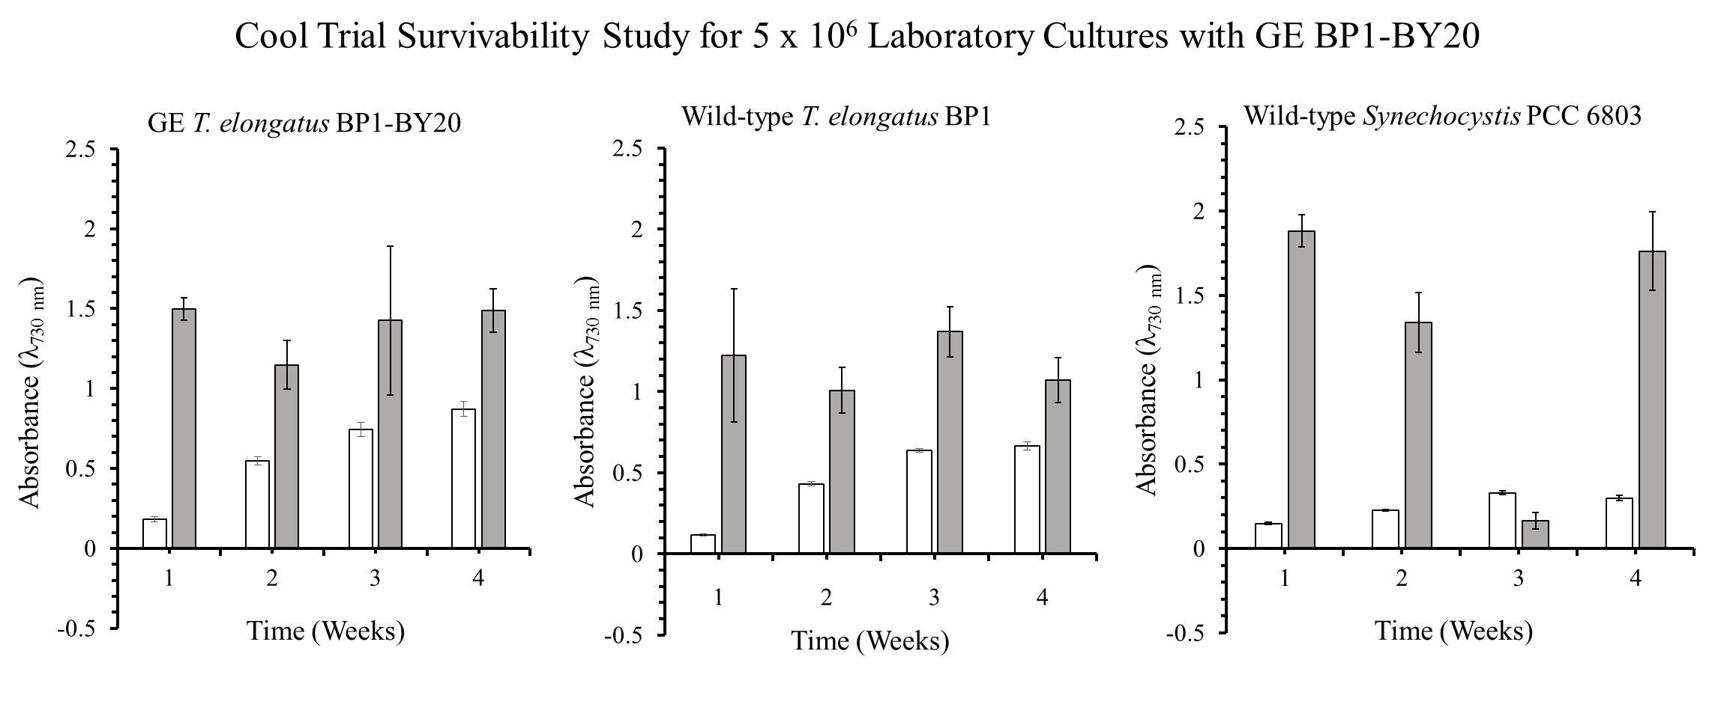Figure S15: Optical density (λ=730 nm) of survivability assay for wild-type T. elongatus BP1, wild-type Synechocystis PCC6803 and GE T. elongatus BP1-BY20 cultures at 5 x 10⁶ cells/mL incubated in laboratory conditions (~42.2 ºC for the GE and wild-type T. elongatus BP1 and room temperature for the wild-type Synechocystis PCC 6803) serving as control for the cool temperatures study. A sample of each replicate was inoculated in fresh BG-11 media after 1, 2, 3 and 4 weeks of incubation in laboratory conditions, in duplicates and placed in the Percival environmental chamber (~42.2 ºC) for 21 days. The growth was monitored by measuring the optical density (λ=730 nm) weekly. The results are shown as the mean value of duplicate measurements of each replicate culture (n=6). The error bars denote the standard deviation (n=6). The graph is displayed as follows: white bar ( ) = OD₇₃₀ before placed in Percival chamber and grey bar ( ) = OD₇₃₀ after 21 days in Percival chamber.

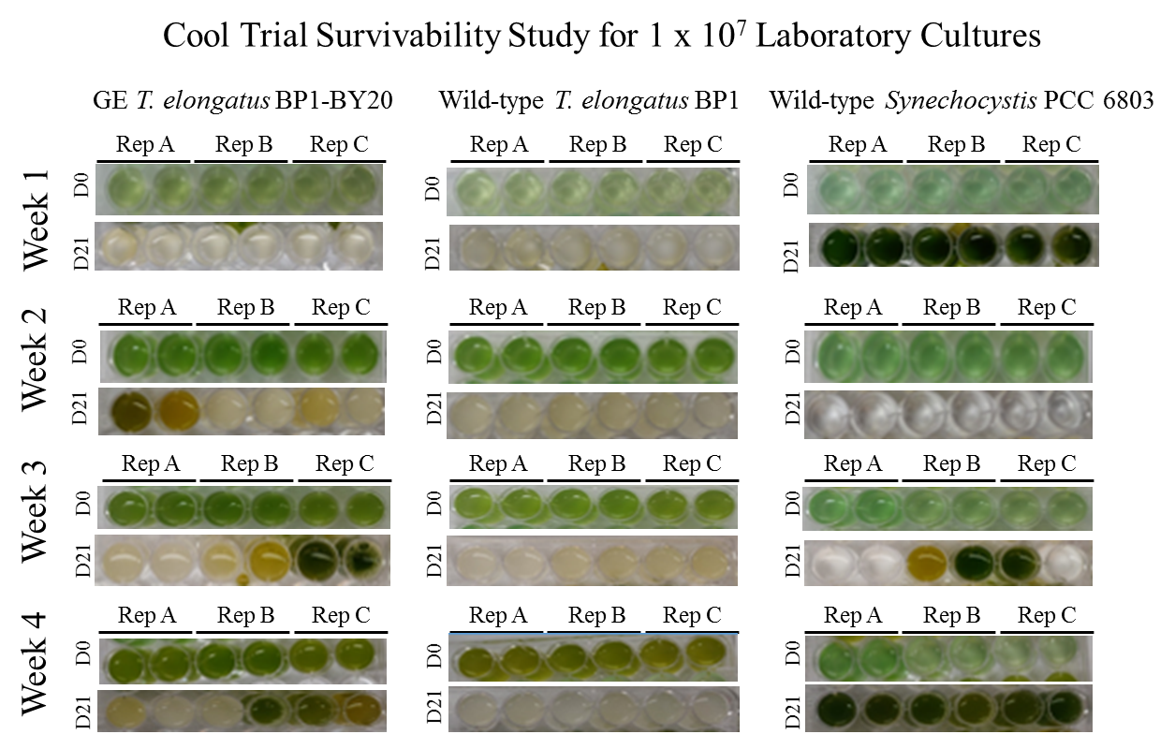
Figure S16: Survivability assay for wild-type T. elongatus BP1, wild-type Synechocystis PCC 6803 and GE T. elongatus BP1-BY20 cultures at 1 x 10⁷ cells/mL incubated in laboratory conditions (~42.2 ºC for the GE and wild-type T. elongatus BP1 and room temperature for the wild-type Synechocystis PCC 6803) serving as control for the cool temperatures study. A sample of each replicate was inoculated in fresh BG-11 media after 1, 2, 3 and 4 weeks of incubation in laboratory conditions, in duplicates and placed in the Percival environmental chamber (~42.2 ºC) for 21 days. The pictures of the multi-well plates were taken on day 0 and after 21 days in the Percival environmental chamber (~42.2 ºC).

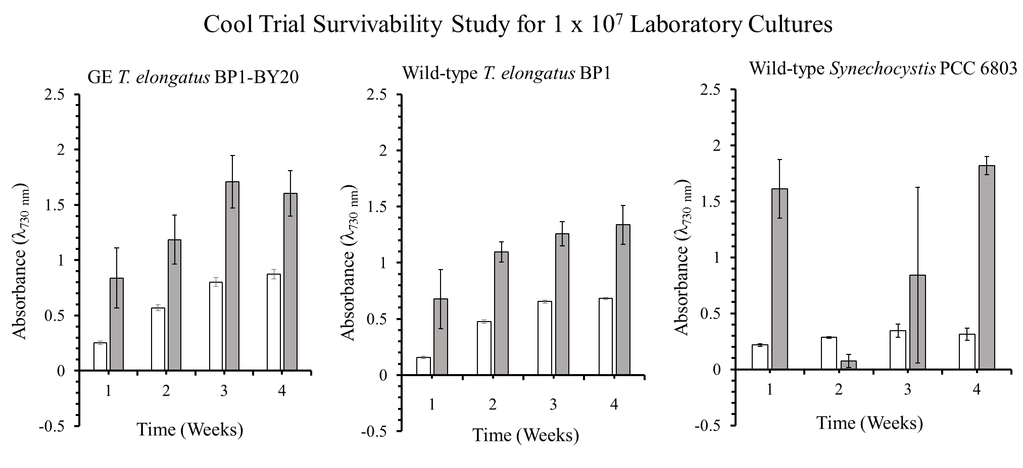
Figure S17: Optical density (λ=730 nm) of survivability assay for wild-type T. elongatus BP1, wild-type Synechocystis PCC6803 and GE T. elongatus BP1-BY20 cultures at 1 x 10⁷ cells/mL incubated in laboratory conditions (~42.2 ºC for the GE and wild-type T. elongatus BP1 and room temperature for the wild-type Synechocystis PCC 6803) serving as control for the cool temperatures study. A sample of each replicate was inoculated in fresh BG-11 media after 1, 2, 3 and 4 weeks of incubation in laboratory conditions, in duplicates and placed in the Percival environmental chamber (~42.2 ºC) for 21 days. The growth was monitored by measuring the optical density (λ=730 nm) weekly. The results are shown as the mean value of duplicate measurements of each replicate culture (n=6). The error bars denote the standard deviation (n=6). The graph is displayed as follows: white bar ( ) = OD₇₃₀ before placed in Percival chamber and grey bar ( ) = OD₇₃₀ after 21 days in Percival chamber.

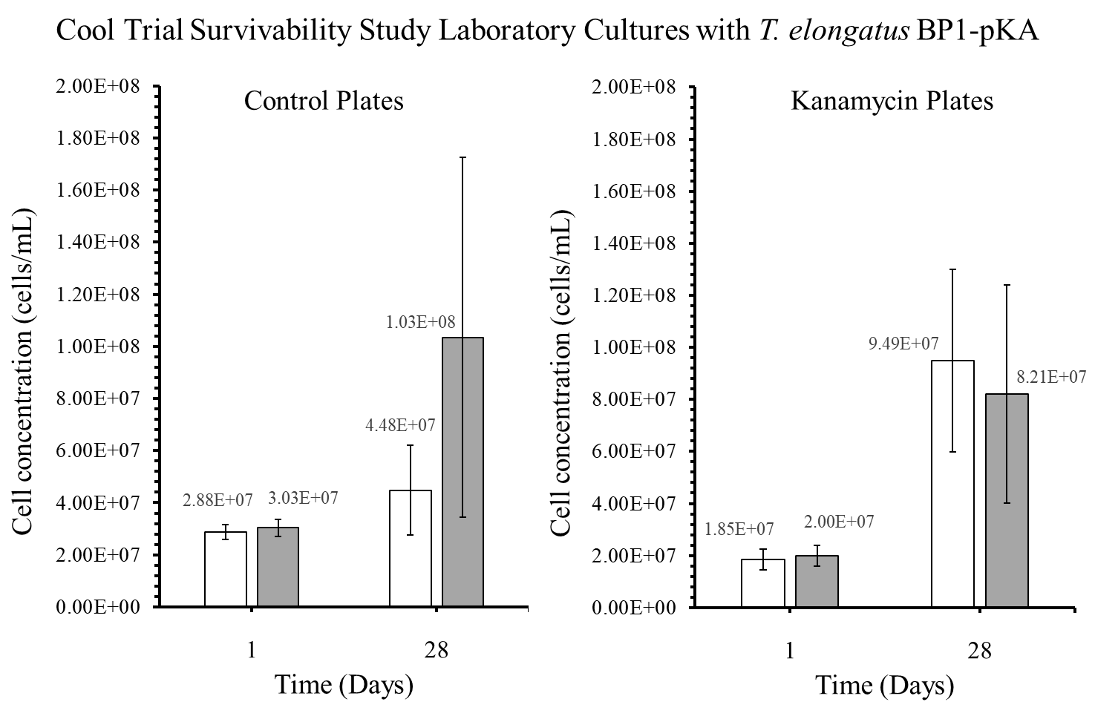
Figure S18: Colony forming units (CFU) in cells/mL for the GE T. elongatus BP1-pKA cultures incubated in laboratory conditions (~42.2 ºC) and serving as control for the cool temperatures study. A sample from the laboratory cultures was plated on BG-11 agar plates after 1 and 28 days and placed in the Percival environmental chamber (~42.2 °C) for 2 weeks. The colonies were counted and the dilution factor was applied to obtain the CFU for each culture, which is also known as the viable cell concentration (cells/mL). The results are shown as the mean value of duplicate measurements of each replicate culture (n=6). The error bars denote the standard deviation (n=6). The graph is displayed as follows: white bar () = cultures at 5 x 10⁶ cells/mL and grey bar () = cultures at 1 x 10⁷ cells/mL.

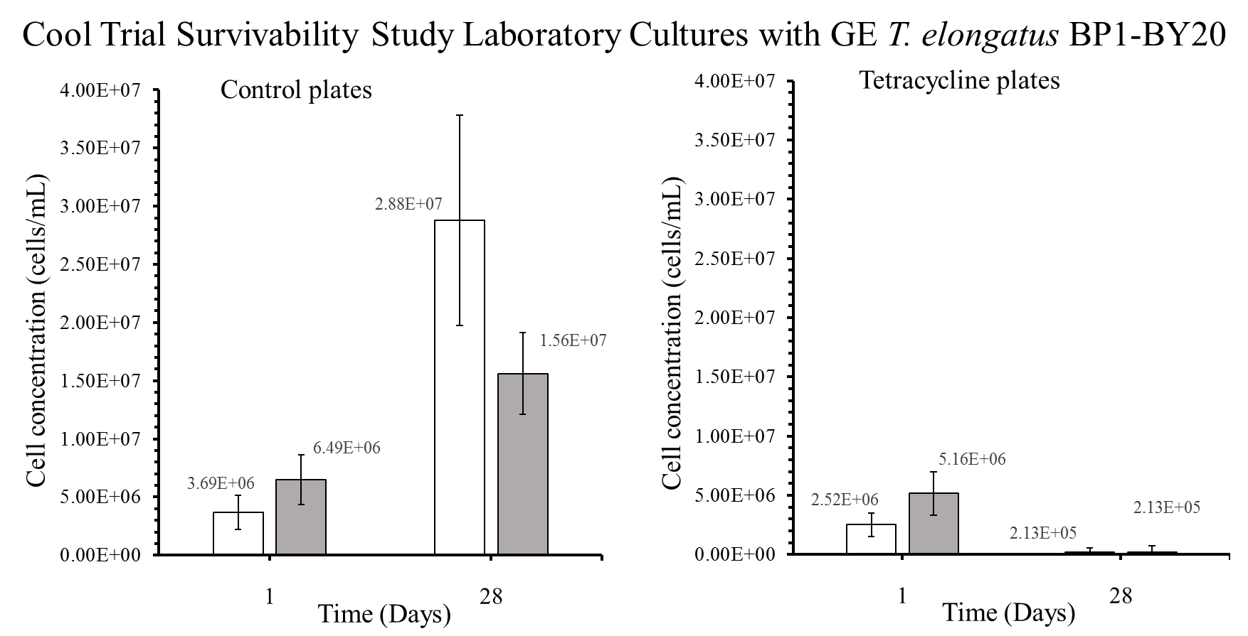Figure S19: Colony forming units (CFU) in cells/mL for the GE T. elongatus BP1-BY20 cultures incubated in laboratory conditions (~42.2 ºC) and serving as control for the cool temperatures study. A sample from the laboratory cultures was plated on BG-11 agar plates after 1 and 28 days, and placed in the Percival environmental chamber (~42.2 ºC) for 2 weeks. The colonies were counted and the diluted factor was applied to obtain the CFU for each culture, which is also known as the viable cell concentration (cells/mL). The results are shown as the mean value of duplicate measurements of each replicate culture (n=6). The error bars denote the standard deviation (n=6). The graph is displayed as follows: white bar ( ) = at 5 x 10⁶ cells/mL and grey bar ( ) = 1 x 10⁷ cells/mL.

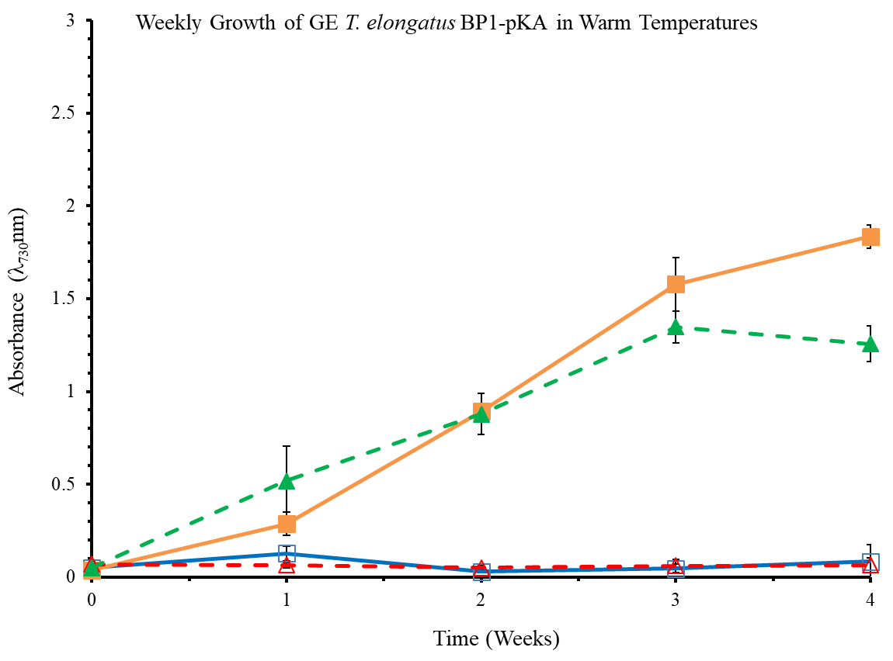
Figure S20: Optical Density of wild-type and GE T. elongatus BP1 (BP1-pKA) cultures at 5 x 10⁶ cells/mL during warm temperatures (31.42 ºC to 36.27 ºC) were monitored weekly during a 4-week period in the greenhouse. Control cultures were grown in Percival environmental chamber (~42.2ºC) in Percival incubator. The results shown here are liquid culture absorbance measurements at 730 nm in duplicates for each replicate (n=6). The graph is displayed as follows: ( ) is wild-type T. elongatus BP1in Percival, ( ) is wild-type T. elongatus BP1 in Greenhouse, ( ) is the GE T. elongatus BP1-pKA in Percival, and ( ) is the GE T. elongatus BP1-pKA in Greenhouse. Wild-type T. elongatus BP1 = solid lines, BP1-pKA = dashed lines, closed symbols = control set and open symbols = greenhouse set.

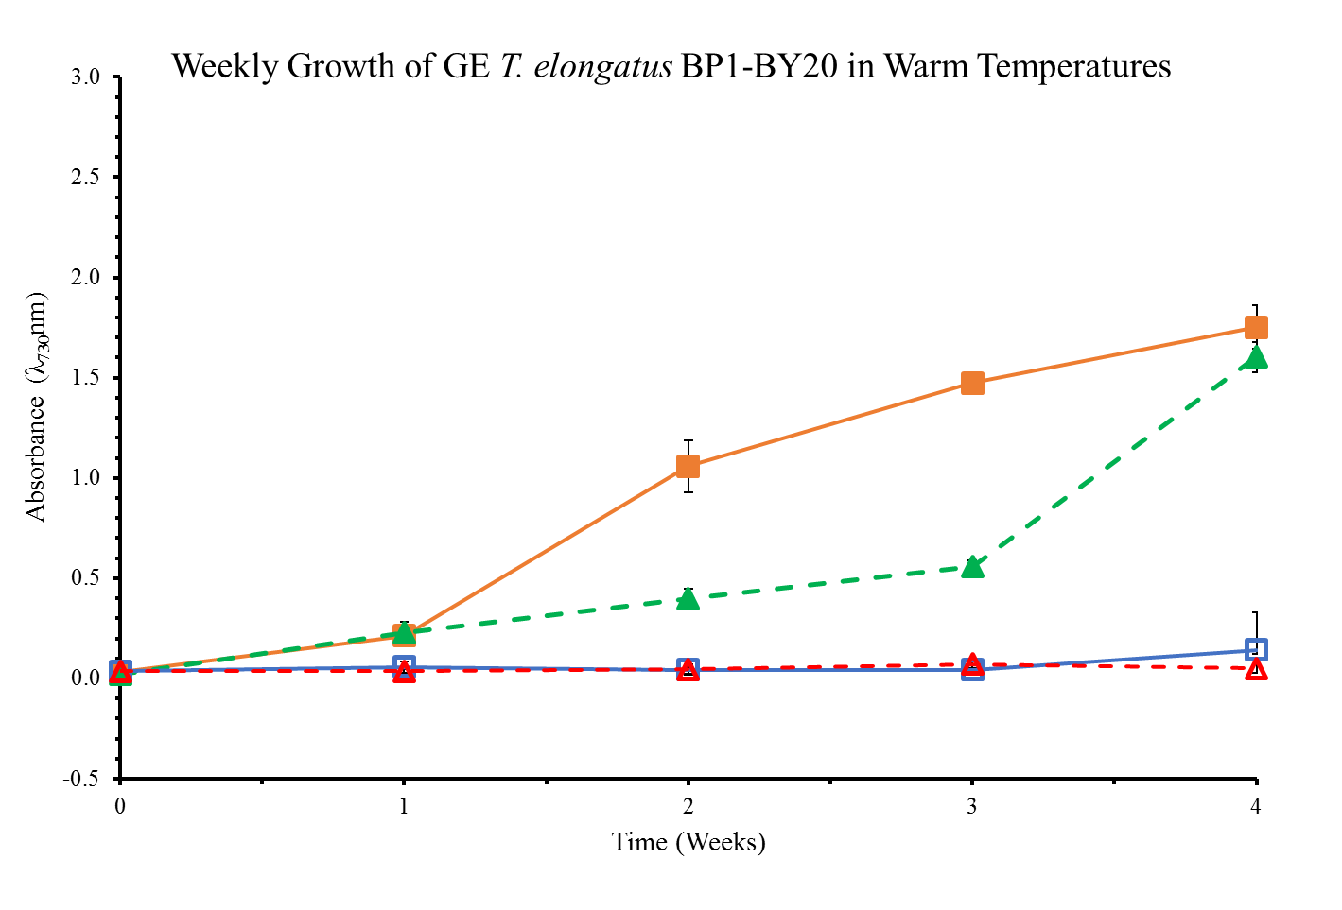
Figure S21: Optical Density of wild-type and GE T. elongatus BP1 (BP1-BY20) cultures at 5 x 10⁶ cells/mL during warm temperatures (31.42ºC to 36.27ºC) were monitored weekly during a 4-week period in the greenhouse. Control cultures were grown in Percival environmental chamber (~42.2ºC) in Percival incubator. The results shown here are liquid culture absorbance measurements at 730 nm in duplicates for each replicate (n=6). The graph is displayed as follows: ( ) is wild-type T. elongatus BP1in Percival, ( ) is wild-type T. elongatus BP1 in Greenhouse, ( ) is the GE T. elongatus BP1- BY20 in Percival, and ( ) is the GE T. elongatus BP1- BY20in Greenhouse. Wild-type T. elongatus BP1 = solid lines, BP1- BY20= dashed lines, closed symbols = control set and open symbols = greenhouse set.

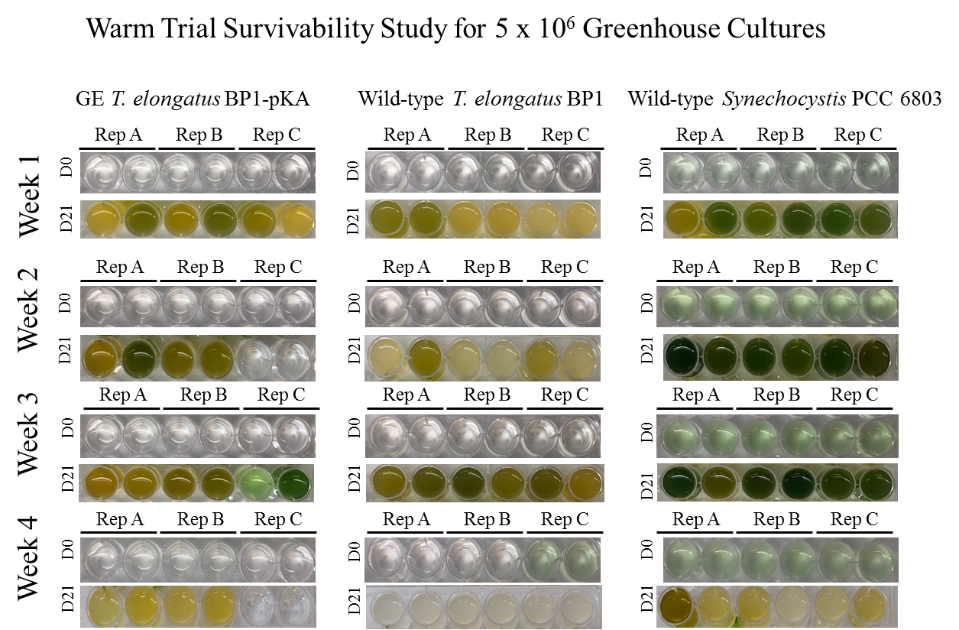
Figure S22: Survivability assay for wild-type T. elongatus BP1, wild-type Synechocystis PCC 6803 and GE T. elongatus BP1-pKA cultures at 5 x 10⁶ cells/mL during warm temperatures (31.42 ºC to 36.27 ºC) in the greenhouse. A sample of each replicate was inoculated in fresh BG-11 media after 1, 2, 3 and 4 weeks in greenhouse in duplicates and placed in the Percival environmental chamber (~42.2 ºC) for 21 days. The pictures of the multi-well plates were taken on day 0 and after 21 days in the Percival environmental chamber (~42.2 ºC).

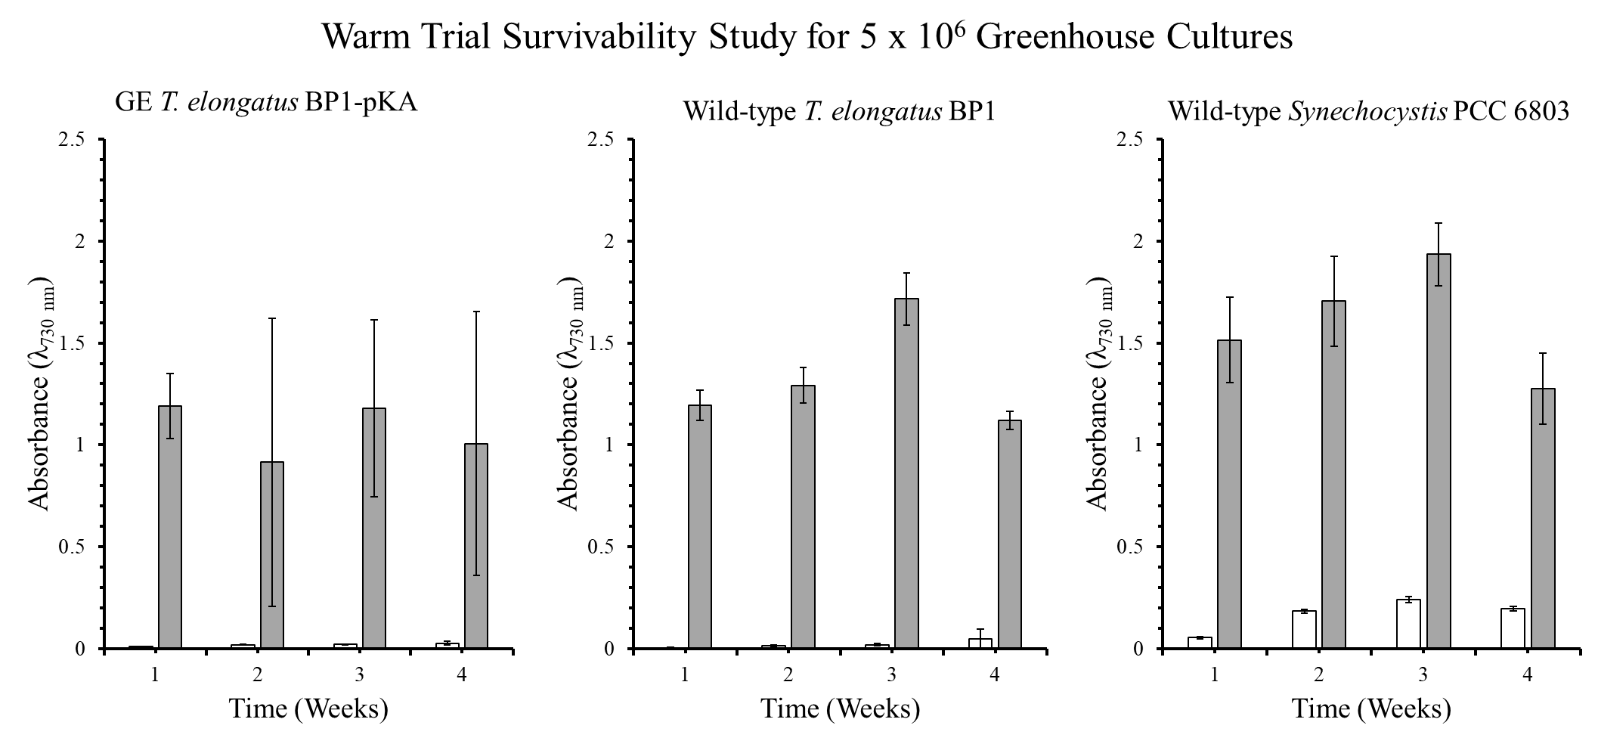
Figure S23: Optical density (λ=730 nm) of survivability assay for wild-type T. elongatus BP1, wild-type Synechocystis PCC6803 and GE T. elongatus BP1-pKA cultures at 5 x 10⁶ cells/mL during warm temperatures (31.42 ºC to 36.27 ºC) in greenhouse conditions. A sample of culture after 1, 2, 3 and 4 weeks in greenhouse was inoculated in fresh BG-11 media and placed in the Percival environmental chamber (~42.2 ºC) for 21 days. The growth was monitored by measuring the optical density (λ=730 nm) weekly. The results are shown as the mean value of duplicate measurements of each replicate culture (n=6). The error bars denote the standard deviation (n=6). The graph is displayed as follows: white bar ( ) = OD₇₃₀ before placed in Percival chamber and grey bar ( ) = OD₇₃₀ after 21 days in Percival chamber.

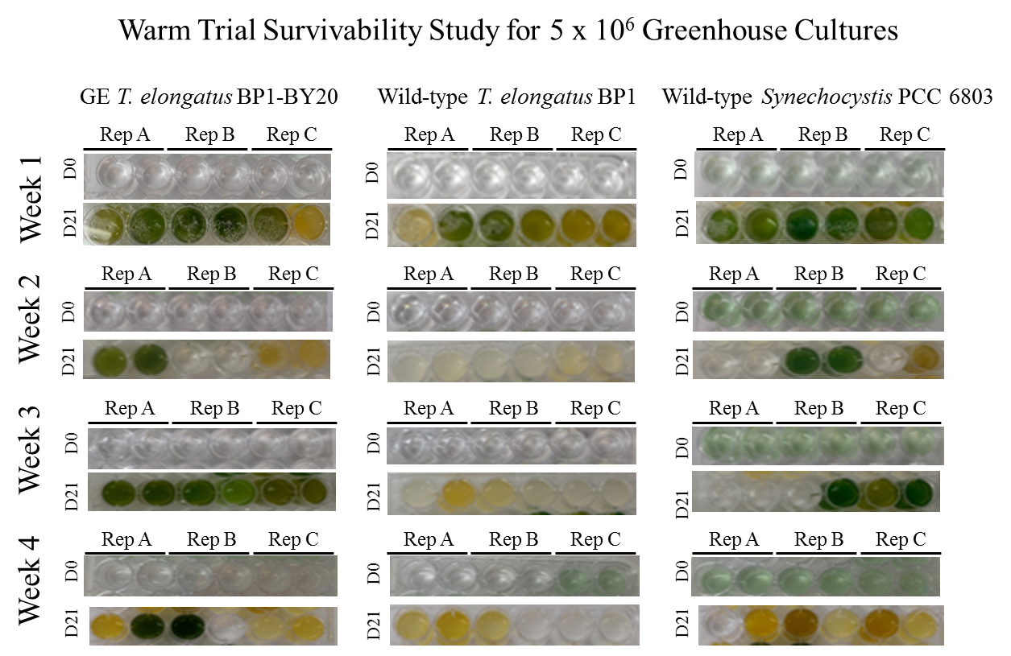
Figure S24: Survivability assay for wild-type T. elongatus BP1, wild-type Synechocystis PCC 6803 and GE T. elongatus BP1- BY20 cultures at 5 x 10⁶ cells/mL during warm temperatures (31.42 ºC to 36.27 ºC) in the greenhouse. A sample of each replicate was inoculated in fresh BG-11 media after 1, 2, 3 and 4 weeks in greenhouse in duplicates and placed in the Percival environmental chamber (~42.2 ºC) for 21 days. The pictures of the multi-well plates were taken on day 0 and after 21 days in the Percival environmental chamber (~42.2 ºC).

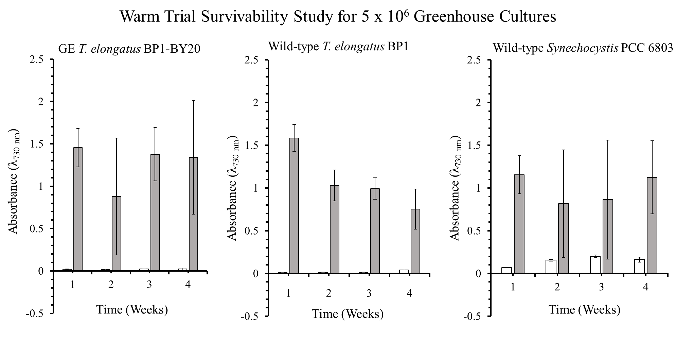
Figure S25: Optical density (λ=730 nm) of survivability assay for wild-type T. elongatus BP1, wild-type Synechocystis PCC6803 and GE T. elongatus BP1- BY20 cultures at 5 x 10⁶ cells/mL during warm temperatures (31.42 ºC to 36.27 ºC) in greenhouse conditions. Samples of culture after 1, 2, 3 and 4 weeks in greenhouse were inoculated in fresh BG-11 media and placed in the Percival environmental chamber (~42.2 ºC) for 21 days. The growth was monitored by measuring the optical density (λ=730 nm) weekly. The results are shown as the mean value of duplicate measurements of each replicate culture (n=6). The error bars denote the standard deviation (n=6). The graph is displayed as follows: white bar ( ) = OD₇₃₀ before placed in Percival chamber and grey bar ( ) = OD₇₃₀ after 21 days in Percival chamber.

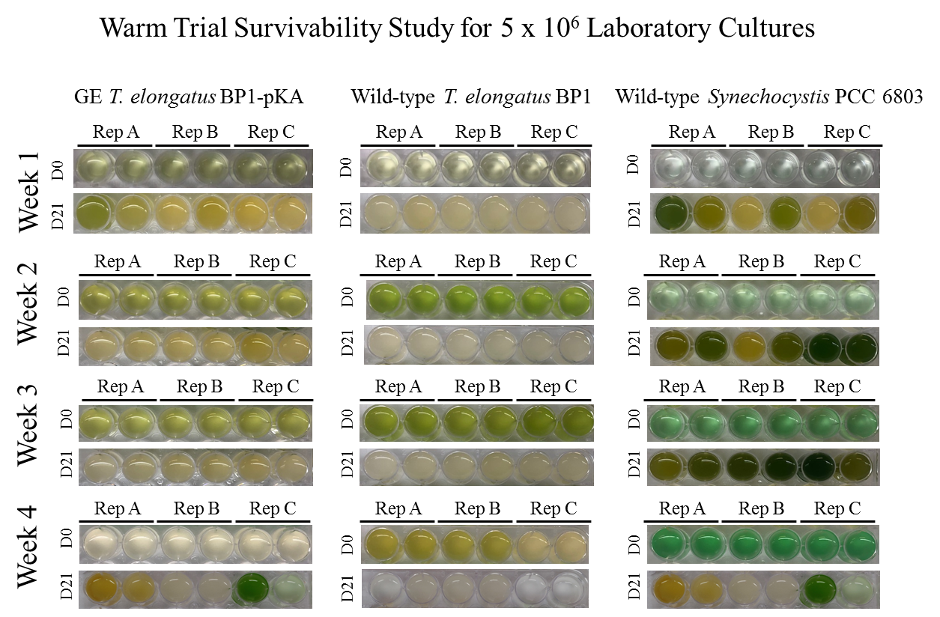
Figure S26: Survivability assay for wild-type T. elongatus BP1, wild-type Synechocystis PCC 6803 and GE T. elongatus BP1-pKA cultures at 5 x 10⁶ cells/mL incubated in laboratory conditions (~42.2 ºC for the GE and wild-type T. elongatus BP1 and room temperature for the wild-type Synechocystis PCC 6803) serving as control for the warm temperatures study. A sample of each replicate was inoculated in fresh BG-11 media after 1, 2, 3 and 4 weeks in laboratory conditions, in duplicates and placed in the Percival environmental chamber (~42.2 ºC) for 21 days. The pictures of the multi-well plates were taken on day 0 and after 21 days in the Percival environmental chamber (~42.2 ºC).

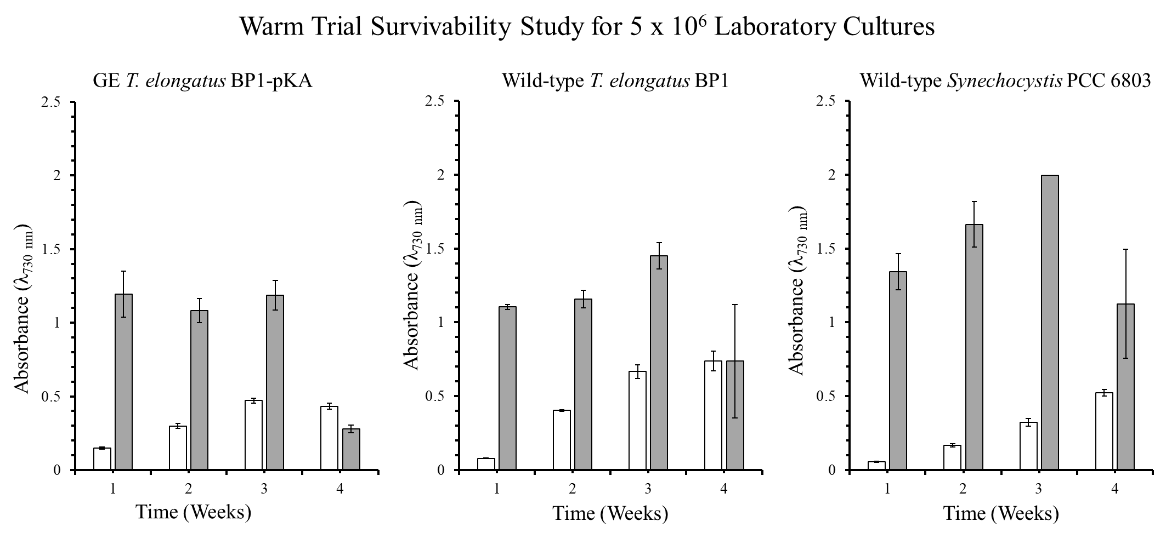
Figure S27: Optical density (λ=730 nm) of survivability assay for wild-type T. elongatus BP1, wild-type Synechocystis PCC6803 and GE T. elongatus BP1-pKA cultures at 5 x 10⁶ cells/mL incubated in laboratory conditions (~42.2 ºC for the GE and wild-type T. elongatus BP1 and room temperature for the wild-type Synechocystis PCC 6803) serving as control for the warm temperatures study. A sample of culture after 1, 2, 3 and 4 weeks in laboratory conditions was inoculated in fresh BG-11 media and placed in the Percival environmental chamber (~42.2 ºC) for 21 days. The growth was monitored by measuring the optical density (λ=730 nm) weekly. The results are shown as the mean value of duplicate measurements of each replicate culture (n=6). The error bars denote the standard deviation (n=6). The graph is displayed as follows: white bar ( ) = OD₇₃₀ before placed in Percival chamber and grey bar ( ) = OD₇₃₀ after 21 days in Percival chamber.

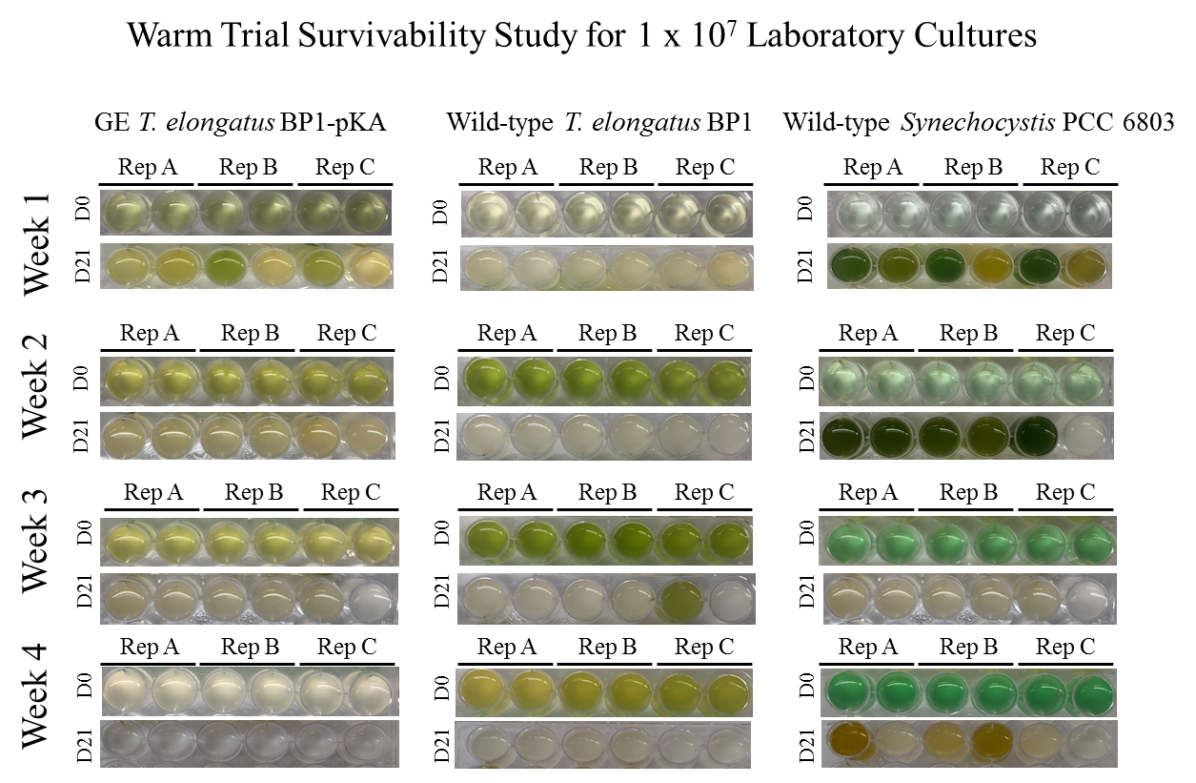
Figure S28: Survivability assay for wild-type T. elongatus BP1, wild-type Synechocystis PCC 6803 and GE T. elongatus BP1-pKA cultures at 1 x 10⁷ cells/mL incubated in laboratory conditions (~42.2 ºC for the GE and wild-type T. elongatus BP1 and room temperature for the wild-type Synechocystis PCC 6803) serving as control for the warm temperatures study. A sample of each replicate was inoculated in fresh BG-11 media after 1, 2, 3 and 4 weeks in laboratory conditions and placed in the Percival environmental chamber (~42.2 ºC) for 21 days. The pictures of the multi-well plates were taken on day 0 and after 21 days in the Percival environmental chamber (~42.2 ºC).

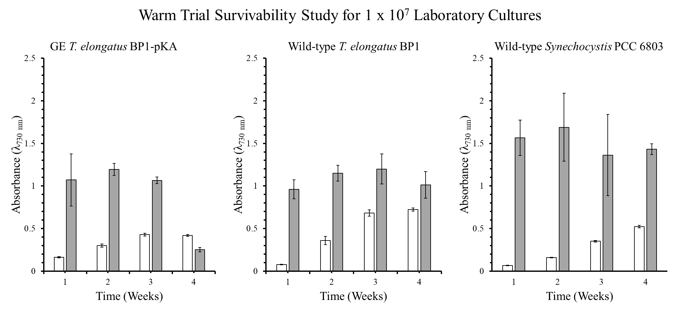
Figure S29: Optical density (λ=730 nm) of survivability assay for wild-type T. elongatus BP1, wild-type Synechocystis PCC6803 and GE T. elongatus BP1-pKA cultures at 1 x 10⁷ cells/mL incubated in laboratory conditions (~42.2 ºC for the GE and wild-type T. elongatus BP1 and room temperature for the wild-type Synechocystis PCC 6803) serving as control for the warm temperatures study. A sample of culture after 1, 2, 3 and 4 weeks in laboratory conditions was inoculated in fresh BG-11 media and placed in the Percival environmental chamber (~42.2 ºC) for 21 days. The growth was monitored by measuring the optical density (λ=730 nm) weekly. The results are shown as the mean value of duplicate measurements of each replicate culture (n=6). The error bars denote the standard deviation (n=6). The graph is displayed as follows: white bar ( ) = OD₇₃₀ before placed in Percival chamber and grey bar ( ) = OD₇₃₀ after 21 days in Percival chamber.

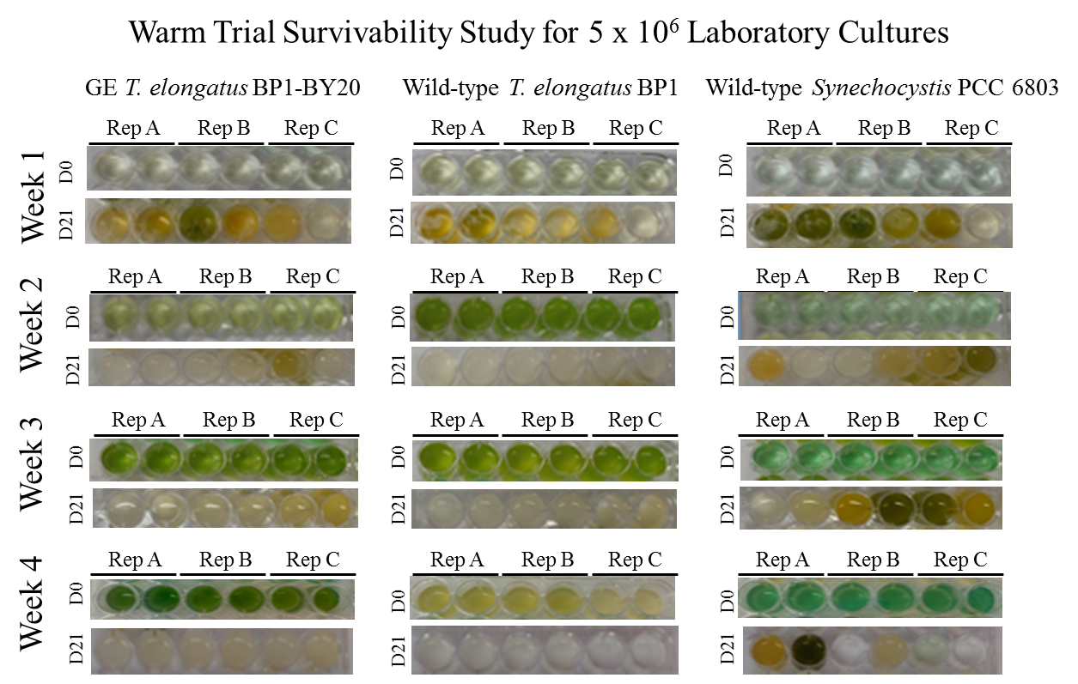
Figure S30: Survivability assay for wild-type T. elongatus BP1, wild-type Synechocystis PCC 6803 and GE T. elongatus BP1- BY20 cultures at 5 x 10⁶ cells/mL incubated in laboratory conditions (~42.2 ºC for the GE and wild-type T. elongatus BP1 and room temperature for the wild-type Synechocystis PCC 6803) serving as control for the warm temperatures study. A sample of each replicate was inoculated in fresh BG-11 media after 1, 2, 3 and 4 weeks in in laboratory conditions, in duplicates and placed in the Percival environmental chamber (~42.2 ºC) for 21 days. The pictures of the multi-well plates were taken on day 0 and after 21 days in the Percival environmental chamber (~42.2 ºC).

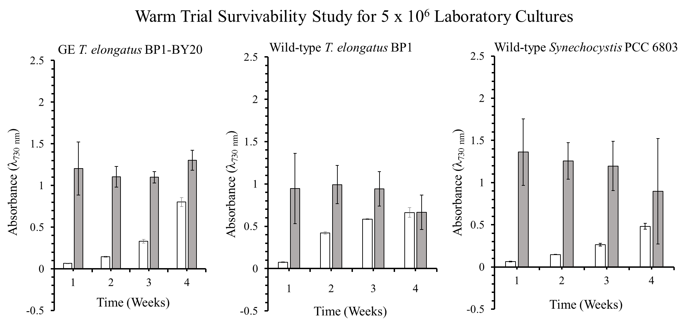
Figure S31: Optical density (λ=730 nm) of survivability assay for wild-type T. elongatus BP1, wild-type Synechocystis PCC6803 and GE T. elongatus BP1-BY20 cultures at 5 x 10⁶ cells/mL incubated in laboratory conditions (~42.2 ºC for the GE and wild-type T. elongatus BP1 and room temperature for the wild-type Synechocystis PCC 6803) serving as control for the warm temperatures study. A sample of culture after 1, 2, 3 and 4 weeks in laboratory conditions was inoculated in fresh BG-11 media and placed in the Percival environmental chamber (~42.2 ºC) for 21 days. The growth was monitored by measuring the optical density (λ=730 nm) weekly. The results are shown as the mean value of duplicate measurements of each replicate culture (n=6). The error bars denote the standard deviation (n=6). The graph is displayed as follows: white bar ( ) = OD₇₃₀ before placed in Percival chamber and grey bar ( ) = OD₇₃₀ after 21 days in Percival chamber.

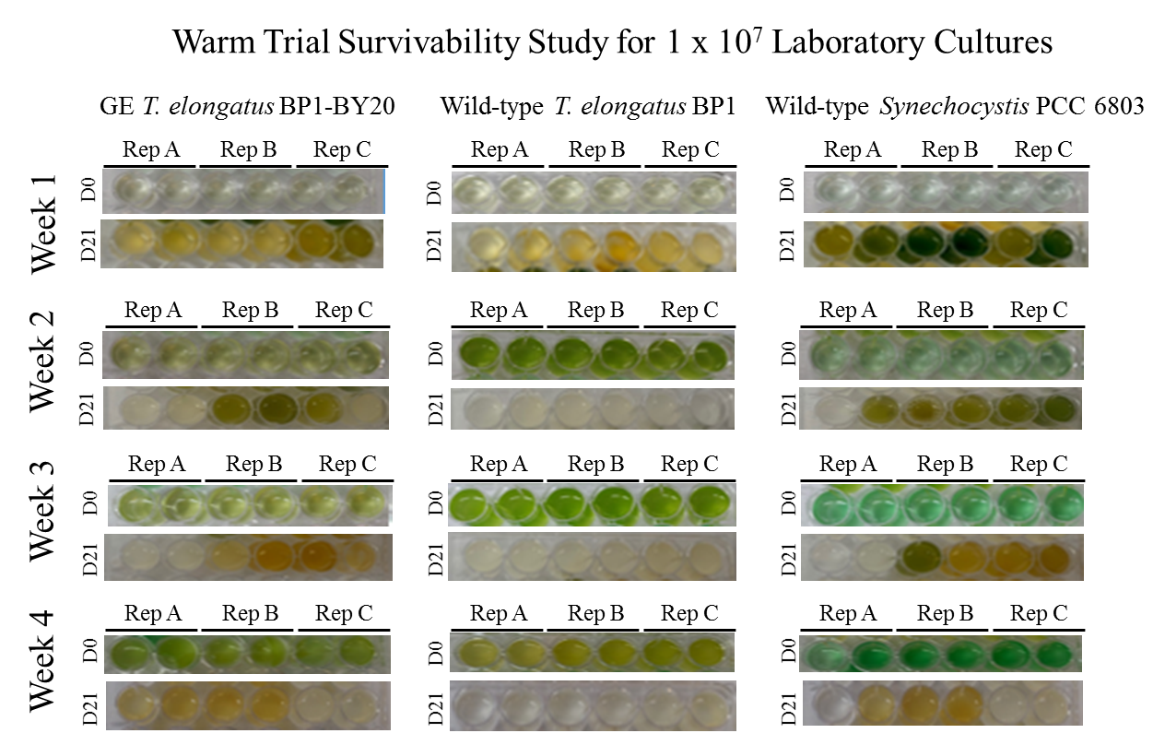
Figure S32: Survivability assay for wild-type T. elongatus BP1, wild-type Synechocystis PCC 6803 and GE T. elongatus BP1- BY20 cultures at 1 x 10⁷ cells/mL incubated in laboratory conditions (~42.2 ºC for the GE and wild-type T. elongatus BP1 and room temperature for the wild-type Synechocystis PCC 6803) serving as control for the warm temperatures study. A sample of each replicate was inoculated in fresh BG-11 media after 1, 2, 3 and 4 weeks in laboratory conditions, in duplicates and placed in the Percival environmental chamber (~42.2 ºC) for 21 days. The pictures of the multi-well plates were taken on day 0 and after 21 days in the Percival environmental chamber (~42.2 ºC).

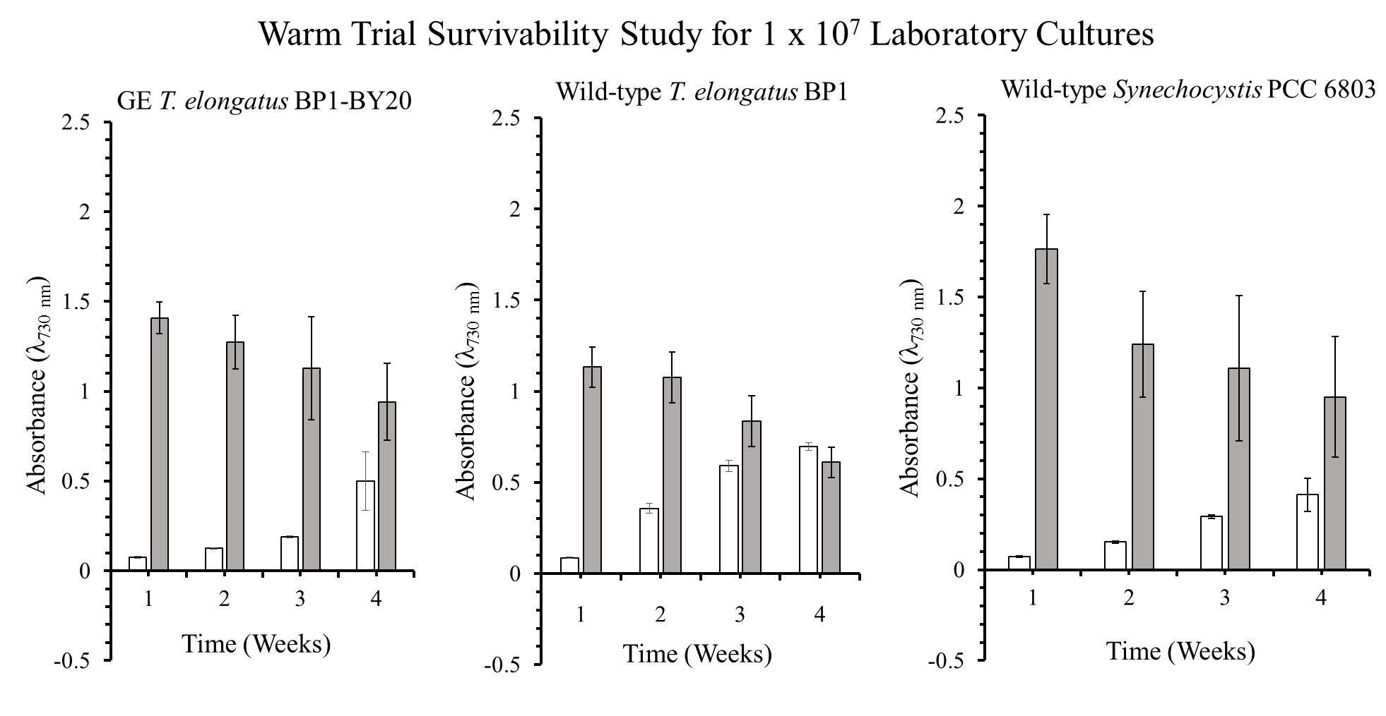
Figure S33: Optical density (λ=730 nm) of survivability assay for wild-type T. elongatus BP1, wild-type Synechocystis PCC6803 and GE T. elongatus BP1- BY20 cultures at 1 x 10⁷ cells/mL incubated in laboratory conditions (~42.2 ºC for the GE and wild-type T. elongatus BP1 and room temperature for the wild-type Synechocystis PCC 6803) serving as control for the warm temperatures study. A sample of culture after 1, 2, 3 and 4 weeks in laboratory conditions was inoculated in fresh BG-11 media and placed in the Percival environmental chamber (~42.2 ºC) for 21 days. The growth was monitored by measuring the optical density (λ=730 nm) weekly. The results are shown as the mean value of duplicate measurements of each replicate culture (n=6). The error bars denote the standard deviation (n=6). The graph is displayed as follows: white bar ( ) = OD₇₃₀ before placed in Percival chamber and grey bar ( ) = OD₇₃₀ after 21 days in Percival chamber.

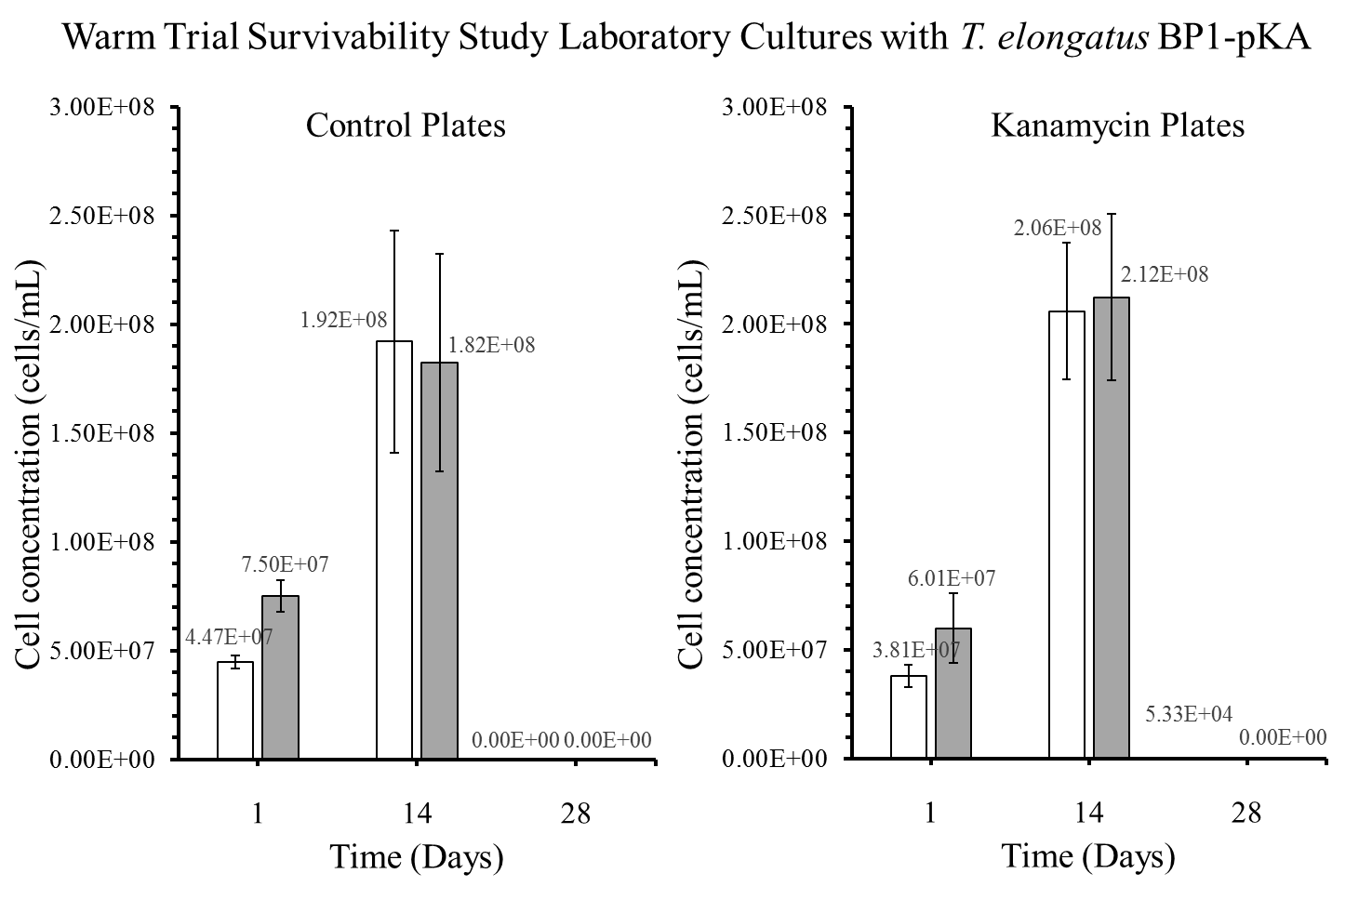
Figure S34: Colony forming units (CFU) in cells/mL for the GE T. elongatus BP1-pKA cultures incubated in laboratory conditions (~42.2 ºC) serving as control for the warm temperatures study. A sample from the laboratory cultures was plated on BG-11 agar plates after 1, 14 and 28 days, and placed in the Percival environmental chamber (~42.2 °C) for 2 weeks. The colonies were counted and the dilution factor was applied to obtain the CFU for each culture, which is also known as the viable cell concentration (cells/mL). The results are shown as the mean value of duplicate measurements of each replicate culture (n=6). The error bars denote the standard deviation (n=6). The graph is displayed as follows: white bar () = cultures at 5 x 10⁶ cells/mL and grey bar () = cultures at 1 x 10⁷ cells/mL.

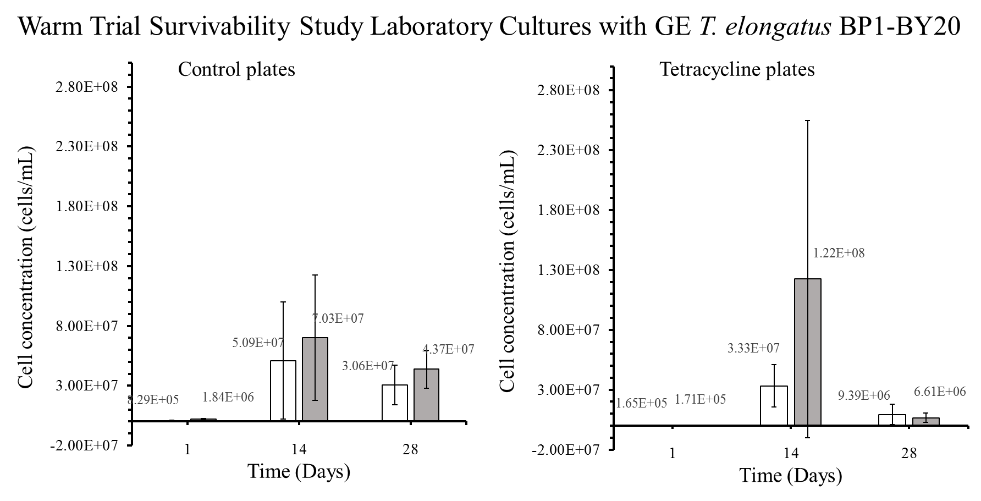
Figure S35: Colony forming units (CFU) in cells/mL for the GE T. elongatus BP1-BY20 cultures incubated in laboratory conditions (~42.2 ºC) serving as control for the warm temperatures study. A sample from the laboratory cultures was plated on BG-11 agar plates after 1, 14 and 28 days, and placed in the Percival environmental chamber (~42.2 ºC) for 2 weeks. The colonies were counted and the diluted factor was applied to obtain the CFU for each culture, which is also known as the viable cell concentration (cells/mL). The results are shown as the mean value of duplicate measurements of each replicate culture (n=6). The error bars denote the standard deviation (n=6). The graph is displayed as follows: white bar ( ) = at 5 x 10⁶ cells/mL and grey bar ( ) = 1 x 10⁷ cells/mL.

